四:

截屏2024-12-17 15.48.32

截屏2024-12-17 15.53.39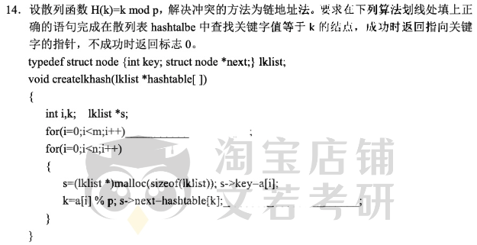截屏2024-12-18 08.54.32

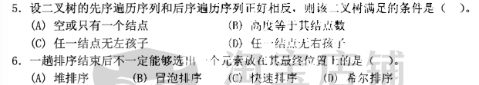截屏2024-12-18 08.56.08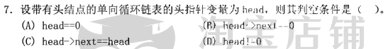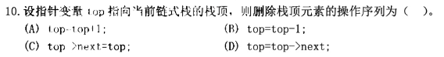截屏2024-12-18 09.57.48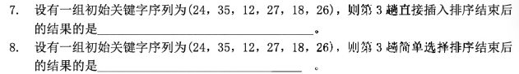截屏2024-12-18 11.05.34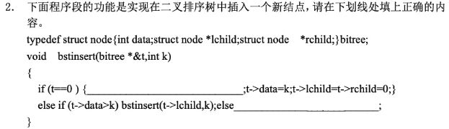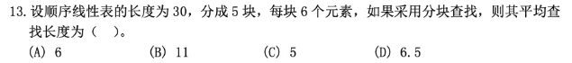截屏2024-12-18 15.55.11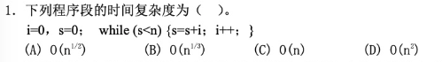截屏2024-12-19 16.23.22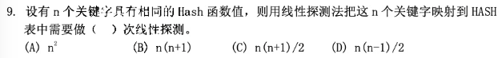截屏2024-12-19 16.23.55截屏2024-12-19 16.23.45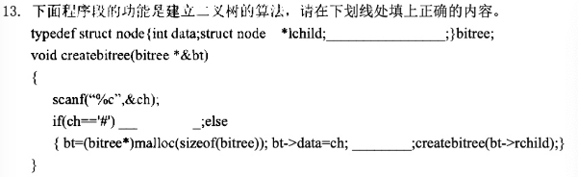截屏2024-12-19 16.24.03