**Matrix**

Prob 1:



Prob2:

Find the row-reduced echelon matrices that are row-equivalent to the following matrices:

a,

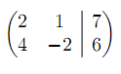1 0 -18

0 1 43

b,

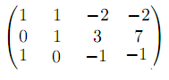

c,

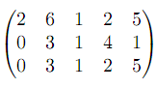

d,

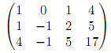

e,

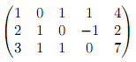

Prob 3:

Let ,

Calculate

a, (A+B)+C

b, A+(B+C)

c, 3A

Prob 4:

1, 

2, 

3, 

4,

5, 

6, 

7, 

Prob 5:

Calculate the inverse of the following matrices:

1, 

2, 

3, 

4, 

5, 

6, 

Prob 6:



Verify that (AB)C=A(BC) (association)