EEE404/591 Real Time DSP
Lab 2: Introduction to ARM Assembly Coding and Circular Convolution
Chao Wang
Note: this serves as a template only. Make sure you fill out the tables, include correct screenshots and correct code.

- Tables
Include the two filled-out tables from Task 1 and Task 2 2).
Multiply and Accumulate | Pure C | Hybrid | Pure Assembly
Cycle count
Size of .elf file (in bytes)

Circular Convolution | Pure C | Hybrid | Pure Assembly
Cycle count
Size of .elf file (in bytes)

- Screenshots
Include the following screenshots of the IDE window from Task 2 3). You need to make sure the screenshots are clearly readable. Highlight the requested parts or values as shown in the screenshots below.

- Show your modified SIZE, x and y arrays in “main.c” and “main_hybrid.c” using the values of SIZE = 6, x = [1, 1, 1, 1, 0, 0], y = [1, 1, 1, 0, 0, 0]. Expression window shows the FINAL circular convolution result s and cycle_count. Note your numbers should be different from the screenshot below.

For main.c:
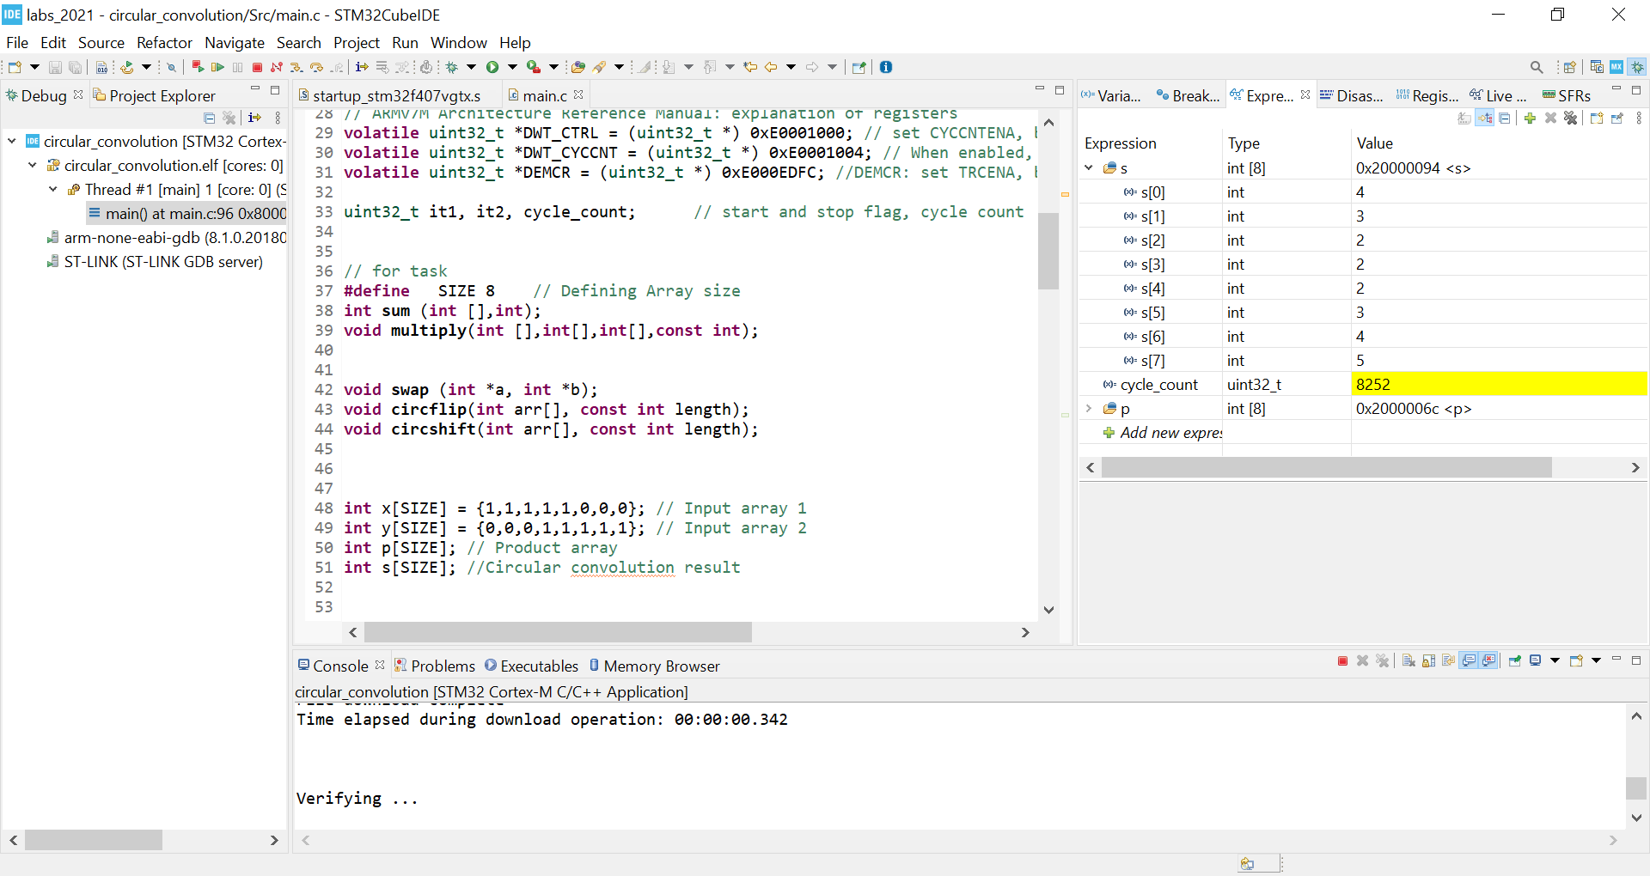
For main_hybrid.c:
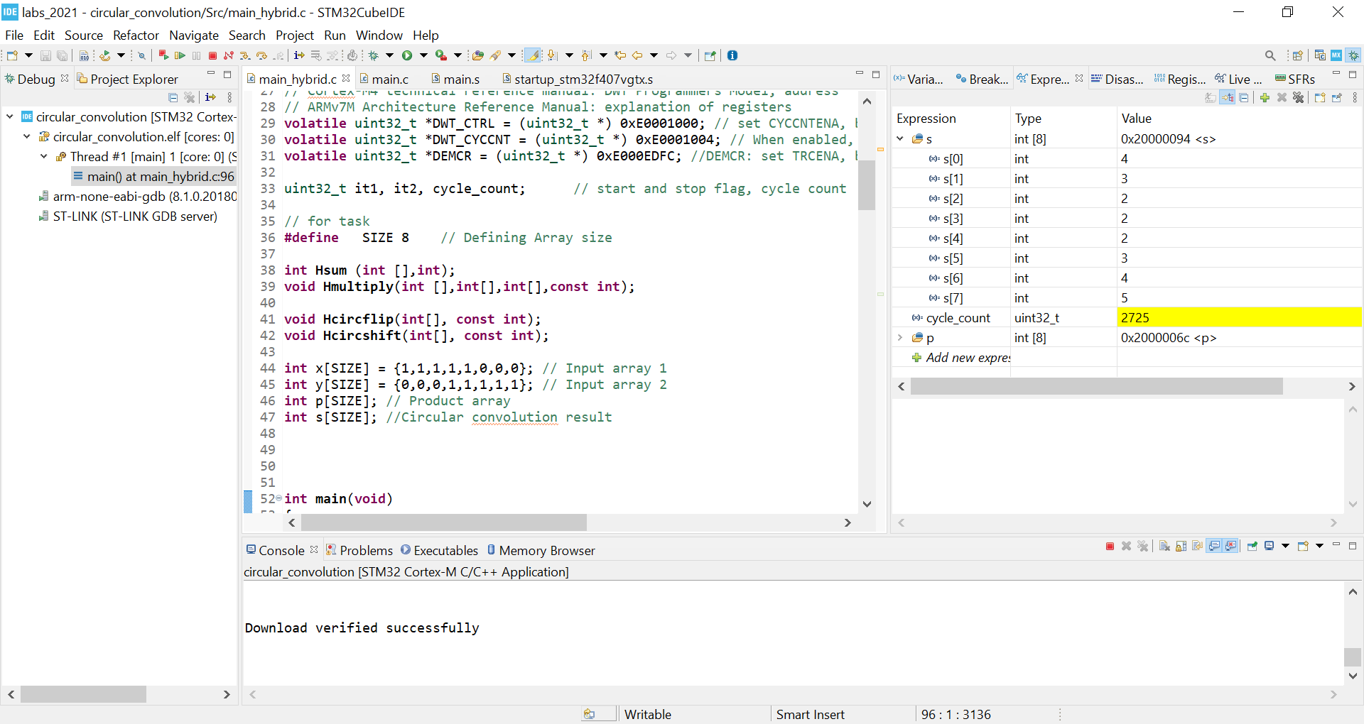

- Modify “main.s” using SIZE = 6, x = [1, 1, 1, 1, 0, 0], y = [1, 1, 1, 0, 0, 0]. Show your modified x and y arrays and the content of your memory starting from 0x2000 0000. Highlight the portion showing the FINAL circular convolution result and cycle_count. Note your numbers should be different from the screenshot below.

For main.s:
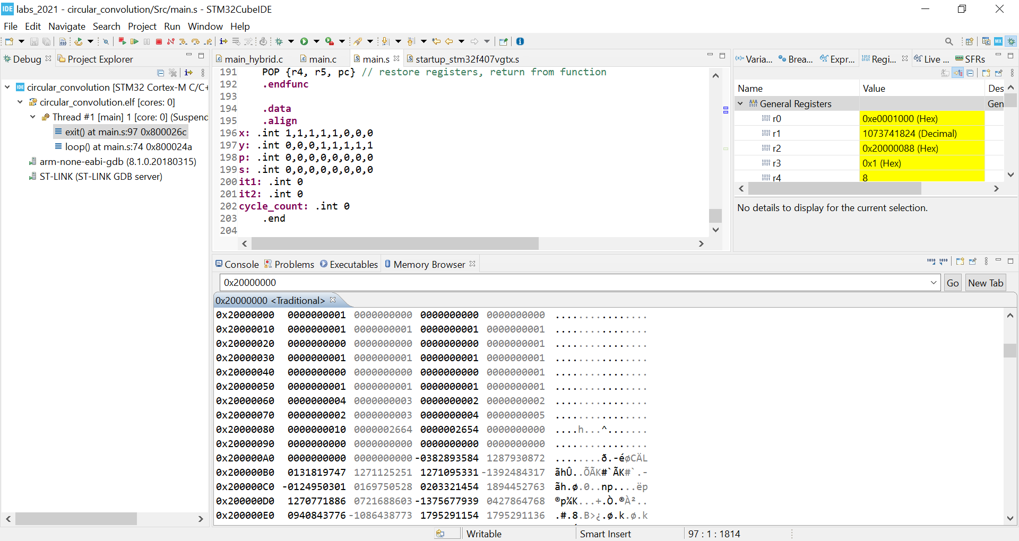

For main.s (Graduate Student Only Tasks)


- Code
Copy and paste your code from Task 2 using the following template. Indicate the file the code belongs to.

- In main.c:
// ===== INSERT YOUR CODE: START =====
Your code goes here.
// ===== INSERT YOUR CODE: END =====

- In main_hybrid.c:
// ===== INSERT YOUR CODE: START =====
Your code goes here.
// ===== INSERT YOUR CODE: END =====

- In main.s:
// ===== INSERT YOUR CODE: START =====
Your code goes here.
// ===== INSERT YOUR CODE: END =====

- In main.s: (Graduate Student Only Tasks)
// ===== INSERT YOUR CODE: START =====
Your code goes here.
// ===== INSERT YOUR CODE: END =====

