File permissions in Linux

Project description
As a security professional working with the research team at a large organization, I am responsible for ensuring that users on the team are authorized with the appropriate permissions. In this project, I used Linux commands to examine the existing permissions on the files and the subdirectory in the /home/researcher2/projects directory, which belongs to the researcher2 user. Where the permissions did not match the authorization that should be given, I modified them to authorize the appropriate users and remove any unauthorized access. This helps keep the system secure.

Check file and directory details
To check the permissions set for the files and subdirectory in the projects directory, I navigated to the directory and listed its contents with the ls -la command:
cd projects/
ls -la
The -l option displays the long format, which includes the permission string, the owner, and the group for each entry. The -a option displays all entries, including hidden files whose names begin with a dot (.). A plain ls or ls -l command would not show hidden files. The output of the command was:
drwx--x--- 2 researcher2 research_team 4096 drafts
-rw-rw-rw- 1 researcher2 research_team 46 project_k.txt
-rw-r----- 1 researcher2 research_team 46 project_m.txt
-rw-rw-r-- 1 researcher2 research_team 46 project_r.txt
-rw-rw-r-- 1 researcher2 research_team 46 project_t.txt
-rw--w---- 1 researcher2 research_team 46 .project_x.txt
All of the files are owned by the user researcher2 and the group research_team. The listing also revealed a hidden file, .project_x.txt, which is only visible because the -a option was used. The screenshot below shows the terminal from the Manage authorization lab, including the history of the commands used in this project:
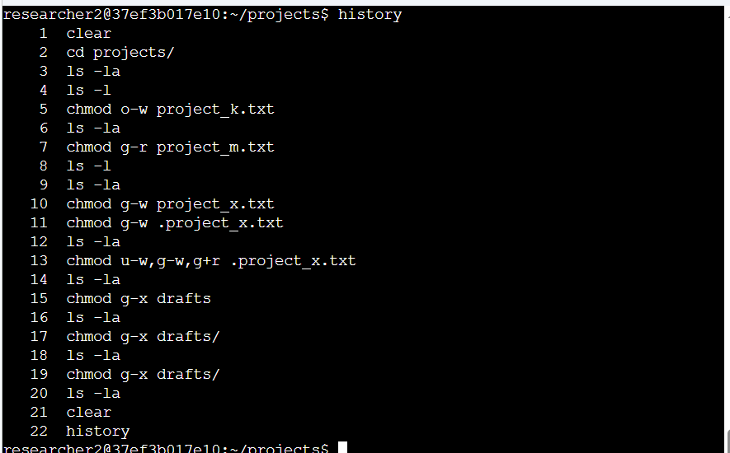

Describe the permissions string
Each line of the ls -la output begins with a 10-character string that represents the type of the file or directory and its permissions. As an example, the permission string for project_k.txt is -rw-rw-rw-, and each part of the string represents the following:
The first character indicates the file type. A hyphen (-) indicates a regular file, while the letter d indicates a directory (for example, the d at the start of drwx--x--- for the drafts directory).
The second, third, and fourth characters (rw-) represent the permissions of the user who owns the file, in this case researcher2. They show that the user has read (r) and write (w) permissions, but not execute (-) permission.
The fifth, sixth, and seventh characters (rw-) represent the permissions of the group that owns the file, in this case research_team. They show that the group also has read and write permissions, but not execute permission.
The eighth, ninth, and tenth characters (rw-) represent the permissions of other, which means all other users on the system apart from the user and the group. They show that other users also have read and write permissions on this file, but not execute permission.
Reading the string this way makes it possible to check whether the permissions on a file match the authorization that should be given, before deciding whether they need to be changed.

Change file permissions
The organization does not allow others to have write access to any files. Reviewing the permission strings from the previous step, project_k.txt (-rw-rw-rw-) was the file that granted write permission to others, so I used the chmod command to remove it:
chmod o-w project_k.txt
In this command, o sets the permissions for the other owner type, and -w removes the write permission. The chmod command itself produces no output, so I verified the change by running ls -la again. The output confirmed that project_k.txt is now -rw-rw-r--, which means others can read the file but can no longer write to it.
During the same audit, I also corrected project_m.txt. This is a restricted file, and its string -rw-r----- showed that the group had read permission. I removed the group read permission so that only the user can access the file:
chmod g-r project_m.txt

Change file permissions on a hidden file
The research team has archived .project_x.txt, which is why it is a hidden file: its name begins with a dot, so it does not appear in a normal directory listing and can only be seen with ls -la. According to the permissions checked earlier, its string was -rw--w----, which means the user had read and write permissions, the group had write permission only, and other users had no permissions. An archived file should not have write permissions for anyone, but the user and the group should be able to read it, so I used chmod to assign the appropriate authorization:
chmod g-w .project_x.txt
chmod u-w,g-w,g+r .project_x.txt
In these commands, u sets the permissions for the user and g sets the permissions for the group. The -w removes the write permission from both the user and the group. Because the group previously had write permission but not read permission, g+r was also needed to add the read permission for the group. I verified the result with ls -la: the string for .project_x.txt is now -r--r-----, so the user and the group can read the file, and no one can write to it. Note that the leading dot is part of the hidden file's name and must be included when typing the filename in a command.

Change directory permissions
The files and directories in the projects directory belong to the researcher2 user, and only researcher2 should be allowed to access the drafts directory and its contents. The permission string for drafts was drwx--x---. The d shows it is a directory, and the group position (--x) shows that the group had execute permission. For a directory, execute permission is what allows a user to access the directory and its contents, so the group had unauthorized access. I removed the group execute permission with chmod:
chmod g-x drafts
In this command, g sets the permissions for the group, and -x removes the execute permission. I verified the change with ls -la: drafts is now drwx------, which means only the user researcher2 has any access to the directory and its contents.

Summary
In this project, I examined the permissions on the files and subdirectory in the /home/researcher2/projects directory using ls -la, which displays all files, including hidden files, along with their 10-character permission strings. I then used chmod to modify the permissions that did not match the required authorization: I removed write access for others on project_k.txt, removed the group read permission on the restricted project_m.txt file, set the archived hidden file .project_x.txt so that the user and group can read it but no one can write to it, and removed the group's access to the drafts directory. After each change, I listed the directory again to verify the new permissions. These tasks ensure that only authorized users can access or modify the research team's files, which protects the information and keeps the system secure.

