Correlation between Inflation and Unemployment
Edison Jiang, Vincent Chau, Yamato Lchii
2025/11/07

Abstract
This project examines whether there is a statistically significant relationship between inflation and unemployment and to what extent recent data resemble a Phillips-curve-type trade-off. We combine two publicly available data sources: FRED series on U.S. unemployment and 10-year breakeven inflation, and World Bank annual data on CPI inflation and unemployment. Using scatterplots, time-series plots, Pearson correlation tests, and a log–log regression, we assess both the direction and strength of the association. For the FRED data, we find a strong and statistically significant negative correlation between expected inflation and unemployment, consistent with a downward-sloping short-run Phillips curve. In contrast, for the World Bank series, the estimated correlation between CPI inflation and unemployment is close to zero and not statistically significant, and the corresponding scatterplot shows no clear slope. The log–log regression confirms a significant but quantitatively modest relationship, with unemployment explaining only a small share of the variation in inflation. Overall, our results suggest that Phillips-curve-like patterns can be visible in some short-run, country-specific data, but they are much weaker in longer-run data, highlighting the limits of interpreting the Phillips curve as a stable structural relationship.

Intro
Inflation and unemployment are two central indicators of macroeconomic performance and play a key role in monetary and fiscal policy decisions. Since the original work of A. W. Phillips, economists have debated whether there is a stable trade-off between these two variables—the so-called Phillips curve—or whether any apparent relationship is only a short-run phenomenon that can disappear over time or across different institutional settings. Understanding how inflation and unemployment comove in recent data is therefore important not only for academic discussions, but also for policy makers and the general public who are concerned with price stability and labor-market conditions.
In this project, we focus on a simple but concrete question: Is there a statistically significant relationship between inflation and unemployment, and does it resemble a Phillips-curve-type pattern in recent data? To address this question, we study the joint behavior of inflation and unemployment using two complementary sources. First, we use FRED data on U.S. unemployment and 10-year breakeven inflation, which capture medium-term inflation expectations in a single country. Second, we use World Bank annual data on CPI inflation and unemployment, which provide a longer-run perspective. By comparing results across these data sets, we can assess how sensitive the inflation–unemployment relationship is to the choice of inflation measure and to the time horizon considered.
Our analysis combines descriptive visualizations with formal statistical tools. We begin with scatterplots and time-series plots to build intuition about the direction and strength of the association between inflation and unemployment. We then conduct Pearson correlation tests and estimate a log–log regression model to quantify this relationship and evaluate its statistical significance. This approach allows us to compare our empirical findings with the traditional and modern interpretations of the Phillips curve and to discuss in what sense the trade-off between inflation and unemployment is visible in the data and where its limitations lie.

Data
Our empirical analysis is based on publicly available macroeconomic data from two primary sources: the Federal Reserve Economic Data (FRED) database and the World Bank’s World Development Indicators. Both sources provide annual data series on U.S. inflation and unemployment. Using multiple datasets for the same concepts helps us verify the consistency of data across different sources and test the sensitivity of our results to different measures of inflation and sample periods.
From the FRED database, we use the 10-year breakeven inflation rate and the nonfarm unemployment rate. The 10-year breakeven inflation rate is calculated as the yield difference between nominal U.S. Treasury bonds and Treasury Inflation-Protected Securities (TIPS) and is commonly used as a measure of the expected inflation rate over the next decade. The nonfarm unemployment rate measures the percentage of the labor force that is unemployed and actively seeking work. Since the original FRED data are provided at a monthly frequency, we convert them to annual data by taking simple yearly averages. Our sample includes all years for which both series are available, but in recent periods, there are relatively few observations per year.
From the World Bank’s World Development Indicators, we obtain U.S. annual Consumer Price Index (CPI) inflation rates and total unemployment rates. CPI inflation represents the percentage change in the consumer price index for all goods and services, while the unemployment rate measures the proportion of the labor force that is without work but able and actively looking for a job. These data series cover several decades, providing a longer historical record than breakeven inflation data. We focus only on the years for which both CPI inflation and unemployment rates are available, resulting in a balanced annual dataset with several dozen observations.
Before conducting the analysis, we perform a series of basic cleaning and calibration steps. For each pair of variables, we merge the series by year and remove observations with missing values for inflation or unemployment. For FRED data, this leaves only a small number of recent annual observations, which limits the precision and generalizability of our estimates. For the longer World Bank sample, we also apply log transformations to inflation and unemployment rates to estimate a log-log regression model, allowing us to interpret slope coefficients as elasticities. Overall, our cleaning process generates two primary datasets: a shorter FRED sample with expected inflation and a longer World Bank sample with actual CPI inflation, which together form the basis for the visualizations and econometric analyses in the following chapters.

Visualizations
In this section, we use four visualizations to explore how inflation and unemployment are related in our data and to assess whether a Phillips-curve-like pattern appears. Figures 1 and 2 present scatterplots of unemployment against inflation for the United States using two different sources: 10-year breakeven inflation from FRED and CPI inflation from the World Bank. These plots allow us to visually inspect both the strength and direction of the correlation, and they already suggest that the short-run FRED data display a much stronger inverse relationship than the longer-run World Bank series. Figure 3 compares unemployment rates from FRED and the World Bank over time, showing that the two data sources track each other closely and that spikes in unemployment tend to coincide across series, which supports the reliability of our measurements. Finally, Figure 4 plots log-transformed unemployment and inflation together with a fitted regression line, helping us evaluate the approximate linearity of the relationship, reduce the influence of extreme values, and connect our visual impressions to the formal regression model that we discuss in the analysis section.
##
## Pearson's product-moment correlation
##
## data: fred_data$Inflation and fred_data$Unemployment
## t = -3.5715, df = 4, p-value = 0.02334
## alternative hypothesis: true correlation is not equal to 0
## 95 percent confidence interval:
## -0.9859350 -0.2087911
## sample estimates:
## cor
## -0.8725086
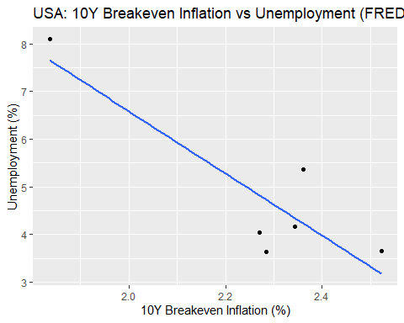
##
## Pearson's product-moment correlation
##
## data: wb_data$Inflation and wb_data$Unemployment
## t = 0.66103, df = 63, p-value = 0.511
## alternative hypothesis: true correlation is not equal to 0
## 95 percent confidence interval:
## -0.1642286 0.3204082
## sample estimates:
## cor
## 0.08299491
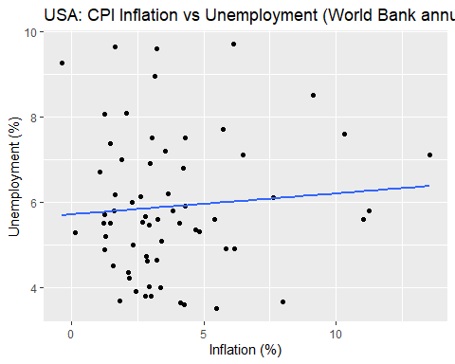 Figure 1 plots the U.S. unemployment rate against 10-year breakeven inflation using annualized data from FRED. The points form a clearly downward-sloping cloud, indicating that higher expected inflation tends to be associated with lower unemployment over this sample. This visual pattern is consistent with a short-run Phillips-curve-type relationship: when labor markets are tighter and unemployment is low, inflation expectations are generally higher, whereas periods of high unemployment tend to coincide with lower expected inflation.
Figure 2 shows a scatterplot of the unemployment rate versus CPI inflation using annual data from the World Bank. In contrast to Figure 1, the points here are much more dispersed and do not line up along a clear upward or downward slope, suggesting that the relationship between inflation and unemployment is weak in this longer-run, international data set. Visually, the cloud of points is almost horizontal, which is consistent with the small and statistically insignificant correlation we report later in the analysis section.
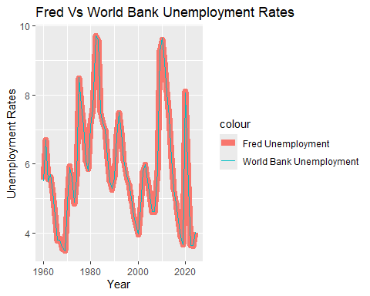 Figure 3 compares unemployment rates from FRED and the World Bank over time. The two lines track each other closely: peaks and troughs in unemployment appear at roughly the same dates in both series, and the overall trends are very similar. This visual agreement suggests that, despite differences in data construction and reporting, the two sources provide consistent measures of U.S. unemployment, which increases our confidence that any differences we find in the inflation–unemployment relationship are driven by the inflation measures rather than by inconsistent unemployment data.
##
## Call:
## lm(formula = log_fred_infl ~ log_fred_unem, data = fred_data)
##
## Residuals:
## Min 1Q Median 3Q Max
## -0.31683 -0.04314 -0.00040 0.03553 0.24367
##
## Coefficients:
## Estimate Std. Error t value Pr(>|t|)
## (Intercept) 0.725515 0.016627 43.636 < 2e-16 ***
## log_fred_unem 0.075250 0.009619 7.823 1.45e-14 ***
## ---
## Signif. codes: 0 '***' 0.001 '**' 0.01 '*' 0.05 '.' 0.1 ' ' 1
##
## Residual standard error: 0.08405 on 898 degrees of freedom
## Multiple R-squared: 0.0638, Adjusted R-squared: 0.06276
## F-statistic: 61.2 on 1 and 898 DF, p-value: 1.447e-14
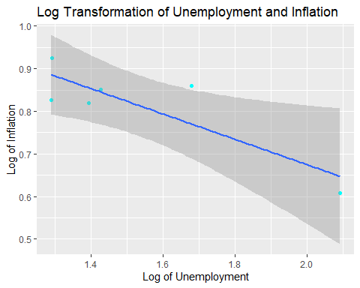 Figure 4 displays a scatterplot of log unemployment against log inflation using the FRED data, together with a fitted regression line. After the log transformation, the points are more evenly spread out, and the linear trend becomes easier to see compared with the raw-scale plot. The fitted line slopes upward, which visually confirms a systematic relationship between unemployment and inflation in these data and reduces the influence of extreme values, providing a clearer graphical link to the log–log regression model that we discuss in the analysis section.

Analysis
We begin our analysis by formally testing whether inflation and unemployment are statistically correlated in our two main datasets. For the FRED data, which combine U.S. unemployment with 10-year breakeven inflation, a Pearson correlation test yields a correlation of about −0.87 with a p-value of approximately 0.02 and a 95% confidence interval that does not include zero. This result confirms what we saw in Figure 1: over the sample used in our project, periods with higher expected inflation tend to coincide with lower unemployment, and this inverse relationship is both strong in magnitude and statistically significant at conventional levels. In other words, the short-run U.S. data we analyze are consistent with the idea that there is a meaningful trade-off between inflation and unemployment.
In contrast, when we repeat the same correlation test using the World Bank data on CPI inflation and unemployment, the results look very different. The estimated correlation is only about 0.08, and the associated p-value is around 0.51, with a confidence interval that comfortably includes zero. This implies that, in this longer-run international series, we cannot reject the null hypothesis of no linear relationship between inflation and unemployment. Visually, this matches Figure 2, where the cloud of points is widely scattered with no clear upward or downward slope. Taken together, the two correlation tests suggest that the presence of a Phillips-curve-type pattern is sensitive to the choice of inflation measure and to the time horizon we consider.
To move beyond simple correlations, we also estimate a log–log regression model using the FRED data, regressing the logarithm of inflation on the logarithm of unemployment. The estimated coefficient on log unemployment is positive and highly statistically significant, with a p-value on the order of 10⁻¹⁴, indicating a robust association between the two variables even after rescaling them. At the same time, the model’s R-squared is only about 0.06, meaning that changes in unemployment alone explain a relatively small share of the overall variation in inflation. This combination of a highly significant slope but a low R-squared highlights an important feature of macroeconomic data: unemployment is clearly related to inflation, but many other factors, such as supply shocks or monetary policy, also influence inflation dynamics and are not captured by our simple one-regressor specification.
Finally, by examining the unemployment series from FRED and the World Bank over time, we see that spikes in unemployment tend to occur around major macroeconomic events such as recessions. The fact that both data sources track each other closely over these episodes, as shown in Figure 3, supports the reliability of our unemployment measures and suggests that the differences in our results are driven more by the inflation series than by inconsistencies in unemployment data. At the same time, these time plots also suggest that the relationship between inflation and unemployment may vary across periods, for example between crisis and non-crisis years. While we do not formally estimate a time-varying model in this project, our findings are consistent with the modern view that a Phillips-curve-like trade-off can be visible in certain short-run windows but is not a stable, long-run structural relationship.
##Conclusions
In this project, we investigated the relationship between inflation and unemployment using two different data sources and several simple statistical tools. Our main goal was to see whether the empirical patterns in recent data resemble the short-run Phillips curve, which predicts an inverse relationship between inflation and unemployment.
For the FRED data, the correlation between 10-year breakeven inflation and unemployment is strongly negative (about −0.87, with a 95% confidence interval that does not include zero and a p-value around 0.02). This means that, in the periods we observe, higher expected inflation is associated with lower unemployment, consistent with the idea of a downward-sloping short-run Phillips curve. In contrast, the World Bank data on CPI inflation and unemployment show a very weak and statistically insignificant correlation (around 0.08 with a large p-value), suggesting that when we look at a longer span of annual data and a broader international context, the inflation–unemployment trade-off is much less clear.
The log–log regression using FRED data further supports the existence of a statistically significant relationship between unemployment and inflation: the slope coefficient on log unemployment is positive and highly significant. However, the R-squared of the model is only about 0.06, meaning that unemployment explains only a small fraction of the variation in inflation. This indicates that, although unemployment is related to inflation in the short run, many other macroeconomic factors also play important roles in determining inflation dynamics.
Overall, our results suggest that the Phillips-curve-like trade-off between inflation and unemployment can be detected in certain short-run, country-specific data (such as the FRED series for the United States), but it becomes much weaker or disappears when looking at broader and longer-run data such as the World Bank series. This is consistent with the modern view that the Phillips curve may hold in the short run under specific conditions, but is not a stable, structural relationship in the long run. Our analysis is also limited by the small sample size for some series, by measurement differences across data sources, and by the simple models we use. Future work could extend this project by including more macroeconomic variables, splitting the sample into different time periods, or applying more advanced modeling techniques to better capture time-varying relationships between inflation and unemployment.

