**De novo genome assembly of Agrobacterium sp. strains against P. infestans in potato plant**

P. Amrein, L. Brönnimann & M. Laverrière

1. **Introduction**

The most devastating disease of potato is late blight caused by the oomycete (fungus-like microorganism) Phytophthora infestans. [1] It destroys the leaf surface, attacks the tubers and causes storage losses. P. infestans is thus the focus of all fungicide measures in potato cultivation. The pathogen prefers cold ( < 18°C) and moist environment for the distribution of sporulation and zoospore production. For the lesion growth are favored warmer temperatures ( > 20°C).   
The conventional agriculture fungicide treatments are damaging the environment and increases the health risk. The organic agriculture uses cooper, which will accumulate in the soil and with time also damaging the environment. Breeding resistant cultivation needs a very long selection process and can be bypassed after a while.  
The research project from Vivien Pichon is focusing for new effective microbial biocontrol. [2] The hypothesis “Cry of Help” from the plants to the microbial community should help to find the “protecting” bacteria strains. After isolation of bacterial strains from resistant plants, an in-planta assay started with a mock vs. the isolated bacteria infected soil. A community shift should characterize the different threated plants. After this experiment the most abundant / interested strains would be selected for further experiments.

The aim of this study is to find second metabolites against P. infestans. For this we assembled and annotate three genome sequences (strain AL034, AL039 and AR061). With the data from the further experiments and the genomes we focused for the differences. Which strains showed inhibition effects from the in-planta assay and also showed differences in the secondary metabolite.  
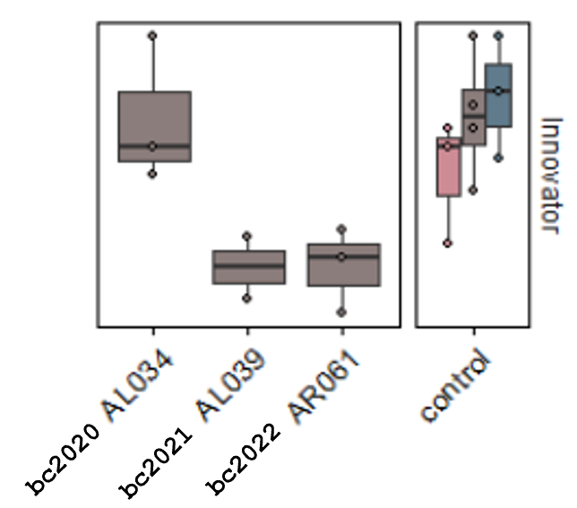

Hypothesis “Cry of Help”

Phytophthora infestans (Oomycete, Eukaryote) -> what is it? No mushroom (so no chitin)

Experiments of vivien (3 Experiment), we focuse on the in planta experiment.

Search for secondary metabolite against P. infestans. Easier to use in the field.

1. **Material and Methods**

***Bacterial strains***

We obtained three different fastq files (bc2020:AL34, bc2021:AL39, bc2022:AR61).

***Assembly of sequencing reads***

Before we started the assembly, we used fastqc (fastqc-0.11.9) for the quality check. The results showed for all three strains a very high phred score around 90 with a basepair length for each read from ~700 – 20’000. Checking the files directly showed the highest ASCI encoding value, which corresponds to the character “ ~ ” (=126). This means that the value was mostly higher than the highest available phred score. The accuracy of this sequences are 99.999999999%. The coverage was also very high (over ???).  
Today, this high accuracy can only be reached with HiFi reads. HiFi reads are produced using circular consensus sequencing (CCS) mode on PacBio long-read systems. HiFi reads provide base-level resolution with 99.9% single-molecule read accuracy.

The uniform GC content of 58% is a sign for a similar strain. For the assembly we used Unicycler, Flye and SMRT (provided from falquet directly). The comparison with QUAST (quast-4.6.0) let us decide for the annotation with the unicycler assembly files. Unicycle was the only one, who showed 5 contigs for the sample bc2020 (AL34). The rest of the assembly showed 4 contigs.

Bc2020:

unicycle

  2 circular unitigs

  3 linear unitigs

  total size = 5,876,342 bp

flye:

#seq_name length cov. circ. repeat mult. alt_group graph_path

contig_2 2932466 37 Y N 1 * 2

contig_1 2112419 36 N N 1 * *,1,*

contig_4 500960 40 Y N 1 * 4

contig_3 312243 41 Y N 1 * 3

bc2021:

  3 circular unitigs

  1 linear unitig

  total size = 5,743,859 bp

flye:

#seq_name length cov. circ. repeat mult. alt_group graph_path

contig_2 2933413 41 Y N 1 * 2

contig_1 2212068 42 N N 1 * *,1,*

contig_4 490306 47 Y N 1 * 4

contig_3 108725 32 Y N 1 * 3

bc2022:

  2 circular unitigs

  2 linear unitigs

  total size = 5,710,061 bp

flye:

***#seq_name length cov. circ. repeat mult. alt_group graph_path***

***contig_2 2966923 28 Y N 1 * 2***

***contig_1 2046983 28 N N 1 * *,1,\****

***contig_4 371897 28 Y N 1 * 4***

***contig_3 329561 27 Y N 1 * 3***

***https://www.sciencedirect.com/topics/agricultural-and-biological-sciences/agrobacterium***

***Annotation of the contigs***

For the annotation with prokka we need to know our species of the strains. For this we used the website (http://fbac.dmicrobe.cn/tools/species_find). With the assembled fasta files we get the result, that the strains are to ~90% are Agrobacterium sp. (alpha Protebacterie). The value of over 95% would be gave us also the potential species.

3 Strains

Quality of data

Comparing different assembler (unicycle, flye, smrt) -> check with Quast

Depth of assembly, length of chromosomes, how many plasmids

Search the species (maybe different website than bff)

1. Results

Quastplot (Qualitycomparison of assembly with one strain)

Secondary metabolite (Antismash and roary)

1. Discussion

Maybe no difference in strains (like in the in Vitro experiment of Zoospore germination)

1. References

[1] <https://bsppjournals.onlinelibrary.wiley.com/doi/full/10.1111/j.1364-3703.2007.00465.x>

[2] 20221107_Genome_Assembly_Pichon.pdf, 2022, Unifr

**Identification of genomic suppressor mutations by high-throughput sequencing of yeast genomes**

P. Amrein, L. Brönnimann & M. Laverrière

1. Introduction

Properties of yeast (Eucaryote haploid, little Introns, GC 38%, Genomsize.

∆acl4

How associated with RPL4A

1. Material and Methods

Reference genome R64 vs. W303 (differences and similarities)

1. Results

CAF130 (and interactors)

1. Discussion

We should take advantage of the computational power and compare all strains together (~20). Better list with higher chance of interesting genes.

1. References