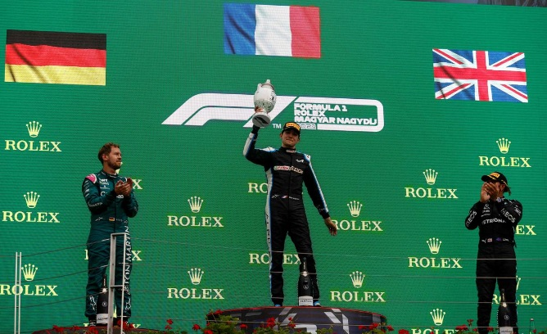

Hungary

the french driver ,

Estebane Ocoan win

the Grand Prix of fomule1

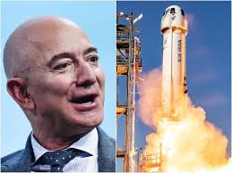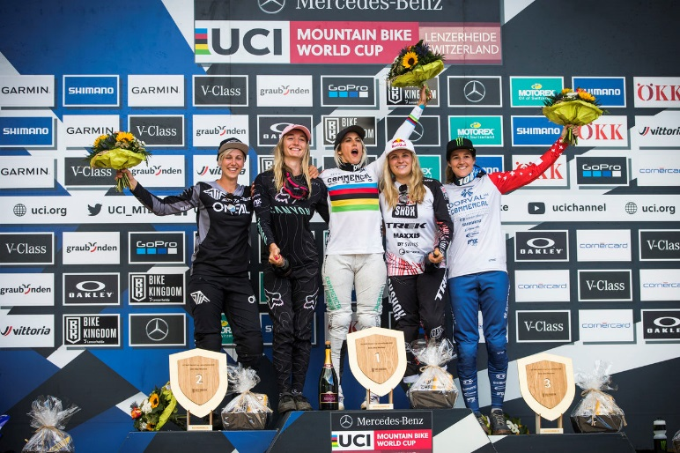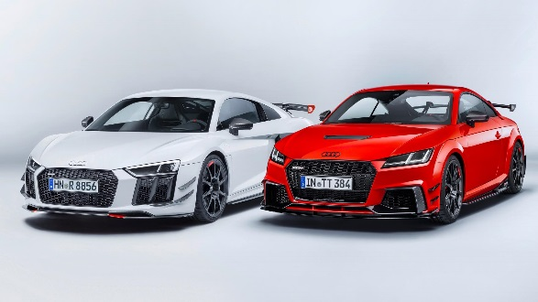

The company Audi has announced stoppage of production their the sport car.

The company Blue Origin organizes its very first manned flight in space

Swiss

The french rider Myriam

Nicole win a new stage

of the world cup of mountain

bike.