# 

**the news of the news**

Hungary

the french driver ,

Estebane Ocoan

win the Grand

Prix of fomule1

made in La providence

The company Audi has announced stoppage of production their the sport car.

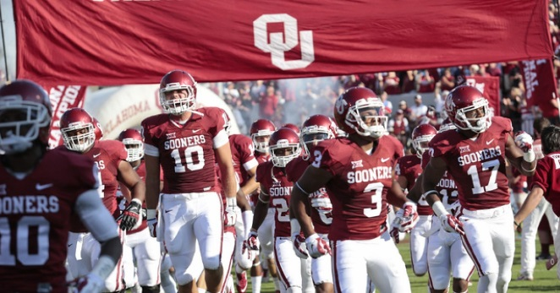

USA, West Virginia

The rider Austrian Vali Holl wins a World Cup round at Snowshoe.

Oklahoma City

Oklahoma City Sooners win second game of season against WESTERN CAROLINA Catamounts

The company Blue Origin organizes its very first manned flight in space