Task

Léa Bernard

technical document

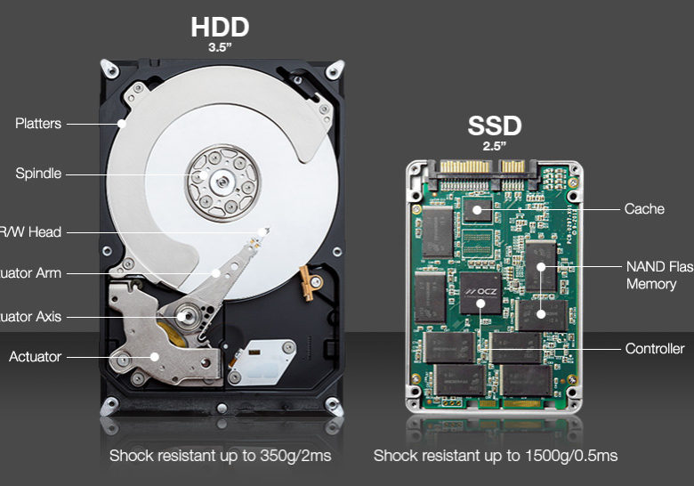<https://microage.ca/quebec/ssd-vs-hdd/>

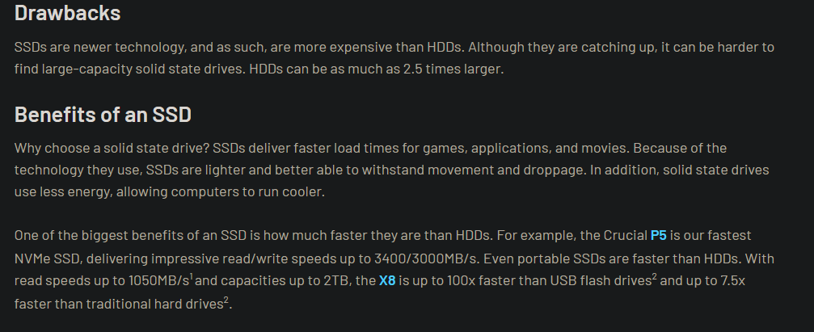 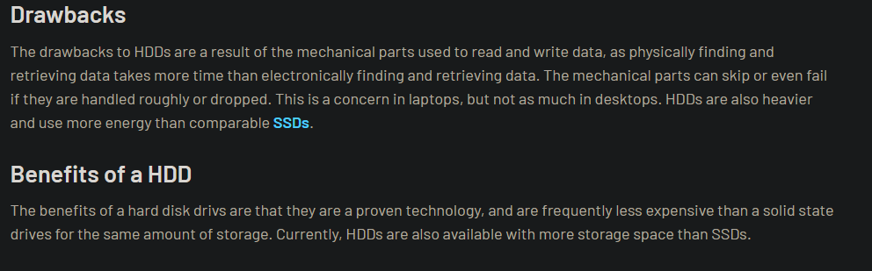

hdd

ssd

<https://www.crucial.com/articles/about-ssd/ssd-vs-hdd>

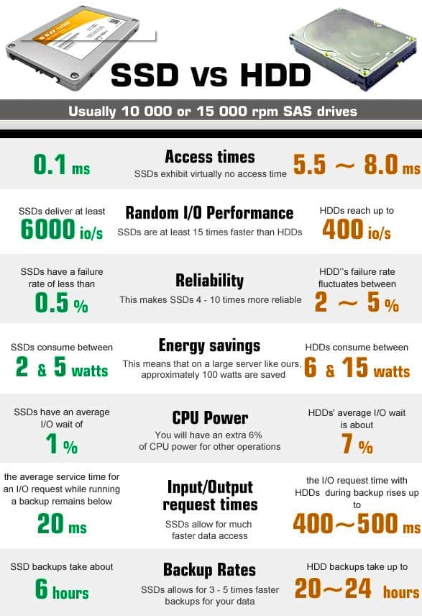

<https://wintechlab.com/ssd-vs-hdd-which-is-better-for-you/>