## Module 4 – Missing Data Assignment

# Lea Shipley

options(tidyverse.quiet = TRUE)   
library(tidyverse)  
library(VIM)

## Warning: package 'VIM' was built under R version 3.6.2

## Loading required package: colorspace

## Loading required package: grid

## Loading required package: data.table

##   
## Attaching package: 'data.table'

## The following objects are masked from 'package:dplyr':  
##   
## between, first, last

## The following object is masked from 'package:purrr':  
##   
## transpose

## VIM is ready to use.   
## Since version 4.0.0 the GUI is in its own package VIMGUI.  
##   
## Please use the package to use the new (and old) GUI.

## Suggestions and bug-reports can be submitted at: https://github.com/alexkowa/VIM/issues

##   
## Attaching package: 'VIM'

## The following object is masked from 'package:datasets':  
##   
## sleep

library(mice)

## Warning: package 'mice' was built under R version 3.6.2

## Loading required package: lattice

## Registered S3 methods overwritten by 'lme4':  
## method from  
## cooks.distance.influence.merMod car   
## influence.merMod car   
## dfbeta.influence.merMod car   
## dfbetas.influence.merMod car

##   
## Attaching package: 'mice'

## The following object is masked from 'package:tidyr':  
##   
## complete

## The following objects are masked from 'package:base':  
##   
## cbind, rbind

grades <- read_csv("class-grades.csv")

## Parsed with column specification:  
## cols(  
## Prefix = col_double(),  
## Assignment = col_double(),  
## Tutorial = col_double(),  
## Midterm = col_double(),  
## TakeHome = col_double(),  
## Final = col_double()  
## )

str(grades)

## Classes 'spec_tbl_df', 'tbl_df', 'tbl' and 'data.frame': 99 obs. of 6 variables:  
## $ Prefix : num 5 8 8 7 8 7 8 7 8 7 ...  
## $ Assignment: num 57.1 95 83.7 81.2 91.3 ...  
## $ Tutorial : num 34.1 105.5 83.2 96.1 93.6 ...  
## $ Midterm : num 64.4 67.5 30 49.4 95 ...  
## $ TakeHome : num 51.5 99.1 63.1 105.9 107.4 ...  
## $ Final : num 52.5 68.3 48.9 80.6 73.9 ...  
## - attr(*, "spec")=  
## .. cols(  
## .. Prefix = col_double(),  
## .. Assignment = col_double(),  
## .. Tutorial = col_double(),  
## .. Midterm = col_double(),  
## .. TakeHome = col_double(),  
## .. Final = col_double()  
## .. )

summary(grades)

## Prefix Assignment Tutorial Midterm   
## Min. :4.000 Min. : 28.14 Min. : 34.09 Min. : 28.12   
## 1st Qu.:7.000 1st Qu.: 80.88 1st Qu.: 83.93 1st Qu.: 52.50   
## Median :8.000 Median : 89.94 Median : 93.37 Median : 69.38   
## Mean :7.313 Mean : 85.49 Mean : 89.79 Mean : 67.70   
## 3rd Qu.:8.000 3rd Qu.: 95.00 3rd Qu.:100.56 3rd Qu.: 81.56   
## Max. :8.000 Max. :100.83 Max. :112.58 Max. :110.00   
## NA's :1 NA's :3   
## TakeHome Final   
## Min. : 16.91 Min. : 28.06   
## 1st Qu.: 69.91 1st Qu.: 52.91   
## Median : 88.42 Median : 66.11   
## Mean : 81.12 Mean : 68.23   
## 3rd Qu.: 99.07 3rd Qu.: 83.61   
## Max. :108.89 Max. :108.89   
## NA's :3 NA's :4

**Task 1**

There is 1 missing observation in Tutorial, 3 missing observations in Midterm, 3 missing in TakeHome, and 4 missing in Final.

**Task 2**

vim_plot = aggr(grades, numbers = TRUE, prop = c(TRUE, FALSE),cex.axis=.7)

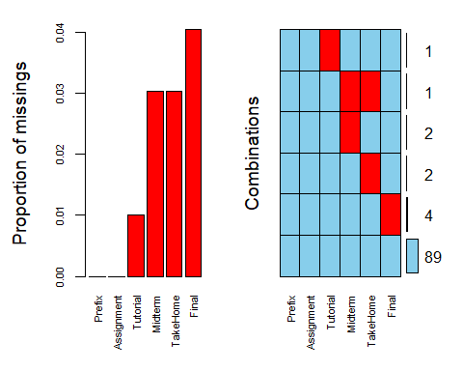

#the cex.axis reduces size of text on x-axis so labels fit better

It does not appear that there is systematic missingness, but there is one student that is missing both a Midterm and a TakeHome grade.

**Task 3**

grades2 = grades %>% drop_na

After completing row-wise deletion of missing values there are 89 rows in the new data frame.

**Task 4**

grades3 <- grades %>% select(-c(Tutorial, Midterm,TakeHome, Final))

Only two columns remain in this new data frame after doing column-wise deletion of missing values.

**Task 5**

Row-wise deletion would be preferable for this dataset, as we only lose ten observations that way. Column-wise deletion for this dataset does not leave enough information to work with.

**Task 6**

grades_imp = mice(grades, m=1, method = "pmm", seed = 12345)

##   
## iter imp variable  
## 1 1 Tutorial Midterm TakeHome Final  
## 2 1 Tutorial Midterm TakeHome Final  
## 3 1 Tutorial Midterm TakeHome Final  
## 4 1 Tutorial Midterm TakeHome Final  
## 5 1 Tutorial Midterm TakeHome Final

#in line above: m=1 -> runs one imputation, seed sets the random number seed to get repeatable results  
summary(grades_imp)

## Class: mids  
## Number of multiple imputations: 1   
## Imputation methods:  
## Prefix Assignment Tutorial Midterm TakeHome Final   
## "" "" "pmm" "pmm" "pmm" "pmm"   
## PredictorMatrix:  
## Prefix Assignment Tutorial Midterm TakeHome Final  
## Prefix 0 1 1 1 1 1  
## Assignment 1 0 1 1 1 1  
## Tutorial 1 1 0 1 1 1  
## Midterm 1 1 1 0 1 1  
## TakeHome 1 1 1 1 0 1  
## Final 1 1 1 1 1 0

densityplot(grades_imp)

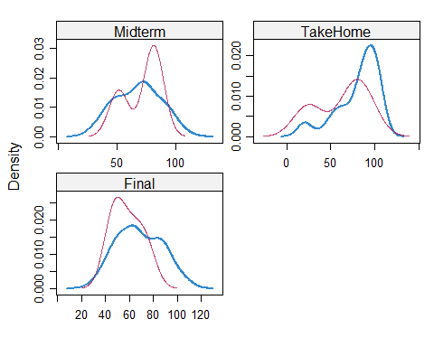

#red imputed, blue original, only shows density plots when more than 1 value the variable was imputed  
#note that the density plots are fairly uninteresting given the small amount of missing data  
grades_complete = complete(grades_imp)  
summary(grades_complete)

## Prefix Assignment Tutorial Midterm   
## Min. :4.000 Min. : 28.14 Min. : 34.09 Min. : 28.12   
## 1st Qu.:7.000 1st Qu.: 80.88 1st Qu.: 84.69 1st Qu.: 52.50   
## Median :8.000 Median : 89.94 Median : 93.10 Median : 69.38   
## Mean :7.313 Mean : 85.49 Mean : 89.76 Mean : 67.80   
## 3rd Qu.:8.000 3rd Qu.: 95.00 3rd Qu.:100.55 3rd Qu.: 81.88   
## Max. :8.000 Max. :100.83 Max. :112.58 Max. :110.00   
## TakeHome Final   
## Min. : 16.91 Min. : 28.06   
## 1st Qu.: 67.96 1st Qu.: 52.09   
## Median : 87.96 Median : 65.56   
## Mean : 80.54 Mean : 67.81   
## 3rd Qu.: 98.42 3rd Qu.: 83.19   
## Max. :108.89 Max. :108.89

**Task 7**

When using row-wise or column-wise deletion there is potential to discard good data along with the bad. When using imputation reasonable values may not be able to be obtained based on the other variables, and it is important to make sure that the imputed values look reasonable on the density plot. Imputation can influence the results of a statistical analysis, so perhaps should not be used when a very high level of accuracy is necessary.