Pipelines, Netbacks and Trade: A Case Study of the Oil Sands

Andrew Leach

March 2019

### Introduction

The rise of light tight oil since 2008 has fundamentally altered global crude oil markets: it has added more than 5 million barrels per day of production at relatively low costs from the United Stats, it has caused a prolonged and un-expected depression in global oil prices, and has changed the geopolitics of crude oil markets. In North America, the change has been even more pronounced. Regions which had historically been short oil, like the US Midwest, became over-supplied and started moving oil out to other US markets. The US Gulf Coast, long solely an oil importer became an exporter of crude oil, at least the lighter and medium grades thereof, while continuing to import heavier crudes. We've seen what used to be premium benchmark prices such as West Texas Intermediate (WTI) invert to trade at significant discounts to global crudes such as Brent, and a host of other pricing relationships have followed. This new resource play has created what is, in many ways, a perfect storm for Alberta’s oil sands.

Alberta’s massive oil resources are stuck at the northern end of the North American pipeline network. For decades, Alberta benefitted from easy access to northern US markets willing to pay a premium for oil in general, and saw many refineries in those regions refit to process the heavier crude which began to flow from Alberta's then-novel in situ oil sands projects. Now, those refineries benefit from a market over-supplied with heavy crude and Alberta, isolated from other markets, has seen its products face large differentials and its economy faces an uncertain future. While much of this challenge in Alberta has been passed off as a lack of market access or, more simply, a lack of pipelines, this chapter will take that analysis one step deeper and argue that Alberta has also seen its market eroded by the change in flow in North American oil markets which has set Alberta's crude further away from key markets and which makes a return to the good times in Alberta something which will not be achieved simply with the construction of pipelines. That’s not to say that pipelines don’t matter – they do. They just won’t usher in a return to the boom times of the past decade.

This chapter proceeds as follows. First, we characterize the changes in production in both Canada and the United States, with a particular focus on the Canadian oil sands and the US light, tight (or shale) oil production. We then show and discuss how these changes in production, along with regulatory changes, have led to changes in crude movements into and out of Canada and the United States. Next, we examine how infrastructure constraints, combined with these changes in flows, have altered the value of Canadian crude oils and, in particular, the value of oil sands bitumen. Finally, we look forward to the potential roles of pipeline construction and re-alignment to increase the value derived from Canadian crude oil production: the value of infrastructure to the Canadian oil sands.

### North American Oil Production Growth

Beginning around 2008, North American oil and gas companies began exploiting the combined innovations of horizontal drilling and multi-stage hydraulic fracturing to allow the extraction of long-known hydrocarbon deposits. The gas deposits in the northeast and Appalachian regions and oil in North Dakota’s Bakken and the Permian and Eagle Ford regions in Texas have boomed and continue to drive US production. As shown in Figure 1, US total oil production has increased to approximately 12 million barrels per day, with the total production from light tight oil having grown by over 5 million barrels per day since 2008.

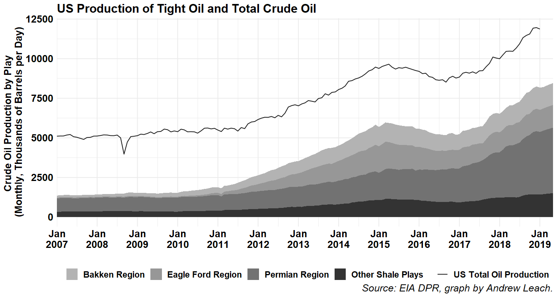

Figure : US total oil production and oil production from key light tight or shale plays.

Canadian production has also been growing over this timeframe, fueled mostly by the oil sands boom in Alberta, with sustained production in Saskatchewan, BC, and Manitoba in the West and Newfoundland and Nova Scotia in the East as shown in Figure 2.

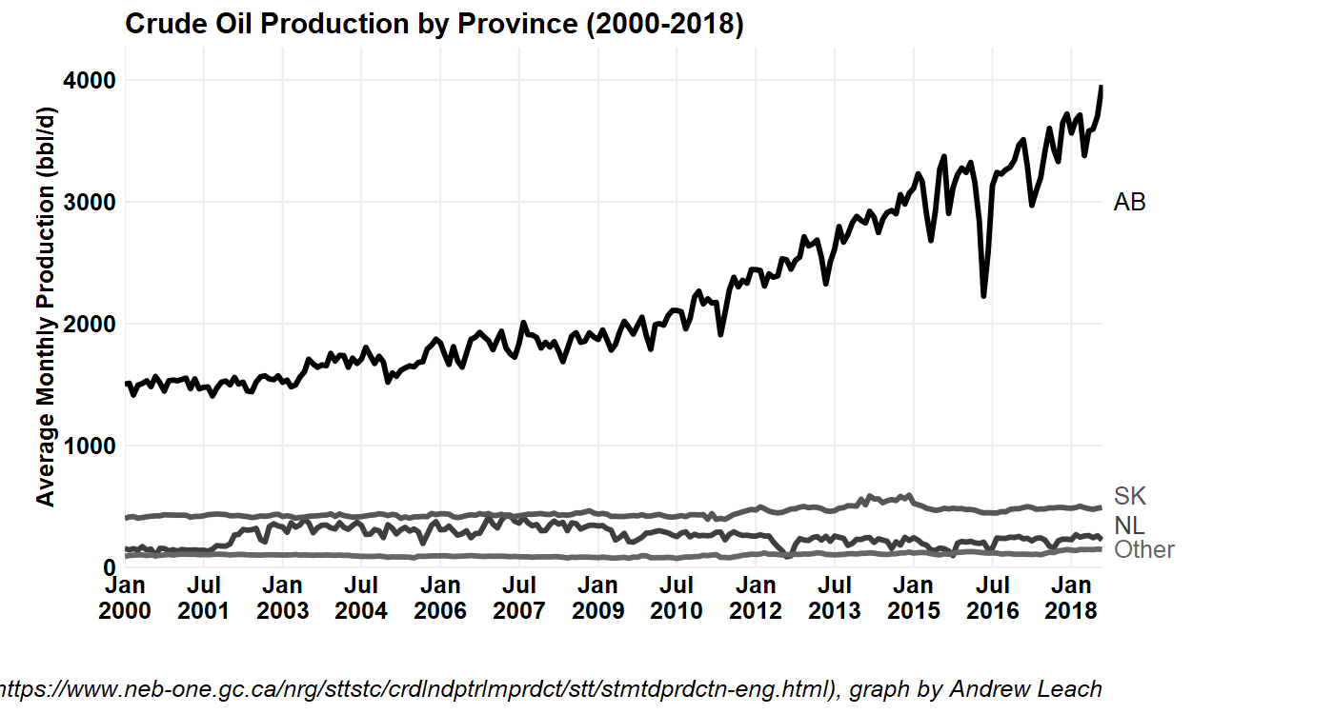

Figure : Canadian oil production by province

We don’t discuss Mexican production much in this chapter since, for our purposes, their lack of pipeline connection to the US implies that they are treated like any other global crude. Mexican production has been a bit of a countervailing force in North America: as of the end of 2018, Mexican crude oil production had dropped to 1.7 million barrels per day from a peak of 3.5 million barrels per day in 2003. (EIA IEO Data, 2019)

### Crude Oil Demand and Infrastructure

Refineries are important to crude value since they define the demand for produced crude. There are two major refining centres in Canada: in and around Edmonton, AB and in and around Sarnia, ON. Canadian refineries are dwarfed by their US counterparts which are concentrated in the Great Lakes region and in particular on the US Gulf Coast.

### 

US and Canadian refineries have evolved to serve demand centers for the most part, with the exception of the massive refining complex on the US Gulf Coast which has important pipeline connections to serve markets as far away as the US northeast. Historically, Canadian crude exports served the major demand center in the US mid-continent, from the western end of Lake Superior south and east through the Great Lakes region, and what Canada could not supply was made-up-for with movements north from the Gulf Coast. More recently, with the decline in Mexican and Venezuelan production and the rise in oil sands production, we’ve seen more Canadian crude making its way to the Gulf Coast.

The United States continues to drive demand for crude oil in North America. Crude oil inputs to US refineries have increased since 2009 lows by over 2.6 million barrels per day. (EIA 298402) Canadian refinery runs, on the other hand, have been declining from highs reached in the mid-2000s, and Canadian crude deliveries to Canadian refineries are down from 1.9 million barrels per day in 2004 to 1.7 million barrels per day in 2018. (Statistics Canada, 2019a and 2019b – see energyplotsnew.R)

The US is also driving sales or refined products. In 2018, US product supplied (a proxy for demand) for crude oil and petroleum products averaged 20.4 million barrels per day. With demand up more than 1 million barrels per day since 2015, US demand threatens to set new historic highs in 2019 or 2020. US product supplied reached its previous peak in 2005, at 21.6 million barrels per day of demand. Canadian domestic sales of petroleum products are seeing a similar resurgence with 2018 average sales being the highest 12 month sales ever seen in Canada for total products, surpassing previous peaks in the 2011-2015 period. Despite this resurgence in demand, the increase in refined product consumption has not kept pace with US refined product production, and so net exports of petroleum products have also increased to over 2.5 million barrels per day. (EIA 314539) Canada is also a net exporter of products, with 300,000 barrels per day of imports and approximately 450,000 barrels per day of exports.

In Western Canada, not including refineries west of the Rockies, refinery runs should be expected to average about 90,000 cubic meters (560,000 barrels) per day. NEB data for 2018-2019 shows an average run rate of approximately that level, but their reported data do not include the Northwest Redwater Refinery but do include the Parkland Refinery in Burnaby. Once Northwest Redwater is operating at full capacity, we should expect approximately 95,000 cubic meters (600,000 barrels) per day of crude supply processed at refineries in the areas of Western Canada East of the Rockies.

Crude supply in Western Canada will exceed refinery demand, leading to significant call on exports. The Canadian Association of Petroleum Producers (CAPP) (2018) estimates 2019 supply to be 762,000 cubic meters (4.8 million barrels) per day, leaving a net demand for export capacity of approximately 667,000 cubic meters (4.2 million barrels) per day in 2019. With no significant expansion of refinery capacity planned, and expected production expansion of 222,000 cubic meters (1.4 million barrels) per day by 2035 per CAPP (2018), the call on export pipelines is expected to increase.

While US and total North American refinery inputs have increased, they have not kept pace with total crude production. US exports of crude oil have increased to over 3 million barrels per day leading to a decrease in net imports of crude oil to less than 4 million barrels per day by early 2019. (EIA 314539) Canada has seen much the same evolution in trade: crude oil exports have increased to an average of 3.7 million barrels per day in 2018, with net exports averaging 2.9 million barrels per day. Combined, Canada and the US produced almost as much crude as they consume today. With Mexico included, the entire continent of North America is in crude oil balance – a drastic change from what would have been foreseen less than a decade ago.

### Changes in Crude Movements

While the total market dynamics are important for Canada, what matters more is where US crude production has occurred and how that has changed what were, for a time, our key markets. We tend to frame our trade as occurring between countries – Canada and the US – however, for crude oil, it’s best to think of trade as occurring between distinct markets and then think of transportation infrastructure as the means to connect those markets. In Canada, most of our trade has historically gone to the US Midwest for both geographic and economic reasons. Changes in crude flows in and out of the Midwest have drastically changed the value of our crude oil.

Most of what follows in this section relies on differences in transportation costs and regional arbitrage. If transportation were both costless and not capacity constrained, then prices in different markets would tend to the same values. If transportation were also instantaneous, then there would be no economic driver for price differences between markets. As it is, transportation is neither free from capacity constraints nor costless and so we do see long-term discrepancies between prices in one region and another. There is also not a single shipping price, but rather a continuum of costs depending on the method chosen: long-term pipeline contracts tend to be cheapest, while truck transport tends to be the most expensive, with spot service pipeline contracts, rail shipments, and barges filling in the intervening values. Finally, shipping capacities may not be symmetric, in the sense that pipeline capacity to flow from A to B is not, in a short timeframe, equivalent to capacity to flow from B to A. Pipelines can be reversed, but this takes time and regulatory approvals. Rail, truck, and barge capacity is more nimble, but loading and unloading infrastructure may not be perfectly reversible in very short time periods.

Historically, the dominant flows into the US market for crude oil were imports into the east, south and west, with flows from the Gulf Coast north into PADD 2. As shown in Figure 3, all US regions have been and continue to be dependent on some crude imports, with increasing imports from Canada in the Midwest and decreasing imports into the east and gulf coasts, with relatively stable imports into the West Coast.

The movements between regions shown in Figure 3 also tell an important story of domestic production. Beginning in 2008 or so, production in PADDs 2 and 3 begins to account for an important share of crude supply. In PADD 2, we also see rapidly decreasing movements in from PADD 3 as well as increasing supply into PADD 3 from PADD 2: the region into which most Canadian pipelines flow quickly became oversupplied by mid-2010 and shipments into the Gulf Coast and, to a lesser degree, by rail to the east and west coasts became a safety valve.

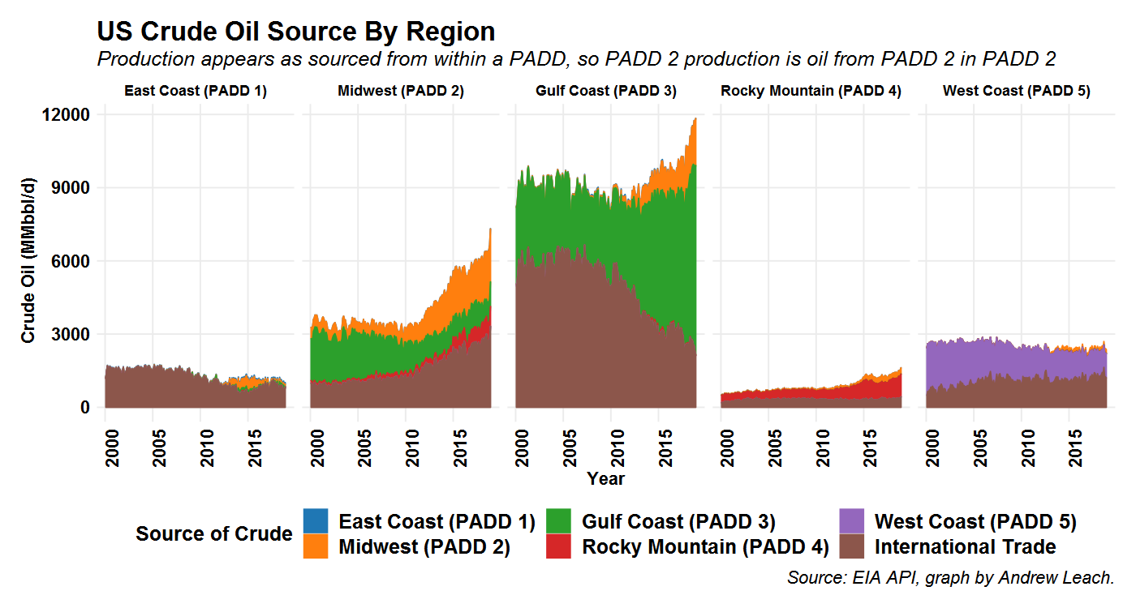

Figure US Movements of Crude Oil Between PADD districts by pipeline, tanker and barge. Source: EIA (2019)

The second half of the story comes from looking at where US regions send crude oil. In Figure 4, we see the rising movements out of the US Midwest and out of the US Gulf Coast. With the reversal of the Line 9 pipeline in Ontario to allow delivery from Sarnia to Montreal, along with projects such as the Flanagan South and Seaway projects on the Enbridge system and the Marketlink project on TransCanada’s system, crude can and now does flow from the Midwest both east and south. From the Gulf Coast, we see what used to be a large, historic flow north into the Midwest mostly reversed. This was initially offset by declining imports of crude oil, but more recently has been offset by increasing exports of light oil while the Gulf continues to import some heavier crudes to supply its refineries. Some of those Gulf Coast exports are imported to eastern Canada, which now receives over half of its crude imports from US suppliers. (National Energy Board)

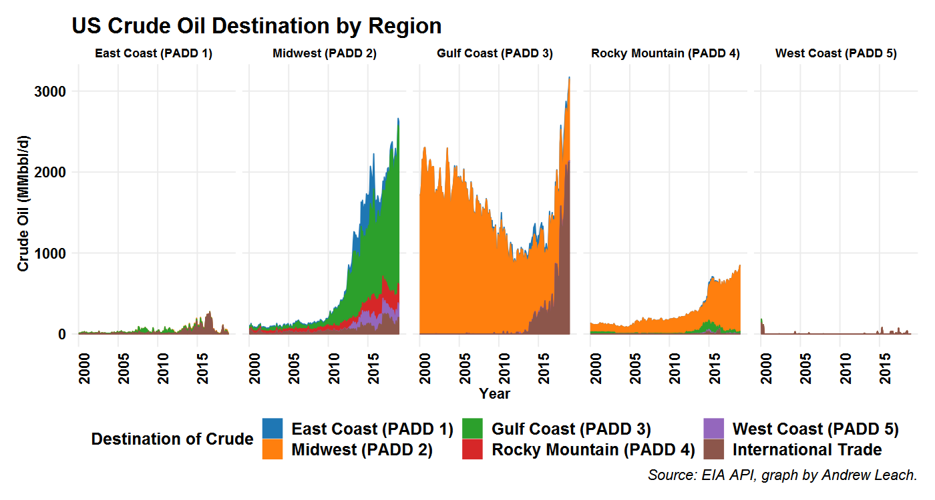

Figure US Crude oil destination by region. Source: EIA (2019)

The impact of these changes in US market flows is evident in Canadian crude movements with rising exports with a Gulf Coast destination. We still ship about 2 million barrels per day to the US Midwest, but according to NEB data shown in Figure 6 we now ship approximately 1 million barrels per day to the US Gulf Coast, a figure which does not account for barrels shipped initially to the US and then blended and shipped onward to the Gulf.

We can get a more compelling picture when we look in a little more detail at US imports of crude oils by grade, as shown in Figure 5. A few pieces of detail are worthy of note and relevant to Alberta oil sands. First, the US imports of light and medium crude oils are down across the board, with the exception of the West Coast where they remain relatively stable. Next, movements into the largest refining market, the Gulf Coast PADD 3, are down, with lights eliminated almost entirely, and mediums down by more than half in a decade. Heavy crude imports are also down, with Canadian volumes occupying a larger (but still relatively small) share of the overall market. Next, we see that imports into the Midwest and Rocky Mountain regions are, almost exclusively, Canadian crude, but all the growth in imports processed in the Midwest has been in heavy crudes. We can see, however, indications that this market is saturated with heavy crude as we see movements into the Gulf Coast growing, particularly after 2015 with the opening of the new pipeline access via the Keystone Marketlink and Enbridge Flanagan South and Seaway pipeline projects. Finally, and perhaps most importantly for Canadian crude oil, the total of US non-Canadian imports is declining, and the remaining markets in the US are further away and in areas not as reliably served by pipelines. The remaining market consists of about 3.8 million barrels per day (February, 2019), so the constraint is not binding at present, but this figure is down from 7.1 million barrels per day of non-Canadian imports less than a decade ago. The US market is shrinking and moving further away from Alberta.

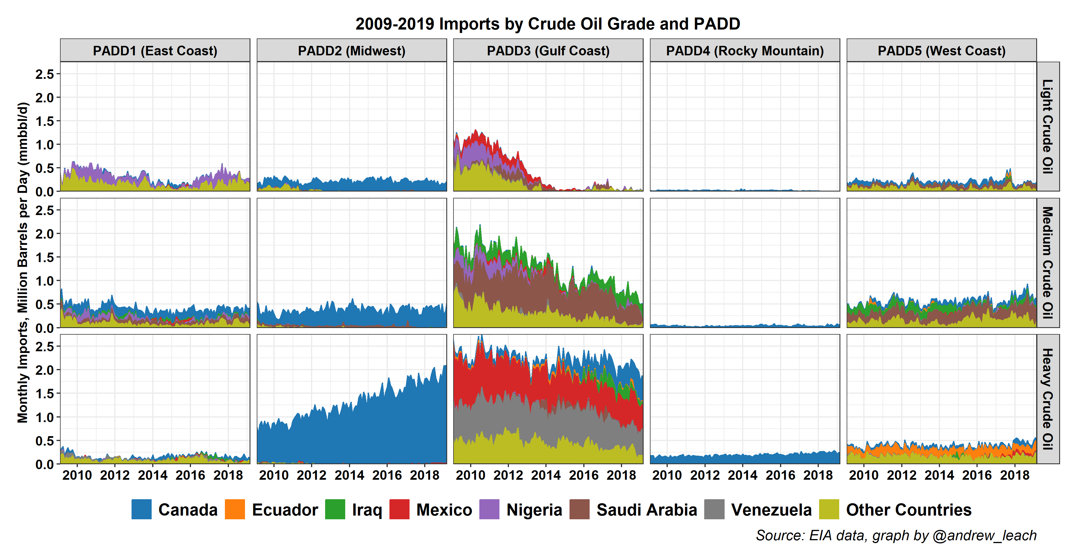

Figure US crude oil imports by grade, country of origin and destination refinery PADD. Source: EIA API 1293019 and 1293182

We can break down the Canadian parts of these exports as well, looking at exports by destination and grade from Canadian National Energy Board data, shown in Figure 6. The saturation of the heavy crude market in PADD 2 is evident here was well, with all of the growth in total Canadian heavy oil exports since 2015 being destined for the Gulf Coast.

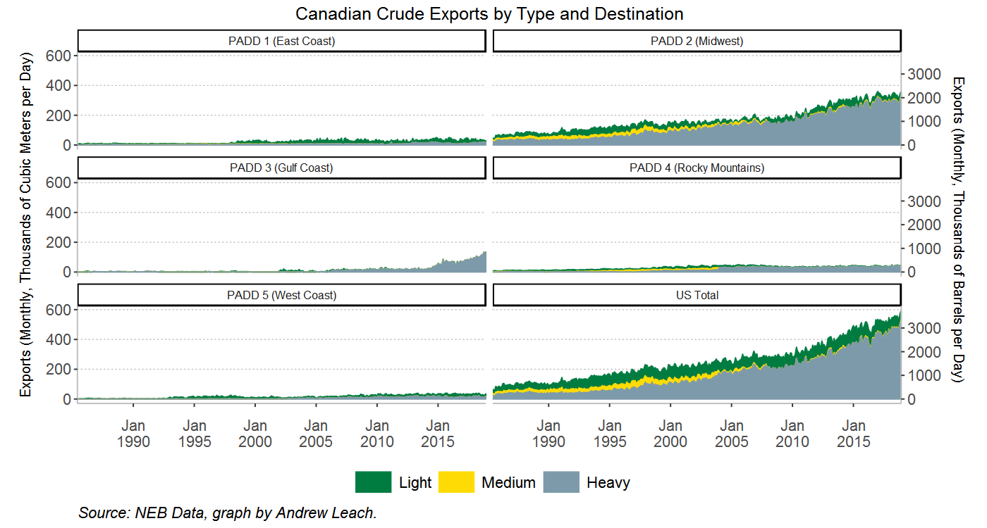

Figure 6 Canadian Crude Exports by Destination. Data via National Energy Board (2019)

There is import-dependent market on Canada’s east coast, but that does not provide much of a safety valve for western Canadian crude. The Canadian east coast today imports about 550,000 barrels per day of crude (CIMT, 2019). Of these barrels, approximately 150,000 barrels per day of light crude moved is moved into Sarnia by Enbridge’s Mainline along with 420,000 barrels per day of domestic, light crude and 160,000 barrels per day of domestic heavy crude (NEB Pipeline Profiles). Some of these barrels serve Montreal’s refinery via Enbridge’s Line 9 pipeline. This leaves approximately 400,000 barrels per day of mostly light crudes which are transported into the Eastern Canadian market by water and which could be served by additional infrastructure to move incremental western crude oil. This is largely theoretical since there Western Canadian production of light crude is expected to decrease in the coming decades per both CAPP (2018) and NEB (2018), and so this is largely an academic discussion. If we moved existing Canadian light oil volumes east, these would be in competition with US light oil volumes moving from the Gulf Coast, but would also leave a hole for US barrels to fill in the Midwest market. We’d be investing in additional infrastructure which would see us ship our crude further and simply be shifting the balance of flows slightly in the North American market.

Combined, these data on movements and trade flows show us that there remains some room for Canadian heavy oil growth into the US market, but that potential exists for the most part on the US Gulf and West Coasts. Canadian crudes will have to travel further, and/or get across the Mountains to the West to reach these markets, which will mean the need for more pipelines as well as incurring higher than historic transportation costs. There is some space, hypothetically, for more Canadian crude to serve Eastern Canadian markets, but this would be at the expense of our current sales to much more proximal markets in the US Midwest and Rocky Mountain regions.

### Pipeline Utilization

The capacity of existing pipelines out of Western Canada is insufficient to meet current and future export demand. Currently, the capacity of the existing pipeline network is approximately 4 million barrels per day (NEB, 2018) with variations in any given month.

There is no single data point that one can cite to justify that our existing pipeline infrastructure is *full*, although we can point to many market indicators. The first and most obvious is utilization. In the last quarter of 2018, pipeline utilization among the three major export pipeline systems (TransCanada Keystone, Enbridge Mainline, and Transmountain) was 98%. (NEB, 2019). We can also ask whether pipelines are oversubscribed, and they are. In almost every month since mid-2016, each of the three main pipelines has seen excess demand for their common carrier capacity, and so capacity as been apportioned (NEB Apportionment data). This is an imperfect metric, since there is significant evidence of over-nomination of barrels, or shippers requesting shipping service for more barrels than they intend to ship in order to get a larger pro-rated share of the scarce, available capacity. This has, at times, reached near-comedic proportions. For example, the NEB (2019) found that, “in December 2018, more than 13 million barrels per day of oil were nominated for shipment on pipelines exporting oil from western Canada,” which is more than double the total supply theoretically available for export that month. Finally, of course, we can look at spot pricing differentials. If pipeline capacity were available, no matter who holds the contract for that capacity, it should almost always be worth it to ship crude if crude is available in the domestic market at a substantial discount. Through most of late 2018, that was certainly the case, with market pricing differentials to comparable grades of crude oil many multiples larger than pipeline tolls to compete in those markets.

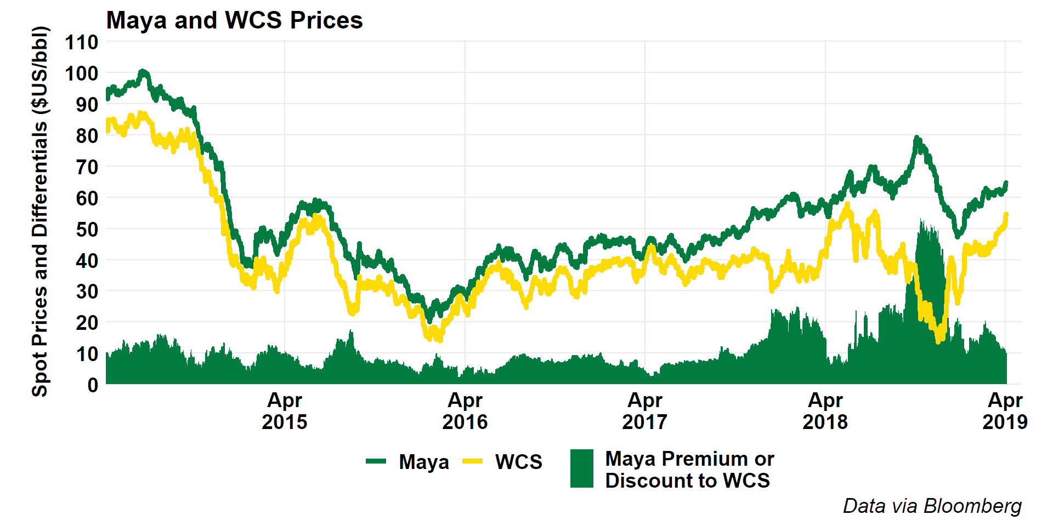

For example, consider the data above which show prices for Western Canada select, a diluted bitumen and heavy oil blend priced for delivery at Hardisty, Alberta and the free-on-board price for Maya crude on the US gulf coast. When we consider that the uncommitted, joint tariff for delivery from Hardisty, Alberta to the US Gulf Coast on the Keystone system is $US 10/bbl and US$8.87 per barrel on the Enbridge system, differentials between the two markets of more than $10-15 per barrel must reflect unavailable pipeline capacity and storage shortages in Alberta, which was also the case in late 2017 and much of 2018.

The interaction between apportionment rules, limited available pipeline capacity, and lack of available storage is where we really start to see the impact of constrained pipeline capacity on resource value. The NEB (2019) does an excellent job of explaining this dynamic:

When shippers over-nominate to pipelines, apportionment is exacerbated. Contracts in place between producers and shippers are structured such that a shipper is able to “push back” apportioned barrels to the producer. As apportionment levels increase, more barrels can be pushed back to producers. This sudden, artificial increase to the oil supply in the local market can cause western Canadian crude prices to become severely depressed, particularly when producers lack access to adequate storage. Consequently, producers receive materially lower prices for their crude oil. NEB (2019)

The NEB also explains that the over-nomination of crude oil to pipelines by certain shippers leaves them with excess capacity which they are then able to fill with distressed or stranded barrels they purchase at hefty discounts from contracted producers with no other options.

Another market indicator of a pipeline-constrained market is observed decisions to ship crude oil by rail. Crude by rail is generally more expensive than shipping crude by pipeline, with ARC Energy (2019) estimating $16 to $20 per barrel costs to move Western Canada Select barrels from Hardisty to the Gulf Coast. As a rule, if uncommitted pipeline shipments are available at $8.50 to $10, that will be a preferable option and rail will be relegated to use where a niche market exists or where there is an advantage to shipping crude rapidly, as rail has shorter cycle times. As shown in Figure 8, Canadian crude by rail shipments have been at or close to record highs in late 2018 and early 2019, but have been rising steadily since pipeline apportionment became more expected in mid-2016. Many shippers have built or contracted with rail loading terminals to be able to access rail service in anticipation of the coming pipeline constraint. While rail does allow quantities of crude to leave Alberta, it is only viable at higher volumes if producers are forced through other constraints to sell their crude at a significant discount to prices in destination markets.

Figure 8 shows the volumes of Canadian crude oil moving by rail and these volumes correlate very strongly with the price differentials shown above – when there is a differential which justifies the shipping of crude by rail, more crude is shipped by rail. The causality here is reversed, however – when there is insufficient pipeline capacity available to move the marginal barrel, the market will choose between storage and rail shipment. As storage is full or unavailable, more barrels move by rail. Since the only option available for marginal shippers is spot rail contracts, the value of a spot barrel in Hardisty comes to reflect the price of crude at destinations, net a rail toll equivalent discount.

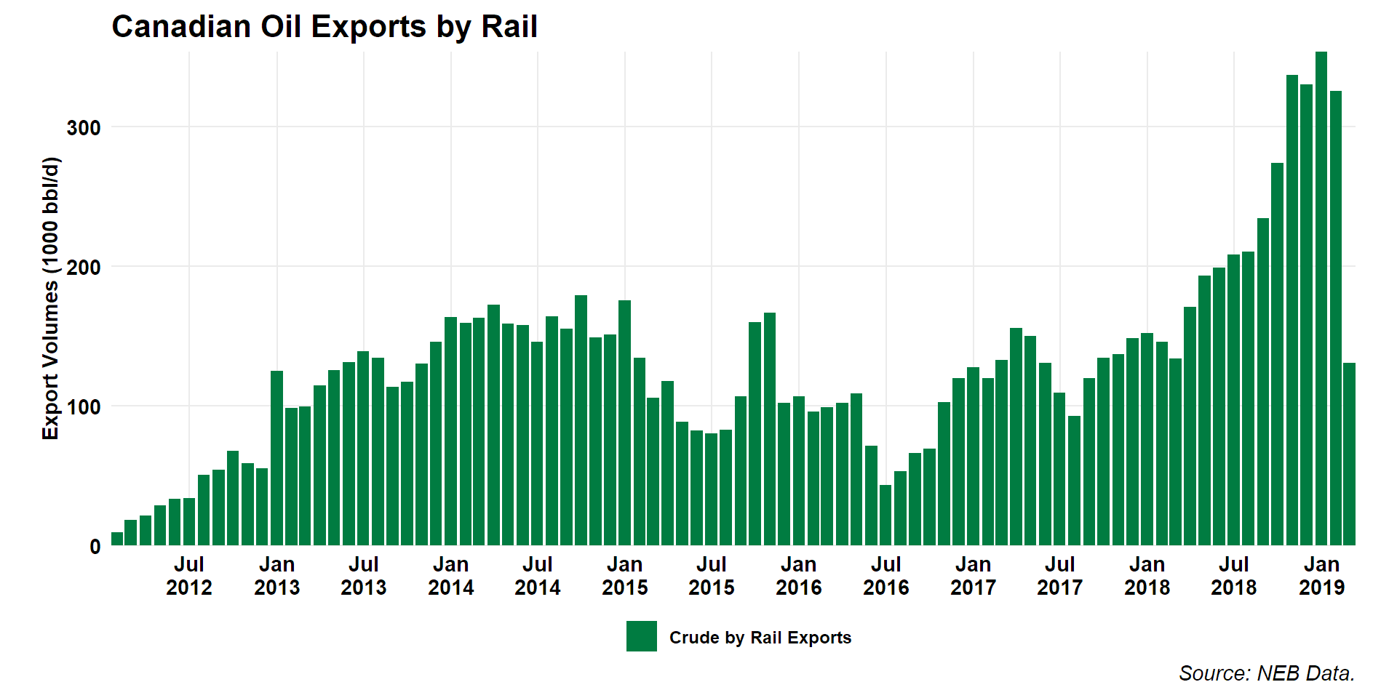

Figure Canadian Crude By Rail Exports

The case for new pipelines to support the value of Canadian oil sands thus has two key underpinning elements. First, with the expected growth in Canadian oil production, the existing network would remain over-subscribed and would lead to some combination of foregone production, discounted barrels, and increased shipment by rail and truck. Second, with our pipeline network largely focused on the US mid-continent market, which this chapter has argued at length is over-supplied, there is a need for access to markets such as the Asia-Pacific region and the US PADD 5/West Coast regions, which are currently not accessible to most Alberta crude production.

There are currently 3 projects which will, if completed, add capacity to this network. Improvements to the Enbridge mainline including the Line 3 replacement project, as well as the expansion of the Line 67/Alberta Clipper pipeline, along with other system enhancements could add as much as 670,000 barrels per day of capacity to the US Midwest (Enbridge, 2019). TransCanada’s Keystone XL project would, on its own, add a further 830,000 barrels per day. And the TransMountain pipeline expansion project would add approximately 600,000 barrels per day. Combined, these projects would add over 2 million barrels per day, more than sufficient to accommodate planned production expansions for most of the next two decades, as shown in Figure 7 below.

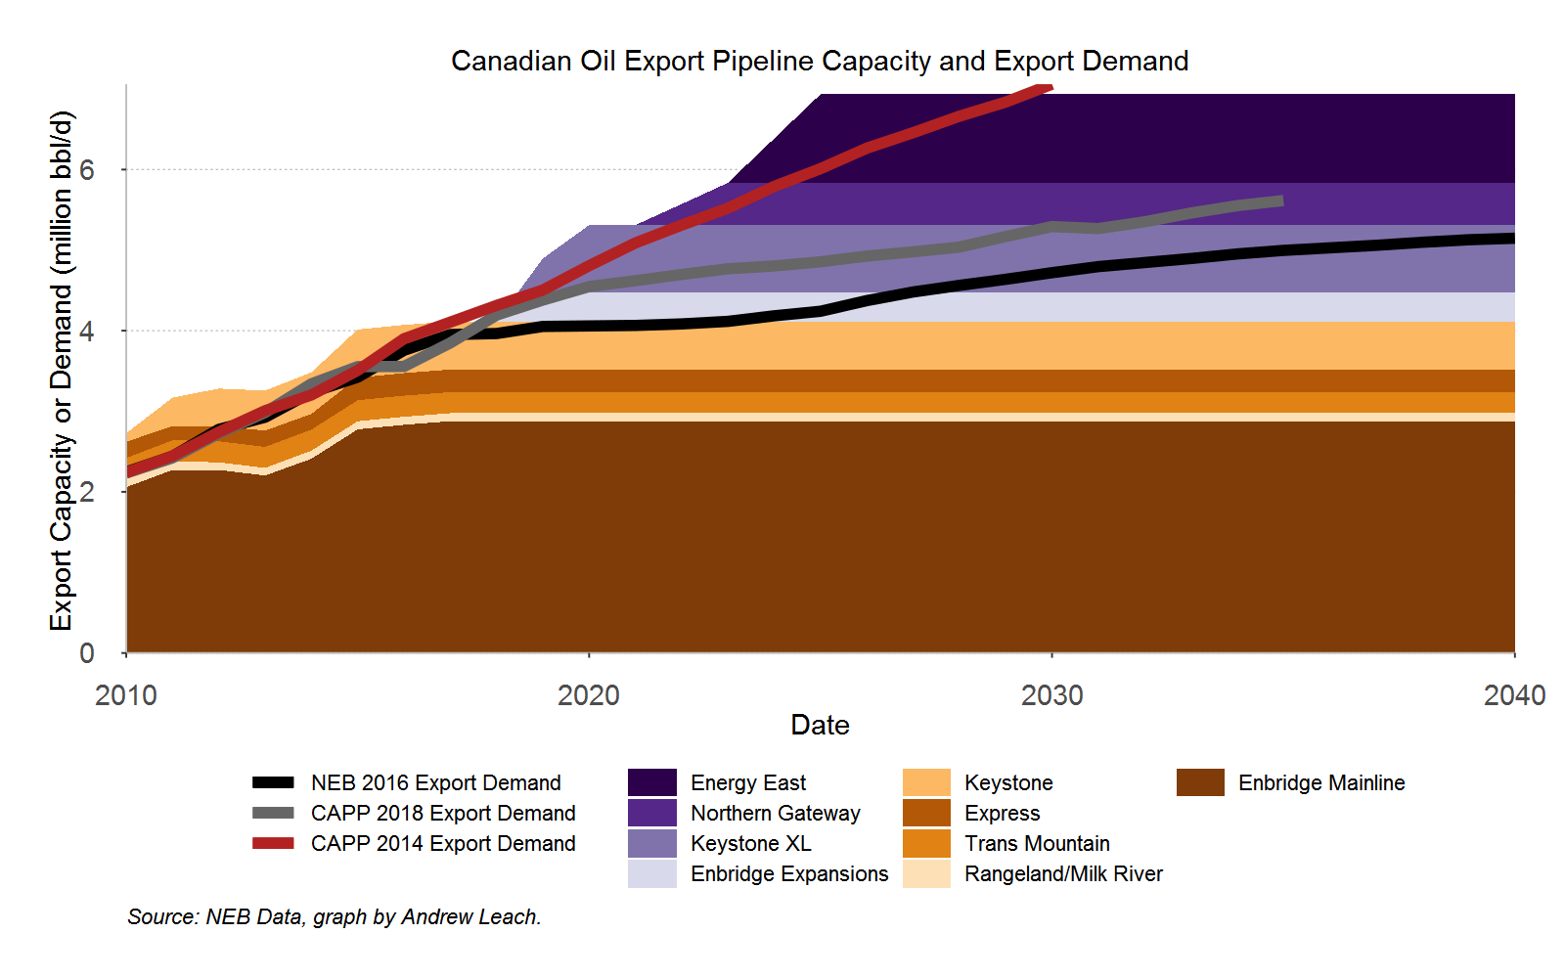

Figure 7 Canadian Pipeline Capacity and Crude Oil Export Demand

Two other previously-proposed pipeline projects, the 1.1 million barrel per day Energy East project linking Hardisty, Alberta and the Canadian east coast port of Saint John, New Brunswick and the 525,000 barrel per day Northern Gateway project from Edmonton, Alberta to the west coast of Canada at Kitimat, BC are also shown in Figure 7, as is an older export demand forecast from CAPP (2014). These are included to show the degree to which demand for export capacity has decreased with the decline in global oil prices since 2014, and the degree to which these projects have become superfluous to expected offtake demand.

The three major pipeline projects currently approved or in the regulatory process in Canada, and their capacities are shown along with the capacity of existing pipelines and oil export demand forecasts in Figure 7. Combined, the Enbridge network expansions including the Line 3 rehabilitation project, the TransMountain expansion and Keystone XL provide sufficient capacity well-into the 2030s, so long as production growth does not markedly exceed CAPP (2018) forecasts. Of these, only the TransMountain expansion serves markets other than the US, although both Keystone XL and an expanded Enbridge network allow for deliveries to the US Gulf Coast.

An unconstrained pipeline network will provide more value to Alberta producers and to the resource owners, the people of Alberta. However, it will not provide a return to the days when Alberta oil sold at parity to global prices. Prior to the US fracking revolution, the crude flows into North America meant that all regions in the US were short crude, and needed to draw imports into their markets by offering premium prices. Canadian barrels earned a premium in the Midwest, as the marginal barrels into that market required a significant premium to Brent in order to justify the import to the US and pipeline shipment north to the Great Lakes. As recently as 2009, for example, we saw monthly average premia of WTI over Brent of more than $3.50 per barrel, which meant that, net of transportation tolls, a barrel at Edmonton would be worth close to Brent prices. Today, pipeline infrastructure will, at best, let our barrels fetch global prices at tidewater, meaning that Edmonton barrels are worth at most global prices net pipeline tolls.

### Canadian Oil Netbacks and the Value of Pipeline Capacity

We’ve seen a lot of headlines which tie oil sands discounts to a lack of pipeline capacity, often suggesting that with new pipelines in place, oil sands bitumen barrels would capture prices comparable to light oil. They won’t. Oil sands crude trades at a discount to globally traded light crudes such as Brent for both quality and geographic reasons. We can use the information above to first decompose the discount on the value of a barrel of oil sands diluted bitumen into constituent parts and then examine the degree to which these differential components are affected by pipeline constraints.

First, the quality differential. Diluted bitumen is both a dense (heavy) and a sour (high sulphur content) crude oil – in fact, Western Canada Select is the heaviest, and most sour benchmark crude oil listed among global prices tracked by the Energy Information Administration.[1] Its density and sulphur content compare to a Maya crude, although a WCS blend tends to have more asphaltenes (heavier molecules) and more light ends than a Maya barrel, so we use Gulf Coast Maya pricing as a rough proxy for potential WCS values on the Gulf Coast. From this, we deduct an efficient transportation proxy cost equal to $8.50 per barrel in today’s dollars to give us the deemed value of a barrel of WCS with unconstrained transportation.

To get from a WCS barrel’s price to the implied value of a barrel of bitumen, we net out the value of diluent. We don’t talk very much about diluent when we talk about oil sands and infrastructure, but the ability to deliver diluent is a very important part of the supply chain.

An oil sands barrel shipped as diluted bitumen will contain approximately 30% diluent. This means that, for the 1.8 million barrels per day of non-upgraded bitumen that is expected to be produced in Alberta, approximately 750,000 barrels per day of diluent would be required to allow the blended product to meet pipeline specifications. Some of these shipments within Alberta would see the diluent recovered, such that diluent exports from the provide will be a bit smaller than the total Alberta Energy Regulator (2018) forecast for diluent demand of 750,000 barrels per day in 2019. Nonetheless, when you account for both condensate imports and diluted bitumen exports, we use over 1 million barrels per day of pipeline capacity moving diluent to and from Alberta every day.

Diluent also matters in pricing, as diluent feeds are more valuable than bitumen or heavy oil feeds. For a typical heavy crude oil blend of bitumen and diluent, the diluent could be as much as 50% of the cost of goods sold if we value both the bitumen and the diluent at market prices. For example, on April 22, 2019, the Western Canadian Select diluted bitumen blend traded at a value of 55.49 USD, while condensate at Edmonton, a proxy for diluent pricing, traded at $65.70. If we assume a 30% blend ratio, the diluent in the barrel would be worth $19.71, while the 70% of a barrel of bitumen would be worth $35.78. In this case, the diluent is 35% of the cost of the diluted bitumen barrel offered for sale. Over April 2018 to April 2019, the diluent share of the value of a barrel of WCS, assuming a 30% blend ratio, was 51%. As a result, infrastructure which lowers the cost of diluent into the Canadian market, or other factors which reduce the need for diluent, can increase the value of Canadian bitumen.[2]

Figure 9 shows the difference between bitumen value (black area) and light crude oil (black line) decomposed into quality and geographic discounts, and netting out the value of diluents.

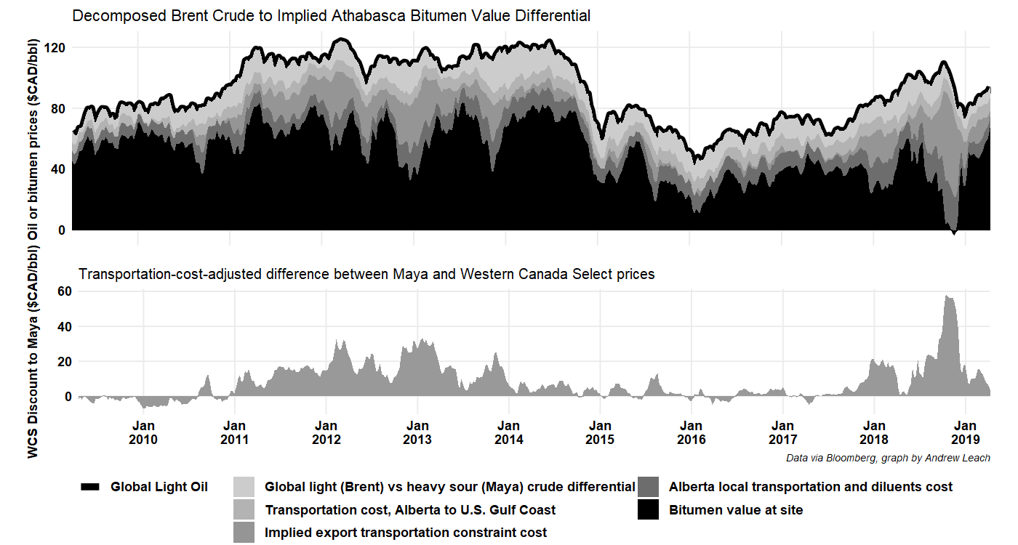

Figure Alberta Bitumen Value

We can see in the lower panel of Figure 9 the transportation-cost-adjusted discounts to Alberta crude oil. We can see, in the past decade, three incidents of large, sustained discounts. Between 2011 and 2014, we saw pipeline constraints affect crude oil prices broadly across inland North America. While some of the Alberta discounts were large in relative terms, we saw discounts affect even principal pricing benchmarks like West Texas Intermediate (WTI) which saw spot prices close to $30 per barrel below comparable global blends such as Brent in 2011, and elevated values for most of 2011 through 2014. The latter two incidents of high overall discounts to Alberta crude also reflect periods of constrained overall infrastructure in central North America, but also some Alberta-specific factors. In late 2017, a spill on the Keystone pipeline system led to decreased flow for the month of November and then, beginning in mid-2018, we saw the combined effects of decreased refinery utilization in PADD 2, constrained pipeline capacity out of Alberta, and growing production. The combined effects of these factors peaked in late 2018 when discounts to Alberta diluted bitumen were so high that, once the costs of embedded diluent were accounted for, Alberta bitumen was effectively selling for a negative value. In fact, using the Alberta government’s *Bitumen Valuation Methodology*, the monthly deemed value for Alberta bitumen in December 2018 was -US$6.94 per barrel. Yes, negative.

These differentials have come down since, due to a set of actions taken by the Government of Alberta and by market forces. On December 2, 2018, the Government of Alberta announced 325,000 barrels per day of crude curtailment, with the intention that this be implemented in January, 2019. These measures were also coincident with a rebound in refinery inputs into refineries in the US mid-continent. In October of 2018, refinery inputs in the US PADD 2 region had dropped to under 3 million barrels per day for the first time since 2010, and those levels had increased back to 4 million barrels per day by early December. Combined, these effects have led to much less excess crude upstream of PADD 2, and thus both lower differentials and less crude being shipped by rail.

On its face, these incidents do not explicitly argue for more pipeline capacity although there is a case to be made that more capacity, in particular to higher-value markets, would alleviate the severity and frequency of these incidents and would allow Alberta to grow production without eating its own lunch.

### Conclusions

This chapter has attempted to show the degree to which increased production in Canada and, in particular, in the US lower-48, has changed the movement of crude oil in North America. These changes in crude movements have, effectively, moved Alberta barrels further from the market for their marginal barrel, leading to increasing discounts to Alberta crude even in the presence of unconstrained pipeline networks. We’ve shown that the constraints affecting the pipeline network have exacerbated these issues by imposing discounts which, at times, have led to negative derived valuation for Alberta bitumen. Finally, we’ve argued that new pipelines can reduce the costs of constraints to Alberta bitumen and will, to a degree, assure that our products sell at close to global prices. However, in contrast to what used to be the case, we’ll see at best a price representing a global price net of pipeline tolls. The market is moving further and further from Alberta and the costs of this shift will continue to mount.

1. WCS has 5 year average Sulphur content of 3.6% and density of 928kg/m3 compared to a WTI specification of density less than 822kg/m3 and 0.42% or less Sulphur content.
2. Currently, two pipelines provide import capacity for condensate, Enbridge Southern Lights (180 000 barrels per day) and Kinder Morgan Cochin (95 000 barrels per day). In total, Canadian imports of natural gasoline or pentanes plus used as diluent averaged 180 000 barrels per day in 2018. This, combined with total Canadian natural gas condensate and pentanes plus production of 365 000 barrels per day, provides an important input to shipping oil sands bitumen. (StatsCan 25-10-0063-01)