This tutorial illustrates three options for processing binary content within File Adapter.

1. Opaque Content
2. Opaque Content with Streaming
3. Attachment

**Step 1**: Create a new SOA Composite with a BPEL Process that has an inbound file adapter as shown below.

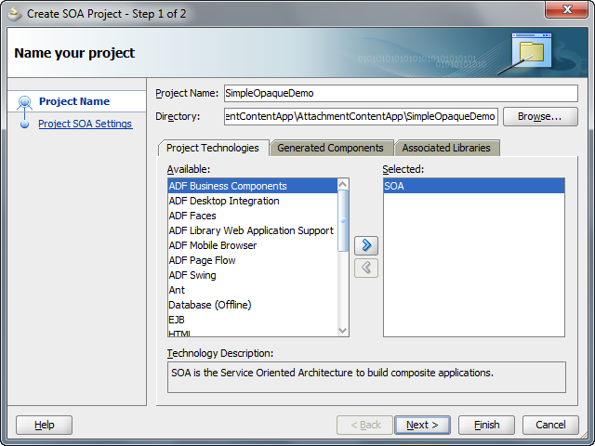

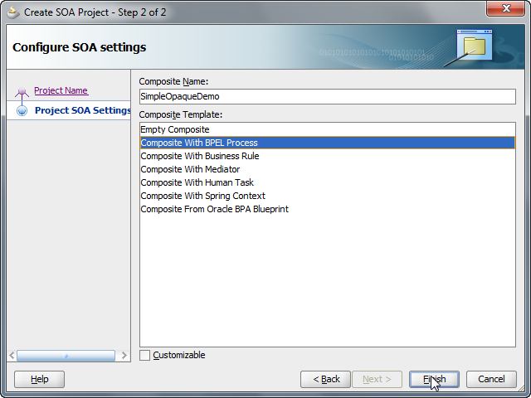

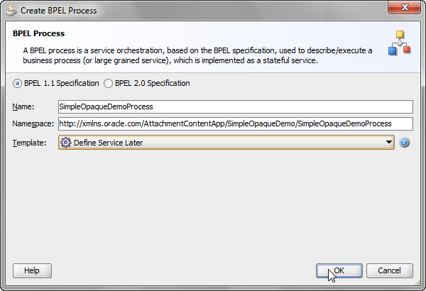

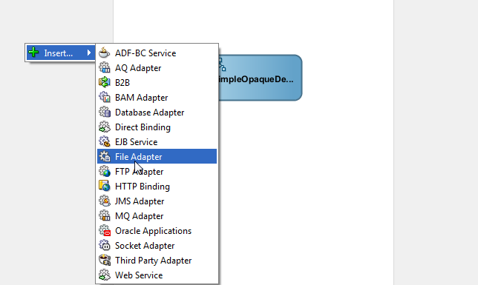

**Step 2:** Step through the File Adapter wizard to configure an inbound read operation.

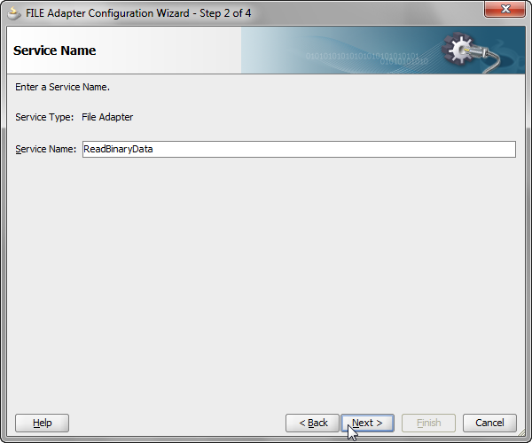

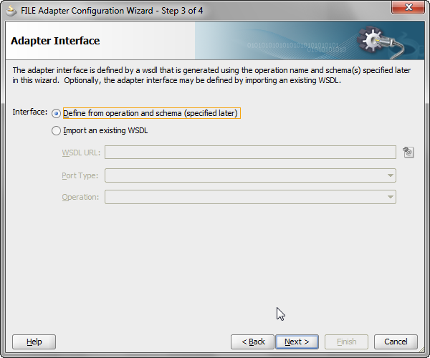

**Step 3:** If you want to build a simple opaque read use-case, leave the “Use file streaming” box unchecked. Else, ensure that it is checked. For attachments, check the option “Read File as Attachment” as shown below.

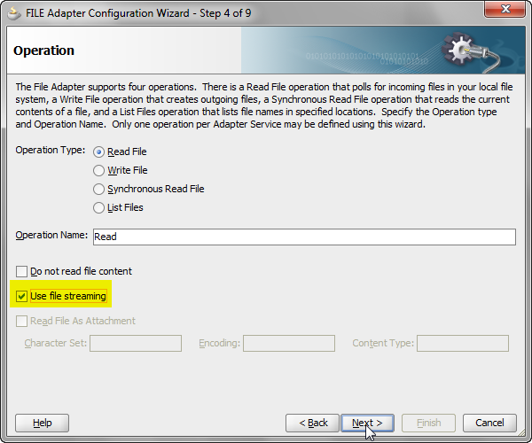

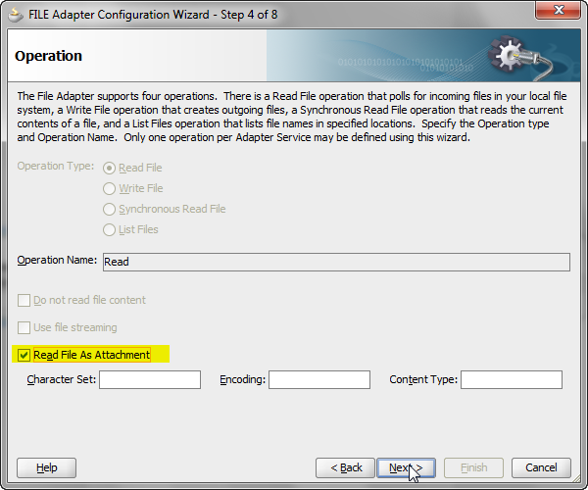

Choose any arbitrary input directory an file naming pattern of your choice.

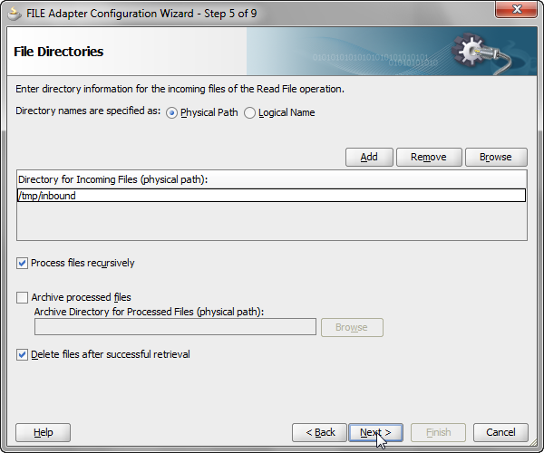

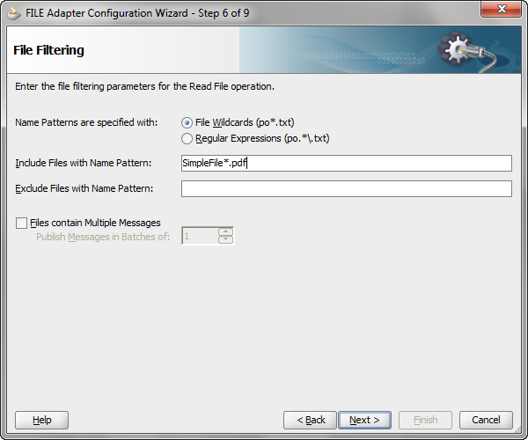

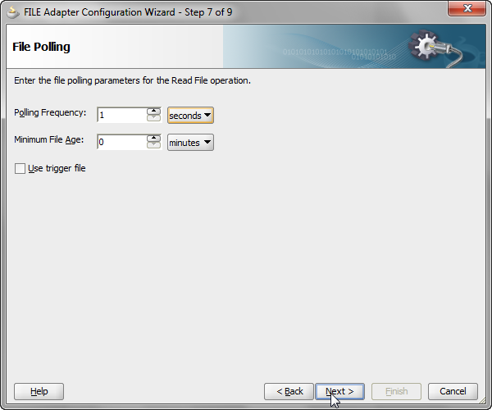

**Step 4**: Ensure that the opaque schema has been chosen.

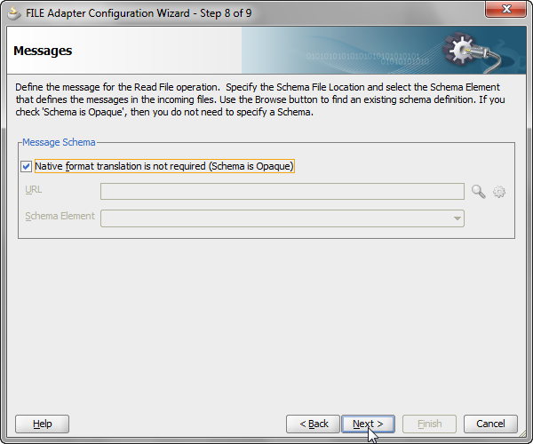

**Step 5:** Wire the Service to the BPEL Process.

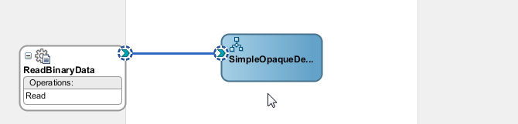

If you had chosen to build an Opaque w/streaming use-case, you can see that the activation-spec points to a ScalableFileActivationSpec class, indicating the input payload will be loaded as a ScalableDOM to handle processing of large size documents. For both other use-cases, the activation-spec class will refer to the FileActivationSpec.

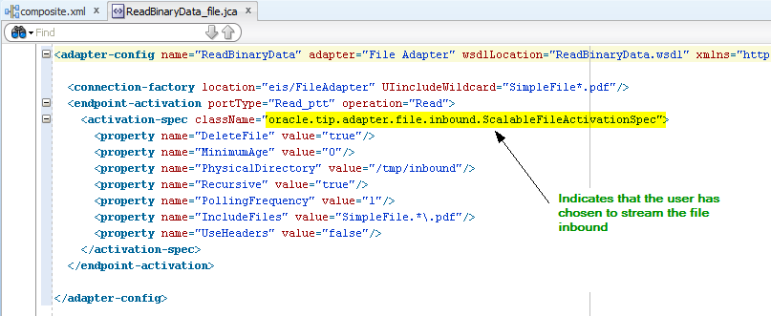

Case 1: Opaque with streaming

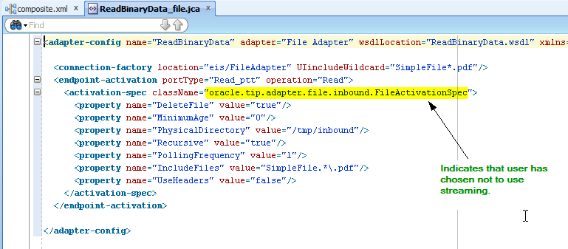

Case 2: Opaque without streaming

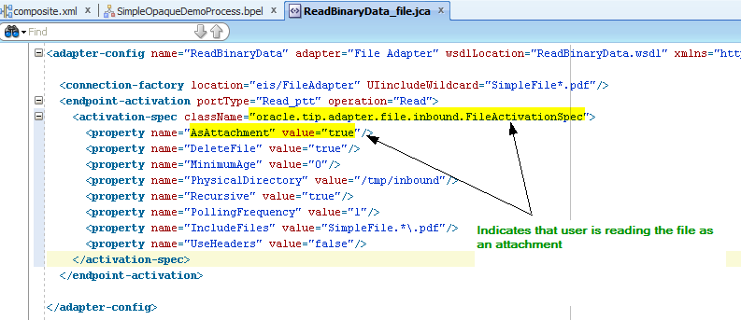

Case 3: Attachment

In case you are building the attachment use-case, the inbound WSDL will also be different. Instead of using an opaqueElement as the input message, it would use an *attachmentElement* instead.

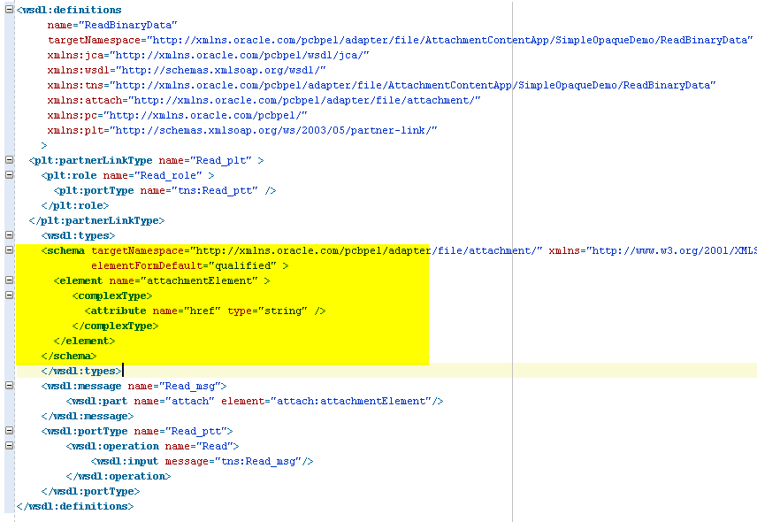

**Step 7**: Open up the BPEL Editor, wire the receive activity to the inbound partnerlink. Accept the defaults for the input variable name.

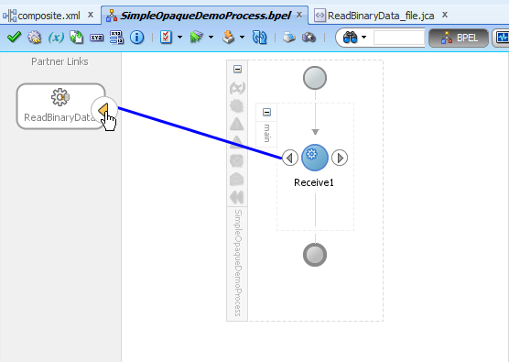

**Step 8:** Next, create the outbound file adapter write interaction. For Opaque w or w/o streaming, choose opaque content as the message type. For Attachments, create a schema named Attachment.xsd as will be shown and use the root element *attach* as the message type.

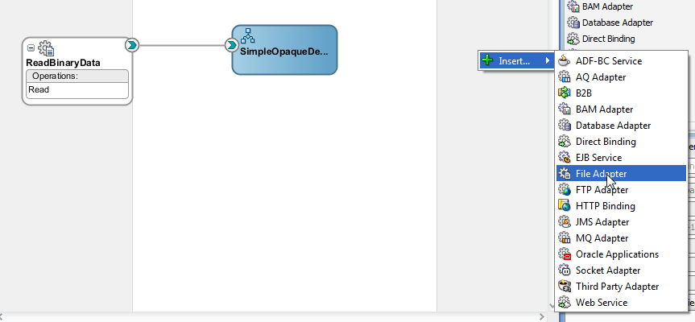

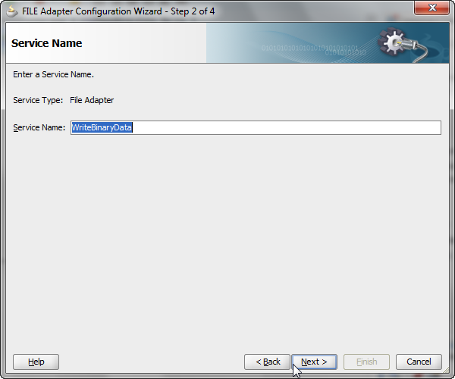

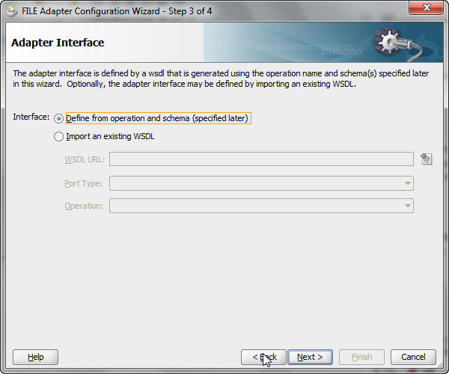

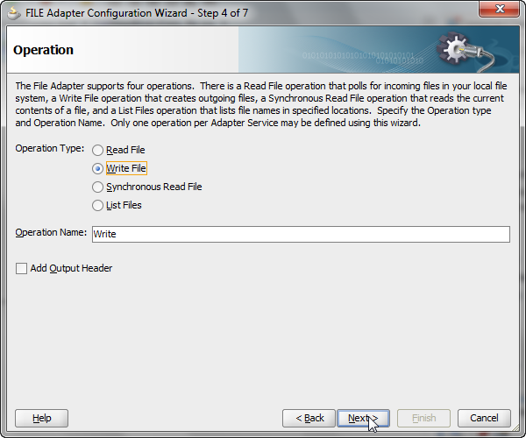

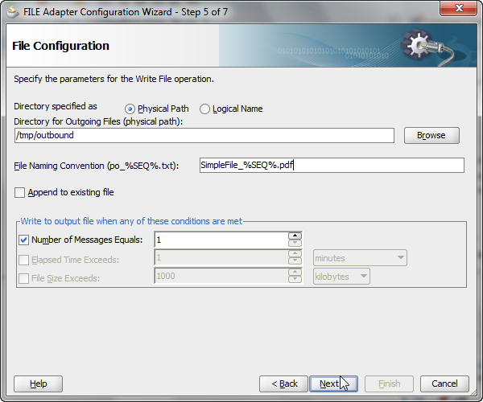

Step 9: Check the box for opaque schema for opaque or opaque w/streaming use-case. For attachment use-case, create a new XSD named Attachment.xsd with the content shown below, and choose *attach* as the root element.

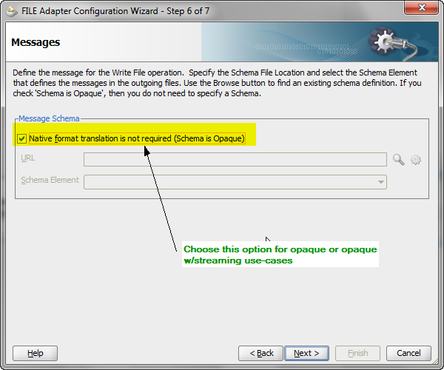

Attachment.xsd [Below] and specifying the root element

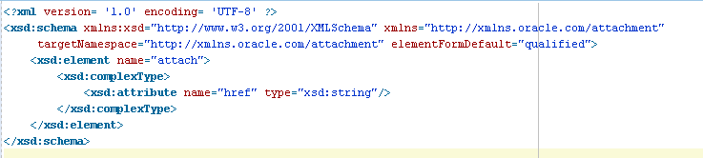

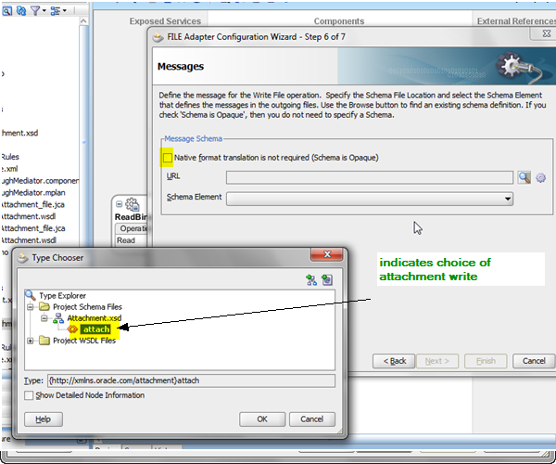

Step 10: Wire the outbound service reference and wire the partnerlink within the BPEL process via an invoke activity.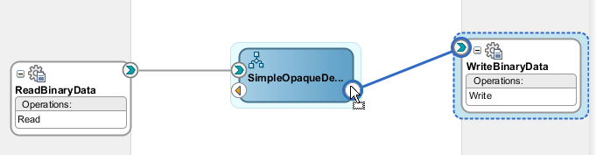

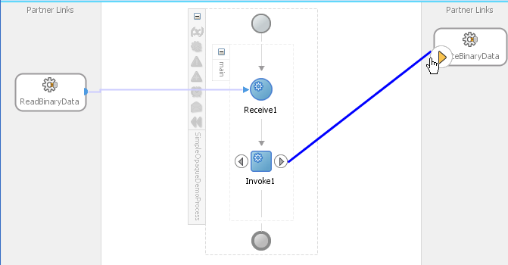

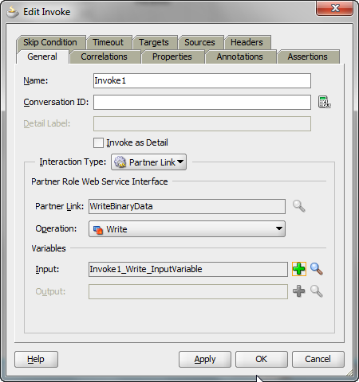

**Step 11:** For opaque and the attachment use-cases, perform the appropriate assignments to copy the source to the target.

Case 1: Opaque use-case

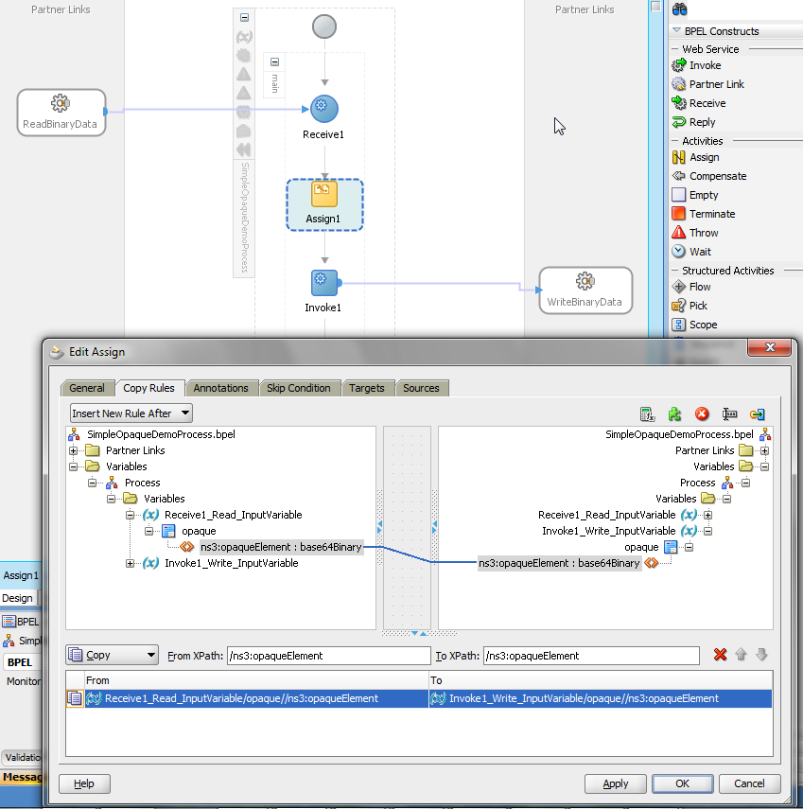

Case 2: Attachment use-case

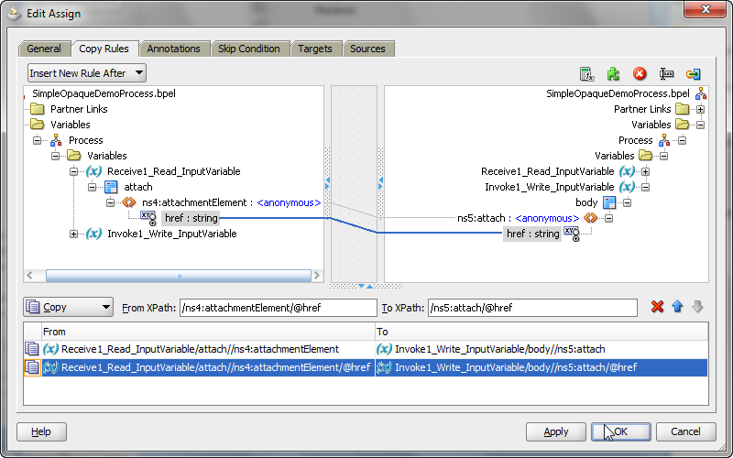

**Step 12:** Deploy and test the process by dropping the file with the name you had specified into the input directory and verify functionality.