**Section 1: Create the Service that receives the SOAP With Attachment**

**Step 1:** Create a new Composite with a One-Way BPEL Process.

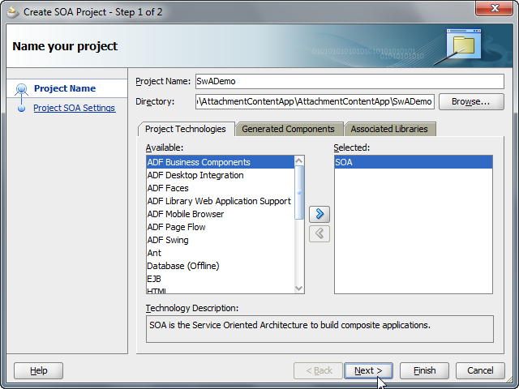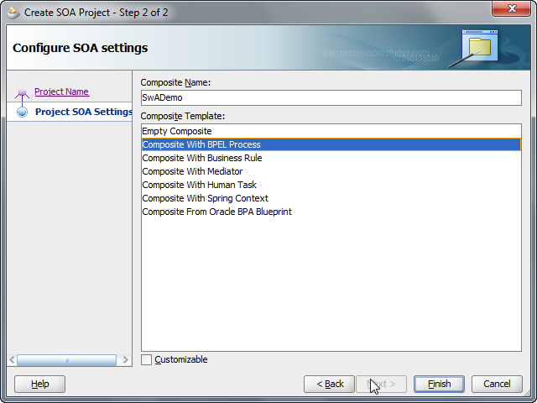

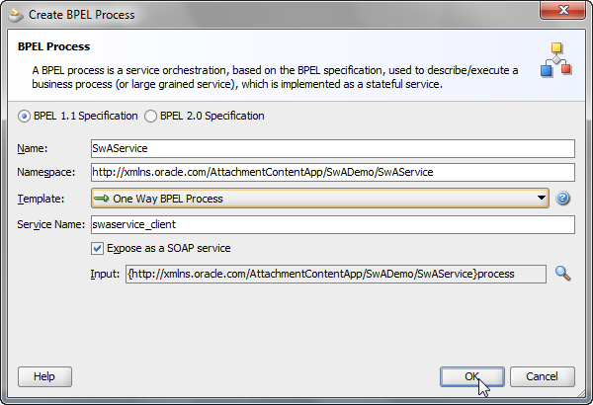

**Step 2:** Update the generated WSDL as follows:

1. Add an additional message part named “attach” of base64Binary type – this is the attachment within the additional MIME part.
2. Populate the bindings section as shown.

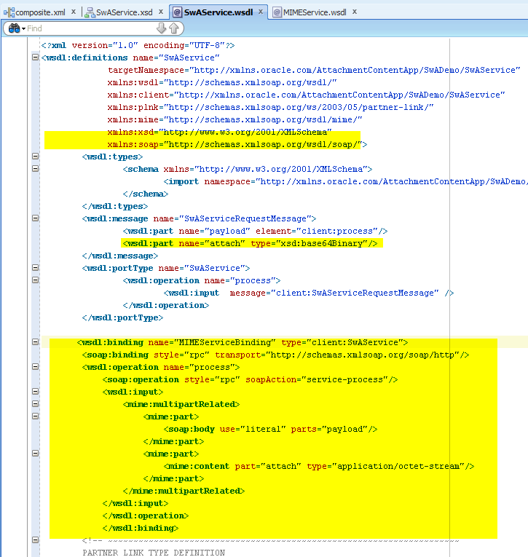

**Step 3:** Create the XML Schema for the attachment. This will define the messageType for the outbound file adapter interaction. The inboundbinary attachment will be passed by reference from the inbound message via the href.

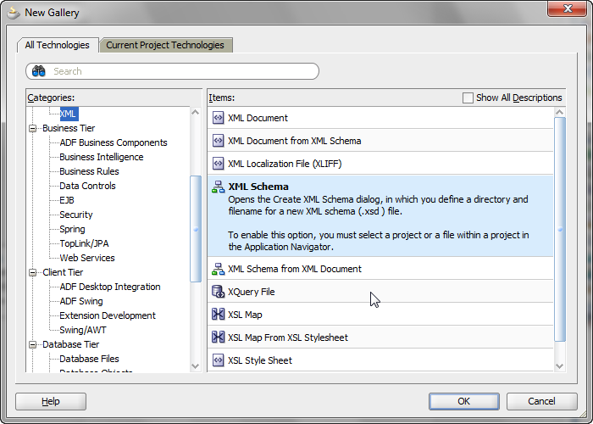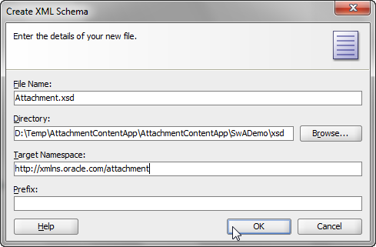

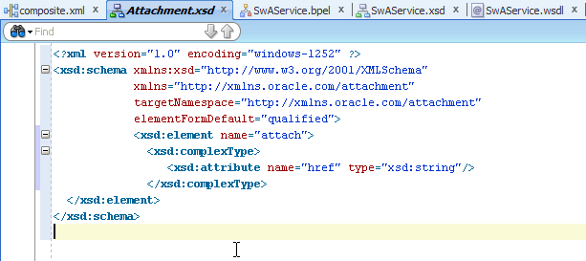

**Step 4:** Create an outbound File Adapter interaction. Choose a directory of your choice to write into, and a file Naming convention. Ensure that the message definition is chosen from the newly created Attachment.xsd as shown.

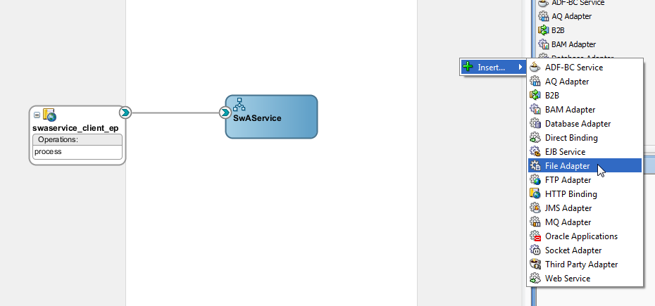

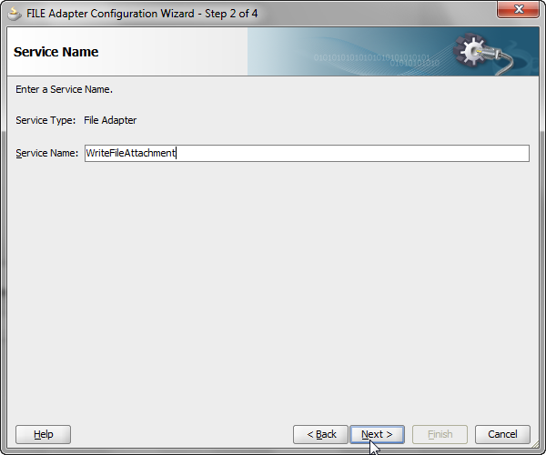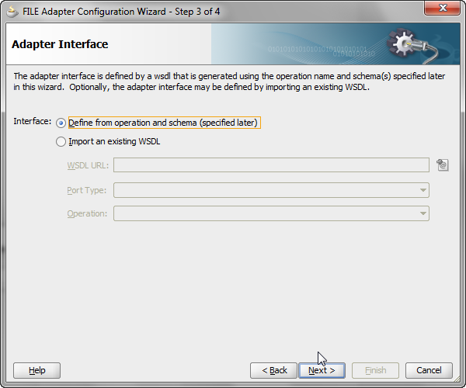

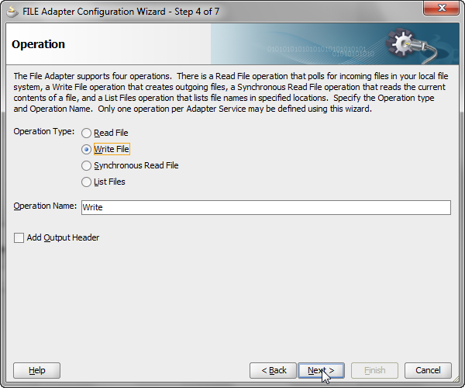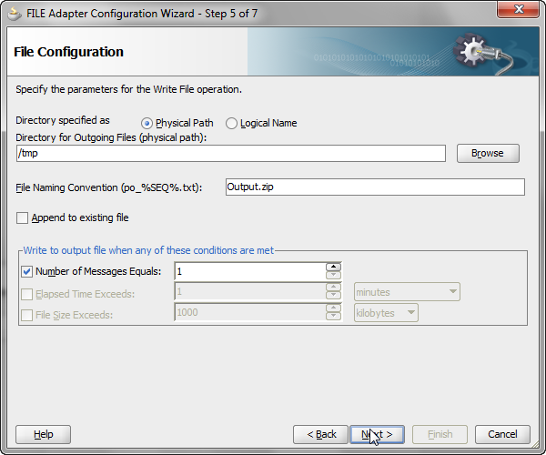

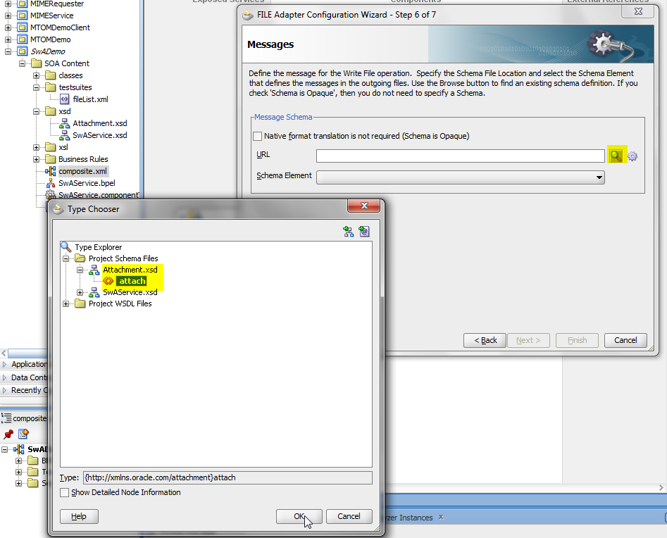

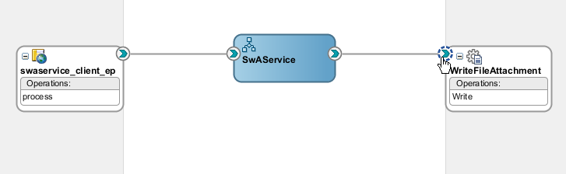

**Step 5:** Wire the BPEL Process and drop in an assign to copy the attach element across.

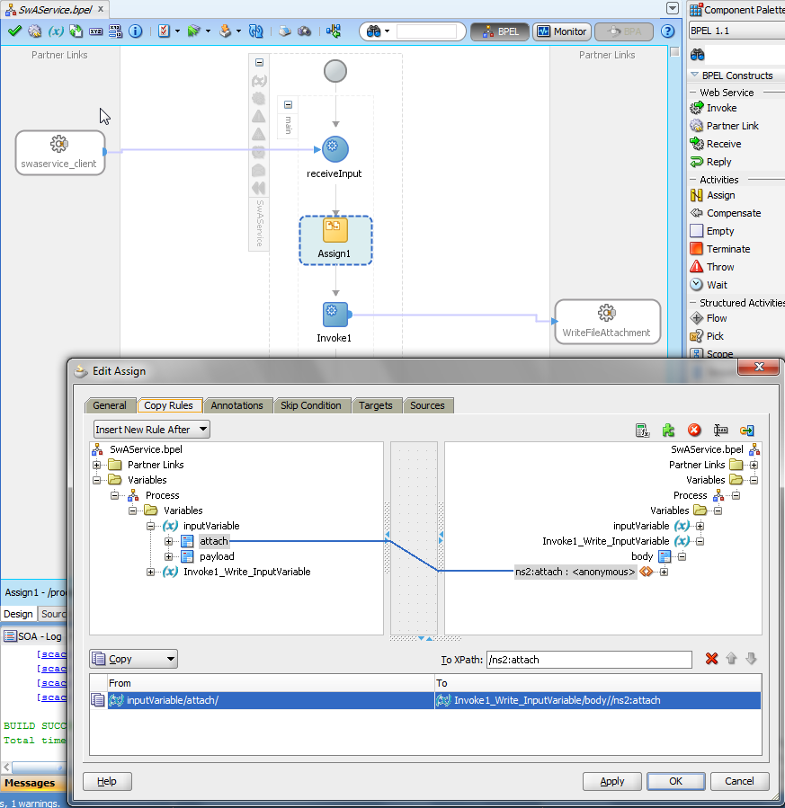

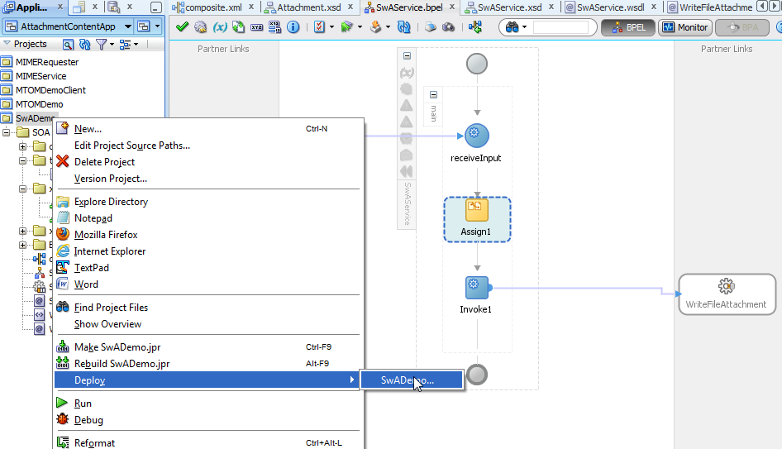

**Section 2: Create the Service that passes the message with the Attachment [SOAP w/Attachment]**

**Step 1:** Create a new SOA Composite project with an inbound file adapter. Choose an inbound directory and file name of your choice, but ensure that the “Read File as Attachment” in Step 4 of the Adapter configuration wizard is checked.

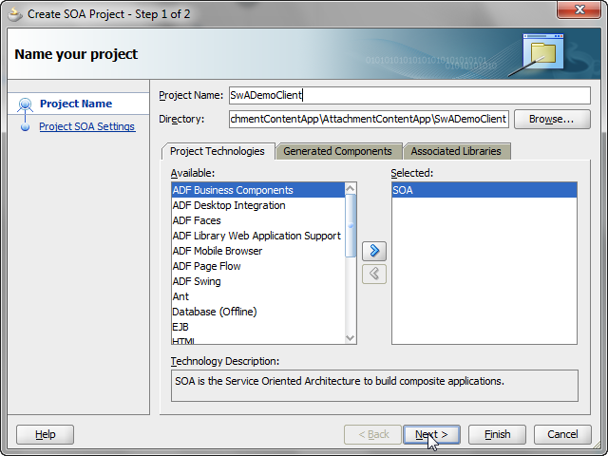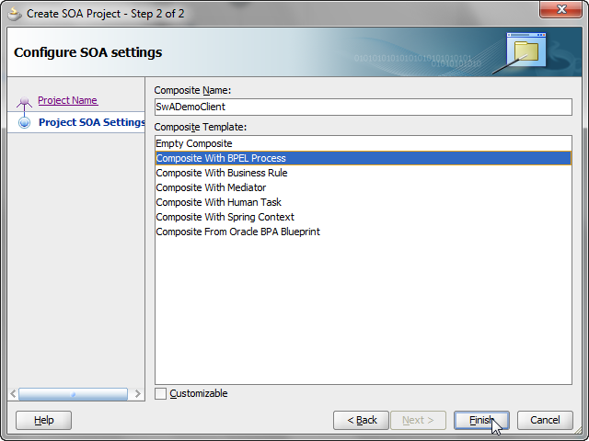

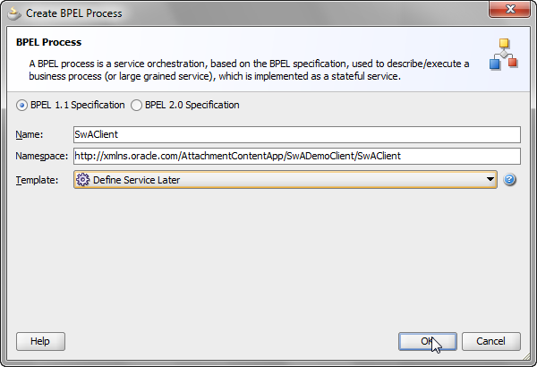

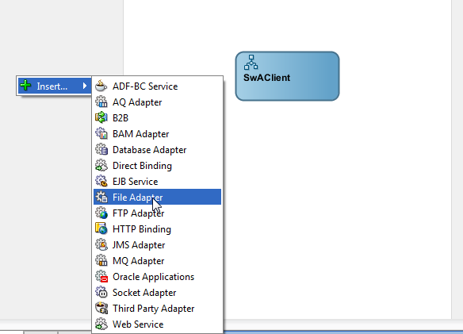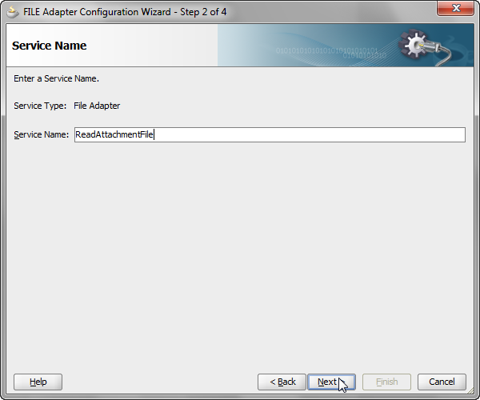

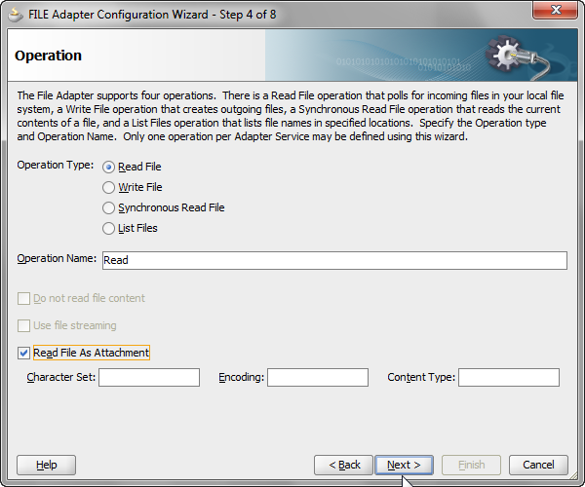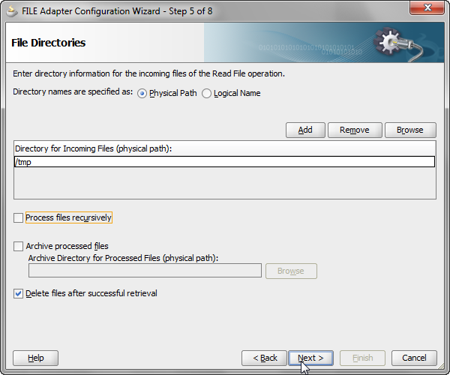

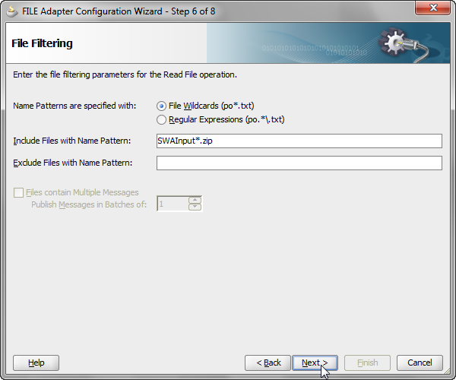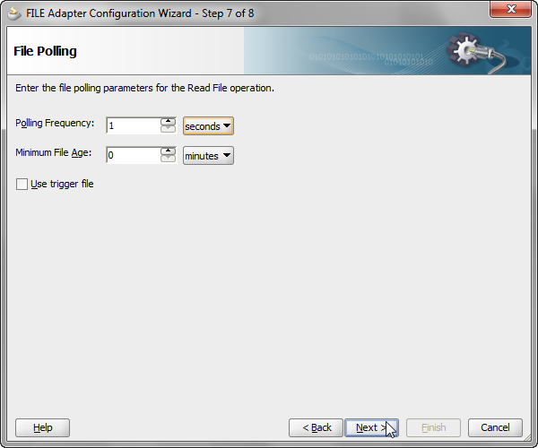

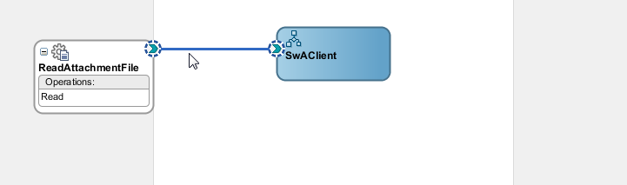

**Step 2:** Create an invoke activity to invoke the SWADemo Composite, and drop an assign activity to copy the *attachment* element from the adapter messageType to the *attach* part of the target service. Deploy and run the service.

