M A R K E T I N G & R E V E N U E P L A N
SkulHub
Marketing & Revenue Strategy
12-Month Growth Plan for the Kenyan Education Market
Version: 1.0
Date: August 2026
Prepared by: SkulHub
Website: skulhub.co.ke
Phone: 0742 340 924

CONFIDENTIAL SkulHub 2026

1. Executive Summary
SkulHub is a comprehensive school management system built for the Kenyan education market. This document outlines the marketing strategy, pricing model, revenue projections, and growth plan for the first 12 months of operation.
The target is to acquire 35 schools within 12 months, generating KES 175,000/month in recurring revenue (KES 2.1M annually). The strategy focuses on direct school visits, WhatsApp group marketing, Facebook advertising, and a referral program offering 15% commission.

2. Market Analysis

2.1 Target Market
Kenya has over 30,000 primary and secondary schools. The target market for SkulHub is private schools, which have the budget and decision-making autonomy to adopt digital management systems. There are approximately 8,000 private schools in Kenya.

2.2 Competitor Landscape
Competitor | Strengths | Weaknesses | SkulHub Advantage
EduManage | Established brand | No M-Pesa, no CBC, limited modules | 33+ modules, M-Pesa Daraja, CBC support
ClassCharts | Attendance focus | Not built for Kenya, expensive | Built for Kenya, affordable, parent portal
Manual Systems | Free | Error-prone, time-consuming, no analytics | Saves 10+ hours/week, real-time analytics
Excel/Google Sheets | Flexible, free | No multi-user, no automation | 13 roles, auto-invoicing, M-Pesa

3. Pricing Strategy
SkulHub offers 4 pricing tiers designed to accommodate schools of all sizes, from small primary schools to large secondary institutions.
Plan | Monthly (KES) | Annual (KES) | Students | Key Features
Starter | 2,500 | 25,000 (2 months free) | Up to 200 | All 33+ modules, 5 users, parent portal, email support
Standard | 5,000 | 50,000 (2 months free) | Up to 1,000 | 20 users, SMS notifications, priority support, data migration
Premium | 10,000 | 100,000 (2 months free) | Unlimited | M-Pesa Daraja, dedicated support, custom branding, API access
Enterprise | Custom | Custom | Unlimited | On-premise, SLA, custom development, dedicated manager

3.1 Expected Plan Distribution
Based on market research and competitor analysis, the expected distribution of schools across pricing plans is projected as follows:
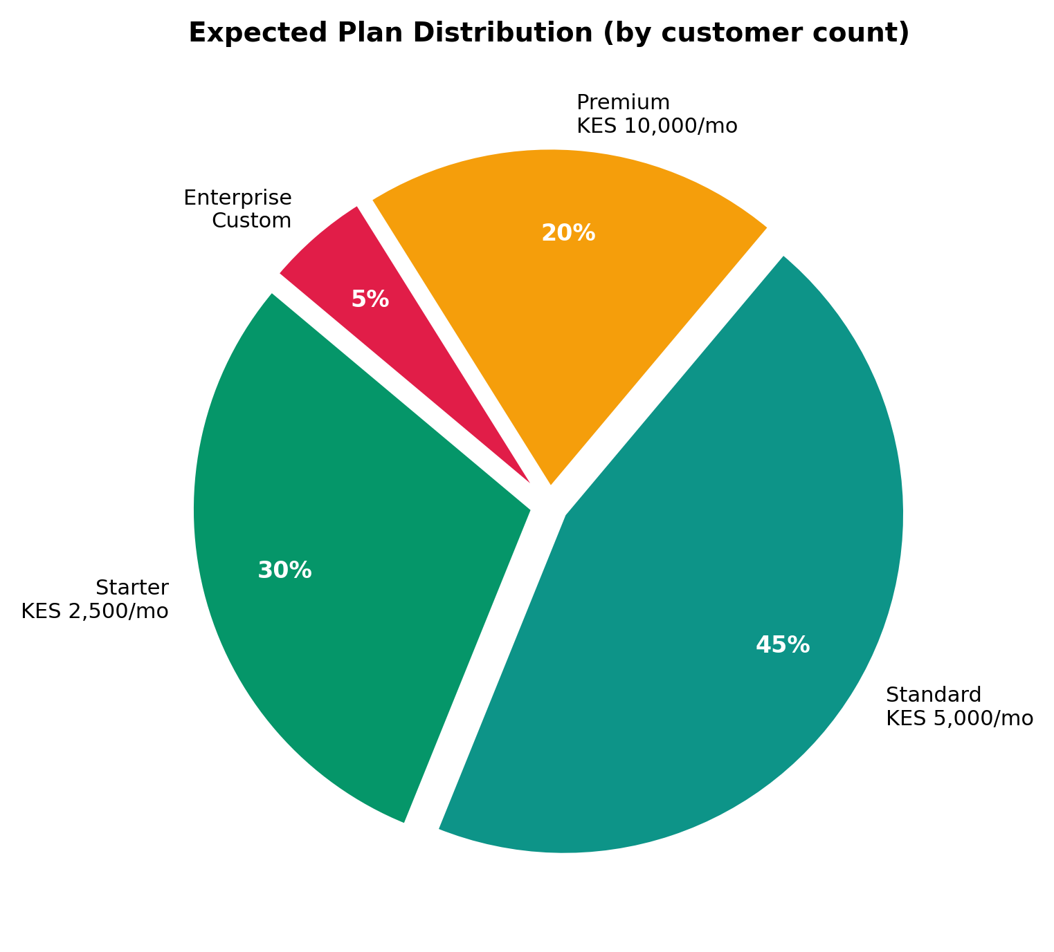

3.2 Annual Revenue by Plan (Year 1 Projection)
With 35 schools in Year 1, the projected annual revenue by plan:
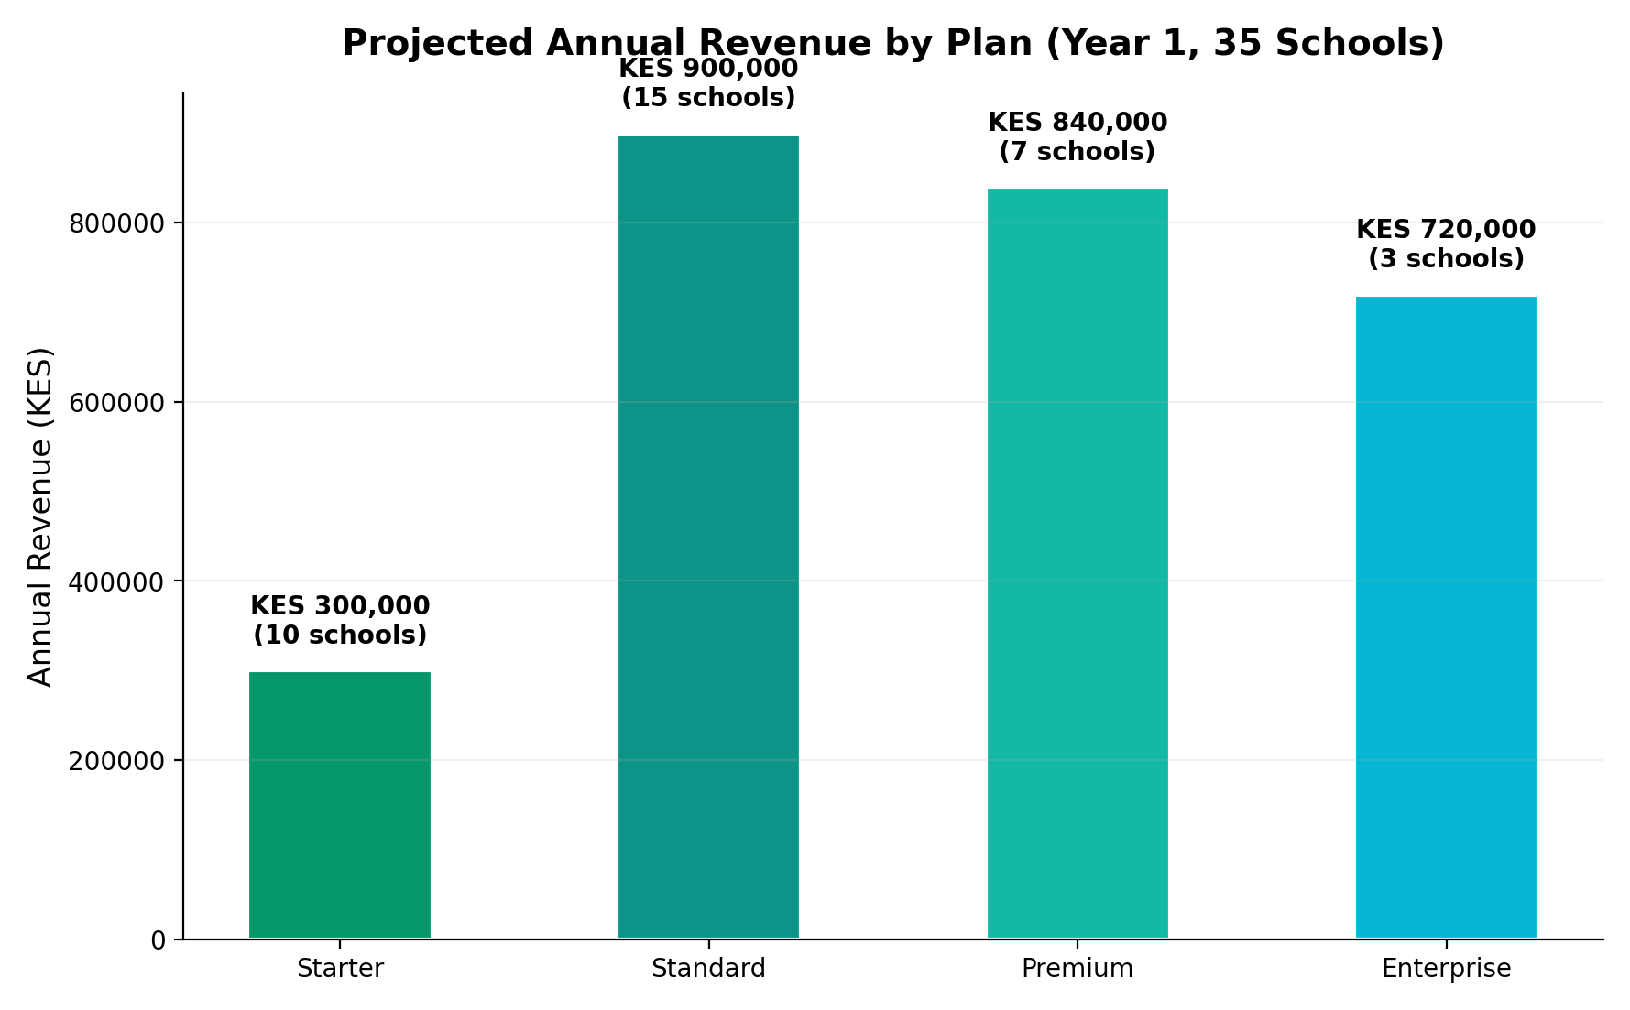

4. Revenue Projections
The following chart shows the projected revenue growth and school acquisition over 12 months:
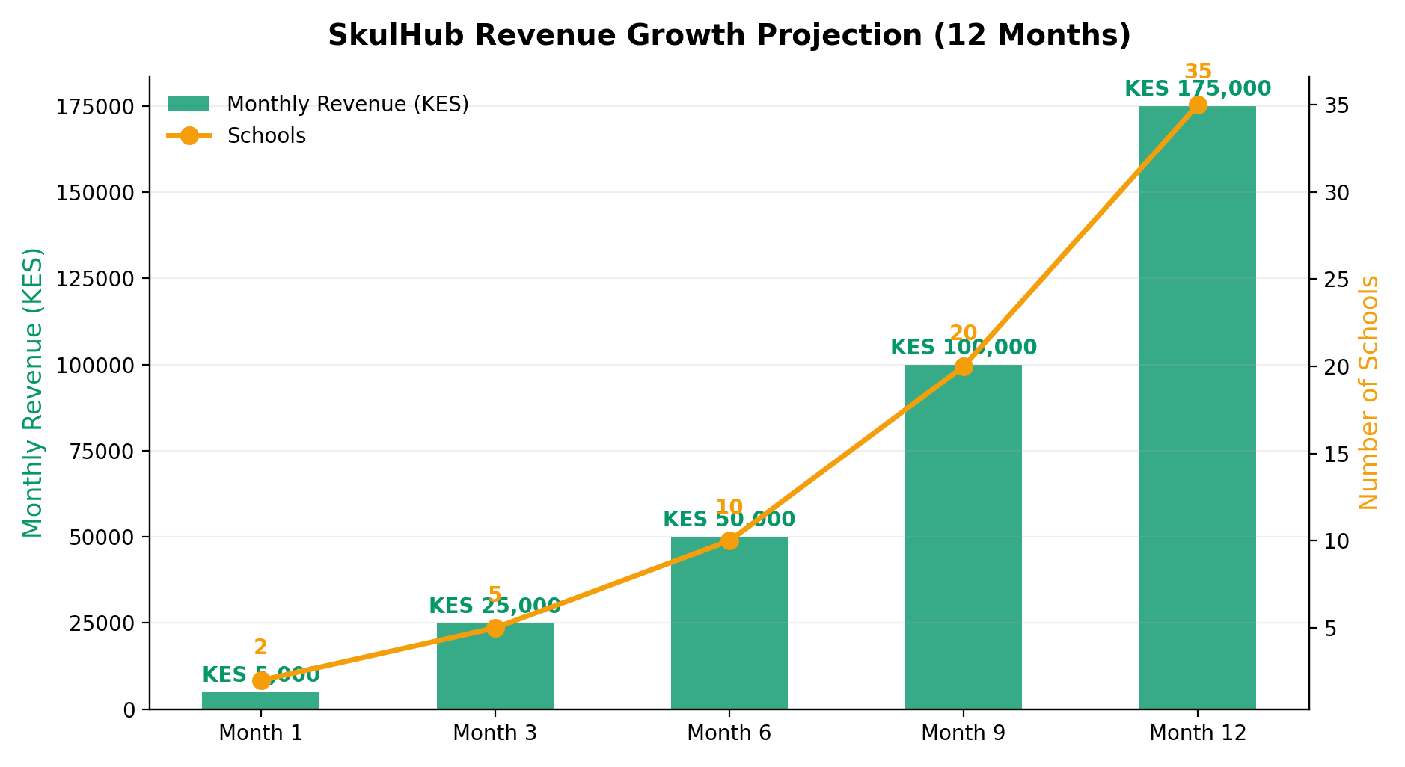

4.1 Monthly Revenue Breakdown
Month | New Schools | Total Schools | Monthly Revenue (KES) | Cumulative Revenue (KES)
Month 1 | 2 | 2 | 5,000 | 5,000
Month 2 | 3 | 5 | 12,500 | 17,500
Month 3 | 5 | 10 | 25,000 | 42,500
Month 4 | 3 | 13 | 32,500 | 75,000
Month 5 | 4 | 17 | 42,500 | 117,500
Month 6 | 3 | 20 | 50,000 | 167,500
Month 7 | 5 | 25 | 62,500 | 230,000
Month 8 | 3 | 28 | 70,000 | 300,000
Month 9 | 4 | 32 | 80,000 | 380,000
Month 10 | 1 | 33 | 82,500 | 462,500
Month 11 | 1 | 34 | 85,000 | 547,500
Month 12 | 1 | 35 | 87,500 | 635,000
Note: Monthly revenue varies based on the mix of Starter (KES 2,500), Standard (KES 5,000), and Premium (KES 10,000) plans. The Year 1 total projected revenue is approximately KES 635,000, with a run-rate of KES 87,500/month by Month 12.

4.2 Year 2-3 Projections
Metric | Year 1 | Year 2 | Year 3
Total Schools | 35 | 80 | 150
Monthly Revenue (KES) | 87,500 | 200,000 | 375,000
Annual Revenue (KES) | 1,050,000 | 2,400,000 | 4,500,000
Referral Commission Paid (KES) | 157,500 | 360,000 | 675,000
Net Revenue (KES) | 892,500 | 2,040,000 | 3,825,000

5. Marketing Strategy

5.1 Marketing Channels
The following chart shows the projected customer acquisition by marketing channel:
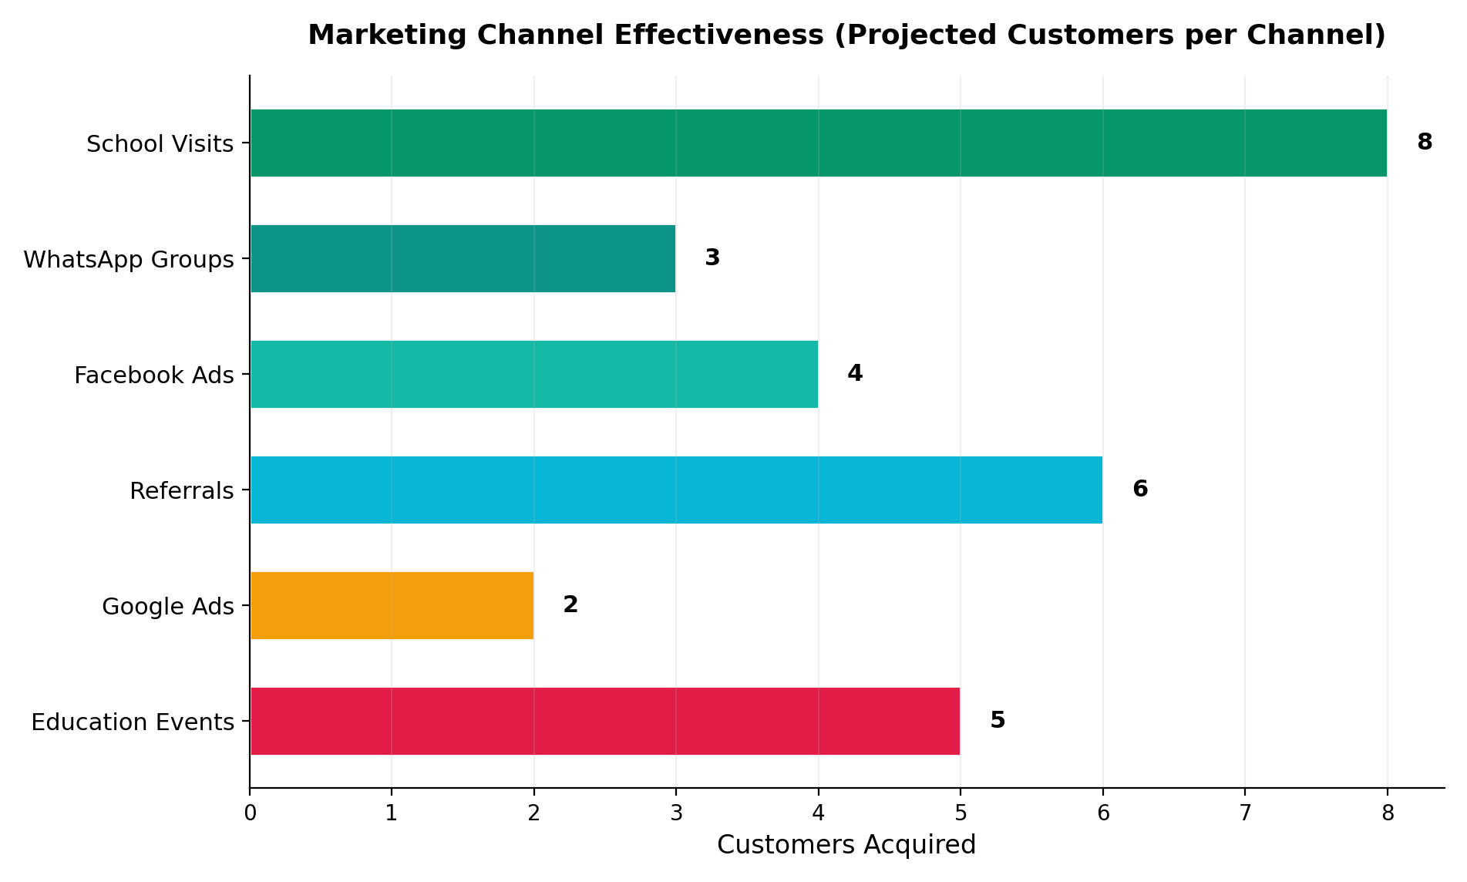

5.2 Channel Breakdown
Channel | Cost (KES/mo) | Expected Customers/yr | Cost per Customer | ROI
School Visits | 500 (transport) | 8 | KES 750 | High
WhatsApp Groups | 0 (free) | 3 | KES 0 | Very High
Facebook Ads | 3,500 | 4 | KES 10,500 | Medium
Referrals | 1,500 (commission) | 6 | KES 3,000 | High
Google Ads | 1,000 | 2 | KES 6,000 | Medium
Education Events | 5,000 (per event) | 5 | KES 12,000 | Medium

5.3 12-Month Marketing Calendar
Month | Focus Area | Activities | Budget (KES)
Month 1-2 | Foundation | Social media setup, Google My Business, content creation | 5,000
Month 3-4 | Direct Outreach | Visit 10 schools, join WhatsApp groups, email campaigns | 10,000
Month 5-6 | Paid Advertising | Facebook ads, Google ads, flyer distribution | 20,000
Month 7-8 | Partnerships | Education consultants, referral program launch | 15,000
Month 9-10 | Events | Attend KESSHA, KAPE, education fairs | 30,000
Month 11-12 | Retention & Growth | Customer success, upsell to higher plans, annual contracts | 10,000

6. Sales Script

6.1 Opening (30 seconds)
"Good morning! I'm [Your Name] from SkulHub. We've built a complete school management system designed specifically for Kenyan schools, with CBC support, M-Pesa fee collection, and a parent portal. I'd love to show you how it works in just 10 minutes."

6.2 Demo Flow (10 minutes)
- Show the dashboard (2 min) - real-time stats, 410 students, KES 3.6M billed
- Add a student (2 min) - show how fast admissions work
- Generate an invoice (2 min) - show the fee structure and auto-generation
- Record a payment (2 min) - show auto-receipt with school letterhead
- Show the parent portal (1 min) - parents check fees on their phone
- Show report cards (1 min) - KCSE-style printable reports

6.3 Close (30 seconds)
"You can start your free 30-day trial today, no credit card needed. Your school code will be ready in 2 minutes. Would you like me to set that up for you right now?"

6.4 Objection Handling
Objection | Response
We already have a system | SkulHub integrates M-Pesa and CBC, most systems don't. Can I show you the difference in 5 minutes?
It's too expensive | At KES 2,500/month for 200 students, that's KES 12.50 per student. One late fee saved pays for the whole year.
We need to think about it | Absolutely. Start the free trial, test it with real data for 30 days. No commitment.
Our staff isn't tech-savvy | The interface is designed for non-technical users. I'll personally train your team, free for the first session.
We're worried about data security | All data is encrypted and stored on secure cloud servers. We use the same security as banks.
Can we get a discount? | Yes! Annual billing gives you 2 months free. And if you refer another school, you both get 1 month free.

7. Referral Program
SkulHub's referral program incentivizes existing customers and education consultants to bring in new schools. Referrers earn 15% commission on every referred school's monthly subscription, for as long as the school remains a customer.

7.1 Commission Structure
Plan | Monthly Subscription | Commission Rate | Monthly Commission | Annual Commission
Starter | KES 2,500 | 15% | KES 375 | KES 4,500
Standard | KES 5,000 | 15% | KES 750 | KES 9,000
Premium | KES 10,000 | 15% | KES 1,500 | KES 18,000
Enterprise | KES 20,000+ | 15% | KES 3,000+ | KES 36,000+

7.2 Example Earnings
- Refer 1 school on Standard plan: KES 750/month (KES 9,000/year)
- Refer 5 schools: KES 3,750/month (KES 45,000/year)
- Refer 10 schools: KES 7,500/month (KES 90,000/year)
- Refer 20 schools: KES 15,000/month (KES 180,000/year)

8. Module Usage Analytics
The following chart shows the projected module usage rate across all schools on the platform:
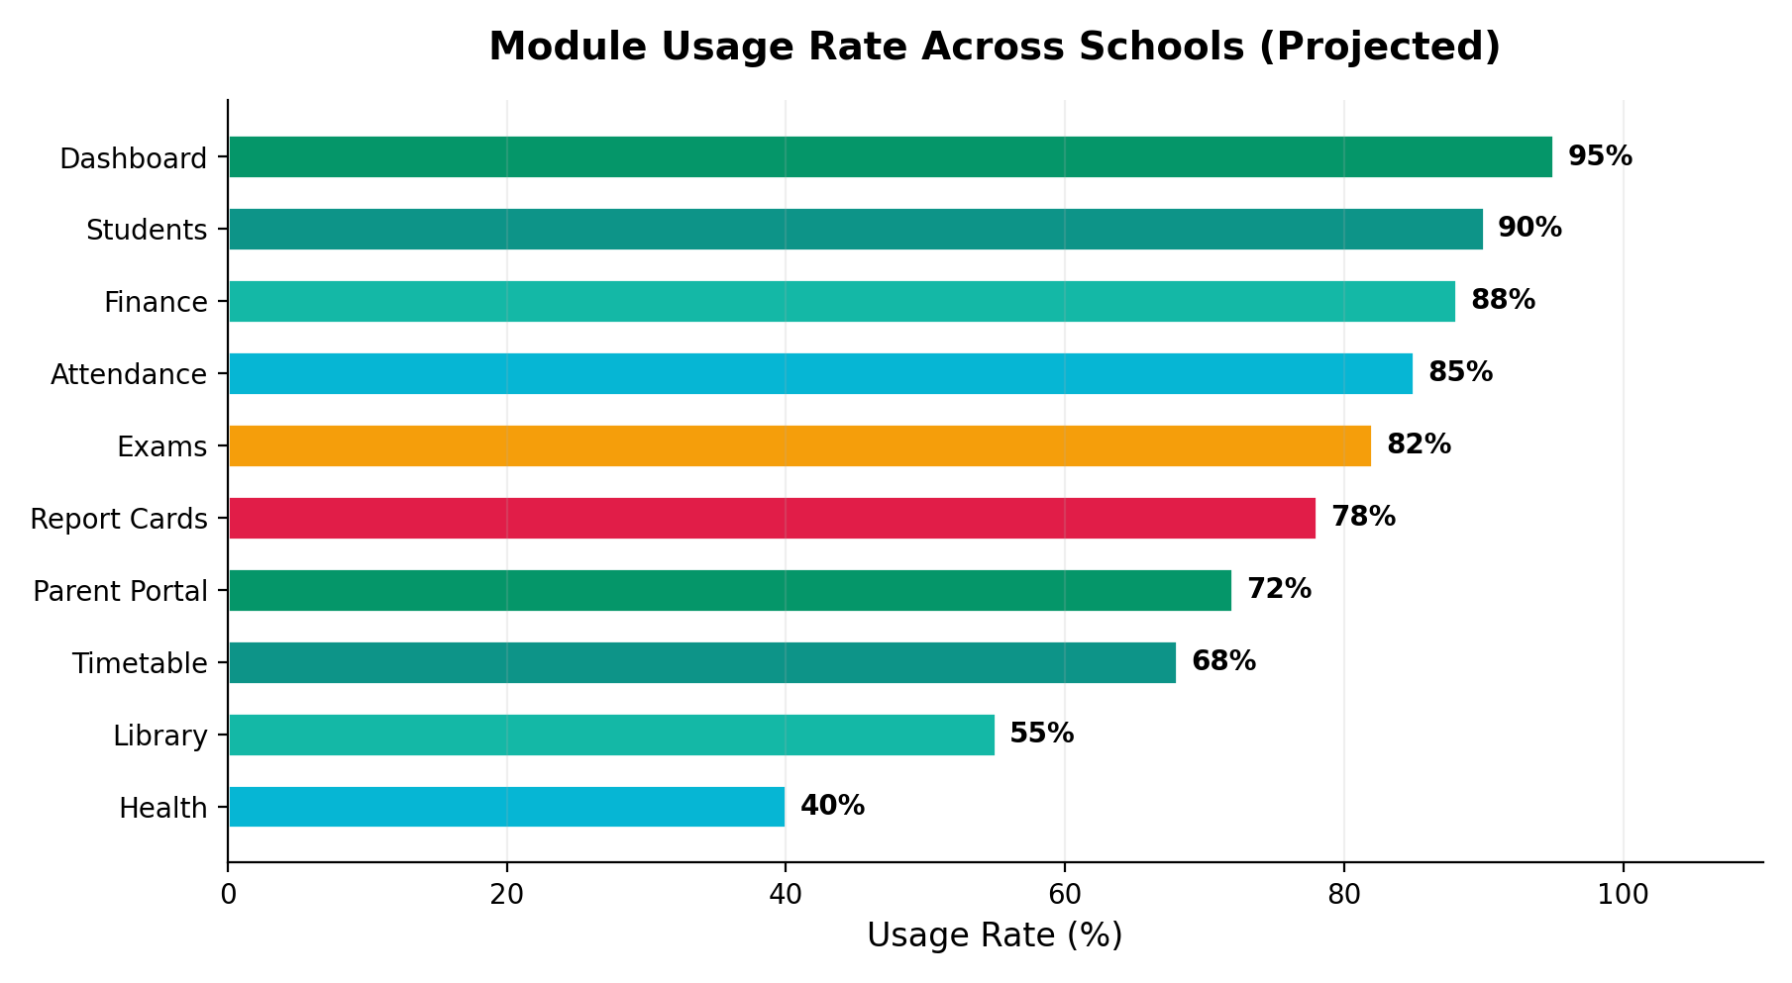

9. Key Performance Indicators (KPIs)
KPI | Month 3 Target | Month 6 Target | Month 12 Target
Total Schools | 10 | 20 | 35
Monthly Revenue (KES) | 25,000 | 50,000 | 87,500
Free Trials Active | 5 | 8 | 10
Trial-to-Paid Conversion | 60% | 65% | 70%
Customer Churn Rate | < 5% | < 3% | < 2%
Average Revenue per School | KES 2,500 | KES 2,750 | KES 2,857
Referral Signups | 2 | 6 | 12
Support Response Time | < 4 hours | < 2 hours | < 1 hour

10. Risks & Mitigation
Risk | Impact | Likelihood | Mitigation
Slow adoption by schools | High | Medium | Free 30-day trial, free training, personal demos
Competitor price war | Medium | Low | Focus on value (M-Pesa, CBC), not just price
Internet connectivity issues | Medium | Medium | Offline mode (future), mobile-first design
Data security concerns | High | Low | Encrypted storage, SSL, regular backups
Staff turnover at client schools | Medium | High | Easy onboarding, documentation, video tutorials
Economic downturn | High | Low | Flexible pricing, Starter plan at KES 2,500/mo

11. Contact Information
Channel | Details
Website | skulhub.co.ke
Email | info@skulhub.co.ke
Phone | 0742 340 924
WhatsApp | 0742 340 924
Location | Nairobi, Kenya
Hours | Mon-Fri 8AM-6PM EAT

--- End of Marketing & Revenue Plan ---

