- What actress starred in "The Lion in Winter"?
- What American composer wrote the music for "West Side Story"?
- What are Cushman and Wakefield known for?
- What are John C. Calhoun and Henry Clay known as?
- What are the names of Jacques Cousteau's two sons?
- What are the two houses of the Legislative branch?
- What body of water are the Canary Islands in?
- What card company sells Christmas ornaments?
- What caused the Lynmouth floods?
- What city did the Flintstones live in?
- What city in Florida is Sea World in?
- What city is 94.5 KDGE Radio located in?
- What city is Massachusetts General Hospital located in?
- What city's newspaper is called "The Enquirer"?
- What continent is Bolivia on?
- What continent is Egypt on?
- What country are Godiva chocolates from?
- What country did Ponce de Leon come from?
- What county is Modesto, California in?
- What county is Phoenix, AZ in?
- What Cruise Line does Kathie Lee Gifford advertise for?
- What currency is used in Algeria?
- What day and month did John Lennon die?

- What day is known as the "national day of prayer"?
- What did Vasco da Gama discover?
- What does CNN stand for?
- What does CPR stand for?
- What does EKG stand for?
- What does Final Four refer to in the sports world?
- What does Knight Ridder publish?
- What does NAFTA stand for?
- What does NASA stand for?
- What does Nicholas Cage do for a living?
- What does SIDS stand for?
- What famous model was married to Billy Joel?
- What flower did Vincent Van Gogh paint?
- What format was VHS's main competition?
- What French province is cognac produced in?
- What French ruler was defeated at the battle of Waterloo?
- What hemisphere is the Philippines in?
- What hockey team did Wayne Gretzky play for?
- What is Alice Cooper's real name?
- What is another astronomic term for the Northern Lights?
- What is another name for vitamin B1?
- What is Australia's national flower?
- What is Betsy Ross famous for?
- What is Black Hills, South Dakota most famous for?
- What is California's capital?
- What is California's state tree?
- What is Chiricahua the name of?
- What is Dick Clark's birthday?
- What is Dr. Ruth's last name?
- What is Hawaii's state flower?
- What is Martin Luther King Jr.'s real birthday?
- What is one of the cities that the University of Minnesota is located in?
- What is the abbreviation for Original Equipment Manufacturer?
- What is the airport code for Los Angeles International?
- What is the average speed of the horses at the Kentucky Derby?

- What is the average weight of a Yellow Labrador?

- What is the birthstone for June?
- What is the capital of Burkina Faso?
- What is the capital of Haiti?
- What is the capital of Mongolia?
- What is the capital of Yugoslavia?
- What is the depth of the Nile river?
- What is the distance in miles from the earth to the sun?
- What is the electrical output in Madrid, Spain?
- What is the highest dam in the U.S.?

- What is the length of the coastline of the state of Alaska?
- What is the location of the Sea of Tranquility?
- What is the longest suspension bridge in the U.S.?

- What is the longest word in the English language?

- What is the major fault line near Kentucky?
- What is the mascot for Notre Dame University?
- What is the most common kind of skin cancer in the U.S.?
- What is the most frequently spoken language in the Netherlands?
- What is the name of a Greek god?
- What is the name of a Salt Lake City newspaper?
- What is the name of Joan Jett's band?
- What is the name of Neil Armstrong's wife?
- What is the name of Roy Roger's dog?
- What is the name of the chocolate company in San Francisco?

- What is the name of the Jewish alphabet?
- What is the name of the leader of Ireland?
- What is the name of the Lion King's son in the movie, "The Lion King"?
- What is the name of the longest ruling dynasty of Japan?

- What is the name of the satellite that the Soviet Union sent into space in 1957?

- What is the nickname of Pennsylvania?
- What is the normal resting heart rate of a healthy adult?
- What is the Ohio state bird?
- What is the oldest city in the United States?

- What is the oldest university in the US?

- What is the Pennsylvania state income tax rate?
- What is the population of China?
- What is the population of Japan?
- What is the population of Kansas?
- What is the population of Mexico?
- What is the population of Mozambique?
- What is the population of Nigeria?
- What is the population of Ohio?
- What is the population of Seattle?
- What is the population of the Bahamas?
- What is the population of the United States?
- What is the primary language of the Philippines?
- What is the real name of the singer, Madonna?
- What is the salary of a U.S. Representative?
- What is the sales tax in Minnesota?
- What is the size of Argentina?
- What is the state nickname of Mississippi?
- What is the telephone number for the University of Kentucky?
- What is the zip code for Fremont, CA?
- What is the zip code for Parsippany, NJ?
- What kind of a sports team is the Wisconsin Badgers?
- What kind of animal was Winnie the Pooh?
- What kind of sports team is the Buffalo Sabres?
- What king was forced to agree to the Magna Carta?
- What language is mostly spoken in Brazil?
- What movie did Madilyn Kahn star in with Gene Wilder?
- What nationality was Jackson Pollock?
- What New York City structure is also known as the Twin Towers?
- What ocean did the Titanic sink in?
- What party was Winston Churchill a member of?
- What peninsula is Spain part of?
- What position did Willie Davis play in baseball?
- What province is Edmonton located in?
- What province is Montreal in?
- What radio station did Paul Harvey work for?
- What river in the US is known as the Big Muddy?
- What sport do the Cleaveland Cavaliers play?
- What state did the Battle of Bighorn take place in?
- What state does Martha Stewart live in?
- What state does MO stand for?
- What state in the United States covers the largest area?
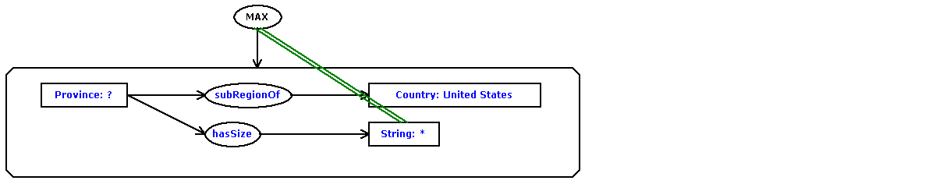
- What state is Niagra Falls located in?
- What state is the Filenes store located in?
- What store does Martha Stewart advertise for?
- What task does the Bouvier breed of dog perform?
- What tourist attractions are there in Reims?
- What type of bridge is the Golden Gate Bridge?
- What type of currency is used in Australia?
- What type of horses appear on the Budweiser commercials?
- What type of hunting are retrievers used for?
- What U.S. Government agency registers trademarks?
- What U.S. state's motto is "Live free or Die"?
- What university was Woodrow Wilson President of?
- What was the ball game of ancient Mayans called?
- What was the death toll at the eruption of Mount Pinatubo?
- What was the name of Jacques Cousteau's ship?
- What was the name of the movie that starred Sharon Stone and Arnold Schwarzenegger?
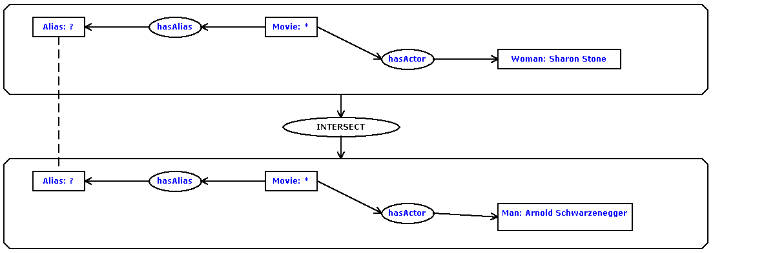
- What was the name of the sitcom that Alyssa Milano starred in with Tony Danza?

- What was the name of the Titanic's captain?
- What was the purpose of the Manhattan project?
- What was W.C. Fields' real name?
- What were Christopher Columbus' three ships?
- What were the names of the three ships used by Columbus?
- What wrestling star became "The Incredible Hulk"?
- What year did Hitler die?
- What year did the Titanic sink?
- What year did the Vietnam War end?
- What year did WWII begin?
- What year was the Avery Dennison company founded?
- What year was the Mona Lisa painted?
- What's the formal name for Lou Gehrig's disease?
- What's the most famous tourist attraction in Rome?
- What's the name of a golf course in Myrtle Beach?
- What's the name of a hotel in Indianapolis?
- What's the name of Pittsburgh's baseball team?

- What's the name of the actress who starred in the movie, "Silence of the Lambs"?
- What's the name of the star of the cooking show, "Galloping Gourmet"?
- What's the name of the Tampa newspaper?
- What's the name of the tiger that advertises for Frosted Flakes cereal?
- What's the name of the Tokyo Stock Exchange?
- What's the population of Biloxi, Mississippi?
- What's the population of Mississippi?
- What's the tallest building in New York City?

- Which comedian's signature line is "Can we talk"?
- Which mountain range in North America stretches from Maine to Georgia?

- Which U.S. President is buried in Washington, D.C.?
- Where are the headquarters of Eli Lilly?
- Where are the National Archives?
- Where are the Rocky Mountains?
- Where are the U.S. headquarters for Procter and Gamble?
- Where did Bill Gates go to college?
- Where did Hillary Clinton graduate college?
- Where did Howard Hughes die?
- Where did the Inuits live?
- Where did the Maya people live?
- Where did Woodstock take place?
- Where does Mother Angelica live?
- Where is Amsterdam?
- Where is Ayer's rock?
- Where is Basque country located?
- Where is Belize located?
- Where is Burma?
- Where is Glasgow?
- Where is Guam?
- Where is John Wayne airport?
- Where is Kings Canyon?
- Where is Las Vegas?
- Where is Logan International located?
- Where is McCarren Airport?
- Where is Melbourne?
- Where is Milan?
- Where is Ocho Rios?
- Where is Perth?
- Where is Prince Edward Island?
- Where is Rider College located?
- Where is Romania located?
- Where is Santa Lucia?
- Where is the bridge over the river Kwai?
- Where is the Danube?
- Where is the Euphrates River?
- Where is the Grand Canyon?
- Where is the Holland Tunnel?
- Where is the Isle of Man?
- Where is the Kalahari desert?
- Where is the location of the Orange Bowl?
- Where is the Louvre?
- Where is the Mall of the America?
- Where is the Mayo Clinic?
- Where is the Orinoco River?
- Where is the Orinoco?
- Where is the Shawnee National Forest?
- Where is the Smithsonian Institute located?
- Where is the Thomas Edison Museum?
- Where is the Valley of the Kings?
- Where is the volcano Mauna Loa?
- Where is the volcano Olympus Mons located?
- Where is Tornado Alley?
- Where is Trinidad?
- Where is Tufts University?
- Where is Venezuela?
- Where is Webster University?
- Where is Windsor Castle?
- Where was John Adams born?
- Where was Poe born?
- Where was Pythagoras born?
- Where was Tesla born?
- Where's Montenegro?
- Who assassinated President McKinley?
- Who created "The Muppets"?
- Who created the character James Bond?
- Who created the character of Scrooge?
- Who created the comic strip, "Garfield"?
- Who developed the Macintosh computer?
- Who discovered America?
- Who found Hawaii?
- Who invented the game Scrabble?
- Who is a German philosopher?
- Who is buried in the great pyramid of Giza?
- Who is Secretary-General of the United Nations?
- Who is the emperor of Japan?
- Who is the founder of the Wal-Mart stores?
- Who is the leader of India?
- Who is the monarch of the United Kingdom?
- Who is the president of Bolivia?
- Who is the Prime Minister of Canada?
- Who is the prophet of the religion of Islam?
- Who killed Caesar?
- Who killed Martin Luther King?
- Who manufacturers Magic Chef applicances?
- Who manufactures the software, "PhotoShop"?
- Who owns CNN?
- Who owns the St. Louis Rams?
- Who painted Olympia?
- Who played the teacher in Dead Poet's Society?
- Who portrayed Jake in the television show, "Jake and the Fatman"?
- Who provides telephone service in Orange County, California?
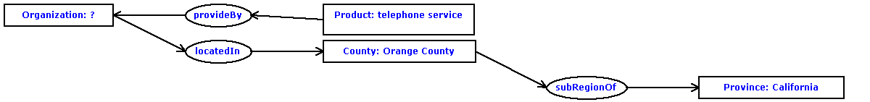
- Who shot Billy the Kid?
- Who started the Dominos Pizza chain?
- Who was Charles Lindbergh's wife?
- Who was Darth Vader's son?
- Who was Samuel Johnsons's friend and biographer?
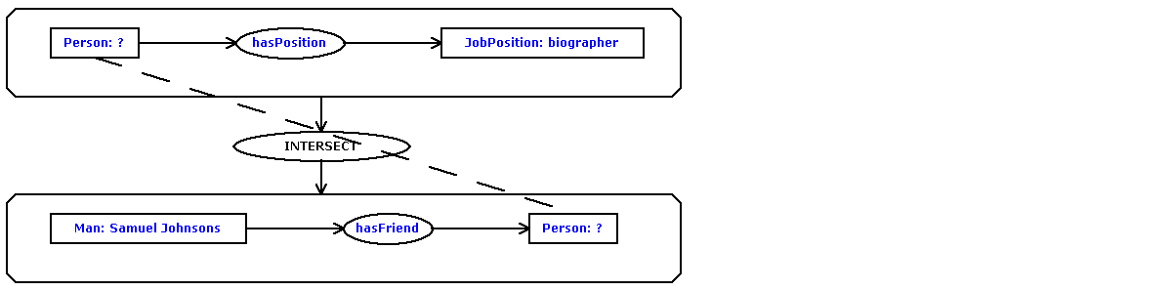
- Who was the abolitionist who led the raid on Harper's Ferry in 1859?

- Who was the architect of Central Park?
- Who was the author of the book about computer hackers called "The Cuckoo's Egg: Tracking a Spy Through the Maze of Computer Espionage"?
- Who was the founding member of the Pink Floyd band?
- Who was the oldest U.S. president?
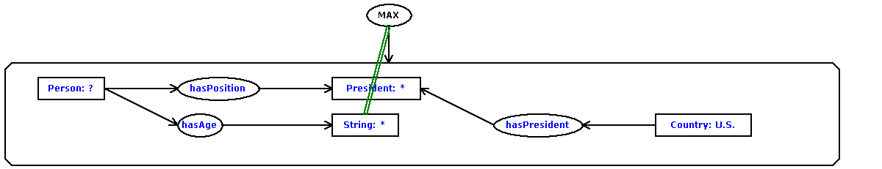
- Who was the president of Vichy France?
- Who was the tallest U.S. president?
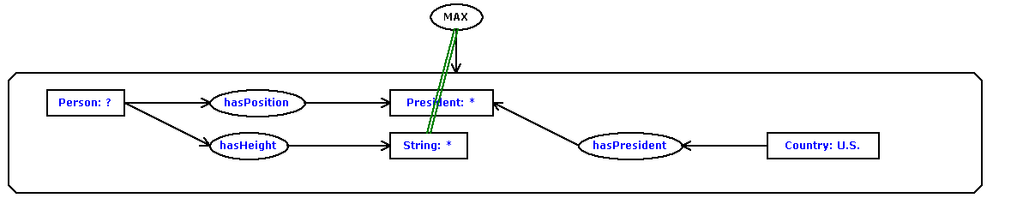
- Who won Ms. American in 1989?
- Who won the nobel prize in literature in 1988?
- Who won the rugby world cup in 1987?
- Who won the Superbowl in 1982?
- Who wrote "An Ideal Husband"?
- Who wrote "The Pit and the Pendulum"?
- Who wrote "The Scarlet Letter"?
- Who wrote the book, "Huckleberry Finn"?
- Who wrote the book, "Song of Solomon"?
- Who wrote the book, "The Grinch Who Stole Christmas"?
- Who wrote the hymn "Amazing Grace"?
- Who wrote the song, "Boys of Summer"?
- Who wrote the song, "Silent Night"?
- Who's the lead singer of the Led Zeppelin band?
- When did Aldous Huxley write, "Brave New World"?
- When did Amtrak begin operations?
- When did Elvis Presley die?
- When did Muhammad live?
- When did the California lottery begin?
- When did the Carolingian period begin?
- When did the Chernobyl nuclear accident occur?
- When did the Hindenberg crash?
- When did the royal wedding of Prince Andrew and Fergie take place?

- When did World War I start?
- When is Bastille Day?
- When is Boxing Day?
- When is hurricane season in the Caribbean?
- When is the Tulip Festival in Michigan?
- When was "the Great Depression"?
- When was Algeria colonized?
- When was Babe Ruth born?
- When was Beethoven born?
- When was Hurricane Hugo?
- When was John D. Rockefeller born?
- When was Lyndon B. Johnson born?
- When was Microsoft established?
- When was Nostradamus born?
- When was Rosa Parks born?
- When was the Brandenburg Gate in Berlin built?
- When was the De Beers company founded?
- When was the Hoover Dam constructed?
- When was the movie, Caligula, made?
- When was the NFL established?
- When was the San Francisco fire?
- When was the Triangle Shirtwaist fire?
- When were William Shakespeare's twins born?
- How big is Australia?
- How big is the Electoral College?
- How did Bob Marley die?
- How far away is the moon?
- How far is it from Denver to Aspen?
- How far is Pluto from the sun?
- How fast can a Corvette go?
- How hot is the core of the earth?
- How large is Missouri's population?
- How long did Rip Van Winkle sleep?
- How long would it take to get from Earth to Mars?
- How many casinos are in Atlantic City, NJ?
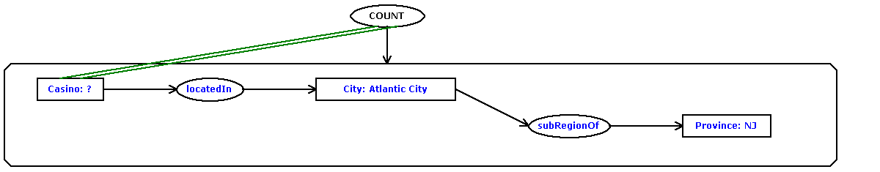
- How many counties are in Indiana?

- How many films did Ingmar Bergman make?

- How many Great Lakes are there?

- How many islands does Fiji have?

- How many miles is it from London, England to Plymouth, England?
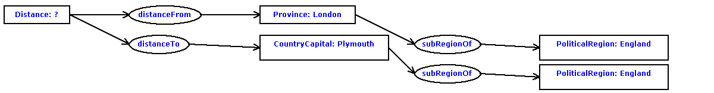
- How many people die from snakebite poisoning in the U.S. per year?

- How many people live in Chile?
- How many Stradivarius violins were ever made?

- How many Superbowls have the 49ers won?
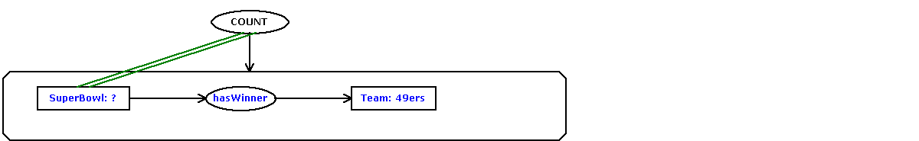
- How many zip codes are there in the U.S.?

- How much in miles is a ten K run?
- How much money does the Sultan of Brunei have?
- How much was a ticket for the Titanic?
- How tall is Kilimanjaro?
- How tall is the Gateway Arch in St. Louis, MO?
- How tall is the Sears Building?
- How wide is the Atlantic Ocean?
- How wide is the Milky Way galaxy?
- In Poland, where do most people live?

- In what area of the world was the Six Day War fought?
- In what book can I find the story of Aladdin?
- Italy is the largest producer of what?

- Mercury, what year was it discovered?
- Name a ballet company Mikhail Baryshnikov has danced for?
- Name a film in which Jude Law acted.
- Name a Gaelic language
- Name a movie that the actress, Sandra Bullock, had a role in.
- Name a novel written by John Steinbeck.
- Name a tiger that is extinct?
- Name an American made motorcycle
- Name an American war plane?
- Name an art gallery in New York.
- Name one of the Seven Wonders of the Ancient World
- Tell me what city the Kentucky Horse Park is near?
- About how many soldiers died in World War II?

- Can you give me the name of a clock maker in London, England?
- For what disease is the drug Sinemet used as a treatment?
- George Bush purchased a small interest in which baseball team?

