Các câu sinh ra đồ thị khác anh Hoàng Anh
(các đồ thị bên dưới là của anh Hoàng Anh)
17- What county is Phoenix, AZ in?
40- What is Black Hills, South Dakota most famous for?
52- What is the electrical output in Madrid, Spain?
65- What is the name of the Jewish alphabet?
66- What is the name of the Lion King's son in the movie, ‘The Lion King’?
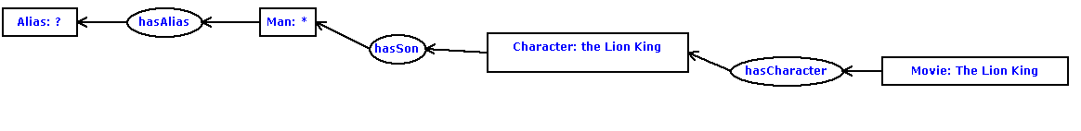

67- What is the name of the satellite that the Soviet Union sent into space in 1957?


75- What is the zip code for Fremont, California?
76- What is the zip code for Parsippany, NJ?
103- What type of horses appear on the Budweiser commercials?
106- What U.S. state's motto is ‘Live free or Die’?
113- What was the name of the sitcom that Alyssa Milano starred in with Tony Danza?


117- What were Christopher Columbus' three ships?
118- What were the names of the three ships used by Columbus?
141- Where did Bill Gates go to college?
142- Where did Hillary Clinton graduate college?
162- Where is the Mall of the America?
188- Who is a German philosopher?
193- Who is the prophet of the religion of Islam?
202- Who provides telephone service in Orange County, California?
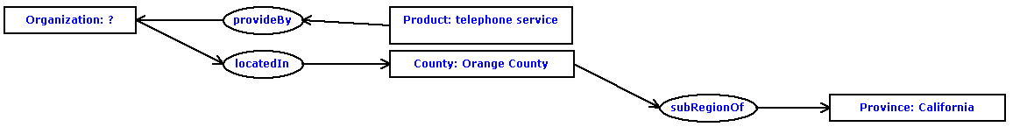
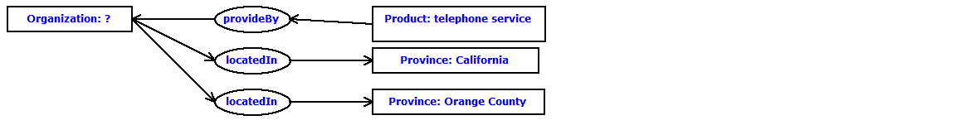
210- Who was the author of the book about computer hackers called ‘The Cuckoo's Egg Tracking a Spy Through the Maze of Computer Espionage’?
216- Who won the Superbowl in 1982?
226- Who's the lead singer of the Led Zeppelin band?
240- When is hurricane season in the Caribbean?
241- When is the Tulip Festival in Michigan?
251- When was the Brandenburg Gate in Berlin built?

Các câu sinh ra được đồ thị giống anh Hoàng Anh nhưng có vẻ sai
80- What king was forced to agree to the Magna Carta?
136- Which mountain range in North America stretches from Maine to Georgia?

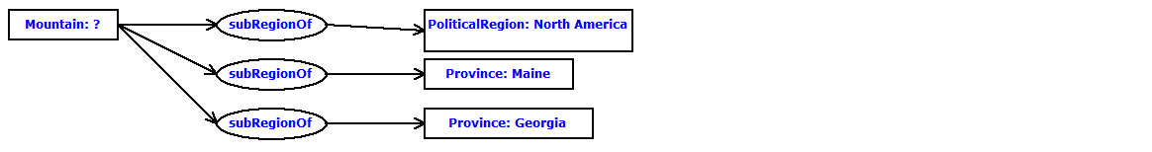
213- Who won Ms. American in 1989?
214- Who won the nobel prize in literature in 1988?
215- Who won the rugby world cup in 1987?

Các câu không sinh được đồ thị do có quan hệ ba ngôi
35- What imaginary line is halfway between the North and South Poles?
53- What is the exchange rate between England and the U.S.?
89- What river flows between Fargo, North Dakota and Moorhead, Minnesota?

110- What was the last year that the Chicago Cubs won the World Series?
112- What was the name of the famous battle in 1836 between Texas and Mexico?

124- What year was Desmond Mpilo Tutu awarded the Nobel Peace Prize?
207- Who was elected president of South Africa in 1994?

