PHỤ LỤC: ĐỒ THỊ Ý NIỆM SINH RA ĐÚNG TỪ TREC 2002
- What actress starred in "The Lion in Winter"?
- What American composer wrote the music for "West Side Story"?
- What are Cushman and Wakefield known for?
- What are John C. Calhoun and Henry Clay known as?
- What are the names of Jacques Cousteau's two sons?
- What are the two houses of the Legislative branch?
- What body of water are the Canary Islands in?
- What card company sells Christmas ornaments?
- What caused the Lynmouth floods?
- What city did the Flintstones live in?
- What city in Florida is Sea World in?
- What city is 94.5 KDGE Radio located in?
- What city is Massachusetts General Hospital located in?
- What city's newspaper is called "The Enquirer"?
- What continent is Bolivia on?
- What continent is Egypt on?
- What country are Godiva chocolates from?
- What country did Ponce de Leon come from?
- What county is Modesto, California in?
- What county is Phoenix, AZ in?
- What Cruise Line does Kathie Lee Gifford advertise for?
- What currency is used in Algeria?
- What day and month did John Lennon die?

- What day is known as the "national day of prayer"?
- What did Vasco da Gama discover?
- What does "Sitting Shiva" mean?
- What does CNN stand for?
- What does CPR stand for?
- What does EKG stand for?
- What does Final Four refer to in the sports world?
- What does Knight Ridder publish?
- What does NAFTA stand for?
- What does NASA stand for?
- What does Nicholas Cage do for a living?
- What does SIDS stand for?
- What famous model was married to Billy Joel?
- What flower did Vincent Van Gogh paint?
- What format was VHS's main competition?
- What French province is cognac produced in?
- What French ruler was defeated at the battle of Waterloo?
- What hemisphere is the Philippines in?
- What hockey team did Wayne Gretzky play for?
- What is Alice Cooper's real name?
- What is another astronomic term for the Northern Lights?
- What is another name for vitamin B1?
- What is Australia's national flower?
- What is Betsy Ross famous for?
- What is Black Hills, South Dakota most famous for?
- What is California's capital?
- What is California's state tree?
- What is Chiricahua the name of?
- What is Dick Clark's birthday?
- What is Dr. Ruth's last name?
- What is Hawaii's state flower?
- What is Martin Luther King Jr.'s real birthday?
- What is one of the cities that the University of Minnesota is located in?
- What is the abbreviation for Original Equipment Manufacturer?
- What is the airport code for Los Angeles International?
- What is the average speed of the horses at the Kentucky Derby?

- What is the average weight of a Yellow Labrador?

- What is the birthstone for June?
- What is the capital of Burkina Faso?
- What is the capital of Haiti?
- What is the capital of Mongolia?
- What is the capital of Yugoslavia?
- What is the depth of the Nile river?
- What is the distance in miles from the earth to the sun?
- What is the electrical output in Madrid, Spain?
- What is the highest dam in the U.S.?

- What is the length of the coastline of the state of Alaska?
- What is the location of the Sea of Tranquility?
- What is the longest suspension bridge in the U.S.?

- What is the longest word in the English language?

- What is the major fault line near Kentucky?
- What is the mascot for Notre Dame University?
- What is the most common kind of skin cancer in the U.S.?
- What is the most frequently spoken language in the Netherlands?
- What is the name of a Greek god?
- What is the name of a Salt Lake City newspaper?
- What is the name of Joan Jett's band?
- What is the name of Neil Armstrong's wife?
- What is the name of Roy Roger's dog?
- What is the name of the chocolate company in San Francisco?

- What is the name of the Jewish alphabet?
- What is the name of the leader of Ireland?
- What is the name of the Lion King's son in the movie, "The Lion King"?
- What is the name of the longest ruling dynasty of Japan?

- What is the name of the satellite that the Soviet Union sent into space in 1957?

- What is the nickname of Pennsylvania?
- What is the normal resting heart rate of a healthy adult?
- What is the Ohio state bird?
- What is the oldest city in the United States?

- What is the oldest university in the US?

- What is the Pennsylvania state income tax rate?
- What is the population of China?
- What is the population of Japan?
- What is the population of Kansas?
- What is the population of Mexico?
- What is the population of Mozambique?
- What is the population of Nigeria?
- What is the population of Ohio?
- What is the population of Seattle?
- What is the population of the Bahamas?
- What is the population of the United States?
- What is the primary language of the Philippines?
- What is the real name of the singer, Madonna?
- What is the salary of a U.S. Representative?
- What is the sales tax in Minnesota?
- What is the size of Argentina?
- What is the state nickname of Mississippi?
- What is the telephone number for the University of Kentucky?
- What is the zip code for Fremont, CA?
- What is the zip code for Parsippany, NJ?
- What kind of a sports team is the Wisconsin Badgers?
- What kind of animal was Winnie the Pooh?
- What kind of sports team is the Buffalo Sabres?
- What king was forced to agree to the Magna Carta?
- What language is mostly spoken in Brazil?
- What movie did Madilyn Kahn star in with Gene Wilder?
- What nationality was Jackson Pollock?
- What New York City structure is also known as the Twin Towers?
- What ocean did the Titanic sink in?
- What party was Winston Churchill a member of?
- What peninsula is Spain part of?
- What position did Willie Davis play in baseball?
- What province is Edmonton located in?
- What province is Montreal in?
- What radio station did Paul Harvey work for?
- What river in the US is known as the Big Muddy?
- What sport do the Cleaveland Cavaliers play?
- What state did the Battle of Bighorn take place in?
- What state does Martha Stewart live in?
- What state does MO stand for?
- What state in the United States covers the largest area?
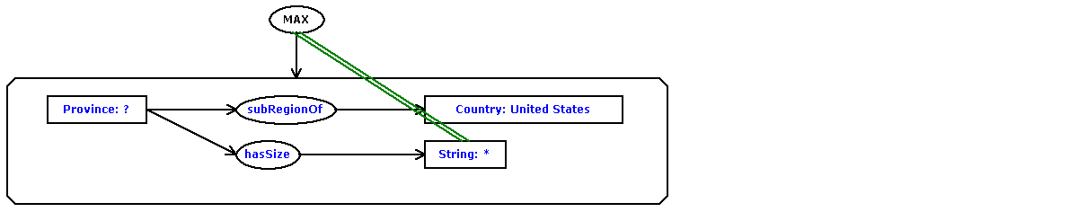
- What state is Niagra Falls located in?
- What state is the Filenes store located in?
- What store does Martha Stewart advertise for?
- What task does the Bouvier breed of dog perform?
- What tourist attractions are there in Reims?
- What type of bridge is the Golden Gate Bridge?
- What type of currency is used in Australia?
- What type of horses appear on the Budweiser commercials?
- What type of hunting are retrievers used for?
- What U.S. Government agency registers trademarks?
- What U.S. state's motto is "Live free or Die"?
- What university was Woodrow Wilson President of?
- What was the ball game of ancient Mayans called?
- What was the death toll at the eruption of Mount Pinatubo?
- What was the name of Jacques Cousteau's ship?
- What was the name of the movie that starred Sharon Stone and Arnold Schwarzenegger?
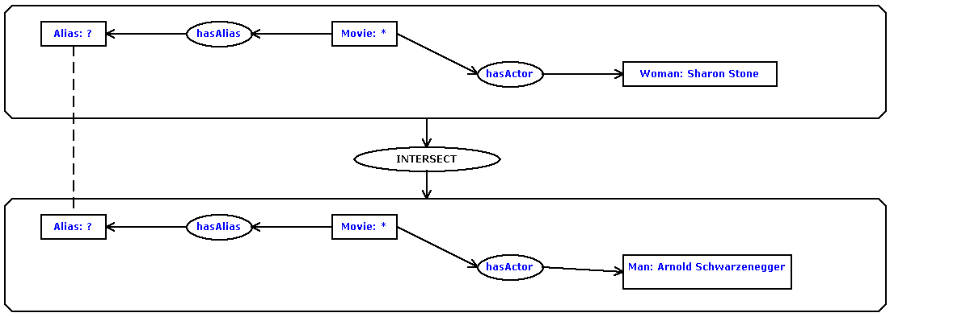
- What was the name of the sitcom that Alyssa Milano starred in with Tony Danza?

- What was the name of the Titanic's captain?
- What was the purpose of the Manhattan project?
- What was W.C. Fields' real name?
- What were Christopher Columbus' three ships?
- What were the names of the three ships used by Columbus?
- What wrestling star became "The Incredible Hulk"?
- What year did Hitler die?
- What year did the Titanic sink?
- What year did the Vietnam War end?
- What year did WWII begin?
- What year was the Avery Dennison company founded?
- What year was the Mona Lisa painted?
- What's the formal name for Lou Gehrig's disease?
- What's the most famous tourist attraction in Rome?
- What's the name of a golf course in Myrtle Beach?
- What's the name of a hotel in Indianapolis?
- What's the name of Pittsburgh's baseball team?

- What's the name of the actress who starred in the movie, "Silence of the Lambs"?
- What's the name of the star of the cooking show, "Galloping Gourmet"?
- What's the name of the Tampa newspaper?
- What's the name of the tiger that advertises for Frosted Flakes cereal?
- What's the name of the Tokyo Stock Exchange?
- What's the population of Biloxi, Mississippi?
- What's the population of Mississippi?
- What's the tallest building in New York City?

- Which comedian's signature line is "Can we talk"?
- Which mountain range in North America stretches from Maine to Georgia?

- Which U.S. President is buried in Washington, D.C.?
- Where are the headquarters of Eli Lilly?
- Where are the National Archives?
- Where are the Rocky Mountains?
- Where are the U.S. headquarters for Procter and Gamble?
- Where did Bill Gates go to college?
- Where did Hillary Clinton graduate college?
- Where did Howard Hughes die?
- Where did the Inuits live?
- Where did the Maya people live?
- Where did Woodstock take place?
- Where does Mother Angelica live?
- Where is Amsterdam?
- Where is Ayer's rock?
- Where is Basque country located?
- Where is Belize located?
- Where is Burma?
- Where is Glasgow?
- Where is Guam?
- Where is John Wayne airport?
- Where is Kings Canyon?
- Where is Las Vegas?
- Where is Logan International located?
- Where is McCarren Airport?
- Where is Melbourne?
- Where is Milan?
- Where is Ocho Rios?
- Where is Perth?
- Where is Prince Edward Island?
- Where is Rider College located?
- Where is Romania located?
- Where is Santa Lucia?
- Where is the bridge over the river Kwai?
- Where is the Danube?
- Where is the Euphrates River?
- Where is the Grand Canyon?
- Where is the Holland Tunnel?
- Where is the Isle of Man?
- Where is the Kalahari desert?
- Where is the location of the Orange Bowl?
- Where is the Louvre?
- Where is the Mall of the America?
- Where is the Mayo Clinic?
- Where is the Orinoco River?
- Where is the Orinoco?
- Where is the Shawnee National Forest?
- Where is the Smithsonian Institute located?
- Where is the Thomas Edison Museum?
- Where is the Valley of the Kings?
- Where is the volcano Mauna Loa?
- Where is the volcano Olympus Mons located?
- Where is Tornado Alley?
- Where is Trinidad?
- Where is Tufts University?
- Where is Venezuela?
- Where is Webster University?
- Where is Windsor Castle?
- Where was John Adams born?
- Where was Poe born?
- Where was Pythagoras born?
- Where was Tesla born?
- Where's Montenegro?
- Who assassinated President McKinley?
- Who created "The Muppets"?
- Who created the character James Bond?
- Who created the character of Scrooge?
- Who created the comic strip, "Garfield"?
- Who developed the Macintosh computer?
- Who discovered America?
- Who found Hawaii?
- Who invented the game Scrabble?
- Who is a German philosopher?
- Who is buried in the great pyramid of Giza?
- Who is Secretary-General of the United Nations?
- Who is the emperor of Japan?
- Who is the founder of the Wal-Mart stores?
- Who is the leader of India?
- Who is the monarch of the United Kingdom?
- Who is the president of Bolivia?
- Who is the Prime Minister of Canada?
- Who is the prophet of the religion of Islam?
- Who killed Caesar?
- Who killed Martin Luther King?
- Who manufacturers Magic Chef applicances?
- Who manufactures the software, "PhotoShop"?
- Who owns CNN?
- Who owns the St. Louis Rams?
- Who painted Olympia?
- Who played the teacher in Dead Poet's Society?
- Who portrayed Jake in the television show, "Jake and the Fatman"?
- Who provides telephone service in Orange County, California?
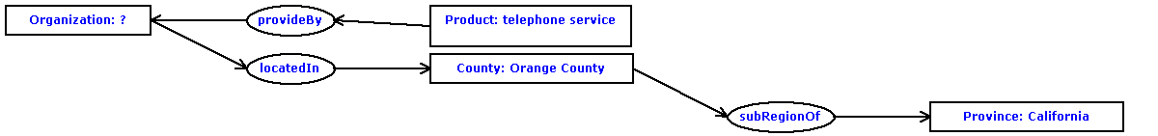
- Who shot Billy the Kid?
- Who started the Dominos Pizza chain?
- Who was Charles Lindbergh's wife?
- Who was Darth Vader's son?
- Who was Samuel Johnsons's friend and biographer?
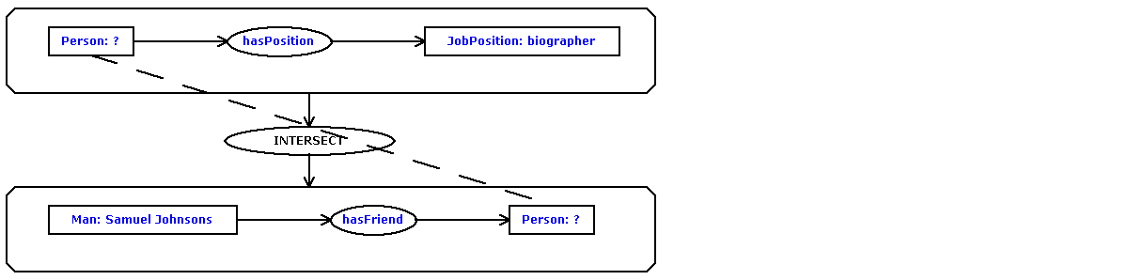
- Who was the abolitionist who led the raid on Harper's Ferry in 1859?

- Who was the architect of Central Park?
- Who was the author of the book about computer hackers called "The Cuckoo's Egg: Tracking a Spy Through the Maze of Computer Espionage"?
- Who was the founding member of the Pink Floyd band?
- Who was the oldest U.S. president?
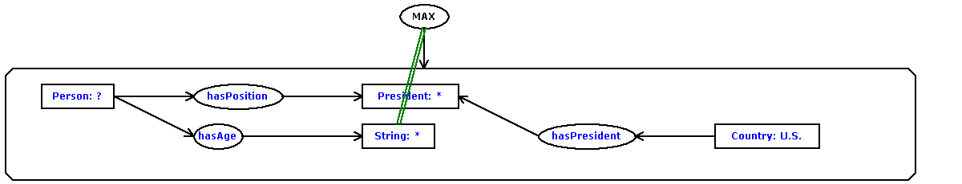
- Who was the president of Vichy France?
- Who was the tallest U.S. president?
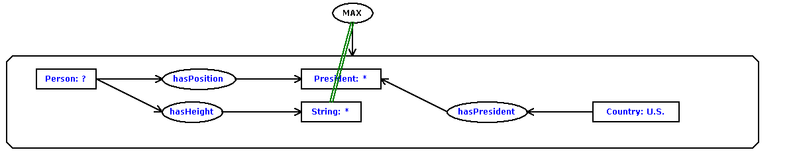
- Who won Ms. American in 1989?
- Who won the nobel prize in literature in 1988?
- Who won the rugby world cup in 1987?
- Who won the Superbowl in 1982?
- Who wrote "An Ideal Husband"?
- Who wrote "The Pit and the Pendulum"?
- Who wrote "The Scarlet Letter"?
- Who wrote the book, "Huckleberry Finn"?
- Who wrote the book, "Song of Solomon"?
- Who wrote the book, "The Grinch Who Stole Christmas"?
- Who wrote the hymn "Amazing Grace"?
- Who wrote the song, "Boys of Summer"?
- Who wrote the song, "Silent Night"?
- Who's the lead singer of the Led Zeppelin band?
- When did Aldous Huxley write, "Brave New World"?
- When did Amtrak begin operations?
- When did Elvis Presley die?
- When did Muhammad live?
- When did the American Civil War end?
- When did the California lottery begin?
- When did the Carolingian period begin?
- When did the Chernobyl nuclear accident occur?
- When did the Hindenberg crash?
- When did the royal wedding of Prince Andrew and Fergie take place?

- When did World War I start?
- When is Bastille Day?
- When is Boxing Day?
- When is hurricane season in the Caribbean?
- When is the Tulip Festival in Michigan?
- When was "the Great Depression"?
- When was Algeria colonized?
- When was Babe Ruth born?
- When was Beethoven born?
- When was Hurricane Hugo?
- When was John D. Rockefeller born?
- When was Lyndon B. Johnson born?
- When was Microsoft established?
- When was Nostradamus born?
- When was Rosa Parks born?
- When was the Brandenburg Gate in Berlin built?
- When was the De Beers company founded?
- When was the Hoover Dam constructed?
- When was the movie, Caligula, made?
- When was the NFL established?
- When was the San Francisco fire?
- When was the Triangle Shirtwaist fire?
- When were William Shakespeare's twins born?
- How big is Australia?
- How big is the Electoral College?
- How did Bob Marley die?
- How far away is the moon?
- How far is it from Denver to Aspen?
- How far is Pluto from the sun?
- How fast can a Corvette go?
- How hot is the core of the earth?
- How large is Missouri's population?
- How long did Rip Van Winkle sleep?
- How long would it take to get from Earth to Mars?
- How many casinos are in Atlantic City, NJ?
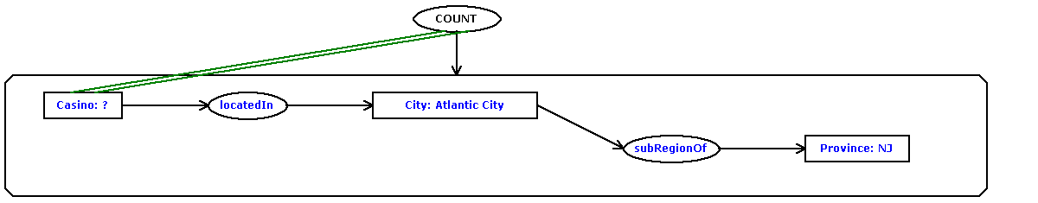
- How many counties are in Indiana?

- How many films did Ingmar Bergman make?

- How many Great Lakes are there?

- How many islands does Fiji have?

- How many miles is it from London, England to Plymouth, England?
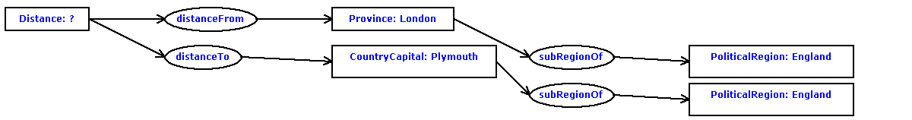
- How many people die from snakebite poisoning in the U.S. per year?

- How many people live in Chile?
- How many Stradivarius violins were ever made?

- How many Superbowls have the 49ers won?

- How many zip codes are there in the U.S.?

- How much in miles is a ten K run?
- How much money does the Sultan of Brunei have?
- How much was a ticket for the Titanic?
- How tall is Kilimanjaro?
- How tall is the Gateway Arch in St. Louis, MO?
- How tall is the Sears Building?
- How wide is the Atlantic Ocean?
- How wide is the Milky Way galaxy?
- In Poland, where do most people live?

- In what area of the world was the Six Day War fought?
- In what book can I find the story of Aladdin?
- Italy is the largest producer of what?

- Mercury, what year was it discovered?
- Name a ballet company Mikhail Baryshnikov has danced for?
- Name a film in which Jude Law acted.
- Name a Gaelic language
- Name a movie that the actress, Sandra Bullock, had a role in.
- Name a novel written by John Steinbeck.
- Name a tiger that is extinct?
- Name an American made motorcycle
- Name an American war plane?
- Name an art gallery in New York.
- Name one of the Seven Wonders of the Ancient World
- Tell me what city the Kentucky Horse Park is near?
- About how many soldiers died in World War II?

- Can you give me the name of a clock maker in London, England?
- For what disease is the drug Sinemet used as a treatment?
- George Bush purchased a small interest in which baseball team?

5 CÂU TRUY VẤN TỰ SƯU TẦM
What dam in U.S. are higher than Dworshak?

What dam in U.S. are higher than 220 meters?

What suspension bridge is longer than 1000 meters in the U.S.?
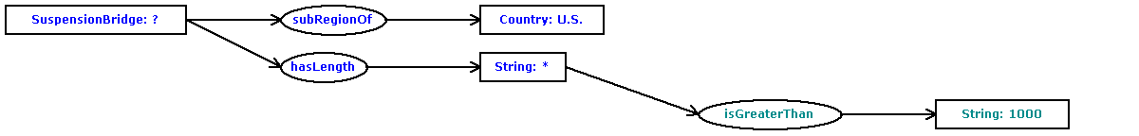
What suspension bridge in the U.S. is longer than Tacoma Narrows?
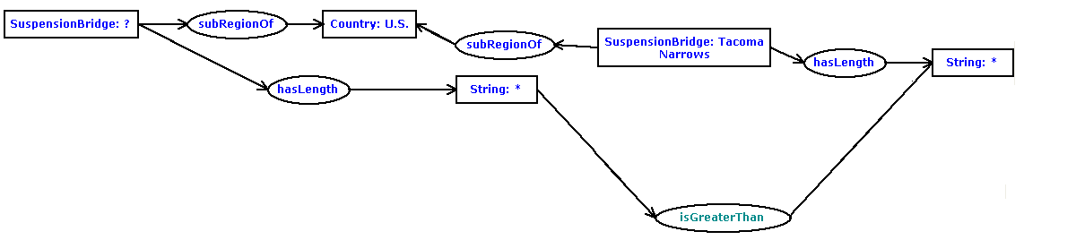
How many dams in U.S. are higher than 220 meters?


