 

Reg No: DA201 Vat. XZX#245 [www.thedailystar.net](http://www.thedailystar.net) Jumada Al-Awwal 16,1446 Ogrohayon 4,1431 16 P Max: TK 15.00

DHAKA TUESDAY NOVEMBER 19, 2024

# 24 factories of Beximco shut amid liquidity crunch

# Amid a severe liquidity crisis and unpaid labour dues, troubled Beximco Group's Shinepukur Ceramics recently halted operations, bringing the total number of closed ventures of the group to 24. The group's inability to open new letters of credit (LCs) for raw material imports has forced its factories to halt production since August this year following the political changeover.

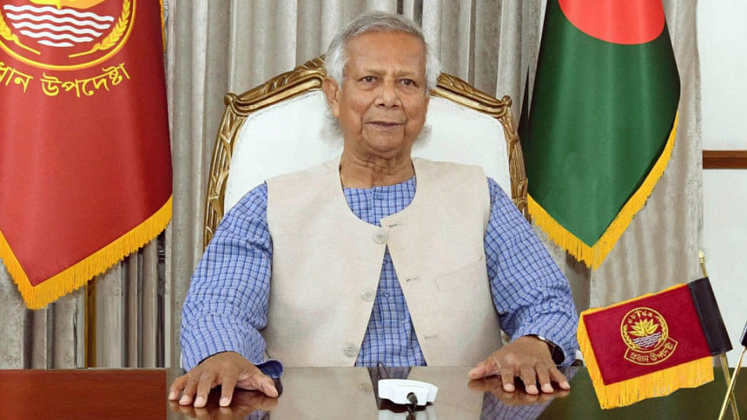

**Dhaka to pursue extradition of Hasina, Prof Yunus tells The Hindu**

# Titumir college students boycott classes, demand university status

# In the morning, the students gathered on the campus, awaiting a response from the government regarding their demand.

# https://tds-images.thedailystar.net/sites/default/files/styles/very_big_1/public/images/2024/11/19/ff6f8088-772f-4ba2-8797-3d2748bfda0e.jpg

Bangladesh will pursue the extradition of ousted Prime Minister Sheikh Hasina from India, Chief Adviser Professor Muhammad Yunus told The Hindu. He however admitted that he had no objection to her party, Awami League, contesting the elections. In an exclusive interview with The Hindu at his residence in Dhaka, Yunus spelt out his vision for ties with India and plans for reform. His interview was released in online version of the Indian daily today. Prof Yunus defended his government's record in 100 days since it was formed and called reports over the rise of radicalism and safety of the nation's Hindus and other minorities "propaganda", which has led to sharp criticism from India and US president-elect Donald Trump.

World Toilet Day 2024

**Women should not have to struggle with a toilet crisis**

World Toilet Day, observed on November 19 each year, highlights the global sanitation crisis. In countries like Bangladesh, it is essential to address how this issue disproportionately affects women in the workforce, particularly those who face long commutes.

# Ex-food minister Qamrul on 8-day remand

# **A Dhaka court today placed former food minister Qamrul Islam on an eight-day remand in a murder case filed over the death of trader Abdul Wadud during quota reform protests in Dhaka's New Market area on July 19.**

# Hong Kong jails 45 democracy activists in landmark national security trial

**Hong Kong's High Court on Tuesday sentenced 45 pro-democracy activists to jail terms of up to 10 years in a landmark national security trial that has damaged the city's once feisty democracy movement and drawn international condemnation.**

# 4 killed as bus, pickup collide in Tangail

**Four people were killed in a head-on collision between a bus and a pickup truck in Malauri area of Tangail's Madhupur upazila early today.** The identities of the deceased could not be known immediately, said Rasel Ahmed, officer-in-charge (Investigation) of Madhupur Police Station.