**Charming Latinamerica**

**9 days 9天**

**迷人的拉丁美洲**

**Confirmed departure dates 2019: Feb 2-10, Abr 5-13, Jun 1-9, Sep 29-Oct 7**

**确认出发日期 2019:  2月2日至10日 - 4月5日至13日 - 6月1日至9日 - 9月29日至10月7日**

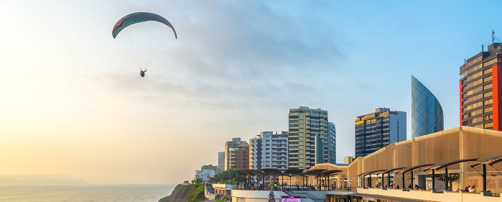**Planned itinerary**

Day 1 Lima Arrival

Arrival at the Jorge Chavez airport in Lima, meet and greet by a representative of our company, who will be waiting for you with a sign with your name. Transfer to the hotel and check in. Free day to rest or book any optional activity.

第1天LIMA抵达

利马。 到达利马Jorge Chaves机场，由我们公司手举带有您姓名牌的代表人员欢迎和迎接您。前往酒店办理入住。

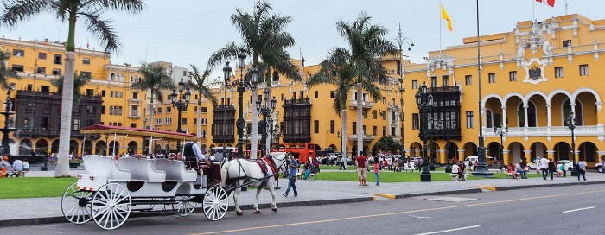

Day 2 LIMA - CITY TOUR - CUSCO

Breakfast at the hotel. Between 9:10 hours and 9:40 hours, we will transfer you to Lima's Historic Downtown in a guided tour along the most important sites of Lima. We will visit the Monumental Centre, well known for its colonial architecture, traditional balconies and colonial mansions. Plaza Mayor is located there and it is surrounded by the Government Palace, the Cathedral, the Archbishop's Palace and the Municipality of Lima. Then, we will visit the Convent of San Francisco, where you can see cloisters and catacombs from the Colonial era. The tour continues through the traditional, residential and commercial areas of Lima and it ends with a spectacular panoramic view of the Pacific Ocean and the beaches of Miraflores.

Lunch

Transfer to the airport in order to take your flight to Cusco city. Upon arrival, our staff will be waiting at the airport to transfer you to your hotel.

Meals: B L

第2天：LIMA  - 城市之旅 - CUSCO

在酒店享用早餐。 09:00到09:40之间我们将会带领你前往利马历史城市中心，由导游带领参观游览利马最重要的景点。我们将参观纪念碑中心，由其殖民建筑而闻名，传统的阳台和殖民宅邸。大广场坐落于那里，并且被政府宫殿、大教堂、Archbishop宫殿还有利马市政府所包围。然后我们将参观圣弗朗西斯科修道院，在那里你可以看到殖民时期的修道院和地下墓穴。此次旅程将继续沿着利马的传统区域、住宅区和商业区进行，在太平洋无与伦比的全景风光与Miraflores沙滩上画上句号。

午餐

在规定的时间带您前往机场乘坐飞机前往库斯科城。到达后，我们的员工将会在机场等待并带您前往酒店

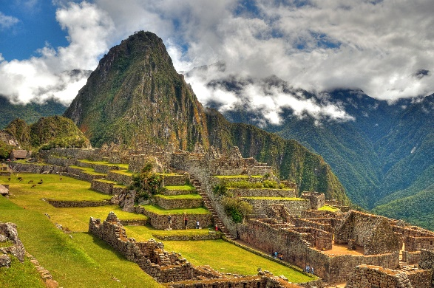Day 3 TOUR TO MACHU PICCHU

Breakfast at the hotel. Transfer to the train station to begin the excursion to the Sacred City of Machu Picchu declared by UNESCO as Cultural Heritage for Humanity and chosen as one of the new seven wonders of the world. Once we reach the archaeological site we will begin a guided tour around the citadel that will last about 2 hours. During the tour you will find temples, palaces, squares and streets of military and agricultural areas. The beauty of Machu Picchu is exalted by the extraordinary scenery where it is located. Around the citadel, the National Reserve covers an area of 32.500 hectares and includes a constellation of archaeological monuments which we believe that were built as part of the complex of Machu Picchu and not in an isolation way. At the arranged time with the guide, we will descend to Aguas Calientes town, where we will have included the lunch. Return to Cusco. Upon arrival, reception and transfer to your hotel.

Meals: B L

第3天   马丘比丘之旅

在酒店享用早餐。前往火车站开启被联合国教科文组织宣布为人类文化遗产以及世界新七大奇迹的圣谷马丘比丘之旅。一旦我们到达考古遗址，我们将由导游带领参观城堡周围，将持续大于2小时。在旅程中你将会看到寺庙、宫殿、广场还有军事以及农业地区。马丘比丘的美被其所处地区无与伦比的风景而进一步提升。在城堡周围，自然保护区覆盖了32.500公顷并且包括了一系列的考古遗迹，我们相信他们是作为马丘比丘建筑群的一部分而建成，并不只是孤立的。在安排的时间里跟随导游，我们接着前往阿瓜斯卡连特斯镇，含一顿午餐。然后返回库斯科。到达后，由我们接到并送您前往酒店。

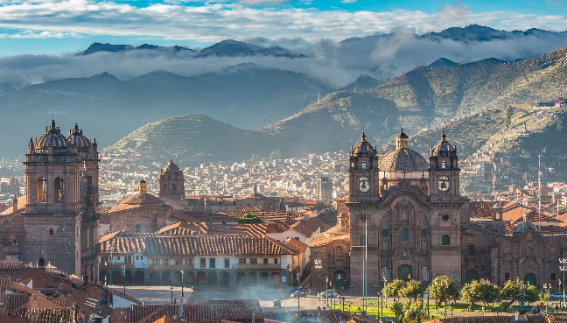

Day 4 CUSCO CITY TOUR & NEARBY RUINS / BOGOTA  Night time in "Andrés Carne de Res D.C"

Breakfast at the hotel.

Pick up you from your hotel to begin our city tour visiting the Cathedral and de Convent of Santo Domingo, well known as the Temple of the Sun or Q'oricancha. Likewise, we will visit the surrounding archaeological sites of Sacsayhuaman, Q'enco, Puca Pucara and Tambomachay.

Lunch. Transfer to Cusco´s airport.

Flight to Bogotá. Arrival at El Dorado airport from Bogotá, welcome and assistance by a company representative, who will be waiting for you with a sign with your name . Transfer to the hotel and check in.

Transfer to Andrés Carne de Res, the right place if you want to spend a night out with the best atmosphere in town. The place will take you on an unforgettable night with its decoration, amability, variety of drinks and music. The place also offers the best quality local food that you can taste while having fun.

Meals: B L

第4天  库斯科-城市之旅&附近遗迹  / 波哥大 . AndrésCarnede Res派对

在酒店享用早餐。在规定的时间带您前往机场乘坐飞机前往库斯科城。到达后，我们的员工将会在机场等待并带您前往酒店。

在13:00到13:30之间，我们将会来酒店接您，开始我们的城市之旅，参观大教堂和圣多明哥修道院，以太阳庙或Q'oricancha而闻名。同时，我们还将参观周围的考古遗址Sacsayhuaman, Q'enco, Puca Pucara和Tambomachay。

午餐. 转机到机场

到达机场. 由我们公司一位拿着你姓名牌的代表来欢迎与接待你. 接机送往酒店.

AndrésCarnede Res派对. 这里会用它的装饰、服务和各种不同的酒水音乐让你体验一个难以忘怀的夜晚。同时这里也提供高品质的食物。

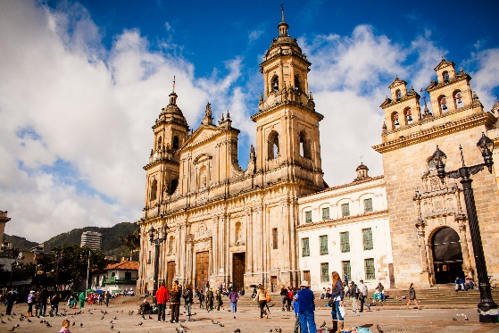

Day 5 BOGOTA Salt cathedral - City Tour with Monserrate

Breakfast at the hotel.

8:00 am We will exit Bogotá through the savannah towards Zipaquirá 40 km away; a town of high indigenous value dominated by the ancient Muisca cacique: Zipa. We will enter the Salt Cathedral, an architectural work built inside the salt mines at 180 meters deep. It is a unique place that has become a religious center and is one of the most famous Catholic sanctuaries in the country that commemorates Jesus Christ life, attracting pilgrims and tourists. At the end of the visit there is a brief stop in Zipaquirá´s Square to freely explore its most representative streets.

Lunch

In the afternoon, discover the most emblematic places of Bogotá, the capital of Colombia. A big, diverse and multicultural city. We will start walking La Candelaria, the historical and cultural center of Bogotá through Bolívar´s square to see the main cathedral, the Liévano Palace, the Archbishop's Palace, the Capitol, the Communards house, the 20th July house, the Gold Museum (closed on Mondays), the Coin house and Botero museum (closed on Tuesdays). We will end rising Monserrate´s hill, located at 3152 meters above sea level to appreciate the best view of the city, at the top it lodges The fallen Lord sanctuary, a famous catholic place for pilgrims and religious people.

Meals: B L

第5天  波哥大  盐教堂 - 波哥大蒙塞拉特城市之旅

在酒店享用早餐。

8:00 盐教堂距离波哥大约一个小时距离，建在Zipaquira的盐矿里，是一个独一无二的地方。这里也是国家的宗教中心，为了纪念耶稣，吸引着朝圣者和游客。这一建筑工程是在180米深的房子里建造的，是该地区和矿工们的鬼斧神工;最后一站是Zipaquira´s主要广场。

午餐

发现波哥大最具象征意义的地方，让自己从蒙塞拉特开始沉浸在它的历史和美丽的山水画中。我们将在旅馆大厅集合，开车去市中心。我们将从参观波哥大历史文化中心“Candelaria”开始，参观共和文化广场黄金博物馆(周一闭馆)、波特罗博物馆入口(周二闭馆)。走在玻利瓦尔广场，参观主教堂、大主教的宫殿、总统府、国会大厦、“comuneros”房子和7月20日博物馆。我们将在蒙塞拉特山结束旅程,位于海拔3152米的高度，欣赏城市、保护区和,宗教朝圣地最美的风景。

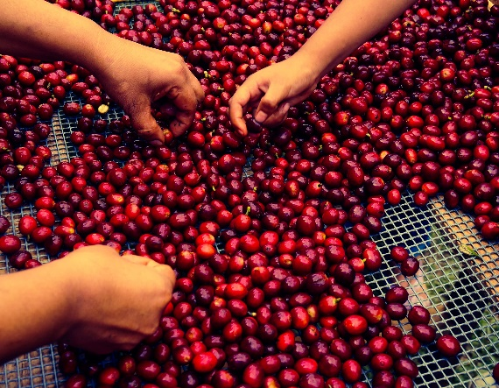

Day 6 BOGOTÁ - PEREIRA Flight to Pereira - Coffee tour - Bath therms

Breakfast at the hotel.

Hotel / airport transfer: At agreed hour, assistance and transfer by the driver to the airport.

Arrival at Matecaña airport from Pereira, welcome and assistance by a company representative, who will be waiting for you with a sign with your name . Transfer to the coffee farm.

Lunch

Coffee tour at Finca del Café, located in Santa Rosa municipality with an average height of 1,900 meters above sea level in soils of volcanic origin of the Central Andean mountain range. In this beautiful place it is said that a coffee tastes much better when you live the experience of the farm.

Visit to Santa Rosa de Cabal thermals, they are famous for their thermal pools and their cascade of cold water. You will enjoy a relaxing thermal bath surrounded by an impressive waterfall, flowers and birds. It is ideal for people of all ages.

22:00 Transfer to hotel in Pereira.

Meals: B L

第6天  波哥大 - 佩雷拉  飞往佩雷拉 - 咖啡之旅 - 温泉

在酒店享用早餐。

酒店接送机, 在约定的时间，由司机送机前往机场. 到达机场. 由我们公司一位拿着你姓名牌的代表来欢迎与接待你. 转移到咖啡农场

午餐

里萨拉尔达咖啡之旅. Finca del Café位于平均海拔1900米的Santa Rosa市，安第斯山脉中部的天然火山土壤中。据说在这个美丽的地方，咖啡品尝起来比在农场里更美味。游览并享受圣罗莎德卡瓦尔温泉浴。22:00 接机送往酒店

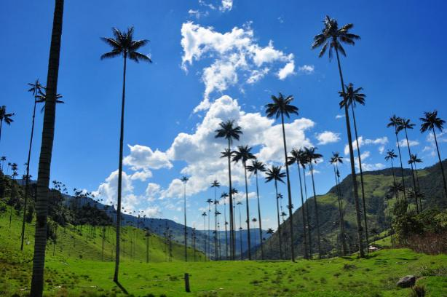

Day 7 PEREIRA Cocora Valley, Salento and Filandia

Breakfast at the hotel.

The Cocora Valley is a natural landscape located in a mountainous valley of the central mountain range of the Colombian Andes, specifically in the Department of Quindío, making part of the National Park natural Los Nevados. It is the main home of the national Tree of Colombia, the wax palm of Quindío (Ceroxylon quindiuense), as well as a great variety of flora and fauna, much of it in danger of extinction and protected under the status of Natural National Park. The valley, as well as the nearby towns of Salento and Filandia, located among the main tourist destinations of Colombia.

Meals: B L

第7天  佩雷拉 科科拉山谷、萨伦托和芬兰迪亚

在酒店享用早餐。

科科拉山谷是一处自然风景，位于哥伦比亚安第斯山脉中心山脉一个多山的山谷中，确切来说是在金迪奥省，也是Nevados自然国家公园的一部分。这里是哥伦比亚树木的主要家园，比如金迪奥棕榈蜡，还有各种不同的植物群和动物群，它们中的大多数都属于濒危物种，被这个国家公园所庇护。这个山谷同时毗邻 Salento 镇和Filandia镇，是哥伦比亚最主要的旅游目的地之一。

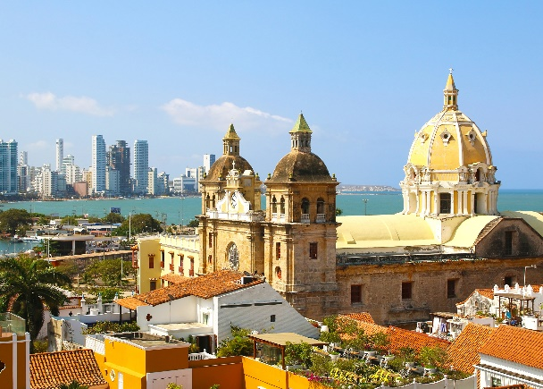

Day 8 PEREIRA - CARTAGENA  Flight to Cartagena - City tour in Cartagena

Breakfast at the hotel. At the arranged time, transfer by the driver to the airport.

Arrival at Rafael Nuñez airport from Cartagena, welcome and assistance by a company representative, who will be waiting for you with a sign with your name . Transfer to the hotel and check in.

Lunch

14:00 City tour, Cartagena is a city rich in history and culture. Regardless of the street you are on, you can find a significant anecdote in the history of this beautiful city. The best of all is that you can travel it in a very short time and nourish yourself with knowledge about what happened in its streets and buildings. In the City Tour of Cartagena you will visit this heroic city guided by an expert in history starting in the bay of Cartagena, then you will make a panoramic tour on the Island of Manga, continuing to the San Felipe de Barajas castle, a great military work built during the colonial times. The visit continues in the historic and walled city of Cartagena, taking a walk through the most important vaults, streets and squares of the city.

Meals: B L

第8天  佩雷拉 - 卡塔赫纳   飞往卡塔赫纳 - 卡塔赫纳城市之旅

在酒店享用早餐。

酒店接送机. 由我们公司一位拿着你姓名牌的代表来欢迎与接待你. 接机送往酒店.

午餐

14:00 卡塔赫纳城市之旅: 卡塔赫纳是一个历史和文化丰富的城市。无论在哪条街，都可以找到这个美丽城市历史的惊人轶事。最重要的是，你可以在很短的时间了解并熟知这些轶事，同时了解在这些街道和建筑物身上发生的故事。在卡塔赫纳城市之旅中，我们将在一位历史专家的陪同下参观这座英雄城市，从卡塔赫纳湾（Bay of Cartagena）起步，然后在Manga进行全景游览，接着继续前往巴拉哈斯城堡的圣费利佩（San Felipe of Barajas），这是殖民时期建造的伟大军事工程。然后继续游览历史悠久的围墙中心，观看城市的拱顶、街道和大广场。

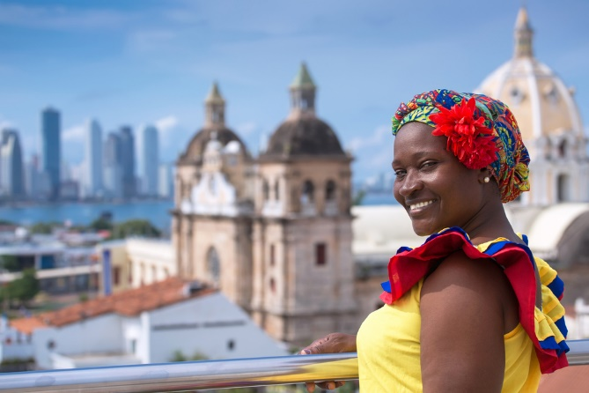

Day 9 CARTAGENA Breakfast at the hotel. At the arranged time, transfer by the driver to the airport.

Meals: B

9天  卡塔赫纳 在酒店享用早餐。 酒店接送机

**End of our services** **服务结束**

You can take extensions to continue living an unforgettable experience. 你可以通过更多的夜晚、参加更多的活动来继续这段难忘的经历

**Includes**

Flight tickets in economic class: Lima - Cusco - Bogota - Pereira - Cartagena

Guide in chinesse

Transfers airports / hotels / airports  
Hotel 1 night Lima, 2 nights Cusco, 2 nights Bogotá, 2 nights Pereira, 1 night Cartagena.

8 breakfasts: American breakfast

7 lunchs: Local menus.   
Activities in Lima: City tour

Activities in Cusco: City tour, nearby ruins and Machupicchu

Activities in Bogotá: Salt cathedral, city tour, Night time in Andres Carne de Res

Activities in the coffee region: Coffee tour, natural thermals, Cocora Valley, Salento and Filandia.

Activities in Cartagena: City tour

Medical assistance card 9 days  
**包含**

机票: 利马 - 库斯科 - 波哥大 - 佩雷拉 - 卡塔赫纳

中文指南

接机送往酒店/酒店送机

酒店   1晚利马, 2晚库斯科, 2晚波哥大, 2晚佩雷拉, 1晚卡塔赫纳

8早餐: 美式早餐

7午餐: 当地菜单

利马的活动: 城市游

库斯科的活动:  城市游, 库斯科-城市之旅&附近遗迹

波哥大的活动：盐教堂, 波哥大蒙塞拉特城市之旅, AndrésCarnede Res派对.

咖啡区的活动: 咖啡之旅,  洗澡, 科科拉山谷、萨伦托和芬兰迪亚

卡塔赫纳的活动: 城市游

医疗救助卡9天

**Does not include**

International flight ticket

Meals not described  
Volunteer hotel insurance to pay at the hotel  
Suggested activities are not included in the program price  
Not stipulated or personal expenses and tips

**不包含**

国际机票

未提及餐食

自愿支付酒店保险

推荐自选活动费用不包含在行程总价中

未规定的个人消费和小费

**Price per person in USD (Min 2 people)**

**人均价格 - 对至少两人有效**

**Confirmed departure dates 2019: Feb 2-10, Abr 5-13, Jun 1-9, Sep 29-Oct 7**

**确认出发日期 2019:  2月2日至10日 - 4月5日至13日 - 6月1日至9日 - 9月29日至10月7日**

|  |  |  |  |  |
| --- | --- | --- | --- | --- |
| Hotel | Triple 三人 | Double 两人 | Simple 一人 | Child (2-9) 儿童 |
| 4* | 3.960 | 4.030 | 4.770 | 3.470 |
| 4** | 3.945 | 4.050 | 4.800 | 3.490 |
| 5* | 4.425 | 4.655 | 6.110 | 3.810 |

**Optional Extensions**

**自选活动**

**5 days 5天**

**Argentine Essence**

We suggest to book it before Charming Latin america

我们建议在迷人的拉丁美洲之前预订

Day 1 Buenos Aires-  Arrival

Arrival at the Ezeiza airport in Buenos Aires, meet and greet by a representative of our company, who will be waiting for you with a sign with your name. Transfer to the hotel and check in. Free day to rest or book any optional activity.

第1天 布宜诺斯艾利斯, 到达

到达机场. 由我们公司一位拿着你姓名牌的代表来欢迎与接待你. 接机送往酒店并办理入住。第一天自由活动，休息，或者可以预定自选活动。

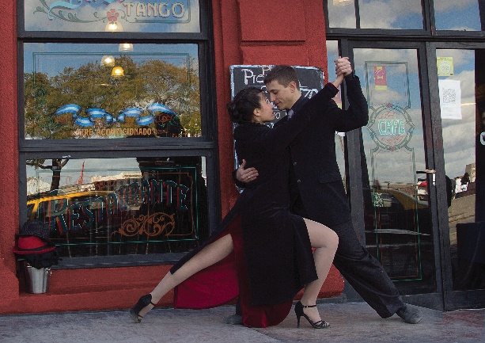Day 2 Buenos Aires- City tour - Boca Stadium and museum - Tango show with dinner

Breakfast at the hotel. In the morning, city tour visiting Retiro neighborhood. Palermo neighborhood. Forests of Palermo (Galileo Galilei Planetarium, Monument to the Magna Carta and the Four Argentine Regions) .- Neighborhood of Recoleta (National Museum of Fine Arts, Ntra. Sra. Del Pilar Church, Recoleta Cemetery) 9 de Julio Av. - Colón theatre - Obelisk - Av. Diag. Roque Saenz Peña - Mayo square, Metropolitan Cathedral, neighborhood of San Telmo, Lezama park. La Boca neighborhood with walk by Caminito and artisans gallery, free time for photographs, Port of La Boca and Puerto Madero.

Lunch

In the afternoon, visit to Boca museum is a thematic football museum dedicated to the history and the characters linked to the Boca Juniors Athletic Club. It was founded in 2001 and is located under the stands of the team's stadium, the so-called Bombonera. Boca Juniors is synonymous with passion, triumphs, joy and celebrations. As one of the most important and famous clubs in the world, we are the ambassadors of Argentine football and its best exponent. The Museum offers each visitor the unique opportunity to relive the rich history of over 100 years of the Club through the tour of the various multimedia exhibits and the most prestigious trophies obtained. Enjoy an unforgettable tour of the historic stadium after visiting the Museum La Bombonera, located in the heart of La Boca, is the pride and home of the entire village of Boca. The festivities and the Olympic laps have been recorded on the field.

Meals: B L

1. 布宜诺斯艾利斯, 城市游, 博卡体育场和博物馆，tango秀晚餐

在酒店享用早餐。早晨，城市之旅，游览Retiro和Palermo街区。Palermo森林（伽利略伽利莱天文馆，大宪章纪念碑和四个阿根廷地区）- Recoleta街区（国家美术博物馆、Ntra.Sra.Del Pilar教堂、Recoleta公墓）7月9日大道-科隆大剧院-方尖碑- Diag. Roque Saenz Peña大道-五月广场、大都会教堂、San Telmo街区、Lezama公园。博卡街区，步行可到达Caminito和工匠画廊，有空闲时间可以拍照，博卡港和Madero港。

午餐

下午，参观博卡博物馆。这是一个足球主题的博物馆，致力于历史与博卡青年运动员俱乐部相关的人物。它成立与2001年，位于球队体育场的展台下，即所谓的Bombonera。博卡青年是激情、胜利、欢乐和庆祝的代名词。作为世界上最重要以及最著名的俱乐部之一，我们是阿根廷足球的大使和代表。博物馆给予每一位访问者提供了独特的机会，通过参观各种多媒体展览和获得的最负盛名的奖杯，重温百年俱乐部的丰富历史。 参观位于博卡中心的Bombonera博物馆后，您可以享受令人难忘的历史体育场之旅，这是整个博卡村的骄傲和家园。 在赛场上记录了庆祝活动和奥运会圈数。

餐食：早餐、午餐

Day 3 BUENOS AIRES - IGUAZÚ - Dinner show

Breakfast at the hotel. At the arranged time, transfer by the driver to the airport.

Arrival at Iguazú airport, welcome and assistance by a company representative, who will be waiting for you with a sign with your name . Transfer to the hotel and check in.

At night time, transfer to the dinner show; a sensational evening to enjoy a performance that shows the culture and tradition of Brazil and other Latin American countries with the most representative dances and music, from tango to samba. Here you can enjoy a free buffet with Brazilian dishes.

Meals: B D

第3天 布宜诺斯艾利斯-伊瓜苏-晚餐秀

在酒店享用早餐。在安排的时间，由司机送往机场。到达伊瓜苏机场，由我们公司手举您姓名牌的代表人员欢迎与协助。送往酒店，办理入住。

在晚上，我们将接您前往晚餐秀，这是一场令人震撼的表演，展示了巴西的文化和传统，还有拉美其他国家最具代表的音乐和舞蹈，探戈与桑巴。在这里你可以享用自助餐和巴西美食。

餐食：早餐、晚餐

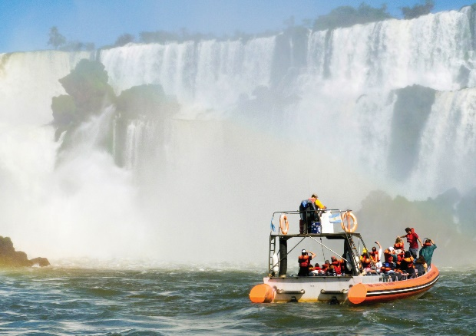

Day 4 IGUAZÚ - Iguazú Falls

Breakfast at the hotel. Departure to Iguazú Falls, chosen as World Heritage by UNESCO and also as one of the 7 Natural Wonders of the World. This natural jewel is located in the Natural Park of the Iguazu Falls, right on the border between Argentina and Brazil. These falls consist of 275 waterfalls up to 80 m high. You can take boat rides under the jumps and hikes on trails appreciating some animals of the subtropical jungle. The Devil's Throat, being the highest jump (80 m) and the highest flow, is one of the best show, which can be enjoyed in all its majesty from only 50 m.

Meals: B

第4天：伊瓜苏-伊瓜苏瀑布

在酒店享用早餐。出发前往伊瓜苏瀑布，被联合国教科文组织选为世界遗产，也是世界7大奇迹之一。这颗大自然的珍宝位于国家公园的伊瓜苏瀑布，在阿根廷和巴西的边界。这些瀑布由275个80米高的瀑布组成。你可以乘坐跳船和徒步行走欣赏动物和亚热带丛林。恶魔之喉，最高的跳点（80米）和最高的流量，也是最好的景观之一，你可以仅50米远的地方欣赏它的壮美。

Day 5 IGUAZÚ

Breakfast at the hotel. At the arranged time, transfer by the driver to the airport.

Meals: B

第5天 伊瓜苏

在酒店享用早餐。在安排的时间由司机送往机场。

餐食：早餐

|  |  |  |  |  |
| --- | --- | --- | --- | --- |
| Hotel | Triple 三人 | Double 两人 | Simple 一人 | Child (2-9) 儿童 |
| 4** | 2.070 | 2.215 | 2.910 | 1.850 |

**Includes**Flight tickets in economic class: Bueno Aires - Iguazu - Buenos Aires

Guide in chinese

Transfers airports / hotels / airports  
Hotel 2 Buenos Aires, 2 nights Iguazú

4 breakfasts: American breakfast

1 lunch: Local menus.

2 dinner show  
Activities in Buenos Aires: City tour, Boca Stadium and museum - Tango show with dinner

Activities in Iguazu: Iguazú Falls, Dinner show

Medical assistance card 5 days  
**包含**

经济舱机票：布宜诺斯艾利斯 - 伊瓜苏 - 布宜诺斯艾利斯

中文指南

接机送往酒店/酒店送机

旅馆   2布宜诺斯艾利斯, 2伊瓜苏

4早餐: 美式早餐

1午餐: 当地菜单

2 晚餐秀

布宜诺斯艾利斯的活动:  城市游，博卡体育场和博物馆, Tango秀与晚餐

伊瓜苏的活动：伊瓜苏瀑布，晚餐秀

医疗救助卡5天

**Does not include**Meals not described  
Volunteer hotel insurance to pay at the hotel  
Suggested activities are not included in the program price  
Not stipulated or personal expenses and tips

**不包含**

国际 机票

未提及餐食

自愿支付酒店保险

推荐自选活动费用不包含在行程总价中

未规定的个人消费和小费

**Basic Panamá**

**2 days 2天**

**基本的巴拿马**

We suggest to book it after Charming Latin america

我们建议在魅力拉丁美洲之后预订

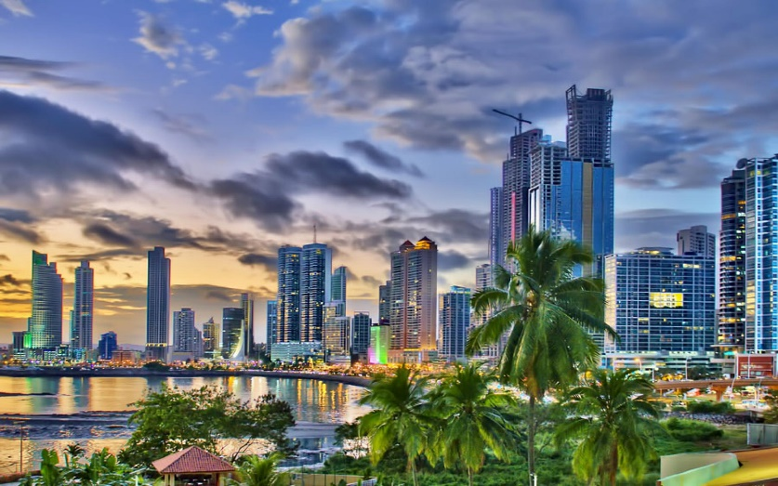

Day 1 PANAMA CITY - Arrival - City tour - Canal - Dinner and folklore show

Arrival at the airport in Panama city, meet and greet by a representative of our company, who will be waiting for you with a sign with your name.

Straight to start the city tour, visit the ruins of Old Panama, destroyed by the pirate Morgan in the year 1671, then visit the old town where you can enjoy the Metropolitan Cathedral, the National Theater, Plaza Simón Bolivar where you can appreciate the Colonial art of the Old City. Then we visit the Miraflores locks, where you will observe the operation and transit of Navios by the Panama Canal. End in the fort of Amador and Causeway where you will have the opportunity to buy in the tax free shops and enjoy a lunch in the restaurant Al Dente.

Hotel check in.

At night time, pick up at the hotel to take dinner and folklore show; the show has the best of Panamanian culture and some of the most attractive folcloricas heritages in Latin America. You can enjoy traditional dances with colorful costumes accompanied by a rich Panamanian food. The "skirt" cotton dress made entirely by hand complementing with precious jewels which is exhibited while dancing.

Meals: B L D

第1天  巴拿马城 - 到达 - 城市游 - 运河 - 晚餐以及民俗秀

到达机场. 由我们公司一位拿着你姓名牌的代表来欢迎与接待你.

参观1671年被海盗Morgan摧毁的巴拿马La Vieja遗址，然后参观老城，在那里你可以欣赏到大都会大教堂、国家剧院和西蒙玻利瓦尔广场，在那里你可以欣赏到老城的殖民艺术。然后我们参观Miraflores船闸，在那里你会看到海军通过巴拿马运河的运作和过境。参观Amador和Causeway，在那里你将有机会在免税商店购无和在al dente餐厅享受午餐。

酒店入住。

该演出拥有巴拿马最好的文化和拉丁美洲一些最具吸引力的民俗文化遗产。你可以享受传统的舞蹈，欣赏丰富的服装搭配，品尝丰富的巴拿马美食。“裙子”，棉质连衣裙，由全手工制成，附着着珍贵的珠宝，这些也都会在舞蹈表演时展出。

Day 2 PANAMA CITY

Breakfast at the hotel. At the arranged time, transfer by the driver to the airport.

Meals: B

第2天  巴拿马城

在酒店享用早餐。 在约定的时间，由司机送机前往机场

|  |  |  |  |  |
| --- | --- | --- | --- | --- |
| Hotel | Triple 三人 | Double 两人 | Simple 一人 | Child (2-9) 儿童 |
| 4** | 625 | 730 | 1.090 | 450 |

**Includes**Guide in chinese

Transfers airports / hotels / airports  
Hotel 1 night in Panama city

1 breakfasts: American breakfast

1 lunch: Local menus.

1 dinner show  
Activities in Panama city: City tour - Canal - Dinner and folklore show

Medical assistance card 2 days  
**包含**

中文指南

接机送往酒店/酒店送机

旅馆   1 巴拿马城

1早餐: 美式早餐

1午餐: 当地菜单

1 晚餐秀

巴拿马城的活动：城市游 - 运河 - 晚餐以及民俗秀

医疗救助卡2天

**Does not include**Flight tickets

Meals not described  
Volunteer hotel insurance to pay at the hotel  
Suggested activities are not included in the program price  
Not stipulated or personal expenses and tips

**不包含**

机票

国际 机票

未提及餐食

自愿支付酒店保险

推荐自选活动费用不包含在行程总价中

未规定的个人消费和小费

**Planned Hotels 计划的酒店**

|  |  |  |  |  |  |  |  |  |
| --- | --- | --- | --- | --- | --- | --- | --- | --- |
| Hotel  酒店 | Bogota  波哥大 | Pereira  佩雷拉 | Cartagena  卡塔赫纳 | Lima  利马 | Cusco  库斯科 | Buenos Aires  布宜诺斯艾利斯 | Iguazú  伊瓜苏 | Panama City  巴拿马城 |
| 4* | Four Points by Sheraton | Sonesta | Estelar Cartagena | Casa Andina, El Pardo by Hilton | Aranwa, Novotel | - | - | - |
| 4** | Four Points by Sheraton | Sonesta | Las Americas | Casa Andina, El Pardo by Hilton | Aranwa, Novotel | Sofitel, Sheraton | Amerian, Panamerican | Golden Tower |
| 5* | Casa Dann | San Carlos Lodge | Sophia | Westin Libertador, Country Club | Belmond, Palacio del Inca | . | - | - |

**Important**

* Rates do not include 19% VAT (Residents outside of Colombia and foreigners enjoy tax exemption as established in decree 2646 of 2013 that regulates the article) To enjoy this exemption at check in hotels the passenger must show a stamped passport, otherwise they must pay the tax at the hotel.

* Children: Rate applies when sharing a bed with their parents and the child's consumption is paid at the hotel. If you want a separate bed, you must pay the adult rate. Maximum 2 children per room.

* Infants: They only pay Medical insurance 3 USD / day + air tickets from 2 years old.

* Accommodations: For DOUBLE rooms indicate if it is twin or double bed, it will be assigned in twin if the hotel has availability at check-in, otherwise it will always be a double bed. TRIPLE rooms in double bed + additional bed or sofa bed; subject to the type of room that allows it; except in hotels that have rooms with 3 beds.

* Hotel hours: Check In 3:00 p.m. - Check out 1:00 p.m.

* Planned Hotels: Please consider, in case of not having availability in the planned hotels, the reservation will be confirmed in hotels of similar category.

* Suggested activities are not included in the value of the plan; and must check that the duration of the optional activity does not interfere in the flights arrival and departures. For domestic flights must arrive 2 hours before at the airport, and 3 hours for international flights.

**重要**

*推荐自选活动费用不包含在行程总价中。

*价格不包括19%的增值税（哥伦比亚境外居民和外国人享有2013年第2464号法令规定的免税待遇)。在入住酒店时享受此待遇，同时必须出示加盖护照，否则必须在酒店缴纳税款。

*儿童：与父母同床时，价格适用，同时儿童产生的消费将在酒店支付。如果你想要一张单独的床，你必须取消成人价格。每个房间最多两名儿童。

*婴儿：只需支付3美元/天的医疗保险+2岁儿童的机票

*住宿：双人间如果是两张单人床的双床间或一张大床房，在入住酒店时如有空房，则安排双床间，没有则安排大床房。三人间为一张双人床+一张单人床/沙发床，视房型而定；入住带三张床的酒店除外。

*酒店时间：下午3点入住-第二天下午1点退房

*酒店计划：考虑到预定的时间，如果预定的酒店没有空房，将会安排入住同等级别的酒店。

**联系我们 / Contact us**