**Claim the Vikings** *A card game for 2 players.*

Contents:

* 30 Viking cards
* 20 Valkyrie cards

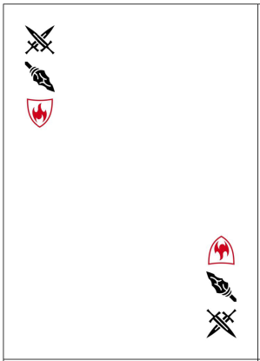A great battle was waged by the Vikings, and now the warriors who fell in battle await their fates. You are the Valkyries who choose which warriors will join Odin in Valhalla.

Each Viking bears two weapons and one shield into battle, which are indicated by icons on the edge of the card. The example card shown to the right is a card for a Viking with a sword, a spear, and a fire shield. You will use these symbols to claim the Vikings. Whoever claims the most Vikings escorts their warriors to Valhalla (i.e., wins the game).

**Setup**

Create separate piles for the Viking and Valkyrie cards. Shuffle each pile separately. Deal 2 Valkyrie cards to each player. Place the rest of the Valkyrie cards face down to form the Valkyrie draw pile. Place the Viking draw pile face down within reach of both players. Decide which player will go first.

**How to play**

Deal three Viking cards face up. (If the Viking draw pile is empty, you may have less than three cards showing. If some Vikings were not collected on the previous turn, you may have more than three cards showing.)

Draw a Valkyrie card from the action draw pile. Choose one Valkyrie card to play, and place it face-up so your opponent can also see it. You must play a Valkyrie card, even if none are beneficial to you.

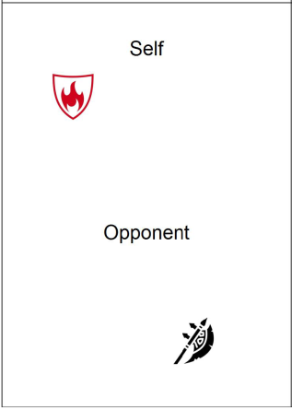Each Valkyrie card has two symbols. The “self” symbol allows you to claim any of the face-up Viking cards that have that symbol. The “opponent” symbol allows your opponent to claim any of the face-up cards that have that symbol. You can claim as many of the face-up cards that match your symbol. If a Viking card does not have the “self” symbol on your action card, you may not claim it. If a Viking card has both the “self” and “opponent” symbol, neither you nor your opponent may claim it on this turn.

Once you and your opponent have claimed your Vikings, discard your Valkyrie card. Leave any unclaimed Vikings face-up, so they can be claimed in future turns. It is now your opponent’s turn.

**How to win**

Your goal is to collect more Vikings than your opponent. The game ends when all Vikings have been claimed, or when both players run out of Valkyrie cards.

**Credits**

Designed by and © Jennifer Leaf

Icons made by Delapouite; Lorc. Available on <http://game-icons.net>

Version 0.2 April 21 2017