Willow Quick Start Guide

1. Hardware connections

a. Connect the 12VDC power supply to datanode via the barrel jack on the side
b. Connect TCP and UDP ports on back of datanode to a network switch using 2 ethernet cables
c. Connect network switch to workstation using another ethernet cable

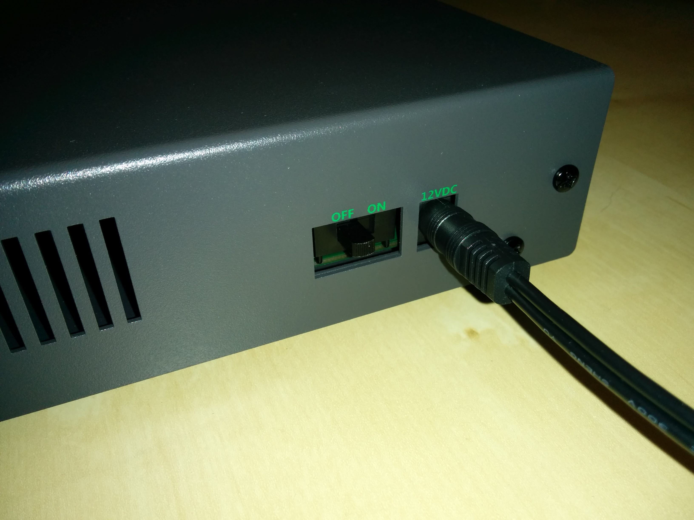
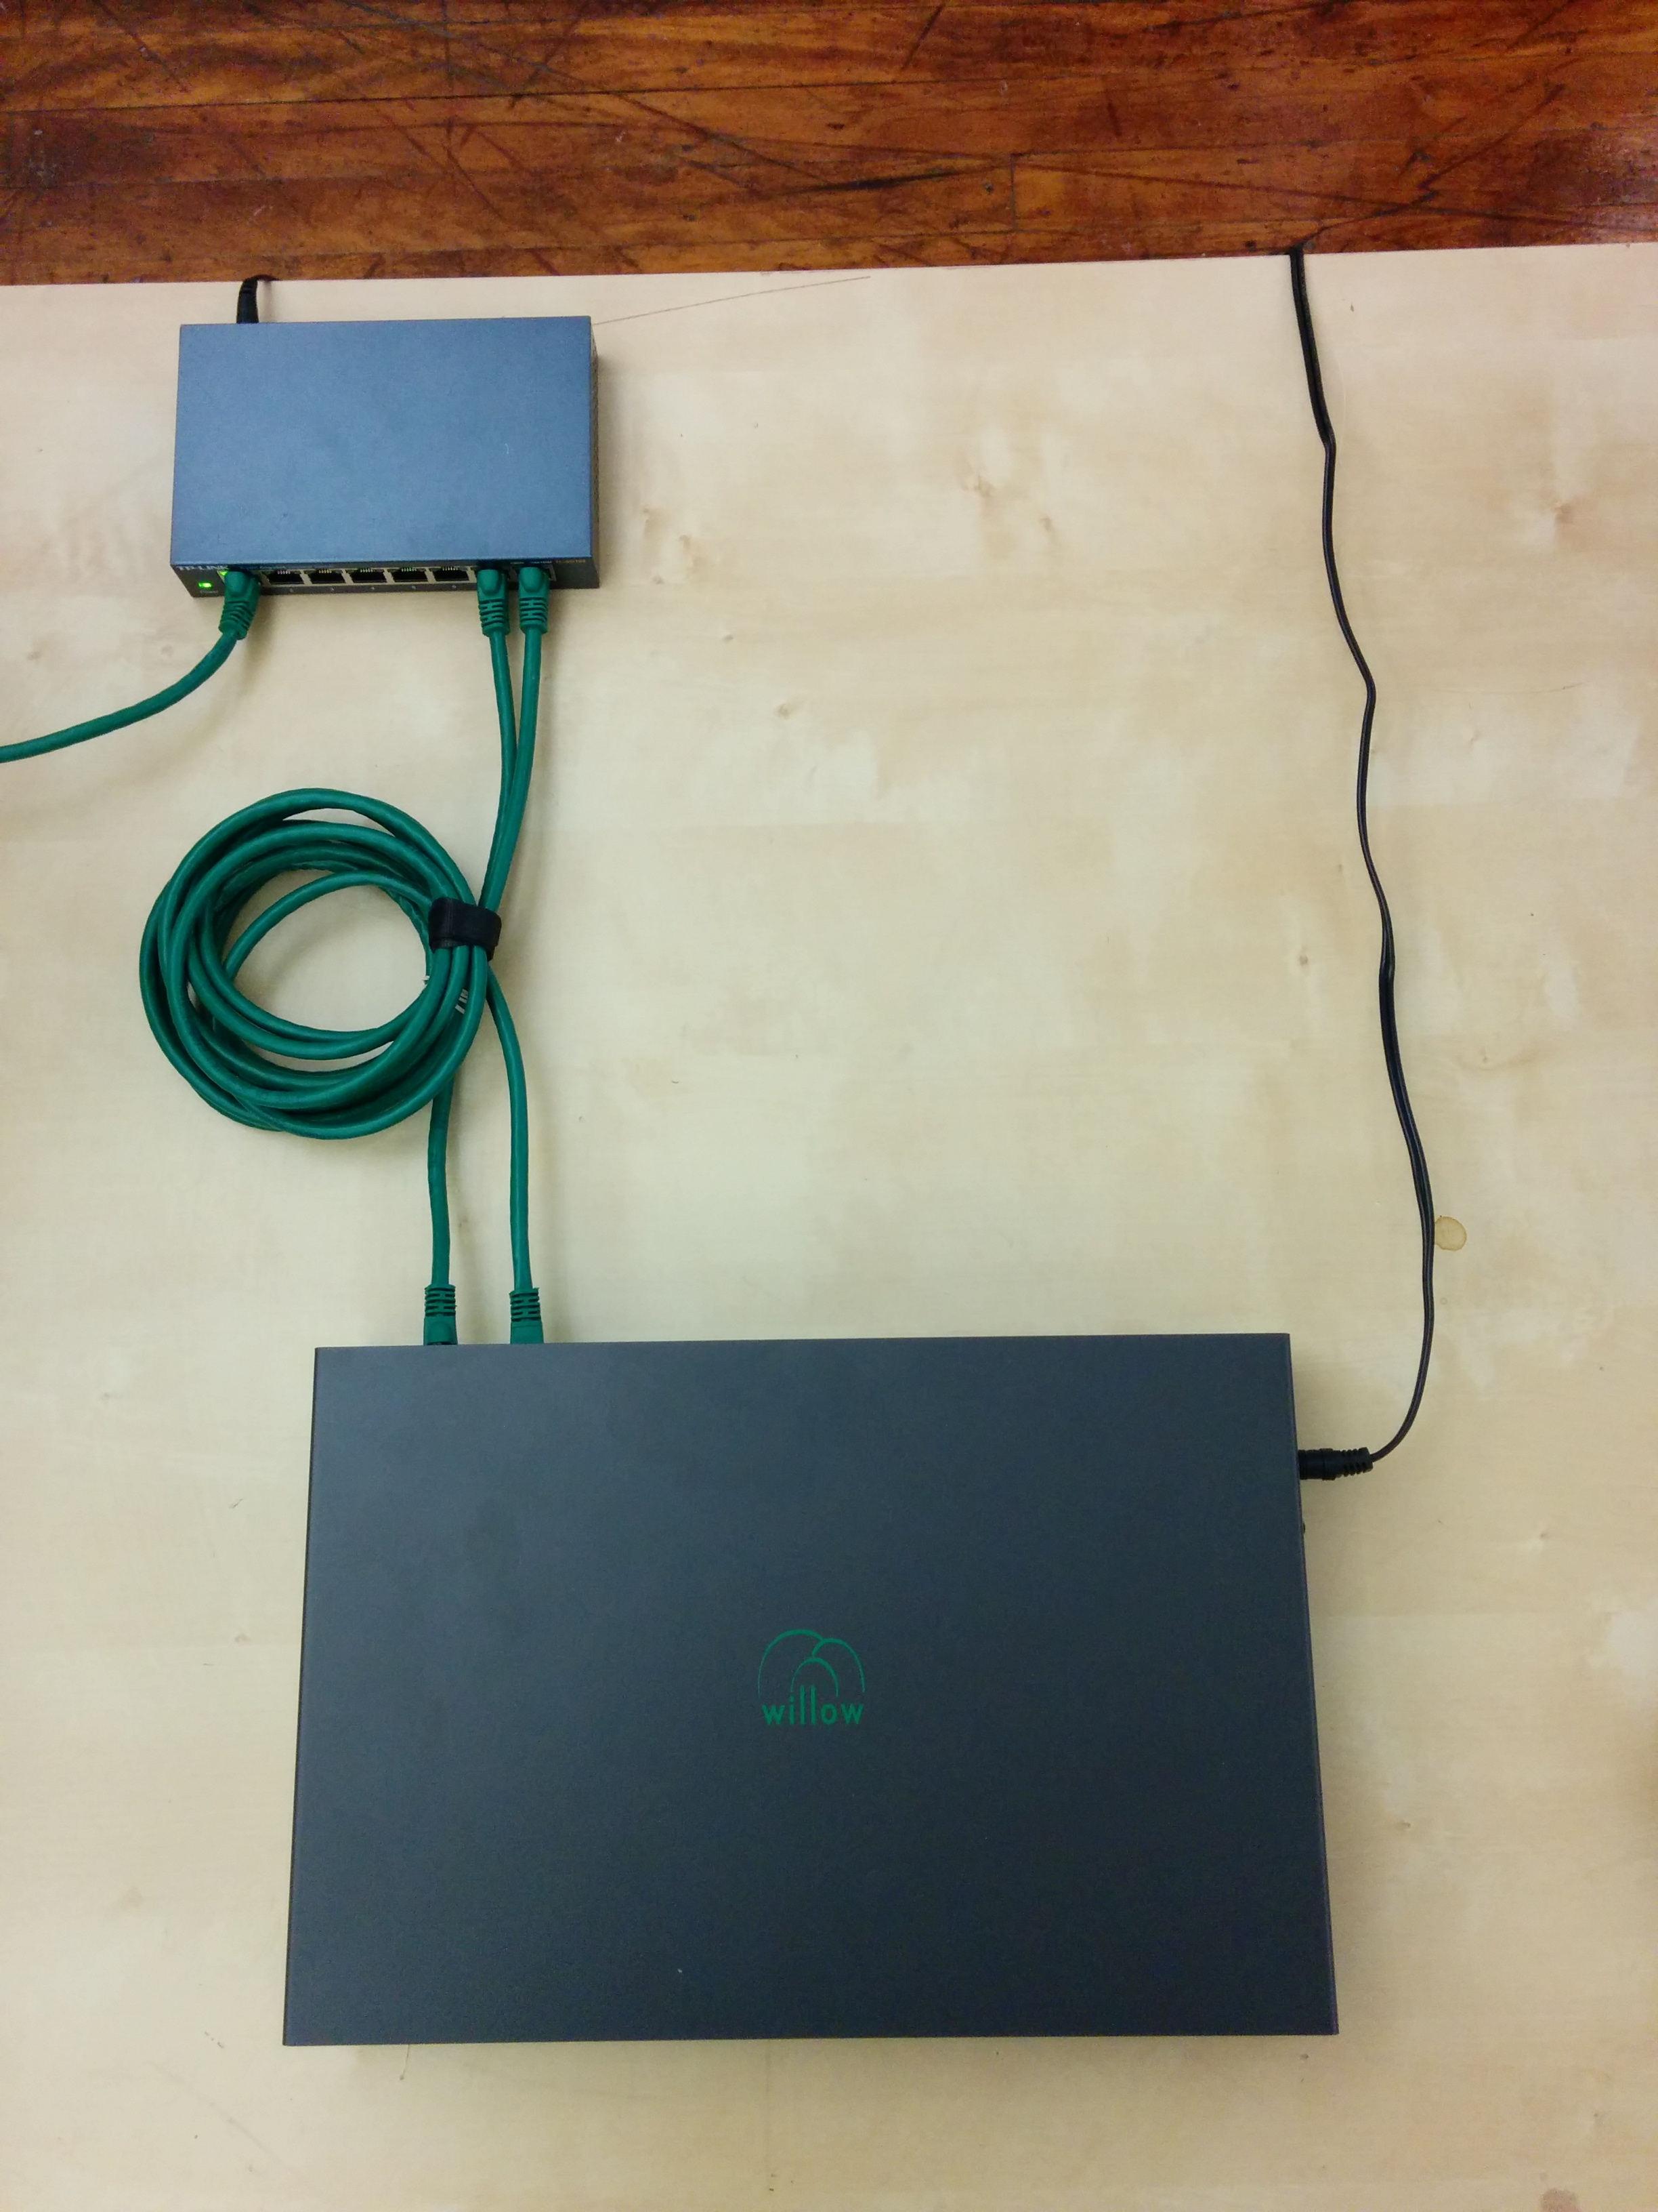
d. Connect datanode to headstages using HDMI cables. Connect MOSI 1 and MISO 1 to MOSI and MISO (respectively) on the first headstage. Continue for all headstages you wish to use.
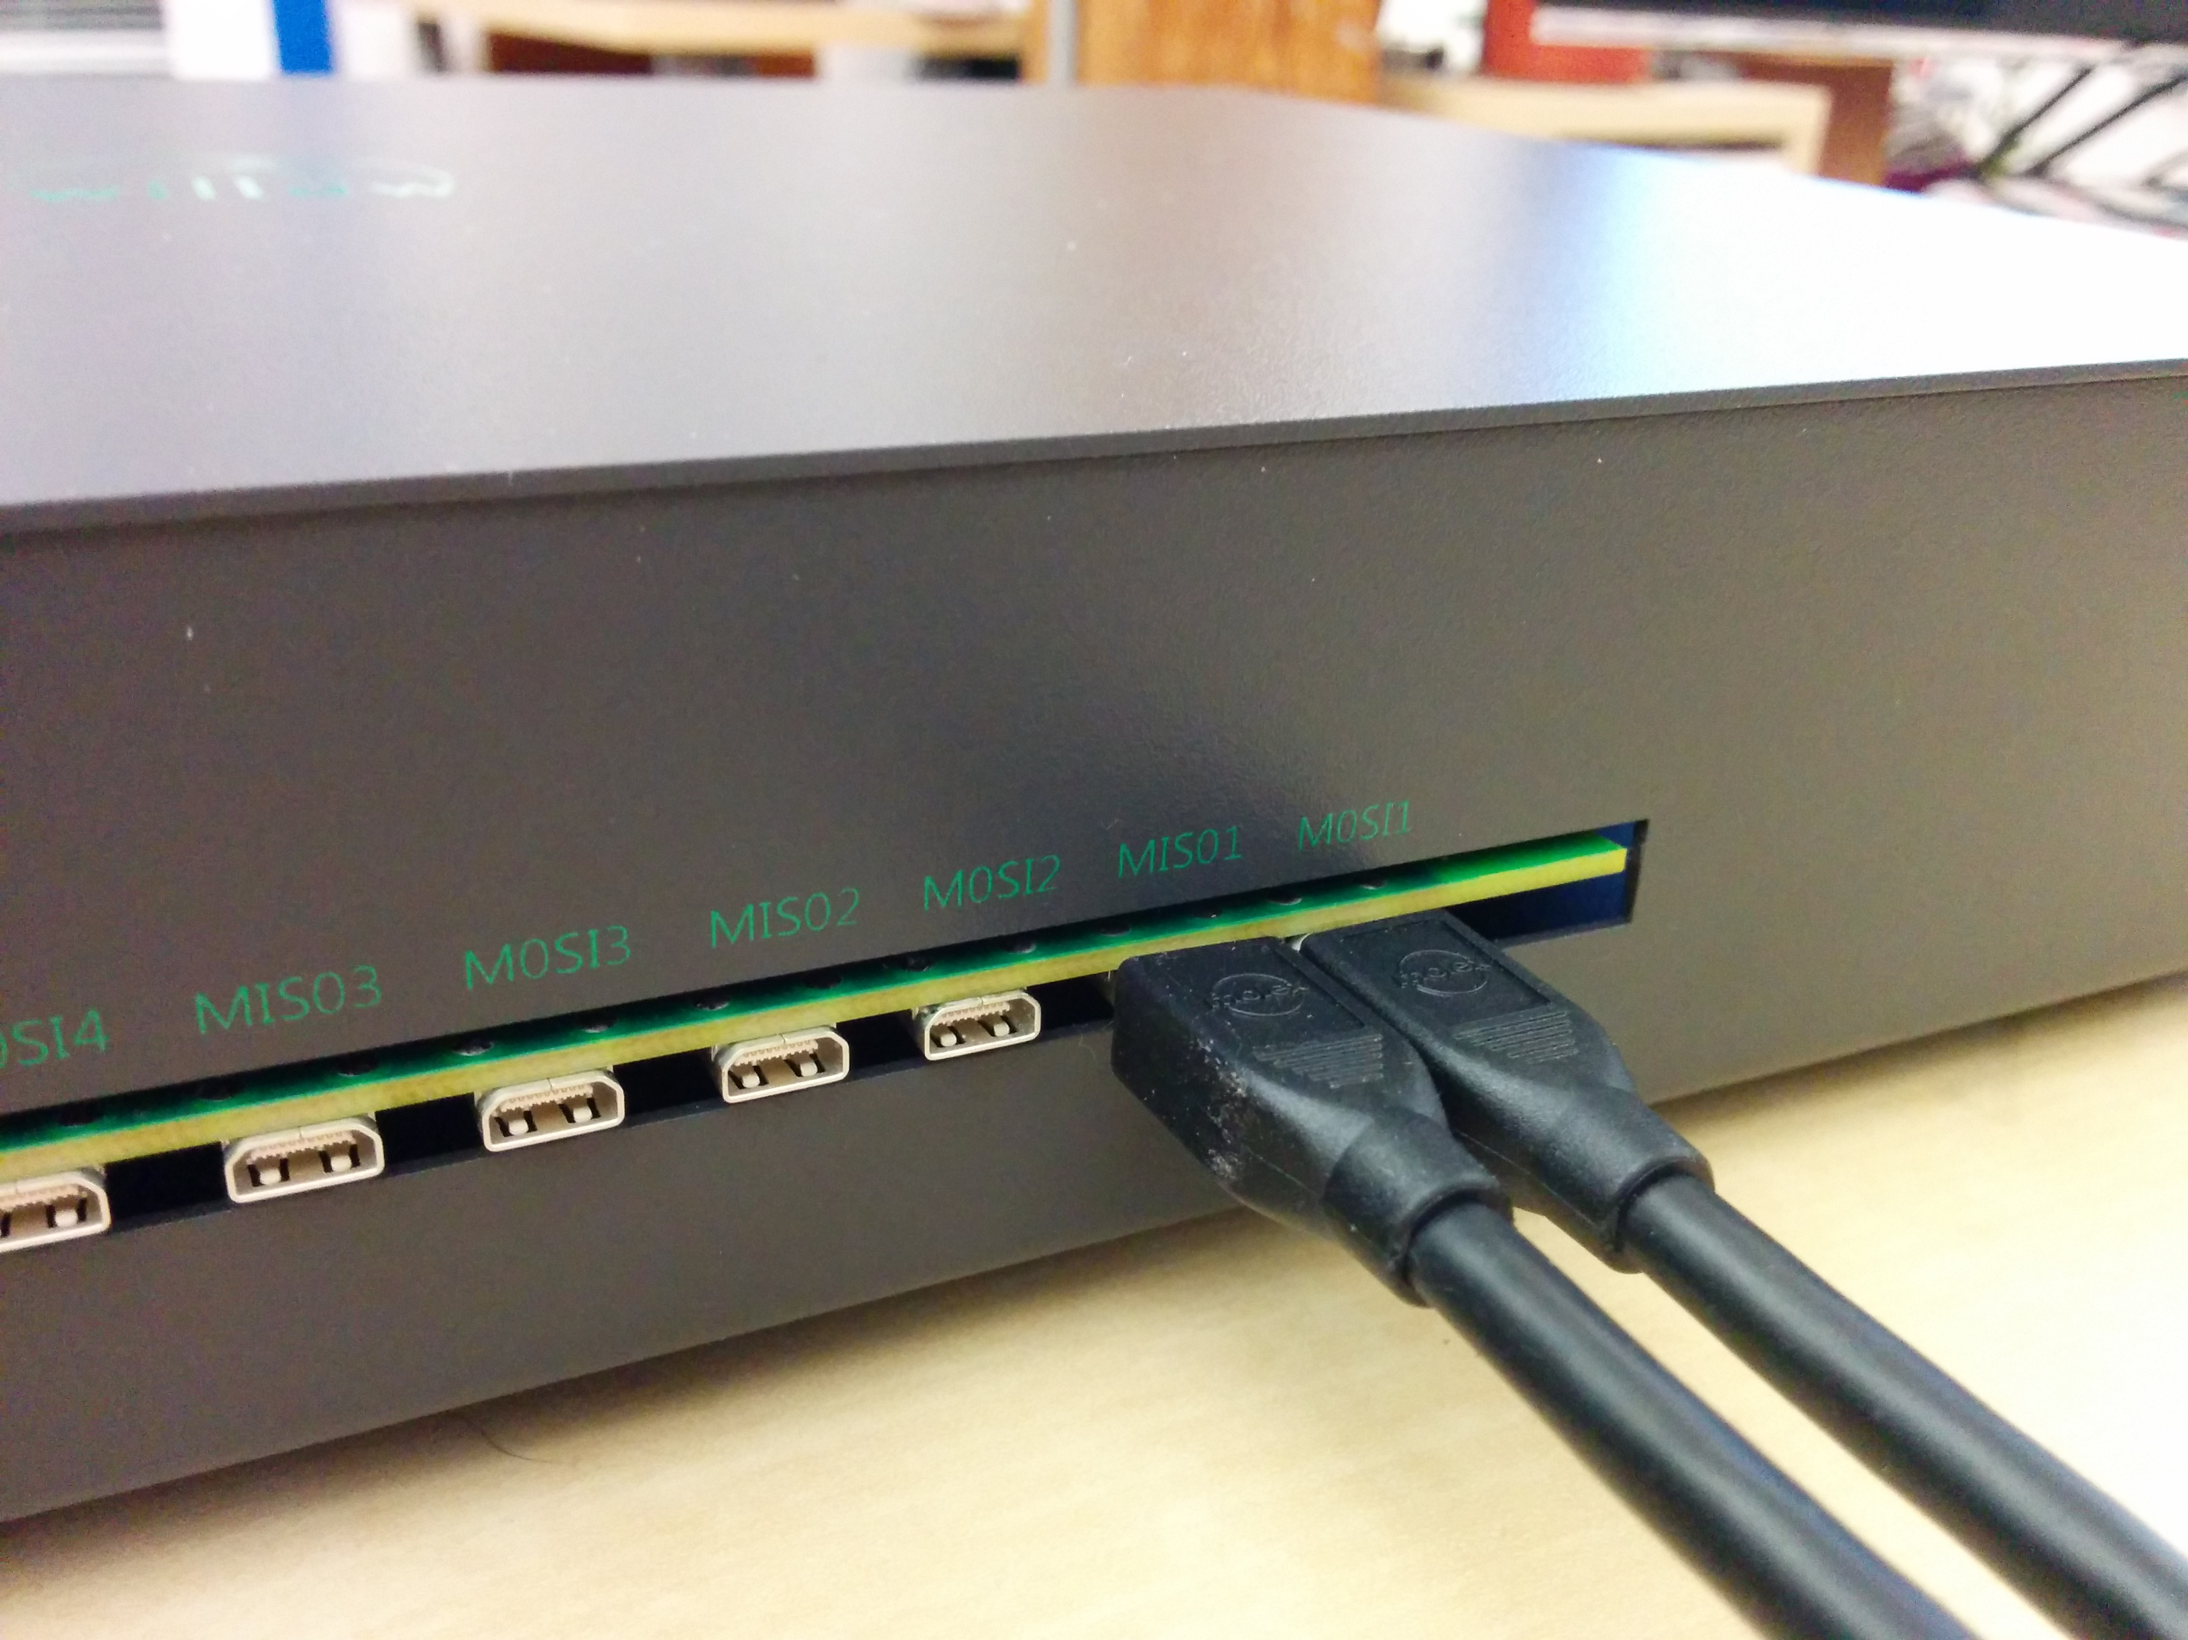
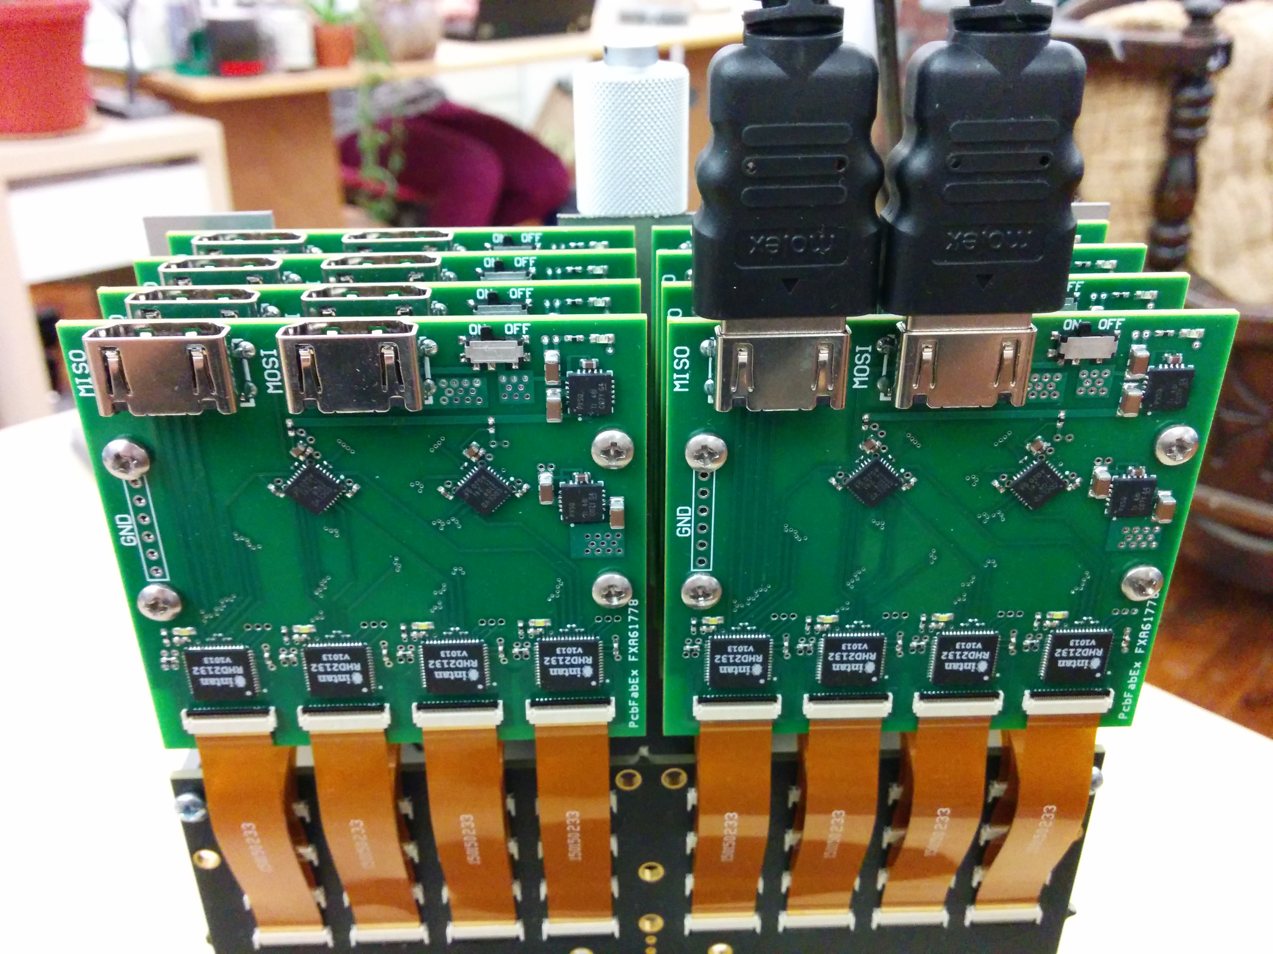
e. Power on datanode by sliding the side switch to the ON position. Wait until white LEDs on headstages flash twice (takes about 15 seconds).

2. Network configuration

Select “Willow” from the Network Connections applet in the top-right corner of the desktop.

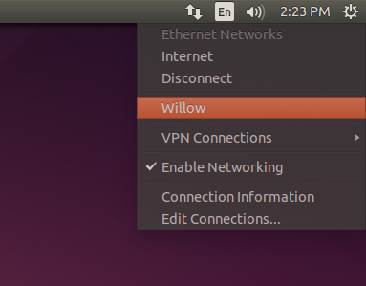
3. Start the GUI

Click on the “Willow GUI” icon on the Unity launcher side panel. If everything is set up correctly, the status bar at the top of the GUI should be all green with, no errors.

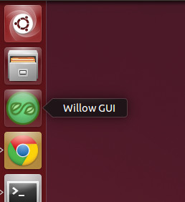
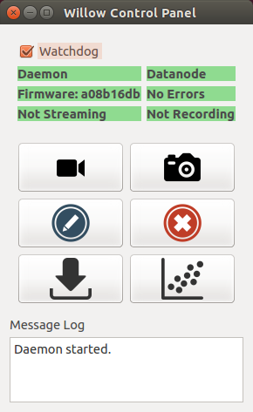

4. GUI Usage

a. Stream live data:

Click this button to launch a Stream Window. You will be presented with a dialog to select the channel number, plotting range, and frame rate. After clicking “OK”, the stream window (shown below) will pop up. Start and stop the stream by clicking the “play” and “pause” buttons at the top.

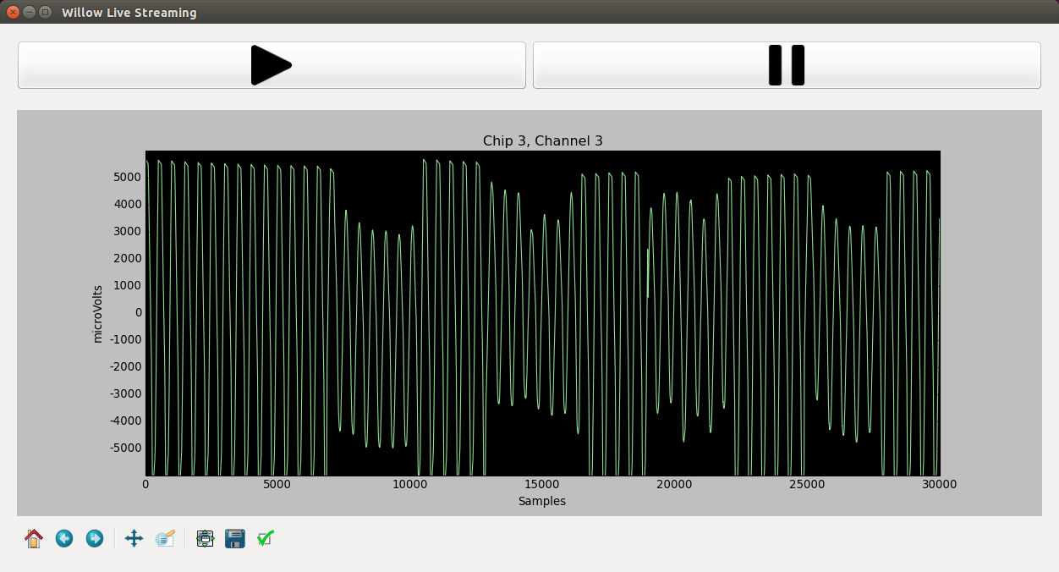


b. Take a snapshot:

Click this button to take a snapshot, which is a short (1-10 second) sampling of all 1024 channels, stored in an HDF5 data file. You will be presented with a dialog to select the number of samples you wish to collect, and the target filename. By default, the snapshot will be 1 second long (30000 samples) and have a timestamp-specific filename of the form snapshot_YYYYMMDD-hhmmss.h5. You may also check “Plot When Finished” to open the snapshot data in a Plot Window.

c. Start recording:

Click this button to start recording to the datanode. WARNING: this will start recording at the beginning of the disk, overwriting any previously recorded experiments. Make certain that you have transferred any important experiments off the datanode (see Transfer Experiment below) before you start recording. While recording, the recording label in the status bar will become red and list the current disk usage.

d. Stop recording:

Click this button to stop recording. The recording label should turn back to its green “Not Recording” state.
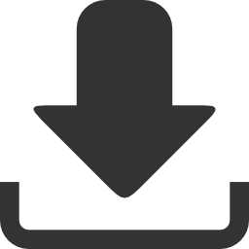
e. Transfer experiment:

Click this button to transfer an experiment (i.e. a continuous recording) to the workstation. You will be presented with a dialog to select the number of samples to transfer (or the entire experiment, if you wish), and the target filename. Select “Name Automatically” to name the file with the experiment cookie, which is the UNIX timestamp from when the recording was started. TODO: IMPLEMENT THIS!
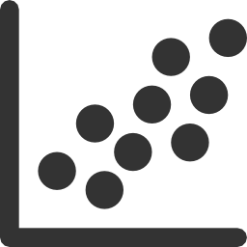
f. Plot data:

Click this button to plot data from a previously acquired experiment or snapshot. You will be presented with a file browser to select the file (HDF5 format required) and then a separate dialog to select how much data you wish to import. This will open a Plot Window (shown below) in which you can view the channel traces as line plots. Click “Waterfall” near the top-right of the Plot Window to open a Waterfall Plot – a 2D spectrogram-like visualization with channel count on the y-axis, and time on the x-axis (shown below).



