Willow Quick Start Guide

I. HARDWARE CONNECTIONS

1. Connect Datanode Power Supply to port labeled 12VDC on right side of Datanode. (Fig. 1)
2. Connect TCP/UDP ports to network switch using two Ethernet cables. (Fig. 2)
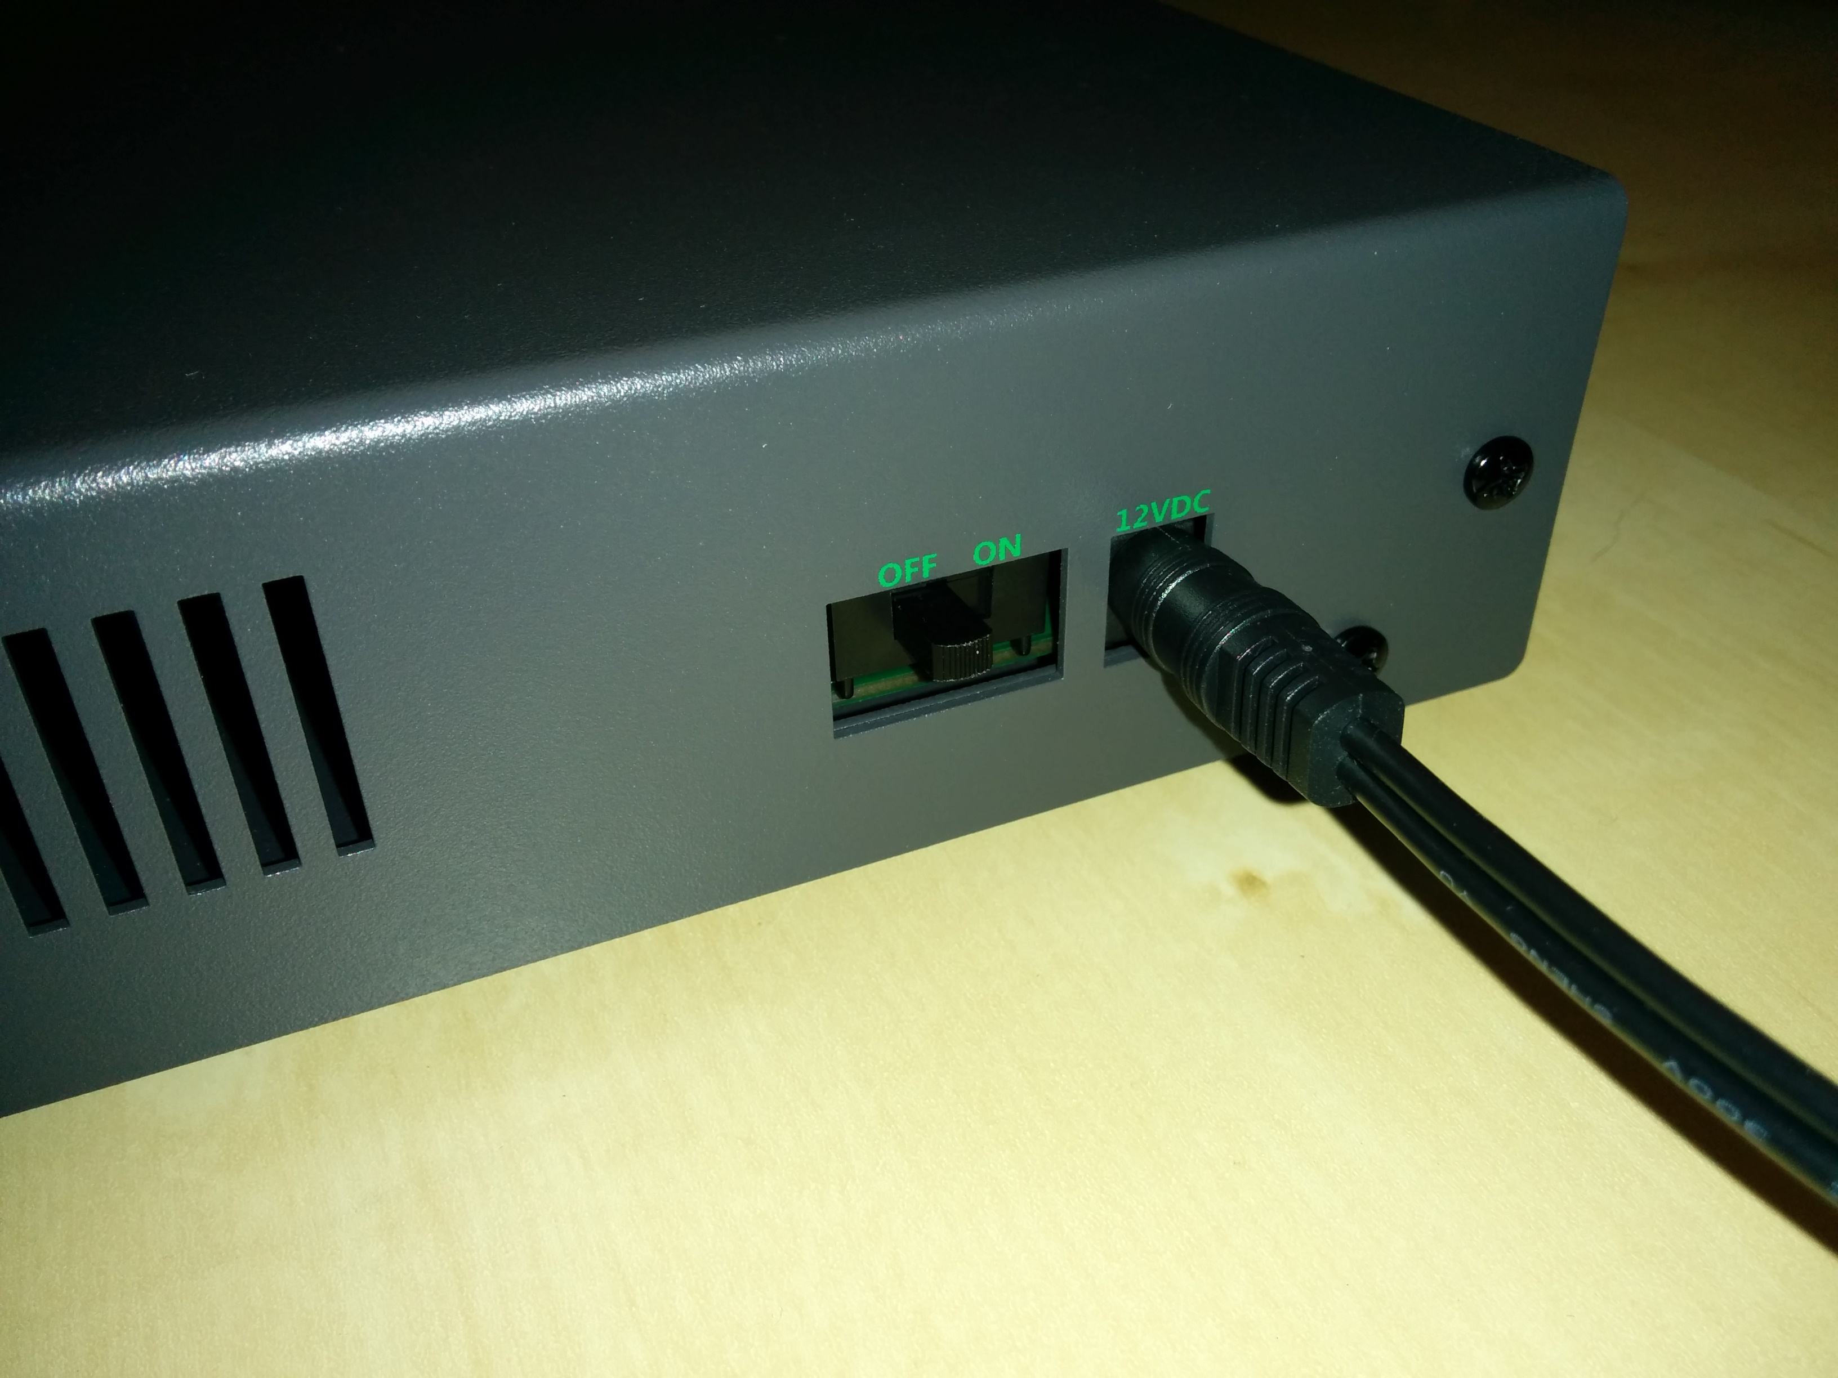
Figure 1. - Datanode 12VDC power port
Figure 2. - Datanode TCP/UDP ports connected to network switch
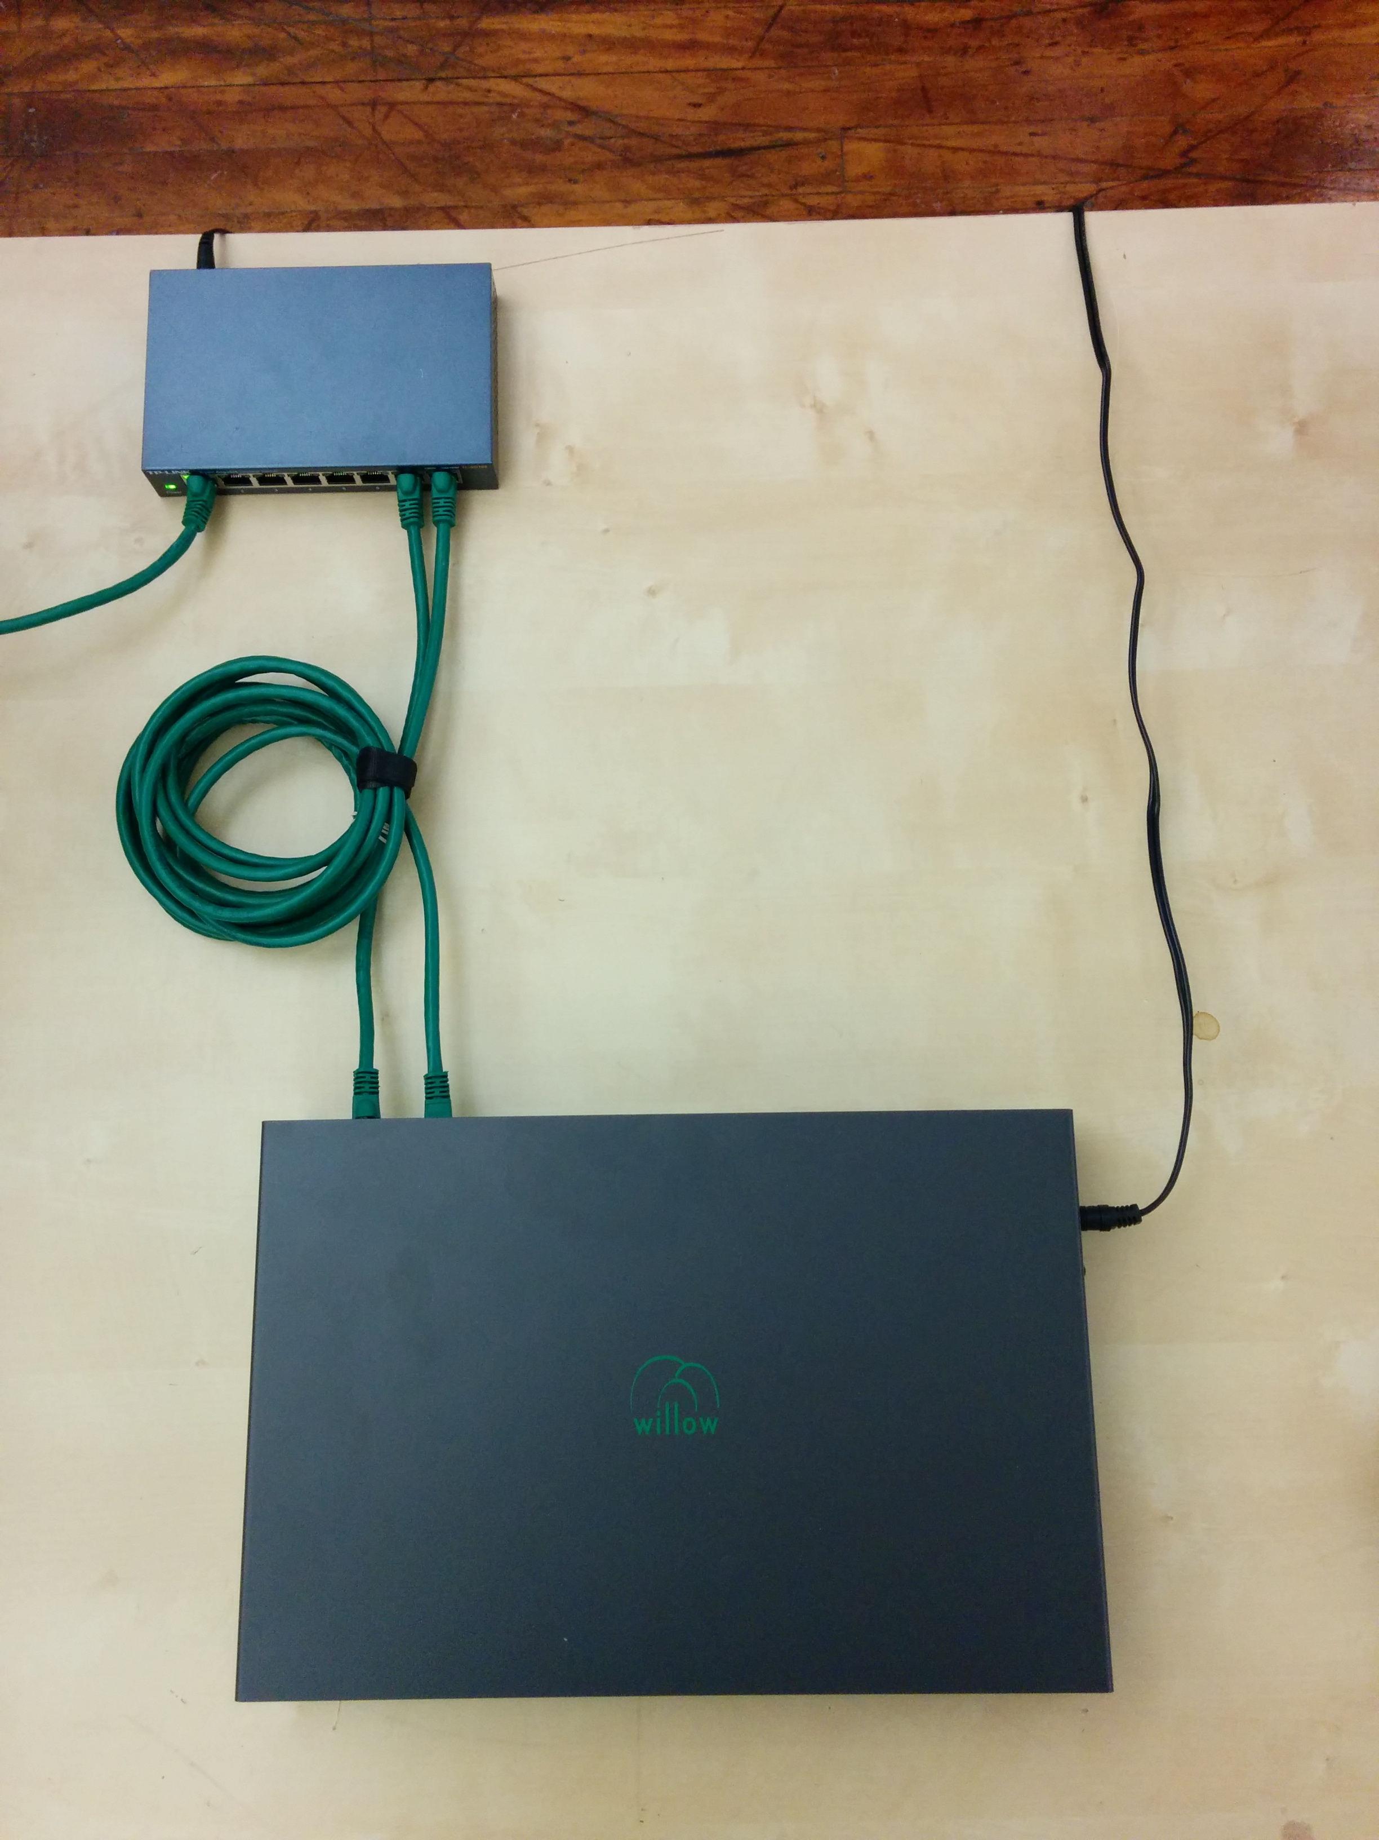

3. Connect workstation to the same network switch via Ethernet cable.
4. Connect Datanode to Headstages via HDMI cables. Connect any Datanode MISO/MOSI paired-ports to respective MISO/MOSI paired-ports on any Headstage. Repeat desired number of paired-port connections between Datanode and Headstages, as needed. (Fig. 3)
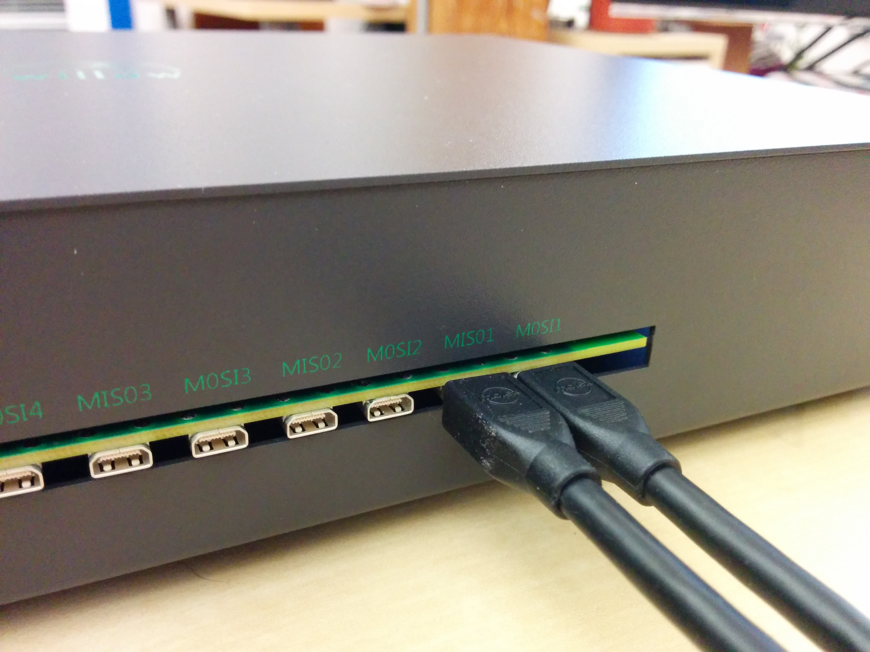
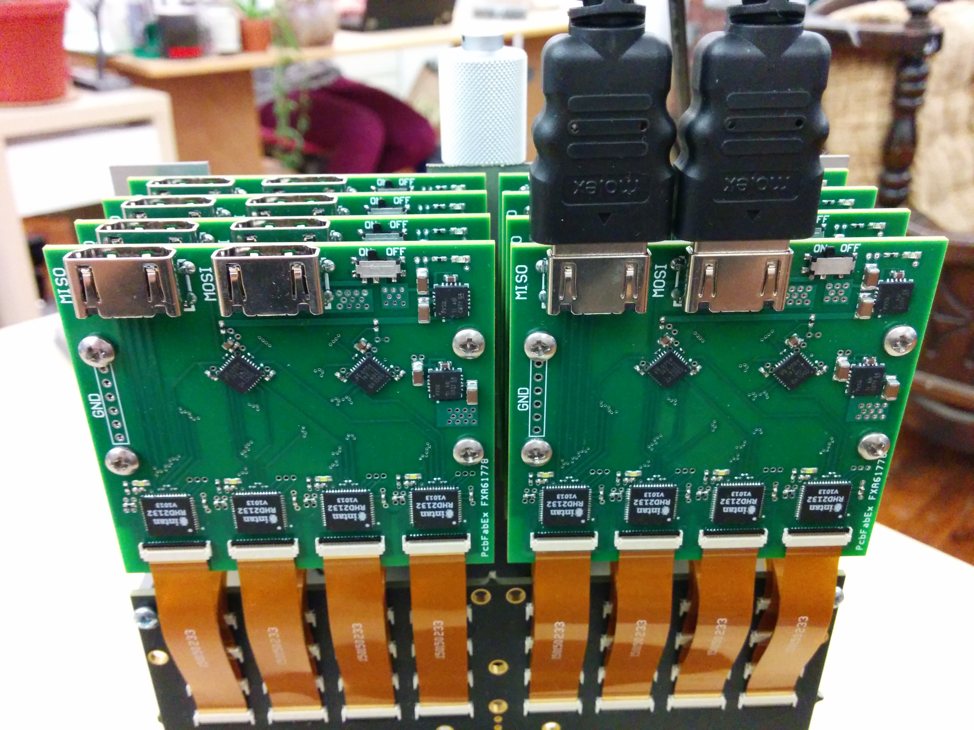
Figure 3. - Example of Datanode paired-ports MISO1 and MOSI1 connected to a Headstage's MISO/MOSI ports

5. Slide power switch on side of Datanode to ON position to power Datanode. Wait until white LEDs on Headstages flash twice (takes about 15 seconds).

II. NETWORK CONFIGURATION AND GUI STARTUP

1. Select “Willow” from the Network Connections applet in top-right corner of the desktop.
Note: Selecting Willow will disconnect from the Internet, and vice versa. (Fig. 4)

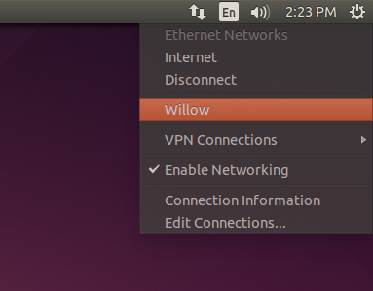
Figure 4. - Selecting Willow as current network configuration

2. To start the GUI, click on “Willow GUI” icon on the Unity Launcher side panel. If set up is correct, the six status bars on the Willow GUI will display green indicating no errors. (Fig. 5,6)

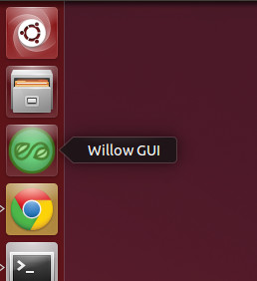
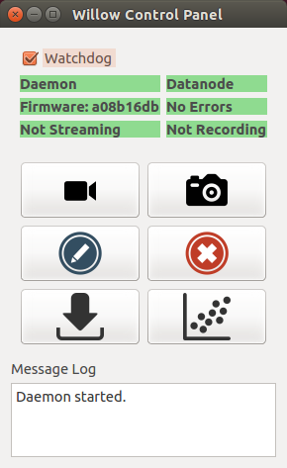
Figure 5. - (Above) Willow GUI icon on the Unity Launcher side panel.

Figure 6. - (Right) Willow GUI status bars indicating successful setup.

III. GUI USAGE

1. Stream live data:

Click this button to launch a Stream Window (Fig. 7). A dialog box will appear in which channel number, plotting range, and frame rate can be entered. After clicking “OK”, the Stream Window will appear. Start/stop the stream by clicking the “play” and “pause” buttons. Note: The stream will stutter unless the Watchdog box is unchecked.

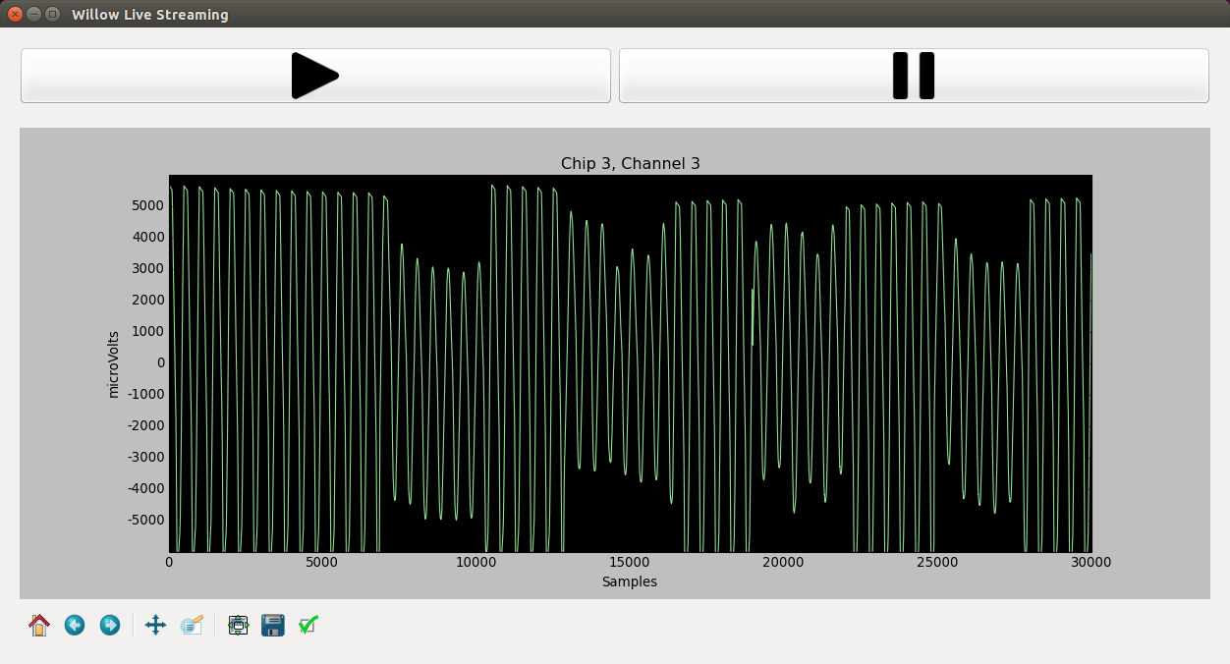

Figure 7. - Stream Window streaming


2. Take a snapshot:

Click this button to take a snapshot, which is a short (1-10 second) sampling of all 1024 channels, stored in an HDF5 data file. A dialog box will appear in which number of samples to collect and the target filename can be entered. By default, the snapshot will be 1 second long (30000 samples) and have a timestamp-specific filename of the form:

snapshot_YYYYMMDD-hhmmss.h5.

Selecting “Plot When Finished” to open the snapshot data in a Plot Window (see Section 6).

3. Start recording:

Click this button to start recording to the Datanode. WARNING: Each recording will start at the beginning of the disk, overwriting any previously recorded experiments. To ensure that no data is lost, make certain that any important experiments have been transferred off the Datanode (see Transfer Experiment below) before recording. While recording, the recording label in the status bar will turn red and list the current disk usage.

4. Stop recording:

Click this button to stop recording. The 'recording' status bar will turn back to its green “Not Recording” state.
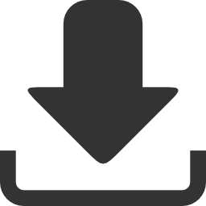
5. Transfer experiment:

Click this button to transfer an experiment (i.e. previous recording) to the workstation. YA dialog box will appear in which the number of samples to transfer (or entire recording), and the target filename can be selected. Select “Name Automatically” to name the file with the UNIX time-stamp from when the recording was started.

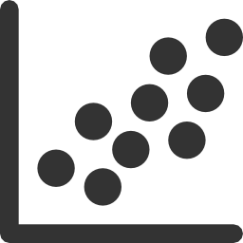
6. Plot data:

Click this button to plot data from a previously acquired recording or snapshot. A file browser will appear in which the desired file can be selected. A subsequent dialog box will appear in which the amount of data desired for import can be selected. Upon selection, a Plot Window will open in which channel traces can be viewed as line plots. (Fig. 8)

Click “Waterfall” near the top-right of the Plot Window to open a Waterfall Plot – a 2D spectrogram-like visualization with channel count on the y-axis, and time on the x-axis. (Fig. 9)
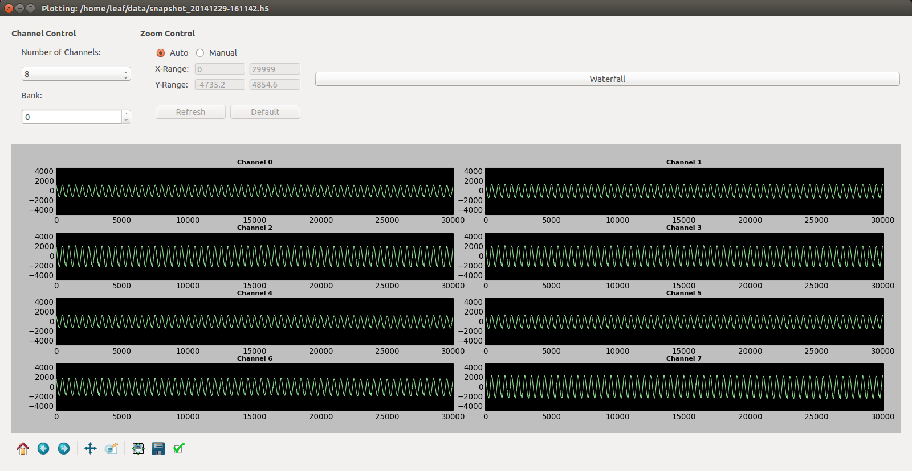

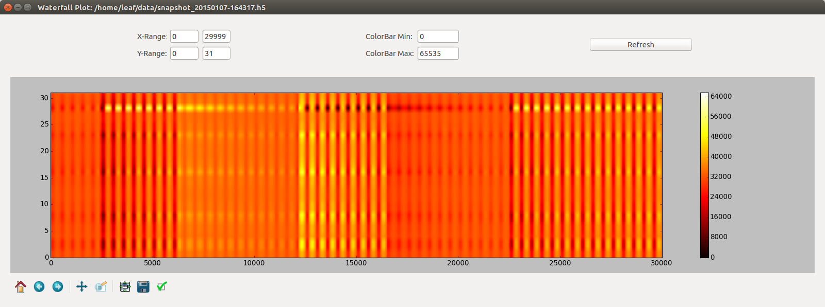
Figure 9.- Example Waterfall plot showing channel count versus time.
Figure 8. - Example data plot showing the first 8 channels of data.

