Description: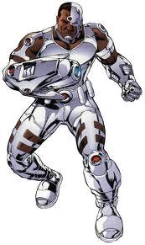

Vedant Shah

Using your knowledge and understanding of Internal and External Hardware, you will create a Cyborg: a human being made partly out of computer parts. You will incorporate the internal and external parts of the computer onto your being to create your Cyborg. However, each computer part which you add has to replace a similar function on a human being. For example, if you add a computer speaker, which projects sound from a computer, then you will probably use that computer part to replace the mouth of a human being.

**Criteria:**

**Part 1: Visual (15 marks)**

You will visually (draw, cut & paste, collage, etc) include all the following parts into your Cyborg. You may use the human outline on next page to complete your work.

|  |  |
| --- | --- |
| **Internal Parts** | **External Parts** |
| * CPU: Brain * Hard Drive: Hippocampus/Cortex * Motherboard: Skeleton * Power Supply: Heart * Optical Drive: Eyes * RAM: Prefrontal lobe * Expansion Card: Arms/Limbs * Expansion Slot: Blood | * Keyboard: Hands * Mouse: Finger * Monitor: Face * Printer: Mouth * Speaker: Mouth * Scanner: Eyes * Microphone: Ears |

**Part 2: Written (15 marks)**

You are to justify reasons of ALL replacements.

1. The CPU is used to replace **the brain** because **the brain gets the data from the nervous system, handles those signals and forms decisions about them and then directs them back to the nervous system for another time. Similarly, the CPU turns user typed commands into machine language that are directed to the concerned parts for decision making and then directed back to the processor to turn them into user language again. Both the brain and the CPU have huge amounts of information. Lastly, they both utilize electricity as the brain utilizes chemicals to transfer information while the CPU uses electricity.**
2. The Hard Drive is used to replace **the** **hippocampus/cortex (part of the brain)** because **after going through the hippocampus, the memory becomes long-term, like the hard drive. Also, if the hard drive is broken, some information will not exist and mostly, the information would get destroyed which is similar to the hippocampus because if there is a disease like Alzheimer's, it may cause short-term memory. Another reason why the HDD is used to replace the hippocampus is that both can retrieve data.**

1. The Motherboard is used to replace **the skeleton** because **the job of the skeleton is to keep all the bones of the human body together, similar to how the motherboard holds the majority of the important computer parts together. Also, the skeleton makes sure that the components of the body are working together, similar to how the parts on the motherboard work together.**
2. The Power Supply is used to replace **the heart** because **the heart pumps blood all over the body, similar to how the power supply gives electricity and power to the computer.**
3. The Optical Drive is used to replace **the eyes** because **the eyes would read something and the brain would process it, which is similar to the optical drive as it reads Blu-rays and compact discs.**
4. The RAM is used to replace **the prefrontal lobe (part of the brain)** because **it keeps a piece of information for a short time to do a task, which is similar to RAM because the RAM stores information for a short time until the computer is closed. The prefrontal lobe temporarily stores short-term memory, and that's alike to RAM because RAM is volatile, meaning that it is a short-term memory as well.**
5. The Expansion Card is used to replace **the arms/limbs** because **when you take a flu shot, it protects your body from diseases or viruses, which is similar to an expansion card because it enhances things in the computer.**
6. The Expansion Slot is used to replace **the blood** because **it is the place where the fluid from the vaccines enter, making your immune system prone to infections, which is similar to the expansion slot because it is a spot where an expansion card is placed to provide the computer with more abilities.**
7. The Keyboard is used to replace **the hands** because **the hands transfer signals from the sense of its touch to the brain to be processed, which is similar to the keyboard because it also transfers data and orders (input) to the CPU.**

1. The Mouse is used to replace **the fingers** because **fingers act as pointers and transmitters of signals or orders so the body will be able to answer to stimuli, which is similar to the mouse because it would be able to answer to the user. Also, the mouse helps the keyboard and fingers help the hands.**

1. The Monitor is used to replace **the face** **because the face displays our feelings/expressions and similarly, the monitor shows information. The monitor shows what the CPU processed and suppose someone tells you something that makes you happy, the output on your face will be a smile. This is because the brain processes the information and tells you what emotion you have to feel.**
2. The Printer is used to replace **the mouth** **because the mouth is an output device, like the printer. When you talk, the voice comes out of your mouth, similar to the printer because when you send a document to be printed, the printer would send the output, which is paper.**
3. The Speaker is used to replace **the mouth** because **both the mouth and the speakers create sound waves. Also, the speaker would replace the mouth because since the speakers turn electrical signals into acoustical signals, the mouth would throw out the stomach contents when vomiting.**
4. The Scanner is used to replace **the eyes** because **the eyes can detect light and changes an inverse image into a real image. This is similar to the scanner because it also changes the pattern of light and dark colors into a digital signal in order to transport the image from the paper to the computer.**
5. The Microphone is used to replace **the ears** because **the ears receive sound waves, similar to how the microphone also gets sound waves. The microphone is used to replace the ears because a tiny organ in the inner ear called cochlea turns vibrations into nerve impulses that go to the brain. It is similar to the microphone because when the diaphragm in the microphone vibrates, that turns acoustical energy (sound waves) into electrical energy (audio signal).**

You may submit **Part 1** on a piece of letter size (or bigger) paper or on Moodle. You **must** upload **Part 2** on Moodle.

Due date: **February 14, 2017, Tuesday**

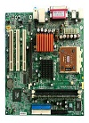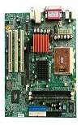Image result for printer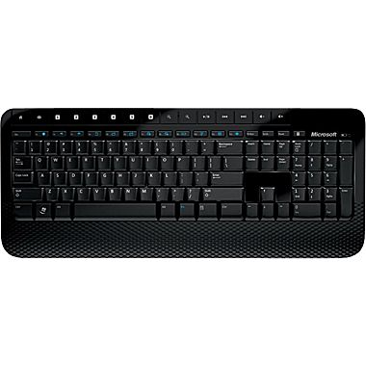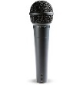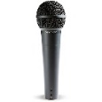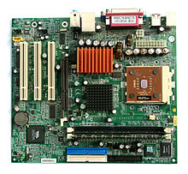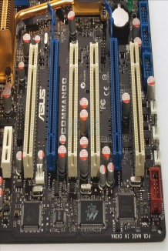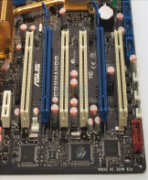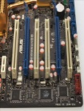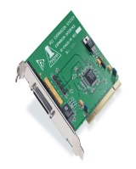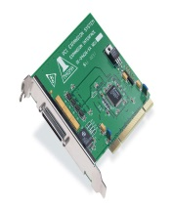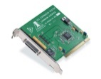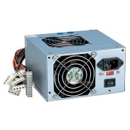Image result for hard driveImage result for ram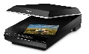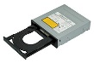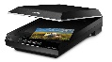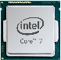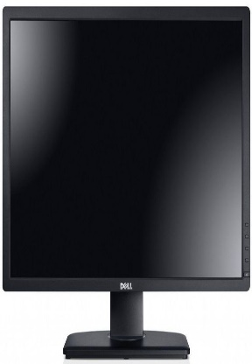Image result for speakers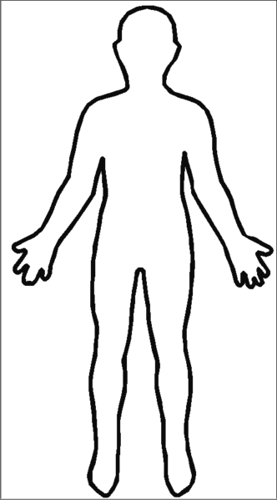Image result for wireless computer mouseImage result for wireless computer mouseImage result for wireless computer mouseImage result for wireless computer mouseImage result for wireless computer mouseImage result for wireless computer mouseImage result for wireless computer mouseImage result for wireless computer mouse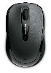Image result for wireless computer mouse

Keyboard: Hands

Expansion Slot: Blood

Expansion Slot: Blood

Motherboard: Skeleton

Motherboard: Skeleton

Motherboard: Skeleton

Mouse: Fingers

Expansion Slot: Blood

Printer: Mouth

Mouse: Fingers

Power Supply: Heart

Speaker: Mouth

Monitor: Face

Scanner: Eyes

Microphone: Ear

Optical Drive: Eyes

Expansion Card: Arms/Limbs

Expansion Card: Arms/Limbs

Keyboard: Hands

CPU: Brain

Microphone: Ear

RAM: Prefrontal lobe

Hard Drive: Hippocampus/Cortex