Vedant Shah

ENG 2D1

Ms. Melanie Schizas

Monday, March 13, 2017

Death of Sister on Twelfth Birthday

The death of a loved one is an event in your life where you think of the cherishable moments you had with that person. It makes you think of the regrets that you had promised your loved one but could not fulfill. This was the position my parents and I were in when my beloved sister, Palak, had passed on July 18, 2013, which also happened to be my twelfth birthday.

July 2011

The journey of my sister’s cancer began on July 9th, 2011. Prior to this day, Palak was bleeding a lot from her nose and at first, we thought that the bleeding was due to her runny nose as she had a cold. However, after blood kept on oozing out of her nose for several days, my parents took her to SickKids Hospital, which is located in Toronto and is one of the best hospitals for children in the world, for some tests to make sure everything was normal with Palak; unfortunately, the news was not what they had expected. After several tests, the doctors told my parents, Rachana (my mother) and Bhavesh (my father), that Palak was diagnosed with cancer known as “rhabdomyosarcoma”. My family felt devastated because Palak was a naïve girl who always put a smile on others face with her cuteness. In August of 2011, Palak’s first chemotherapy occurred. When that finished, Palak had taken a bath and saw that her hair was coming off. She became upset so my parents took her to the barber and the barber cut Palak’s hair up to her neck. Then, when her second chemotherapy was completed, my parents and Palak noticed that more hair was coming off. She felt very odd and started to cry. Even though I was not there, I think she cried because since all her friends had long hair, she felt inferiority complex. Thereafter, my parents took Palak to the barber again and she shaved Palak’s hair, completely. After the barber cut Palak’s hair, she came to my uncle’s home, and when they came, my cousins and I were shocked to see this. However, my uncle explained everything to us and made us understand why this drastic step was taken. We went to Palak and played with her for many hours that day.

September 2011

The summer vacation had finished and I was heading into grade 6, while Palak was on medication. I felt excited entering grade 6 because I was going to an IB school called Milne Valley Middle School, but I also was a little upset. All my friends from my elementary school were going to their home school and it was the same as me, but instead, my parents applied me to Milne Valley. After a few weeks, we got a letter and an email home stating that I got selected at Milne Valley and my family was very excited. For Palak, though, her treatment had begun and the doctors had put a “G-tube (feeder tube)” in Palak’s stomach which was a tube that transported a special type of food in her stomach. She had to have this tube placed into her stomach because she was not able to eat well and this was necessary to make sure she had enough nutrients in her body so her body would function well.

December 2011

For some time, I had been thinking of how to raise money for SickKids. In December of 2011, I was in my science class when I came up with the idea to raise money: doing fundraisers. Immediately, I started to organize a fundraiser with one my best friends, Aly. We made announcements in the morning many times a week to let the students know what the fundraiser was about and who we were doing this for; we were going to sell chocolates and candies in the front foyer in order to raise money for SickKids Foundation. The fundraiser we had went great. I was very pleased with our success as Aly and I raised over $90. After this fundraiser, we decided to do three to four fundraisers that year but selling different things. On Mother’s Day in May 2012, we sold roses to the students at our school to give to their mother’s and once, we had dodgeball games during lunch time between teachers and students where students who wanted to spectate the matches had to pay a small fee. All our fundraisers went great and we enjoyed every bit of it. This continued until the end of the school year of June 2012. The main reason I was doing this fundraiser was to support Palak because she had lost her childhood. She did not go to school because of her illness and could not play like a normal child because a feeder was attached to her stomach which she had to carry around all day. I tried to make her happy as much as I could by entertaining her to make sure she did not feel any sorrow and could enjoy her childhood similar to other children. Also, another person to support Palak was a woman that would come to our home to perform reiki on Palak. Reiki is a healing technique where the therapist would be able to transport energy into the patient by touch so that the person’s mental and physical health would be reinstated. That woman was intelligent, did her job very well, and her reiki helped Palak a lot.

June 2012

In June 2012, Palak’s treatment completed and my parents brought Palak to SickKids for an MRI (Magnetic Resonance Imaging) and amazingly, the MRI showed that the cancer was gone. It was a huge moment for my family. We spent a lot of time outside with Palak and my family made sure Palak was able to do everything she wanted. We were often at cousin’s home and enjoyed our time with them. We cherished every single moment that we spent with Palak. It was the best summer ever.

September 2012

In September of 2012, my parents took Palak for a check-up MRI to make sure the cancer did not come back. Again, they did not get the answer they were looking for! Palak’s cancer had come back and she was admitted to SickKids Hospital again! Her treatment would have to start again; furthermore, my father decided to stay with her at the hospital 24/7 to make sure she was well and my mother stayed home to take care of me. My parents were much tensed about this situation because Palak was admitted again and the doctors did not know how the cancer came back. I was also terrified from this situation because I did not what was happening (my parents did not tell me the real reason at that time because they knew I was very protective of my sister and I get emotional about her) and I was not able to see and play with Palak, but fortunately, my mother and I would go to visit Palak on the weekend and spend quality time with her. That girl was still cheerful, despite living at the hospital for weeks and taking many needles that month. Soon, my mother’s mother, meaning my grandmother, came to live with me and my mother went to live at the hospital with Palak and my father in the same month. My grandmother was a savior during this time because she would always live with my uncle, but since Palak had to be admitted again to SickKids, she told us she would come stay with me while my parents were with Palak. At first, I wanted to be with my mother, but my grandmother explained the situation to me and I understood it. Palak needed both our parents with her so she could feel secure and wanted both of them to be by her side for their support.

My grandmother would help me with my homework and cooked mouth-watering meals for my parents and Palak, as well as me. Each day, when I came home from school, I smelled the aroma of rotis being prepared in the kitchen. This continued until Palak was able to come home in April of 2013.

April 2013

My uncle (or as we say “mama”), Pratik, wanted to have a secret “Princess and Pirate” party for Palak in his basement. For several weeks, we planned out the surprise with him to make sure Palak would enjoy the party. We invited many of our relatives, family friends, and Palak’s friends. Also, volunteers from Camp Ooch wanted to come, visit Palak, and participate in our surprise party because Palak was their favourite camper as they shared many memorable moments with her. We were all downstairs in the basement, waiting for Palak’s arrival and everyone was dressed up either as a princess or pirate. As soon as she walked downstairs, we yelled “Surprise” which caused her to become scared. Fortunately, after a few minutes, she came downstairs in a princess dress. She was the prettiest princess there and talked with everyone. No one could say that she was suffering from cancer. We ate food and laughed a lot. Everyone participated in all games we had set up and they loved it. The main thing was to see Palak’s million dollar smile and for her to relax with her friends. After the party finished and everyone left with their gift bags, while we stayed back to clean-up and continued playing with Palak.

May 2013

Now in May of 2013, we were planning on going to Disneyland, Florida because Palak would mostly likely die as the doctors had said that Palak had a few months (this was another thing I was not told until a woman from SickKids told me about Palak’s situation); however, the doctors did not give us permission to go because since the cancer was behind Palak’s ear, the noise of the plane would affect her ear drums. It was unfortunate because this would have been the last trip we would have with Palak, but my mother asked my family if we wanted to go to Great Wolf Lodge at Niagara Falls, Ontario. Everyone enthusiastically said “Yes!” My mother asked her mother and my cousin sister if they wanted to come and they also said “Yes!” We were heading to Great Wolf Lodge. My father took our Chevrolet Uplander and we got to Great Wolf Lodge in the afternoon. After we got to our premium suite and unpacked, Palak, my cousin, and I headed straight for the water park. It was enormous. All of three us first played at the wave pool and then headed on to all the other water slides. My parents and my grandmother sat on the benches capturing all the moments in the camera we brought. In the evenings, we played in the arcade zone for at least a half hour and then, everyone went upstairs to eat pizza or the food we brought from home. It was the last trip we would have with my sister, but we treasured every single second of it. After we stayed there for four days, we headed back to Toronto.

June 2013

After our trip to Great Wolf Lodge, Palak was not feeling very well and she had many mood swings. A few days later, the social worker that worked with us, Karen Fung, came to our house and asked me some questions, similar to an interview. In the interview, she asked me questions about what I liked, disliked, and also, Karen asked me a question about what I want to be when I grow up. “An aerospace engineer”, was what I answered. It was a huge dream for me to accomplish and this is why I applied to Northview Heights Secondary School for the HMST program. Again my parents did not tell me the reason for this sudden interview-like meeting. Soon, my parents got a call from Karen and said that my family was going to Pearson International Airport to meet pilots of an “Air Canada” plane. Then, my parents told me that we were going to the airport because since we were not able to go to Disneyland and I wanted to be an aerospace engineer when I grow up, Karen organized a tour for us at Pearson International Airport. It was courtesy of Air Canada. After a few days, my grandmother, my parents, Palak, and I went to the airport to meet the pilots. That day, I learned many things about the engine of the plane, what the altitude of the plane, and other fascinating features of the plane. We even saw the place where the pilots and air hostesses take their breaks and where they sleep. It was extremely amazing learning about the plane, but Palak did not enjoy the tour as she was feeling uneasy. She was moody for the entire trip and looked really tired, so we decided to go home after a few hours. For me, though, it was the perfect experience to love aerospace engineering and dive deeper into the topic.

July 2013

In July 2013, Palak was completely on bed rest and would rarely wake up. This started three or four days after our visit to Pearson International Airport. The doctors had decided to let her stay home because she was on her last stage as her tumor had torn apart. Due to this, nurses would come to our home to clean the area where the tumor tore apart and to make sure Palak did not get an infection. Doctors would also come to check her pulse rate and to ensure that she was doing well. On July 1st, 2013, I went to Wonderland with my best friend, John Carter. We enjoyed all the rides and a lot of amusement. In the afternoon, we left and went to his house, which is about three minutes far from my house by foot. While the both of us were playing basketball, his father got a call that Palak had woke and wanted to drink mango juice. He immediately dropped me off at my home and my uncle went to get the mango juice. She drank a little bit of it and my cousins and I played with her for approximately two minutes before she went back to sleep. Thereafter, I went to “Camp Green Acres”, thanks to SickKids Hospital. I enjoyed all the activities that they offered and it was a great experience. On my birthday, July 18th, I decided to stay home with my family so I can celebrate it with Palak. In the morning, my parents and Palak, who was still sleeping, gave me my gift. After a few hours, my cousin sister, Nidhi, and my grandmother also came to celebrate my birthday. My father bought Nidhi and I subs from “Subway”. We ate our lunch and watched Tom & Jerry for a half hour before my mother went into her bedroom to check on Palak. She checked her breathing and could not feel her breaths. My mother checked her pulse and could not feel that either. She became terrified and started to cry. However, she remained strong and called the doctors and nurses to let them know of the situation. Nidhi and I ran inside to see what the situation was and saw that Palak had passed away. A few doctors and nurses rushed over to our home and confirmed that Palak had lost the battle against cancer. We called our relatives and family friends to let them know that Palak had died and many people came to visit us that day. My angel had been taken away from me on my birthday. I was in tears for hours as were my parents. Palak had always put a smile on our faces and was positive no matter what the situation was. Furthermore, my uncle, who never cries, had cried for the first time in many years. He deeply loved Palak as his own daughter and always wished the best for her. They even had a small dance that they performed. My uncle and Palak shared a special bond. We called my father and found out that he was driving so we did not inform him until he came back home. As soon as he got home, he went straight to Palak and stayed there with her, crying, until the funeral home came to take Palak and kept her body there until the funeral.

Two days later, we held her funeral in Brampton, where more than five hundred people came to mourn our loss. Even though I was far from the table with the flowers, I was able to smell the petals people were placing on my sister during the funeral and I heard the sobs and tears of the people mourning for Palak, as well as the sound of prayers. People were surrounding the body of Palak, mourning in peace and photos of a very intelligent and pretty Palak were put on a slideshow. Palak was dressed in a wonderful blue dress, which looked lovely on her and everyone could taste the sorrow my family members felt. My cousins, my uncle, the principal of her school, Dr. Mira (Palak’s doctor), and I said some beautiful words about her and how she has changed us in a positive way. Then, we went to cremate her body, which was in the coffin. When we got there, I collapsed and had to be taken back to the room where we had her service so I could drink water. After the funeral completed, my family, my uncle’s family, and a friend of my uncle came to my home. I went to sleep early that day because I was exhausted. For many days, we would stay home most of the time and talk with our relatives who called in to check on us. My family talked about what Palak liked to do and do things in her remembrance, like watch Tom & Jerry. We would cry sometimes to let out our emotions and talk about how we feel because when we shared our sorrow with each other, the sorrow we had decreased. My parents and I did not have specific conversations but we shared our thoughts on what we remember Palak by and look at the photos we had of her to make us feel better. Eventually, my parents and I started to move on and forget about the death of Palak but cherish the entertaining moments we had with her. From the death of my sister, my family and I have learned one main thing: positivity. Palak had remained positive during her entire treatment. Whenever she had any difficulty, she said it was temporary and faced it with a smile. She always looked forward in her life and kept her hopes high, no matter what came. This changed me a lot because I also try to face all difficulties with my hopes high of being successful in the end. An example was when my sister got chemotherapy, the number of cells she had would decrease. From that, she got a fever and always believed that her fever would go away and she could be able to go back home. All this has thought me to have a positive aspect in the most difficult situations in life and to have a positive attitude as that will create optimism. Positivity matters because it creates happiness and you would never feel upset. It also motivates you to achieve your goals and gives you the strength to overcome obstacles.

After several months, all of us started to cope the fact that Palak, a girl who loved to make others laugh and smile, had passed away with honour, but will always be remembered by her innocence.

Soundtrack to My Memoir

The song that I have chosen to represent the tone and story of my memoir is “Falling Down” by Nick Carter. This was a song that Nick Carter had dedicated to his sister Leslie, when she passed away. When I heard this song, I knew that this was the song for me as “Falling Down” fits the story of my memoir because of the lyrics and tone of the song. The tone of the song reminds me of the time when Palak did not have cancer because it is not saddening, but to me is a tone that makes you remember the times when life was perfect. The tone reminds me of when Palak and I were young and we watched “Tom & Jerry” together as that was Palak’s favourite show. My parents would watch with us as well and we would eat ice cream or popcorn. Also, the lyrics of the song connect to my memoir because when he says, “I don’t wanna live my life without you, the hardest thing I ever do is try to pick myself up off the ground”, it reminds me of all the memories my sister and I shared. My sister and I made two comical videos during the time she had cancer. Whenever I watch those videos, it brings me back to the day we made it and I wish that she were here with me. When she passed away, I could not grip the fact that she had died on my birthday. I tried to engage with other people and talk to them, but I could not muster the courage to do so; this happened many times, but I began to live without her, keeping her memories. Those lyrics from Nick Carter also link to my mother. She cried many times after the death of Palak and could not live without her. She was not able to move on in her life in the first few months as she could not bear the loss of Palak which connects to the part in the lyrics where he sings, “The hardest thing I ever do is try to pick myself up off the ground”. The condition my mother was in similar to how my father felt. If he saw a toy or any of Palak’s clothes, immediately his eyes would be filled with tears because he loved her a lot. Also, if he saw a park anytime during the day, he would start crying because when Palak would come home from the hospital or go to my uncle’s home, on the way, she would tell my father to note down any park she saw so they could visit that park after her treatment was completed. Her death has played a big role in our lives, which is another reason to why Falling Down connects to the death of my sister. In another part of the song, Nick Carter sing’s, “I’m still haunted by the stupid things I’ve said”, brings me back to the time when my sister and I argued over small things. I remember days when she was very obstinate and I did not like that so I said stupid things to her, which would anger her. This would continue for a short time before I would give up knowing her situation and that made me feel responsible and wise. Falling Down is a song with a tone that makes you remind of the days when there were no troubles and has the story which connects to my memoir as it reminds me of my beloved sister, Palak Shah.

Link to Falling Down: <https://www.youtube.com/watch?v=e59p-gd701w>

My father, Bhavesh

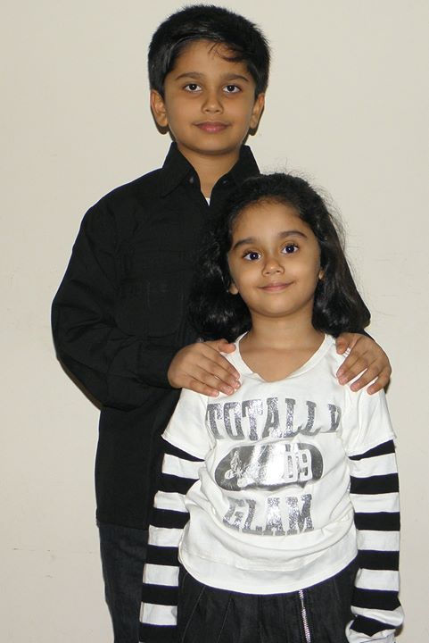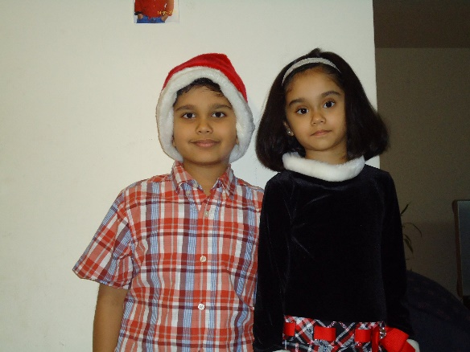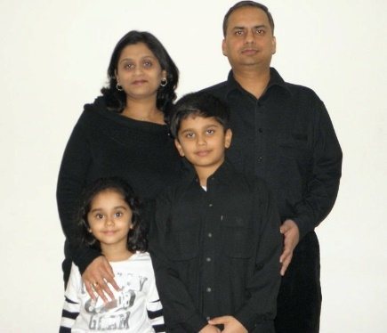

My mother, Rachana

My cousin, Karan

Vedant

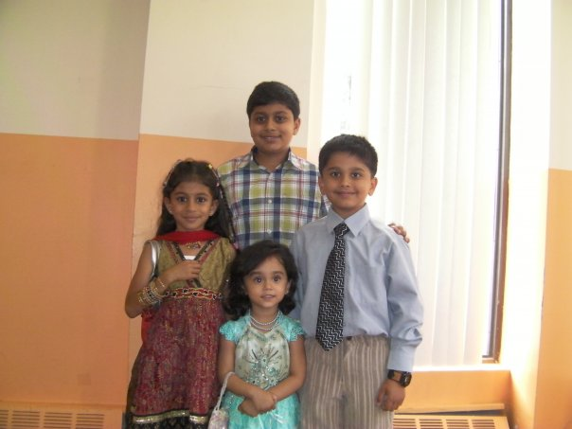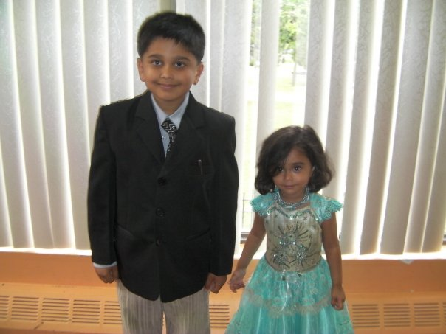

Palak

My cousin, Nidhi