MFE Assignment 1

Yang Ye

10/29/2018

## R Markdown

What’s normal distribution?

sample_norm <- rpois(1000, 3)  
hist(sample_norm)

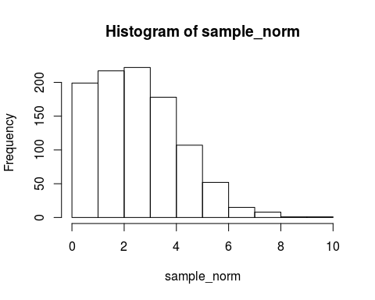

# chunk

## Random number

Give a random please, Gini! rnorm(1, 0, 1)

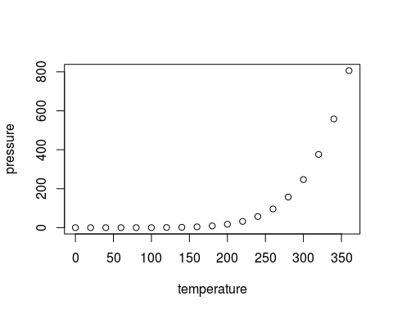

Note that the echo = FALSE parameter was added to the code chunk to prevent printing of the R code that generated the plot.