Debugging Quarto
#load data
dat <- read.csv("sat_data.csv", # FIX 1: correct file name
header = TRUE)
1. Calculate the standard error for the mean SAT score in Condition C.
# install.packages("dplyr") # FIX 2: DON'T install packages in a Quarto script
library(dplyr)
(se_c <- as.numeric(dat %>%
filter(condition == "c") %>%
summarize(SE = sd(score)/sqrt(nrow(.)))))
[1] 11.39762
2. Calculate the 95% confidence interval for the mean SAT score in Condition C.
n_c <- sum(dat$condition == "c")
mean_c <- mean(dat$score[dat$condition == "c"])
CI_c <- se_c*qt(p = .025,
df = n_c - 1,
lower.tail = FALSE)
upperCI_c <- mean_c + CI_c
lowerCI_c <- mean_c - CI_c
95%CI[518.46;564.26]
3. Create a plot of boxplots for SAT score by condition,
library(ggplot2) # FIX 3: load in packages before you use their functions (could instead load in tidyverse)
dat %>%
ggplot(aes(x = condition, y = score)) +
geom_boxplot(width = .25) +
ylim(c(200, 800))
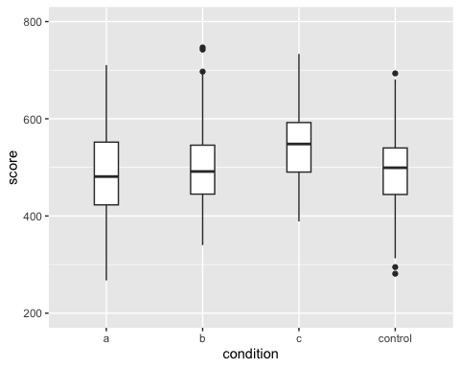
4. Create Q-Q plots by group for each condition. Make it so the plot matrix has two rows of two plots, instead of one row of four plots.
dat %>%
ggplot(aes(sample = score)) +
geom_qq() +
geom_qq_line() +
facet_wrap(. ~ condition) # FIX 4: spell "condition" correctly
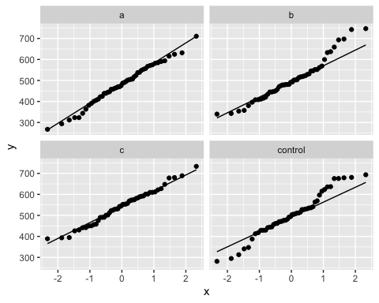
5. Run Levene’s test. Based on these results, as well as visual inspection of the plots you made, comment on whether the assumptions of normality and homogeneity of variance are violated.
library(car)
leveneTest(score ~ condition, dat)
Levene's Test for Homogeneity of Variance (center = median)
Df F value Pr(>F)
group 3 0.4305 0.7314
196
The assumption of homogeneity of variances has not been violated. However, it certainly seems that the distribution of group B presents a noticeable right-skewed, as both the violin plot and QQ plot show signs of non-normality. In addition, Shapiro-Wilk’s test also suggests a violation of the normality assumption for group B. Hence, one could be slightly concerned about including group B in the final analysis.
6. Find the standardized mean difference between Condition C and Control.
library(effectsize)
cohens_d(dat$score[dat$condition == "c"], dat$score[dat$condition == "control"])
Cohen's d | 95% CI
------------------------
0.44 | [0.04, 0.84]
- Estimated using pooled SD.
7. Perform a one way ANOVA for score based on condition, and call summary(). Then, without using eta_squared(), find $η^{2}$. HINT: you may be able to use some of the values from the summary() output as a shortcut. Check your work using eta_squared()
ANOVA <- aov(score ~ condition, dat)
(AOV_summary <- summary(ANOVA))
Df Sum Sq Mean Sq F value Pr(>F)
condition 3 98058 32686 3.712 0.0125 *
Residuals 196 1726034 8806
---
Signif. codes: 0 '***' 0.001 '**' 0.01 '*' 0.05 '.' 0.1 ' ' 1
Hand calculation:
(eta_sq <- (AOV_summary[[1]]$`Sum Sq`[1])/sum(AOV_summary[[1]]$`Sum Sq`))
[1] 0.05375696
Function output:
eta_squared(ANOVA)
For one-way between subjects designs, partial eta squared is equivalent
to eta squared. Returning eta squared.
# Effect Size for ANOVA
Parameter | Eta2 | 95% CI
-------------------------------
condition | 0.05 | [0.01, 1.00]
- One-sided CIs: upper bound fixed at [1.00].
8. Use omega_squared() to get ω2, then interpret the results of your analysis from questions 8 - 10.
omega_squared(ANOVA)
For one-way between subjects designs, partial omega squared is
equivalent to omega squared. Returning omega squared.
# Effect Size for ANOVA
Parameter | Omega2 | 95% CI
---------------------------------
condition | 0.04 | [0.00, 1.00]
- One-sided CIs: upper bound fixed at [1.00].
The F-ratio is significantly different from 0, which implies that the effect of tutoring on SAT results is unlikely to be due to chance. However, both $η^{2}$ and $ω^{2}$ suggest that this effect is rather small, with condition only accounting for around 4% of the variance in SAT scores.

Extra Credit (10 points)
The expected population mean of SAT scores on the math section is 500, with SD = 100.
- Find the 95% confidence interval using a normal distribution for a sample of size 5 with mean = 500, SD = 100.
se_1 <- 100/sqrt(5)
upperCI_1 <- 500 + (1.96*se_1)
lowerCI_1 <- 500 - (1.96*se_1)
cat(paste0("95%CI[", round(lowerCI_1, 2), ";", round(upperCI_1, 2), "]"))
95%CI[412.35;587.65]
- Find the 95% confidence interval using a normal distribution for a sample of size 500 with mean = 500, SD = 100.
se_2 <- 100/sqrt(500)
upperCI_2 <- 500 + (1.96*se_2)
lowerCI_2 <- 500 - (1.96*se_2) # FIX 5: need to define lowerCI_2 earlier in the script than when we refer to it
cat(paste0("95%CI[", round(lowerCI_2, 2), ";", round(upperCI_2, 2), "]"))
95%CI[491.23;508.77]
- Find the 95% confidence interval using a t-distribution, instead of a normal distribution for a sample of size 5 with mean = 500, SD = 100.
se_3 <- 100/sqrt(5)
upperCI_3 <- 500 + (qt(p = .025, df = 5 - 1,lower.tail = FALSE)*se_3)
lowerCI_3 <- 500 - (qt(p = .025, df = 5 - 1,lower.tail = FALSE)*se_3)
cat(paste0("95%CI[", round(lowerCI_3, 2), ";", round(upperCI_3, 2), "]"))
95%CI[375.83;624.17]
- Find the 95% confidence interval using a t-distribution, instead of normal distribution, for a sample of size 500 with mean = 500, SD = 100
se_4 <- 100/sqrt(500)
upperCI_4 <- 500 + (qt(p = .025, df = 500 - 1,lower.tail = FALSE)*se_4)
lowerCI_4 <- 500 - (qt(p = .025, df = 500 - 1,lower.tail = FALSE)*se_4)
cat(paste0("95%CI[", round(lowerCI_4, 2), ";", round(upperCI_4, 2), "]"))
95%CI[491.21;508.79]

