let productName = "Hammer",
productId = "H123";
console.log(productName, productId);

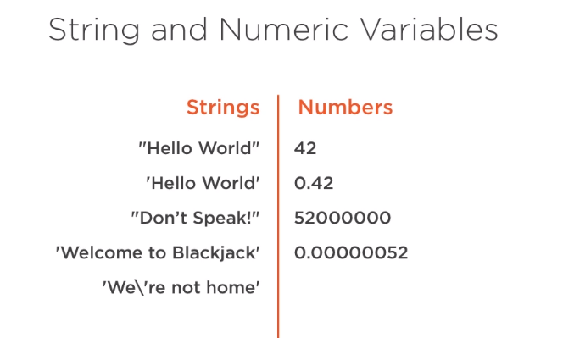

let productName = "John\'s Hammer",
price1 = 5,
price2 = 2,
firstName = "John",
lastName = "Doe";
console.log(productName);
console.log(price1, price2);
console.log(firstName + " " + lastName);

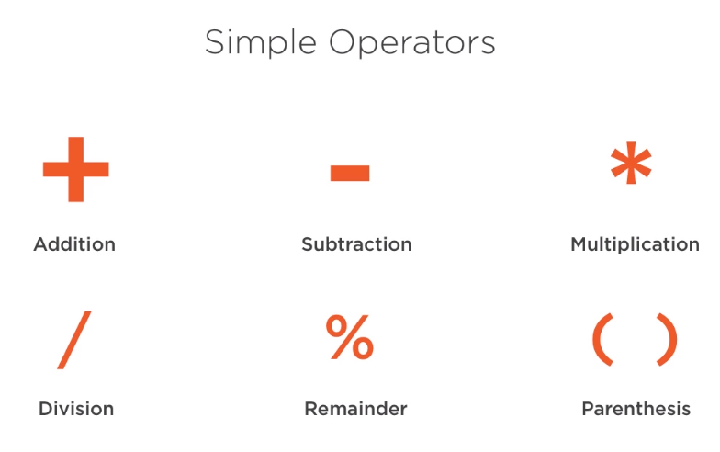

let first = 12,
second = 6,
third = (3 + 4) * 5,
fourth = 3 + (4 * 5);
let answer = first + second;
console.log(answer);
console.log(third);
console.log(fourth);

//Commenting Code
// This is a comment
//
// This is a comment
//
/*
This is a comment
*/
let name = "Jackfruit"; // This is a comment

/*
Blackjack
by Leah Joyce
*/
let card1 = "Ace of Spades",
card2 = "Ten of Hearts";
console.log("Welcome to Blackjack!");
console.log("You are dealt: ");
console.log(" " + card1);
console.log(" " + card2);
Types Basics : Strings and Numbers
let value = "apple",
value1 = 9;
console.log( typeof(value) );
console.log( typeof(value1) );

Boolean Types
let value = false,
calculateSalesTax = true;
console.log( typeof(value) );
console.log(calculateSalesTax, typeof(calculateSalesTax) );

// undefined and null
let calculateSalesTax,
tax;
calculateSalesTax = null;
console.log(calculateSalesTax, typeof(calculateSalesTax));
console.log(tax);

// Storing Multiple values using an Array
//Create an Array
let values = [1, 2, 3];
console.log(values[0]); //1
console.log(values[1]); //2
console.log(values[2]); //3
console.log(values[3]); // undefined
let cards = ["Ace", "King", "Queen", "Jack"];
console.log(cards[0]); //Ace
console.log(cards[1]); //King
console.log(cards[2]); //Queen
console.log(cards[3]); //Jack
console.log(cards[4]); //undefined
// Array Features
//.push()
let values = [];
values.push(44);
values.push(33);
console.log(values); // [44, 33]
// .length
let cities = ['New York', 'Los Angeles', 'Chicago'];
console.log(cities.length); //3

//.pop()
let values = [1, 2, 3];
values.pop();
console.log(values);

//.shift()
let values = [1, 2, 3];
values.shift();
console.log(values);
// .splice()
let values = [1, 2, 3, 4];
values.splice(3, 1);
console.log(values); //[1, 2, 3]
let values = [1, 2, 3, 4];
values.splice(0, 3, 11, 22, 44);
console.log(values); [11, 22, 44, 4]
// Adding Arrays to Blackjack

let deck = [
"Ace of Spades",
"Two of Spades",
"Three of Spades"
];
let playerCards = [deck[0], deck[2]];
console.log("Welcome to Blackjack!");
console.log("You are dealt: ");
console.log(" " + playerCards[0]);
console.log(" " + playerCards[1]);

/* Welcome to Blackjack!
script.jsYou are dealt:
script.js:13 Ace of Spades
script.js:14 Three of Spades
*/

References

Array Methods
https://developer.mozilla.org/en-US/docs/Web/JavaScript/Reference/Global_Objects/Array

Array

The JavaScript Array object is a global object that is used in the construction of arrays; which are high-level, list-like objects.
Create an Array
var fruits = ['Apple', 'Banana'];

console.log(fruits.length);
// 2
Access (index into) an Array item
var first = fruits[0];
// Apple

var last = fruits[fruits.length - 1];
// Banana
Loop over an Array
fruits.forEach(function(item, index, array) {
console.log(item, index);
});
// Apple 0
// Banana 1
Add to the end of an Array
var newLength = fruits.push('Orange');
// ["Apple", "Banana", "Orange"]
Remove from the end of an Array
var last = fruits.pop(); // remove Orange (from the end)
// ["Apple", "Banana"];
Remove from the front of an Array
var first = fruits.shift(); // remove Apple from the front
// ["Banana"];
Add to the front of an Array
var newLength = fruits.unshift('Strawberry') // add to the front
// ["Strawberry", "Banana"];
Find the index of an item in the Array
fruits.push('Mango');
// ["Strawberry", "Banana", "Mango"]

var pos = fruits.indexOf('Banana');
// 1
Remove an item by index position
var removedItem = fruits.splice(pos, 1); // this is how to remove an item

// ["Strawberry", "Mango"]
Remove items from an index position
var vegetables = ['Cabbage', 'Turnip', 'Radish', 'Carrot'];
console.log(vegetables);
// ["Cabbage", "Turnip", "Radish", "Carrot"]

var pos = 1, n = 2;

var removedItems = vegetables.splice(pos, n);
// this is how to remove items, n defines the number of items to be removed,
// from that position(pos) onward to the end of array.

console.log(vegetables);
// ["Cabbage", "Carrot"] (the original array is changed)

console.log(removedItems);
// ["Turnip", "Radish"]
Copy an Array
var shallowCopy = fruits.slice(); // this is how to make a copy
// ["Strawberry", "Mango"]

let score = 1000;
if (score >= 1000) {
score = score + 100;
}
console.log("Score is: ", score); // 1100

let score = 1000;
if (score != 1000) {
score = score + 100;
}
console.log("Score is: ", score); // 1000

let score = 1000;
if (score > 1000) {
score = score + 100;
}
else if (score === 1000) {
console.log("Almost");
}
else {
console.log("Nice try!")
}
console.log("Score is: ", score); // 1000

