Website Planning Document

Predictor

Author: Leah DeSpain Tomlinson

Site Purpose

Predictor will provide concise weather information at easy access to anyone with an Internet browser. It will relay information such as current temperatures and conditions as well as provide weather related stories.

Target Audience

We expect visitors from all walks of life but typically the people that will be using this site will be anywhere from early 20s to mid 30s. It will likely be those who are in need of quick information mostly such as college students and young professionals. These will generally be those who are unmarried and likely do not choose to have access to normal weather outlets like news channels.

Site Map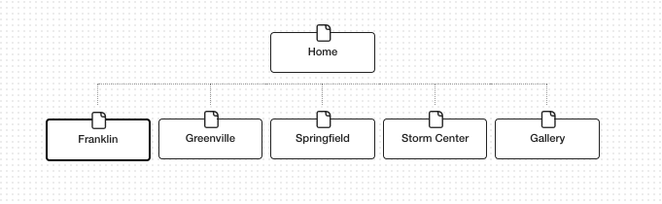

Color Scheme

The colors that we will be using on the site will be yellow blue and gray because they represent the colors of the sky and also because it will appeal to the youthfulness of our audience while still creating trust. We believe that the overall color scheme will enhance the user experience without distracting the overall message.

Macintosh SSD:Users:leahdespain:Desktop:Screen Shot 2017-10-07 at 1.06.47 PM.pngMacintosh SSD:Users:leahdespain:Desktop:Screen Shot 2017-10-07 at 1.07.07 PM.pngMacintosh SSD:Users:leahdespain:Desktop:Screen Shot 2017-10-07 at 1.07.29 PM.png

Typography

As for typography we will be using a Open sans condensed for all aspects EXCEPT for paragraphs which will be in open sans.