**TimeQuest**



**User Manual**

ECSE 424

November 12, 2019

# TABLE OF CONTENTS

1. **Introduction**
2. **App setup process**
3. **Step-by-step procedures**
4. **Contact**

# INTRODUCTION

**Project**

TimeQuest is an android application built to help users limit their phone usage. The goal of this app is not to restrict access but encourage and motivate users to save time throughout the day. This manual offers all the steps required for setting up the app and offers a set of instructions to go through the app.

**Suggested hardware**

We recommend running the application on an emulator (Pixel 3 API 29). Optionally the app can be run on an android phone with an updated OS and that is plugged to the computer using a USB cable. We recommend using an emulator since there might be unexpected bugs with new/different devices.

For questions on how to run the APK please contact us (contact info on last page).

**Alpha-system limitations**

For the purpose of testing only main features will be available on the app, which means not all features will be fully working/available.

**App Installation**

First download the APK file listed under the prototype implementation section.

To install the APK please use the following steps:

1. Before you can install it on your phone you will need to make sure that third-party apps are allowed on your device.
2. Go to **Menu > Settings > Security >** and check **Unknown Sources** to allow your phone to install apps from sources other than the Google Play Store.
3. **Newer versions of Android do things a little differently**. Rather than check a global setting to allow installation from unknown sources, you'll be prompted to allow your browser or file manager to install APKs the first time you attempt to do so.
4. If you like, you can also download a file manager app so you can easily find files on your Android device. We recommend our favorite file managers in our list of the [best file explorers for Android](https://www.androidpit.com/best-android-file-manager).
5. Once you've downloaded the APK file on your computer, connect your Android device to it.
6. At this point, you may be asked if you want to charge your phone or connect it as a 'media device.' Choose **Media device**.

1. Then, find your phone's folder on your computer. It will be in 'My Computer' or 'Computer' on Windows (PC).
2. Copy the APK file into a folder of your choice in your Android smartphone.
3. You will now be able to search for the file location in the **My files** folder of your device.
4. Find the APK file, tap it, then hit install.
5. Before testing the app, you will need to give it permission to view your app usage. Head over to Settings and open “Usage information access” under “Apps”. This will vary on every android device. Use the search bar in settings to find it.
6. Turn on “usage information access” for TimeQuest.

# APP SETUP

When first launching the app, the user will be prompted to login or sign up. They will then be greeted with a series of setup pages.

**Login screen**

The login screen allows the user to sign in into his account to be able to access the app. The user must enter their email in the username text field and his password underneath. After entering the required data just tap the login button.

For first time users a signup button is provided to create an account. Enter an email, full name and password and tap the signup button.

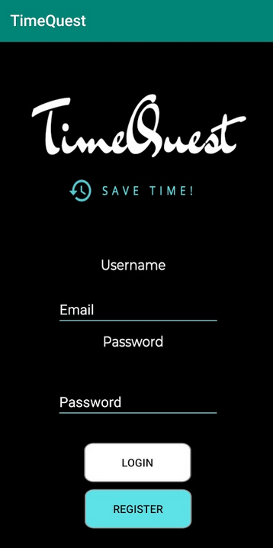 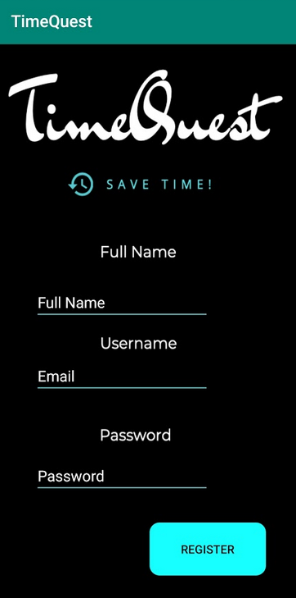

**Usage limit**

This page gives the option to choose one of the three usage limits: Limit total usage, limit by app and limit by category.

Choosing the first option by tapping on it brings a page that prompts the user to enter the time he wants to save. Once a time is chosen, tap the “Let’s go” button. If the second option is chosen, then a page with the list of all installed (non-system) apps shows up. The user should choose from the list of apps he wants to monitor, and once done, taps the “Let’s go” button.

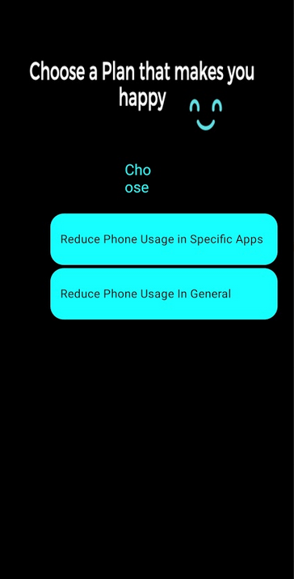 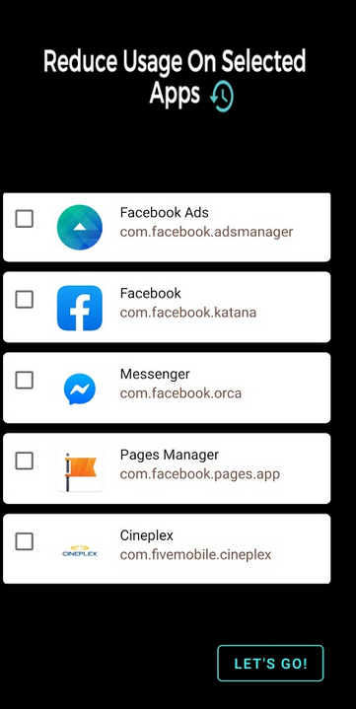 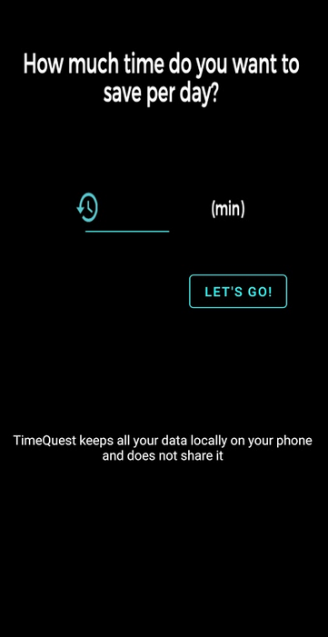

# STEP-BY-STEP PROCEDURES

**Checking today’s usage**

1. Open the application through the emulator or using an android phone. You will be greeted with the usage progress ring for the day. Scrolling down will bring a more detailed graph of your app usage per day. This data is taken from the apps you selected in the list at the beginning.

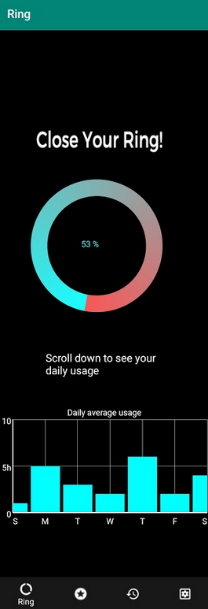

**Viewing a detailed daily usage history**

1. Tapping the “history” icon on application tab in the bottom will take you to the history page where you’ll see a calendar with your progress for each day in the past. Choose a date and tap “get results” to view how much of your goal you achieved that day.

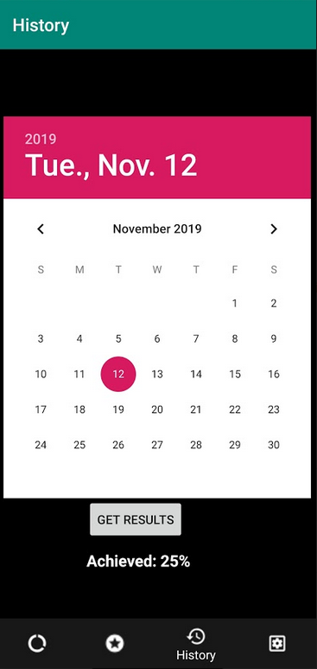

**Viewing your awards**

1. Tapping the “rewards” icon on the application tab in the bottom will take you to the rewards page where all your earned rewards from previous competitions will show up.

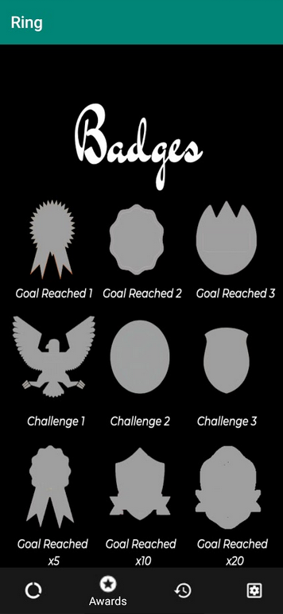

**Changing settings and logging out**

1. Tapping the “settings” icon on the application tab in the bottom will take you to the settings page where users can change their password, edit their time goals and logout out of their account.

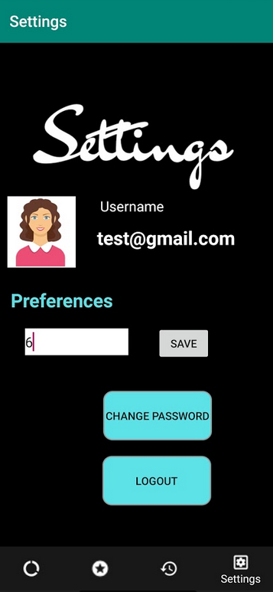

# CONTACT DETAILS

Abed Atassi - [abed.atassi@mail.mcgill.ca](mailto:abed.atassi@mail.mcgill.ca)

Mark Kuhn – [mark.kuhn@mail.mcgill.ca](mailto:mark.kuhn@mail.mcgill.ca)

Lea Akkari – [lea.akkari@mail.mcgill.ca](mailto:lea.akkari@mail.mcgill.ca)