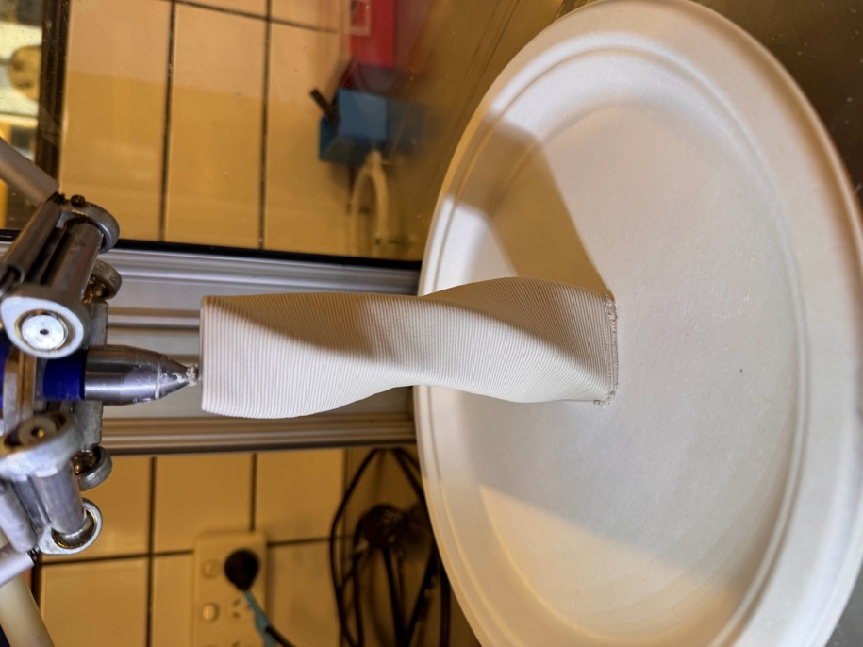twised-square-72g-3mm-2base.gcode | 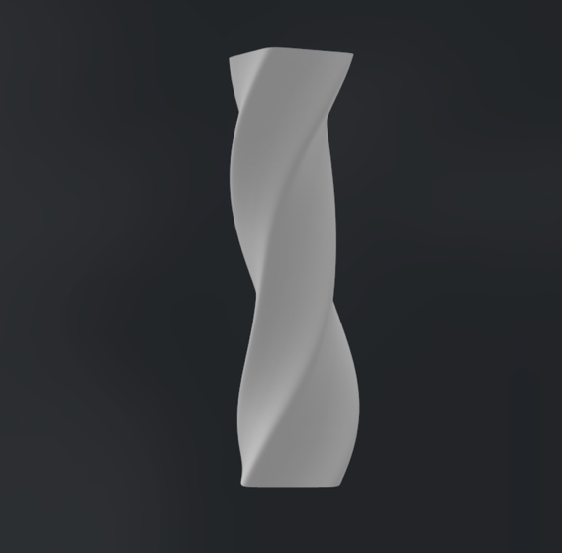 | 001
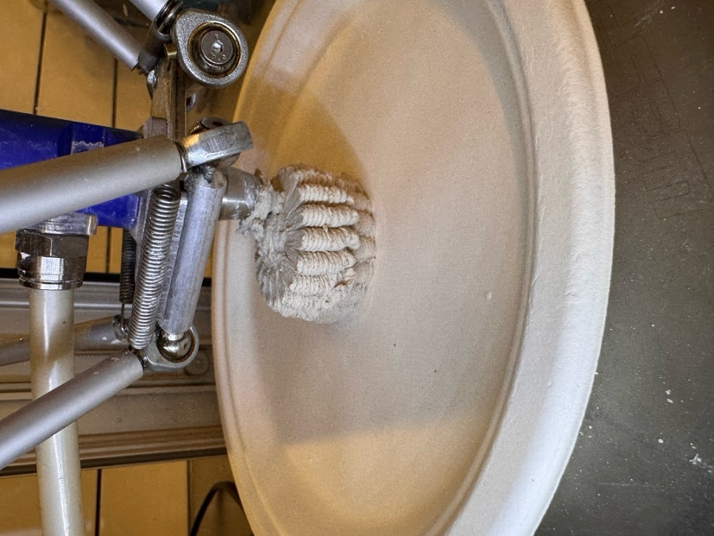  folded-lantern-114g-3mm-2base.gcode | 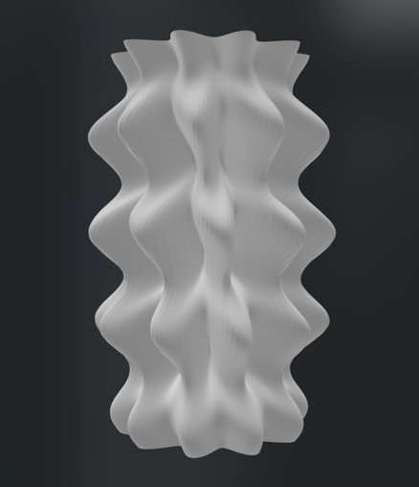 | 002
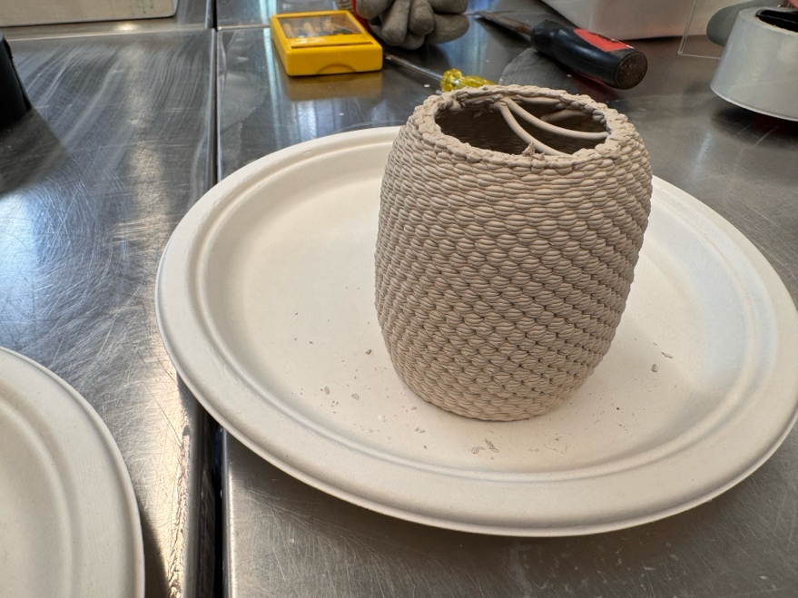  CHECK:  berryvesselBase3mm.gcode | 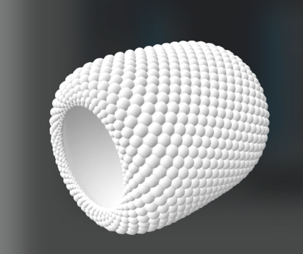  berryvessel.stl  003.gcode | 003
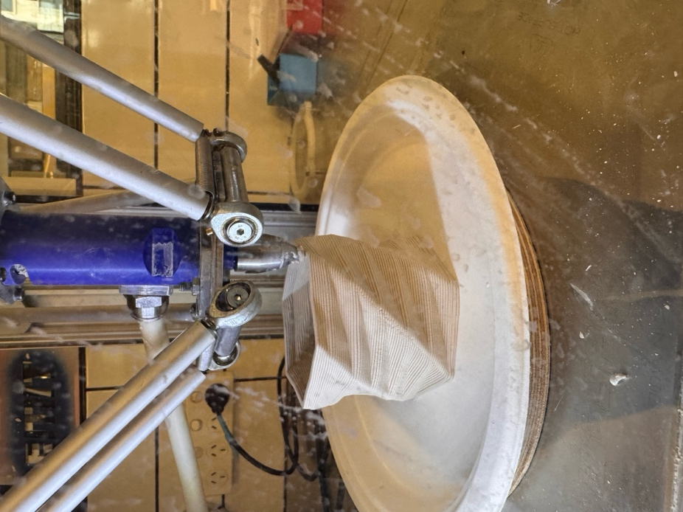  edged-cyclinder-3mm-2laybase-89g.gcode | 004.gcode | 004
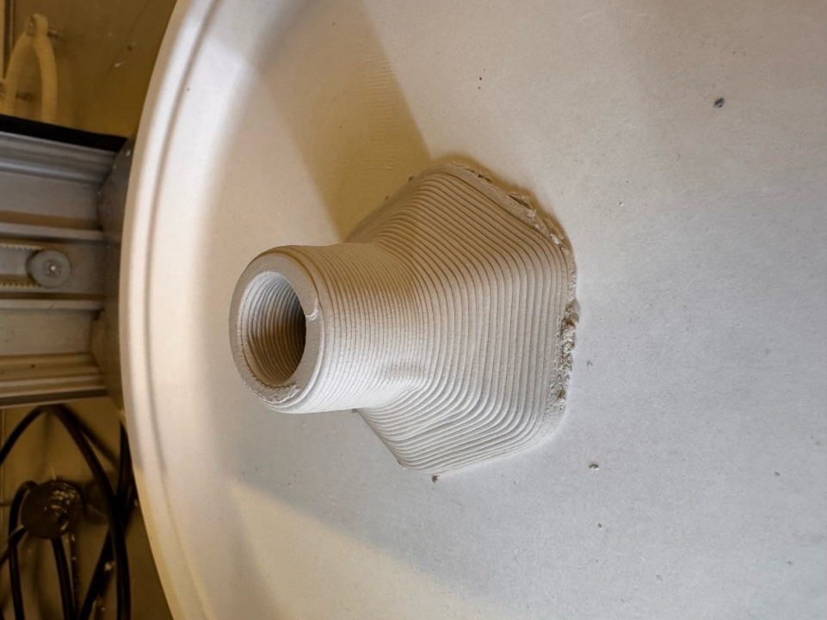  funnelaerowithbasez43.gcode | 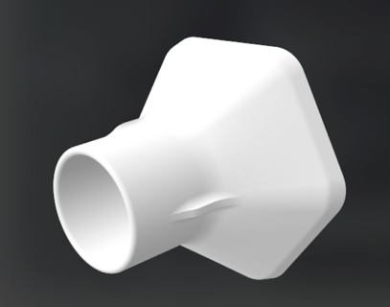  funnelaero.stl | 005
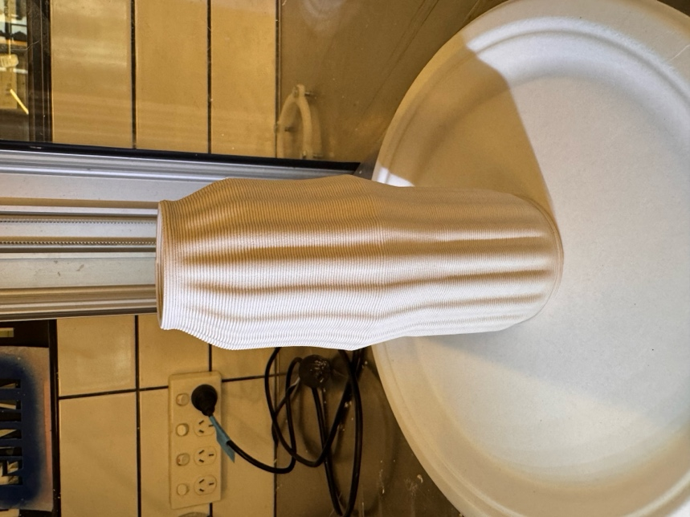  rouleau_texture_vase_3mm_v1.gcode | Without texture:  rouleau_vase_3mm_v1.gcode | 006
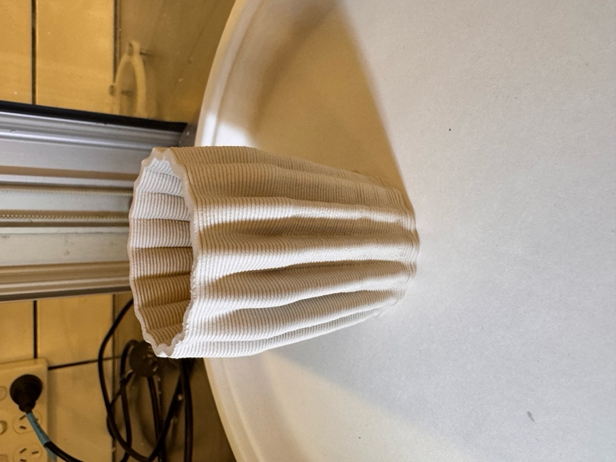  folded-lantern-91g-3mm-2base.gcode | 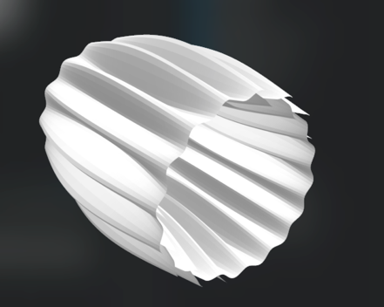  folded-lantern-side.stl | 007
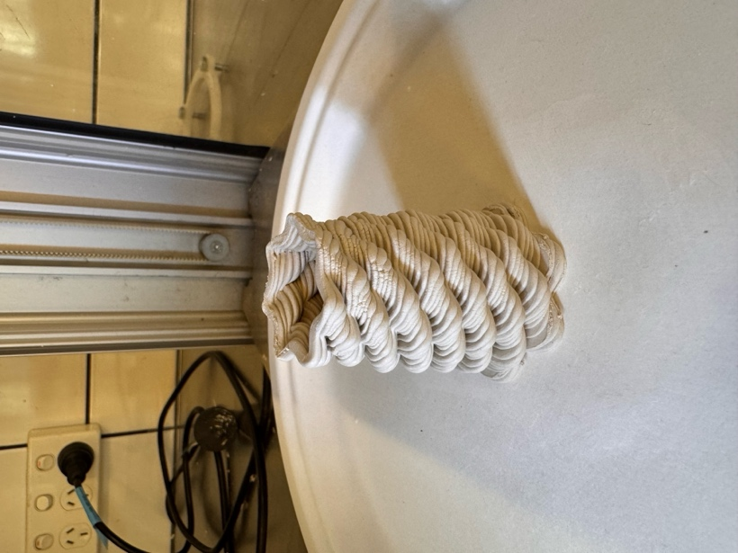  bubbles-twist-33g-3mm-2base.gcode | 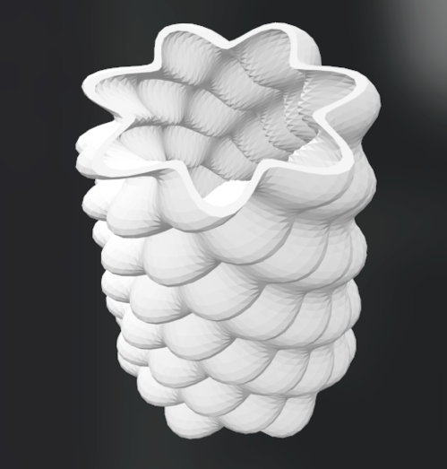  bubbles-twist.stl  008.gcode | 008
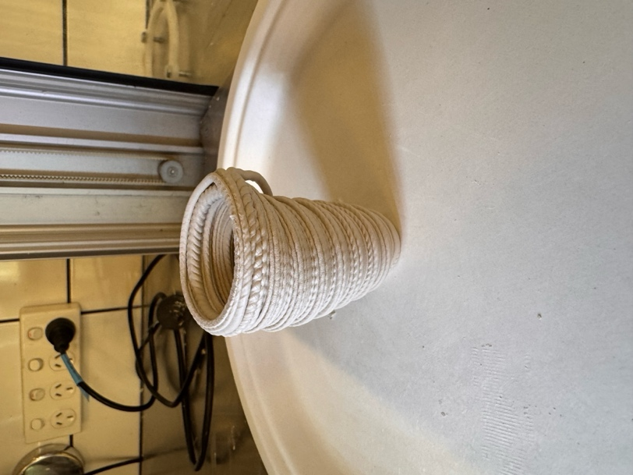  divs-vase-34g-3mm-2base.gcode | 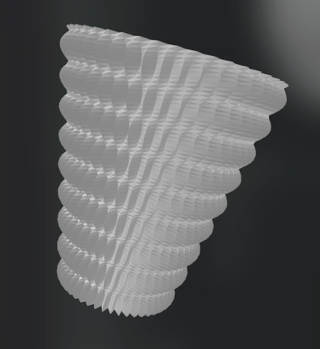  divs-vase.stl | 009
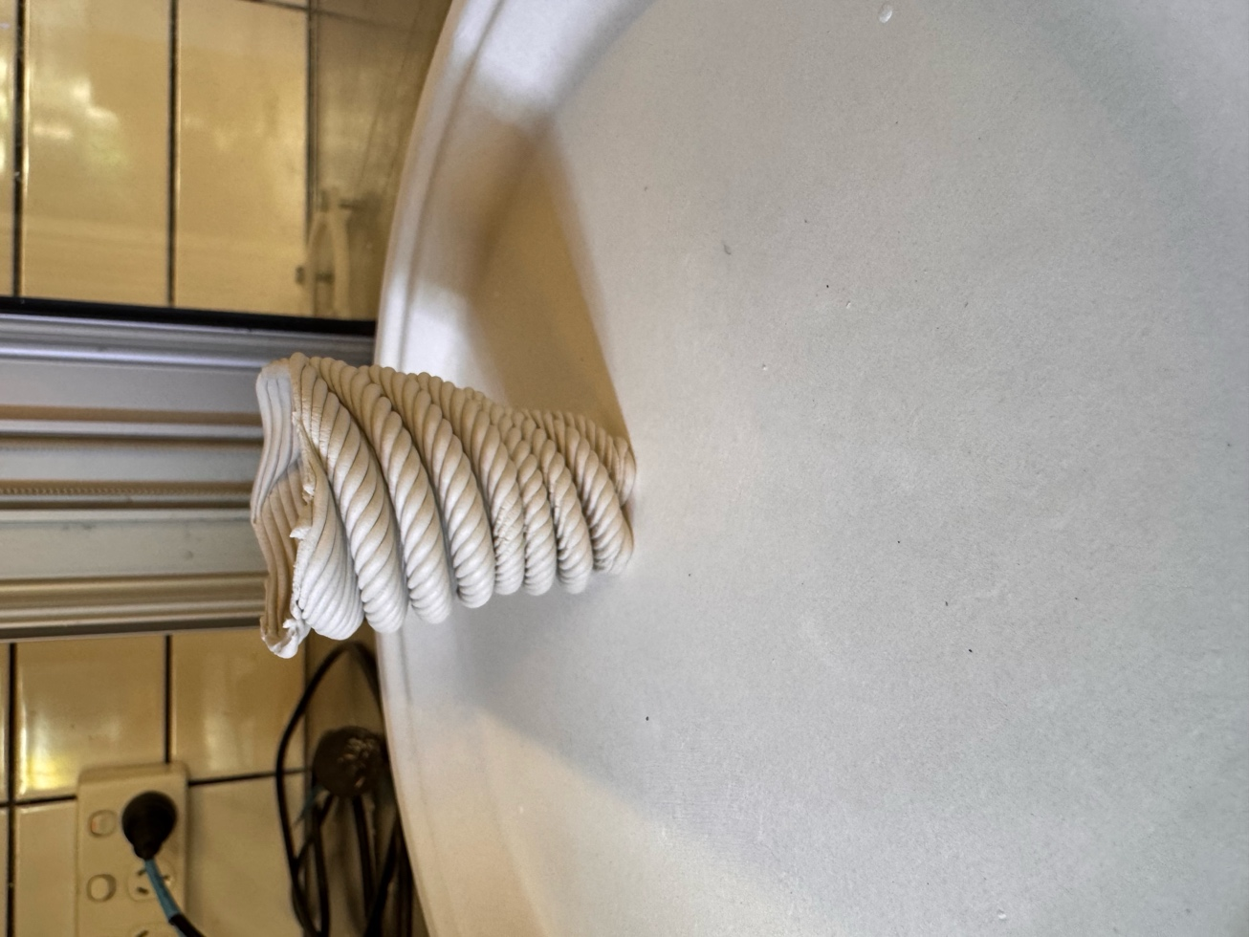  spiral-35g-3mm-2base.gcode | 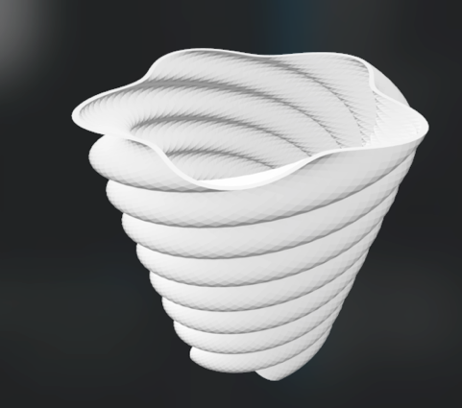  spiral.stl | 010
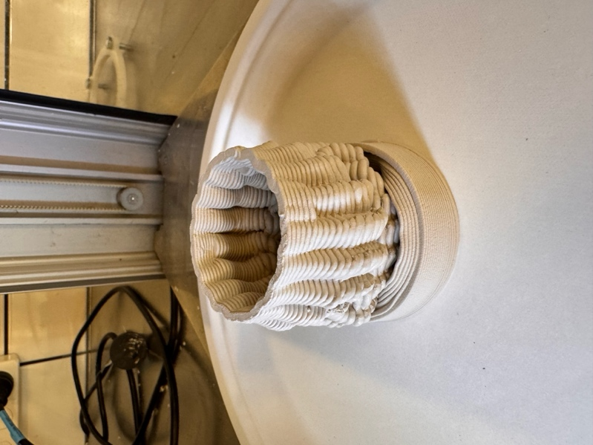  two-component-78g-3mm-2base.gcode |  | 011
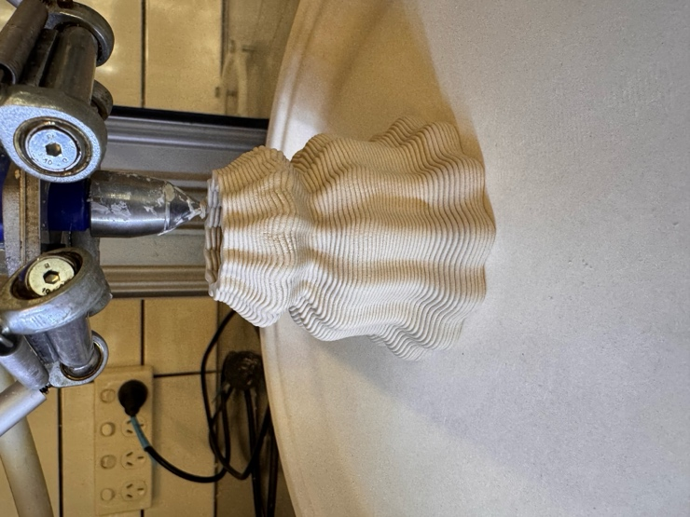  fluid-vase-3mm-2laybase-69g.gcode |  | 012
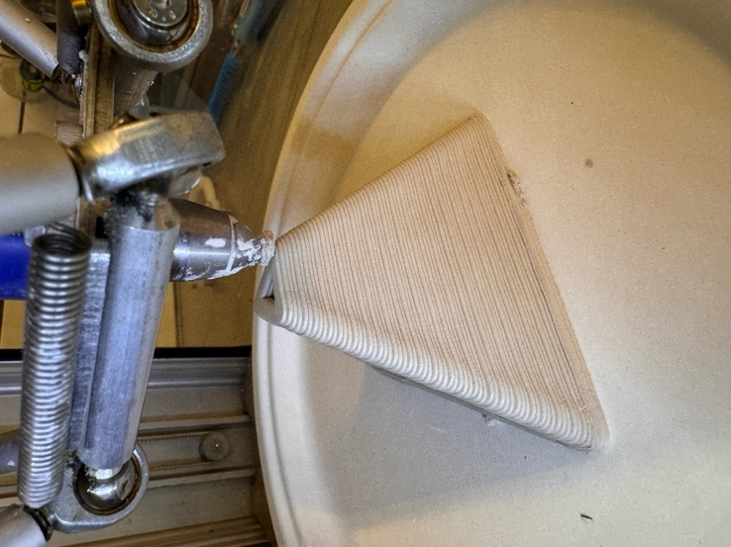 |   Tetraeder.stl | 013
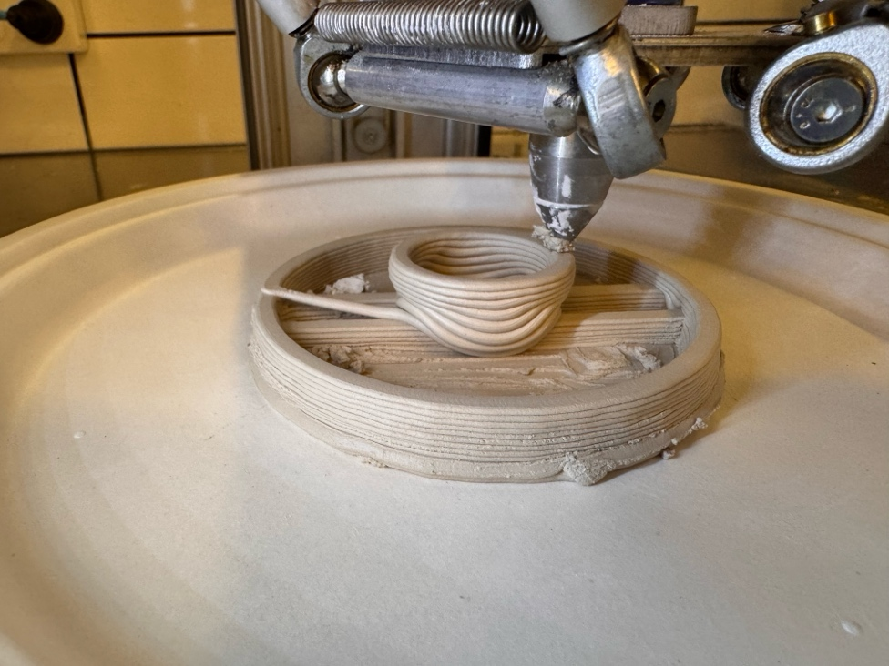  slotted-disk-test-3mm-2laybase-34g.gcode | 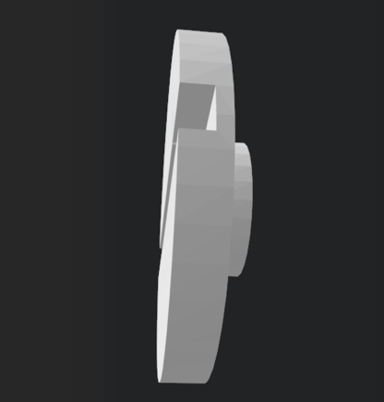  slotted-disk.stl | 014
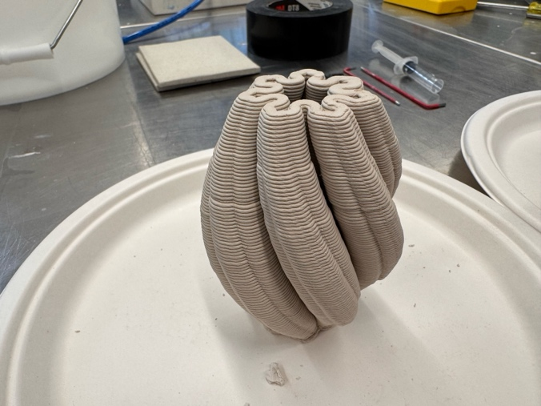 | Might be:  181026_julia_z7_700_VERSION_2.stl | 015
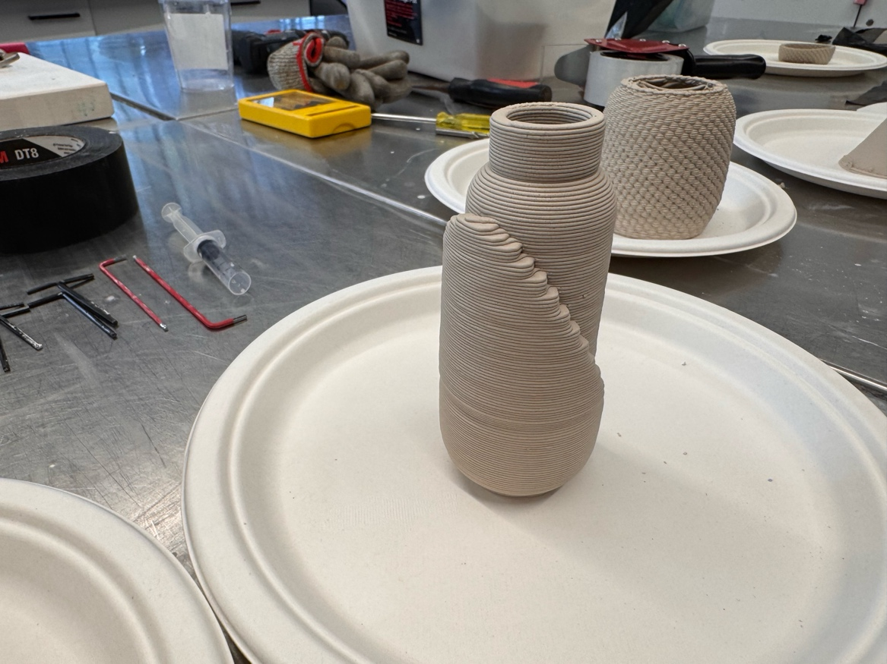 | Might be:  step-vase-42g-3mm-2base.gcode  inlay bottle/  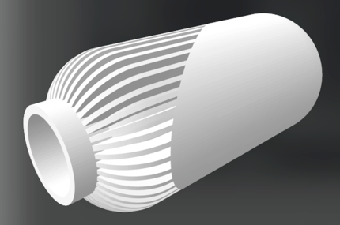  yaovase.stl | 016
gcode_march/  vase_basic_53g_3mm.gcode | 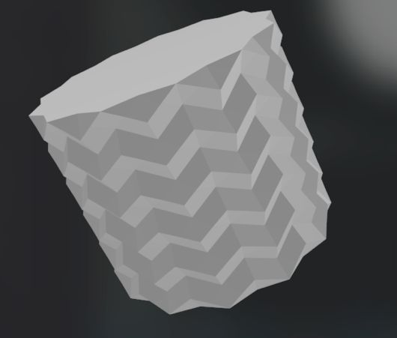CFFFP_clean_vase_basic.stl | 017
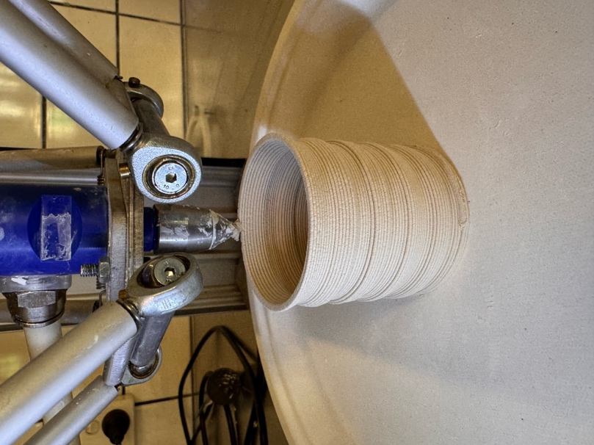  step-vase-42g-3mm-2base.gcode | 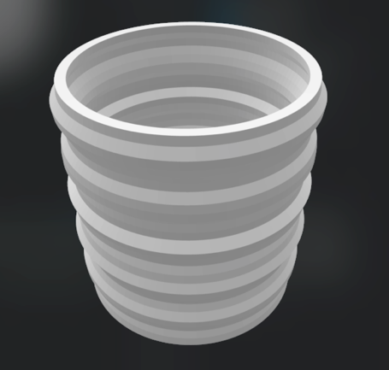  step-vase.stl | 018
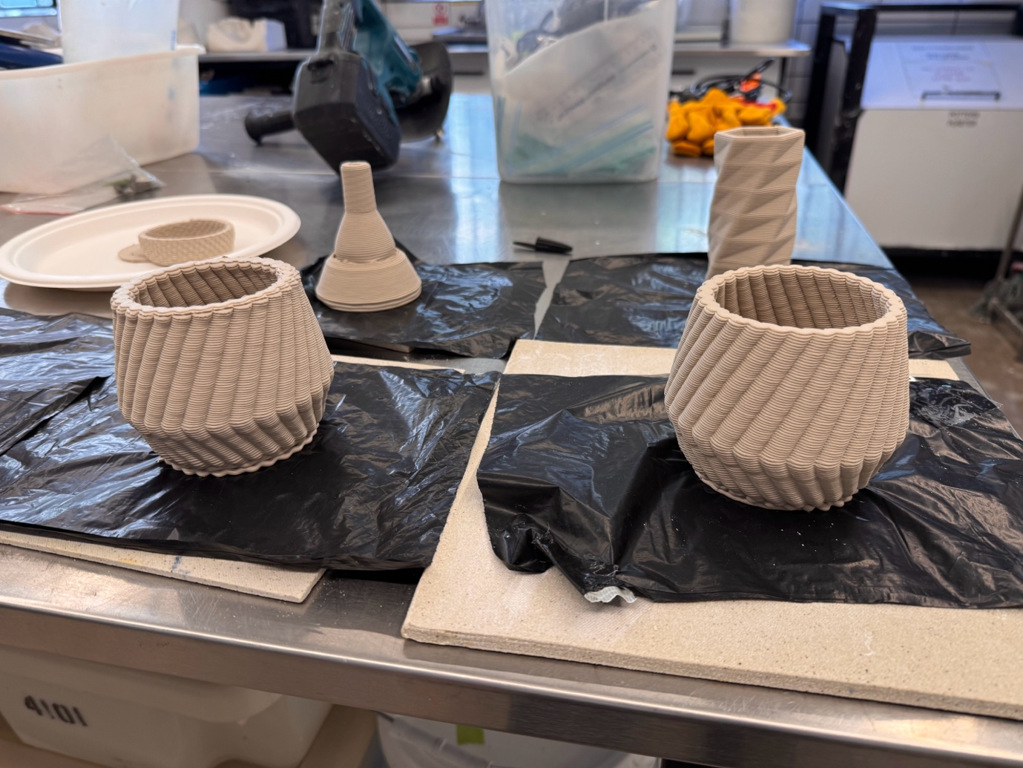 | 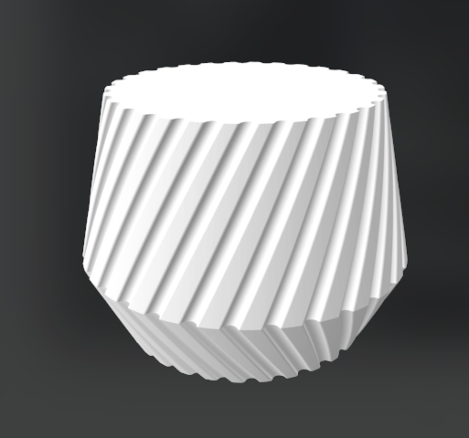  vase_geo_slim.stl | 019
cube-3mm-2laybase-51g.gcode | 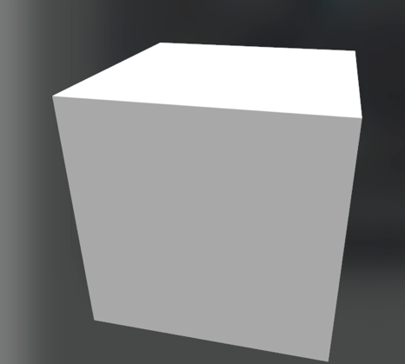  Hexaeder.stl  020.gcode | 020
ikosaeder-3mm-40sec-64g.gcode | 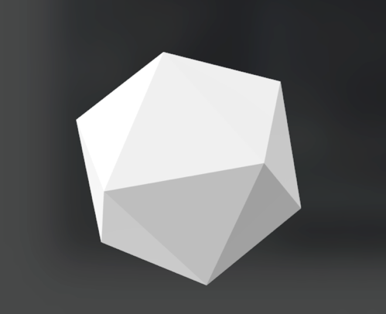  Ikosaeder.stl | 021
dodekaeder-3mm-40sec-61g.gcode | 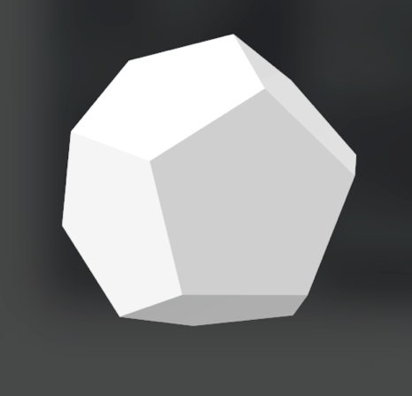  dodekaeder.stl  022.gcode | 022
oktaeder-3mm-40sec-57g.gcode |   Oktaeder.stl | 023
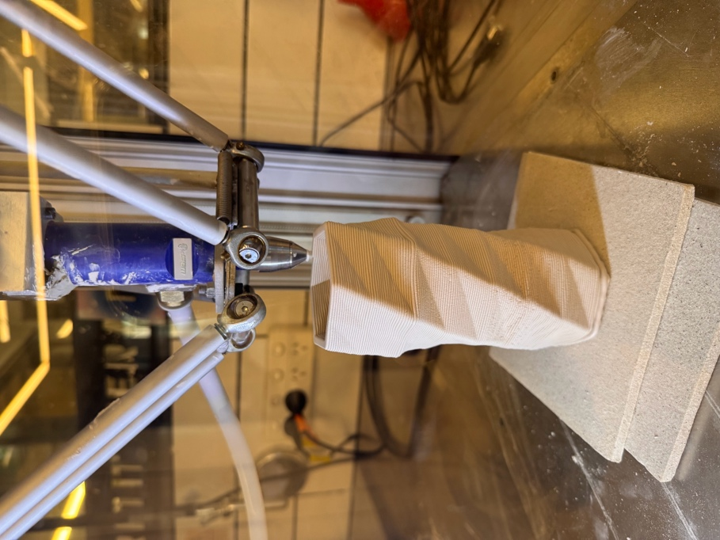  vase_basic_z99.gcode  *recreated 08/03/26 | 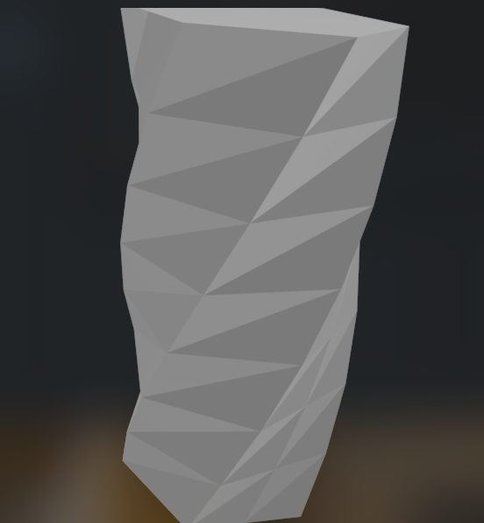vase_basic.stl | 024
 | 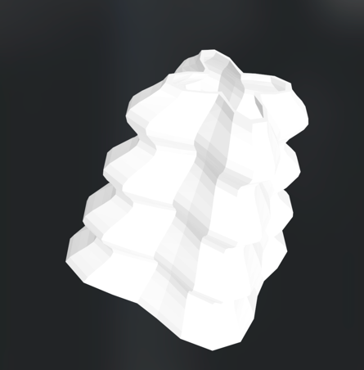  025.stl | 025
 | 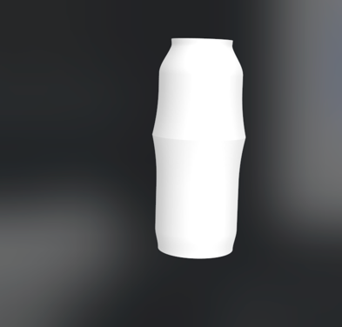  rouleau_vase_v1.stl | 026
 | 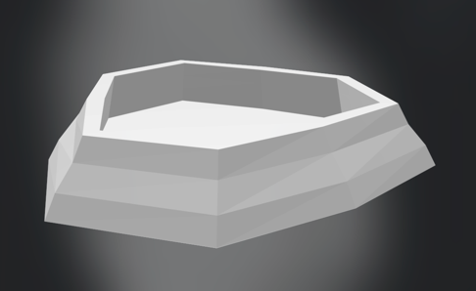  027.stl | 027
 | 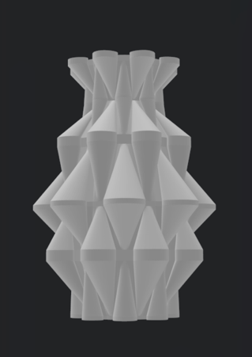  028.stl | 028
 | 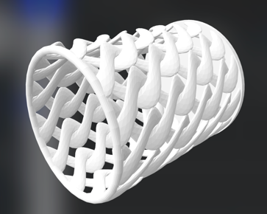  029.stl | 029
 | 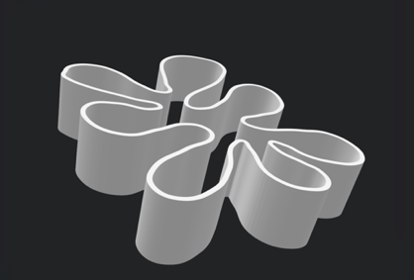  030.stl | 030
 | 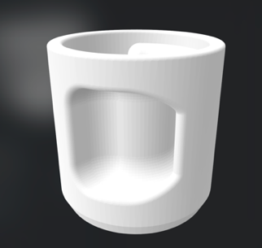  031.stl | 031
 | 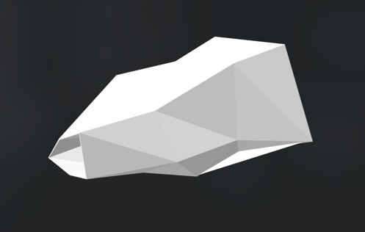  0.32stl | 032

