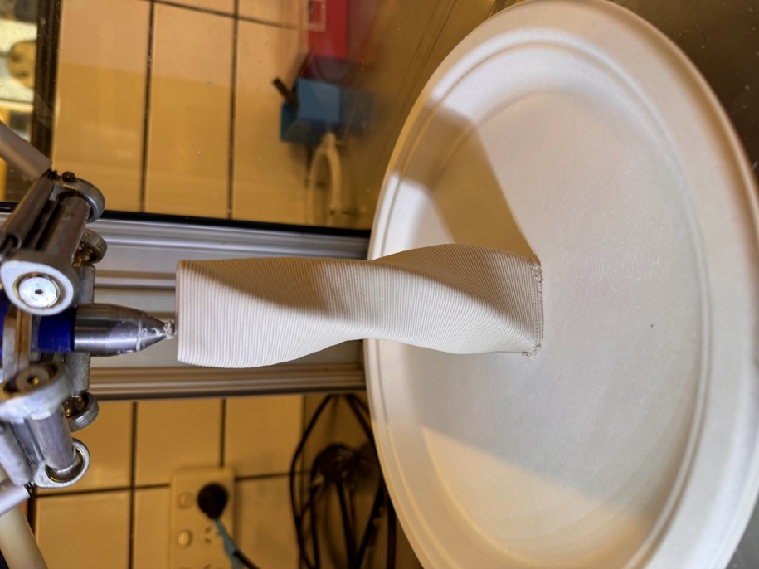twised-square-72g-3mm-2base.gcode

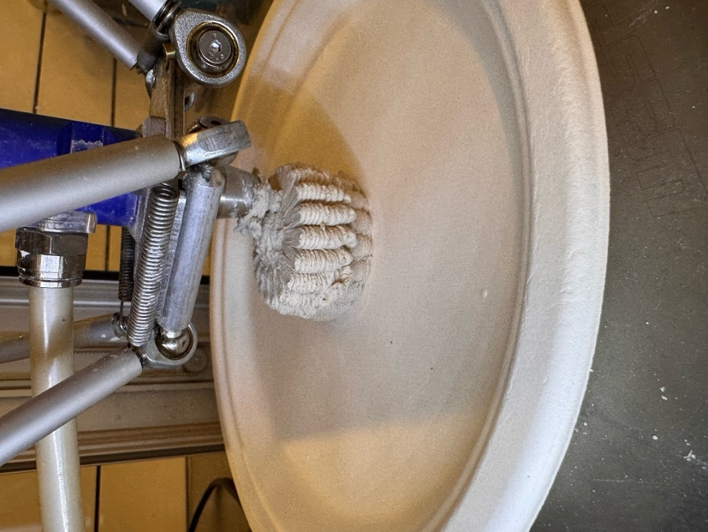
folded-lantern-114g-3mm-2base.gcode

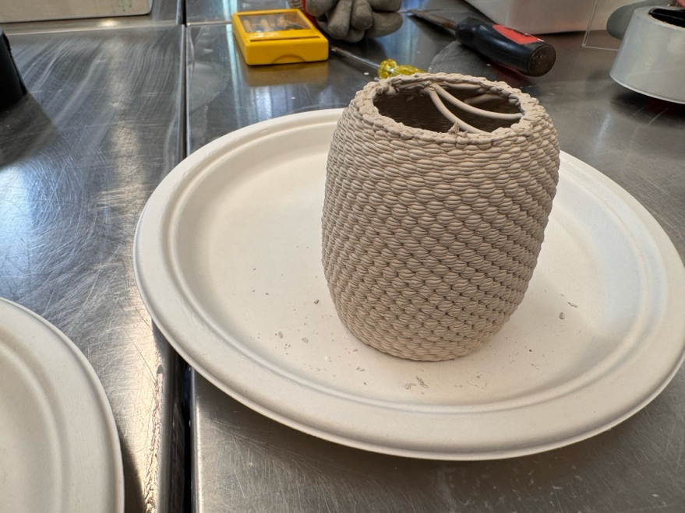  CHECK:  berryvesselBase3mm.gcode | 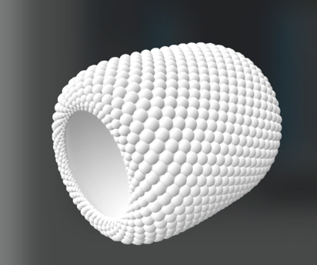  berryvessel.stl
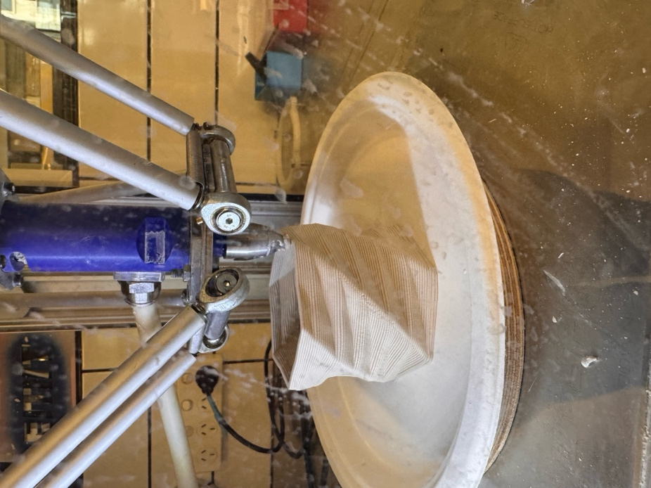
edged-cyclinder-3mm-2laybase-89g.gcode

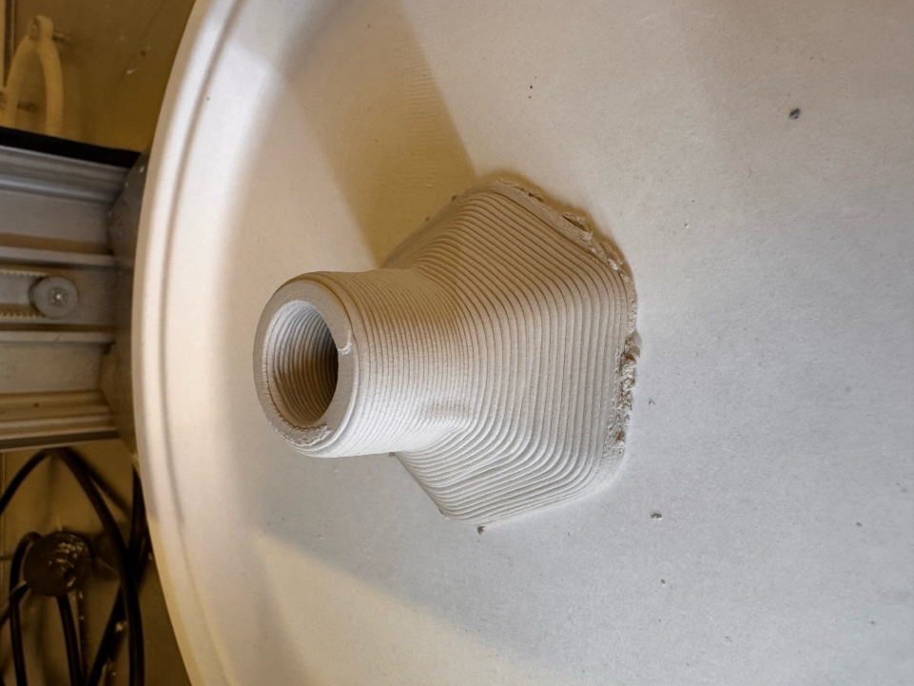  funnelaerowithbasez43.gcode | 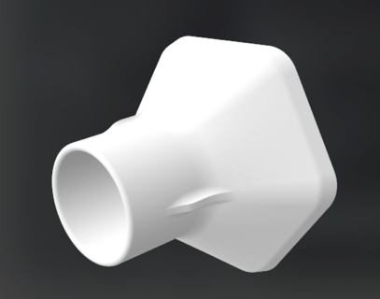  funnelaero.stl
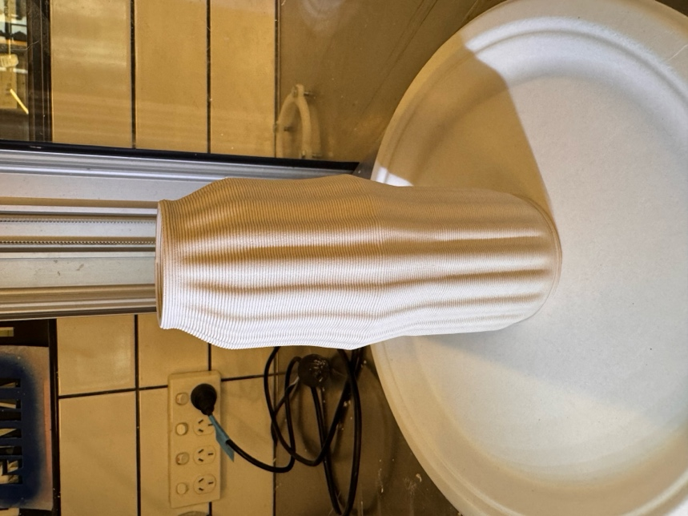  rouleau_texture_vase_3mm_v1.gcode | Without texture:  rouleau_vase_3mm_v1.gcode
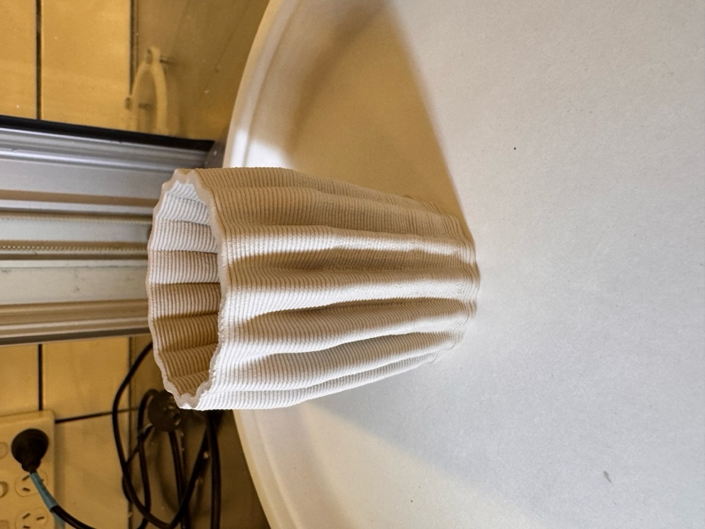  folded-lantern-91g-3mm-2base.gcode | 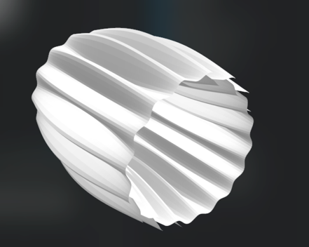  folded-lantern-side.stl
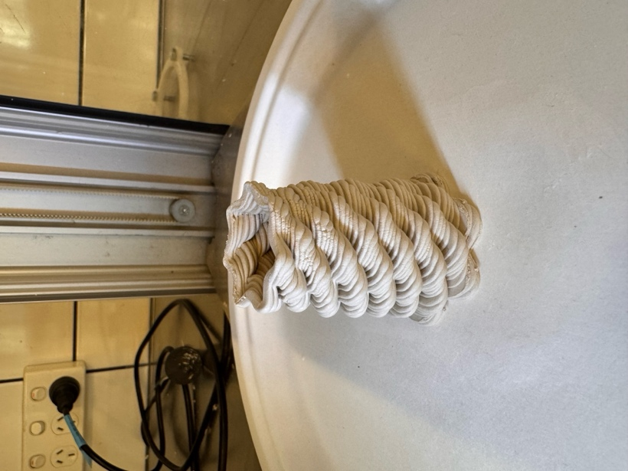  bubbles-twist-33g-3mm-2base.gcode | 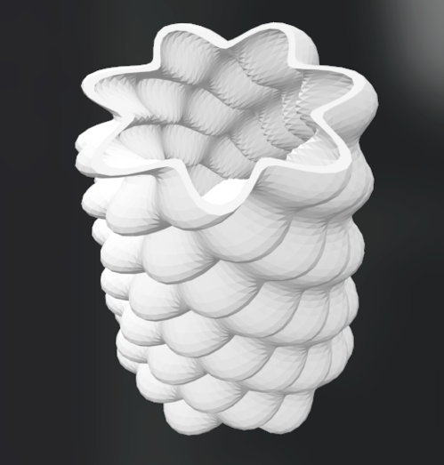  bubbles-twist.stl
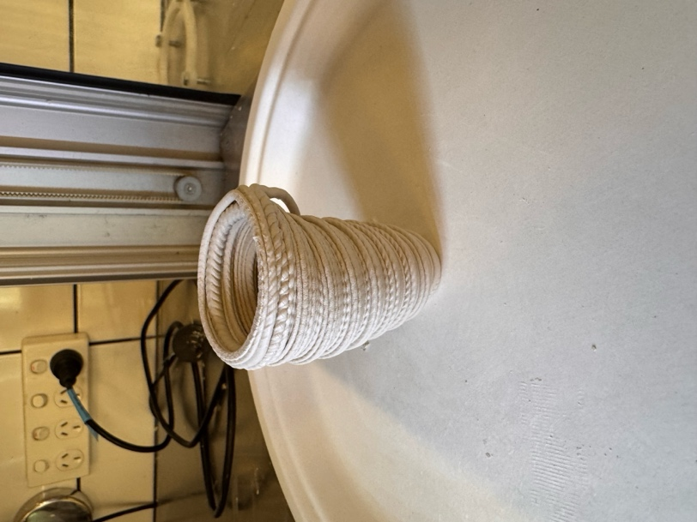  divs-vase-34g-3mm-2base.gcode | 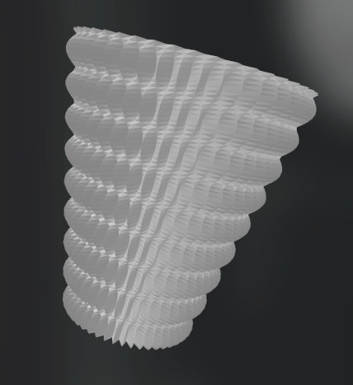  divs-vase.stl
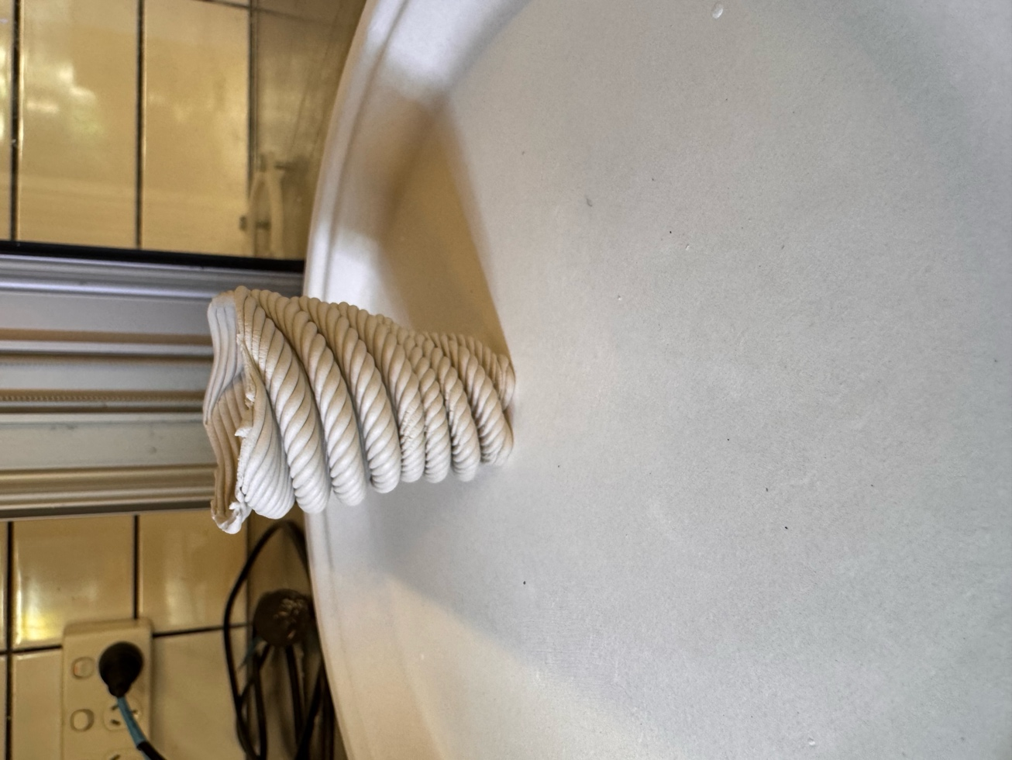  spiral-35g-3mm-2base.gcode | 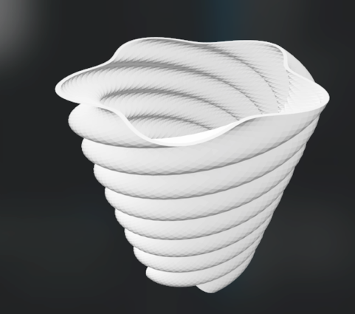  spiral.stl
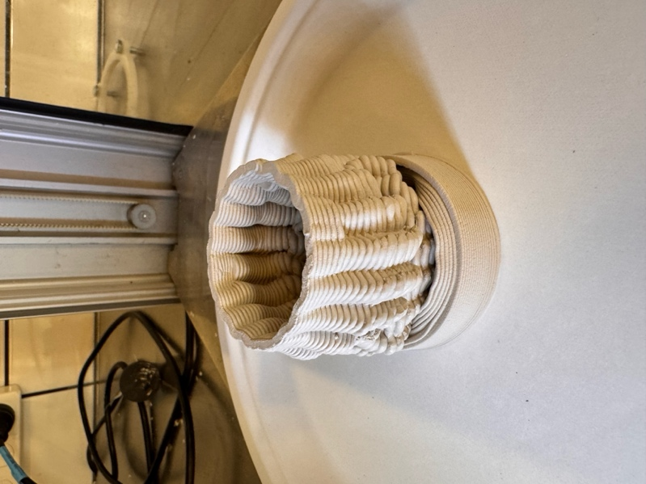
two-component-78g-3mm-2base.gcode

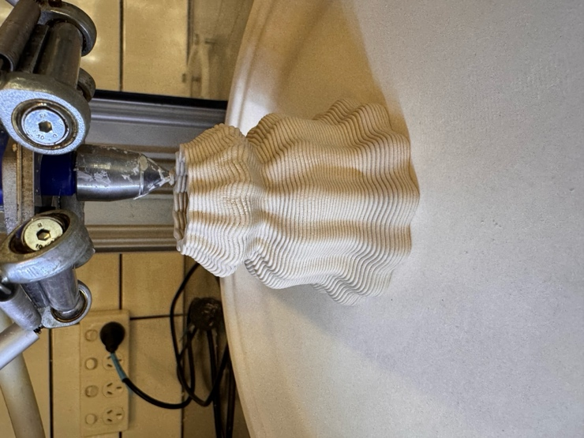
fluid-vase-3mm-2laybase-69g.gcode

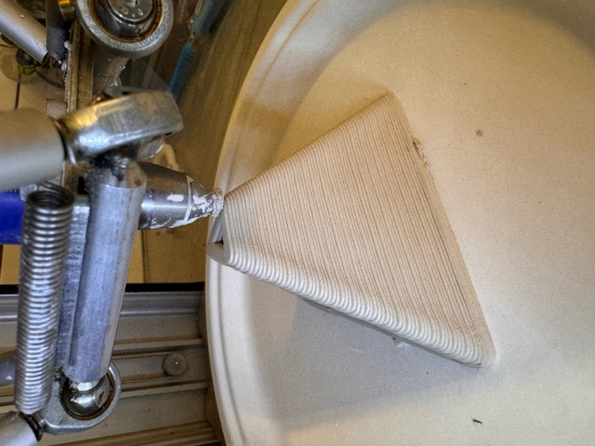 |   Tetraeder.stl
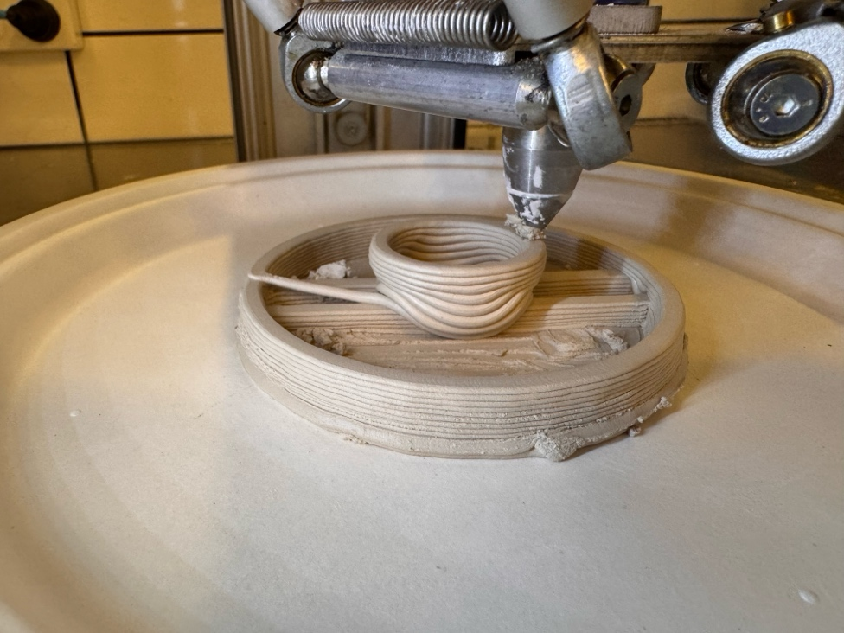  slotted-disk-test-3mm-2laybase-34g.gcode | 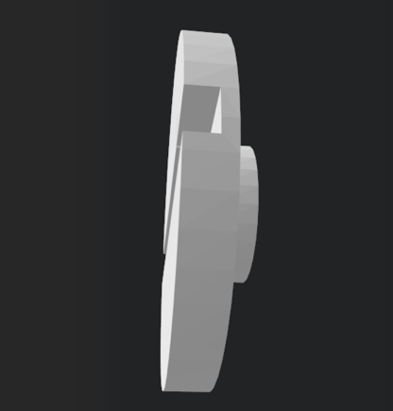  slotted-disk.stl
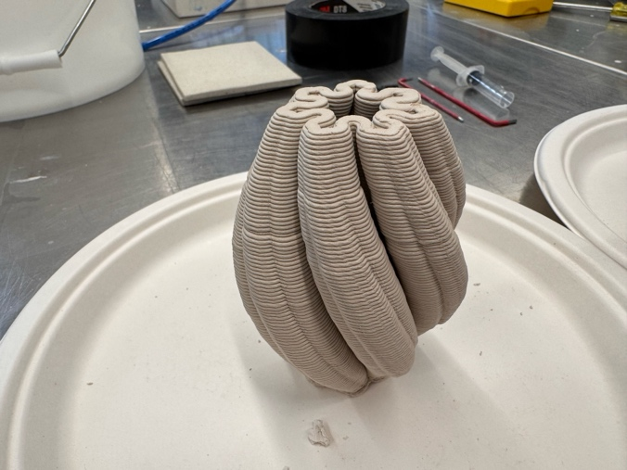 | Might be:  181026_julia_z7_700_VERSION_2.stl
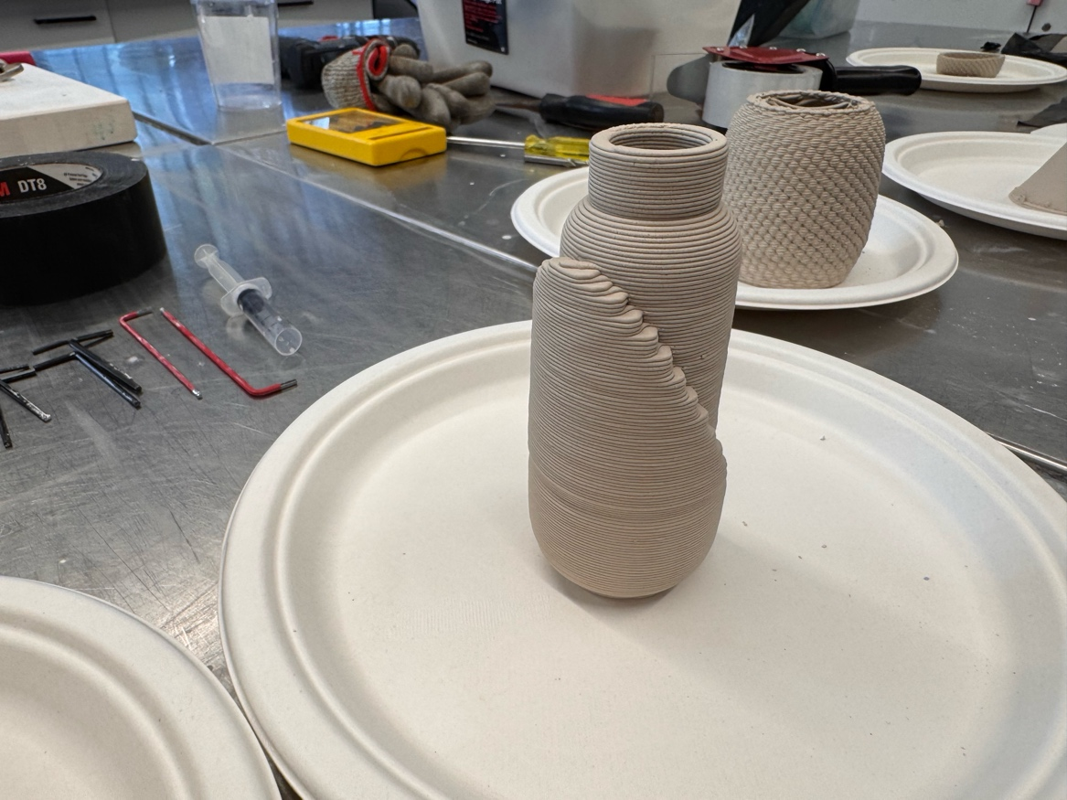 | Might be:  step-vase-42g-3mm-2base.gcode  inlay bottle/  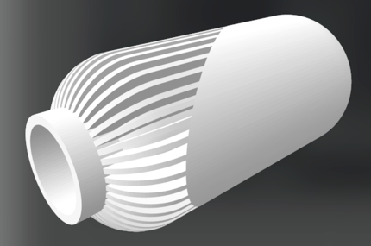  yaovase.stl
gcode_march/  vase_basic_53g_3mm.gcode | 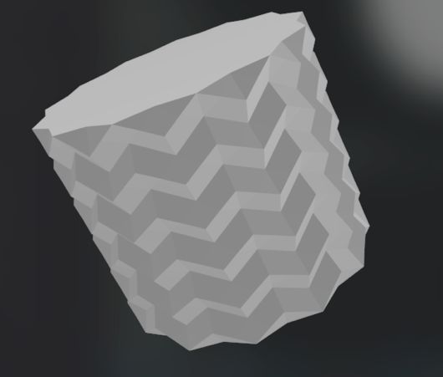CFFFP_clean_vase_basic.stl
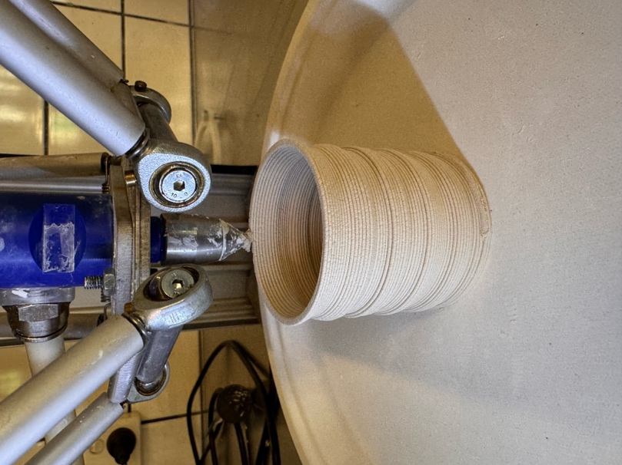  step-vase-42g-3mm-2base.gcode | 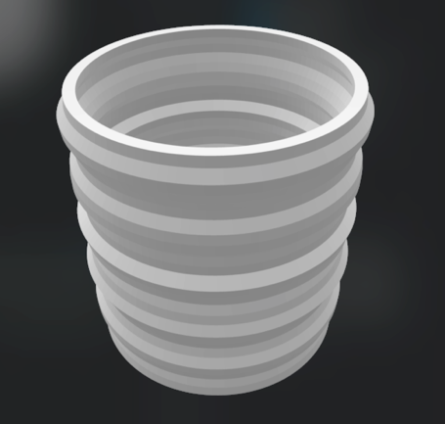  step-vase.stl
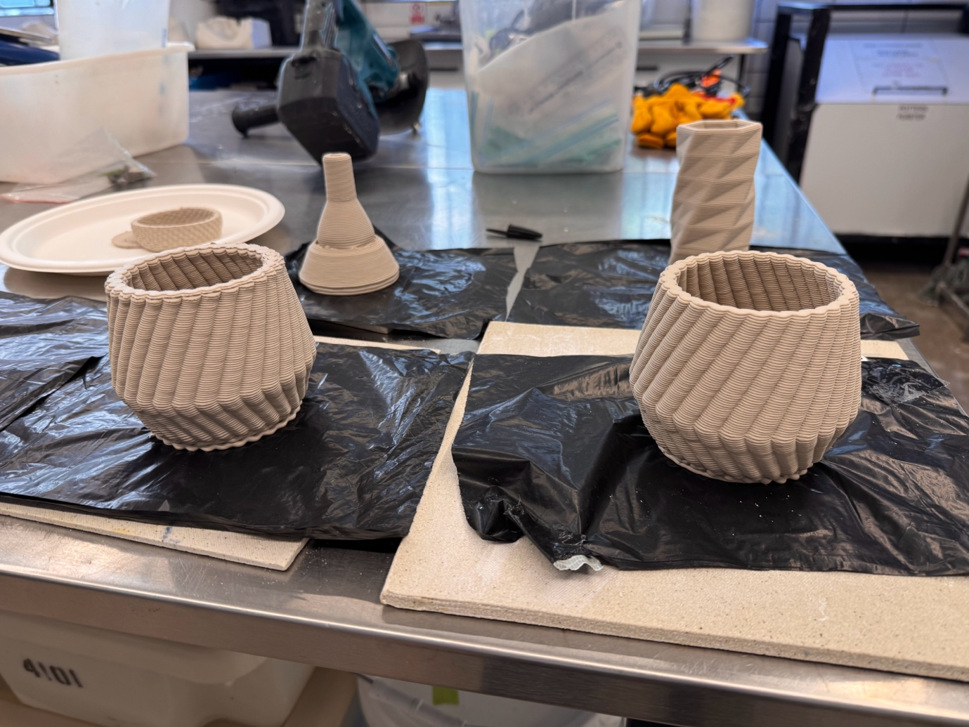 | 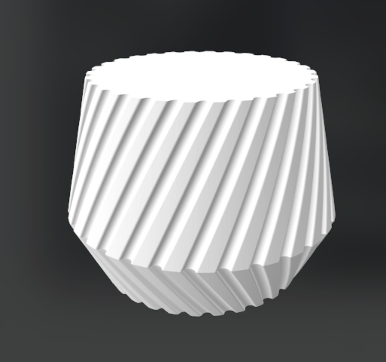  vase_geo_slim.stl
cube-3mm-2laybase-51g.gcode | 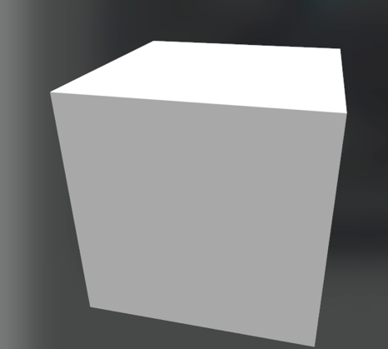  Hexaeder.stl
ikosaeder-3mm-40sec-64g.gcode | 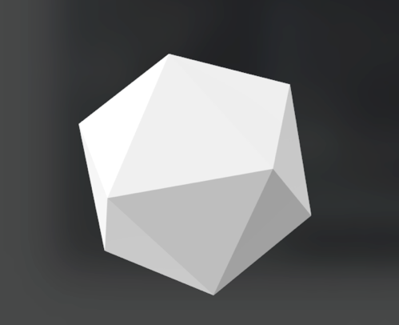  Ikosaeder.stl
dodekaeder-3mm-40sec-61g.gcode | 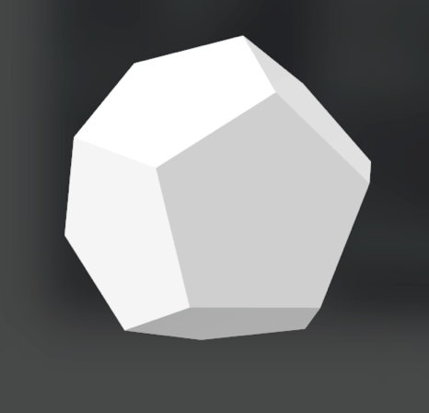  dodekaeder.stl
oktaeder-3mm-40sec-57g.gcode | 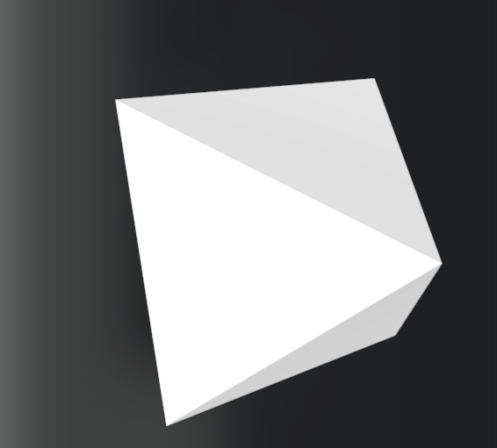  Oktaeder.stl
 | clean_vase_geo.stl
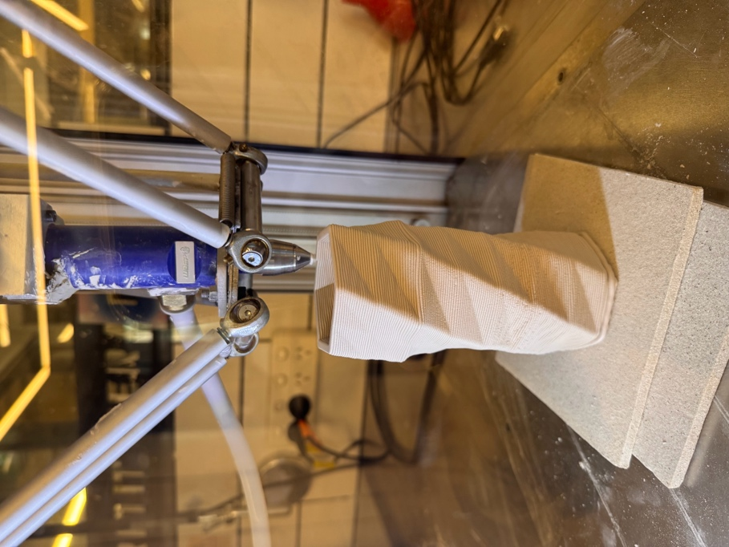  vase_basic_z99.gcode  *recreated 08/03/26 | 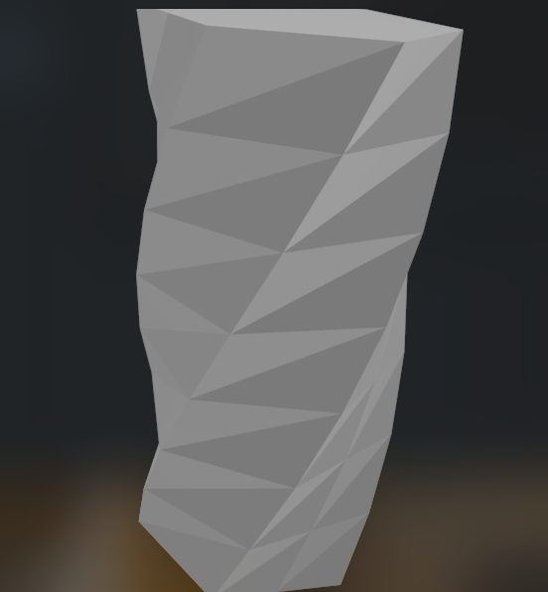vase_basic.stl

