


Safety Plan Lane Assistance
Document Version: 1.0
Template Version 1.0, Released on 2017-06-21



Document history
Date | Version | Editor | Description
05/12/18 | 1.0 | Diogo Leal | First submission

Table of Contents

Document history
Table of Contents
Introduction
Purpose of the Safety Plan
Scope of the Project
Deliverables of the Project
Item Definition
Goals and Measures
Goals
Measures
Safety Culture
Safety Lifecycle Tailoring
Roles
Development Interface Agreement
Confirmation Measures

Introduction

Purpose of the Safety Plan

The purpose of the Safety Plan is to provide an overall framework for the Lane Assistance Item,
and to assign roles and responsibilities for functional safety for this item.

Scope of the Project

For the lane assistance project, the following safety lifecycle phases are in scope:

Concept phase
Product Development at the System Level
Product Development at the Software Level

The following phases are out of scope:

Product Development at the Hardware Level
Production and Operation

Deliverables of the Project

The deliverables of the project are:

Safety Plan
Hazard Analysis and Risk Assessment
Functional Safety Concept
Technical Safety Concept
Software Safety Requirements and Architecture

Item Definition

The Lane Assistance Item alerts the driver that the vehicle has departed its lane and attempts to steer the vehicle back to the center of the lane.

The Lane Assistance System will have two functions:

- Lane departure warning
- Lane keeping assistance

The Lane Departure Warning (LDW) function shall apply an oscillating steering torque to provide the driver a haptic feedback. The Lane Keeping Assistance (LKA) function shall apply the steering torque when active in order to stay in ego lane (the vehicle current lane).

The Camera Subsystem, the Electronic Power Steering Subsystem, and the Car Display Subsystem are all responsible for each of the functions. Below is the Lane Assistance System Architecture presenting the boundaries of the item, which subsystems are inside and which are outside of it:
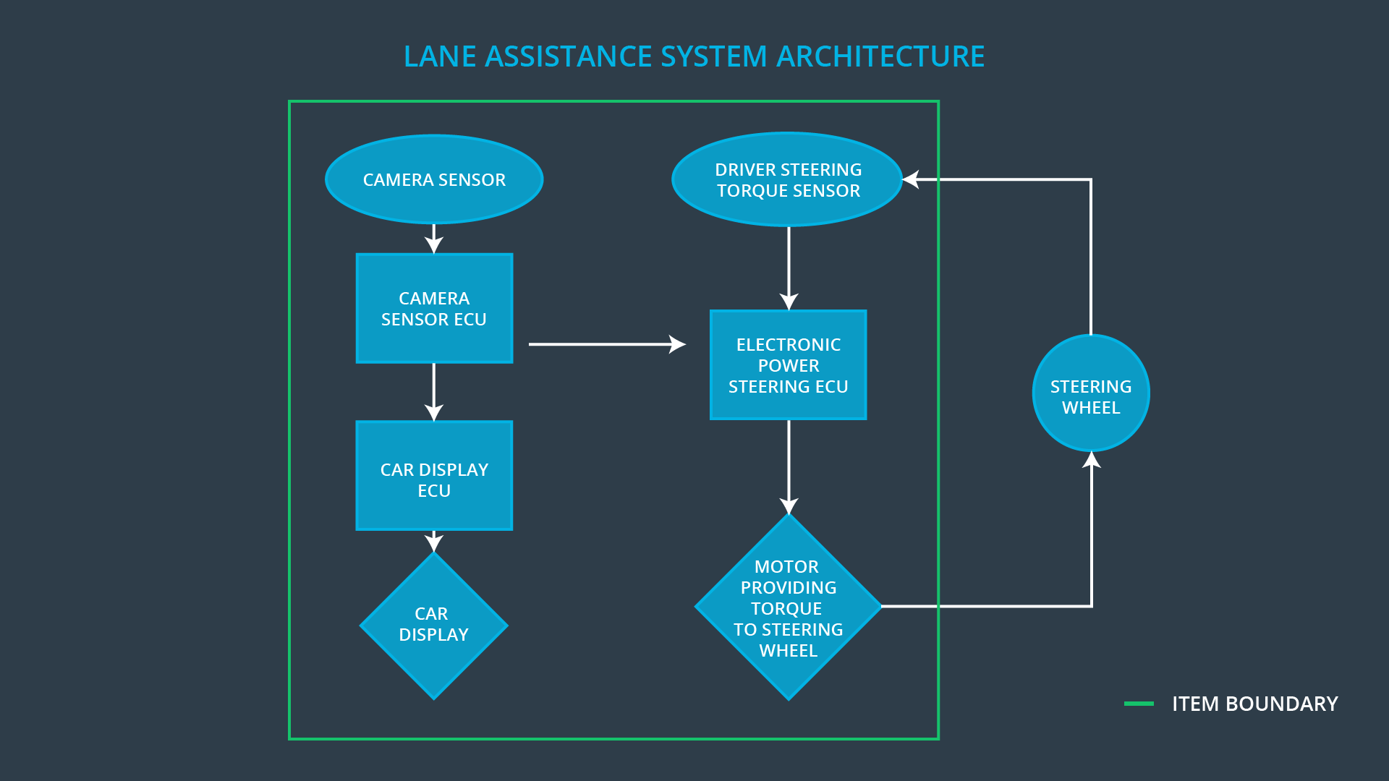

Goals and Measures

Goals

Identify high risk situations that could cause harm and find ways to lower these risks to reasonable, acceptable levels.

Measures

Measures and Activities | Responsibility | Timeline
Follow safety processes | All Team Members | Constantly
Create and sustain a safety culture | All Team Members | Constantly
Coordinate and document the planned safety activities | Safety Manager | Constantly
Allocate resources with adequate functional safety competency | Project Manager | Within 2 weeks of start of project
Tailor the safety lifecycle | Safety Manager | Within 4 weeks of start of project
Plan the safety activities of the safety lifecycle | Safety Manager | Within 4 weeks of start of project
Perform regular functional safety audits | Safety Auditor | Once every 2 months
Perform functional safety pre-assessment prior to audit by external functional safety assessor | Safety Manager | 3 months prior to main assessment
Perform functional safety assessment | Safety Assessor | Conclusion of functional safety activities

Safety Culture

To ensure a good safety culture, the characteristics bellow are followed inside the company:
- High priority: safety has the highest priority among competing constraints like cost and productivity
- Accountability: processes ensure accountability such that design decisions are traceable back to the people and teams who made the decisions
- Rewards: the organization motivates and supports the achievement of functional safety
- Penalties: the organization penalizes shortcuts that jeopardize safety or quality
- Independence: teams who design and develop a product should be independent from the teams who audit the work
- Well defined processes: company design and management processes should be clearly defined
- Resources: projects have necessary resources including people with appropriate skills
- Diversity: intellectual diversity is sought after, valued and integrated into processes
- Communication: communication channels encourage disclosure of problems

Safety Lifecycle Tailoring

For the lane assistance project, the following safety lifecycle phases are in scope:

Concept phase
Product Development at the System Level
Product Development at the Software Level

The following phases are out of scope:

Product Development at the Hardware Level
Production and Operation

Roles

Role | Org
Functional Safety Manager- Item Level | OEM
Functional Safety Engineer- Item Level | OEM
Project Manager - Item Level | OEM
Functional Safety Manager- Component Level | Tier-1
Functional Safety Engineer- Component Level | Tier-1
Functional Safety Auditor | OEM or external
Functional Safety Assessor | OEM or external

Development Interface Agreement

A Development Interface Agreement (DIA) defines the roles and responsibilities between companies involved in developing a product. The DIA also specifies what evidence and work products each party will provide to prove that work was done according to the agreement.

The responsibilities of the Tier-1 company is to develop and produce the various subsystems following the requirements provided by the OEM. It will also pre-audit the project to make sure it conforms with the safety plan from the OEM and ISO 26262.

Confirmation Measures

The purpose of the Confirmation Measures is to verify that the project really does make the vehicle safer.

The Confirmation Review ensures that the project complies with ISO 26262. As the product is designed and developed, an independent person would review the work to make sure ISO 26262 is being followed.

Checking to make sure that the actual implementation of the project conforms to the safety plan is called a Functional Safety Audit.

Confirming that plans, designs and developed products actually achieve functional safety is called a Functional Safety Assessment.

