


Functional Safety Concept Lane Assistance
Document Version: 1.0
Template Version 1.0, Released on 2017-06-21



Document history
Date | Version | Editor | Description
05/12/18 | 1.0 | Diogo Leal | First submission

Table of Contents
Document history
Table of Contents
Purpose of the Functional Safety Concept
Inputs to the Functional Safety Analysis
Safety goals from the Hazard Analysis and Risk Assessment
Preliminary Architecture
Description of architecture elements
Functional Safety Concept
Functional Safety Analysis
Functional Safety Requirements
Refinement of the System Architecture
Allocation of Functional Safety Requirements to Architecture Elements
Warning and Degradation Concept

Purpose of the Functional Safety Concept

The purpose of the Functional Safety Concept is to refine the safety goals in what are called functional safety requirements looking at the general functionality of the item.

Inputs to the Functional Safety Concept

Safety goals from the Hazard Analysis and Risk Assessment

ID | Safety Goal
Safety_Goal_01 | The oscillating steering torque from the lane departure warning function shall be limited
Safety_Goal_02 | The lane keeping assistance function shall be time limited, and the additional steering torque shall end after a given time interval so that the driver cannot misuse the system for autonomous driving

Preliminary Architecture

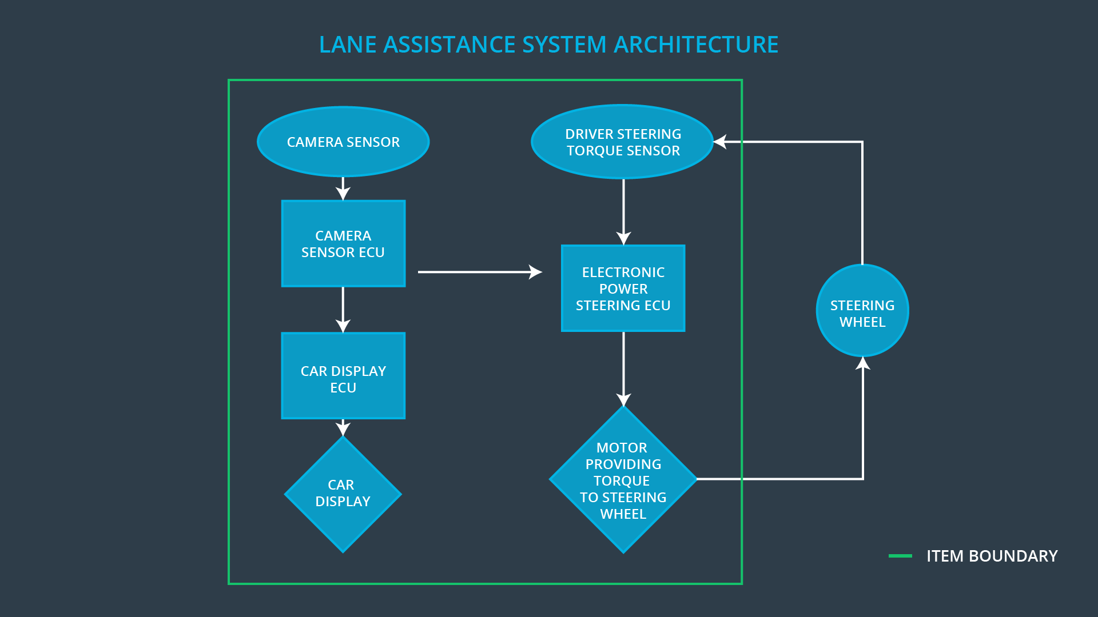

Description of architecture elements

Element | Description
Camera Sensor | Responsible for detecting lane lines
Camera Sensor ECU | Determines when the vehicle leaves the lane by mistake
Car Display | Alerts the driver if the system is on/off, active/inactive and if a fault has occured
Car Display ECU | Treats the information from the EPS to display to the driver
Driver Steering Torque Sensor | Responsible for measuring the torque provided by the driver
Electronic Power Steering ECU | Adds an appropriate amount of torque based on a lane assistance system torque request
Motor | Moves the steering wheel

Functional Safety Concept

The functional safety concept consists of:
- Functional safety analysis
- Functional safety requirements
- Functional safety architecture
- Warning and degradation concept

Functional Safety Analysis

Malfunction ID | Main Function of the Item Related to Safety Goal Violations | Guidewords (NO, WRONG, EARLY, LATE, MORE, LESS) | Resulting Malfunction
Malfunction_01 | Lane Departure Warning (LDW) function shall apply an oscillating steering torque to provide the driver a haptic feedback | MORE | The lane departure warning function applies an oscillating torque with very high torque amplitude (above limit)
Malfunction_02 | Lane Departure Warning (LDW) function shall apply an oscillating steering torque to provide the driver a haptic feedback | MORE | The lane departure warning function applies an oscillating torque with very high torque frequency (above limit)
Malfunction_03 | Lane Keeping Assistance (LKA) function shall apply the steering torque when active in order to stay in ego lane | NO | The lane keeping assistance function is not limited in time duration which leads to misuse as an autonomous driving function

Functional Safety Requirements

Lane Departure Warning (LDW) Requirements:

ID | Functional Safety Requirement | ASIL | Fault Tolerant Time Interval | Safe State
Functional  Safety  Requirement  01-01 | The lane keeping item shall ensure that the lane departure oscillating torque amplitude is below Max_Torque_Amplitude | C | 50ms | Oscillating torque from LDW function is set to zero
Functional  Safety  Requirement  01-02 | The lane keeping item shall ensure that the lane departure oscillating torque frequency is below Max_Torque_Frequency | C | 50ms | Oscillating torque from LDW function is set to zero

Lane Departure Warning (LDW) Verification and Validation Acceptance Criteria:

ID | Validation Acceptance  Criteria and Method | Verification Acceptance  Criteria and Method
Functional  Safety  Requirement  01-01 | Test how drivers react to the value chosen for the torque amplitude | Verify that the the lane assistance output is set to zero within the 50 ms when the torque amplitude is higher than the value chosen during validation
Functional  Safety  Requirement  01-02 | Test how drivers react to the value chosen for the torque frequency | Verify that the the lane assistance output is set to zero within the 50 ms when the torque frequency is higher than the value chosen during validation

Lane Keeping Assistance (LKA) Requirements:

ID | Functional Safety Requirement | ASIL | Fault Tolerant Time Interval | Safe State
Functional  Safety  Requirement  02-01 | The electronic power steering ECU shall ensure that the lane keeping assistance torque is applied for only Max_Duration | B | 500ms | Torque request from the LKA function is set to zero

Lane Keeping Assistance (LKA) Verification and Validation Acceptance Criteria:

ID | Validation Acceptance  Criteria and Method | Verification Acceptance  Criteria and Method
Functional  Safety  Requirement  02-01 | Test if the maximum duration chosen really dissuade drivers from taking their hands off the wheel | Verify that the system really does turn off if the lane keeping assistance is active for a period bigger than the maximum duration

Refinement of the System Architecture

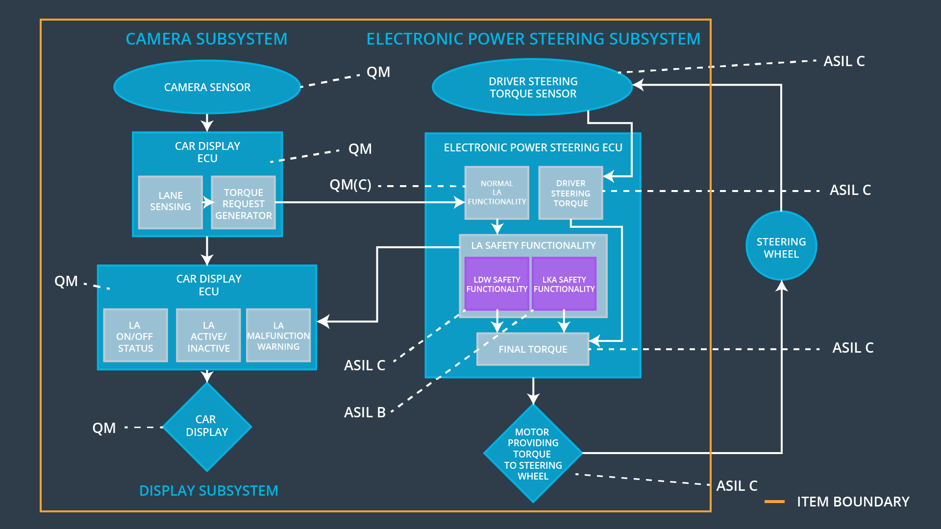

Allocation of Functional Safety Requirements to Architecture Elements

ID | Functional Safety Requirement | Electronic Power Steering ECU | Camera ECU | Car Display ECU
Functional  Safety  Requirement  01-01 | The lane keeping item shall ensure that the lane departure oscillating torque amplitude is below Max_Torque_Amplitude | X
Functional  Safety  Requirement  01-02 | The lane keeping item shall ensure that the lane departure oscillating torque frequency is below Max_Torque_Frequency | X
Functional  Safety  Requirement  02-01 | The electronic power steering ECU shall ensure that the lane keeping assistance torque is applied for only Max_Duration | X

Warning and Degradation Concept

ID | Degradation Mode | Trigger for Degradation Mode | Safe State invoked? | Driver Warning
WDC-01 | Turn off the functionality | The lane departure warning function applies an oscillating torque with very high torque frequency or amplitude (above limit) | Yes | Warning light on the dashboard
WDC-02 | Turn off the functionality | The lane keeping function torque is applied for a very long period (above limit) | Yes | Warning light on the dashboard

