


Technical Safety Concept Lane Assistance
Document Version: 1.0
Template Version 1.0, Released on 2017-06-21



Document history
Date | Version | Editor | Description
05/12/18 | 1.0 | Diogo Leal | First submission

Table of Contents

Document history
Table of Contents
Purpose of the Technical Safety Concept
Inputs to the Technical Safety Concept
Functional Safety Requirements
Refined System Architecture from Functional Safety Concept
Functional overview of architecture elements
Technical Safety Concept
Technical Safety Requirements
Refinement of the System Architecture
Allocation of Technical Safety Requirements to Architecture Elements
Warning and Degradation Concept

Purpose of the Technical Safety Concept

The purpose of the Technical Safety Concept is to develop requirements that cover how sensors, control units and actuators should interact between them to ensure funcitonal safety.

Inputs to the Technical Safety Concept

Functional Safety Requirements

ID | Functional Safety Requirement | ASIL | Fault Tolerant Time Interval | Safe State
Functional  Safety  Requirement  01-01 | The lane keeping item shall ensure that the lane departure oscillating torque amplitude is below Max_Torque_Amplitude | C | 50ms | Oscillating torque from LDW function is set to zero
Functional  Safety  Requirement  01-02 | The lane keeping item shall ensure that the lane departure oscillating torque frequency is below Max_Torque_Frequency | C | 50ms | Oscillating torque from LDW function is set to zero
Functional  Safety  Requirement  02-01 | The electronic power steering ECU shall ensure that the lane keeping assistance torque is applied for only Max_Duration | B | 500ms | Torque request from the LKA function is set to zero

Refined System Architecture from Functional Safety Concept

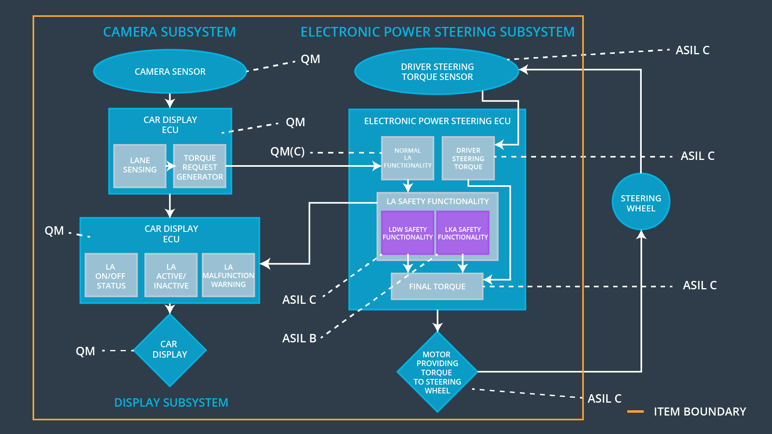

Functional overview of architecture elements

Element | Description
Camera Sensor | Captures images from the road
Camera Sensor ECU - Lane Sensing | Detects lanes on the road and when the driver leaves the lane
Camera Sensor ECU - Torque request generator | Sends torque request to the Electronic Power Steering Subsystem
Car Display | Lights that alerts the driver about the system current state
Car Display ECU - Lane Assistance On/Off Status | Controls the light that tells the driver if the Lane Keeping Item is On or Off
Car Display ECU - Lane Assistant Active/Inactive | Controls the light that tells the driver if the Lane Departure Warning is activated
Car Display ECU - Lane Assistance malfunction warning | Controls the light that tells the driver if there is a malfunction
Driver Steering Torque Sensor | Responsible for measuring the torque provided by the driver
Electronic Power Steering (EPS) ECU - Driver Steering Torque | Sense how much the driver is turning the steering wheel
EPS ECU - Normal Lane Assistance Functionality | Block responsible for normal lane assistance item behavior
EPS ECU - Lane Departure Warning Safety Functionality | Responsible for guaranteeing functional safety requirements of the LDW function
EPS ECU - Lane Keeping Assistant Safety Functionality | Responsible for guaranteeing functional safety requirements of the LKA function
EPS ECU - Final Torque | Output final torque to the motor
Motor | Moves the steering wheel

Technical Safety Concept

Technical Safety Requirements

Lane Departure Warning (LDW) Requirements:

Functional Safety Requirement 01-01 with its associated system elements
(derived in the functional safety concept)
ID | Functional Safety Requirement | Electronic Power Steering ECU | Camera ECU | Car Display ECU
Functional  Safety  Requirement  01-01 | The lane keeping item shall ensure that the lane departure oscillating torque amplitude is below Max_Torque_Amplitude | X

Technical Safety Requirements related to Functional Safety Requirement 01-01 are:
ID | Technical Safety Requirement | ASIL | Fault Tolerant Time Interval | Architecture Allocation | Safe State
Technical  Safety  Requirement  01 | The LDW safety component shall ensure that the amplitude of the 'LDW_Torque_Request' sent to the 'Final electronic power steering Torque' component is below 'Max_Torque_Amplitude | C | 50ms | LDW Safety Functionality | LDW torque output is set to zero
Technical  Safety  Requirement  02 | As soon as the LDW function deactivates the LDW feature, the 'LDW Safety' software block shall send a signal to the car display ECU to turn on a warning light | C | 50ms | LDW Safety Functionality | LDW torque output is set to zero
Technical  Safety  Requirement  03 | As soon as a failure is detected by the LDW function, it shall deactivate the LDW feature and the 'LDW_Torque_Request' shall be set to zero | C | 50ms | LDW Safety Functionality | LDW torque output is set to zero
Technical  Safety  Requirement  04 | The validity and integrity of the data transmission for 'LDW_Torque_Request' signal shall be ensured | C | 50ms | Data Transmission Integrity Check | LDW torque output is set to zero
Technical  Safety  Requirement  05 | Memory test shall be conducted at start up of the EPS ECU to check for any faults in memory | A | Iginition cycle | Safety Startup | LDW torque output is set to zero

Functional Safety Requirement 01-2 with its associated system elements
(derived in the functional safety concept)
ID | Functional Safety Requirement | Electronic Power Steering ECU | Camera ECU | Car Display ECU
Functional  Safety  Requirement  01-02 | The lane keeping item shall ensure that the lane departure oscillating torque frequency is below Max_Torque_Frequency | X

Technical Safety Requirements related to Functional Safety Requirement 01-02 are:
ID | Technical Safety Requirement | ASIL | Fault Tolerant Time Interval | Architecture Allocation | Safe State
Technical  Safety  Requirement  01 | The LDW safety component shall ensure that the frequency of the 'LDW_Torque_Request' sent to the 'Final electronic power steering Torque' component is below 'Max_Torque_Frequency’ | C | 50ms | LDW Safety Functionality | LDW torque output is set to zero
Technical  Safety  Requirement  02 | As soon as the LDW function deactivates the LDW feature, the 'LDW Safety' software block shall send a signal to the car display ECU to turn on a warning light | C | 50ms | LDW Safety Functionality | LDW torque output is set to zero
Technical  Safety  Requirement  03 | As soon as a failure is detected by the LDW function, it shall deactivate the LDW feature and the 'LDW_Torque_Request' shall be set to zero | C | 50ms | LDW Safety Functionality | LDW torque output is set to zero
Technical  Safety  Requirement  04 | The validity and integrity of the data transmission for 'LDW_Torque_Request' signal shall be ensured | C | 50ms | Data Transmission Integrity Check | LDW torque output is set to zero
Technical  Safety  Requirement  05 | Memory test shall be conducted at start up of the EPS ECU to check for any faults in memory | A | Ignition cycle | Safety Startup | LDW torque output is set to zero

Lane Keeping Assistance (LKA) Requirements:

Functional Safety Requirement 02-1 with its associated system elements
(derived in the functional safety concept)
ID | Functional Safety Requirement | Electronic Power Steering ECU | Camera ECU | Car Display ECU
Functional  Safety  Requirement  02-01 | The lane keeping item shall ensure that the lane keeping assistance torque is applied for only Max_Duration | X

Technical Safety Requirements related to Functional Safety Requirement 02-01 are:
ID | Technical Safety Requirement | ASIL | Fault Tolerant Time Interval | Allocation to Architecture | Safe State
Technical  Safety  Requirement  01 | The LKA safety component shall ensure that the 'LKA_Torque_Request' sent to the 'Final electronic power steering Torque' component is not active for a period longer than ‘Max_Duration’ | B | 500ms | LKA Safety Functionality | LKA torque output is set to zero
Technical  Safety  Requirement  02 | As soon as the LKA function is turned off, the 'LKA Safety' software block shall send a signal to the car display ECU to turn on a warning light | B | 500ms | LKA Safety Functionality | LKA torque output is set to zero
Technical  Safety  Requirement  03 | As soon as a failure is detected by the LKA function, it shall turn off the lane keeping assistant and the 'LKA_Torque_Request' shall be set to zero | B | 500ms | LKA Safety Functionality | LKA torque output is set to zero
Technical  Safety  Requirement  04 | The validity and integrity of the data transmission for 'LKA_Torque_Request' signal shall be ensured | B | 500ms | Data Transmission Integrity Check | LKA torque output is set to zero
Technical  Safety  Requirement  05 | Memory test shall be conducted at start up of the EPS ECU to check for any faults in memory | A | Ignition cycle | Safety Startup | LKA torque output is set to zero

Refinement of the System Architecture

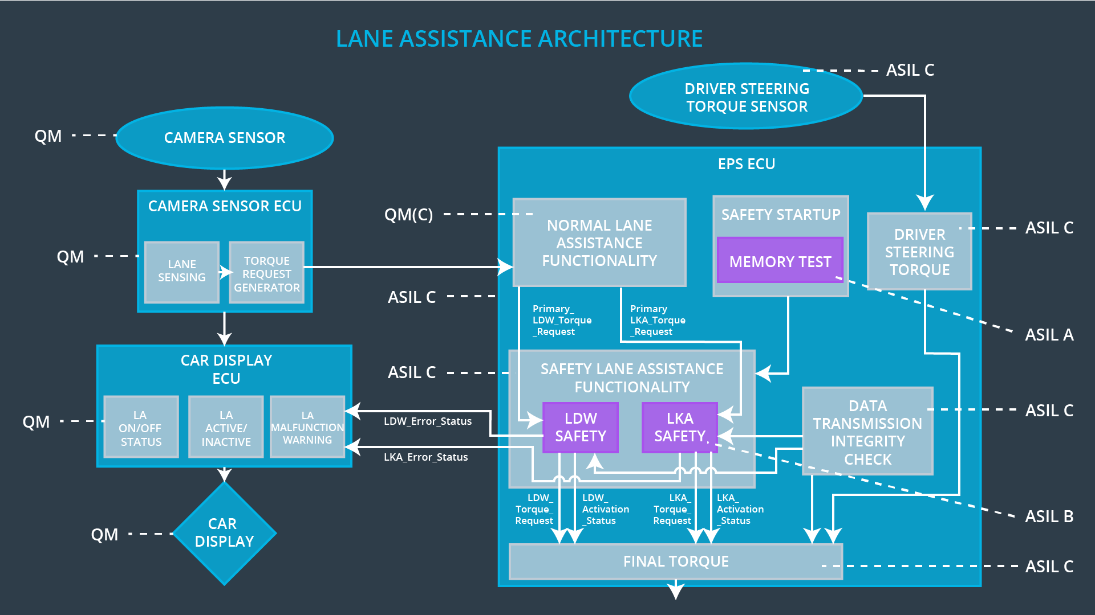

Allocation of Technical Safety Requirements to Architecture Elements

For this particular item, all technical safety requirements are allocated to the Electronic Power Steering ECU.

Warning and Degradation Concept

ID | Degradation Mode | Trigger for Degradation Mode | Safe State invoked? | Driver Warning
WDC-01 | Turn off the functionality | The lane departure warning function applies an oscillating torque with very high torque frequency or amplitude (above limit) | Yes | Warning light on the dashboard
WDC-02 | Turn off the functionality | The lane keeping function torque is applied for a very long period (above limit) | Yes | Warning light on the dashboard

