College of Computer Studies
Laboratory Activity Form

Course
Topics Covered: | Object-oriented Programming 2
Objectives:
Description
Create the GUIs and implement the classes to be used to make the UI work:

Login.java Logoff.java
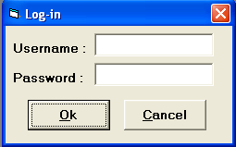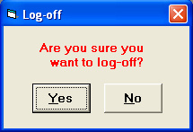

Employee.java Position.java
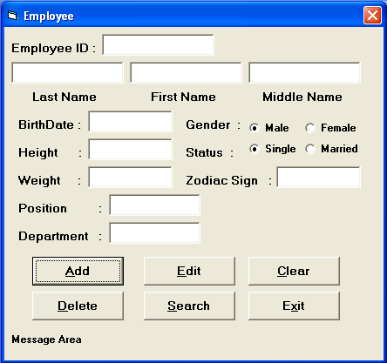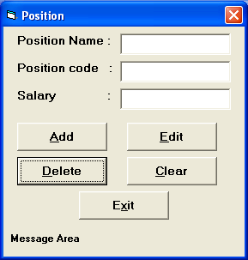

Main.java
 File: Log-in, Log-off and Exit About: Help

Note: citlogo.jpeg is included in this folder

Sample Output if Applicable
Remarks
Implement the functionalities of each form using file handling in Java.

The password and username should be CIT.
Position should be added first before an employee.
Design the classes and make sure to save the data on file.

To Add an employee: all fields should not be empty
To delete: search first if the employee exists then output the record through the textfields,
pop out confirmation dialog box before deleting.

Use your best judgment for the rest of the buttons.

