To understand the Route Properties dialog and its planning features, let's imagine we plan a route from Ibiza in Balearic Islands to Sao Vicente in C. Verde. We will see how this feature includes specific options for every stage of the planning process.
In the first instance, let's say we plan the route at home, and we have not set a departure date yet. We first trace the route. When it is ready, double click in the route to open its Route Properties dialog. This is how it would look like:
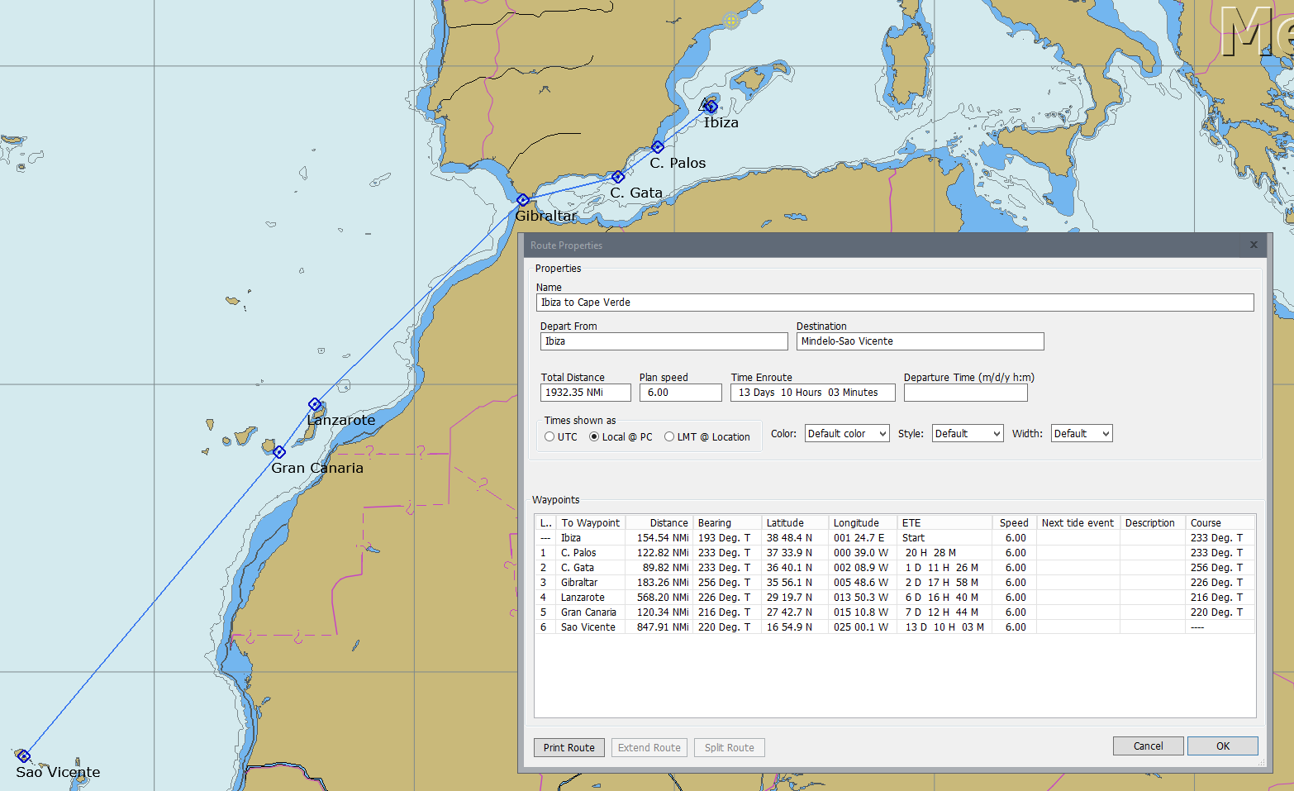
By default there is a plan speed of 6 knots that we can change at any time; The Departure Time box is still blank, so for now the table includes just an ETE (Expected Time En-route) column where we can check the time needed to arrive to every waypoint at that particular planned speed. The distance from the current position to the first waypoint is shown, but not taken into ETE calculations. That's good for planning a route well in advance, before even setting a departure date.
Now let's imagine we plan to leave in the near future, and already have an intended departure date: we plan to leave Ibiza on May 23rd 2016 at 10:00. So we first check that "Time shown as" option is set at Local@PC; then we enter "5/23/2016 10:00" in the Departure Time box and press "Enter". As we can see, the ETE data is changed to ETA (Estimated Time of Arrival): for the given planned speed and departure date and time, we are presented the date and time of arrival at every waypoint, from the first waypoint of the route (Ibiza). Distance to the first waypoint is again shown, but not taken into ETA calculations:

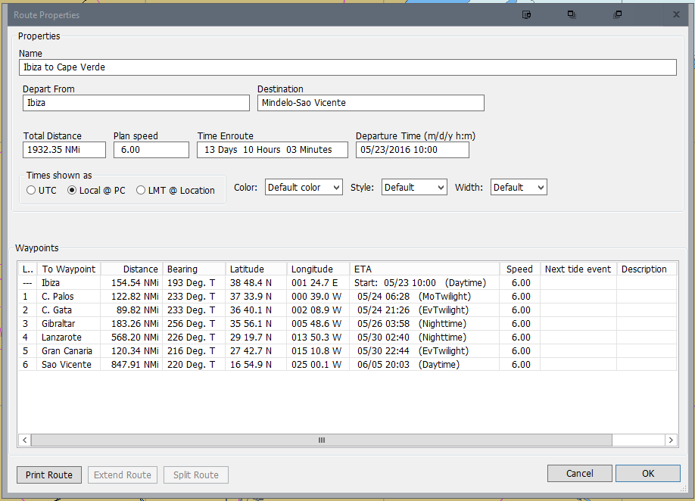
Next, let' say we are already on May 22nd, the day before to the intended departure day from Ibiza. We are already on board of our boat, berthed in Barcelona, and we are ready to leave to Ibiza and start the planned route from there. We connect our GPS so OpenCPN knows the current position, or just use the "Move the boat here" option in the context menu to ensure the boat is located in Barcelona. Then we can enter ">" in the "Departure Time" box. The sign ">" will mean "now" for OpenCPN. When we enter ">" and press enter, the Route Properties dialog show a slightly different data: we see the ETA to every waypoint leaving now, at planned speed, but the calculations now include also the distance from the current position to the first waypoint of the route. That's the difference between entering the departure time manually, and using ">" sign. A manually typed departure date indicates we will leave at that moment from the first waypoint of the route; instead, ">" means leaving "now" FROM THE CURRENT POSITION, so the distance to the first waypoint is included in ETA calculations. This is the screenshot:
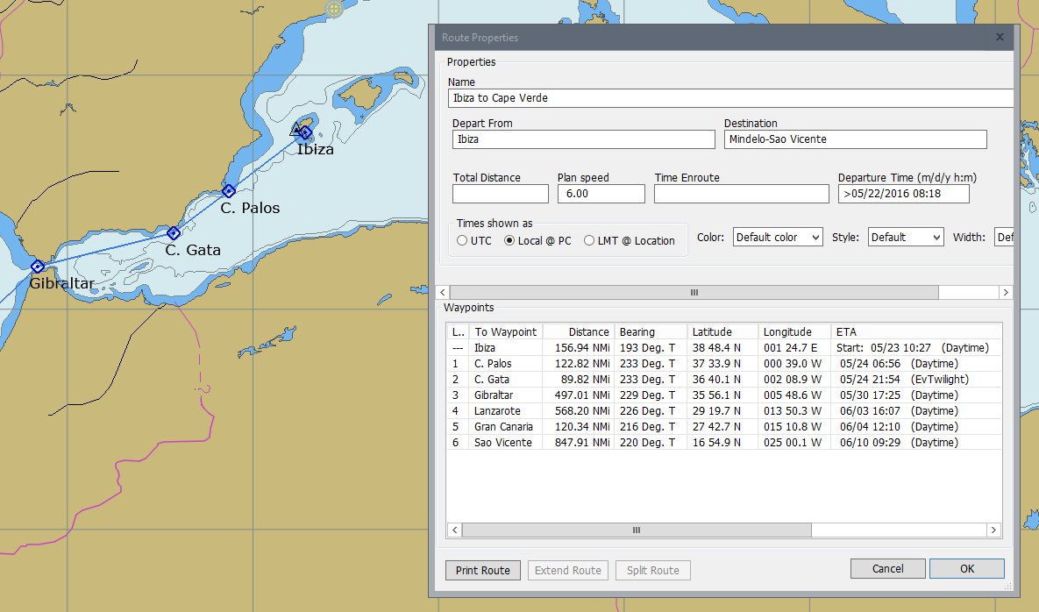
Now the most interesting part, we are now sailing. Our route is now set as Active, we already passed the first waypoints: Ibiza, C.Palos and C. Gata are left behind, and we have an active next waypoint: Gibraltar. During the trip we just need to enter ">" in the Departure Time box and press enter, and we'll get the ETAs for the remaining waypoints of the route:
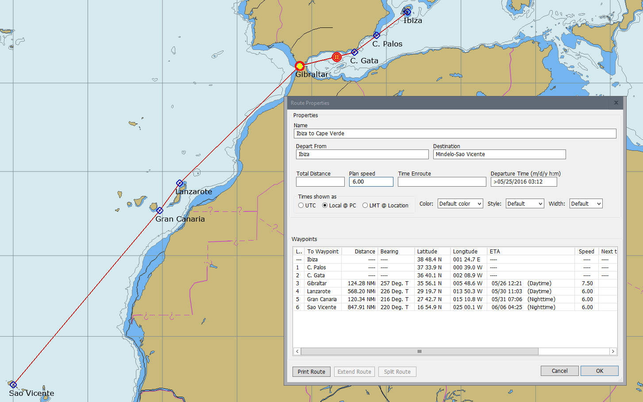
As can be seen in the picture, the waypoints already left behind are dismissed. The distance from current position to the next active waypoint is included in calculations, and also the next legs of the route, providing ETAs to the remaining waypoints of the route. We can update this ETAs at any time just entering again the sign ">" as departure time. The speed taken for calculations is the planned speed for all legs except the current one, in which the real speed is used instead. Also different leg speeds can be chosen by entering for example the string "VMG=4.5;" for a leg speed of 4,5kts in the description field of the previous waypoint of the route. And even an extended stopover can be planned in a particular waypoint, for example leaving Gran Canaria on June 4th , just by entering in the description of that waypoint the string "ETD=04/06/2016 12:00;"

