

IT342 - G4

SYSTEMS INTEGRATION AND ARCHITECTURE 1

FUNCTIONAL REQUIREMENTS SPECIFICATION (FRS)

Project Title: Mini App
Prepared By: Leana Mariﬂor A. Belaguas Date of Submission: 02/06/26
Version: 2
Table of Contents
- Introduction 3
  - Purpose 3
  - Scope 3
  - Definitions, Acronyms, and Abbreviations 3
- Overall Description 3
  - System Perspective 3
  - User Classes and Characteristics 3
  - Operating Environment 3
  - Assumptions and Dependencies 3
- System Features and Functional Requirements 3
  - Feature 1 3
  - Feature 2 3
- Non-Functional Requirements 3
- System Models (Diagrams) 4
  - ERD 4
  - Use Case Diagram 4
  - Activity Diagram 4
  - Class Diagram 4
  - Sequence Diagram 4
- Appendices 4

Introduction

Purpose
The objective of this system is to furnish a secure and dependable authentication module for a web application. This document is intended for developers, quality assurance testers, and stakeholders to facilitate a comprehensive understanding of the system's operational flow and database architecture before implementation.

Scope
The system manages User Registration, Login, Profile Viewing, and Logout. It establishes boundaries by protecting specific dashboard and profile routes, ensuring that protected pages cannot be accessed when a user is logged out.

Definitions, Acronyms, and Abbreviations
ERD: Entity Relationship Diagram.
JWT: JSON Web Token used for secure, stateless authentication.
UML: Unified Modeling Language used for the Activity, Class, and Sequence diagrams.
SPA: Single Page Application (referring to the React UI).

Overall Description

System Perspective
This module acts as the "Gatekeeper" for the application. It manages the interaction between the React UI, the Spring Boot API, and the Database.

User Classes and Characteristics
Guest User: Unauthenticated individuals who can only access the Register and Login use cases.
Authenticated User: Users who have successfully logged in and are granted access to View Profile/Dashboard and Logout.

Operating Environment
Frontend: ReactJS. Backend: Spring Boot. Database: MySQL.
Tools: draw.io / diagrams.net.

Assumptions and Dependencies

System Features and Functional Requirements

Feature 1: User Registration
Description: Allows new users to create an account by providing a username, email, and password.

Functional Requirements:
    - The system shall provide a Register Page for user input.
    - The system shall validate if the Username or Email already exists in the Database via the existsByEmail method.
    - If unique, the system shall hash/encrypt the password using the PasswordEncoder.
    - The system shall save the user record with fields including userID, username, email, password, and role.

Feature 2: Authentication (Login/Logout)
Description: Validates user credentials and initiates an authenticated session. Functional Requirements:
    - The system shall verify credentials using the authenticate method in the AuthService.
    - Upon successful verification, the TokenProvider shall generate a JWT.
    - The React UI shall store the token (e.g., in localStorage) to maintain the authenticated state.
    - The system shall return a 401 Unauthorized error for invalid credentials.

Feature 3: Profile and Dashboard Access
Description: Allows authenticated users to view protected data. Functional Requirements:
    - The system shall allow access to the Dashboard and Profile only if a valid JWT is provided.
    - The TokenProvider must validate the token for every protected request.
    - The system shall fetch the current user's data from the Database using findByUsername.

Feature 4: Logout
Description: Terminates the user session. Functional Requirements:
    - The system shall invalidate the token via the TokenProvider.
    - The React UI shall clear local storage and reset the authentication state.
    - The system shall redirect the user back to the login or landing page.
Non-Functional Requirements

    - Security: Passwords must be hashed; protected pages must remain inaccessible to unauthenticated users.
    - Usability: The system must provide clear feedback, such as "Email already taken" or "Invalid Credentials".
    - Traceability: Every user record must include created_at and updated_at timestamps for auditing.

System Models (Diagrams)
  - ERD
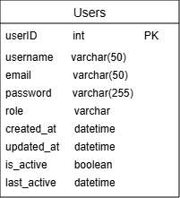
  - Use Case Diagram
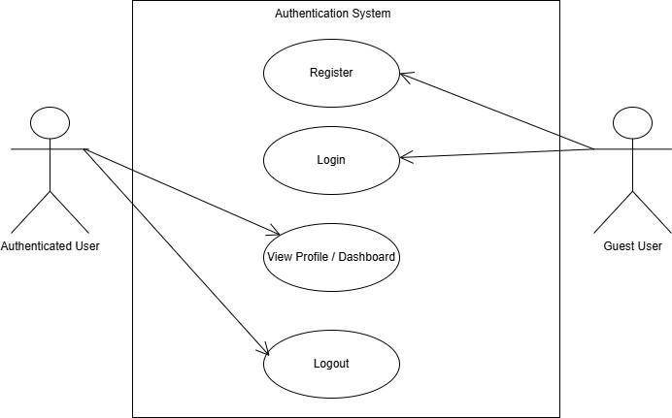
  - Activity Diagram
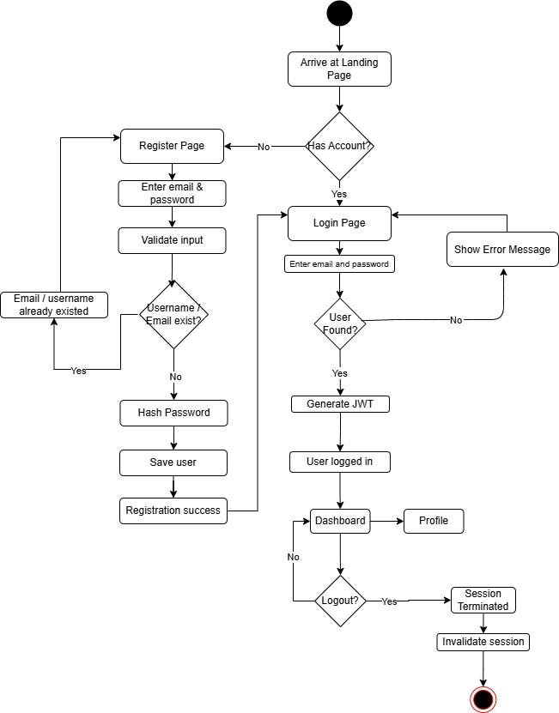
  - Class Diagram
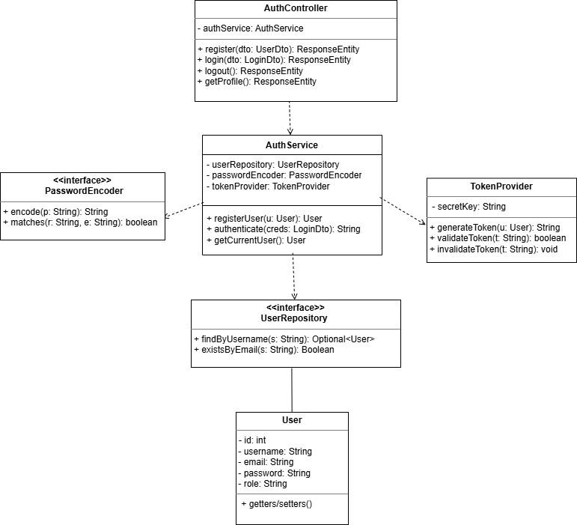
  - Sequence Diagram
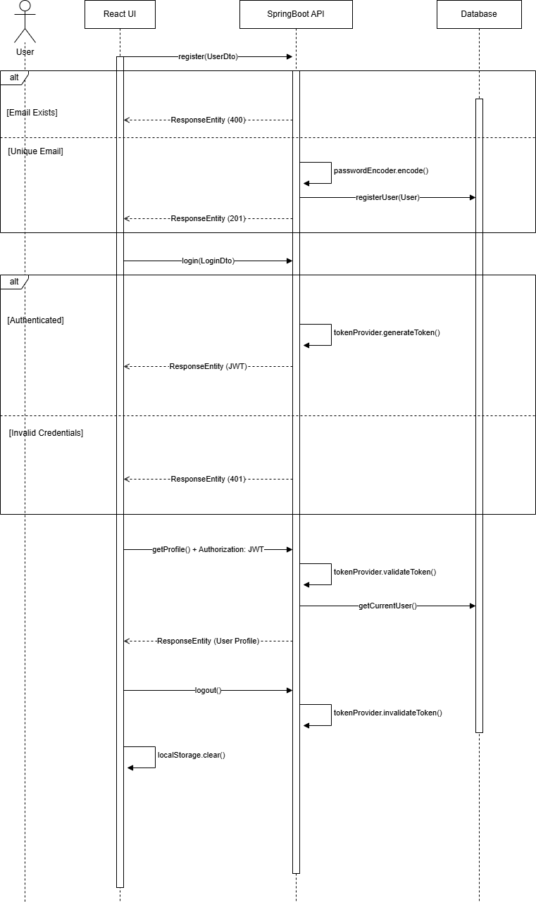

Appendices
Logout Result / Landing page
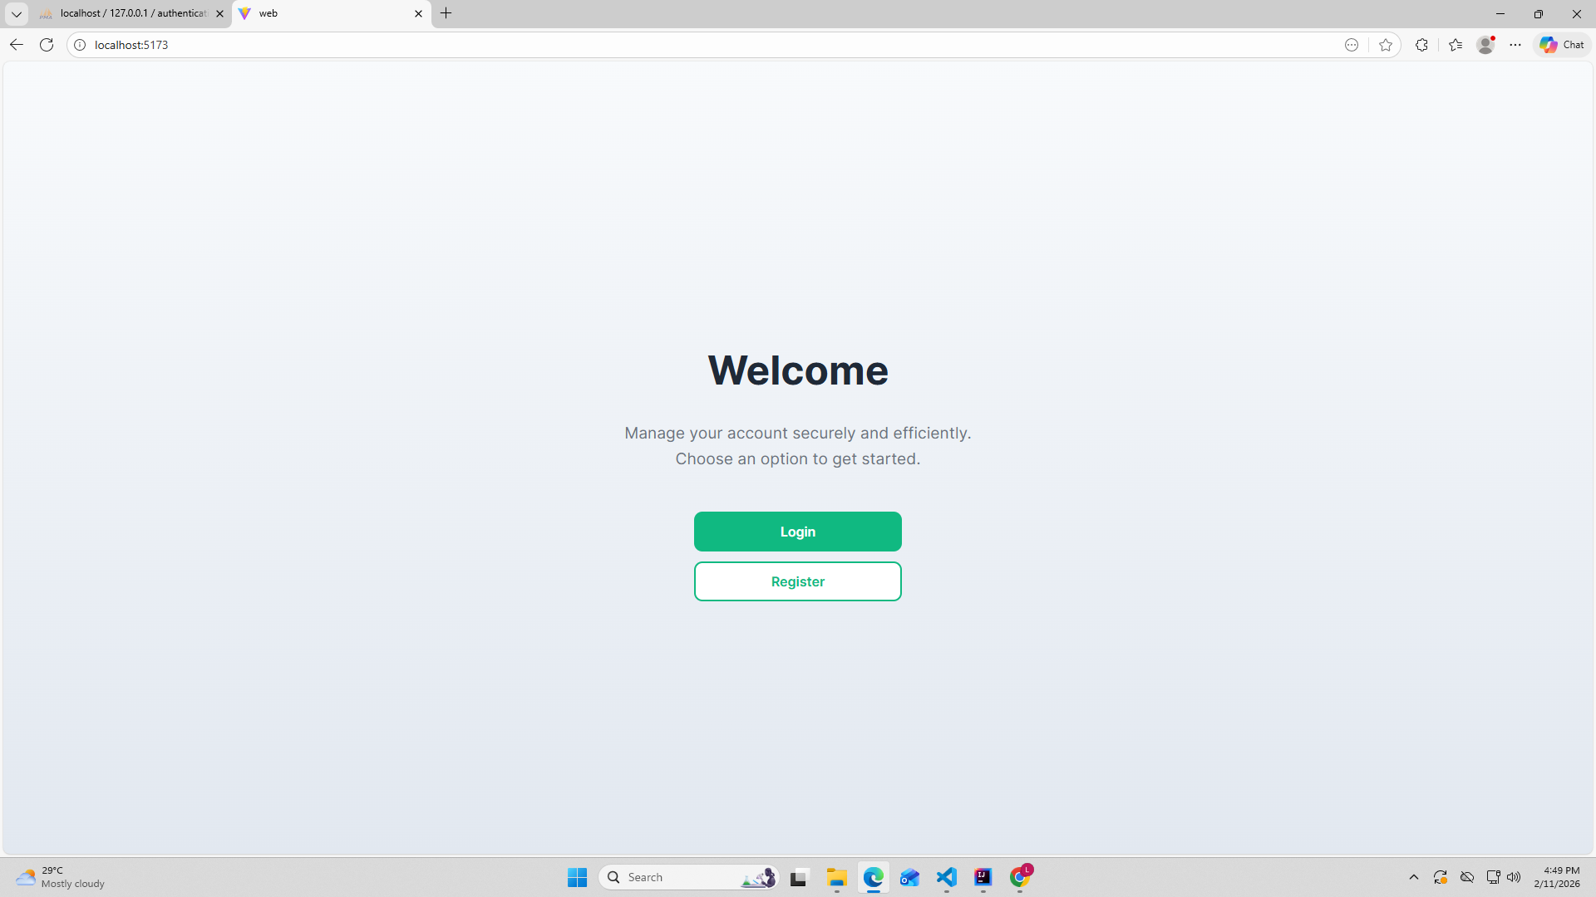
Register
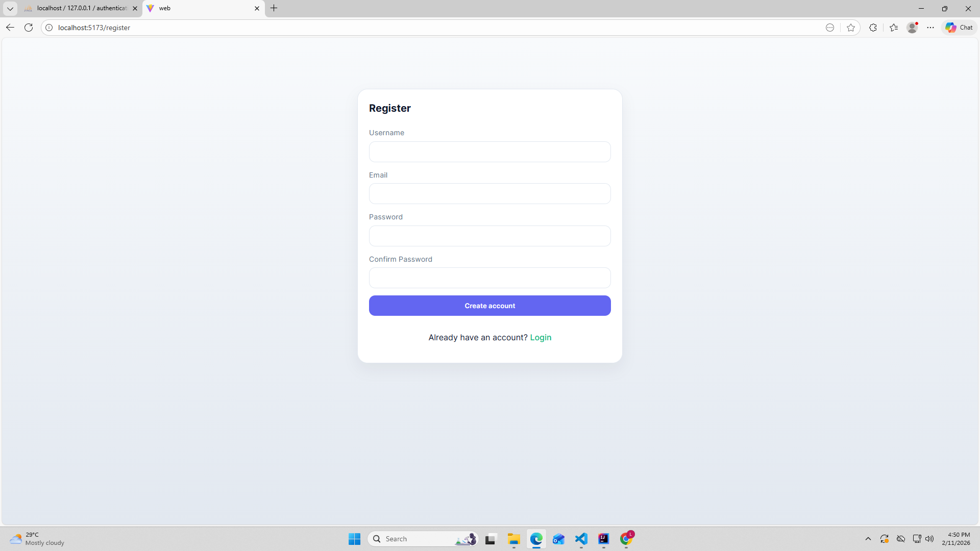

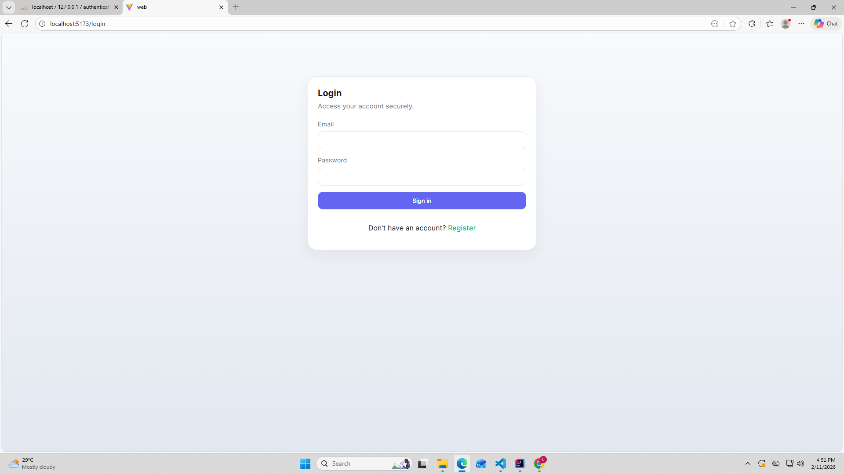
Login

Proof of Integration
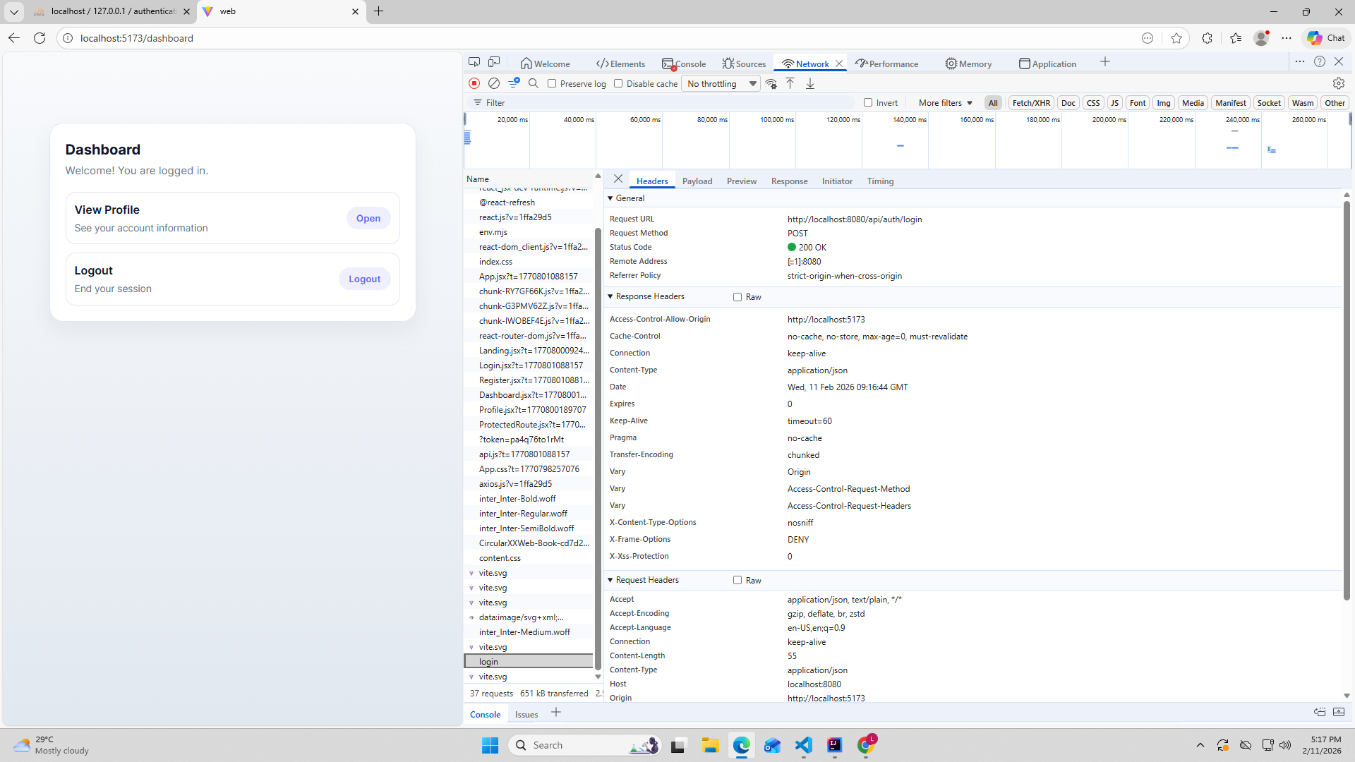
Dashboard
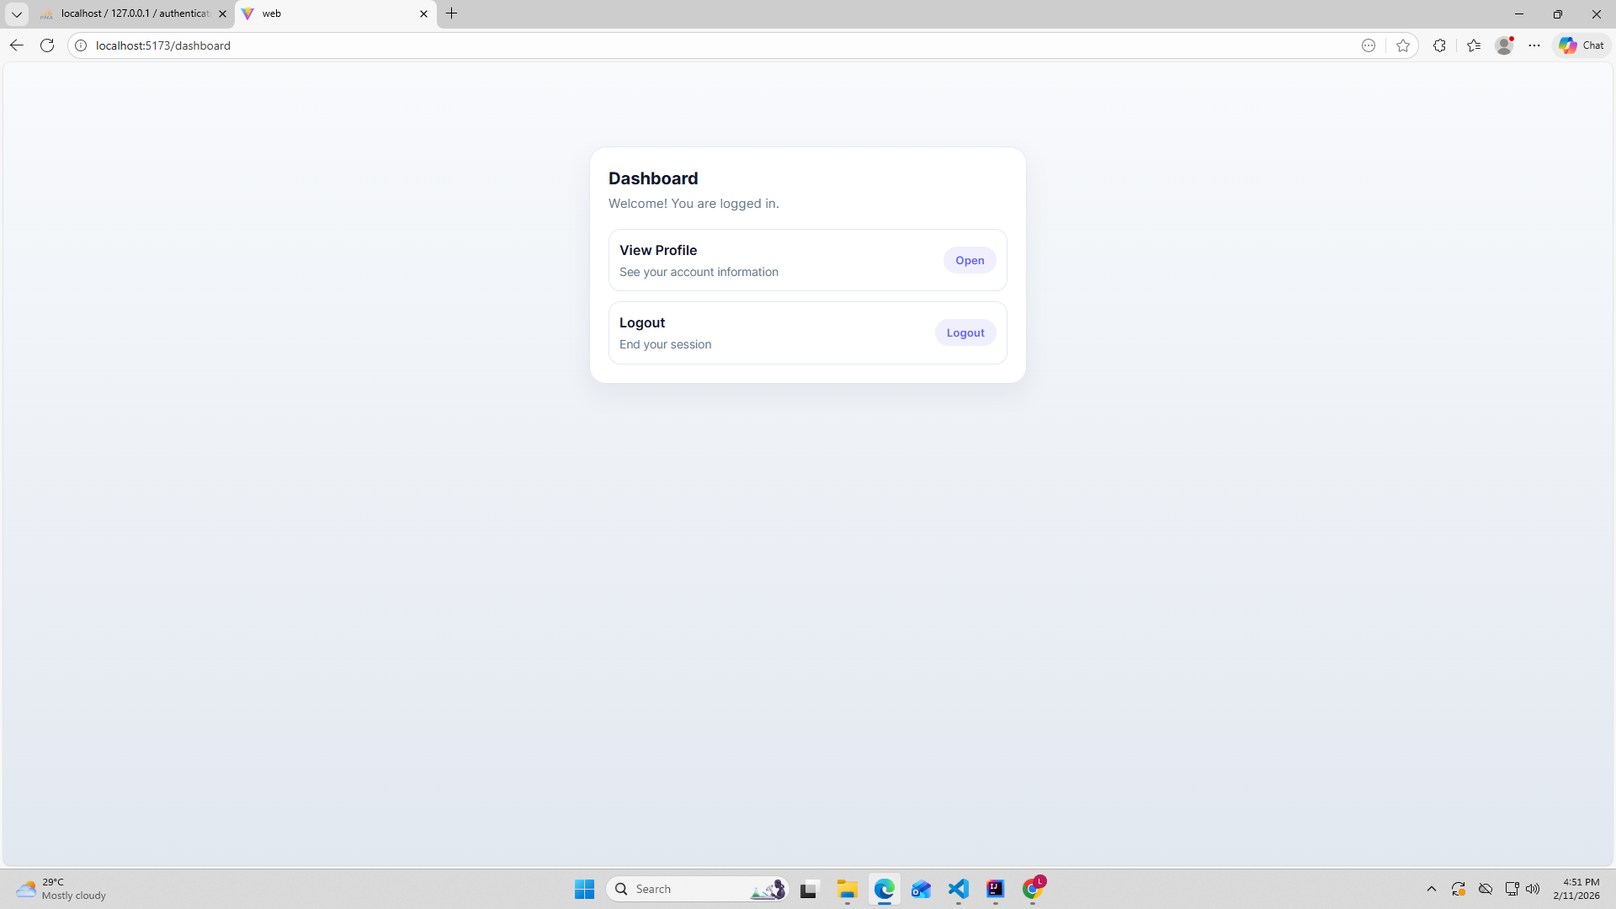

Profile
