Homework 1

1.

a) delay sensitive - Opening a file involves less message transfers.

b) bandwidth sensitive – Many message transfer is required for reading a file.

c) delay sensitive – Contents of a directory are of small size.

d) delay sensitive – Attributes of a files are smaller size than the actual file itself.

e) bandwidth sensitive – Average video file is larger than common files.

2.

a) Transmit Time for single link = Size / Bandwidth

= 10000 / 100 Mbps

= 100 μs

Propagation delay for each link = 20 μs

With one switch, there will be two links,

Therefore, required total latency = 2 * Transmit Time + 2 * Propagation Delay

= 2 * 100 + 2 * 20 μs

= **240 μs**

b) With three switches, there will be four links,

So, required total latency = 4 * Transmit Time + 4 * Propagation Delay

= 4 * 100 + 4 * 20 μs

= **480 μs**

c) With cut-through switching, the switch delay = 200 / 100 Mbps = 2 μs

Therefore, required total latency = Transmit time + Propagation Delay + Switch delay

= 100 + 20 + 2

= **122 μs**

3.

Bandwidth between A and S = 100 Mbps

Latency between A and S = 20 μs

Bandwidth between B and S = 50 Mbps

Latency between B and S = 30 μs

Switch delay = 40 μs

a)

Transmit Time A to S= Size / Bandwidth

= 10000 / 100 Mbps

= 100 μs

Time needed to send 10,000 bit from A to S = Transmit Time + Propagation Delay

= 100 + 20

= 120 μs

Transmit Time S to B = Size / Bandwidth

= 10000 / 50 Mbps

= 200 μs

Time needed to send 10,000 bit from S to A = Transmit Time + Propagation Delay

= 200 + 30

= 230 μs

Total time taken to send 10,000 bit packet from A to B = Total time from A to S + Total time

from S to B + switch delay

= 120 + 230 + 40

= **390 μs.**

b) Bandwidth between A and S is 100 Mbps and between S and B is 50 Mbps, So, 50 Megabits should be buffered for every second. So S has to provide buffering of **5Mb** such that packets won’t be dropped until after 100ms has elapsed.

c) Total time taken to transmit 10,000 bit from A to B = 390 μs.

Time taken to transmit signal from B to A = Switch delay + propagation delay

= 40 μs + 50 μs

= 90 μs

Total RTT between A and B = 390 + 90 = 480 μs

Total bits sent by A during this RTT = 480 * 10 ^ -6 * 100 * 10 ^ 6

= 48000 bits

So approximate number of packets sent by A is **5**.

4. Packet overhead = 50 bytes

Total number of bytes of data sent = 1 million bytes

= 1 * 10 ^ 6 bytes

Packet size – 1000 data bytes

Total number of packets = 1 * 10 ^ 6 / 1000

= 1000 packets

Total overhead = 1000 * 50 = 50000 bytes

Loss in bytes = 1000 bytes (Since overhead is added in total overhead)

Total overhead + loss for 1000 data bytes = 51000 bytes

Packet size – 10000 data bytes

Total number of packets = 1 * 10 ^ 6 / 10000

= 100 packets

Total overhead = 100 * 50 = 5000 bytes

Loss in bytes = 10000 bytes (Since overhead is added in total overhead)

Total overhead + loss for 10000 data bytes = 15000 bytes

Packet size – 20000 data bytes

Total number of packets = 1 * 10 ^ 6 / 20000

= 50 packets

Total overhead = 50* 50 = 2500 bytes

Loss in bytes = 20000 bytes (Since overhead is added in total overhead)

Total overhead + loss for 20000 data bytes = 22500 bytes

The total number of overhead + loss byte for packet data sizes of

**1000 = 51000 bytes**

**10000 = 15000 bytes**

**20000 = 22500 bytes**

By overhead and loss,

Packet data size of **10000 is optimal**.

5)

a)

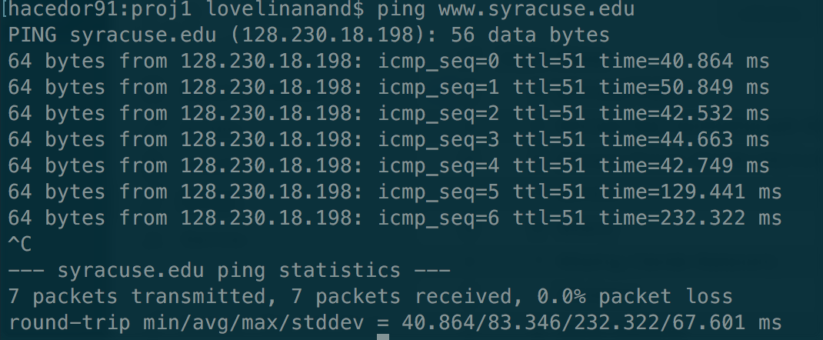

Ping response from [www.syracuse.edu](http://www.syracuse.edu):

Round trip minimum = 40.864 ms

Round trip maximum = 232.322 ms

Round trip average = 40.864 ms

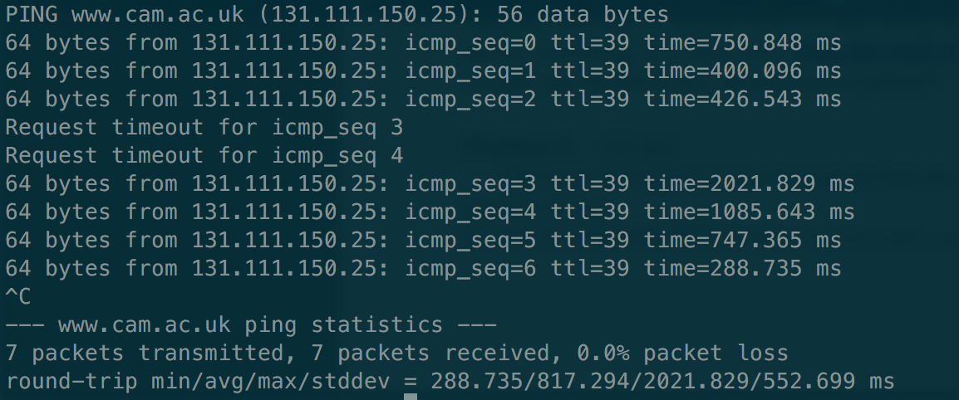

Ping response from [www.cam.ac.uk](http://www.cam.ac.uk):

Round trip minimum = 288.735 ms

Round trip maximum = 2021.829 ms

Round trip average = 817.294 ms

b) From the result, we can infer that RTT from [www.syracuse.edu](http://www.syracuse.edu) is faster than [www.cam.ac.uk](http://www.cam.ac.uk)

Possible reasons for the differences are

1) Server location and distance from Binghamton.

2) Number of hops between server and the client.

3) Traffic load in these servers.

6)

1 0 1 0 0

1 0 1 0 0

1 1 0 0 0

1 1 0 1 1

0 1 0 1 1

So the data to be sent is **1010 0 1010 0 1100 0 1101 1 0101 1**

7)

a) Data = 1011 0010 011

Polynomial = 10011 ( x^4 + x + 1)

10011 1 0 1 1 0 0 1 0 0 1 1 0 0 0 0

1 0 0 1 1

0 0 1 0 1 0 1

1 0 0 1 1

0 0 1 1 0 0 0

1 0 0 1 1

0 1 0 1 1 1

1 0 0 1 1

0 0 1 0 0 1 0

1 0 0 1 1

0 0 0 0 **1 0 0 0 - CRC**

Final data to be transmitted is:

**1011 0010 0111 000**

b)

Error pattern = 1000 1000 0000 000

Data received with error = 0011 1010 0111 000

10011 0 0 1 1 1 0 1 0 0 1 1 1 0 0 0

1 0 0 1 1

1 0 1 0 0

1 0 0 1 1

0 0 1 1 1 0 1

1 0 0 1 1

0 1 1 1 0 0

1 0 0 1 1

0 1 1 1 1 0

1 0 0 1 1

0 1 1 0 1 1

1 0 0 1 1

0 1 0 0 0 1

1 0 0 1 1

0 0 0 1 0 1 0 0

1 0 0 1 1

**0 0 1 1 1 0**

Since the remainder is not zero, this shows the input data has error. So error can be detected.

c)

Error pattern = 1001 1000 0000 000

Data received with error = 0010 1010 011 000

10011 0 0 1 0 1 0 1 0 0 1 1 0 0 0

1 0 0 1 1

1 0 1 1 0

1 0 0 1 1

0 0 1 0 1 0 1

1 0 0 1 1

0 0 1 1 0 0 0

1 0 0 1 1

0 1 0 1 1 1

1 0 0 1 1

0 0 1 0 0 1 0

1 0 0 1 1

0 0 0 0 **1 0 0**

Since the remainder is **not zero**, the error can be detected in the received data

8)

Input = 1010 1010 101

a) Minimum number of parity bits required is 4 ( _ _ 1 _ 0 1 0 _ 1 0 1 0 1 0 1 )

b) Hamming code for the above message is

1 0 1 1 0 1 0 0 1 0 1 0 1 0 1