1../assignment1 -readers=1 -askers=1 -askdelay=10 -chan=true

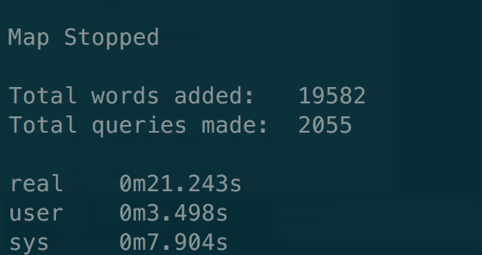

2../assignment1 -readers=16 -askers=2 -askdelay=10 -chan=true

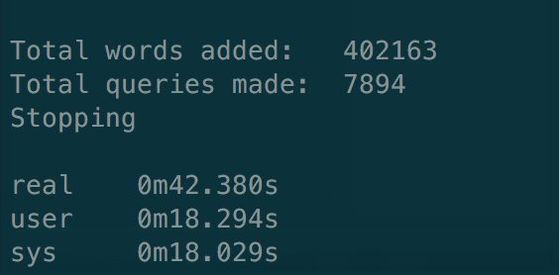

3. ./assignment1 -readers=4 -askers=8 -askdelay=10 -chan=true

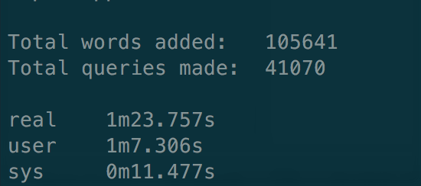

4. ./assignment1 –readers=16 –askers=32 –askdelay=10 –chan=true (**Incomplete Output, Terminated due to over time more than 1 hr**)

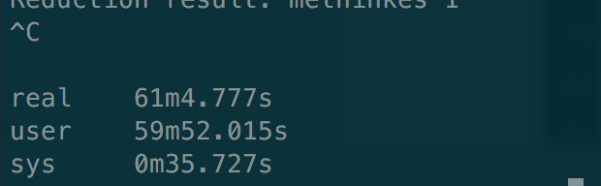

Status during terminating

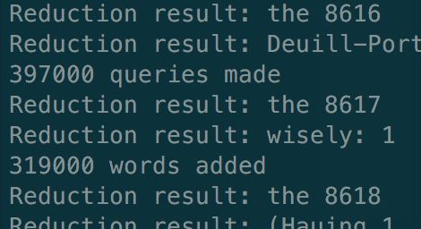

5./ ./assignment1 –readers=16 –askers=32 –askdelay=10 –chan=true (**Incomplete Output, Terminated due to over time more than 1 hr**)



Status during terminating

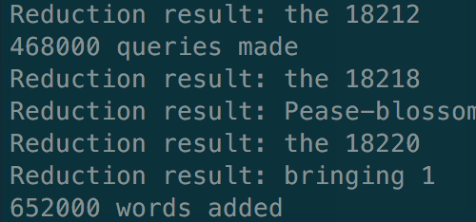

From the Result, we can infer that

1. Increasing askers increases the time completion rapidly.

2. Increasing readers does not affect the time completion when compared with askers