
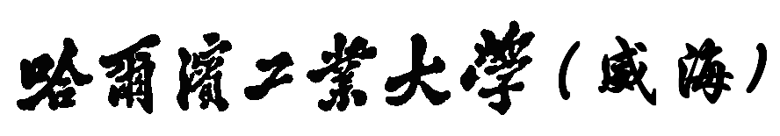
Harbin Institute of Technology at Weihai
信息安全设计与实践I
课程设计报告

设计题目： bmp压缩jpeg格式并加密

班 级： 1504202
学 号： 150730120
姓 名： 方亮
验收日期： 2018.06.22

哈尔滨工业大学（威海）计算机学院
二零一八年六月

绪 论

设计项目简介
简介：
- 对bmp格式的图片进行压缩，生成体积更小的Jpeg格式文件
- 用户进行被压缩文件的选择
- 用户进行压缩文件名的选择
- 用户可以进行压缩的程度的选择
- 对Jpeg格式的文件，进行加密
- 选择了更加安全的一次一密的加密方式
- 对用户想要加密的Jpeg文件进行加密

设计目的
  - 掌握JPEG图像格式（对原始图像进行正向离散余弦变换（FDCT），然后对DCT系数进行量化，得到量化系数表，然后分别对量化系数表表中的DC系数和AC系数进行熵编码（游程编码和霍夫曼编码，即压缩））；
  - 对JPEG图像的熵编码后的数据流进行加密（可以用最简单的流加密形式）；
能够得到雪花状的JPEG格式的密文图像，并能够解密功能

设计内容
- 对bmp图像进行压缩：
- 对Jpeg格式的文件进行加密
- 读取jpeg格式的文件
- 进行rc4编码
- 写被加密后的文件
- 对加密后的文件进行解密
- 读Jpeg格式，被加密的文件
- 读取存储的密钥流文件

应用范围
    - 想要压缩原始图像体积的情况
    - 想要对Jpeg图像进行加密的情况

2.系统总体设计功能图
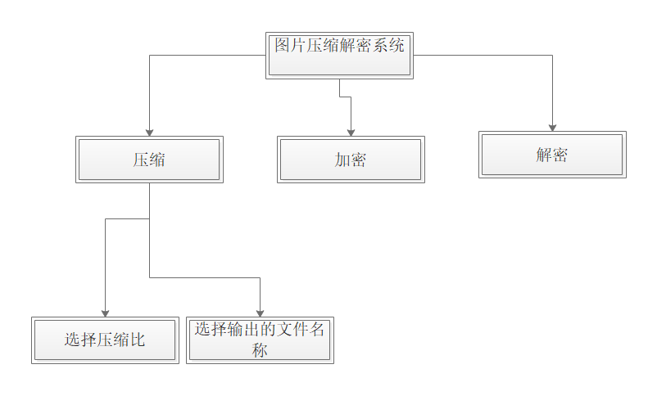
图2-1-1 功能结构图

3.设计思想、算法与功能流程图

3.1） 设计思想：
- 对bmp图像进行压缩：
- 先对文件进行读取
- 将读取到的文件的rgb字节进行颜色空间的转换
- 进行DCT变换
- 进行量化表的量化分析
- 进行编码，包括
- 游程编码
- 对后一部分的值Bit的编码
- 对前一部分的值进行Huffman编码
- 写Jpeg格式的文件
- 对Jpeg格式的文件进行加密
- 读取jpeg格式的文件
- 先读文件的头
- 再读文件的图像像素部分
- 最后图像文件的中介符号
- 进行rc4编码
- 生成随机的初始密钥流
- 通过状态向量，生成进行加密的一次一密密钥流
- 把密钥流写成文件进行保存
- 用密钥流进行加密
- 写被加密后的文件
- 对加密后的文件进行解密
- 读Jpeg格式，被加密的文件
- 读取存储的密钥流文件
- 用密钥流对加密文件进行解密—异或
- 写解密后的文件

3.2） 功能流程图

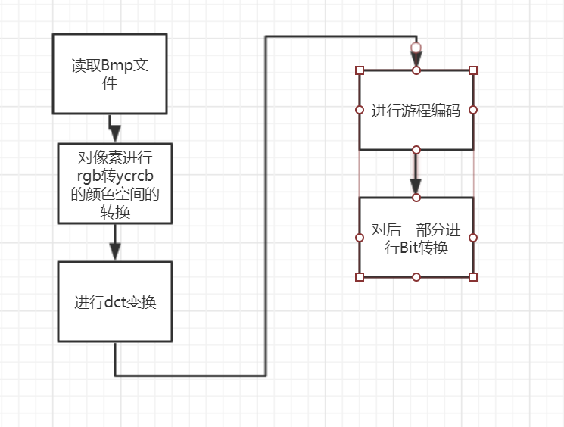
图3-2-1 压缩的功能流程图

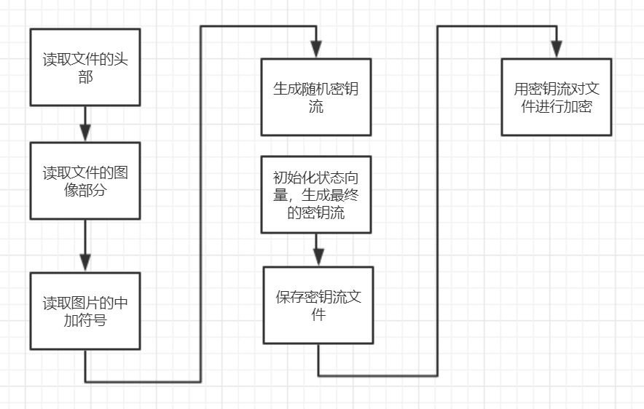
图3-2-2 加密功能的流程图
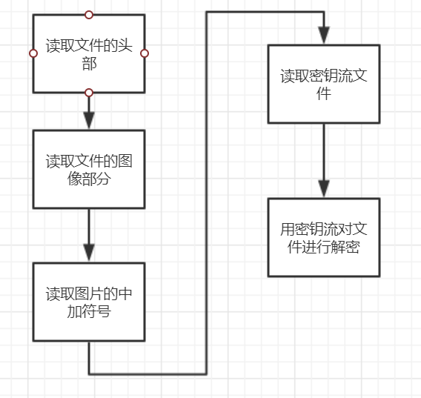
图3-2-3 解密功能的流程图

4.系统功能实现

4.1 压缩功能实现
给出主要功能部分的系统界面截图及核心代码来，并给出必要的描述说明。按功能模块来分节。

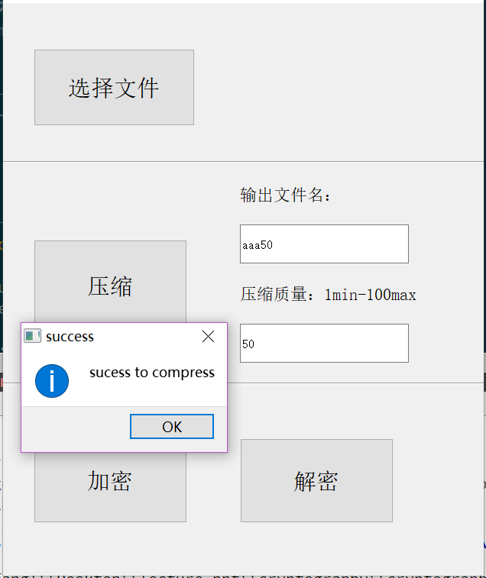
图4-1-1 压缩成功的图片

核心代码：
bool JpegEncoder::readFromBMP(const char* fileName)
{
//清理旧数据
clean();

//BMP 文件格式
#pragma pack(push, 2)
typedef struct {
unsigned short bfType;
unsigned int bfSize;
unsigned short bfReserved1;
unsigned short bfReserved2;
unsigned int bfOffBits;
} BITMAPFILEHEADER;

typedef struct {
unsigned int biSize;
int biWidth;
int biHeight;
unsigned short biPlanes;
unsigned short biBitCount;
unsigned int biCompression;
unsigned int biSizeImage;
int biXPelsPerMeter;
int biYPelsPerMeter;
unsigned int biClrUsed;
unsigned int biClrImportant;
} BITMAPINFOHEADER;
#pragma pack(pop)

//打开文件
FILE* fp = fopen(fileName, "rb");
if(fp==0) return false;
qDebug()<<"open bmp file successfully";
bool successed=false;
do
{
//bmp file header
BITMAPFILEHEADER fileHeader;

//bmp file info header
BITMAPINFOHEADER infoHeader;

if(1 != fread(&fileHeader, sizeof(fileHeader), 1, fp))
{
qDebug()<<"fail to read header";
break;
}
if(fileHeader.bfType!=0x4D42) break;

if(1 != fread(&infoHeader, sizeof(infoHeader), 1, fp)) break;
if(infoHeader.biBitCount!=24 || infoHeader.biCompression!=0) break;

int width = infoHeader.biWidth;
int height = infoHeader.biHeight < 0 ? (-infoHeader.biHeight) : infoHeader.biHeight;

if((width&7)!=0 || (height&7)!=0){
qDebug()<<"width and height is not the multiple of 8";
break;
} //必须是8的倍数

int bmpSize = width*height*3;

unsigned char* buffer = new unsigned char[bmpSize];
if(buffer==0) break;

fseek(fp, fileHeader.bfOffBits, SEEK_SET);

if(infoHeader.biHeight>0)
{
//i: 0-height-1, index on row of image array
for(int i=0; i<height; i++)
{
//Q:put the first row read from stream to the last row of array
if(width != fread(buffer+(height-1-i)*width*3, 3, width, fp))
{
qDebug()<<"width != fread(buffer+(height-1-i)*width*3, 3, width, fp)";
delete[] buffer; buffer=0;
break;
}
}
}
else
{
if(width*height != fread(buffer, 3, width*height, fp))
{
qDebug()<<"width*height != fread(buffer, 3, width*height, fp)";
delete[] buffer; buffer=0;
break;
}
}
//m_rgbBuffer: store original pixel stream
m_rgbBuffer = buffer;
//width of jpeg image array
m_width = width;
//height of jpeg image array
m_height = height;
successed=true;
}while(false);

fclose(fp);fp=0;

return successed;
}

//-------------------------------------------------------------------------------
//fileName: target file name
//quality_scale: compression degree
bool JpegEncoder::encodeToJPG(const char* fileName, int quality_scale)
{
//尚未读取？
if(m_rgbBuffer==0 || m_width==0 || m_height==0) return false;

//输出文件
FILE* fp = fopen(fileName, "wb");
if(fp==0) return false;

//初始化量化表
_initQualityTables(quality_scale);

//文件头
_write_jpeg_header(fp);
// previous Y channel DC value of previous block
short prev_DC_Y = 0,
prev_DC_Cb = 0,
prev_DC_Cr = 0;
int newByte=0, newBytePos=7;

//m_height: height of image array in pixel
//yPos: row index of image array
for(int yPos=0; yPos<m_height; yPos+=8)
{
// m_width: widht of image array in pixel
//xPos: column index of image array
for (int xPos=0; xPos<m_width; xPos+=8)
{
//
char yData[64], cbData[64], crData[64];

//yQuant: array of data after do dct and quantization on each 8*8 block whose coordinate of first entry is (x,y)
short yQuant[64], cbQuant[64], crQuant[64];

//转换颜色空间
_convertColorSpace(xPos, yPos, yData, cbData, crData);

BitString outputBitString[128];
int bitStringCounts;

//Y通道压缩
_foword_FDC(yData, yQuant);
//prev_DC_Y: dc value of Y channel
//m_Y_DC_Huffman_Table: Y DC huffman code table
//m_Y_AC_Huffman_Table: Y AC huffman code table
_doHuffmanEncoding(yQuant, prev_DC_Y, m_Y_DC_Huffman_Table, m_Y_AC_Huffman_Table, outputBitString, bitStringCounts);
_write_bitstring_(outputBitString, bitStringCounts, newByte, newBytePos, fp);

//Cb通道压缩
_foword_FDC(cbData, cbQuant);
_doHuffmanEncoding(cbQuant, prev_DC_Cb, m_CbCr_DC_Huffman_Table, m_CbCr_AC_Huffman_Table, outputBitString, bitStringCounts);
_write_bitstring_(outputBitString, bitStringCounts, newByte, newBytePos, fp);

//Cr通道压缩
_foword_FDC(crData, crQuant);
_doHuffmanEncoding(crQuant, prev_DC_Cr, m_CbCr_DC_Huffman_Table, m_CbCr_AC_Huffman_Table, outputBitString, bitStringCounts);
_write_bitstring_(outputBitString, bitStringCounts, newByte, newBytePos, fp);
}
}

_write_word_(0xFFD9, fp); //Write End of Image Marker

fclose(fp);

return true;
}

//-------------------------------------------------------------------------------
void JpegEncoder::_initHuffmanTables(void)
{
//m_Y_DC_Huffman_Table: dc coefficient huffman table of Y channel
memset(&m_Y_DC_Huffman_Table, 0, sizeof(m_Y_DC_Huffman_Table));
_computeHuffmanTable(Standard_DC_Luminance_NRCodes, Standard_DC_Luminance_Values, m_Y_DC_Huffman_Table);

memset(&m_Y_AC_Huffman_Table, 0, sizeof(m_Y_AC_Huffman_Table));
_computeHuffmanTable(Standard_AC_Luminance_NRCodes, Standard_AC_Luminance_Values, m_Y_AC_Huffman_Table);

memset(&m_CbCr_DC_Huffman_Table, 0, sizeof(m_CbCr_DC_Huffman_Table));
_computeHuffmanTable(Standard_DC_Chrominance_NRCodes, Standard_DC_Chrominance_Values, m_CbCr_DC_Huffman_Table);

memset(&m_CbCr_AC_Huffman_Table, 0, sizeof(m_CbCr_AC_Huffman_Table));
_computeHuffmanTable(Standard_AC_Chrominance_NRCodes, Standard_AC_Chrominance_Values, m_CbCr_AC_Huffman_Table);
}
//-------------------------------------------------------------------------------
//value: for AC, value of index i in block
JpegEncoder::BitString JpegEncoder::_getBitCode(int value)
{
//BIT code of a value
BitString ret;

//v: absolute value of parameter value
int v = (value>0) ? value : -value;

//bit 的长度
int length = 0;
for(length=0; v; v>>=1) length++;

ret.value = value>0 ? value : ((1<<length)+value-1);
ret.length = length;

return ret;
};

//-------------------------------------------------------------------------------
//initial q value table of Y,CBCR channel
void JpegEncoder::_initQualityTables(int quality_scale)
{
if(quality_scale<=0) quality_scale=1;
if(quality_scale>=100) quality_scale=99;

for(int i=0; i<64; i++)
{
//the Q value at index i of Y quantization table
int temp = ((int)(Luminance_Quantization_Table[i] * quality_scale + 50) / 100);
if (temp<=0) temp = 1;
if (temp>0xFF) temp = 0xFF;

//store q value of Y channel after zigzag order
m_YTable[ZigZag[i]] = (unsigned char)temp;

temp = ((int)(Chrominance_Quantization_Table[i] * quality_scale + 50) / 100);
if (temp<=0) temp = 1;
if (temp>0xFF) temp = 0xFF;

// store q value of Cb Cr channle after zigzag order
m_CbCrTable[ZigZag[i]] = (unsigned char)temp;
}
}

//-------------------------------------------------------------------------------
//nr_codes: array of number recording the count of huffman code whose length is the same
//std_table: array of value to be encoded into huffman bit code
//huffman_table: Y or CB huffman table
void JpegEncoder::_computeHuffmanTable(const char* nr_codes, const unsigned char* std_table, BitString* huffman_table)
{
//position in standard huffman value table
unsigned char pos_in_table = 0;
//huffman code bit value
unsigned short code_value = 0;

//k: length of huffman bit code
for(int k = 1; k <= 16; k++)
{
//j: index of array containing huffman code with same length
for(int j = 1; j <= nr_codes[k-1]; j++)
{
/*
//std_table[pos_in_table]: value to be encoded into huffman code -- huffman encoded bit code;
//as the index of huffman table
*/
huffman_table[std_table[pos_in_table]].value = code_value;
huffman_table[std_table[pos_in_table]].length = k;
pos_in_table++;
code_value++;
}
code_value <<= 1;
}
}

//-------------------------------------------------------------------------------
void JpegEncoder::_write_byte_(unsigned char value, FILE* fp)
{
_write_(&value, 1, fp);
}

//-------------------------------------------------------------------------------
void JpegEncoder::_write_word_(unsigned short value, FILE* fp)
{
//value converted to little endian
unsigned short _value = ((value>>8)&0xFF) | ((value&0xFF)<<8);
_write_(&_value, 2, fp);
}

//-------------------------------------------------------------------------------
//the byte size of element
void JpegEncoder::_write_(const void* p, int byteSize, FILE* fp)
{
fwrite(p, 1, byteSize, fp);
}

//-------------------------------------------------------------------------------
//DU: y or cb,cr channel data of a 8*8 block after dct and quantization data;
//prevDC:
//HTDC: Y or CBCR, DC created huffman table
//HTAC: Y or CbCr, AC created huffman table
//outputBitString:
//bitstringCounts: size of bitstring array
void JpegEncoder::_doHuffmanEncoding(const short* DU, short& prevDC, const BitString* HTDC, const BitString* HTAC,
BitString* outputBitString, int& bitStringCounts)
{
BitString EOB = HTAC[0x00];

//bit string huffman encode of 0xF0
BitString SIXTEEN_ZEROS = HTAC[0xF0];

//index of output bitstring array
int index=0;

// encode DC
// DU[0]: DC value of current block
//dcDiff: difference between current dc value to dc value of previous block
int dcDiff = (int)(DU[0] - prevDC);
prevDC = DU[0];

if (dcDiff == 0)
//HTDC[0]:
outputBitString[index++] = HTDC[0];
else
{
//DC encode, use the difference between two DC as value to do huffman encode for current DC
BitString bs = _getBitCode(dcDiff);

outputBitString[index++] = HTDC[bs.length];
outputBitString[index++] = bs;
}

// encode ACs
//endPos: index of 8*8 block from 63-
int endPos=63; //end0pos = first element in reverse order != 0
while((endPos > 0) && (DU[endPos] == 0)) endPos--;

//i: index of 8*8 block, from 1 to endPos
for(int i=1; i<=endPos; )
{
//start position when count number of zero
int startPos = i;
while((DU[i] == 0) && (i <= endPos)) i++;

//count of continuous zero value in 8*8 block
int zeroCounts = i - startPos;
if (zeroCounts >= 16)
{
for (int j=1; j<=zeroCounts/16; j++)

outputBitString[index++] = SIXTEEN_ZEROS;
zeroCounts = zeroCounts%16;
}
//DU[i]: value of index i in block
BitString bs = _getBitCode(DU[i]);

outputBitString[index++] = HTAC[(zeroCounts << 4) | bs.length];
outputBitString[index++] = bs;
i++;
}

if (endPos != 63)
outputBitString[index++] = EOB;

//count of bitstring in bitstring output array
bitStringCounts = index;
}

//-------------------------------------------------------------------------------
//bs: bitstring array of 8*8 block
//couts: count of bitstring in bitstring array
//newByte:
//newBytePos:
void JpegEncoder::_write_bitstring_(const BitString* bs, int counts, int& newByte, int& newBytePos, FILE* fp)
{
unsigned short mask[] = {1,2,4,8,16,32,64,128,256,512,1024,2048,4096,8192,16384,32768};

//i: index of bitstring array
for(int i=0; i<counts; i++)
{
//value: output bitstring value
int value = bs[i].value;

//index from length-1 to 0
int posval = bs[i].length - 1;

while (posval >= 0)
{
//mask[]: number only at index = posval bit=1, other bit digit is 0
if ((value & mask[posval]) != 0)
{
//newByte: create new byte to remove extra blank bit
newByte = newByte | mask[newBytePos];
}
posval--;
//index from 7 to 0
newBytePos--;
if (newBytePos < 0)
{
// Write to stream
_write_byte_((unsigned char)(newByte), fp);
if (newByte == 0xFF)
{
// Handle special case
_write_byte_((unsigned char)(0x00), fp);
}

// Reinitialize
newBytePos = 7;
newByte = 0;
}
}
}
}

//-------------------------------------------------------------------------------
//(xPos,yPos) coordinate of left uppermost pixel of current block;
//xPos: coordinate of x axis, index of column; yPos: coordinate of y axis, index of row
//yData: store all y value of current block
//cbData: all Cb value of current block
//crData: all cr value of current block
void JpegEncoder::_convertColorSpace(int xPos, int yPos, char* yData, char* cbData, char* crData)
{
//y: index of row of 8*8 block
for (int y=0; y<8; y++)
{
//p: point to the position of (x,y) in original pixel stream
unsigned char* p = m_rgbBuffer + (y+yPos)*m_width*3 + xPos*3;

//x: index of column of 8*8 block
for (int x=0; x<8; x++)
{
//B: B value of RGB
unsigned char B = *p++;
//G: G value of RGB pixel value
unsigned char G = *p++;
//R: R value
unsigned char R = *p++;

//y value of (x,y) entry of 8*8 block
yData[y*8+x] = (char)(0.299f * R + 0.587f * G + 0.114f * B - 128);
//cb value of (x,y) entry of 8*8 block
cbData[y*8+x] = (char)(-0.1687f * R - 0.3313f * G + 0.5f * B );
//cr value of (x,y) entry of 8*8 block
crData[y*8+x] = (char)(0.5f * R - 0.4187f * G - 0.0813f * B);
}
}
}

//-------------------------------------------------------------------------------
//channel_data: y or cb or cr channel data of each 8*8 block
//fdc_data: store the data of channel after dct transformation
void JpegEncoder::_foword_FDC(const char* channel_data, short* fdc_data)
{
const float PI = 3.1415926f;
//index on row of fdc data array
for(int v=0; v<8; v++)
{
//index on column of fdc data array
for(int u=0; u<8; u++)
{
float alpha_u = (u==0) ? 1/sqrt(8.0f) : 0.5f;
float alpha_v = (v==0) ? 1/sqrt(8.0f) : 0.5f;

float temp = 0.f;

//x: index of channel data column
for(int x=0; x<8; x++)
{
//y: index of channel data row
for(int y=0; y<8; y++)
{
float data = channel_data[y*8+x];

data *= cos((2*x+1)*u*PI/16.0f);
data *= cos((2*y+1)*v*PI/16.0f);

temp += data;
}
}

//temp: (u,v) entry data in array after dct and quantization transformation
temp *= alpha_u*alpha_v/m_YTable[ZigZag[v*8+u]];

fdc_data[ZigZag[v*8+u]] = (short) ((short)(temp + 16384.5) - 16384);
}
}
}

//-------------------------------------------------------------------------------
void JpegEncoder::_write_jpeg_header(FILE* fp)
{

//SOI//
//write two bytes
_write_word_(0xFFD8, fp); // marker = 0xFFD8

//APPO//
_write_word_(0xFFE0,fp); // marker = 0xFFE0
//the sum of length of current segement
_write_word_(16, fp); // length = 16 for usual JPEG, no thumbnail

_write_("JFIF", 5, fp); // 'JFIF\0'
_write_byte_(1, fp); // version_hi
_write_byte_(1, fp); // version_low

_write_byte_(0, fp); // xyunits = 0 no units, normal density
//pixel density in the x direction
_write_word_(1, fp); // xdensity
//pixel density in the y direction
_write_word_(1, fp); // ydensity
_write_byte_(0, fp); // thumbWidth
_write_byte_(0, fp); // thumbHeight

//DQT//: define quantization table
_write_word_(0xFFDB, fp); //marker = 0xFFDB
//sum of length of following segement including current segement
_write_word_(132, fp); //size=132
_write_byte_(0, fp); //QTYinfo== 0: bit 0..3: number of QT = 0 (table for Y)
// bit 4..7: precision of QT
// bit 8 : 0
_write_(m_YTable, 64, fp); //YTable
_write_byte_(1, fp); //QTCbinfo = 1 (quantization table for Cb,Cr)
_write_(m_CbCrTable, 64, fp); //CbCrTable

//SOFO//: start of frame
_write_word_(0xFFC0, fp); //marker = 0xFFC0
//length of bytes of SOFO segement exclude marker part
_write_word_(17, fp); //length = 17 for a truecolor YCbCr JPG
_write_byte_(8, fp); //precision = 8: 8 bits/sample
_write_word_(m_height&0xFFFF, fp); //height
_write_word_(m_width&0xFFFF, fp); //width
_write_byte_(3, fp); //nrofcomponents = 3: We encode a truecolor JPG

_write_byte_(1, fp); //IdY = 1
_write_byte_(0x11, fp); //HVY sampling factors for Y (bit 0-3 vert., 4-7 hor.)(SubSamp 1x1)
_write_byte_(0, fp); //QTY Quantization Table number for Y = 0

_write_byte_(2, fp); //IdCb = 2
_write_byte_(0x11, fp); //HVCb = 0x11(SubSamp 1x1)
_write_byte_(1, fp); //QTCb = 1

_write_byte_(3, fp); //IdCr = 3
_write_byte_(0x11, fp); //HVCr = 0x11 (SubSamp 1x1)
_write_byte_(1, fp); //QTCr Normally equal to QTCb = 1

//DHT//: define huffman table
_write_word_(0xFFC4, fp); //marker = 0xFFC4 of DHT segament
//length of current segement
_write_word_(0x01A2, fp); //length = 0x01A2
_write_byte_(0, fp); //HTYDCinfo bit 0..3 : number of HT (0..3), for Y =0
// bit 4 : type of HT, 0 = DC table,1 = AC table
// bit 5..7 : not used, must be 0

_write_(Standard_DC_Luminance_NRCodes, sizeof(Standard_DC_Luminance_NRCodes), fp); //DC_L_NRC
_write_(Standard_DC_Luminance_Values, sizeof(Standard_DC_Luminance_Values), fp); //DC_L_VALUE

_write_byte_(0x10, fp); //HTYACinfo marker
_write_(Standard_AC_Luminance_NRCodes, sizeof(Standard_AC_Luminance_NRCodes), fp);
_write_(Standard_AC_Luminance_Values, sizeof(Standard_AC_Luminance_Values), fp); //we'll use the standard Huffman tables

_write_byte_(0x01, fp); //HTCbDCinfo
_write_(Standard_DC_Chrominance_NRCodes, sizeof(Standard_DC_Chrominance_NRCodes), fp);
_write_(Standard_DC_Chrominance_Values, sizeof(Standard_DC_Chrominance_Values), fp);

_write_byte_(0x11, fp); //HTCbACinfo
_write_(Standard_AC_Chrominance_NRCodes, sizeof(Standard_AC_Chrominance_NRCodes), fp);
_write_(Standard_AC_Chrominance_Values, sizeof(Standard_AC_Chrominance_Values), fp);

//SOS//: start to scan
_write_word_(0xFFDA, fp); //marker = 0xFFC4
_write_word_(12, fp); //length = 12
_write_byte_(3, fp); //nrofcomponents, Should be 3: truecolor JPG

_write_byte_(1, fp); //Idy=1
_write_byte_(0, fp); //HTY bits 0..3: AC table (0..3)
// bits 4..7: DC table (0..3)
_write_byte_(2, fp); //IdCb
_write_byte_(0x11, fp); //HTCb

_write_byte_(3, fp); //IdCr
_write_byte_(0x11, fp); //HTCr

_write_byte_(0, fp); //Ss not interesting, they should be 0,63,0
_write_byte_(0x3F, fp); //Se
_write_byte_(0, fp); //Bf
}

4.2 加密功能实现
给出主要功能部分的系统界面截图及核心代码来，并给出必要的描述说明。按功能模块来分节。
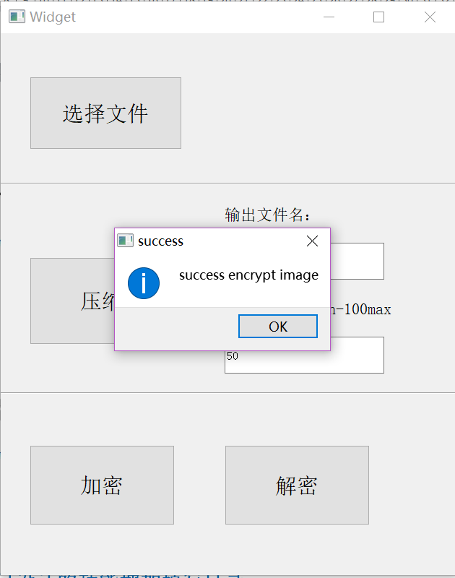
图4-2-1 加密成功的图片
核心代码：

bool Encrpytor::encrpyt(){

//生产密钥流
this->r.keyStream(data.size());

ofstream outks;

//read the key stream in
outks.open("C:\\Users\\fangl\\Desktop\\lecture_ppt\\cryptography\\cryptograph-ex\\keystream.dat",ios::binary);
for(int i=0;i<data.size();++i){
outks<<(r.k[i]);
}
outks.close();

e_data.clear();
// index on plain text
for(int i=0;i<data.size();++i){
e_data.push_back((unsigned char)(data[i]^r.k[i]));
}

return true;
}

4.3 解密功能实现
给出主要功能部分的系统界面截图及核心代码来，并给出必要的描述说明。按功能模块来分节。
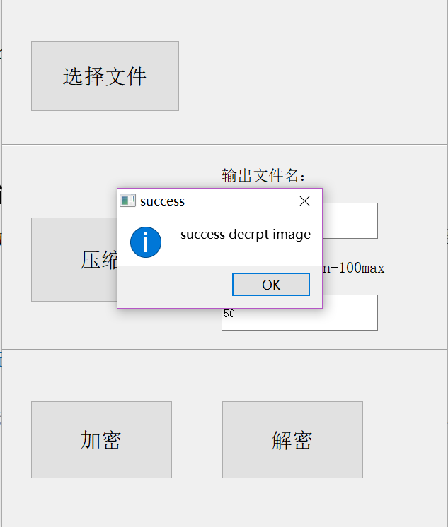
图4-3-1 成功解密的截图

5.总结

- 学到的东西：
- 学到了bmp文件的格式
- 学会了Jpeg文件的格式
- 学会了rc4的一次一密的加密算法

- 体会：
多加断点调试，对于没有任何提示信息类型的Bug,只能多加断点调试

