Establishing relationships between LWC and MPa, Part 2

Indra Boving

11/9/2022

##setup

## New names:  
## • `` -> `...1`

From what weeks do we have the most trees?

## Warning: Ignoring unknown parameters: stat

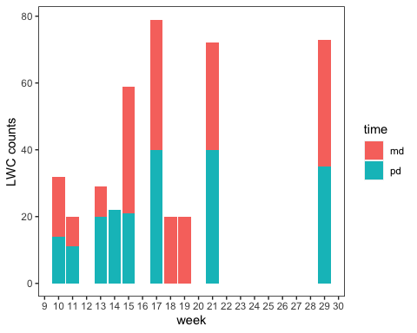

## Warning: Ignoring unknown parameters: stat

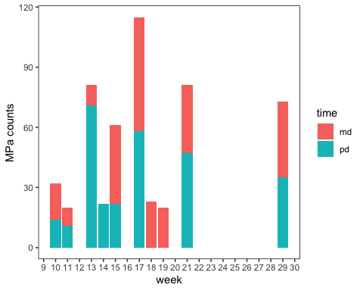 A: week 17, 21, 29, 10

#Hydration per week:

MPa ~ lwc + (lwc|tree) + (1|wk)

wc_qudo_df %>%   
 #filter(week %in% c(10, 13, 17, 21, 29)) %>%   
 ggplot(aes(y = water_potential,   
 x = lwc,   
 color = as.factor(tree)  
 )) +  
 geom_point(aes(shape = time)) +   
 geom_smooth(method = "lm",  
 se = F) +  
 facet_wrap(~week, scales = "free") +  
 theme(legend.position = "none")

## `geom_smooth()` using formula 'y ~ x'

## Warning: Removed 3 rows containing non-finite values (stat_smooth).

## Warning: Removed 3 rows containing missing values (geom_point).

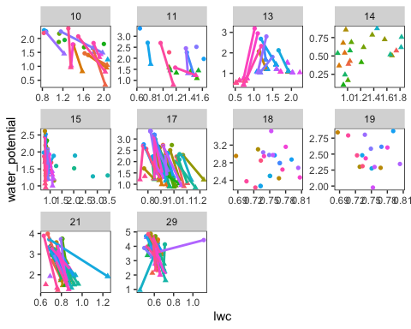

Okay, now try running the model:

MPa ~ lwc + (lwc|tree) + (1|wk)

wc_qudo_df %>%   
 ggplot(aes(y= water_potential,   
 x = lwc,   
 color = interaction(tree, week),   
 shape = time)) +  
 geom_point() +  
 geom_smooth(method = "lm", se = F) +  
 theme(legend.position = "none")

## `geom_smooth()` using formula 'y ~ x'

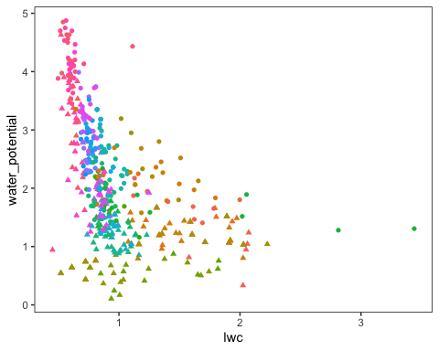

This give us a random slope and intercept per tree and per week

m_wk_rand <- lmer(water_potential ~ lwc + (lwc|tree) + (lwc|week), data = wc_qudo_df)

## boundary (singular) fit: see help('isSingular')

#unique(wc_qudo_df$week)

grand_slope <- broom.mixed::tidy(m_wk_rand)  
grand_slope

## # A tibble: 9 × 6  
## effect group term estimate std.error statistic  
## <chr> <chr> <chr> <dbl> <dbl> <dbl>  
## 1 fixed <NA> (Intercept) 3.34 0.629 5.31  
## 2 fixed <NA> lwc -1.58 0.554 -2.85  
## 3 ran_pars tree sd__(Intercept) 0.190 NA NA   
## 4 ran_pars tree cor__(Intercept).lwc -1.00 NA NA   
## 5 ran_pars tree sd__lwc 0.107 NA NA   
## 6 ran_pars week sd__(Intercept) 1.89 NA NA   
## 7 ran_pars week cor__(Intercept).lwc -0.949 NA NA   
## 8 ran_pars week sd__lwc 1.59 NA NA   
## 9 ran_pars Residual sd__Observation 0.575 NA NA

#ran_list <- ranef(m_wk_rand)  
  
ran_list2 <- coef(m_wk_rand)  
  
ran_df <- as.data.frame(ran_list2[['week']])%>%   
 mutate(estimate = `(Intercept)`,   
 slope = `lwc`,   
 -lwc) %>%  
 select(-`(Intercept)`)  
  
ran_err <- arm::se.ranef(m_wk_rand)  
ran_err_df <- as.data.frame(ran_err[['week']]) %>%   
 mutate(std.error = `(Intercept)`,   
 std.error.slope = `lwc`)%>%   
 select(-`(Intercept)`,   
 -lwc)  
  
weeks <- data_frame(1:10)

## Warning: `data_frame()` was deprecated in tibble 1.1.0.  
## ℹ Please use `tibble()` instead.

weeks$week <- c(10, 11, 13, 14, 15, 17, 18, 19, 21, 29)   
  
ran_df_week <- bind_cols(weeks, ran_df, ran_err_df) %>%   
 select(-`1:10`) %>%   
 data_frame()

Random slopes of each week:

ran_df_week %>%   
 # filter(week %in% c(14, 17, 21, 29)) %>%   
 # filter(term == "lwc") %>%   
 mutate(upr = slope + (std.error.slope/2),   
 lwr = slope - (std.error.slope/2)) %>%   
 ggplot(aes(color= week)  
 ) +   
 geom_point(aes(y = slope ,x = week), size =3) +  
 geom_point(aes(y = upr, x = week), size = 1) +  
 geom_point(aes(y = lwr, x = week), size = 1) +  
 #geom_line(aes(group = week, y = week, x = upr)) +  
 geom_segment(aes(y= lwr,   
 yend = upr,   
 x = week,   
 xend = week,   
 color = week))+  
 labs(x = "Week",   
 color = "week",   
 y = "Slope") +  
 # facet_wrap(~y_var_name, scales = "free") +   
theme(  
 strip.background = element_blank(),  
 strip.text.y = element_blank(),   
 strip.text.x = element_text(size = 18),   
 # axis.text.y = element_blank(),   
 #axis.ticks.y = element_blank(),   
 axis.title = element_text(size = 20),   
 legend.title = element_text(size = 18)  
 ) +  
 geom_hline(yintercept = 0, linetype="dotted") +   
 scale_x_continuous(breaks = seq(9, 30, by = 1)) +  
 theme(legend.position = "none")

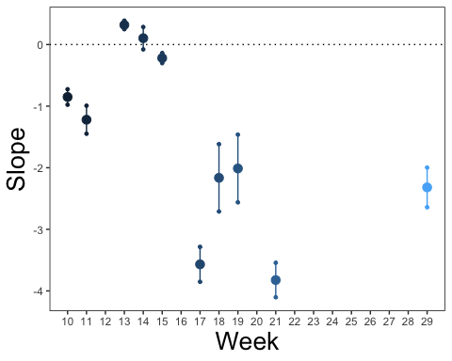

Random intercepts of each week:

ran_df_week %>%   
 # filter(week %in% c(14, 15, 17, 21, 29)) %>%   
 # filter(term == "lwc") %>%   
 mutate(upr = estimate + (std.error/2),   
 lwr = estimate - (std.error/2)) %>%   
 ggplot(aes(color= week)  
 ) +   
 geom_point(aes(y = estimate,x = week), size =3) +  
 geom_point(aes(y = upr, x = week), size = 1) +  
 geom_point(aes(y = lwr, x = week), size = 1) +  
 #geom_line(aes(group = week, y = week, x = upr)) +  
 geom_segment(aes(y= lwr,   
 yend = upr,   
 x = week,   
 xend = week,   
 color = week))+  
 labs(x = "Week",   
 color = "week",   
 y = "Intercept") +  
 # facet_wrap(~y_var_name, scales = "free") +   
theme(  
 strip.background = element_blank(),  
 strip.text.y = element_blank(),   
 strip.text.x = element_text(size = 18),   
 # axis.text.y = element_blank(),   
 #axis.ticks.y = element_blank(),   
 axis.title = element_text(size = 20),   
 legend.title = element_text(size = 18)  
 ) +  
 geom_hline(yintercept = 0, linetype="dotted") +   
 scale_x_continuous(breaks = seq(9, 30, by = 1))

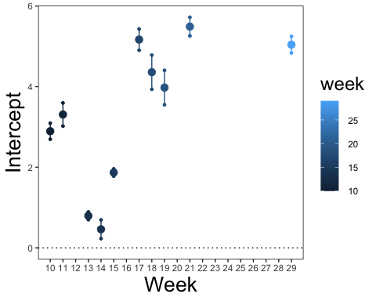

#Space

1. Center and scale by week
2. Plot all midday grand slopes

wc_wk_centered_df <- wc_qudo_df %>%   
 filter(time == "md") %>%   
 group_by(week) %>%   
 mutate(lwc_scaled = scale(lwc)) %>%   
 filter(lwc_scaled < 4)  
  
#not scaled  
wc_wk_centered_df %>%   
 #filter(time == "md") %>%   
 ggplot(aes(y = water_potential,   
 x = lwc,   
 #color = tree_factor  
 color = as.factor(week)  
 )) +  
 geom_point(alpha = .3,   
 aes (shape = site)) +  
 geom_smooth(method = "lm", se = F)

## `geom_smooth()` using formula 'y ~ x'

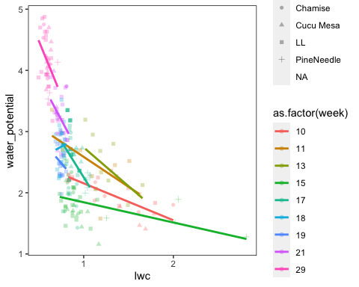

#scaled  
wc_wk_centered_df %>%   
 ggplot(aes(y = water_potential,   
 x = lwc_scaled,   
 #color = tree_factor  
 color = as.factor(week)  
 )) +  
 geom_point(alpha = .3,   
 aes (shape = site)) +  
 geom_smooth(method = "lm", se = F) +   
 geom_vline(xintercept = 0, linetype = "dotted") +  
 labs(y= "Midday MPa",   
 x = "LWC (scaled and centered by week)",   
 color = "Week")

## `geom_smooth()` using formula 'y ~ x'

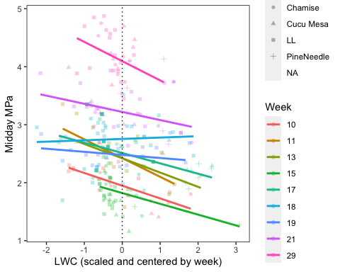

space_mod <- lmer(water_potential ~ lwc_scaled + (lwc_scaled|week) + (1|tree), data = wc_wk_centered_df)  
summary(space_mod)

## Linear mixed model fit by REML ['lmerMod']  
## Formula: water_potential ~ lwc_scaled + (lwc_scaled | week) + (1 | tree)  
## Data: wc_wk_centered_df  
##   
## REML criterion at convergence: 233.4  
##   
## Scaled residuals:   
## Min 1Q Median 3Q Max   
## -2.97851 -0.55725 -0.04097 0.60619 2.40978   
##   
## Random effects:  
## Groups Name Variance Std.Dev. Corr   
## tree (Intercept) 0.012381 0.11127   
## week (Intercept) 0.478163 0.69149   
## lwc_scaled 0.001978 0.04447 -0.22  
## Residual 0.116511 0.34134   
## Number of obs: 243, groups: tree, 45; week, 9  
##   
## Fixed effects:  
## Estimate Std. Error t value  
## (Intercept) 2.62314 0.23275 11.270  
## lwc_scaled -0.15766 0.03263 -4.831  
##   
## Correlation of Fixed Effects:  
## (Intr)  
## lwc_scaled -0.100

space_mod_df <- broom.mixed::tidy(space_mod)  
#space_mod_df  
  
ran_list3 <- coef(space_mod)  
  
#ran_list2 <- coef(m_wk_rand)  
  
ran_df <- as.data.frame(ran_list3[['week']])%>%   
 mutate(estimate = `(Intercept)`,   
 slope = `lwc_scaled`,   
 -lwc_scaled) %>%  
 select(-`(Intercept)`)  
  
ran_err3 <- arm::se.ranef(space_mod)  
ran_err_df <- as.data.frame(ran_err3[['week']]) %>%   
 mutate(std.error = `(Intercept)`,   
 std.error.slope = `lwc_scaled`)%>%   
 select(-`(Intercept)`,   
 -lwc_scaled)  
  
weeks <- data_frame(1:9)  
weeks$week <- c(10, 11, 13, 15, 17, 18, 19, 21, 29)   
  
ran_df_week <- bind_cols(weeks, ran_df, ran_err_df) %>%   
 select(-`1:9`) %>%   
 data_frame()  
  
ran_df_week %>%   
 # filter(week %in% c(14, 17, 21, 29)) %>%   
 # filter(term == "lwc") %>%   
 mutate(upr = slope + (std.error.slope/2),   
 lwr = slope - (std.error.slope/2)) %>%   
 ggplot(aes(color= week)  
 ) +   
 geom_point(aes(y = slope ,x = week), size =3) +  
 geom_point(aes(y = upr, x = week), size = 1) +  
 geom_point(aes(y = lwr, x = week), size = 1) +  
 #geom_line(aes(group = week, y = week, x = upr)) +  
 geom_segment(aes(y= lwr,   
 yend = upr,   
 x = week,   
 xend = week,   
 color = week))+  
 labs(x = "Week",   
 color = "week",   
 y = "Slope") +  
 # facet_wrap(~y_var_name, scales = "free") +   
theme(  
 strip.background = element_blank(),  
 strip.text.y = element_blank(),   
 strip.text.x = element_text(size = 18),   
 # axis.text.y = element_blank(),   
 #axis.ticks.y = element_blank(),   
 axis.title = element_text(size = 20),   
 legend.title = element_text(size = 18)  
 ) +  
 geom_hline(yintercept = 0, linetype="dotted") +   
 scale_x_continuous(breaks = seq(9, 30, by = 1)) +  
 theme(legend.position = "none")

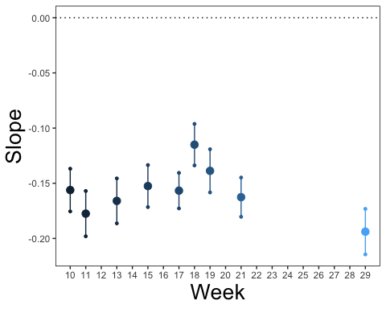

ran_df_week %>%   
 # filter(week %in% c(14, 15, 17, 21, 29)) %>%   
 # filter(term == "lwc") %>%   
 mutate(upr = estimate + (std.error/2),   
 lwr = estimate - (std.error/2)) %>%   
 ggplot(aes(color= week)  
 ) +   
 geom_point(aes(y = estimate,x = week), size =3) +  
 geom_point(aes(y = upr, x = week), size = 1) +  
 geom_point(aes(y = lwr, x = week), size = 1) +  
 #geom_line(aes(group = week, y = week, x = upr)) +  
 geom_segment(aes(y= lwr,   
 yend = upr,   
 x = week,   
 xend = week,   
 color = week))+  
 labs(x = "Week",   
 color = "week",   
 y = "Intercept") +  
 # facet_wrap(~y_var_name, scales = "free") +   
theme(  
 strip.background = element_blank(),  
 strip.text.y = element_blank(),   
 strip.text.x = element_text(size = 18),   
 # axis.text.y = element_blank(),   
 #axis.ticks.y = element_blank(),   
 axis.title = element_text(size = 20),   
 legend.title = element_text(size = 18)  
 ) +  
 geom_hline(yintercept = 0, linetype="dotted") +   
 scale_x_continuous(breaks = seq(9, 30, by = 1))

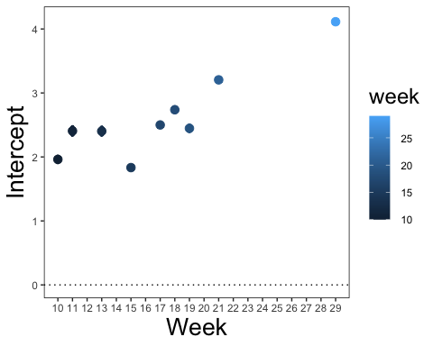

#Time

wc_qudo_df %>%   
 filter(time == "md") %>%   
 ggplot(aes(y = water_potential,   
 x = lwc,   
 color = as.factor(tree),   
 show.legend = FALSE)) +  
 geom_point(aes(size = week))+  
 geom_smooth(method = "lm", se = F) +  
 # theme(legend.position = "none") +  
 labs(x = "LWC",   
 y = "Midday MPa")

## `geom_smooth()` using formula 'y ~ x'

## Warning: Removed 3 rows containing non-finite values (stat_smooth).

## Warning: Removed 3 rows containing missing values (geom_point).

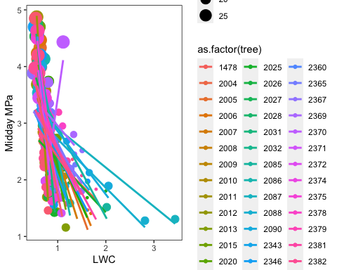

wc_qudo_df %>%   
 filter(time == "pd") %>%   
 ggplot(aes(y = water_potential,   
 x = lwc,   
 color = as.factor(tree),   
 show.legend = FALSE)) +  
 geom_point(aes(size = week))+  
 geom_smooth(method = "lm", se = F) +  
 # theme(legend.position = "none") +  
 labs(x = "LWC",   
 y = "Predawn MPa")

## `geom_smooth()` using formula 'y ~ x'

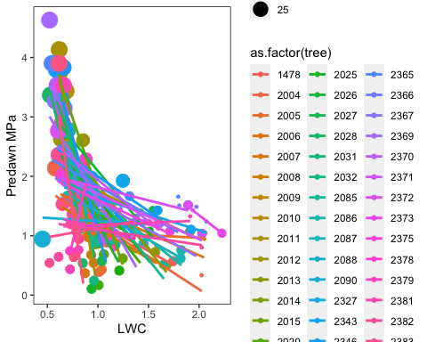 Make week a fixed effect, since that’s what we’re interested in:

Midday slopes for each individual:

wc_qudo_md_df <- wc_qudo_df %>%   
 filter(time == "md")  
   
time_mod <- lmer(water_potential ~ lwc + week + (lwc|tree), data = wc_qudo_md_df)

## boundary (singular) fit: see help('isSingular')

summary(time_mod)

## Linear mixed model fit by REML ['lmerMod']  
## Formula: water_potential ~ lwc + week + (lwc | tree)  
## Data: wc_qudo_md_df  
##   
## REML criterion at convergence: 324.1  
##   
## Scaled residuals:   
## Min 1Q Median 3Q Max   
## -2.3772 -0.7469 0.0395 0.6251 3.3088   
##   
## Random effects:  
## Groups Name Variance Std.Dev. Corr   
## tree (Intercept) 0.0001568 0.01252   
## lwc 0.0320993 0.17916 -1.00  
## Residual 0.1900692 0.43597   
## Number of obs: 245, groups: tree, 45  
##   
## Fixed effects:  
## Estimate Std. Error t value  
## (Intercept) 0.581854 0.222814 2.611  
## lwc -0.173155 0.130884 -1.323  
## week 0.123780 0.006987 17.716  
##   
## Correlation of Fixed Effects:  
## (Intr) lwc   
## lwc -0.869   
## week -0.915 0.640  
## optimizer (nloptwrap) convergence code: 0 (OK)  
## boundary (singular) fit: see help('isSingular')

#ran_list <- ranef(time_mod)  
ran_list <- coef(time_mod)  
  
tree_eff <- as.data.frame(ran_list[['tree']]) %>%   
 mutate(estimate = `(Intercept)`,   
 slope = `lwc`) %>%  
 select(-`(Intercept)`,   
 -lwc)  
tree_eff

## week estimate slope  
## 1478 0.1237798 0.5838772 -0.202094910  
## 2004 0.1237798 0.5818175 -0.172629052  
## 2005 0.1237798 0.5843889 -0.209415554  
## 2006 0.1237798 0.5839886 -0.203688319  
## 2007 0.1237798 0.5818734 -0.173427579  
## 2008 0.1237798 0.5802094 -0.149622567  
## 2009 0.1237798 0.5791370 -0.134280566  
## 2010 0.1237798 0.5822262 -0.178475387  
## 2011 0.1237798 0.5873994 -0.252485297  
## 2012 0.1237798 0.5902670 -0.293509515  
## 2013 0.1237798 0.5938948 -0.345408839  
## 2015 0.1237798 0.5800514 -0.147361724  
## 2020 0.1237798 0.5841654 -0.206218201  
## 2021 0.1237798 0.5762163 -0.092496339  
## 2024 0.1237798 0.5854643 -0.224799999  
## 2025 0.1237798 0.5868025 -0.243945768  
## 2026 0.1237798 0.5762840 -0.093465030  
## 2027 0.1237798 0.5808501 -0.158788165  
## 2028 0.1237798 0.5859307 -0.231473727  
## 2031 0.1237798 0.5893517 -0.280414760  
## 2032 0.1237798 0.5876563 -0.256159762  
## 2085 0.1237798 0.5896242 -0.284312898  
## 2086 0.1237798 0.5900175 -0.289940230  
## 2087 0.1237798 0.5902201 -0.292838544  
## 2088 0.1237798 0.5940124 -0.347091428  
## 2090 0.1237798 0.5874949 -0.253851478  
## 2343 0.1237798 0.5842352 -0.207216134  
## 2346 0.1237798 0.5801873 -0.149306297  
## 2347 0.1237798 0.5828989 -0.188098874  
## 2349 0.1237798 0.5720366 -0.032700239  
## 2360 0.1237798 0.5740927 -0.062115648  
## 2365 0.1237798 0.5695467 0.002920018  
## 2367 0.1237798 0.5731551 -0.048701884  
## 2369 0.1237798 0.5527843 0.242728374  
## 2370 0.1237798 0.5822596 -0.178952648  
## 2371 0.1237798 0.5911253 -0.305788114  
## 2372 0.1237798 0.5864283 -0.238592288  
## 2374 0.1237798 0.5872767 -0.250728739  
## 2375 0.1237798 0.5786276 -0.126992972  
## 2378 0.1237798 0.5761618 -0.091717320  
## 2379 0.1237798 0.5680536 0.024281309  
## 2381 0.1237798 0.5799719 -0.146224265  
## 2382 0.1237798 0.5726442 -0.041393283  
## 2383 0.1237798 0.5802304 -0.149923250  
## 2384 0.1237798 0.5785061 -0.125255185

ran_err_tree <- arm::se.ranef(time_mod)  
ran_err_tree <- as.data.frame(ran_err_tree[['tree']]) %>%   
 mutate(std.error = `(Intercept)`,   
 std.error.slope = `lwc`)%>%   
 select(-`(Intercept)`,   
 -lwc)  
  
inds<- data_frame(1:45)  
inds$tree <- c(unique(wc_qudo_md_df$tree))  
  
ran_df_tree <- bind_cols(inds, tree_eff, ran_err_tree) %>%   
 select(-`1:45`) %>%   
 data_frame()  
  
ran_df_tree %>%   
 mutate(tree = as.factor(tree)) %>%   
 # filter(tree %in% c(14, 17, 21, 29)) %>%   
 # filter(term == "lwc") %>%   
 mutate(upr = slope + (std.error.slope/2),   
 lwr = slope - (std.error.slope/2)) %>%   
 ggplot(aes(color= tree)  
 ) +   
 geom_point(aes(y = slope ,x = tree), size =3) +  
 geom_point(aes(y = upr, x = tree), size = 1) +  
 geom_point(aes(y = lwr, x = tree), size = 1) +  
 #geom_line(aes(group = tree, y = tree, x = upr)) +  
 geom_segment(aes(y= lwr,   
 yend = upr,   
 x = tree,   
 xend = tree,   
 color = tree))+  
 labs(x = "tree",   
 color = "tree",   
 y = "Slope") +  
 # facet_wrap(~y_var_name, scales = "free") +   
theme(  
 strip.background = element_blank(),  
 strip.text.y = element_blank(),   
 strip.text.x = element_text(size = 18),   
 # axis.text.y = element_blank(),   
 #axis.ticks.y = element_blank(),   
 axis.title = element_text(size = 20),   
 legend.title = element_text(size = 18)  
 ) +  
 geom_hline(yintercept = 0, linetype="dotted") +   
 # scale_x_continuous(breaks = seq(9, 30, by = 1)) +  
 theme(legend.position = "none")+  
 theme(axis.text.x = element_text(angle = 45, vjust = 0.5, hjust=1))

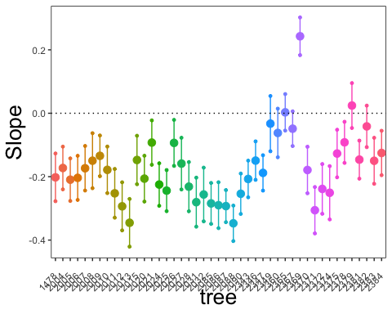 Midday slopes for each individual:

wc_qudo_pd_df <- wc_qudo_df %>%   
 filter(time == "pd")  
   
time_mod <- lmer(water_potential ~ lwc + week + (lwc|tree), data = wc_qudo_pd_df)  
summary(time_mod)

## Linear mixed model fit by REML ['lmerMod']  
## Formula: water_potential ~ lwc + week + (lwc | tree)  
## Data: wc_qudo_pd_df  
##   
## REML criterion at convergence: 302  
##   
## Scaled residuals:   
## Min 1Q Median 3Q Max   
## -3.2498 -0.5131 -0.0753 0.3801 3.6839   
##   
## Random effects:  
## Groups Name Variance Std.Dev. Corr   
## tree (Intercept) 0.20437 0.4521   
## lwc 0.08249 0.2872 -0.84  
## Residual 0.12366 0.3516   
## Number of obs: 280, groups: tree, 48  
##   
## Fixed effects:  
## Estimate Std. Error t value  
## (Intercept) -1.654863 0.192714 -8.587  
## lwc 0.535153 0.099621 5.372  
## week 0.144591 0.005727 25.247  
##   
## Correlation of Fixed Effects:  
## (Intr) lwc   
## lwc -0.890   
## week -0.859 0.620

#ran_list <- ranef(time_mod)  
ran_list <- coef(time_mod)  
  
tree_eff <- as.data.frame(ran_list[['tree']]) %>%   
 mutate(estimate = `(Intercept)`,   
 slope = `lwc`) %>%  
 select(-`(Intercept)`,   
 -lwc)  
tree_eff

## week estimate slope  
## 1478 0.144591 -1.8549583 0.4591576  
## 2004 0.144591 -1.9849208 0.5570671  
## 2005 0.144591 -2.0160926 0.7018241  
## 2006 0.144591 -1.8919019 0.6364859  
## 2007 0.144591 -2.1136911 0.7775868  
## 2008 0.144591 -1.7698204 0.5714107  
## 2009 0.144591 -1.5052281 0.5484402  
## 2010 0.144591 -1.4304890 0.3509358  
## 2011 0.144591 -1.1692580 0.2802043  
## 2012 0.144591 -1.4629748 0.3114607  
## 2013 0.144591 -1.5748433 0.3953406  
## 2014 0.144591 -1.7491270 0.5269365  
## 2015 0.144591 -1.2551568 0.2722628  
## 2020 0.144591 -1.6354961 0.5661619  
## 2021 0.144591 -1.8645303 0.6655080  
## 2024 0.144591 -1.8508695 0.6301205  
## 2025 0.144591 -1.8099058 0.6269547  
## 2026 0.144591 -1.2332843 0.4234889  
## 2027 0.144591 -1.3492720 0.4158547  
## 2028 0.144591 -1.5345418 0.4395752  
## 2031 0.144591 -1.6813013 0.4690125  
## 2032 0.144591 -1.8695842 0.5980395  
## 2085 0.144591 -1.8133845 0.4477585  
## 2086 0.144591 -1.9830721 0.5355002  
## 2087 0.144591 -2.2957843 0.6779777  
## 2088 0.144591 -2.1298707 0.7126597  
## 2090 0.144591 -2.5732582 1.0331246  
## 2327 0.144591 -1.6929325 0.5467373  
## 2343 0.144591 -1.6059859 0.4822909  
## 2346 0.144591 -0.7554058 0.1941994  
## 2347 0.144591 -1.4482909 0.4999574  
## 2360 0.144591 -1.1291360 0.3125741  
## 2365 0.144591 -1.4580511 0.7067498  
## 2366 0.144591 -1.6248685 0.6825163  
## 2367 0.144591 -1.4988200 0.5944364  
## 2369 0.144591 -1.0114604 0.2932644  
## 2370 0.144591 -1.2966259 0.3870795  
## 2371 0.144591 -1.6665852 0.4249281  
## 2372 0.144591 -1.7966089 0.7147227  
## 2373 0.144591 -1.5556968 0.5101277  
## 2375 0.144591 -1.8947579 0.6521306  
## 2378 0.144591 -1.7801135 0.7090543  
## 2379 0.144591 -1.4716820 0.4757128  
## 2381 0.144591 -1.7976699 0.7408381  
## 2382 0.144591 -1.5301262 0.4830345  
## 2383 0.144591 -1.7494747 0.6541078  
## 2384 0.144591 -1.4551911 0.4237558  
## 2385 0.144591 -1.8113219 0.5682933

ran_err_tree <- arm::se.ranef(time_mod)  
ran_err_tree <- as.data.frame(ran_err_tree[['tree']]) %>%   
 mutate(std.error = `(Intercept)`,   
 std.error.slope = `lwc`)%>%   
 select(-`(Intercept)`,   
 -lwc)  
  
inds<- data_frame(1:48)  
inds$tree <- c(unique(wc_qudo_pd_df$tree))  
  
ran_df_tree <- bind_cols(inds, tree_eff, ran_err_tree) %>%   
 select(-`1:48`) %>%   
 data_frame()  
  
ran_df_tree %>%   
 mutate(tree = as.factor(tree)) %>%   
 # filter(tree %in% c(14, 17, 21, 29)) %>%   
 # filter(term == "lwc") %>%   
 mutate(upr = slope + (std.error.slope/2),   
 lwr = slope - (std.error.slope/2)) %>%   
 ggplot(aes(color= tree)  
 ) +   
 geom_point(aes(y = slope ,x = tree), size =3) +  
 geom_point(aes(y = upr, x = tree), size = 1) +  
 geom_point(aes(y = lwr, x = tree), size = 1) +  
 #geom_line(aes(group = tree, y = tree, x = upr)) +  
 geom_segment(aes(y= lwr,   
 yend = upr,   
 x = tree,   
 xend = tree,   
 color = tree))+  
 labs(x = "tree",   
 color = "tree",   
 y = "Slope") +  
 # facet_wrap(~y_var_name, scales = "free") +   
theme(  
 strip.background = element_blank(),  
 strip.text.y = element_blank(),   
 strip.text.x = element_text(size = 18),   
 # axis.text.y = element_blank(),   
 #axis.ticks.y = element_blank(),   
 axis.title = element_text(size = 20),   
 legend.title = element_text(size = 18)  
 ) +  
 geom_hline(yintercept = 0, linetype="dotted") +   
 # scale_x_continuous(breaks = seq(9, 30, by = 1)) +  
 theme(legend.position = "none")+  
 theme(axis.text.x = element_text(angle = 45, vjust = 0.5, hjust=1))

