The Game of Kings
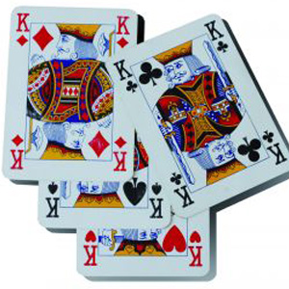

CS 110 Final Project
BY: Brian Doyle and Leandro Ribeiro
Section B-54

Do You Have What it Takes to Play?

CS 110 Final Project
The Game of Kings
BY: Brian Doyle and Leandro Ribeiro
Section B-54

Welcome to the Game of Kings! This is a very simple drinking game, simulated through our GUI program. Everyone enjoys drinking so let's play! There will be digital card deck placed on the GUI, so the users will be able to see what card they draw. Along with the card, the rule associated with this card will also be displayed, so anyone can play without knowing how. After entering the number of people playing the game will start, and will not end until the card deck has been exhausted. Enjoy!

- Starting the game – The Opening Screen
The player will first have to enter the number of people who will be participating in the game. Once this has been done the game can officially start. Player 1 will be the one who first selects a card.
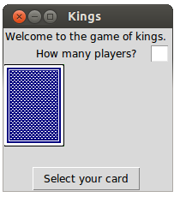
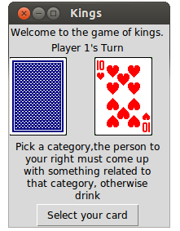

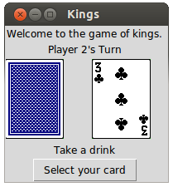

- Playing through – The Bulk of the Deck
The players of the game will rotate through until all 52 cards have been drawn. However if a king is drawn from the deck the player will be able to create a rule which will be displayed throughout the game until its finish.
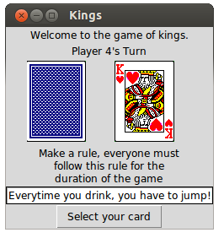
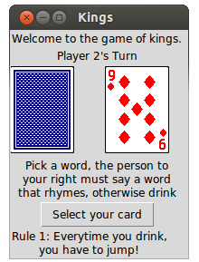

- Finishing the Game – The Finish
Once all the cards have been played the game will come to an end. The GUI will display a final screen with a finishing message and a “Quit” button. Hope you enjoyed playing!
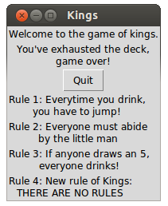

Acceptance Test Procedure

Step List | Procedure | Expected Results | Actual Results | AI
1. | Run gameGUI | Python displays first window of game including the back face of the card deck, a title message, an entry box, and a button.
2. | If user tries to press “select your card” before he/she enters number of players, a pop-up will appear. The user will have to press the 'Okay' button to re-enter good input | A pop-up will display: “Please enter the number of players, then press <ENTER>” The user will then be able to re-enter good data.
3. | Enter number of players by using the keyboard, then press the <ENTER> button for the game to carry through | Game will begin, starting with player 1, displaying: “Player 1's Turn”.
4. | If bad input is entered, there will be a pop-up along with a chance to re-enter good input. User will have to press “okay” button to re enter number of players then press <ENTER> | Pop-up includes message: “Please enter a valid number of players” and an 'Okay' button. Player then will re-enter input.
5. | Player 1 will press button: “Select your card” | GUI window will display a random card from the official card deck. The game will also display the rule associated with the card. The played shall follow dictated rule.
6. | The next player (e.g. Player 2) will then press button: “Select your card” | GUI window will display a random card from the official card deck. The game will also display the rule associated with the card. The played shall follow dictated rule.
7. | Continue looping through players by following which player's turn is indicated on the window. | GUI window will display a random card from the official card deck. The game will also display the rule associated with the card. The played shall follow dictated rule.
8. | If a king appears, the user will have to enter a rule via keyboard. Once the rule is finished the user must press the <ENTER> button for the rule to go through. | The rule will appear on the bottom of the GUI for the entirety of the game**
9. | If the user tries to skip entering a rule, or presses any other button other than the <ENTER> button to enter in the data a pop-up box will appear. The user will have to press the 'Okay' button to have a chance to re-enter good input. | Pop-up window will display “Please type in a rule, then press <ENTER>”. User will then be able to re-enter good input for King's rule.
10. | This process will repeat until the deck has been exhausted (The game will automatically loop through the number of players you have playing). | GUI window will display a random card from the official card deck. The game will also display the rule associated with the card. The played shall follow dictated rule.
11. | Once the game ends, the GUI window will display a final message along with the remaining rules and the title. | “You've exhausted the deck, Game Over!”
12. | The player(s) will be able to quit the game by pressing the button, “Quit” and the game and window will terminate. | You should probably play again because you such a good time!

** - This step will last until all four kings have been found

'''
Leandro Ribeiro
Brian Doyle
lribeir1@binghamton.edu
bdoyle2@binghamton.edu
CS 110 B54
CAs: Nuri & Vlad
'''
import random

'''
This class represents a drinking game named: Kings. This class makes
use of several different constants defined within the class, along
with the use of different constructors, accessors, mutators
and tostrings. The class Game allows for the playing of Kings, which
allows the user to select a card and then display the official rule
associated with the card. When the deck is exhausted the Game class
will terminate.

Output to GUI:
Back of card = gif
Front of selected card = gif
Select button

Input from Keyboard:
How many players - int
King's rules - str

Tasked Allocated to Functions:
getPlayer() - returns player
getCard() - returns card
getCardStatus() - returns the rule associated with card
getKingCount() - checks how many kings have been in play
getPlayerList() - returns the list of players
getDiscardPile() - returns the list of cards that already been used
sameImage() - checks whether or not that image has been displayed
gameOver() - ends game at the point when all cards have been played
makeARule() - allows user to input rule for drawn king(s)
getCardImage() - displays card image associated with code
isPlayable() - predicate to check if that cards has/hasnt been used
setPlayerList() - sets how many players are playing
makeATurn() - bulky definition that allows for the playing of the game
nextPlayer() - runs to next player after user clicks for the next card
'''

class Game:

#-- Class Variables ----------------------------------------------------
ZERO = 0
ONE = 1
FOUR = 4
THIRTEEN = 13
FIFTY_TWO = 52
SUITS = 'cdhs'
SUIT_NUMBER = 4
ACE = 1
HIGH_CARD = 14
GAME_OVER = 13
PLAYER = 'Player '

# Rule associated with the selected card, used via Indexing
RULE_LIST = ['Waterfall: Drink until the person to your left stops.',
'Make two people drink or make one person drink twice.',
'Take a drink',
'Everyone point to the floor, last one pointing drinks.',
'All of the guys drink',
'All of the ladies drink',
'Everyone point to the ceiling, last one pointing drinks',
'Pick a "date", every time you drink they will drink with you',
'Pick a word, the person to your right must say a word that rhymes, otherwise drink',
'Pick a category,the person to your right must come up with something related to that category, otherwise drink',
'Place your thumb on the table, last one to place their thumb drinks',
"Queen's Cup: The person who draws the final queen must finish their cup.",
'Make a rule, everyone must follow this rule for the duration of the game',
"You've exhausted the deck, game over!"]

#-- Constructor --------------------------------------------------------
def __init__(self):
self.__playerList = []
self.__discardPile = []
self.__discardImages = []
self.__currentPlayer = 'Player 1'
self.__cardCount = self.FIFTY_TWO
self.__cardStatus = ''
self.__card = None
self.__maxPlayers = self.ZERO
self.__kingsCount = self.ZERO

#-- Accessors ----------------------------------------------------------
def getPlayer(self):
return self.__currentPlayer

def getCard(self):
return self.__card

def getCardStatus(self):
return self.__cardStatus

def getKingCount(self):
return self.__kingsCount

def getPlayerList(self):
return self.__playerList

def getDiscardPile(self):
return self.__discardPile

def sameImage(self,image):
return image in self.__discardImages

def gameOver(self):
return self.__cardCount == self.ZERO

def makeARule(self,rule):
newRule = 'Rule '+str(self.__kingsCount)+': '+ rule
return newRule

def getCardImage(self):
image = self.SUITS[random.randrange(self.SUIT_NUMBER)] + str(self.__card)+'.gif'
while self.sameImage(image):
image = self.SUITS[random.randrange(self.SUIT_NUMBER)] + str(self.__card)+'.gif'
self.__discardImages += [image]
return image

#-- Predicates ---------------------------------------------------------

def isPlayable(self):
return self.__discardPile.count(self.__card) < self.FOUR

#-- Mutators -----------------------------------------------------------

def setPlayerList(self,playerNum):
for i in range(self.ONE,playerNum+self.ONE):
myPlayer = self.PLAYER + str(i)
self.__playerList += [myPlayer]
myPlayer = ''
self.__maxPlayers = len(self.__playerList)

def makeATurn(self):
if self.gameOver():
self.__cardStatus = self.RULE_LIST[self.GAME_OVER]
else:
self.__card = random.randrange(self.ACE,self.HIGH_CARD)
while not self.isPlayable():
self.__card = random.randrange(self.ACE,self.HIGH_CARD)
self.__cardStatus = self.RULE_LIST[self.__card - self.ONE]
self.__discardPile += [self.__card]
if self.__card == self.THIRTEEN:
self.__kingsCount += self.ONE
if self.__cardCount < self.FIFTY_TWO:
self.nextPlayer()
self.__cardCount -= self.ONE

def nextPlayer(self):
if self.__currentPlayer == self.__playerList[self.__maxPlayers-self.ONE]:
self.__currentPlayer = self.PLAYER+'1'
else:
self.__currentPlayer = self.__playerList[self.__playerList.index(\
self.__currentPlayer)+self.ONE]

'''
Leandro Ribeiro
Brian Doyle
lribeir1@binghamton.edu
bdoyle2@binghamton.edu
CS 110 B54
CAs: Nuri & Vlad
'''
'''
This GUI represents a drinking game named: Kings. This GUI imports
the various classes needed to run program. The GUI allows for the
playing of Kings, whichallows the user to select a card and then
display the official rule associated with the card. When the deck
is exhausted the GUI will terminate.

Output to GUI:
Back of card = gif
Front of selected card = gif
Select button

Input from Keyboard:
How many players - int
King's rules - str

Tasked Allocated to Functions:
validatePlayer(self) - predicate to check good input and circle
through players
makePlayers(self,event) - Creates player list after given input
initialPlayer(self) - starts game off with player 1
changePlayer(self) - loops through players
pickCard(self) - bulkly function to simulate picking cards
newRule(self,event) - deals with King card for entering rules
changeImage(self) - iterates though image folder for specific card
'''

from tkinter import *

from game import *

class gameGUI:

def __init__(self):

#--Window and Frame Initilization---------------------------------------
self.__window = Tk()
self.__window.wm_title("Kings")

self.__game = Game()
self.__title = Label(text='Welcome to the game of kings.')
self.__playerLabel = Label(text= 'How many players?')

#--Card Display and Button Design---------------------------------------

self.__playerEntry = Entry(width=2)
self.__playerEntry.bind('<Return>', self.makePlayers)
self.__playerVal = StringVar()

self.__title.grid(column=1)
self.__playerLabel.grid(row=1,column=1)
self.__playerEntry.grid(row=1,column=1,sticky='E')

self.__mainCanvas = Canvas(width=195, height=100)

self.__backCard = PhotoImage(file="card-BMPs/b1fv.gif")

self.__mainCanvas.create_image(35,50,image=self.__backCard)
self.__mainCanvas.grid(row=2, column=1,columnspan = 3)

self.__rule = StringVar()
self.__rule.set(self.__game.getCardStatus())
self.__ruleLabel = Label(textvariable = self.__rule, wraplengt=180)
self.__ruleLabel.grid(row=3,column=1)

self.__newRuleEntry = Entry(width = 30)
self.__newRuleEntry.bind('<Return>', self.newRule)

self.__myNewRule = ''

self.__pickButton = Button(text='Select your card',
command=self.pickCard)

self.__pickButton.grid(row=5,column=1)

mainloop()

#--Event Handlers-------------------------------------------------------

def validatePlayer(self):
return self.__playerNumStr.isdigit() and int(self.__playerNumStr) > 1

def makePlayers(self,event):
self.__playerNumStr = self.__playerEntry.get()
if self.validatePlayer():
self.__game.setPlayerList(int(self.__playerNumStr))
self.__playerEntry.grid_remove()
self.__playerLabel.grid_remove()
self.initialPlayer()
else:
messagebox.showwarning('Invalid input!','Please enter a valid number of players.')

def initialPlayer(self):
self.__playerVal.set(self.__game.getPlayer()+"'s Turn")
self.__currentPlayer = Label(textvariable = self.__playerVal)
self.__currentPlayer.grid(row=1,column=1)

def changePlayer(self):
self.__playerVal.set(self.__game.getPlayer()+"'s Turn")

def pickCard(self):
if self.__game.gameOver():
self.__game.makeATurn()
self.__rule.set(self.__game.getCardStatus())
self.__mainCanvas.destroy()
self.__pickButton.destroy()
self.__currentPlayer.destroy()
self.__quitButton = Button(text='Quit', command=self.__window.destroy)
self.__quitButton.grid(row=5,column=1)
else:
if len(self.__game.getPlayerList()) > 1:
if len(self.__game.getDiscardPile()) == 0 or self.__game.getCard()\
!= 13 or len(self.__myNewRule) > 0 :
self.__game.makeATurn()
self.__rule.set(self.__game.getCardStatus())
self.changePlayer()
self.changeImage()
if self.__newRuleEntry == True:
self.__newRuleEntry.grid_remove()
else:
messagebox.showwarning('Wait!','Please type in a rule, then press <Enter>.')
if self.__game.getCard() == 13:
self.__newRuleEntry.grid(row=4,column=1)
self.__newRuleEntry.delete(0, END)
self.__myNewRule = ''

else:
messagebox.showwarning('Hold on!','Please enter the number of players, then press <Enter>.')

def newRule(self,event):
if not self.__newRuleEntry.get():
messagebox.showwarning('Wait!','Please type in a rule, then press <Enter>.')
else:
myRule = self.__newRuleEntry.get()
self.__myNewRule = self.__game.makeARule(myRule)
self.__newRuleEntry.grid_remove()
self.__newRuleLabel = Label(text=self.__myNewRule,wraplengt=180)
self.__newRuleLabel.grid(row=self.__game.getKingCount()+5,column=1,sticky='W')

def changeImage(self):
self.__card = PhotoImage(file='card-BMPs/'+self.__game.getCardImage())
self.__mainCanvas.create_image(140,50,image=self.__card)

#--Instance of gameGUI class--------------------------------------------
gameGUI()

Examples of Game Play:

