Name: Leong chen pin (n9527907)

**Personal Portfolio**

In this group project, my team and I had to come out and help desk to help people in the public on requesting services with suitable price and qualities. In this project I was contributed on the **design layout of this website** (Home/About page), **Recover password**, **managing release plan/sprint plan**, and 2 testing part which is testing on the manage account part as well as the sign in part. I would explain the outcome of the designed website section by section.

**1.0 Home/About page**

Firstly, I would like to talk about the outcome of the design layout of "**here2help**" website. As the picture below, it shows the result of our website in the home page.

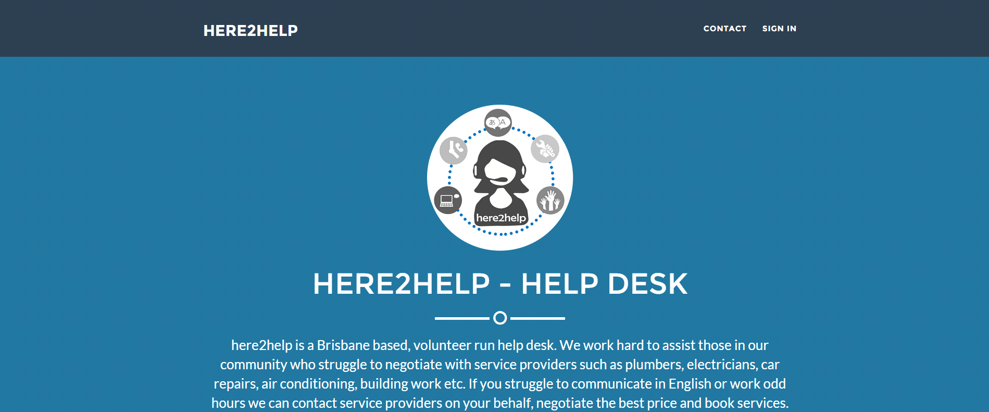

**Figure 1.0** : Shows the home page of the designed website.

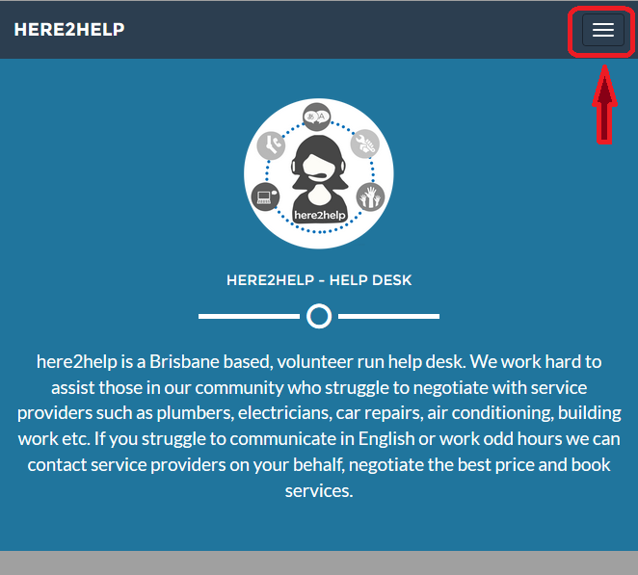

**Figure 1.2:** Shows the icon of the navigation will be changed once the window size changed to smaller size.

As the picture above shows the home page is merged with the description of "about use". The whole idea in the group we decided to put it with the home page instead of having another page just for the description.

**2.0 Password recovery**

Besides of designing the website interface, I was assigned to create the password recovery for the sign-in section. The picture below shows the "password recovery" interface and it required the user's "First name", "Last name" and their "Email". So that the auto generated password would able to send to their email that is the basic concept. The whole sample process will be show at the picture below.

The first screen shows the interface of the password recovery after click on the "I forgot my password" link. It basically require the user's first name , last name and email. Validation had implemented using the JAVAScript to ensure the user key in their information correctly else the user will received a pop-up error message which will be show the next picture.

In the last picture (Figure 2.3), shows the user will receive a pop-up once they successfully changed their password.

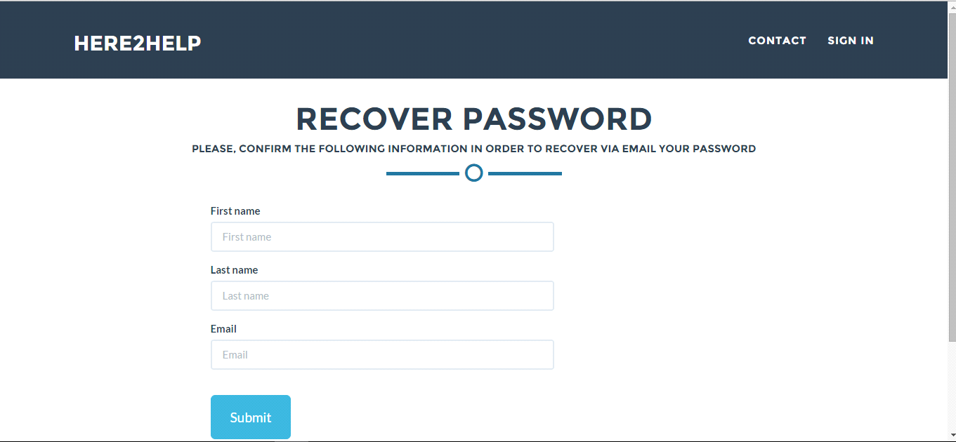

**Figure 2.1:** Shows the interface of the recovery password section.

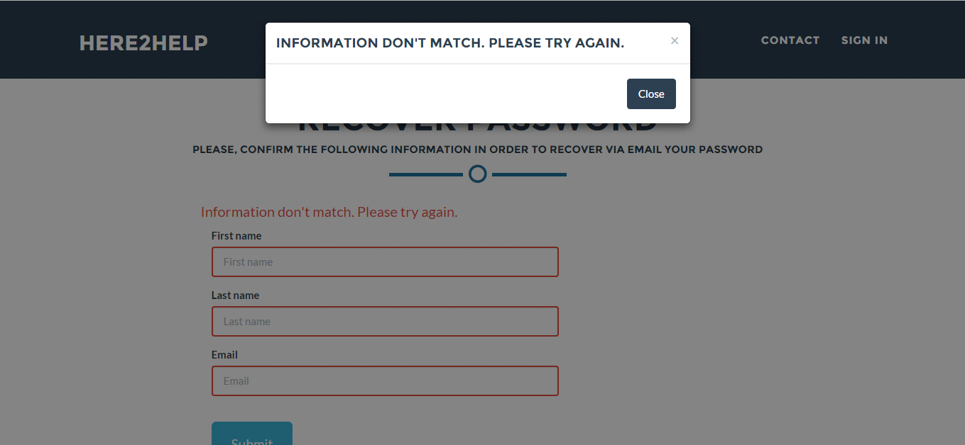

**Figure 2.2:** Shows the pop-up of the error message if the user key in the wrong information.

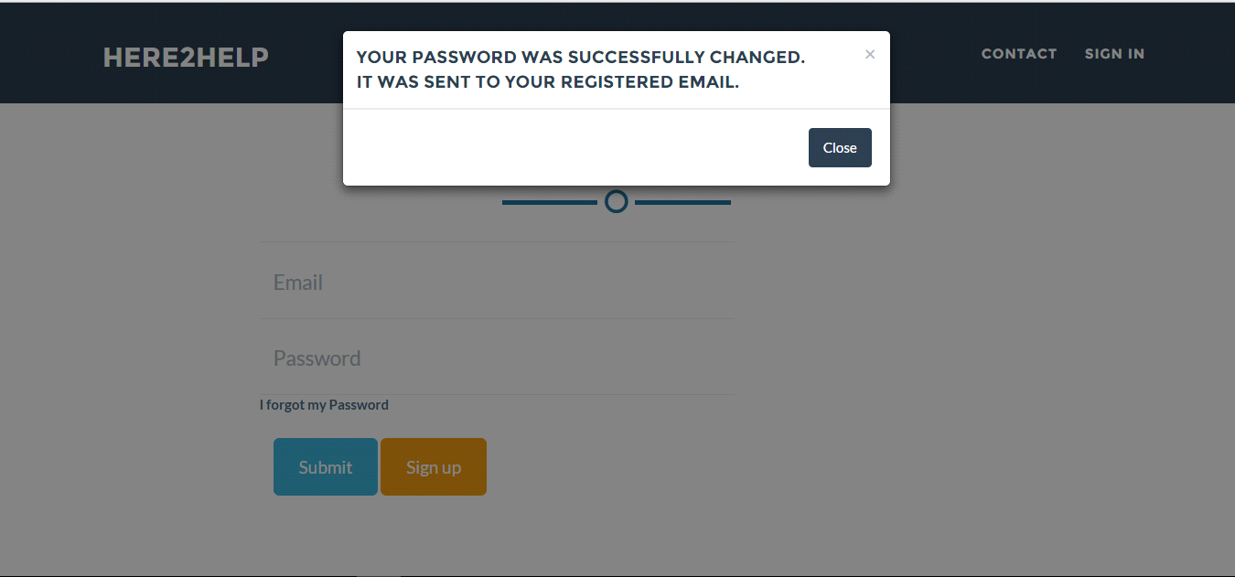

**Figure 2.3:** Shows the result of the pop-up message once the users changed their password successfully.

Once the users successfully change their password, they would require to sign-in to their email account to obtain their auto-generated password in order to sign-in. In this case, I used my email account to demonstration the outcome of the message in my email.

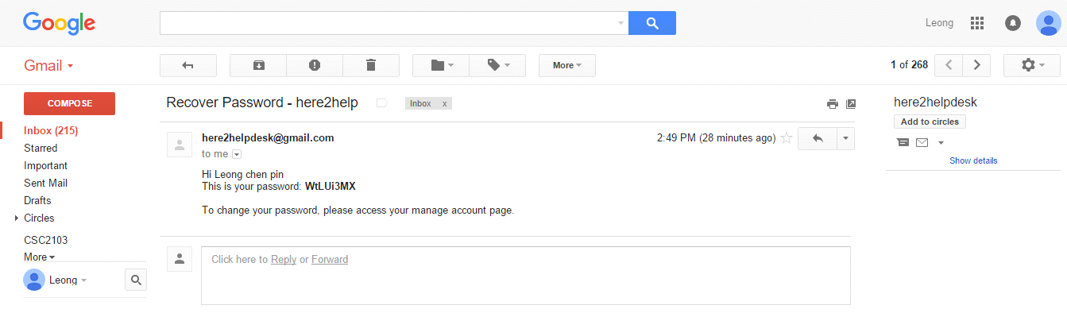

**Figure 2.4:** Shows the auto-generated password to the user's email.

Once the user copy the password to the sign in section and type in his/her email, he/she would able to sign in to the website. The pictures below shows the result of after signing in with the auto generated password.

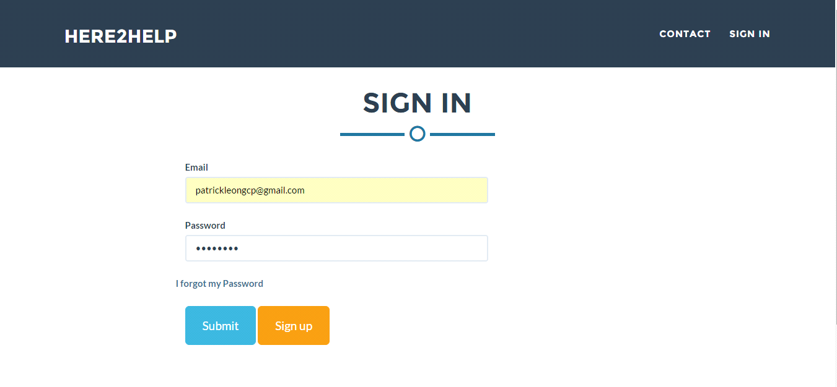

**Figure 2.5:** Shows the sample user login using the auto-generated code.

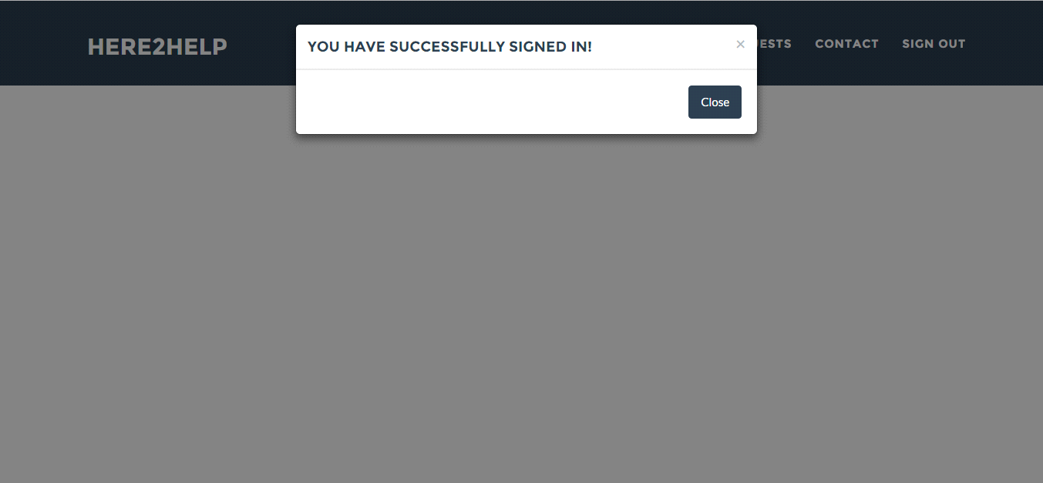

**Figure 2.6:** Shows the auto-generated password works and successfully sign-in to the website.

**3.0 Release plan**

In this section, I will describe of the stuff I'm doing in the release plan. As I pick up the role on collecting information of the release plan and type it to the google docs and Phelia is the one who help on update the release plan to JIRA after every group discussion.

**4.0 Testing Login**

Besides of taking a part on managing the release plan, I was assigned to do run testing in the login section. As the figure below, it shows there is an error when the pop-up message show up and it mention “[error] Element css=button.navbar-toggle.collapsed not found”. As the solution, I discuss with our team and we realize the pop-up must be closed with the “X” sign instead of click the message. The figure below shows the result obtained from the testing.

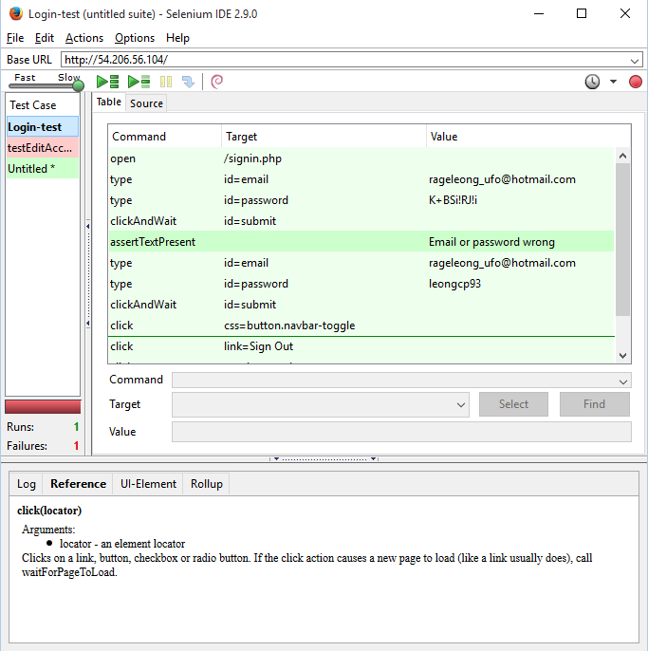

**Figure 4.1 :** Shows the result obtained after the testing.

**5.0 Testing Manage Account**

In this section, I would demonstrate the result of testing on managing account as I was assigned to do this section. Once the testing process runs, my team and I realize there is an error on the “id” as we forgot to change. As the solution, we changed then “id” and we solved the problem. As the figure below shows the result of the testing on user’s account management.

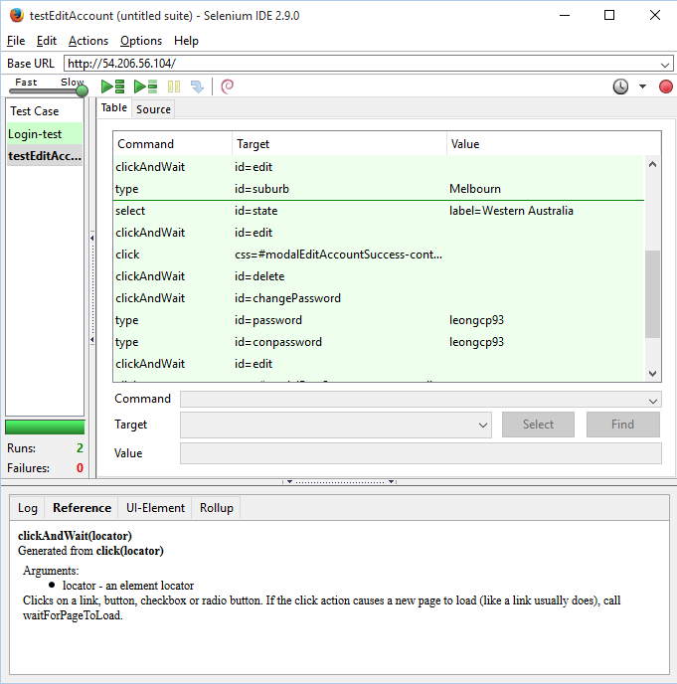

Figure 5.1: Shows the test result was successful after we solved the problem.