A Web-Based Job Recommendation and Referral System with Analytical Dashboard for PESO CSJDM

A Capstone Project by
Alabado, Leandro M.
Nebereja, John Laurence R.
Nimbra, Luis Paolo L.
Poquiz, Lance Andrei P.
Referuga, Kristel

Submitted to the Faculty of Information Technology
Bulacan State University–Sarmiento Campus

In Partial Fulfillment
of the Requirements for the Degree
Bachelor of Science in Information Technology
Major in Data and Business Analytics

2026

CHAPTER I

INTRODUCTION

Background of the Study
As employment markets grow more competitive, job recommendation systems have taken on a central role in helping employment offices match jobseekers to suitable vacancies more efficiently than manual processes can sustain at scale. Rather than going through every available vacancy one by one, these systems use a jobseeker's profile and qualifications to surface the openings most likely to be a good fit, making the referral process faster and more consistent for both staff and jobseekers (Ertuğrul & Bitirim, 2025).
Employment offices handle the daily work of connecting jobseekers to available vacancies, but many still rely on manual processes to do it, with staff pulling up jobseeker records, reviewing vacancy lists separately, and deciding on matches based on personal judgment alone. This approach becomes harder to sustain as the number of jobseekers an office serves grows, making a structured, technology-supported referral process a practical necessity rather than an optional upgrade (Sacchi & Scarano, 2025).
In the Philippines, the Public Employment Service Office was established under Republic Act No. 8759 (1999) to provide free employment services to Filipinos, including job referrals and placement assistance for jobseekers across the country. Over years of daily operations, PESO offices have built up large collections of jobseeker records and placement history, but the tools used to manage these records are built for storing information, not for turning that data into useful guidance for referral decisions (Bachita & Bayoneta, 2021).
An interview conducted by the researchers at the Public Employment Service Office of the City of San Jose del Monte, Bulacan revealed a recurring challenge that plays out every working day. On a regular day, the office receives an average of 15 walk-in jobseekers, rising to 20 to 75 during recruitment activities. For every jobseeker, staff must manually pull up the profile, check the active vacancy list separately, and decide on a referral based entirely on personal judgment, with no tool to help narrow down which openings are the best fit. As the number of jobseekers grows throughout the day, the process slows down, the queue gets longer, the office becomes crowded, and staff are worn out from repeating the same matching steps for every person in line.
The burden does not fall on staff alone. A jobseeker who wants to find work through PESO has to travel to the office just to see which vacancies are currently available, then wait in line to receive a referral. Once referred, they travel again to the employer's location. The whole process is long and repetitive, taking up a significant part of a jobseeker's day for something that could be handled more directly. During job fairs, the same inefficiency plays out on a larger scale. Without any guidance on which booths match their qualifications, jobseekers line up at random, often spending long stretches of time waiting for employers whose requirements they do not meet. The result is congested, disorganized fairs where delays pile up, time is wasted on both ends, and the lack of any structured matching process slows down what should be a straightforward employment process.
The same interview revealed a second problem that affects the office's reporting work. When staff need to summarize the office's registered jobseekers, such as how many belong to a specific barangay, their educational attainment breakdown, or their sex distribution, PEIS provides no consolidated view to work from. Every figure has to be produced by manually filtering and sorting through records one category at a time, a slow and repetitive process that consumes time the office cannot afford and delays the submission of required reports. Producing even a basic overview of the jobseeker pool means going through the same manual steps each time, with no shortcut available.
Taken together, these problems make the case for a web-based job referral portal that allows jobseekers to access available vacancies, receive ranked recommendations based on their profile, and generate a referral without having to travel to the office and wait in line. Building such a system, however, introduces a question the existing literature has not resolved for the Philippine PESO context. Studies comparing Logistic Regression, Random Forest, and Naïve Bayes for job recommendation reach different conclusions depending on the dataset used, and none of them have been applied to the operational placement records of a Philippine PESO office. It also remains unanswered whether a system built on these records would meet established software quality standards and whether the jobseekers, employers, and staff expected to use it would actually adopt it. This study addresses all three by developing a web-based job referral portal with ML-powered recommendation and analytics dashboard for PESO CSJDM, identifying the best-performing classifier on PESO placement data, and evaluating the system for both software quality and user acceptance.

Objectives of the Study
The general objective of this study is to develop and evaluate a web-based job recommendation and referral system with analytical dashboard for PESO CSJDM.
Specifically, the study aims to:
- Develop a web-based job recommendation and referral system with analytical dashboard for PESO CSJDM.
- Implement the best-performing classification algorithm, as determined through a comparative evaluation of Logistic Regression, Random Forest, and Naïve Bayes.
- Evaluate the developed system using ISO/IEC 25010:2023 and the Technology Acceptance Model (TAM).

Significance of the Study
This study benefits multiple groups directly connected to the employment facilitation work of PESO CSJDM. By developing a system that allows jobseekers to access job recommendations and receive referrals online, gives employers a channel to post vacancies and reach matched candidates, and provides PESO staff with an analytical tool for reporting, the study addresses inefficiencies that have long affected everyone involved in the referral process. The following groups stand to gain from this work.
Jobseekers. Jobseekers registered at PESO CSJDM benefit most directly as the system's primary users. Rather than traveling to the office just to find out what vacancies are available and waiting in line for a referral, jobseekers can register online, complete their profile, and receive a ranked list of job recommendations suited to their qualifications. When they find a vacancy they want to apply for, they can generate a referral slip on the spot without needing staff to process it for them. During job fairs, the system helps jobseekers identify which booths match their profile before joining a queue, reducing the time wasted lining up for employers whose requirements they do not meet.
PESO CSJDM Staff. PESO CSJDM staff benefit from a significant reduction in the manual workload that comes with every walk-in jobseeker. Because jobseekers can now manage their own referrals through the system, staff no longer need to manually pull up profiles, review vacancy lists, and decide on matches for every person in the queue. The office also gains access to an Analytical Dashboard that presents its registered jobseekers in one consolidated view, showing counts by barangay, educational attainment, sex distribution, and groups such as youth, senior citizens, and persons with disability. This removes the need to filter through PEIS records one category at a time and makes it easier to prepare the quarterly reports the office is required to submit.
Employers. Employers who register with the system gain a direct channel to reach jobseekers whose profiles have been matched to their posted vacancies. Instead of relying entirely on PESO staff to identify candidates manually, employers can post their job openings, set their requirements, and view the profiles of jobseekers who have been referred to them through the portal. This gives employers a more organized and efficient way to connect with qualified candidates through PESO CSJDM's referral process.
Other PESO Offices Nationwide. The challenge of managing high volumes of walk-in jobseekers with limited staff and outdated recordkeeping tools is not unique to the City of San Jose del Monte. Other PESO offices across the country facing the same inefficiencies can look to this study as a practical reference for what a web-based job recommendation and referral system looks like in a real PESO setting, how it performs on locally collected placement data, and what it takes to build and evaluate one without specialized infrastructure.
Future Researchers. Researchers studying employment technology in government contexts will find in this study the first documented comparison of Logistic Regression, Random Forest, and Naïve Bayes applied to the operational placement records of a Philippine public employment office. The development process, evaluation design, and system architecture are documented in enough detail to serve as a starting point for similar work in other PESO offices or comparable government employment settings. The combined use of ISO/IEC 25010:2023 for software quality and the Technology Acceptance Model for user acceptance also provides a dual evaluation framework that future researchers can replicate or adapt for their own systems.

Scope and Delimitations
The study covers the design, development, deployment, and evaluation of a web-based job recommendation and referral system with analytical dashboard for PESO CSJDM. The system serves three user groups through separate portals. Jobseekers can register an account, complete a profile following the PESO format, receive ranked job recommendations based on their qualifications, and generate a referral slip for any vacancy they choose to apply for. Employers can register, submit a company profile for admin review, and once approved, post job vacancies with specific requirements and view the profiles of jobseekers referred to their postings. PESO admin staff manage employer approvals, oversee user accounts, and access the Analytical Dashboard, which presents a consolidated summary of registered jobseekers by barangay, educational attainment, sex distribution, and special population groups including youth, senior citizens, and persons with disability.
The recommendation engine is trained on 1,083 historical placement records from PESO CSJDM covering five occupational categories: Warehouse and Logistics, Production and Manufacturing, Sales/Service/Retail, Clerical and Administrative, and General Services and Security. Three classification algorithms (Logistic Regression, Random Forest, and Naïve Bayes) are compared using TF-IDF vectorization, with the algorithm achieving the highest Macro F1-Score deployed as the active model. Recommendations are ranked through a three-layer process: occupational category suitability from the ML model, requirement fit based on the vacancy's gender, age, educational attainment, minimum work experience, and required skills, and preferred work location as a final tie-breaker.
The system is accessible through a responsive web interface on both desktop and mobile browsers, deployed on a cloud hosting platform, and operates in English only. Development follows the Rapid Application Development methodology combined with CRISP-DM for the machine learning pipeline. The study is conducted within the operational context of the City of San Jose del Monte, Bulacan, using PESO CSJDM records only. System quality is evaluated using ISO/IEC 25010:2023 assessed by three IT experts, and user acceptance is evaluated using the Technology Acceptance Model assessed by respondents.
Delimitations. The system's scope ends at the point of referral. It does not track what happens after a referral slip is generated, including whether the jobseeker was interviewed, hired, or placed. The system is standalone and operates independently from PEIS. It does not integrate with PEIS through any API or real-time data connection, and does not import jobseeker records from PEIS. All jobseeker data in the system is entered directly by jobseekers through the self-registration portal. Notifications of any kind, including email, SMS, and in-app alerts, are not supported. Self-service password recovery is not implemented; a user who forgets their password must contact the system administrator to have it reset. The recommendation model is trained offline by the research team before deployment and cannot be retrained from within the web interface. The recommendation engine covers only the five occupational categories derived from PESO CSJDM's historical placement records, which reflect the blue-collar and entry-level positions the office historically places. Vacancies that fall outside these categories, such as professional or highly skilled positions, are not well-served by the current recommendation model and should not be posted under an unrelated category. A jobseeker can hold only one active referral at a time, and a new referral can only be requested after the current one is cancelled. Employer accounts must be approved by the admin before any vacancy posting features become accessible. The system is designed specifically for PESO CSJDM and is not intended for direct deployment at other PESO offices without retraining the model on that office's own placement data. It does not support multiple office branches. Advanced classification approaches including gradient boosting, deep learning, and large language model-based matching are outside the scope of this study.
Limitations. The training dataset consists of 1,083 placement records from PESO CSJDM, with distribution concentrated in a small number of occupational categories. This class imbalance sets a ceiling on the classification performance any of the three algorithms can achieve, particularly for the less-represented categories. The classification model and category definitions are based on PESO CSJDM records only and may not generalize to other PESO offices with different local labor market conditions or a different occupational distribution. Recommendations are ranked at the occupational category level first, meaning all vacancies within the same predicted category start with the same base suitability score and are differentiated only by requirement fit and location preference. The system evaluation was conducted in a controlled demonstration setting using pre-loaded test data, and results reflect perceived quality and acceptance under those conditions, which may differ from findings in a full production environment over extended use.

Definition of Terms
The following terms are defined operationally, as they are used in the present study, and are arranged alphabetically.
Analytical Dashboard. The system module available to PESO staff that presents a summary of registered jobseeker data from the database. It shows the total number of registrants with male and female breakdown, counts of youth, senior citizen, and person with disability registrants, distribution by educational attainment, and barangay-level breakdown by District 1 and District 2. The dashboard supports the preparation of the office's quarterly jobseeker reports.
Applicant Profiling. The process of organizing a jobseeker's competency profile, including skills, educational attainment, work experience, and preferred position, into a structured format for classification. The system uses this structured profile to rank suitable job openings by suitability score.
ISO/IEC 25010:2023. An international standard for software product quality used in this study to evaluate the system across nine characteristics: functional suitability, performance efficiency, compatibility, interaction capability, reliability, security, maintainability, flexibility, and safety (Rojas et al., 2025).
Jobseeker. The primary user of the system's public portal. A jobseeker is a person who registers an account, completes a profile, and uses the system to receive job recommendations and generate referral slips. The term is used throughout this study to refer to individuals who are actively seeking employment, and distinguishes them from applicants who have already been referred to a specific vacancy.
Job Recommendation Module. The system module that applies the trained classification pipeline to a jobseeker's profile, ranks the five occupational categories by suitability score, and lists currently active vacancies within each category. It is the primary output of the system's machine learning component.
Job Referral. The process by which a registered jobseeker is connected to a specific employer or job opening based on qualifications. In this study, jobseekers initiate and complete the referral process themselves through the system portal, which generates a referral slip upon confirmation. This removes the need for jobseekers to travel to the PESO office solely to request a referral.
Machine Learning. A field of artificial intelligence in which algorithms learn patterns from historical data and apply those patterns to new inputs. In this study, a machine learning pipeline trained on PESO CSJDM placement records powers the Job Recommendation Module.
Macro F1-Score. The unweighted average of per-class F1-Scores, giving each occupational category equal importance regardless of how many records it contains. Used as the primary algorithm selection criterion because it exposes weak performance on under-represented categories that overall accuracy conceals (Opitz, 2024).
Occupational Category. A broader grouping of related job titles used as the target label for the classification model. In the present study, 88 distinct job position titles from the PESO CSJDM historical placement records are consolidated into five occupational categories: Warehouse and Logistics, Production and Manufacturing, Sales/Service/Retail, Clerical and Administrative, and General Services and Security. Consolidation is necessary because individual job titles are too sparsely represented in the dataset for a valid stratified train-test split.
Philippine Employment Information System (PEIS). The existing recordkeeping system used by PESO offices nationwide to store and retrieve jobseeker and employer information. The proposed system operates independently of PEIS. All jobseeker data is entered through the system's own registration portal and stored in a separate database, with no data exchange between the two systems.
Referral Slip. The system-generated document produced when a jobseeker confirms referral to a job vacancy. Each referral slip is assigned a unique system-generated reference code. The slip contains the jobseeker's name, the employer's name, the job title, and the date of referral, and serves as the official record of the jobseeker-to-vacancy connection within the system.
Technology Acceptance Model (TAM). A framework for measuring technology adoption through three constructs: perceived usefulness, perceived ease of use, and behavioral intention to use. In this study, TAM assesses how respondents perceive and intend to adopt the developed system.
TF-IDF (Term Frequency-Inverse Document Frequency). A text vectorization method that converts a text document into a set of numerical weights by measuring how often each term appears in that document (term frequency) relative to how rarely it appears across all documents in the dataset (inverse document frequency). Terms that appear across nearly all documents receive lower weight because they carry little discriminating information; terms that appear in only a few documents receive higher weight because they are more distinctive. In the present study, TF-IDF transforms each applicant's concatenated profile text into a numerical feature vector as the first step of the classification pipeline.

CHAPTER II

REVIEW OF RELATED LITERATURE AND SYSTEMS
This chapter reviews literature and related systems that inform the design, algorithm selection, and evaluation of the proposed system. Six thematic areas are covered under the Review of Related Literature: the adoption of job recommendation systems by employment offices around the world, algorithm comparison studies that have examined the classifiers under consideration, the machine learning algorithms selected for evaluation, data preprocessing approaches used in comparable systems, supervised machine learning approaches for job recommendation that directly inform the system design, and evaluation metrics for multi-class classification systems that establish the selection criterion used in the present study. Following the literature review, six related systems are described and compared in a structured table, examining how each system addressed the problem of matching applicants to positions and where each falls short relative to the conditions of the present study.

Review of Related Literature

Job Recommendation in Employment Offices
A government employment platform operated by the state of Punjab in India integrated an AI-powered job recommendation system after an assessment confirmed that the existing portal imposed documented barriers that prevented effective vacancy matching: applicants encountered navigational complexity that deterred first-time users, were excluded by the absence of multilingual support, and were required to independently search the full inventory of posted vacancies without any personalized guidance, placing the entire burden of vacancy discovery on job seekers without any recommendation support. The resulting system served hundreds of thousands of registered job seekers in the state and integrated multilingual support in English, Hindi, and Punjabi alongside a profile-based recommendation engine that generated personalized ranked vacancy lists for each applicant, replacing the unassisted manual search process that had characterized the original platform. Assessed on the System Usability Scale and recommendation precision metrics, the deployment achieved a System Usability Scale score of 78.5 out of 100, a Precision@10 recommendation score of 68%, and a factual accuracy rate of 94%, collectively representing a 50% improvement in platform usability over the unaugmented baseline, results that demonstrate how integrating job recommendation into a government employment platform significantly improved the vacancy matching workflow by replacing unguided manual search with a structured, profile-driven recommendation process. This evidence directly establishes the viability of the same transformation for PESO CSJDM, where staff currently perform the functional equivalent of that unstructured process for every walk-in applicant, manually cross-referencing each applicant's profile against the full vacancy list without any recommendation tool, and where introducing a structured recommendation system represents a justified, evidence-backed improvement to the office's daily referral workflow (Srihari et al., 2025).
A randomized controlled trial conducted with over 1,250 job seekers, in partnership with a public employment service, directly measured whether automated job recommendations integrated into an employment platform produce a measurable improvement in the employment office's core operational function: connecting job seekers to suitable positions. The trial evaluated two recommendation approaches under controlled conditions, one that aligned suggestions with each applicant's prior occupational history, and one that derived recommendations from an assessed skill profile rather than past employment, enabling matches beyond previously held job titles and accommodating applicants whose prior roles did not reflect their full competencies. Evaluated on job finding rates as the primary outcome measure, both recommendation types improved job finding rates on average, with profile-based recommendations producing the strongest gains for applicants with limited work experience or mismatch between prior employment and assessed skills, the population most commonly served by walk-in government employment offices. The trial result that automated, profile-based recommendations produced a measurable improvement in employment outcomes at a public employment service provides direct empirical evidence that structured job recommendation systems make a quantifiable, real-world difference in the effectiveness of government employment office workflow, not only in technical performance metrics but in the actual employment results delivered to job seekers. This finding directly supports the design and rationale of the proposed system at PESO CSJDM, where applicant profiles covering skills, education level, work experience, and preferred position are used to generate ranked vacancy recommendations delivered directly to jobseekers through the self-service portal, addressing the same operational gap the trial identified: providing structured, profile-based matching to entry-level and first-time job seekers who constitute a significant share of the office's daily walk-in applicants (Bächli et al., 2025).
A field experiment conducted in partnership with a public employment service evaluated whether providing unemployed job seekers with structured occupational recommendations, specifically suggestions for suitable alternative occupations alongside comparative information about the employment prospects of those alternatives relative to each applicant's initial target occupation, produced measurable improvements in employment outcomes compared to job seekers who received no such recommendations. The intervention was directed at job seekers registered in occupations with limited vacancy availability, a circumstance in which the absence of recommendation support most directly constrains an applicant's ability to find suitable work, and the study found that the vast majority of treated job seekers engaged with the occupational recommendation messages they received. Evaluated at an 18-month follow-up, the experiment found that employment, hours of work, and labor income each improved by 5 to 6 percent among job seekers who received occupational recommendations relative to the untreated control group, a result that demonstrates that structured occupational recommendations provided through a public employment service produced a quantifiable, real-world improvement in the employment office's core function of connecting job seekers to suitable work. This finding reinforces the operational case for the proposed system at PESO CSJDM: staff currently match each walk-in applicant against available vacancies using only manual judgment without any recommendation tool to surface better-matched alternatives, and the 5 to 6 percent employment improvement measured in this trial establishes that replacing unstructured manual matching with structured occupational recommendations at a public employment service produces real, measurable gains in the outcomes that employment offices exist to deliver (Belot et al., 2025).

Algorithm Comparison for Employment Recommendation
K-Nearest Neighbors and Naïve Bayes were evaluated in a career path recommendation system built from 22 assessment indicators spanning academic interests, learning style, and preferred work environment, collected through questionnaires from 300 respondents. The dataset was divided 80/20 for training and testing, and both algorithms were evaluated on accuracy, precision, recall, and F1-score under identical conditions. Naïve Bayes outperformed KNN, achieving 97% accuracy alongside 93% precision, recall, and F1-score, while KNN produced lower values across all four metrics. The authors attributed the Naïve Bayes advantage to its probabilistic structure, which handled the feature independence in questionnaire-based profile data more effectively than the distance-based KNN approach. Among the algorithms compared, Naïve Bayes was identified as the best-performing algorithm (Darma et al., 2026).
A large-scale benchmark study on resume classification constructed a dataset of 13,389 resumes distributed across 43 occupational categories and applied TF-IDF feature extraction to three supervised classifiers, Multinomial Naïve Bayes, Logistic Regression, and Random Forest, under identical training and evaluation conditions. Performance was measured using both accuracy and Macro F1-Score across all 43 categories, ensuring that no category was overweighted in the final comparison. Multinomial Naïve Bayes achieved the highest Macro F1-Score at 82.8% and the highest accuracy at 81.3%, followed by Logistic Regression at 80.6% Macro F1 and 79.8% accuracy, while Random Forest produced the lowest scores at 78.6% Macro F1 and 78.5% accuracy. This result stands in contrast to Betrand et al. (2025), where Random Forest dominated both alternatives on a smaller career guidance dataset, demonstrating that the performance ranking of the three algorithms shifts with every change in data domain and scale. This variation directly motivates the empirical comparison in the present study: rather than adopting a prior literature ranking, an independent evaluation on the actual PESO CSJDM placement records is necessary to determine which algorithm best captures the occupational classification patterns in government employment data (Heakl et al., 2024).
Supervised classification applied to student educational profiles compared Decision Tree, Random Forest, and Naïve Bayes to determine which best classifies a profile to a suitable career trajectory. The study employed SelectKBest feature selection to identify and retain the most discriminative profile attributes before passing the reduced feature set into each classifier. Performance was assessed across accuracy, precision, recall, and F1-score on the same dataset, with Decision Tree and Naïve Bayes producing lower scores across all four metrics. Among the algorithms compared, Random Forest was identified as the best-performing algorithm, though the study relied on a clean, balanced educational dataset, leaving open whether this advantage holds under limited records and heavy category concentration common in government employment data (Betrand et al., 2025).

Machine Learning Algorithms for Text Classification
A comprehensive comparative review of text classification methods established that traditional bag-of-words classifiers, including Logistic Regression, Random Forest, and Naïve Bayes paired with TF-IDF feature extraction, continue to be competitive with more computationally intensive approaches across a wide range of benchmark datasets, and that the performance gaps between classical and deep learning methods narrow substantially when the training data are limited or the feature space is already well-represented by term frequency statistics. The review also established that no single algorithm dominates across all dataset types and class configurations, motivating the empirical classifier comparison used in the present study rather than adoption of a prior literature ranking (Scherp et al., 2022).
Term Frequency-Inverse Document Frequency, commonly referred to as TF-IDF, is a numerical statistic that quantifies the importance of a term within a document relative to its frequency across an entire corpus. The term frequency component measures how often a term appears within a single document, while the inverse document frequency component penalizes terms that appear across many documents because high corpus-wide frequency indicates low discriminative value. The scikit-learn implementation computes the IDF weight as idf(t) = log((1 + n) / (1 + df(t))) + 1, where n is the total number of documents and df(t) is the number of documents containing term t; the addition of one inside the logarithm prevents division by zero, and the additive constant outside ensures that terms appearing in every document still carry a non-zero weight (scikit-learn, n.d.-a). After computing per-term TF-IDF weights for each document, the resulting vectors are normalized to unit length using L2 normalization, ensuring that longer documents do not produce artificially larger vector magnitudes that dominate the learning process. This transformation converts each applicant profile, a free-text string combining education level, preferred position, declared skills, and work experience, into a fixed-length numerical vector in which each position corresponds to a learned vocabulary term and each value encodes that term's discriminative weight for that specific profile, producing a consistent, model-readable representation from heterogeneous textual inputs (Siino et al., 2025).
Logistic Regression is a probabilistic linear classifier that models the relationship between input features and class membership probabilities through a logistic function applied to a linear combination of input weights. For multiclass settings, the One-versus-Rest extension trains one binary classifier per class, treating each class as the positive label and all remaining classes as the negative set, with the final prediction assigned to the class whose binary classifier produces the highest confidence score (Siino et al., 2025). Logistic Regression is among the most consistent performers in text classification benchmarks: a comparative evaluation across 19 benchmark text classification datasets identified Logistic Regression as the top-performing algorithm among all tested traditional classifiers for multiclass text classification settings, with Multinomial Naïve Bayes ranking third on the same benchmark (Alyasiri & Cheah, 2025). Its strong performance on TF-IDF vectorized text is attributed to the fact that TF-IDF vectors are sparse and high-dimensional, a feature space in which linear decision boundaries generalize reliably because TF-IDF weighting already encodes the most class-discriminative terms as the features with the highest magnitude, effectively aligning the input representation with the assumptions of a linear model.
Random Forest is an ensemble classifier that constructs a large number of independent decision trees, each trained on a bootstrap sample of the training data, and combines their individual predictions through majority voting to produce a final classification. At each node split within a tree, a randomly selected subset of features is considered rather than all available features, introducing attribute-level diversity that reduces correlation among individual trees and prevents the ensemble from converging on a single dominant feature pattern (Google for Developers, 2025). This combination of sample-level bagging and attribute-level randomness produces an ensemble whose members disagree on a meaningful fraction of predictions, which translates into lower variance and more stable generalization than any single tree could achieve. A dedicated study on Random Forest for text classification confirmed that feature ranking and optimal tree count selection are the primary tuning levers that determine ensemble performance, and found that a feature-ranked Random Forest consistently outperformed the base variant as well as Logistic Regression, Support Vector Machines, Naïve Bayes, and Decision Trees across multiple benchmark text datasets (Jalal et al., 2022). In the context of the present study, Random Forest is evaluated because its non-linear decision boundaries and ensemble structure may capture interaction patterns between TF-IDF features, such as co-occurrence of education level terms with position preference terms, that a linear model cannot represent (Siino et al., 2025).
Multinomial Naïve Bayes is a probabilistic classifier that applies Bayes' theorem under the assumption that each feature is conditionally independent of every other feature given the class label. For text classification, the multinomial variant models the document as a sequence of term counts drawn from a multinomial distribution, estimating per-class term probability distributions from training data and classifying a new document by selecting the class whose prior probability multiplied by the product of term likelihoods is maximized. Laplace smoothing is applied to prevent zero-probability estimates when a term in the test document was not observed for a given class during training (scikit-learn, n.d.-b). The conditional independence assumption is unrealistic for natural language, where words co-occur non-randomly, but in practice this simplification does not substantially degrade classification performance on term-frequency-based text representations because TF-IDF weighting already reduces the leverage of highly correlated or generic terms by penalizing them with low IDF scores, partially correcting for the correlation structure that the independence assumption ignores. Multinomial Naïve Bayes is computationally lightweight, requiring only a single pass through the training data to estimate class priors and term likelihoods, and it performs well in multiclass text classification settings where the number of training records per class is limited, making it appropriate for datasets such as PESO CSJDM's placement records where the five occupational categories range from 149 to 317 training records after stratified splitting (Siino et al., 2025).

Data Preprocessing Approaches in Job Recommendation Literature
Feature selection in profile-based job recommendation has consistently been anchored in structured profile attributes rather than interaction or behavioral logs. A content-based job recommendation system built to match job seekers to appropriate vacancies used exclusively structured profile text attributes, education level, declared skills, personal interests, salary expectation, and preferred job location, as the feature base for computing applicant-to-vacancy similarity through TF-IDF vectorization and cosine similarity. The system required no ratings, clickstream data, behavioral logs, or prior application history from users to generate recommendations, demonstrating that structured profile text content is a sufficient and appropriate input for employment matching even when interaction data is absent. Evaluated on a test set, the system achieved a Mean Average Precision (MAP) of 0.798, confirming that profile-text-only content-based matching produces reliable recommendation outputs. This operating condition is structurally identical to that of PESO CSJDM: the office collects structured profile text from walk-in applicants through daily registration but maintains no ratings system, no application history database, and no clickstream records, making a profile-text-based classification approach the most appropriate design for the PESO recommendation engine (Winardi et al., 2025).
Sparse job title labels are a documented challenge in employment classification datasets. A data-centric study on automated occupation coding of job advertisements examined how label granularity affects classification performance, using hierarchical International Standard Classification of Occupations (ISCO) codes applied to multilingual job postings. The study found that models trained on fine-grained 6-digit ISCO codes, which distinguish hundreds of specific job titles, produced substantially lower classification accuracy than models trained on broader 1-digit or 2-digit occupational groupings applied to the same data, because fine-grained codes contain too few training examples per-class for the model to learn reliable patterns. Transitioning from fine-grained to broader occupational groupings consistently improved classification accuracy by approximately 1 to 2 percentage points. This finding directly informs the PESO data preparation decision: the raw placement records contain 88 unique job position values, many appearing in only one or two records, which is insufficient for any classifier to learn reliable patterns at the individual title level. All 88 job titles are therefore consolidated into five occupational categories, Warehouse and Logistics, Production and Manufacturing, Sales/Service/Retail, Clerical and Administrative, and General Services and Security, ensuring each class contains enough records for a valid stratified train-test split and that the model learns from categories with sufficient representation (Beręsewicz et al., 2024).
Preprocessing of applicant profile text for job recommendation has been implemented by treating combined user profile content as a single processable text unit rather than encoding each attribute separately. A job recommendation system applied text cleaning, including stop-word removal and HTML tag stripping, to user profile text covering declared skills, interests, and preferred job areas, then computed TF-IDF document vectors from the combined profile text and matched them against vectorized job descriptions through cosine similarity. By treating all profile attribute content as one unified text document for vectorization, the system avoided the need for separate categorical or numerical encoding of individual profile fields before matching. This preprocessing principle informs the feature construction step in the present study: four profile fields collected from PESO CSJDM applicants, education level, preferred position, skills, and work experience, are concatenated into a single profile text string per applicant record before TF-IDF vectorization, creating a unified text representation from which the vectorizer learns the 356 discriminative terms that power the classification model (N. Kumar et al., 2022).

Supervised Machine Learning Approaches for Job Recommendation
A job-candidate matching system was developed whose text classification pipeline closely mirrors the approach adopted in the present study. CVs in PDF, DOCX, and plain-text formats were cleaned through lowercasing, punctuation removal, stop-word filtering, and lemmatization before TF-IDF vectorization produced term-weighted feature vectors from the standardized text. A Random Over Sampler resolved class imbalance in the 1,428 LinkedIn CV dataset prior to training six classifiers, namely Logistic Regression, Random Forest, SVM, k-Nearest Neighbors, Gradient Boosting, and Naïve Bayes, each assessed on accuracy, precision, recall, and F1-score on an 80/20 split. SVM achieved the best results at 96.38% accuracy and 96.40% F1-score, with Logistic Regression second at 94.68%, Random Forest at 89.57%, and Naïve Bayes at 80.96%. The study's final stage applies cosine similarity to rank full job description vectors, a step requiring rich vacancy text unavailable in PESO records, which contain only employer name and job title. The present study replaces this step with predict_proba probability estimates from the best-performing classifier, using each category's confidence score as the vacancy suitability signal. The shared structure of preprocessing, TF-IDF vectorization, and multi-classifier comparison, combined with the presence of Logistic Regression, Random Forest, and Naïve Bayes in the results, directly supports adopting this pipeline design for PESO placement data and establishes a reference baseline for interpreting classifier performance on government records (Chihab et al., 2025).
A study on civil servant recruitment demonstrated that a government office's own administrative records are sufficient for supervised employment classification, applying three classifiers to 2,490 applicant records from Indonesia's Ministry of Finance (Kementerian Keuangan) 2024 recruitment cycle. The dataset consisted of scores from the agency's official assessment battery, including national insight tests, general intelligence evaluations, and personal characteristics and work orientation ratings, sourced directly from the government system rather than from external questionnaires or self-reported inputs. Logistic Regression, Random Forest, and XGBoost were trained and compared using accuracy as the primary metric; XGBoost led at 98.09%, followed by Random Forest at 97.79%, while Logistic Regression recorded 78.97%, confirming that classifier families yield clearly distinct and interpretable results on institutional government data. The structural alignment with the present study is direct: both rely exclusively on a government agency's existing operational records for training, both compare classifier families that include Logistic Regression and Random Forest, and neither requires external data sources, user ratings, or behavioral logs. This validates the present study's decision to train solely on PESO CSJDM historical placement records and confirms that the classifiers evaluated will produce differentiated and meaningful performance outcomes on government-collected applicant data (Adillah et al., 2026).
A comparative evaluation of CNN against seven traditional classifiers for job recommendation provided, through its documentation of the traditional approach, a step-by-step account of TF-IDF as a feature extraction method for occupational text. The pipeline proceeds through text normalization and stop-word removal, tokenization, term frequency measurement as a within-document ratio, inverse document frequency weighting to penalize terms common across the corpus, multiplication of both values to produce a per-term importance score, construction of term-weighted document vectors, and cosine similarity ranking of candidates against vacancy content. Among eight methods evaluated, specifically CNN, Gradient Boosting, AdaBoost, Random Forest, Decision Tree, Logistic Regression, Naïve Bayes, and Linear Regression, CNN achieved the highest performance at 0.97 accuracy and F1-score; among traditional classifiers, Random Forest led at 0.82, followed by Decision Tree at 0.80, Logistic Regression at 0.79, and Naïve Bayes at 0.74. The cosine similarity step is not applicable to the present study because PESO vacancy records contain only employer name and job title rather than full description text; predict_proba outputs from the trained classifier serve as the vacancy ranking signal instead. The study's detailed TF-IDF documentation establishes it as a transparent and replicable method for occupational text data, and the measured performance ordering of Logistic Regression, Random Forest, and Naïve Bayes provides a reference ranking for interpreting the same classifiers' comparative results on PESO placement records (Tiwari & Upadhyay, 2024).
An alternative design for job recommendation applies TF-IDF and cosine similarity within a content-based filtering framework, constructing term-weighted vectors from job seeker profiles and vacancy records then ranking matches by the angular distance between those vectors across multiple criteria including salary, education, skills, interests, and location. Implemented in Python using Scikit-learn, this system achieved a Mean Average Precision score of 0.798, confirming that TF-IDF vectorization is an effective feature extraction method for profile-to-vacancy matching when both sides of the comparison contain sufficient descriptive text for vector construction. Content-based filtering through cosine similarity is therefore an established alternative to supervised classification for job recommendation, but its effectiveness depends entirely on the descriptive richness of the vacancy records being vectorized. PESO CSJDM vacancy records contain only employer name and job title, providing insufficient text for a meaningful cosine similarity computation between an applicant profile vector and a vacancy vector. Supervised classification does not carry this constraint: the trained classifier maps an applicant's profile text to occupational category probabilities using patterns learned from historical placement records, and those probabilities rank active vacancies directly without requiring matching text on the vacancy side. The present study adopts supervised classification over content-based filtering precisely because the approach operates within the data structure of PESO records, where the vacancy side of the matching pair lacks the descriptive content that cosine similarity requires (Winardi et al., 2025).

Evaluation Metrics for Supervised Classification-Based Recommendation Systems
An analytical overview of classification performance metrics for multi-class settings established precise distinctions between accuracy, Micro F1-Score, and Macro F1-Score and their behavior when class frequencies are unequal. The study found that accuracy "tends to hide strong classification errors for classes with few units, since those classes are less relevant compared to the biggest ones," meaning a classifier that fails entirely on a minority class can still record a high accuracy score because minority class errors represent a small fraction of all test records. Micro F1-Score was shown to be mathematically "just equal to Accuracy," carrying the same limitation: both are dominated by the classes that contribute the most samples, leaving minority class performance effectively invisible in the final score. Macro F1-Score, computed as the unweighted average of per-class F1-Scores, corrects this by giving "each class the same weight in the average, so that there is no distinction between highly and poorly populated classes," with high Macro F1-Score values indicating that "the algorithm has good performance on all the classes." These distinctions directly determine the evaluation design of the PESO system: the five occupational categories range from 317 records in Sales/Service/Retail (29.3%) to 149 records in Clerical and Administrative (13.8%) and 150 records in General Services and Security (13.9%). Under accuracy or Micro F1-Score, a model that fails entirely on Clerical or Security positions would still record a high overall score because those two categories together account for less than 28% of all records, and a deployed recommender that cannot correctly rank administrative or security vacancies for applicants in those groups would fail a measurable share of PESO CSJDM's daily walk-in applicants without any warning appearing in the aggregate metric. Macro F1-Score is therefore selected as the sole algorithm selection criterion, computing the F1-Score for each of the five occupational categories separately and averaging them with equal weight, ensuring that failure on the smallest category is penalized as severely as failure on the largest (Grandini et al., 2020).
Table 1. Summary of Related Literature
Author(s) and Year | Focus of the Study | Contribution to the Present Study
Srihari et al. (2025) | AI-powered job recommendation integrated into a government employment portal serving rural job seekers | Established that integrating profile-based job recommendations into a government employment platform significantly improves vacancy matching workflow and serves as evidence supporting the same transformation for PESO CSJDM.
Bächli et al. (2025) | Randomized controlled trial evaluating profile-based and history-based job recommendations at a public employment service | Provided empirical evidence that profile-based recommendations improve job finding rates, particularly for applicants with limited work experience, directly supporting the design rationale of the proposed system.
Belot et al. (2025) | Field experiment measuring the effect of occupational recommendations provided through a public employment service | Demonstrated that structured occupational recommendations at a public employment office produced a 5 to 6 percent improvement in employment outcomes, reinforcing the operational case for the proposed system at PESO CSJDM.
Heakl et al. (2024) | Benchmark comparison of Multinomial Naïve Bayes, Logistic Regression, and Random Forest on a large-scale resume classification dataset | Showed that algorithm rankings shift with data domain and scale, with Naïve Bayes outperforming Logistic Regression and Random Forest on TF-IDF features, motivating an independent empirical comparison on PESO data rather than adopting a prior literature ranking.
Betrand et al. (2025) | Comparison of Decision Tree, Random Forest, and Naïve Bayes for career path classification of student educational profiles | Demonstrated that Random Forest outperformed both alternatives on a structured educational dataset, while noting that this advantage may not hold under limited records and heavy category concentration as found in PESO placement data.
Darma et al. (2026) | Comparison of K-Nearest Neighbors and Naïve Bayes for career path recommendation using questionnaire-based profiles | Found Naïve Bayes to be the best-performing algorithm on questionnaire data, further confirming that classifier performance rankings depend on the dataset type and cannot be transferred across domains without empirical verification.
Scherp et al. (2022) | Comprehensive comparative review of text classification methods across benchmark datasets | Established that traditional TF-IDF-based classifiers remain competitive with deep learning approaches on limited datasets, and that no single algorithm dominates across all configurations, motivating the empirical comparison design of the present study.
Siino et al. (2025) | Text classification pipeline covering TF-IDF vectorization, Logistic Regression, Random Forest, and Multinomial Naïve Bayes | Provided the theoretical foundation for the three classifiers evaluated in this study and detailed how TF-IDF alignment with linear decision boundaries explains Logistic Regression's strong text classification performance.
Beręsewicz et al. (2024) | Multilingual hierarchical classification of job advertisements using occupational coding standards | Found that broad occupational groupings consistently outperform fine-grained job title classification when per-class record counts are low, directly informing the decision to consolidate 88 PESO job titles into five occupational categories.
Winardi et al. (2025) | TF-IDF content-based filtering for job recommendation using structured applicant profile text | Demonstrated that TF-IDF vectorization of structured profile attributes is sufficient for effective job recommendation without behavioral data, confirming that the same approach is appropriate for PESO CSJDM where only profile text is available.
Adillah et al. (2026) | Supervised classification applied to government administrative records for civil servant recruitment | Validated that government operational records alone are sufficient for supervised employment classification, directly supporting the decision to train the proposed system exclusively on PESO CSJDM historical placement records.
Grandini et al. (2020) | Analytical overview of classification metrics for multi-class settings | Established that Macro F1-Score is the appropriate selection criterion when class frequencies are unequal, because it weights each class equally and prevents minority class failure from being masked by high overall accuracy, directly determining the evaluation metric used for classifier selection in this study.

Review of Related Systems
A web-based job recommendation system applies TF-IDF vectorization to extract term-weighted feature vectors from job descriptions and user profiles, then compares eight machine learning methods to determine which produces the most accurate job-to-candidate matches. The preprocessing pipeline cleans and tokenizes text, removes stopwords, applies stemming, and computes TF-IDF scores for each term before constructing a similarity matrix between user profiles and job postings. Eight algorithms were trained and evaluated under the same conditions: Convolutional Neural Network, Random Forest, Logistic Regression, Linear Regression, Decision Tree, Naïve Bayes, AdaBoost, and Gradient Boosting, with performance measured across accuracy, precision, recall, and F1-score. The CNN achieved the highest scores (accuracy 0.97, F1-score 0.97), followed by Gradient Boosting (0.88), AdaBoost (0.85), and Random Forest (0.82), while Logistic Regression recorded 0.79 in both accuracy and F1-score, and Naïve Bayes recorded 0.74 in both metrics. The study demonstrated that a TF-IDF vectorization pipeline followed by multi-algorithm comparison is a replicable and effective design for job recommendation, and that performance gaps among classical classifiers become measurable and consistent when the feature extraction method is held constant across all models (Tiwari & Upadhyay, 2024).
ResuméAtlas is a resume classification system designed to improve automated candidate screening in online recruitment platforms by applying large language models to classify resumes into job categories at scale. The system is built on a curated dataset of 13,389 resumes collected from diverse sources to address the limitations of small, non-standardized datasets that constrained prior resume classification research. BERT and Gemma1.1 2B were evaluated as classification backbones, achieving top-1 accuracy of 92% and top-5 accuracy of 97.5%, demonstrating measurable improvement over the traditional classifiers evaluated on the same dataset, where Multinomial Naïve Bayes led at 82.8% Macro F1, Logistic Regression at 80.6%, and Random Forest at 78.6%. Its strength lies in the scale and diversity of its training data and the representational capacity of transformer-based models for unstructured resume text. Its limitation for the PESO context is the computational and data requirement: LLM fine-tuning requires substantially larger datasets and GPU infrastructure than a single municipal employment office maintains, and the opacity of transformer-based models conflicts with the transparency expectations of a government referral tool. The proposed system addresses both constraints by using lightweight supervised classifiers trained on PESO CSJDM's 1,083 placement records without GPU infrastructure, producing probability-based outputs that staff can directly interpret as occupational suitability scores (Heakl et al., 2024).
A career guidance system applies supervised classification to student educational profiles and compares three classification algorithms to identify which best assigns a profile to a suitable career category. The system collects profile data covering skills and abilities, interests and passions, academic performance factors, and personality traits, and applies SelectKBest feature selection to retain only the most discriminative attributes before training the classifiers. Decision Tree, Random Forest, and Naïve Bayes were trained and evaluated on the same Mendeley career guidance dataset, with performance measured across accuracy, precision, recall, and F1-score alongside per-class confusion matrices. Random Forest outperformed both alternatives across all four metrics, while Decision Tree and Naïve Bayes produced lower scores. The system was deployed as a Django web application integrated with a chatbot component, demonstrating that a supervised ML classification pipeline can be embedded into a functional web interface with minimal infrastructure (Betrand et al., 2025).
JobSphere is an AI-powered career assistant built to augment Punjab's government employment portal PGRKAM, designed specifically for rural job seekers who face language and digital literacy barriers on standard government employment websites. The system provides voice-enabled job search, automated resume parsing with skills extraction, embedding-based job recommendations, and automated mock interview preparation, with multilingual support in English, Hindi, and Punjabi delivered through a Retrieval-Augmented Generation architecture optimized with 4-bit quantization for deployment on consumer-grade GPUs. Evaluations recorded a System Usability Scale score of 78.5 out of 100, a 50% improvement over the baseline portal, with 94% factual accuracy, 68% precision@10 for job recommendations, and a 1.8-second median response time at 89% lower cost than cloud-based equivalents. Its strength lies in multilingual accessibility and voice interaction for underserved populations. Its limitation for the PESO context is the dependency on large language model infrastructure; the RAG and embedding pipeline requires GPU hardware and LLM deployment that a single municipal office cannot maintain. The proposed system differs by operating entirely within a standard Flask web server using scikit-learn classifiers trained on local placement records, requiring no GPU or external language model services (Srihari et al., 2025).
A career path recommendation system for informatics undergraduates at Battuta University applies supervised classification to structured questionnaire responses, helping students identify the IT specialization best aligned with their declared interests, academic performance, and preferred work environment. Data were collected from 300 students through a 22-indicator assessment, split into 240 training and 60 test records. K-Nearest Neighbor and Naïve Bayes were trained and compared; Naïve Bayes achieved the higher performance at 97% accuracy, 93% precision, 93% recall, and 93% F1-score. The system demonstrates that lightweight classifiers trained on structured categorical profiles can achieve high accuracy for career-to-category matching in an institutional setting. Its limitation relative to the PESO system is the reliance on a purpose-built questionnaire instrument: respondents must complete a separate assessment, and the system cannot operate on existing operational records directly. The proposed system eliminates this step by training on historical placement records already held by PESO CSJDM, making TF-IDF vectorization of existing profile text the sole data input without any separate instrument administration (Darma et al., 2026).
I-Recruiter is an intelligent decision support system for HR professionals and recruiters that automates the screening and ranking of job applicants at scale. The system operates through three sequential modules: a training block that builds ML models from a labeled resume dataset, a matching block that aligns submitted resumes with target job descriptions using natural language processing and word embeddings, and an extracting block that ranks candidates in descending order of semantic similarity score computed via cosine distance using NLTK. The system reported high confidence and excellent performance in applicant ranking and targets HR departments managing large applicant volumes where manual review is impractical. Its limitation for the PESO context is the same structural constraint observed in cosine similarity-based systems: meaningful similarity computation between an applicant vector and a vacancy vector requires rich descriptive text on the vacancy side, which PESO records do not provide beyond employer name and job title. The proposed system addresses this by using predict_proba outputs from the trained classifier, deriving vacancy suitability from learned occupational category probabilities rather than direct resume-to-job-description semantic distance (Najjar et al., 2021).

Comparison of Related Systems
Table 2. Comparison of Related Systems
System | Purpose | Approach | Algorithms Compared | Best Performer | Dataset | Platform | Target Users
Tiwari & Upadhyay (2024) | Job-to-candidate matching | TF-IDF + supervised ML | CNN, RF, LR, DT, NB, AdaBoost, GB, Linear Reg | CNN (0.97 F1); RF best among classical (0.82) | Public job postings | Not specified | General job seekers
Heakl et al. (2024) | Resume classification for candidate screening | LLM fine-tuning (BERT, Gemma1.1 2B) | BERT, Gemma1.1 2B vs. traditional ML | BERT/Gemma (top-1 acc. 92%, top-5 acc. 97.5%) | 13,389 resumes (multi-source) | Not specified | Recruitment platform operators, HR tech providers
Betrand et al. (2025) | Student profile to career category | SelectKBest + classification | DT, RF, NB | Random Forest (all four metrics) | Mendeley career guidance dataset | Django web application | Students
Srihari et al. (2025) | Career assistance on government employment portal | RAG + LLM embeddings (voice-enabled, multilingual) | LLM-based; no classifier comparison | N/A; single architecture (68% precision@10) | Punjab PGRKAM portal listings | Consumer GPU (NVIDIA RTX 3050) | Rural job seekers (English/Hindi/Punjabi)
Darma et al. (2026) | Student career path recommendation | Questionnaire + ML classification | KNN, Naïve Bayes | Naïve Bayes (97% accuracy, 93% F1) | 300 student questionnaires (Battuta University) | Not specified | CS students
Najjar et al. (2021) | Resume screening and applicant ranking | NLP + word embeddings + cosine similarity | N/A; single approach | N/A; cosine similarity scoring | Labeled resume dataset | Decision support system | HR professionals and recruiters
Proposed System | Self-service job recommendation, referral, and analytics system for PESO CSJDM | TF-IDF + supervised ML classification | LR, RF, NB | Logistic Regression (Macro F1 0.7370) | PESO CSJDM historical placement records | Flask web application | Jobseekers, Employers, and PESO Admin Staff

Synthesis
The six related systems reviewed above collectively establish the landscape of job and career recommendation technology across government portals, academic institutions, and HR platforms, and together they define the design space within which the present study operates.
Three recurring patterns are evident across the six systems. First, all systems that compare classification algorithms, specifically Tiwari & Upadhyay (2024), Betrand et al. (2025), and Darma et al. (2026), reach different algorithm rankings depending on the data domain, a divergence reinforced in the literature review where Heakl et al. (2024) found Naïve Bayes outperforming Logistic Regression and Random Forest on TF-IDF features, reversing the ordering Tiwari & Upadhyay (2024) reported on a different dataset, confirming that no single classifier universally outperforms the others and that an independent empirical comparison on the actual target dataset is a necessary precondition for a reliable recommendation engine, not an optional step. Second, systems that depend on external infrastructure beyond a basic web server, such as Srihari et al. (2025) with its RAG and LLM pipeline and Heakl et al. (2024) with its GPU-intensive transformer fine-tuning, achieve strong benchmark results but impose hardware and operational requirements that a single municipal employment office cannot sustain. Third, systems that rely on cosine similarity for vacancy matching, specifically Tiwari & Upadhyay (2024) at inference and Najjar et al. (2021) throughout, presuppose that both the applicant profile and the vacancy record contain rich, comparable descriptive text, a condition that does not hold in PESO CSJDM vacancy records, which provide only employer name and job title.
The proposed system is designed to address these constraints directly. It adopts the same TF-IDF vectorization and multi-classifier comparison pipeline established by Tiwari & Upadhyay (2024) and validated by Betrand et al. (2025) and Darma et al. (2026), but grounds the comparison in actual PESO CSJDM placement data rather than in a transferred benchmark. It replaces cosine similarity ranking with predict_proba probability outputs from the deployed classifier, enabling vacancy ranking without requiring descriptive text on the vacancy side, as Najjar et al. (2021) required. It operates entirely within a standard Flask and scikit-learn stack, without the GPU infrastructure or LLM services that Srihari et al. (2025) and Heakl et al. (2024) depend on, making the system maintainable by a municipal government office. No related system examined was built on government-collected operational placement records from a Philippine PESO office; the present study is the first to do so, establishing an empirical baseline that other PESO offices can reference directly.
Unlike the related systems reviewed, which were built on general-purpose datasets such as scraped resumes (Heakl et al., 2024), publicly available job postings (Tiwari & Upadhyay, 2024), or purpose-built questionnaire instruments (Darma et al., 2026), the proposed system is trained exclusively on PESO CSJDM's own operational placement records, making it the first system in the reviewed literature to use Philippine PESO data. Where systems such as Tiwari and Upadhyay (2024), Najjar et al. (2021), and Winardi et al. (2025) rank matches through cosine similarity, a method that requires rich descriptive text on the vacancy side, the proposed system uses predict_proba probability outputs from the trained classifier because PESO vacancy records contain only employer name, job title, and occupational category, which is insufficient for cosine-based matching. The system also operates without the GPU infrastructure that Srihari et al. (2025) and Heakl et al. (2024) depend on, runs on a standard Flask and scikit-learn stack suitable for a municipal government office, and directs its outputs directly to jobseekers through a self-service portal, a user orientation not present in any of the six related systems reviewed. In addition, none of the related systems include an analytical dashboard; the proposed system integrates one to support the office's quarterly job seeker reporting requirements.

CHAPTER III

DESIGN AND METHODOLOGY
This chapter translates the operational requirements established in Chapter I and the design principles drawn from the literature in Chapter II into a concrete system design and evaluation plan. The chapter presents the requirement analysis, the conceptual framework, the development methodology, the system design, the tools and development environment, the development cost, the evaluation methods, and the data handling and analysis procedures that produce the results reported in Chapter IV.

Requirement Analysis and Documentation
Requirements were gathered through the following methods to keep system functions aligned with the daily operational needs of PESO CSJDM. Table 3 summarizes the methods used.
Table 3. Requirements Gathering Methods
Method | Purpose | Participants / Sources
Interview | Understand the daily referral workflow at PESO CSJDM and identify operational problems affecting all parties involved. Surfaced the core problems established in Chapter I: the manual cross-referencing burden on staff for every walk-in, the travel and waiting burden on jobseekers, and the absence of a consolidated view for quarterly reporting. These findings drove the requirements for all three portals. | PESO CSJDM employment officers and staff; jobseekers
Observation | Examine how staff handle walk-in registration, vacancy matching, and referral in practice; observe the jobseeker experience at the counter and during job fairs to identify where self-service workflows and profile-driven ranking reduce wait time and manual effort for both staff and jobseekers. | PESO CSJDM employment officers and staff; jobseekers observed during walk-in registration and job fair queuing
Dataset Profiling | Profile the historical placement records to examine structure, quality, and completeness; determine which fields are suitable as ML input features and how sparsely represented job titles should be handled before training. | PESO CSJDM historical placement records (Excel)

Functional Requirements
Table 4 lists what the system shall do, describing each functional requirement by its process and the users or actions it supports.
Table 4. Functional Requirements
ID | Requirement | Description
FR-01 | Authenticate User | The system shall authenticate users by allowing jobseekers and employers to register accounts by selecting their role and providing their credentials, and all users to log in through email and password verification. Role-based access control restricts each user to their respective portal. Users may update their password and delete their own account. Every login attempt, whether successful, failed, or denied, is recorded with the user, timestamp, IP address, and outcome.
FR-02 | Manage Jobseeker Profile | The system shall allow a registered jobseeker to complete and update a profile following the PESO format, covering personal information, educational background, training certificates, work history, eligibilities, skills, and employment preferences. Education level, preferred position, and skills must be completed before the recommendation module can run.
FR-03 | Generate Job Recommendations | The system shall provide a public job listings page accessible to all visitors showing currently active vacancies. For registered jobseekers with a completed profile, the system shall apply the deployed best-performing classifier to produce suitability scores for the five occupational categories, then rank active vacancies through a three-layer process: occupational category suitability from the ML model, requirement fit based on the vacancy's gender, age, education, minimum work experience, and skill requirements, and preferred work location as a final tie-breaker.
FR-04 | Process Referral | The system shall allow a jobseeker to select a vacancy from the ranked recommendation results, review the referral details on a confirmation page, and confirm to produce a referral slip with a unique system-generated reference code. A jobseeker may view their referral history and cancel an active referral. Only one active referral is permitted at a time.
FR-05 | Manage Employer Portal | The system shall allow a registered employer to complete a company profile and submit a request for admin approval. An employer account cannot be approved if the company profile is incomplete. Once approved, the employer may post, edit, and manage job vacancies specifying the job title, occupational category, salary range, job location, application deadline, number of slots, and requirement fields including gender, age range, minimum education level, minimum work experience in months, and required skills. The employer may toggle any of their vacancies between active and inactive; only active vacancies within their deadline appear in jobseeker recommendation results. The employer dashboard shows a summary of active vacancies, expired vacancies, total referrals received, and recent referral activity. The employer may also view the full profile of each jobseeker referred to their vacancies, including personal information, educational background, work history, skills, contact details, and the ML suitability score captured at the time of application.
FR-06 | Administer System | The system shall allow admin users to review employer registration requests and approve, reject, or deactivate employer accounts; an employer cannot be approved if their company profile is incomplete. Admin may manage all user accounts across all roles including creating, editing, and deactivating staff accounts. Admin may oversee all applicant records including viewing full profiles and permanently deleting records. Admin may toggle any job vacancy active or inactive and permanently delete vacancies. Admin may monitor all referrals submitted through the system and view any referral slip.
FR-07 | Display Analytical Dashboard | The system shall provide admin users with a consolidated summary of registered jobseekers showing total count with sex breakdown, youth, senior citizen, and PWD counts, distribution by educational attainment across ten levels, employment status distribution, and barangay-level distribution by District 1 and District 2, with date range filtering by registration date to support the preparation of the office's quarterly jobseeker reports.

Non-Functional Requirements
Table 5 lists how well the system shall perform. Each NFR corresponds directly to one of the nine quality characteristics of ISO/IEC 25010:2023 (Rojas et al., 2025).
Table 5. Non-Functional Requirements
ID | Category | Description
NFR-01 | Functional Suitability | The system shall accurately and completely deliver its specified functions, including applicant and vacancy management, job recommendation with suitability ranking, and analytical dashboard reporting.
NFR-02 | Performance Efficiency | The system shall respond to user requests, form submissions, and recommendation outputs within an acceptable time frame, shall use server memory and processing resources efficiently during operation, and shall accommodate a growing number of applicant, vacancy, and referral records without significant performance degradation.
NFR-03 | Compatibility | The system shall co-exist with existing tools and workflows used by PESO CSJDM without interference, shall behave consistently across common web browsers and devices, and shall produce referral records and applicant data in formats compatible with the office's reporting and record-keeping practices.
NFR-04 | Interaction Capability | The system shall provide interfaces that each user group (jobseekers, employers, and admin staff) can recognize as appropriate for their tasks, learn to operate without advanced technical skill, and navigate their respective portal and core workflows with minimal error.
NFR-05 | Reliability | The system shall operate consistently and remain accessible through its URL whenever needed, shall store and retrieve data correctly under expected conditions, shall continue functioning when it encounters invalid inputs or minor errors, and shall restore previously saved records intact after an interruption or restart.
NFR-06 | Security | The system shall protect applicant personal information and credentials through secure authentication, input validation, and role-based access control, and shall record key actions such as login events and referral timestamps so they can be traced to the responsible account and cannot be denied later.
NFR-07 | Maintainability | The system shall be modular enough for the deployed model to be updated and the database schema maintained without disrupting other functions.
NFR-08 | Flexibility | The system shall operate across different browsers and devices without loss of function or layout, shall be deployable in different hosting environments, and shall accommodate a growing number of users and records without requiring significant redesign of its database structure or architecture.
NFR-09 | Safety | The system shall enforce data integrity constraints to prevent incomplete or inconsistent records, shall warn users of potential problems before they take effect such as incomplete profile fields required before applying, shall handle unexpected inputs gracefully without entering an unrecoverable state, and shall keep data consistent across its modules so referrals correctly link the jobseeker, vacancy, and employer.

Data Requirements
The recommendation engine is trained on historical placement records provided by PESO CSJDM. Table 6 describes the dataset the algorithm requires.
Table 6. Data Requirements
Attribute | Description
Source | PESO CSJDM historical placement records, provided under a Data Sharing Agreement between the research team and PESO CSJDM
Volume | 1,083 historical placement records covering five occupational categories
Format | Excel (.xlsx) exported from the Philippine Employment Information System (PEIS)
Required Fields | skills, education_level, work_experience, preferred_position, placement_position (target label)
Minimum Records | Each target class must retain sufficient records to support a stratified 80/20 training-test split after label consolidation
Data Quality Standard | Records missing education_level or placement_position (the target label) are removed; exact-duplicate profiles are removed so no record appears in both partitions; duplicate column names in the source export are resolved by renaming with sequential suffixes.
Access Authorization | Data Sharing Agreement executed prior to dataset acquisition; a separate data privacy agreement binds each research team member to responsible handling and prohibits disclosure of personal information outside the study.

Conceptual Framework
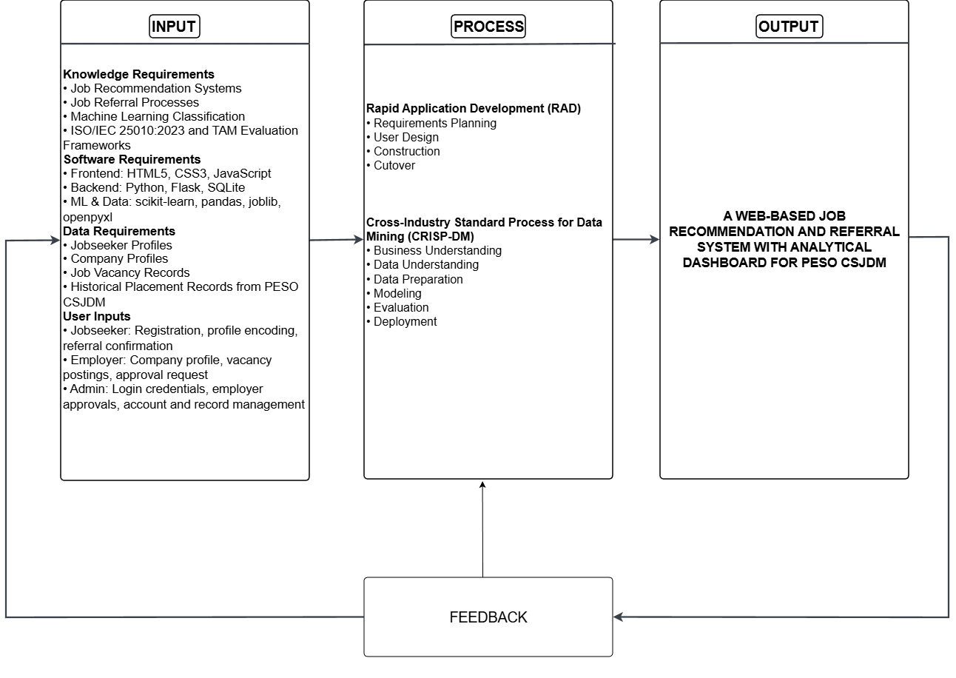
Figure 1. Conceptual Framework
Figure 1 presents the conceptual framework of the study using the Input–Process–Output (IPO) model. The input phase covers the knowledge, software, data, and user inputs required by the system — including domain knowledge on job recommendation and machine learning, the development technologies used, jobseeker and employer records from PESO CSJDM, and the actions performed by each user group. These inputs are processed through the RAD and CRISP-DM methodologies, covering requirements planning, system design, module construction with the integrated machine learning pipeline, and system evaluation. The expected output is A Web-Based Job Recommendation and Referral System with Analytical Dashboard for PESO CSJDM, delivering ranked job recommendations and referral slips to jobseekers, vacancy management to employers, and an analytical dashboard to admin staff. A feedback loop connects the output back to the input to support continuous improvement.

Development Methodology
Two complementary frameworks were adopted: Rapid Application Development (RAD) for the web-based system, and CRISP-DM for the machine learning component.
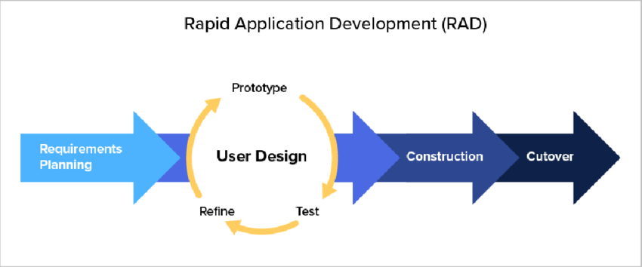
Figure 2. Rapid Application Development Model
Rapid Application Development (RAD). RAD is an iterative software development methodology that prioritizes rapid prototyping and continuous user involvement over exhaustive upfront documentation, so that requirements are discovered and refined through demonstration (Riadi et al., 2024). It was selected for this project because showing stakeholders working screens at each prototype review was the most practical way to surface and validate accurate requirements. The fixed capstone timeline and small team size also aligned naturally with RAD's phase structure, where each phase delivers a testable prototype before the next begins, keeping development bounded without deferring user validation to the end.
CRISP-DM. CRISP-DM is a structured process model for data mining and machine learning projects that organizes work into six phases: Business Understanding, Data Understanding, Data Preparation, Modeling, Evaluation, and Deployment (Shimaoka et al., 2024). It was adopted for the machine learning component because each phase corresponds directly to a concrete task — understanding the referral problem, examining the placement dataset, cleaning and preparing the records, training and comparing the three classifiers, selecting the best performer by Macro F1-Score, and deploying the model through the Flask application. This gave the machine learning work a clear structure that kept the modeling process aligned with the system's operational needs from start to finish.
Table 7 presents how the RAD and CRISP-DM phases were carried out in parallel.
Table 7. RAD and CRISP-DM Phase Alignment
Phase | RAD Activities | CRISP-DM Activities | Key Deliverable
1. Requirements Planning | Conduct interviews and on-site observation with stakeholders (PESO CSJDM staff, jobseekers, and employers); profile the historical placement dataset; define functional and non-functional requirements | Business Understanding: identify the referral decision problem, confirm placement data availability, and define model performance goals | Requirements specification; Data Sharing Agreement
2. User Design | Design system architecture, DFDs, ERD, and high-fidelity mockups; review prototypes with stakeholders; refine per feedback | Examine dataset structure and class distribution; clean records, map 88 job titles to five categories, and split 80/20 with stratification | Validated system design; cleaned dataset; selected feature set
3. Construction | Develop all system modules; integrate the ML pipeline with the Flask application | Fit TF-IDF vectorizer; train Logistic Regression, Random Forest, and Naïve Bayes; select best model by Macro F1-Score; serialize and deploy via Flask | Working system; algorithm comparison results; deployed recommendation model
4. Cutover | Conduct ISO/IEC 25010:2023 evaluation by IT professionals and TAM evaluation by respondents; apply corrections; prepare system handover | Post-deployment review of the deployed model's performance in operational context | Evaluated system; handover package

System Design
This section presents the design diagrams that explain the overall structure and behavior of the system. Each diagram is numbered, labeled, and followed by an explanation.

Context Diagram
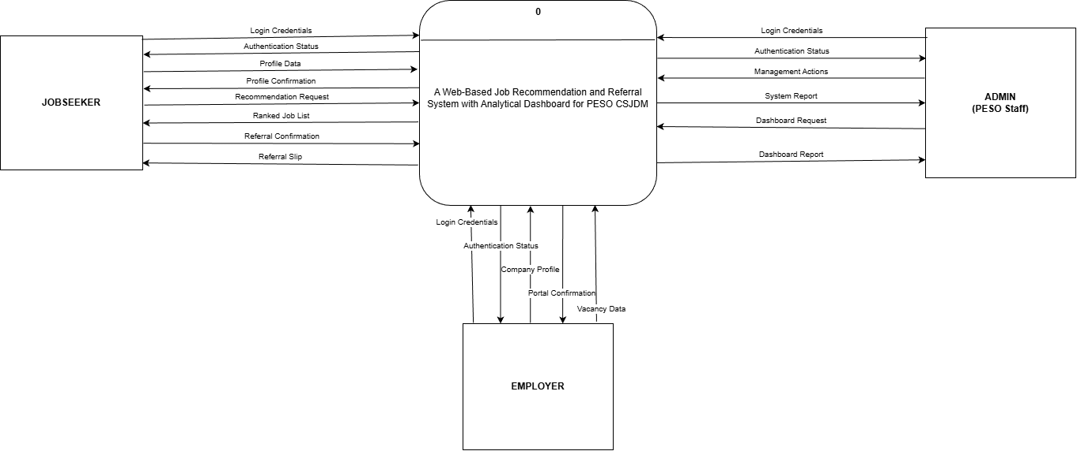
Figure 3. Context Diagram (Proposed)
Figure 3 presents the context diagram, which shows the whole system as a single process interacting with three external entities: Jobseekers, Employers, and Admin (PESO Staff). Jobseekers supply login credentials, profile data, a recommendation request, and referral confirmation, and receive authentication status, profile confirmation, a ranked job list, and a referral slip. Employers supply login credentials, company profile data, and vacancy data, and receive authentication status and portal confirmation. Admin staff supply login credentials, management actions, and a dashboard request, and receive authentication status, a system report, and the dashboard report. The machine learning model is trained offline by the research team before deployment; no user uploads or retrains it at runtime. No external system connects to the system directly.

Data Flow Diagram Level 1
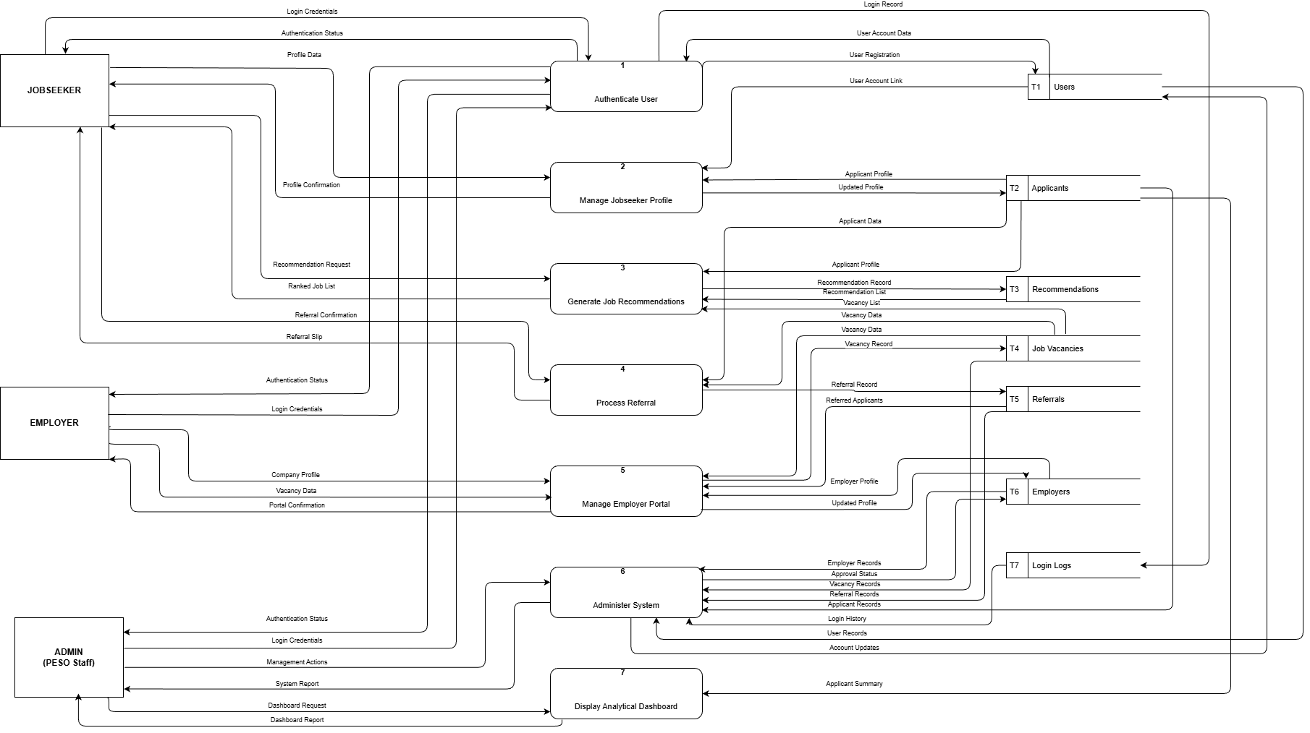
Figure 4. Data Flow Diagram Level 1
Figure 4 decomposes the system into seven processes (P1–P7) and seven data stores (T1–T7) serving three external entities: Jobseeker, Employer, and Admin. P1 authenticates all users and logs attempts to T7. P2 manages jobseeker profiles in T2. P3 reads T2 and T4, runs the ML pipeline, stores results in T3, and returns a ranked job list to the Jobseeker. P4 records referrals in T5 and issues a referral slip. P5 updates employer and vacancy data in T6 and T4. P6 lets Admin manage accounts and approvals across all stores. P7 reads T2 and delivers the analytics dashboard to Admin.

Use Case Diagram
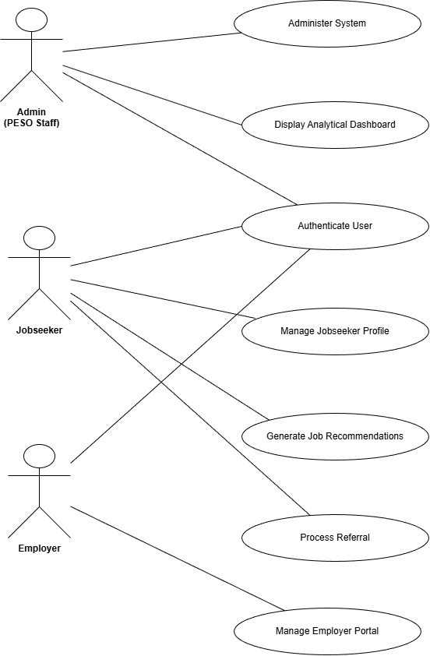
Figure 5. Use Case Diagram
Figure 5 presents the use case diagram showing three actors — Jobseeker, Employer, and Admin (PESO Staff) — and seven use cases. Authenticate User is shared by all three actors. The Jobseeker additionally initiates Manage Jobseeker Profile, Generate Job Recommendations, and Process Referral. The Employer initiates Manage Employer Portal, which covers submitting a company profile, posting vacancies, and viewing referred applicants. The Admin initiates Administer System for managing accounts, approvals, and records, and Display Analytical Dashboard for viewing the jobseeker summary report.

Entity Relationship Diagram (ERD)
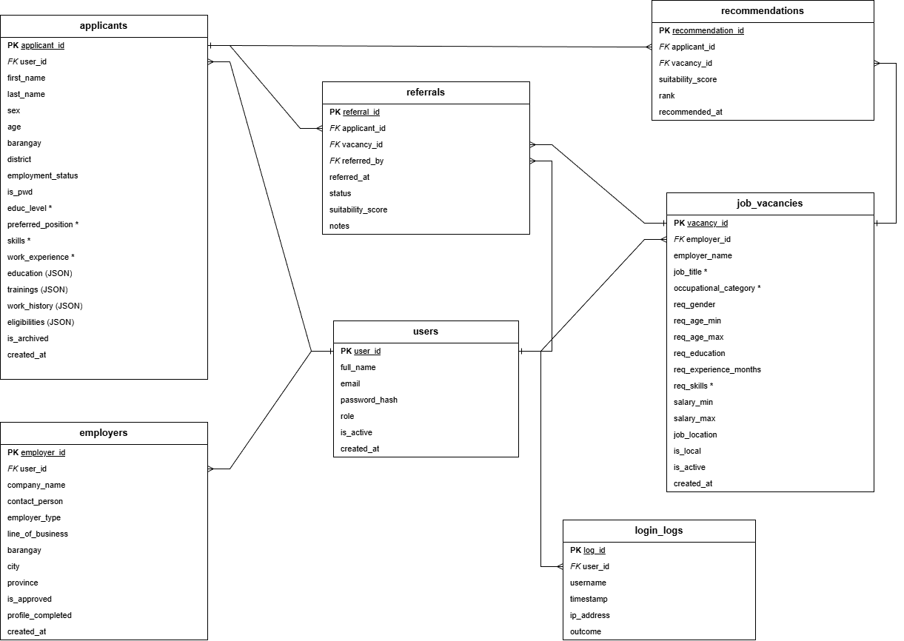
Figure 6. Entity Relationship Diagram
Figure 6 presents the ERD. The database has seven tables corresponding to the data stores in the Level 1 DFD. The users table (T1) is the central hub, storing account credentials and role for all three user types, with all other tables referencing it. The applicants table (T2) stores each jobseeker's profile, including the four ML input fields marked with an asterisk. The employers table (T6) stores company profile details and approval status. The job_vacancies table (T4) stores vacancy requirements, with job title and occupational category marked as ML target fields. The referrals (T5) and recommendations (T3) tables record each referral transaction and ML result respectively, both linking back to applicants, vacancies, and users. The login_logs table (T7) captures each authentication event.

System Architecture Diagram
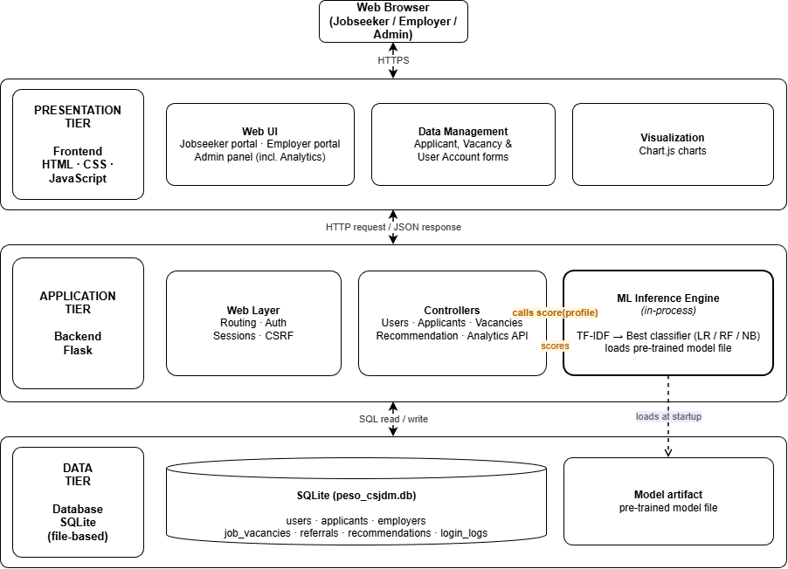
Figure 7. System Architecture Diagram
Figure 7 shows the three-tier architecture of the system. Users access the system through a web browser over HTTPS. The Presentation Tier handles the three portals, data entry forms, and Chart.js visualizations using HTML, CSS, and JavaScript. The Application Tier is a Flask backend that manages routing, authentication, and business logic through its Web Layer and Controllers; it also contains the ML Inference Engine, which applies TF-IDF and the best-trained classifier to produce suitability scores when called by the Controllers. The Data Tier stores all records in a SQLite database and holds the pre-trained model file loaded by the ML Inference Engine at startup.

Flowcharts
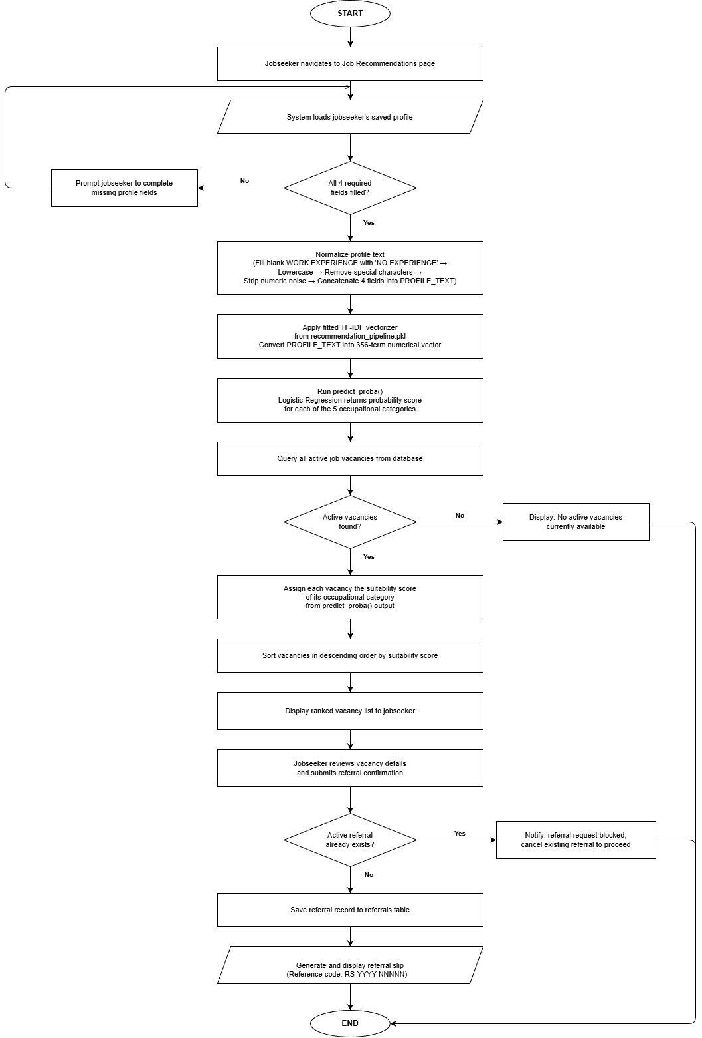
Figure 8. System Process Flowchart
Figure 8 illustrates the system process for generating job recommendations and completing a self-service referral.
The process begins when a registered jobseeker navigates to the Job Recommendations page. The system loads the jobseeker's saved profile from the database and checks whether all four required ML fields are filled: Education Level, Preferred Position, Skills, and Work Experience. If any of the first three mandatory fields are absent, the system displays a prompt for the jobseeker to complete the missing fields before the process can continue. Work Experience is treated separately: if left blank, it is not blocked at the field check but is automatically filled with "NO EXPERIENCE" during the normalization step that follows, preserving the absence of prior work history as a meaningful classification signal consistent with how it was handled during training.
Once all fields are confirmed present, the profile text is normalized using the same steps applied during model training: any blank Work Experience is first filled with "NO EXPERIENCE," all text is then lowercased, special characters are removed, numeric noise is stripped from the Work Experience field, and the four fields are concatenated into a single PROFILE_TEXT string. This ensures that the vocabulary and term weights remain consistent between training and inference.
PROFILE_TEXT is passed through the fitted TF-IDF vectorizer loaded from the pre-trained pipeline file, converting it into a 356-term numerical vector. The trained classifier runs predict_proba() on that vector, returning a probability score for each of the five occupational categories. These scores represent the model's confidence that the applicant belongs to each category based on patterns learned from the 1,083 preprocessed placement records. The system then queries all active job vacancies from the database. If no active vacancies are found, the system displays a notification to the jobseeker and the process ends.
When active vacancies are present, each vacancy is assigned the suitability score of its occupational category from the predict_proba() output. The vacancies are sorted in descending order by suitability score and the ranked vacancy list is displayed to the jobseeker, with vacancies in each category ordered from highest to lowest suitability.
The jobseeker reviews the vacancy details and submits a referral confirmation for the chosen vacancy. The system checks whether the jobseeker already has an active referral. If one exists, the system displays a notification that the request is blocked and instructs the jobseeker to cancel the existing referral before proceeding, and the process ends. If no active referral exists, the referral record is saved to the referrals table, and a referral slip is generated and displayed with a unique system-generated reference code, containing the jobseeker's name, the employer's name, the job title, and the date of referral.
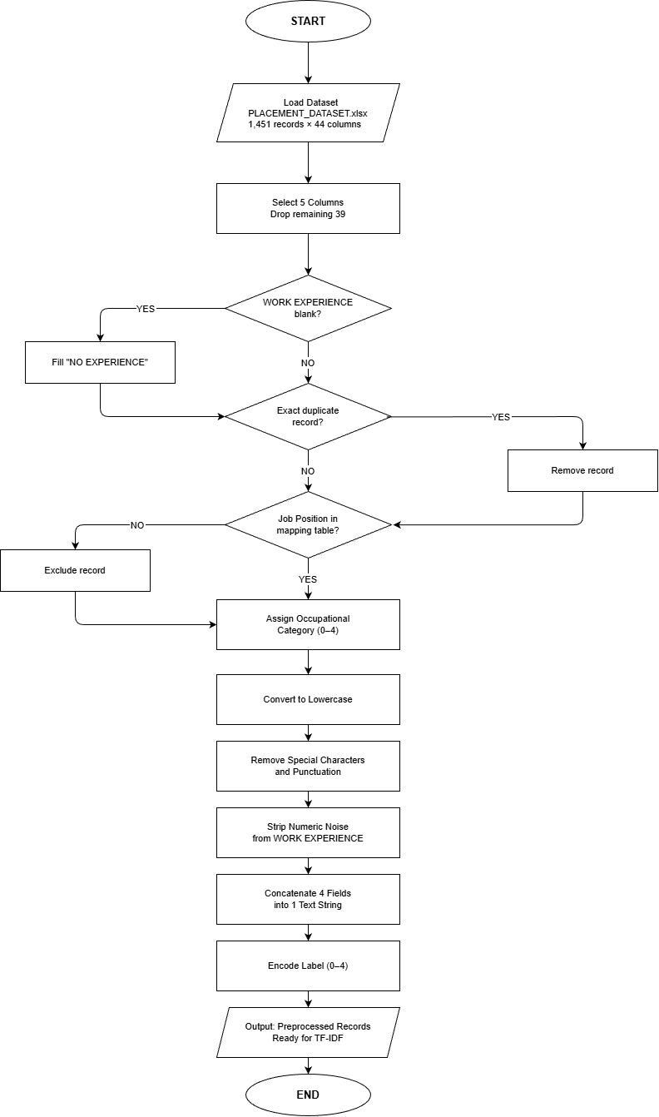
Figure 9. Data Pre-processing Flowchart
Figure 9 illustrates the data preprocessing pipeline applied to the training dataset before TF-IDF vectorization.
The pipeline begins by loading the raw dataset from PLACEMENT_DATASET.xlsx, which contains 1,451 records across 44 columns. Only five columns are retained: EDUC LEVEL, PREFERRED POSITION, SKILLS, WORK EXPERIENCE, and Job Position, as these are the only fields relevant to job category classification (Winardi et al., 2025). All remaining 39 administrative columns are dropped.
Each record is then checked for a blank WORK EXPERIENCE value. Blank entries are filled with "NO EXPERIENCE" to preserve the absence of work history as a meaningful value rather than an empty field. Records confirmed as exact duplicates across all five retained columns are removed and do not proceed further in the pipeline.
Each record's Job Position value is checked against a predefined mapping table. Records with unrecognizable job titles are excluded. Matched records are assigned to one of five occupational categories: Warehouse and Logistics, Production and Manufacturing, Sales/Service/Retail, Clerical and Administrative, and General Services and Security (Beręsewicz et al., 2024).
Text normalization is applied in three steps. All text is converted to lowercase. Special characters and punctuation are removed from all fields. Numeric noise is stripped specifically from WORK EXPERIENCE; entries such as "5 mos as CASHIER" are cleaned to retain only the role term "cashier."
The four normalized fields are then concatenated into a single text string per record (N. Kumar et al., 2022). Finally, the five category labels are encoded as integers zero through four, preparing the target column for classifier input. The preprocessed records are then ready for TF-IDF vectorization.

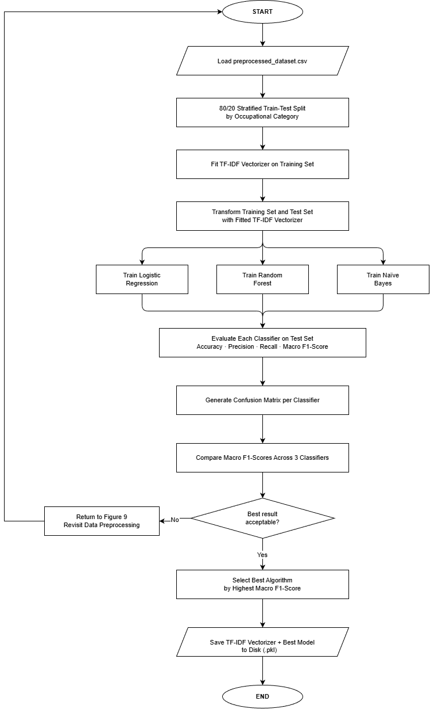
Figure 10. ML Algorithm Flowchart
Figure 10 illustrates the ML algorithm training pipeline that produces the trained model used by the job recommendation module. The pipeline begins by loading the preprocessed dataset from preprocessed_dataset.csv, which contains the 1,083 records output by Figure 9.
The 1,083 records are first divided into a training set (866 records, 80%) and a test set (217 records, 20%) using stratified splitting, which preserves each occupational category's proportion in both halves. This split is performed before any text conversion so the test set remains completely unseen during training, ensuring the final performance scores reflect real-world behavior and not memorized training data.
Each applicant's profile text is then converted into numbers using TF-IDF (Term Frequency-Inverse Document Frequency). Every unique word across the 866 training profiles forms a vocabulary of 356 terms, and each profile receives a score per word based on two factors: how often that word appears in the profile, and how rare it is across all profiles. Words specific to one occupational group, such as "forklift" for Warehouse and Logistics or "cashier" for Sales/Service/Retail, receive high scores because they are strong category signals. Words that appear in nearly every profile receive low scores because they carry no useful distinction between categories. The vectorizer is configured with sublinear_tf=True and fitted on the training set only, producing a training matrix of 866 × 356 and a test matrix of 217 × 356. The same fixed vocabulary and weights are then applied to the test set without any additional learning.
All three classifiers receive the same training matrix so that any difference in performance is attributable to the algorithm and not to the data.
Logistic Regression learns one numerical weight per word per occupational category. To predict a category, it multiplies each word's TF-IDF score by its learned weight and sums the result into a score z_k for each category k. These scores are converted into probabilities using the Softmax function: P(k | x) = e^(z_k) / Σⱼ e^(z_j), which ensures all five category probabilities sum to 1. A word like "cashier" accumulates a high weight for Sales/Service/Retail if it consistently appeared in profiles of that category during training. The category with the highest probability is the predicted class, and those probabilities become the suitability scores used for job recommendations.
Random Forest builds 100 decision trees, each trained on a random subset of records and vocabulary words. Every tree asks a series of yes/no questions about individual word scores, for example whether the score for "forklift" exceeds a threshold, and follows those questions to a final prediction. Split quality at each node is measured by Gini Impurity: Gini = 1 − Σ pᵢ², where pᵢ is the proportion of each category at that node; the split that produces the most category-pure groups is selected. The predicted class for evaluation is decided by majority vote across all 100 trees. For recommendation suitability scoring, the output is the mean class proportion across all trees.
Naive Bayes works through probability estimation. During training, it calculates how likely each word is to appear in a profile belonging to each occupational category. At prediction time, it applies Bayes Theorem: P(y=k | x) ∝ P(x | y=k) × P(y=k), multiplying the prior probability of each category by the likelihood of the applicant's word scores given that category. The classifier assumes each word contributes independently to the total, which is the "naive" assumption the algorithm is named after. The Multinomial variant is used because it accepts the non-negative TF-IDF values produced by the vectorizer, making it the standard choice for text classification pipelines in scikit-learn (Heakl et al., 2024; Chihab et al., 2025).
No resampling or class weighting was applied to any classifier during training. The class imbalance across the five occupational categories is addressed through the choice of Macro F1-Score as the selection criterion rather than through data manipulation, ensuring the evaluation holds every category to the same standard regardless of size.
After training, each classifier predicts the occupational category for the 217 held-out test profiles. Five metrics are computed for each classifier: Accuracy, Precision, Recall, F1-Score, and Macro F1-Score. A confusion matrix is generated as output for each classifier to show the per-category classification results. A fixed random seed (random_state = 42) was applied to the train/test split and to both Logistic Regression and Random Forest to ensure full reproducibility of the results. The Macro F1-Scores of all three classifiers are then compared. If no classifier produces an acceptable result, the pipeline loops back to Figure 9 to revisit the data preprocessing decisions before retraining. When the best result is deemed acceptable, the classifier with the highest Macro F1-Score is selected, and the fitted TF-IDF vectorizer and best model are saved together to disk as a single pipeline file (recommendation_pipeline.pkl), which the Flask application loads at startup to serve job recommendations without retraining.

Tools, Technologies, and Development Environment
Table 8 lists the tools and technologies that will be used to develop the system. All tools are open-source or freely available, chosen to keep the system maintainable within a local government setting without licensing costs.
Table 8. Tools, Technologies, and Development Environment
Category | Tool / Technology | Version | Justification
Frontend | HTML5, CSS3, JavaScript | HTML5 / CSS3 / ES2015 | Standard web markup, styling, and scripting languages for building structured, accessible, and interactive system pages; all frontend output will be rendered through Jinja2 templates served by Flask
Frontend | Bootstrap (via CoreUI 5) | 5.3 | Open-source Bootstrap-based CSS framework providing pre-built, mobile-responsive UI components; will ensure consistent layout across desktop and mobile browsers without custom component development
Backend | Python | 3.14.2 | Single language for both the web application and machine learning pipeline; routing, business logic, session management, and ML inference will all run within one Flask process
Backend | Flask | 3.0 | Lightweight Python micro-framework for routing, Jinja2 templating, and session management; Werkzeug utilities bundled with Flask will handle password hashing and request security utilities
Database | SQLite | 3.46 | Serverless, file-based relational database bundled with Python; will store all seven system tables in a single database file deployed alongside the application without requiring a separate database server
Python / ML Libraries | scikit-learn | 1.4 | Will provide TfidfVectorizer, LogisticRegression, RandomForestClassifier, MultinomialNB, and Pipeline for constructing and comparing the three classification models; NumPy (1.26) is included as a required numerical dependency
Python / ML Libraries | pandas | 2.2 | Will handle .xlsx file reading for training dataset ingestion and all CRISP-DM Data Preparation steps including duplicate removal and missing value handling
Python / ML Libraries | openpyxl | 3.1 | Excel reading engine for .xlsx files required for training dataset ingestion
Model Serving | joblib | 1.4 | Will serialize the trained TF-IDF vectorizer and best-performing classifier into a pre-trained model file; the Flask application will reload this artifact at startup for live inference without retraining
ML Training Script | Python Script (.py) | 3.14.2 | ML training, preprocessing, and model evaluation will be implemented as standalone Python scripts executed directly through the Visual Studio Code terminal; all CRISP-DM Modeling and Evaluation steps will be performed via the Python interpreter without a notebook interface
Data Visualization | Chart.js | 4.4 | Lightweight open-source charting library that will render all Analytical Dashboard charts; chart data will be fetched asynchronously from the Flask JSON API endpoint
Version Control | Git | 2.47 | Will track code changes and coordinate development across the five-member research team throughout all RAD phases
IDE / Code Editor | Visual Studio Code | 1.96 | Free, extensible editor with integrated terminal and Python/JavaScript extensions; will serve as the primary development environment for all team members
UI/UX Design | HTML, CSS, and Bootstrap (via CoreUI 5) | 5.3 | System screens were prototyped directly within the Flask development environment using HTML, CSS, and Bootstrap. Browser screenshots of the running prototype were used for stakeholder review during the User Design phase, eliminating the need for a separate wireframing tool.
Diagram Tools | draw.io | Web-based | Will be used to create all system design diagrams including the context diagram, DFD, use case diagram, ERD, system architecture diagram, and flowcharts
Deployment | PythonAnywhere | Free tier | Free-tier cloud hosting for Flask applications; will provide always-on deployment without requiring separate server configuration or infrastructure costs

Development environment. Development will be carried out on Windows 10/11 machines using the Flask built-in development server for local testing, with application and ML dependencies isolated in a Python virtual environment.

Development Cost
Table 9 presents the estimated breakdown of the cost of building the system.
Table 9. Development Cost
Category | Item | Description | Estimated Cost
Material Costing | Laptop/PC (1 unit) | Coding, testing, ML training | ₱32,000.00
 | External Storage | Backup and system files | ₱2,000.00
 | Miscellaneous Supplies | Printing, documentation, etc. | ₱2,000.00
 | Networking Equipment |  | ₱3,000.00
 | Subtotal |  | ₱39,000.00
Personnel | System Analyst |  | ₱30,000.00
 | Programmer |  | ₱27,000.00
 | Project Manager |  | ₱30,000.00
 | Quality Assurance |  | ₱24,000.00
 | Documenter |  | ₱22,260.00
 | Subtotal |  | ₱133,260.00
Software | Web Hosting Platform | Free tier (PythonAnywhere) | ₱0.00
 | Domain Name | Free subdomain (PythonAnywhere) | ₱0.00
 | Subtotal |  | ₱0.00
Utilities | Electricity | Per month | ₱1,000.00
 | Internet | Per month | ₱1,500.00
 | Subtotal |  | ₱2,500.00
Maintenance | System Maintenance | Weekly check-ups and remote support | ₱6,000.00
 | Technical Support |  | ₱22,000.00
 | Subtotal |  | ₱28,000.00
TOTAL |  |  | ₱202,760.00

Table 9 presents the total estimated development cost of ₱202,760.00, covering materials, personnel, software, utilities, and maintenance required to build and deploy the system.

Evaluation Methods
This section describes how the system will be evaluated following implementation. The objective of the evaluation is to assess the technical quality of the system and its acceptability to users. Two established evaluation models will be used: the ISO/IEC 25010:2023 Software Product Quality Model and the Technology Acceptance Model (TAM).

Evaluation Using ISO/IEC 25010:2023
Purpose. ISO/IEC 25010:2023 will be used to assess the technical quality of the developed system against an international software product quality standard (Rojas et al., 2025).
Quality characteristics. The system will be evaluated across nine characteristics, each defined here in terms of the present system:
- Functional Suitability evaluates whether the system accurately and completely delivers its specified functions: applicant and vacancy management, job recommendation with suitability ranking, and dashboard reporting. This characteristic also serves as the formal verification of Objective 1's functional requirements (FR-01 to FR-07).
- Performance Efficiency covers the speed of generating recommendation outputs, loading applicant data, and handling daily use without degradation.
- Compatibility covers the system's ability to operate alongside existing PESO tools without interference and to behave consistently across common web browsers and devices.
- Interaction Capability covers the degree to which users can recognize the interface as appropriate for their tasks, learn to navigate it without advanced technical skill, and complete their respective workflows with minimal error.
- Reliability evaluates whether the system consistently generates stable outputs and maintains uninterrupted operation under continuous daily use.
- Security covers protection of applicant personal information, credentials, and recommendation records through authentication and access control.
- Maintainability covers ease of updating the ML model, modifying features, and maintaining the database schema.
- Flexibility evaluates whether the system operates across different browsers and devices without loss of function, and whether it can be adapted to different deployment environments.
- Safety evaluates whether the system prevents unacceptable risk to applicant data, including enforcement of authentication controls that restrict access to authorized users only and input validation that protects stored records from unauthorized modification.
Evaluators. Three (3) IT professionals with expertise in web development, database management, or machine learning systems served as evaluators, selected through purposive sampling.
Instrument. A structured evaluation form based on the nine ISO/IEC 25010:2023 quality characteristics will be prepared, with each item rated on a 5-point Likert scale (5 = Strongly Agree to 1 = Strongly Disagree).
Process overview. The system will be deployed and made accessible to the evaluators with test accounts and guided scenarios covering all modules. Each evaluator will interact with the system and complete the instrument; responses will be tabulated and analyzed in Chapter IV.

Evaluation Using the Technology Acceptance Model (TAM)
Purpose. TAM will be used to measure user perceptions of usefulness, ease of use, and intention to adopt the system, following its validated application to web-based systems in public service contexts (Alsyouf et al., 2023).
TAM constructs.
- Perceived Usefulness (PU) assesses whether the system helps users accomplish their tasks better, including whether it improves performance, increases productivity, and helps complete tasks more quickly.
- Perceived Ease of Use (PEOU) assesses whether the interface is clear and navigable, and whether users find the system easy to learn and operate without advanced technical skill.
- Behavioral Intention to Use (BI) assesses whether users are willing to use the system regularly and would recommend or prefer it over manual methods.
Respondents. Twenty-seven (27) respondents will be selected through purposive sampling. Respondents are individuals who will interact with the system and can provide meaningful feedback on its usability and usefulness based on their experience with the system's workflows.
Instrument. A TAM-based questionnaire aligned to the three constructs will be used, rated on the same 5-point Likert scale. Each respondent will receive a guided walkthrough covering the core workflows (completing a jobseeker profile, generating a ranked recommendation, and generating a referral slip) before independently answering the questionnaire.

Data Handling and Analysis
A. Respondents and Population Description
The total evaluation population is thirty (30) respondents, broken down into two groups selected through purposive sampling. Table 10 summarizes the respondent groups.
Table 10. Respondent Groups
Respondent Group | Evaluation Framework | Sampling Method | n
Respondents (jobseekers, employers, and PESO staff who interacted with the system) | TAM | Purposive | 27
IT professionals (web development, database management, or ML systems expertise) | ISO/IEC 25010:2023 | Purposive | 3
Total |  |  | 30

B. Data Analysis
Responses from both evaluator groups will be collected using a 5-point Likert scale: 5 – Strongly Agree, 4 – Agree, 3 – Neutral, 2 – Disagree, 1 – Strongly Disagree. Responses will be interpreted using the conversion scale in Table 11.
Table 11. Likert Scale Conversion
Rating Range | Interpretation
4.51 – 5.00 | Highly Acceptable
3.51 – 4.50 | Acceptable
2.51 – 3.50 | Moderately Acceptable
1.51 – 2.50 | Slightly Acceptable
1.00 – 1.50 | Not Acceptable

A mean of 4.51–5.00 (Highly Acceptable) indicates the criterion is fully met with no significant areas for improvement. A mean of 3.51–4.50 (Acceptable) indicates the criterion is satisfied with only minor refinements needed. A mean of 2.51–3.50 (Moderately Acceptable) indicates the system partially satisfies the criterion and requires targeted improvement. A mean of 1.51–2.50 (Slightly Acceptable) indicates substantial revision is required, and 1.00–1.50 (Not Acceptable) indicates the criterion is not met and fundamental redesign is needed.
C. Statistical Treatment of Data
Frequency is used to count how many respondents chose each rating per item.
Percentage (P) is used to express the proportion of respondents who selected each rating relative to the total number of respondents, using the formula:
P = (F × 100) / N
Where:
- P = Percentage
- F = Frequency of responses for a given rating
- N = Total number of respondents
Arithmetic Mean (AM) is the main tool for interpreting the evaluation results. It is computed per questionnaire item, per ISO/IEC 25010:2023 quality characteristic, per TAM construct, and for the overall score of each instrument using the formula:
AM = Σ(wᵢfᵢ) / n
Where:
- AM = Arithmetic Mean
- wᵢ = Likert scale weight (5, 4, 3, 2, 1)
- fᵢ = Frequency of responses for each weight
- n = Total number of respondents
##### D. Algorithm Performance Metrics
The performance of the embedded algorithm will be evaluated independently from the system quality assessment conducted under ISO/IEC 25010 and the user acceptance evaluation conducted under TAM. Those two evaluations measure the quality and acceptability of the web-based system as a whole, while the algorithm performance evaluation specifically measures how accurately and reliably the classification model assigns applicant profiles to occupational categories. Because the system's algorithm is classification-based, the metrics reported are Accuracy, Precision, Recall, F1-Score, and Macro F1-Score, together with a per-class confusion matrix; regression and clustering metrics do not apply. The algorithm performance results apply to the Job Recommendation Module, which is the sole analytics module powered by the trained model.
Validation technique. A stratified holdout validation approach will be used. The 1,083 preprocessed placement records will be partitioned 80/20 into a training set (866 records) and a held-out test set (217 records), with stratified sampling applied so that each occupational category's proportion is preserved in both partitions. Stratification is necessary because the five categories are not evenly distributed: Sales/Service/Retail holds 317 records (29.3%), Production and Manufacturing holds 292 (27.0%), Warehouse and Logistics holds 175 (16.2%), Clerical and Administrative holds 149 (13.8%), and General Services and Security holds 150 (13.9%). Without stratification, the smaller categories may be underrepresented in the test partition, producing unreliable class-level performance estimates. The 80/20 proportion follows the convention applied in the supervised classification studies reviewed in Chapter II (Chihab et al., 2025; Adillah et al., 2026; Darma et al., 2026). All three candidate algorithms, Logistic Regression, Random Forest, and Naïve Bayes, will be trained on the identical training partition and evaluated on the identical test partition so that performance differences are attributable to the algorithm and not to data variation.
Performance metrics. Table 12 presents the classification metrics used to evaluate all three algorithms, their formulas, and their purpose in the context of the PESO job recommendation model.
Table 12. Classification Performance Metrics
Metric | Formula | Purpose
Accuracy | (TP + TN) / (TP + TN + FP + FN) | Overall proportion of correct category classifications across all 5 categories
Precision | TP / (TP + FP) | Proportion of recommended categories that are actually suitable
Recall | TP / (TP + FN) | Proportion of suitable categories the model successfully identifies
F1-Score | 2 × (Precision × Recall) / (Precision + Recall) | Harmonic mean of Precision and Recall, balancing both error types per-class
Macro F1-Score | (1/k) × Σ F1ᵢ, where k = 5 | Unweighted average of per-class F1, giving all 5 categories equal importance

Where: TP (True Positive) = a job category correctly identified as a suitable match for the applicant's profile; TN (True Negative) = a category correctly identified as not suitable; FP (False Positive) = an unsuitable category incorrectly recommended; FN (False Negative) = a suitable category the model failed to identify. Precision, Recall, and F1-Score are computed separately for each of the five occupational categories and reported as both macro averages, where each category contributes equally to the final score, and weighted averages, where each category is weighted by its share of the test partition.
Selection criterion. The algorithm with the highest Macro F1-Score on the held-out test set will be selected for deployment. Macro F1 is used as the selection criterion rather than Accuracy because the five occupational categories differ in size; Sales/Service/Retail holds 317 records (29.3%) while Clerical and Administrative holds 149 (13.8%) and General Services and Security holds 150 (13.9%). Under an accuracy-only criterion, an algorithm that performs well on the three larger categories while failing on the two smaller ones would still record a deceptively high overall score, masking its inability to correctly recommend clerical or security positions to applicants in those groups. Macro F1 computes the F1-Score for each category separately and averages them with equal weight regardless of how many records each category holds, so failure on the 149-record Clerical category penalizes the score as severely as failure on the 317-record Sales category. The three supervised classification studies reviewed in Chapter II, Chihab et al. (2025), Adillah et al. (2026), and Tiwari and Upadhyay (2024), all selected their best algorithm using accuracy-only without addressing class size differences in their evaluation criterion. The present study applies Macro F1 to correct this gap (Opitz, 2024; Grandini et al., 2020).
Confusion matrix. A 5×5 confusion matrix will be generated for each of the three algorithms after evaluation on the held-out test partition. The rows represent the five actual occupational categories and the columns represent the five categories assigned by the model, producing one cell per actual-predicted category pair. Cells on the main diagonal represent correct classifications for each category, while off-diagonal cells represent misclassifications showing which category the model confused with which. The matrix enables a precise diagnosis of where each algorithm succeeds and where it fails across all five occupational groups, beyond what aggregate metrics reveal.
The complete algorithm performance results, including the classification metrics comparison for Logistic Regression, Random Forest, and Naïve Bayes and the 5×5 confusion matrix for each algorithm, are presented and interpreted in Chapter IV.

CHAPTER IV

RESULTS AND DISCUSSION
This chapter presents the results of the study based on the specific objectives stated in Chapter I. Each objective is addressed in sequence, supported by data, screenshots, tables, or figures, with a brief explanation of what the results show. The first section covers the developed system and its modules. The second section presents the algorithm comparison results and the selected recommendation model. The third section presents the evaluation results under ISO/IEC 25010:2023 and the Technology Acceptance Model (TAM). The chapter closes with a system testing summary and a discussion of findings in relation to the study's objectives and related literature.

Results for Specific Objective 1: Develop a Web-Based Job Recommendation and Referral System with Analytical Dashboard for PESO CSJDM.
The Web-Based Job Recommendation and Referral System with Analytical Dashboard for PESO CSJDM was successfully developed and deployed. The system is built using Python and Flask, SQLite, Bootstrap via CoreUI 5, and scikit-learn, accessible through a responsive web interface on both desktop and mobile browsers. The following sections present the seven core modules aligned with the processes defined in the Data Flow Diagram Level 1.

P1: Authenticate User

Figure 11. Login Page
Figure 11. Login Page
Figure 11 shows the Login Page, which is the entry point of the system for all user roles. Users must provide a valid email address and password to gain access. Passwords are stored in encrypted form to keep them secure. Every login attempt, whether it was successful, failed, or denied because of an inactive account, is recorded along with the user, timestamp, IP address, and outcome. This gives admin an audit trail accessible through the Login History page. Anyone who tries to open a protected page without logging in is automatically redirected to the login screen.

P2: Manage Jobseeker Profile
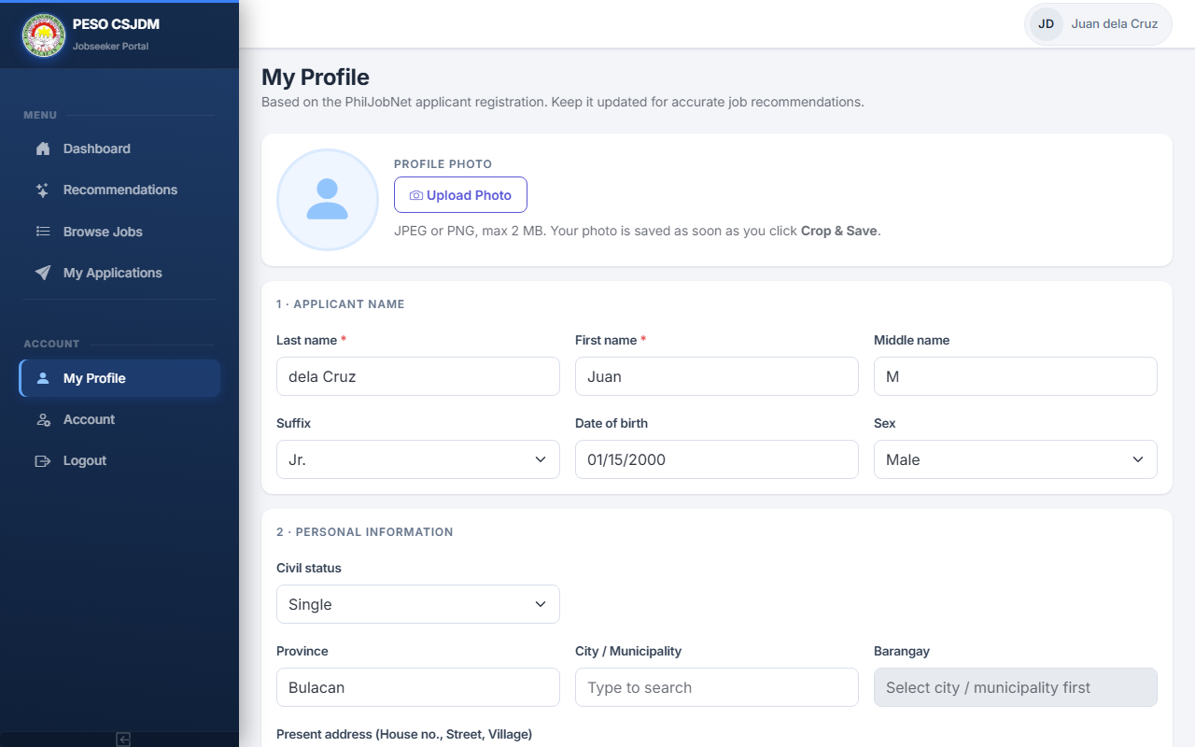
Figure 12. Jobseeker Profile Form
Figure 12. Jobseeker Profile Form
Figure 12 shows the Jobseeker Profile Form, where registered jobseekers complete their personal information, educational background, work history, skills, and employment preferences. The form follows the PhilJobNet/NSRP structure and stores repeatable sections such as education, trainings, work history, and eligibilities as JSON. Four fields are required by the recommendation engine: education level, preferred position, skills, and work experience. A jobseeker cannot generate recommendations until these fields are filled in.

P3: Generate Job Recommendations

Figure 13. Job Recommendation Tab: Empty State
Figure 13. Job Recommendation Tab (No Recommendation Generated Yet)
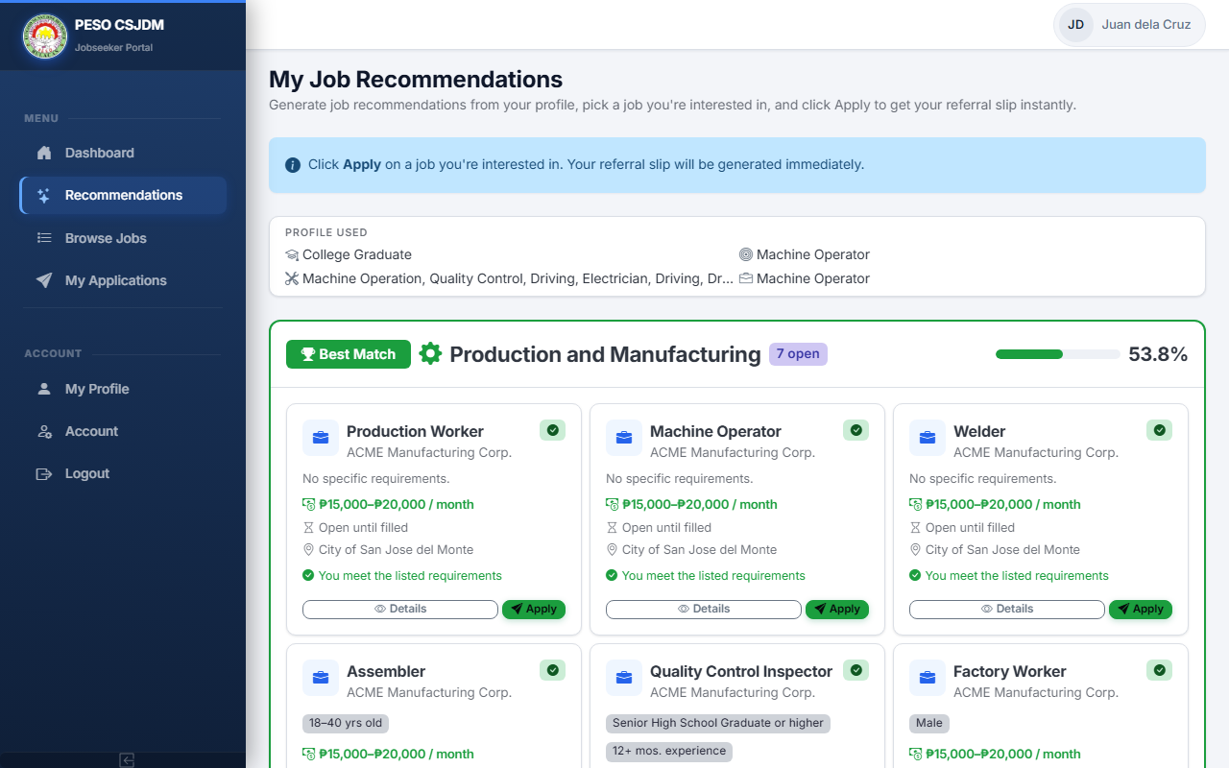
Figure 14. Job Recommendation Tab: Recommendation Results
Figure 14. Job Recommendation Tab (Results Displayed)
Figures 13 and 14 show the Job Recommendations page in the Jobseeker portal. Before recommendations can be generated, the jobseeker's profile must have three required fields completed: education level, preferred position, and skills. If any of these are missing, the system displays a prompt to complete the profile first.
When the jobseeker clicks Generate Recommendations, the system processes the profile fields using the same text preparation steps applied during model training. Work experience is optional; if left blank, the system substitutes "NO EXPERIENCE" so the field still contributes a meaningful value. The processed text is converted into a numerical vector using the saved TF-IDF vectorizer and passed through the trained Logistic Regression model, which returns a suitability score for each of the five occupational categories. The categories are displayed in order from highest to lowest score. The top-ranked category is highlighted as a hero card with the suitability percentage and a list of currently active vacancies in that category. The remaining four categories are listed below with their scores and available openings. When recommendations are generated, the result is saved to the recommendations table with the applicant, vacancy, suitability score, and rank.

P4: Process Referral

Figure 15. Referral Slip Generation
Figure 15. Referral Slip Generation
Figure 15 shows the referral generation step in the Jobseeker portal, which is the core output of the system and directly addresses the problem of jobseekers having to travel to the PESO office just to receive a referral. From the recommendation results page, the jobseeker can select any active vacancy and click Apply to initiate a referral. The system generates a referral slip with a unique reference code that records the jobseeker, vacancy, employer, suitability score, and date. A jobseeker can hold only one active referral at a time. The generated referral slip can be presented to the employer directly, removing the need for a paper referral from the PESO office.

P5: Manage Employer Portal

Figure 16. Employer Company Profile and Vacancy Management
Figure 16. Employer Company Profile and Vacancy Management
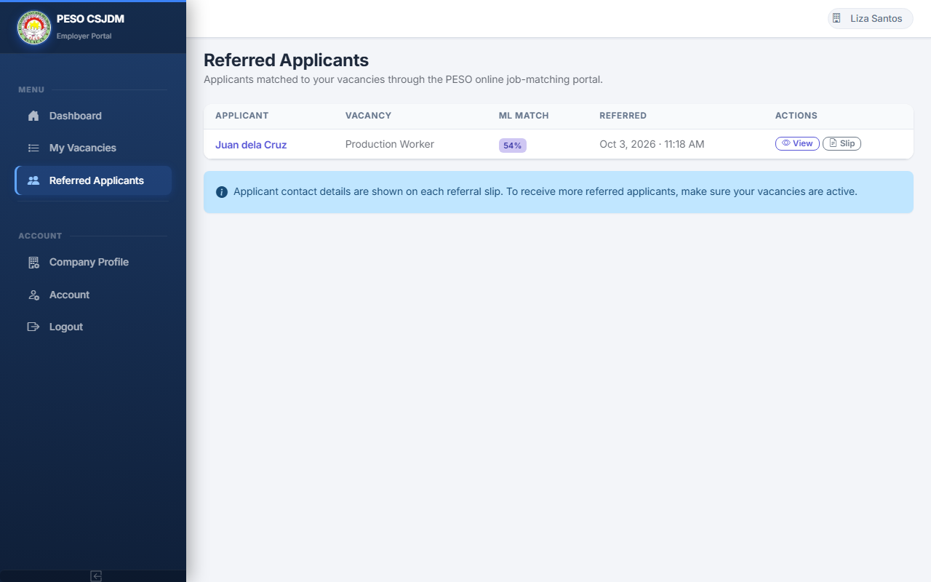
Figure 17. Employer Referred Applicants
Figure 17. Employer Referred Applicants
Employers register by selecting Employer as their role and must complete a company profile before posting vacancies. After completing the profile, the employer submits a request for admin approval. Until approved, the employer can log in and update their profile but cannot post vacancies.
Figure 16 shows the Employer portal's Company Profile and Vacancy Management pages. Once approved, employers can post job vacancies by specifying the job title, occupational category, required education level, age range, preferred gender, minimum work experience, required skills, salary range, application deadline, and number of slots. Only active vacancies within their application deadline appear in jobseeker recommendation results.
Figure 17 shows the Referred Applicants page in the Employer portal. When a jobseeker applies for a vacancy, the referral appears in this list. The employer can view the jobseeker's full profile and the ML suitability score captured at the time of application, giving the employer a basis for assessing whether the applicant meets the vacancy requirements.

P6: Administer System
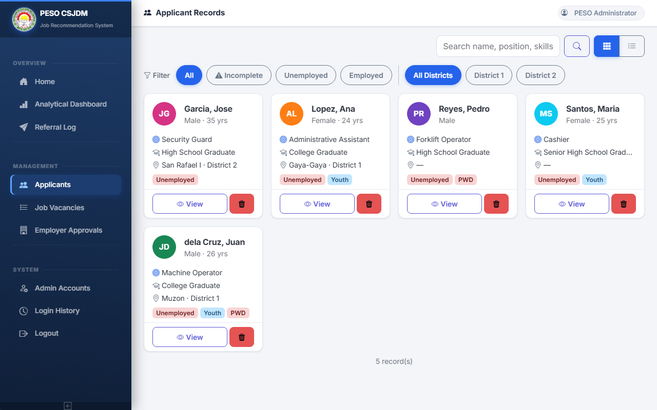
Figure 18. Applicant Management
Figure 18. Applicant Management
Figure 18 shows the Applicant Management module in the Admin panel. Admin can view all registered applicants with card and table views, search by name or skills, and filter by district and employment status. An incomplete filter highlights records with missing profile fields needed for the recommendation engine. Admin can view a jobseeker's complete profile, monitor all submitted referrals, manage job vacancies, approve employer accounts, and manage user accounts across all roles, providing full oversight of all records and workflows in the system.

P7: Display Analytical Dashboard
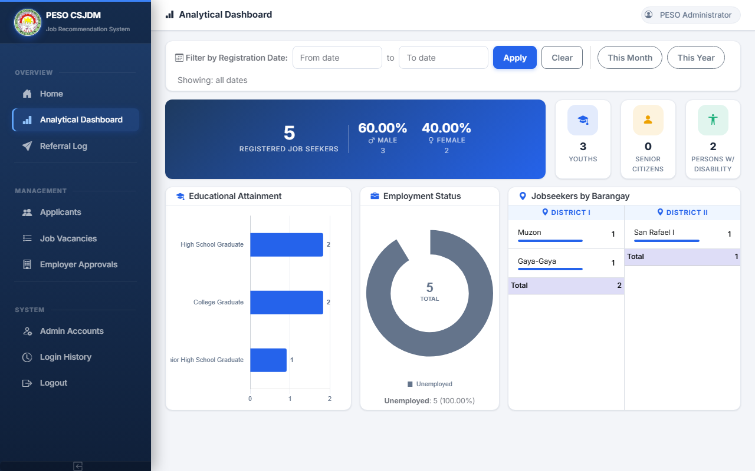
Figure 19. Analytical Dashboard
Figure 19. Analytical Dashboard
Figure 19 shows the Analytical Dashboard, which supports PESO CSJDM's quarterly job seeker reporting requirements. The dashboard presents registered job seeker data across three sections. The top row shows the total number of registered job seekers with a male and female breakdown, and separate counts for youth (ages 15 to 30), senior citizens (ages 60 and above), and persons with disability (PWD). The distribution of registrants by educational attainment is shown as a horizontal bar chart covering the ten canonical levels. The distribution by employment status is shown as a doughnut chart. The barangay-level distribution separated into District 1 and District 2 is shown as two scrollable tables with totals. The dashboard supports date range filtering by registration date so staff can view data for a specific period.
The successful development and deployment of the system across its seven core processes — user authentication, jobseeker profile management, ML-powered job recommendations, referral generation, employer portal management, system administration, and the analytical dashboard — confirms that the system meets all functional requirements established in Chapter III and fulfills the first specific objective of the study.

Results for Specific Objective 2: Implement the best-performing classification algorithm, as determined through a comparative evaluation of Logistic Regression, Random Forest, and Naïve Bayes.

Experimental Setup
The machine learning evaluation used the preprocessed PESO CSJDM placement dataset containing 1,083 records distributed across five occupational categories. Table 13 presents the distribution of records per category.
Table 13. Dataset Distribution by Occupational Category (n = 1,083)
Occupational Category | Records | Proportion
Warehouse and Logistics | 175 | 16.2%
Production and Manufacturing | 292 | 27.0%
Sales/Service/Retail | 317 | 29.3%
Clerical and Administrative | 149 | 13.8%
General Services and Security | 150 | 13.9%
Total | 1,083 | 100.0%

The dataset was divided into a training set and a test set using an 80/20 split, yielding 866 training records and 217 test records. The split was done in a way that kept the proportion of each category the same in both sets, making sure no category was missing from the test data. This division was also done before the text was converted into numbers, so that the test records had no influence on how the model learned its features.
TF-IDF was applied to each applicant's profile text, which is a combined text entry made up of the education level, preferred position, skills, and work experience fields, processed through the same text cleaning steps used when the system generates recommendations. The TF-IDF converter was trained using only the 866 training records, which produced a set of 356 unique terms. Those same terms and weights were then applied to the test set without any further adjustments. This produced a training table with 866 rows and 356 columns, and a test table with 217 rows and 356 columns.
Three classification algorithms were then trained on the same training data: Logistic Regression (max_iter = 1,000), Random Forest (100 decision trees), and Multinomial Naïve Bayes. A fixed random seed was applied to the data split and to both Logistic Regression and Random Forest to make sure the results can be reproduced. No data resampling or class weighting was applied; the class imbalance was handled through the use of Macro F1-Score as the selection measure, as discussed in Chapter III.

Classifier Comparison Results
Table 14 presents the evaluation results for all three classifiers on the 217-record test set.
Table 14. Classifier Comparison Results (n = 217, Test Set)
Classifier | Accuracy | Macro F1-Score | Weighted F1-Score
Logistic Regression | 0.7281 | 0.7370 | 0.7264
Naïve Bayes | 0.7051 | 0.7098 | 0.6979
Random Forest | 0.6590 | 0.6679 | 0.6540

Logistic Regression achieved the highest scores across all three measures. On the primary selection criterion, Macro F1-Score, Logistic Regression (0.7370) outperformed Naïve Bayes (0.7098) by 0.0272 and Random Forest (0.6679) by 0.0691. The same ranking held for both accuracy and Weighted F1-Score, showing that Logistic Regression performed most consistently across all five occupational categories. Logistic Regression was therefore selected as the recommendation model for deployment.
Macro F1-Score was used instead of accuracy because the five categories are not equal in size. Accuracy only counts the total number of correct predictions regardless of which category they belong to. This means a model that performs well on the three larger groups, which are Sales/Service/Retail (317 records, 29.3%), Production and Manufacturing (292 records, 27.0%), and Warehouse and Logistics (175 records, 16.2%), but fails on the two smaller ones, would still appear to have a high overall score. Macro F1-Score, on the other hand, calculates the F1-Score for each of the five categories separately and then averages them equally. This means a poor performance on the smaller Clerical and Administrative group (149 records) is treated just as seriously as a poor performance on the larger Sales/Service/Retail group. This approach ensures that the selected model works well for all categories that PESO staff may need to refer applicants to, not just the ones with more records.

Per-Category Performance of the Selected Model
Table 15 presents the per-category Precision, Recall, F1-Score, and Support for Logistic Regression on the 217-record test set.
Table 15. Logistic Regression Per-Category Performance (n = 217, Test Set)
Occupational Category | Precision | Recall | F1-Score | Support
Warehouse and Logistics | 0.6552 | 0.5429 | 0.5938 | 35
Production and Manufacturing | 0.6964 | 0.6724 | 0.6842 | 58
Sales/Service/Retail | 0.6800 | 0.7969 | 0.7338 | 64
Clerical and Administrative | 0.7500 | 0.7000 | 0.7241 | 30
General Services and Security | 0.9655 | 0.9333 | 0.9492 | 30
Macro Average | 0.7494 | 0.7291 | 0.7370 | 217

General Services and Security achieved the highest F1-Score at 0.9492, with a Precision of 0.9655 and a Recall of 0.9333. This category includes occupations such as security guard, janitor, company driver, and utility worker. Applicants in these roles tend to use words in their profiles that rarely appear in profiles from other categories. Because of this clear separation in terms, the model was able to correctly identify almost all General Services and Security applicants and also avoided placing applicants from other categories into this group.
Warehouse and Logistics recorded the lowest F1-Score at 0.5938, mainly because of a low Recall of 0.5429. This means that many actual Warehouse and Logistics applicants were placed in the wrong category. The main reason for this is that both Warehouse and Logistics and Production and Manufacturing applicants often use similar general labor terms in their profiles, such as "helper" and "laborer," without enough specific words to tell them apart. This overlap reflects the real-world similarity between warehouse and production floor roles in the PESO CSJDM area.
Sales/Service/Retail achieved an F1-Score of 0.7338 with the highest Recall among all categories at 0.7969. The model correctly identified most Sales/Service/Retail applicants because their profiles often contain clear and consistent terms like "cashier," "sales clerk," "service crew," and "merchandiser." The Precision of 0.6800 shows that some applicants from nearby categories were also placed in this group, though the overall balance is still acceptable.
Clerical and Administrative achieved an F1-Score of 0.7241 with the highest Precision among all non-security categories at 0.7500. This means that when the model predicted Clerical and Administrative, it was correct in three out of four cases. The lower Recall of 0.7000 shows that about 30% of actual Clerical and Administrative applicants were placed in other categories, most likely in Sales/Service/Retail, which shares some similar terms related to office and customer-facing roles.
Production and Manufacturing achieved an F1-Score of 0.6842, placing it between the strongest and weakest performers. Terms like "welder," "machine operator," and "production worker" provide clearer signals compared to the general labor vocabulary shared with Warehouse and Logistics, which explains why Production and Manufacturing performed better despite being a neighboring category.

Confusion Matrix
Table 16 shows the confusion matrix for Logistic Regression on the 217-record test set. Each row represents the actual occupational category while each column represents the category the model predicted. The numbers along the diagonal are correct predictions, while those outside it are errors.
Table 16. Logistic Regression Confusion Matrix (n = 217, Test Set)
Actual \ Predicted | Warehouse & Logistics | Production & Manufacturing | Sales/Service/Retail | Clerical & Administrative | General Services & Security
Warehouse and Logistics (n = 35) | 19 | 8 | 6 | 2 | 0
Production and Manufacturing (n = 58) | 5 | 39 | 11 | 3 | 0
Sales/Service/Retail (n = 64) | 4 | 7 | 51 | 2 | 0
Clerical and Administrative (n = 30) | 0 | 2 | 6 | 21 | 1
General Services and Security (n = 30) | 1 | 0 | 1 | 0 | 28

The confusion matrix confirms the patterns noted in the per-category analysis. Warehouse and Logistics had the most errors: 8 of its 35 actual records were predicted as Production and Manufacturing and 6 as Sales/Service/Retail, accounting for the 16 missed cases behind its Recall of 0.5429. Production and Manufacturing also showed errors toward both Warehouse and Logistics (5 records) and Sales/Service/Retail (11 records), reflecting the similar terms shared between these two nearby categories. Sales/Service/Retail had fewer errors, with 4 records going to Warehouse and 7 to Production, while still correctly predicting 51 records, consistent with its Recall of 0.7969. Clerical and Administrative lost 6 records to Sales/Service/Retail and 2 to Production, which fits the vocabulary overlap between administrative and customer-facing roles noted earlier. General Services and Security only had 2 wrong predictions (1 classified as Warehouse, 1 as Sales), in line with its high F1-Score of 0.9492. There were no errors between General Services and Security and Production and Manufacturing, showing that these two categories are clearly distinguishable from each other.
The overall Macro F1-Score of 0.7370 shows that Logistic Regression can correctly group applicant profiles often enough to produce useful job recommendations for PESO CSJDM staff. The weakest area, between Warehouse and Logistics and Production and Manufacturing, is a known limitation of using text-based classification on this dataset and is noted as an area for improvement once more placement records become available.

Discussion of Algorithm Performance
The pattern of results in Table 14 is consistent with the theoretical properties described for each algorithm in Chapter II. Logistic Regression achieved the highest Macro F1-Score across all five categories, which aligns with its documented behavior on sparse, high-dimensional TF-IDF vectors. Alyasiri & Cheah (2025) identified Logistic Regression as the top-performing traditional classifier across 19 benchmark text classification datasets, and the same ranking appeared on the PESO CSJDM data for the same structural reason: TF-IDF vectorization encodes the most class-discriminative terms as the features with the highest magnitude, organizing the feature space in a way that favors linear decision boundaries. Under the One-versus-Rest scheme, Logistic Regression learns a separate set of term weights per occupational category, identifying which terms most strongly predict membership in each class. The direct alignment between TF-IDF's term-weighting structure and Logistic Regression's linear decision mechanism produced the most accurate and consistent classification across all five categories.
Multinomial Naïve Bayes ranked second with a Macro F1-Score of 0.7098. This result confirms the behavior described in Chapter II: despite the conditional independence assumption being unrealistic for real profile text, the algorithm's per-class term probability estimates still captured enough categorical signal from the PESO dataset to perform competitively. With only 149 to 317 training records per category after the 80/20 split, the lightweight single-pass training approach of Naïve Bayes fits the data volume available at PESO CSJDM well. Its estimates assigned high likelihood to clear category-specific terms such as "security guard" and "janitor" in General Services and Security, which is why that category consistently achieved the highest per-category F1-Score across all three classifiers, as seen at 0.9492 for the selected Logistic Regression model in Table 15. The gap between Naïve Bayes and Logistic Regression on the two categories with overlapping vocabularies, Warehouse and Logistics and Production and Manufacturing, reflects the cost of the independence assumption: when two categories share many of the same terms such as "helper," "laborer," and "packer," the per-class probability distributions become difficult to separate, and the multiplicative structure of the Naïve Bayes likelihood calculation does not capture the co-occurrence patterns that would help distinguish between them.
Random Forest recorded the lowest Macro F1-Score at 0.6679, contrary to the result in Betrand et al. (2025), where Random Forest outperformed both Naïve Bayes and Decision Trees on a career guidance dataset. The underperformance here is consistent with the known behavior of ensemble methods on small, sparse text datasets. A 100-tree ensemble built from bootstrap samples of 866 training records means each tree is trained on roughly 632 unique records, distributed across five categories of 119 to 254 records each before sampling. When individual trees additionally consider only a random subset of the 356 TF-IDF features at each split, many trees learn from terms that appear too infrequently in their sampled subset to form reliable split criteria, increasing the proportion of trees that misclassify borderline records. The non-linear ensemble boundaries that make Random Forest advantageous on larger and denser datasets become a liability at this scale because the dataset does not provide each tree with a stable feature distribution from which to learn reliable occupational split points. This outcome is consistent with Scherp et al. (2022), who observed that the performance advantage of more complex classifiers over linear models narrows substantially when the training data are limited and the feature space already captures the class structure through TF-IDF weighting.
The combined result, Logistic Regression first, Naïve Bayes second, and Random Forest third, is consistent with Chihab et al. (2025), where Logistic Regression ranked second overall (behind SVM) and ahead of both Random Forest and Naïve Bayes, and with the benchmark by Alyasiri and Cheah (2025), which identified Logistic Regression as the top-performing traditional classifier for multiclass text classification. It differs from Heakl et al. (2024), where Naïve Bayes led at 82.8% Macro F1 ahead of Logistic Regression at 80.6%, confirming that the relative ordering of Logistic Regression and Naïve Bayes shifts with dataset domain and size, as Chapter II established. The consistent finding across all studies is that Random Forest ranked last when evaluated on limited, sparse text data. The selection of Logistic Regression for deployment is therefore supported not only by its observed Macro F1-Score on the PESO CSJDM dataset but also by the theoretical alignment between its linear decision structure and the discriminative feature encoding produced by TF-IDF vectorization.

Results for Specific Objective 3: Evaluate the developed system using ISO/IEC 25010:2023 and the Technology Acceptance Model (TAM).
The developed system was evaluated using two established frameworks. The first is the ISO/IEC 25010:2023 Software Product Quality Model, which was used by IT professional evaluators to assess the technical quality of the system. The second is the Technology Acceptance Model (TAM), which was used by respondents to measure how willing they are to use the system.

ISO/IEC 25010:2023 Evaluation Results
The system was evaluated by three (3) IT professionals with experience in web development, database management, or machine learning systems, selected through purposive sampling. Each evaluator was given access to the system with a test account and guided through scenarios covering all modules before answering the evaluation instrument on their own. Table 17 presents the rating scale used to interpret all evaluation scores.
Table 17. Rating Scale Interpretation
Mean Score Range | Verbal Interpretation
4.51 – 5.00 | Highly Acceptable
3.51 – 4.50 | Acceptable
2.51 – 3.50 | Moderately Acceptable
1.51 – 2.50 | Slightly Acceptable
1.00 – 1.50 | Not Acceptable

A. Functional Suitability
Functional Suitability evaluates whether the system provides all the functions it is supposed to have and carries them out correctly. It covers three areas: Functional Completeness, Functional Correctness, and Functional Appropriateness. Table 18 shows the evaluation results (n = 3).
Table 18. Evaluation of Functional Suitability (n = 3)
No. | Parameter | 5 | 4 | 3 | 2 | 1 | Mean
Functional Completeness
1 | The system provides a complete set of functions covering the whole process: registration, company profile and vacancy posting (employer), profile encoding and job recommendations (jobseeker), referral generation, and admin moderation. | 3 | 0 | 0 | 0 | 0 | 5.00
Functional Correctness
2 | The system produces accurate results, such as job recommendations that fit the jobseeker profile and referral slips that show the correct jobseeker, job, and employer. | 3 | 0 | 0 | 0 | 0 | 5.00
Functional Appropriateness
3 | The system functions appropriately support matching a jobseeker to a suitable vacancy and generating a referral. | 2 | 1 | 0 | 0 | 0 | 4.67
 | Overall Mean |  |  |  |  |  | 4.89

Verbal Interpretation: Highly Acceptable
The Functional Suitability characteristic received an overall mean of 4.89 (Highly Acceptable). Items 1 and 2, which assessed whether the system provides complete functions and produces accurate results, both received a perfect mean of 5.00, with all three evaluators strongly agreeing. Item 3, which evaluated whether the system's features appropriately support the matching process, received a mean of 4.67, with two evaluators strongly agreeing and one agreeing. These results confirm that the system completely and accurately carries out its intended functions, including registration, vacancy posting, profile encoding, job recommendation, and referral generation, consistent with the functional requirements established in Chapter III.

B. Performance Efficiency
Performance Efficiency evaluates how quickly the system responds to actions and how well it handles a growing number of records and users. It covers Time Behaviour, Resource Utilization, and Capacity. Table 19 shows the evaluation results (n = 3).
Table 19. Evaluation of Performance Efficiency (n = 3)
No. | Parameter | 5 | 4 | 3 | 2 | 1 | Mean
Time Behaviour
4 | The system responds quickly to actions such as submitting forms, generating recommendations, searching, and loading the dashboard. | 3 | 0 | 0 | 0 | 0 | 5.00
Resource Utilization
5 | The system uses memory, storage, and processing resources efficiently, as observed through developer tools or server monitoring during use. | 3 | 0 | 0 | 0 | 0 | 5.00
Capacity
6 | The system processes the available set of records (jobseekers, employers, and vacancies) without noticeable slowdown. | 3 | 0 | 0 | 0 | 0 | 5.00
 | Overall Mean |  |  |  |  |  | 5.00

Verbal Interpretation: Highly Acceptable
Performance Efficiency received a perfect overall mean of 5.00 (Highly Acceptable), with all three evaluators rating all three items as Strongly Agree. This result indicates that the system responds quickly to actions such as form submissions and recommendation generation, uses computing resources efficiently, and handles the available set of records without noticeable slowdown. The strong performance is partly due to the recommendation pipeline being loaded once at application startup and reused for each request, eliminating the overhead of retraining during normal operation.

C. Compatibility
Compatibility evaluates whether the system can operate alongside other tools without interference and behave consistently across different browsers and devices. It covers Co-existence and Interoperability. Table 20 shows the evaluation results (n = 3).
Table 20. Evaluation of Compatibility (n = 3)
No. | Parameter | 5 | 4 | 3 | 2 | 1 | Mean
Co-existence
7 | The system runs in a web browser without negatively affecting other applications on the same device. | 3 | 0 | 0 | 0 | 0 | 5.00
Interoperability
8 | The system behaves consistently across common web browsers and devices (for example Chrome and Edge, desktop and mobile). | 1 | 1 | 1 | 0 | 0 | 4.00
 | Overall Mean |  |  |  |  |  | 4.50

Verbal Interpretation: Acceptable
Compatibility received an overall mean of 4.50 (Acceptable). Item 7, which assessed whether the system operates without conflicting with other applications, received a perfect score of 5.00 with unanimous Strongly Agree ratings. Item 8, which assessed consistent behavior across different browsers and devices, received a mean of 4.00, with one evaluator rating it Neutral due to observed responsive layout issues on certain screen sizes. Overall, the system was confirmed to function alongside other applications without disruption and to operate correctly across common web browsers.

D. Interaction Capability
Interaction Capability evaluates how easy it is for users to understand and use the system, navigate through its features, and complete tasks with minimal errors. It covers Appropriateness Recognizability, Learnability, Operability, User Error Protection, User Engagement, Inclusivity, User Assistance, and Self-descriptiveness. Table 21 shows the evaluation results (n = 3).
Table 21. Evaluation of Interaction Capability (n = 3)
No. | Parameter | 5 | 4 | 3 | 2 | 1 | Mean
Appropriateness Recognizability
9 | Users can easily recognize the system purpose and capabilities on first visit, such as from the landing page. | 1 | 1 | 1 | 0 | 0 | 4.00
Learnability
10 | First-time users can easily learn to register, encode a profile, and generate a referral. | 1 | 0 | 2 | 0 | 0 | 3.67
Operability
11 | The system functions (forms, menus, buttons) are easy to operate and control. | 1 | 2 | 0 | 0 | 0 | 4.33
User Error Protection
12 | The system notifies users when invalid data is entered while managing applicant profiles and job vacancies. | 2 | 0 | 1 | 0 | 0 | 4.33
User Engagement
13 | The system interface is inviting and encourages continued use. | 1 | 2 | 0 | 0 | 0 | 4.33
Inclusivity
14 | The system can be used effectively by people of varied technical backgrounds and abilities. | 0 | 2 | 1 | 0 | 0 | 3.67
User Assistance
15 | The system guides users through tasks with on-screen help such as field hints, placeholders, and instructional messages. | 1 | 2 | 0 | 0 | 0 | 4.33
Self-descriptiveness
16 | The system presents information clearly through labels and icons, so its use is obvious without excessive help. | 1 | 2 | 0 | 0 | 0 | 4.33
 | Overall Mean |  |  |  |  |  | 4.12

Verbal Interpretation: Acceptable
Interaction Capability received an overall mean of 4.12 (Acceptable). Among the eight sub-characteristics, Operability, User Error Protection, User Engagement, User Assistance, and Self-descriptiveness each received a mean of 4.33, indicating that the system's forms, menus, and navigation are easy to operate and the interface encourages continued use. Appropriateness Recognizability received a mean of 4.00, meaning evaluators found the system's purpose clear on first visit. Learnability and Inclusivity each received the characteristic's lowest mean of 3.67, reflecting that while users can navigate the system without extensive training, a brief orientation may help first-time users explore all features independently. All items remained within the Acceptable range, confirming that the system meets usability standards while identifying learnability and inclusivity as areas for continued improvement.

E. Reliability
Reliability evaluates whether the system works consistently without errors during daily use and can recover properly when something goes wrong. It covers Faultlessness, Availability, Fault Tolerance, and Recoverability. Table 22 shows the evaluation results (n = 3).
Table 22. Evaluation of Reliability (n = 3)
No. | Parameter | 5 | 4 | 3 | 2 | 1 | Mean
Faultlessness
17 | The system consistently generates accurate job recommendations and manages records without errors under expected operating conditions. | 2 | 1 | 0 | 0 | 0 | 4.67
Availability
18 | The system is available and accessible whenever needed through its URL. | 3 | 0 | 0 | 0 | 0 | 5.00
Fault Tolerance
19 | The system continues to function properly even when it encounters invalid data entries or minor technical errors. | 2 | 1 | 0 | 0 | 0 | 4.67
Recoverability
20 | After an interruption or restart, the system recovers and previously saved data (profiles, vacancies, referrals) remains intact. | 2 | 1 | 0 | 0 | 0 | 4.67
 | Overall Mean |  |  |  |  |  | 4.75

Verbal Interpretation: Highly Acceptable
Reliability received an overall mean of 4.75 (Highly Acceptable). Availability received a perfect mean of 5.00, with all three evaluators confirming that the system was consistently accessible through its hosted URL during the evaluation period. Faultlessness, Fault Tolerance, and Recoverability each received a mean of 4.67, indicating that the system consistently produces accurate recommendations, handles invalid inputs without crashing, and retains saved data across sessions and interruptions. These results confirm that the system performs reliably under the conditions expected in PESO CSJDM daily operations.

F. Security
Security covers how well the system protects applicant information, staff accounts, and recommendation records from unauthorized access or changes. It covers Confidentiality, Integrity, Non-repudiation, Accountability, Authenticity, and Resistance. Table 23 shows the evaluation results (n = 3).
Table 23. Evaluation of Security (n = 3)
No. | Parameter | 5 | 4 | 3 | 2 | 1 | Mean
Confidentiality
21 | Data is accessible only to authorized users (a jobseeker cannot view another user referral or records). | 3 | 0 | 0 | 0 | 0 | 5.00
Integrity
22 | The system protects records from unauthorized modification or deletion (only the owning employer can edit their vacancy, only admin can approve employers). | 3 | 0 | 0 | 0 | 0 | 5.00
Non-repudiation
23 | The system records that key actions occurred (referral timestamps and login records), so they cannot be denied later. | 3 | 0 | 0 | 0 | 0 | 5.00
Accountability
24 | The system traces actions to the responsible account, for example through the admin login history. | 3 | 0 | 0 | 0 | 0 | 5.00
Authenticity
25 | The system verifies identity through login before granting access (a wrong password or a deactivated account is denied). | 3 | 0 | 0 | 0 | 0 | 5.00
Resistance
26 | The system stays secure under unauthorized access attempts (protected pages redirect to login, approval cannot be bypassed by URL). | 3 | 0 | 0 | 0 | 0 | 5.00
 | Overall Mean |  |  |  |  |  | 5.00

Verbal Interpretation: Highly Acceptable
Security received a perfect overall mean of 5.00 (Highly Acceptable), with all three evaluators rating all six items as Strongly Agree. This result reflects the system's login-based access control, role-separated record visibility, scrypt-hashed password storage, referral and login timestamping, and redirect guards on all protected routes. Every login attempt, whether successful, failed, or denied by account deactivation, is recorded with the user, timestamp, IP address, and outcome, providing a clear and complete accountability trail for administrators.

G. Maintainability
Maintainability covers how easy it is to update or change the system, such as replacing the recommendation model or adjusting a feature, without affecting the rest of the system. It covers Modularity, Reusability, Analysability, Modifiability, and Testability. Table 24 shows the evaluation results (n = 3).
Table 24. Evaluation of Maintainability (n = 3)
No. | Parameter | 5 | 4 | 3 | 2 | 1 | Mean
Modularity
27 | The system is organized into independent modules (routes, templates, ML pipeline, database layer) so a change in one does not break others. | 1 | 2 | 0 | 0 | 0 | 4.33
Reusability
28 | The system reuses shared components such as base templates and helper functions across features. | 3 | 0 | 0 | 0 | 0 | 5.00
Analysability
29 | The system code and structure make it easy to locate the cause of a defect or the impact of a change. | 2 | 1 | 0 | 0 | 0 | 4.67
Modifiability
30 | The system can be updated or enhanced to accommodate changes in PESO operational requirements without errors. | 3 | 0 | 0 | 0 | 0 | 5.00
Testability
31 | The system functions are structured so they can be tested to verify requirements. | 3 | 0 | 0 | 0 | 0 | 5.00
 | Overall Mean |  |  |  |  |  | 4.80

Verbal Interpretation: Highly Acceptable
Maintainability received an overall mean of 4.80 (Highly Acceptable). Reusability, Modifiability, and Testability each received a perfect mean of 5.00, indicating that shared templates and utility functions are reused across features, the system can be updated without introducing new errors, and its functions are structured to be tested systematically. Analysability received a mean of 4.67, and Modularity received 4.33, reflecting that the system's architecture is navigable and that changes to one feature do not disrupt others, though further separation of concerns could be considered as the codebase grows. Overall, evaluators confirmed that the system is organized and testable enough to support future maintenance and enhancement.

H. Flexibility
Flexibility evaluates whether the system can be used on different devices and browsers and whether it can be set up in different environments without major changes. It covers Adaptability, Scalability, Installability, and Replaceability. Table 25 shows the evaluation results (n = 3).
Table 25. Evaluation of Flexibility (n = 3)
No. | Parameter | 5 | 4 | 3 | 2 | 1 | Mean
Adaptability
32 | The system runs across different environments and devices (local and hosted, desktop and responsive mobile). | 2 | 0 | 0 | 1 | 0 | 4.00
Scalability
33 | The system design (database and architecture) can accommodate a growing number of users and records without significant performance loss. | 2 | 1 | 0 | 0 | 0 | 4.67
Installability
34 | The system can be deployed and accessed successfully, as shown by its running hosted instance. | 3 | 0 | 0 | 0 | 0 | 5.00
Replaceability
35 | Records or components can be updated or replaced with minimal disruption (for example editing a vacancy or updating a profile). | 3 | 0 | 0 | 0 | 0 | 5.00
 | Overall Mean |  |  |  |  |  | 4.67

Verbal Interpretation: Highly Acceptable
Flexibility received an overall mean of 4.67 (Highly Acceptable). Installability and Replaceability both received a perfect mean of 5.00, confirming that the system was successfully deployed on PythonAnywhere and that individual components can be updated or replaced with minimal disruption to operations. Scalability received a mean of 4.67, reflecting evaluator confidence that the system's database schema and architecture can accommodate growth in records and users. Adaptability received a mean of 4.00, with one evaluator noting responsive layout issues on mobile screens and text visibility problems in dark mode. These observations are consistent with the recognized limitation that the current responsive implementation may need further refinement for full mobile compatibility.

I. Safety
Safety evaluates whether the system protects applicant data from risks such as unauthorized access or unintended changes. It covers Operational Constraint, Risk Identification, Fail Safe, Hazard Warning, and Safe Integration. Table 26 shows the evaluation results (n = 3).
Table 26. Evaluation of Safety (n = 3)
No. | Parameter | 5 | 4 | 3 | 2 | 1 | Mean
Operational Constraint
36 | The system constrains operations within safe rules (it cannot approve an employer with an incomplete profile, and a jobseeker cannot hold two active referrals). | 3 | 0 | 0 | 0 | 0 | 5.00
Risk Identification
37 | The system identifies risky or invalid operations before they take effect (for example an invalid salary or age range, or a past deadline). | 3 | 0 | 0 | 0 | 0 | 5.00
Fail Safe
38 | The system reverts to a safe state on error and keeps data intact (an invalid form submission returns to the form without data loss). | 3 | 0 | 0 | 0 | 0 | 5.00
Hazard Warning
39 | The system gives timely warnings about potential problems (for example reminding the user to complete the profile before applying, or flagging missing required fields). | 2 | 1 | 0 | 0 | 0 | 4.67
Safe Integration
40 | The system keeps data consistent across its modules (a referral correctly links the jobseeker, vacancy, and employer, and withdrawal updates access consistently). | 3 | 0 | 0 | 0 | 0 | 5.00
 | Overall Mean |  |  |  |  |  | 4.93

Verbal Interpretation: Highly Acceptable
Safety received an overall mean of 4.93 (Highly Acceptable). Operational Constraint, Risk Identification, Fail Safe, and Safe Integration all received a perfect mean of 5.00, confirming that the system enforces business rules such as the one-active-referral constraint, validates inputs before processing, returns invalid form submissions to the user without data loss, and keeps referral records consistently linked across modules. Hazard Warning received a mean of 4.67, reflecting that the system alerts users to incomplete profiles and missing required fields before processing, though evaluators noted that the scope of these warnings could be expanded further in future iterations.

Overall ISO/IEC 25010:2023 Evaluation Summary
Table 27 presents the summary of overall means and verbal interpretations for all nine ISO/IEC 25010:2023 quality characteristics evaluated by the three IT professional evaluators.
Table 27. Overall ISO/IEC 25010:2023 Evaluation Summary (n = 3)
Quality Characteristic | Arithmetic Mean | Verbal Interpretation
A. Functional Suitability | 4.89 | Highly Acceptable
B. Performance Efficiency | 5.00 | Highly Acceptable
C. Compatibility | 4.50 | Acceptable
D. Interaction Capability | 4.12 | Acceptable
E. Reliability | 4.75 | Highly Acceptable
F. Security | 5.00 | Highly Acceptable
G. Maintainability | 4.80 | Highly Acceptable
H. Flexibility | 4.67 | Highly Acceptable
I. Safety | 4.93 | Highly Acceptable
Overall Mean | 4.70 | Highly Acceptable

The overall ISO/IEC 25010:2023 evaluation obtained a weighted mean of 4.70 (Highly Acceptable). All nine quality characteristics received ratings at or above the study's target threshold of 3.51 (Acceptable), confirming that the system meets software quality standards across its functional, technical, and operational aspects. The highest-rated characteristics were Performance Efficiency and Security, both receiving a perfect mean of 5.00. The lowest-rated characteristic was Interaction Capability with a mean of 4.12 (Acceptable), driven by Learnability and Inclusivity sub-items that reflect the challenge of making a multi-role portal fully self-evident to first-time users. These results confirm that the system satisfies Objective 3 from the quality assessment perspective.

TAM Evaluation Results
The system's user acceptance was evaluated by twenty-seven (27) respondents selected through purposive sampling. Each respondent was given a guided walkthrough of the main features, which included completing a jobseeker profile, generating a ranked recommendation, and generating a referral slip, before answering the TAM instrument on their own. Responses were gathered across three areas: Perceived Usefulness (PU), Perceived Ease of Use (PEOU), and Behavioral Intention to Use (BI). The same rating scale in Table 17 was used to interpret all scores.

A. Perceived Usefulness
Perceived Usefulness assesses whether respondents believe the system helps them do their work better, get more done, and finish job referral tasks more easily and quickly. Table 28 shows the evaluation results (n = 27).
Table 28. Perceived Usefulness Evaluation (n = 27)
No. | Statement | 5 | 4 | 3 | 2 | 1 | Mean
PU1 | Using this system improves my performance in accomplishing job referral and job-matching tasks. | 19 | 7 | 1 | 0 | 0 | 4.67
PU2 | Using this system increases my productivity when finding and applying to suitable job vacancies. | 16 | 9 | 2 | 0 | 0 | 4.52
PU3 | This system helps me identify suitable job category matches for a jobseeker more quickly. | 21 | 4 | 2 | 0 | 0 | 4.70
PU4 | This system is useful for generating job category recommendations for jobseekers. | 20 | 6 | 1 | 0 | 0 | 4.70
PU5 | Overall, I find this system beneficial for job referral and employment matching purposes. | 17 | 8 | 2 | 0 | 0 | 4.56
 | Overall Mean |  |  |  |  |  | 4.63

Verbal Interpretation: Highly Acceptable
The Perceived Usefulness construct received an overall mean of 4.63 (Highly Acceptable). Items PU3 and PU4, which assessed whether the system helps users identify suitable job category matches quickly and whether it is useful for generating recommendations, both received the highest individual mean of 4.70. Item PU1, which assessed performance improvement in job referral tasks, received 4.67. Items PU5 and PU2 received means of 4.56 and 4.52 respectively, indicating that while all items were rated highly, respondents found the recommendation and matching functions the most directly useful aspects of the system. These results confirm that users see the system as a practical improvement over the current process of manually searching through vacancy lists for every referral.

B. Perceived Ease of Use
Perceived Ease of Use assesses whether respondents find the system clear, easy to navigate, and simple to use without needing advanced technical skills. Table 29 shows the evaluation results (n = 27).
Table 29. Perceived Ease of Use Evaluation (n = 27)
No. | Statement | 5 | 4 | 3 | 2 | 1 | Mean
PEOU1 | Learning to use this system's features, such as registering, encoding a profile, and generating job recommendations, was easy for me. | 18 | 7 | 2 | 0 | 0 | 4.59
PEOU2 | I find it easy to navigate the system and perform tasks such as encoding a profile or viewing job recommendations. | 18 | 7 | 2 | 0 | 0 | 4.59
PEOU3 | My interaction with the system, including its forms, navigation, and dashboard, is clear and understandable. | 19 | 6 | 2 | 0 | 0 | 4.63
PEOU4 | I find the system easy to use overall. | 17 | 7 | 3 | 0 | 0 | 4.52
PEOU5 | The system's interface (buttons, menus, navigation) is user-friendly. | 17 | 7 | 2 | 0 | 1 | 4.44
 | Overall Mean |  |  |  |  |  | 4.56

Verbal Interpretation: Highly Acceptable
Perceived Ease of Use received an overall mean of 4.56 (Highly Acceptable). Item PEOU3, which assessed the clarity of interaction including forms, navigation, and the dashboard, received the highest mean of 4.63. Items PEOU1 and PEOU2, which assessed how easy it was to learn and to navigate the system, each received 4.59. Item PEOU4 received a mean of 4.52. Item PEOU5, which assessed the user-friendliness of the interface's buttons, menus, and navigation, received a mean of 4.44 (Acceptable), the only TAM item to fall below the Highly Acceptable threshold. This reflects the overall finding that users found the system easy to learn and navigate, while a small number of respondents had minor reservations about specific interface elements.

C. Behavioral Intention to Use
Behavioral Intention to Use assesses whether respondents plan to keep using the system and whether they would choose it over their current manual methods. Table 30 shows the evaluation results (n = 27).
Table 30. Behavioral Intention to Use Evaluation (n = 27)
No. | Statement | 5 | 4 | 3 | 2 | 1 | Mean
BI1 | I intend to use this system regularly if it is made available. | 17 | 7 | 3 | 0 | 0 | 4.52
BI2 | I would recommend this system to others who are looking for a job or who use PESO services. | 18 | 5 | 4 | 0 | 0 | 4.52
BI3 | I plan to use this system regularly for job searching and referral if it becomes available. | 17 | 8 | 2 | 0 | 0 | 4.56
BI4 | Given the chance, I would prefer using this system over manual or walk-in methods for job referral and job searching. | 20 | 3 | 4 | 0 | 0 | 4.59
 | Overall Mean |  |  |  |  |  | 4.55

Verbal Interpretation: Highly Acceptable
Behavioral Intention to Use received an overall mean of 4.55 (Highly Acceptable). Item BI4, which asked whether respondents would prefer the system over manual or walk-in methods, received the highest mean of 4.59, directly reflecting the system's primary purpose of reducing the burden of in-person referral processing. Items BI1 and BI2 each received 4.52, and BI3 received 4.56, indicating that respondents intend to use the system regularly, would recommend it to colleagues, and plan to continue using it once it becomes fully available. These results confirm that users are willing to adopt the system into their regular workflow.

Overall TAM Evaluation Summary
Table 31 presents the summary of overall means and verbal interpretations for all three TAM constructs evaluated by the twenty-seven respondents.
Table 31. Overall TAM Evaluation Summary (n = 27)
TAM Construct | Arithmetic Mean | Verbal Interpretation
A. Perceived Usefulness (PU) | 4.63 | Highly Acceptable
B. Perceived Ease of Use (PEOU) | 4.56 | Highly Acceptable
C. Behavioral Intention to Use (BI) | 4.55 | Highly Acceptable
Overall Mean | 4.58 | Highly Acceptable

The overall TAM evaluation obtained a weighted mean of 4.58 (Highly Acceptable). All three constructs exceeded the study's target threshold of 3.51 (Acceptable), confirming that respondents see the system as useful, easy to use, and worth adopting into their regular workflow. The highest-rated construct was Perceived Usefulness with a mean of 4.63, followed by Perceived Ease of Use at 4.56 and Behavioral Intention to Use at 4.55. These results confirm that the system satisfies Objective 3 from the user acceptance perspective and that respondents are ready to use it regularly in place of manual referral processes.

System Testing Results
System testing was carried out to verify that every module and user workflow of the system functions as expected. Testing covered the complete end-to-end flows across all three portals: from account registration and login through jobseeker profile management, job recommendation generation, referral submission, employer vacancy management, and admin oversight. Table 32 presents the test cases along with the input, expected result, actual result, and whether each test passed.
Table 32. System Testing Results
No. | Test Case | Input | Expected Result | Actual Result | Status
1 | Login with valid credentials | Correct email and password for any role | Access granted; redirected to the role's home page | Access granted; redirected correctly per role | Passed
2 | Login with invalid credentials | Wrong email or incorrect password | Access denied; flash error "Invalid email or password." shown | Access denied; error message shown | Passed
3 | Login with deactivated account | Valid credentials of an inactive account | Access denied; flash message "Your account is deactivated. Contact an administrator." shown | Access denied; correct message shown | Passed
4 | Access a protected page without an active session | Direct URL entry without logging in | Redirected to the Login Page | Redirected to the Login Page | Passed
5 | Register a new account with valid details | Complete registration form with name, email, confirmed email, password, and role selection | Account created; flash success message shown; redirected to Login Page | Account created; redirect and message correct | Passed
6 | Register with an email that is already in use | Email address already associated with an existing account | Flash error "That email is already registered." shown; no duplicate account created | Error shown; no duplicate created | Passed
7 | Complete jobseeker profile with all required fields | Education level, preferred position, and skills filled in and saved | Profile saved; flash success message shown; fields reflected on profile page | Profile saved; changes visible on profile | Passed
8 | Generate job recommendations with a complete profile | Jobseeker with education, preferred position, and skills completed; Generate Recommendations clicked | Ranked list of five occupational categories displayed with suitability scores and active vacancies per category | Ranked results displayed correctly | Passed
9 | Attempt to generate recommendations with incomplete profile | Jobseeker missing education, preferred position, or skills; Generate Recommendations clicked | Prompt shown to complete profile; no recommendation results displayed | Prompt shown; recommendations not generated | Passed
10 | Apply for a vacancy from the recommendations page | Active vacancy selected; Apply clicked and confirmed | Referral slip generated with unique system-generated reference code, jobseeker name, job title, employer, and date | Referral slip generated with correct details | Passed
11 | Attempt to apply while holding an active referral | Apply clicked on a second vacancy while a current referral is active | Flash warning shown to cancel the current referral first; new referral not created | Warning shown; second referral blocked | Passed
12 | Cancel an active referral | Cancel button clicked on an active referral in My Applications | Referral status updated to cancelled; jobseeker is able to apply for another vacancy | Referral cancelled; apply access restored | Passed
13 | Employer submits company profile for admin approval | Complete company profile form submitted; Request Approval clicked | Profile saved; account status shown as pending approval | Profile saved; pending approval status shown | Passed
14 | Employer adds a job vacancy | Complete vacancy form submitted with job title, occupational category, and required fields | Vacancy saved and listed as active in the employer's vacancy list | Vacancy saved and active | Passed
15 | Employer toggles a vacancy between active and inactive | Toggle button clicked on a posted vacancy | Vacancy status switches; inactive vacancies no longer appear in jobseeker recommendations | Status toggled; reflected in recommendations | Passed
16 | Employer views referred applicants | Navigate to Referred Applicants page | List of jobseekers who applied to the employer's vacancies displayed with referral details | Referred applicants list displayed correctly | Passed
17 | Admin approves an employer | Approve button clicked on a pending employer | Employer account activated; employer can now post vacancies | Employer approved; vacancy posting enabled | Passed
18 | Admin toggles any vacancy active or inactive | Toggle button clicked on a vacancy in the admin vacancy list | Vacancy status updated across the system; excluded from or included in recommendation results | Status toggled; reflected in recommendations | Passed
19 | View Analytical Dashboard | Navigate to the Analytical Dashboard tab | Dashboard loads with total registrant count, sex breakdown, youth/senior/PWD counts, education chart, employment status chart, and barangay tables for both districts | All panels populated correctly | Passed
20 | Filter Analytical Dashboard by registration date range | Date range entered in the from and to fields; Apply clicked | Dashboard data updated to show only registrants within the selected date range | Filtered data displayed correctly across all panels | Passed
21 | Add a staff account with non-duplicate credentials | Complete form with full name, email, role, and matching passwords | Account created; listed in the user account list | Account created successfully | Passed
22 | Deactivate a staff account | Toggle button clicked on another staff account | Account marked inactive; account holder is blocked from logging in until reactivated | Account deactivated; login rejected for that account | Passed
23 | Change password with correct current password | Current, new, and confirm password fields filled correctly | Password updated; flash success message shown; session remains active | Password updated; session active | Passed
24 | Change password with incorrect current password or mismatched new passwords | Wrong current password or differing new and confirm fields | Flash error shown; password not changed | Error shown; password unchanged | Passed
25 | View login history | Navigate to the Login History page | Audit table showing recent login events with user, timestamp, IP address, and outcome | Login history table displayed correctly | Passed
26 | Logout | Logout link clicked and confirmed | Session cleared; redirected to the Login Page | Session cleared; redirect to login correct | Passed

All twenty-six test cases passed with actual results matching the expected ones. No critical defects were found during system testing. Minor issues encountered during development, such as the sidebar layout on smaller screens and the display of timestamps in Philippine Time, were resolved before the final round of testing.

CHAPTER V

CONCLUSIONS AND RECOMMENDATIONS
This chapter presents the conclusions drawn from the results of the study and the practical recommendations that follow from those findings. The conclusions correspond to each of the three specific objectives, while the recommendations are directed toward future developers, the client institution, and future researchers.

Conclusions
Objective 1. The web-based job recommendation and referral system with analytical dashboard for PESO CSJDM was successfully developed and deployed. The system was built using Python and Flask as the backend framework, SQLite as the database, Bootstrap via CoreUI 5 for the frontend, and scikit-learn for the machine learning component. It is organized into three role-based portals, namely the Jobseeker portal, the Employer portal, and the Admin panel, which together cover the complete referral workflow from registration through referral generation. The Jobseeker portal addresses the recurring operational problem identified at PESO CSJDM, where staff had to manually pull up profiles, review vacancy lists separately, and decide on matches for every walk-in jobseeker without any tool to guide the process. Jobseekers can now register online, complete their profile, receive ranked job recommendations, and generate a referral slip themselves without traveling to the office or waiting in line, reducing the manual workload on staff and removing the travel burden from jobseekers. The Analytical Dashboard provides PESO staff with a consolidated view of the registered jobseeker pool, covering sex breakdown, youth, senior citizen, and PWD counts, educational attainment distribution, employment status distribution, and barangay-level breakdown by district, eliminating the need to manually filter and count records every time a report is required. All twenty-six system test cases passed with actual results matching expected outcomes, confirming that the system fully satisfies the functional requirements established in Chapter III.
Objective 2. Among the three classifiers evaluated on the PESO CSJDM placement dataset, Logistic Regression performed best and was selected as the recommendation engine for the deployed system. It achieved a Macro F1-Score of 0.7370, which was higher than Naïve Bayes at 0.7098 and Random Forest at 0.6679. The use of Macro F1-Score as the primary selection criterion, rather than accuracy, was appropriate given the unequal distribution of the five occupational categories in the dataset, which ranged from 13.8 to 29.3 percent. This result is consistent with related studies that found Logistic Regression to be a reliable classifier for text-based occupational categorization tasks. The trained model is stored as a pre-trained pipeline artifact and loaded once at application startup, so it can generate ranked category recommendations from any complete applicant profile in under two seconds during normal use.
Objective 3. The system met the target evaluation threshold of 3.51 (Acceptable) for both instruments. The ISO/IEC 25010:2023 evaluation conducted by three IT professionals yielded an overall weighted mean of 4.70, interpreted as Highly Acceptable, with all nine quality characteristics receiving scores at or above the threshold. Performance Efficiency and Security received the highest rating of 5.00, while Interaction Capability received the lowest at 4.12, reflecting that learnability and inclusivity are areas where further improvement could benefit first-time users. The TAM evaluation conducted by twenty-seven respondents yielded an overall mean of 4.58, also interpreted as Highly Acceptable, with Perceived Usefulness receiving the highest construct mean of 4.63, followed by Perceived Ease of Use at 4.56 and Behavioral Intention to Use at 4.55. These results confirm that the system meets recognized software quality standards and that users are prepared to adopt it for regular use in place of the current manual referral process.

Recommendations
For Future Developers:
The five occupational categories used in this study were defined based on the 1,083 clean records available from PESO CSJDM at the time of development. As the office accumulates more placement records over time, future developers are encouraged to retrain the model with a larger and more balanced dataset and to consider expanding the number of categories if the data supports a finer-grained classification. The weakest category boundary in the current model, which falls between Warehouse and Logistics and Production and Manufacturing, is mainly a data volume problem and is expected to improve with additional records.
Future developers are also encouraged to implement an email-based or OTP-based password recovery feature. The current system has no self-service account recovery option; a user who forgets their password must contact the administrator to regain access. Adding a password reset flow tied to the registered email address would remove this dependency and reduce the administrative overhead of managing forgotten credentials. Future developers are additionally encouraged to address the responsive layout issues observed during evaluation, particularly for small screens and dark mode displays, to improve the system's scores under Compatibility and Flexibility.
For PESO CSJDM (Client Institution):
The accuracy of job recommendations depends directly on the completeness and accuracy of the jobseeker profiles stored in the system. PESO CSJDM staff are encouraged to keep applicant and vacancy records up to date, particularly the education level, preferred position, skills, and work experience fields, which are the four inputs the recommendation model depends on. Vacancies that are no longer available should be deactivated promptly so that jobseekers are not referred to positions that have already been filled.
Staff who are new to the system may benefit from a short orientation session, since the ISO evaluation identified learnability as the characteristic with the most room for improvement. A brief walkthrough of the registration, recommendation, and referral generation workflow would reduce the initial adjustment period and ensure consistent use across the team. A designated system administrator should also be assigned to handle employer approval requests, account management, and periodic data review to keep the system running cleanly.
Regular database backups are recommended since the system uses a file-based SQLite database. Backing up the database file before major changes, such as bulk imports or system updates, will protect against accidental data loss and allow recovery if needed.
Once the system is ready for broader use, PESO CSJDM is encouraged to make it accessible beyond the office network so that jobseekers and employers can use it remotely. The current deployment on PythonAnywhere already supports public access, and ensuring that the URL is shared with walk-in clients would allow the system to be used outside of a controlled evaluation setting.
For Future Researchers:
This study compared three classifiers, namely Logistic Regression, Naïve Bayes, and Random Forest, on a dataset of 1,083 records from a single PESO office. Future researchers are encouraged to evaluate more advanced classifiers, such as Support Vector Machines, XGBoost, or transformer-based models, on a larger and more geographically diverse PESO dataset to determine whether a different algorithm produces meaningfully better results at scale. The current Macro F1-Score of 0.7370 leaves room for improvement, particularly for the two categories that share similar applicant profile language.
The system was built for and evaluated within the context of PESO CSJDM only. Applying the same approach to other PESO offices across the country would test whether the occupational categories, profile features, and model performance generalize beyond a single office. A comparative study across multiple PESO offices would also provide more representative data for training a national-level classifier.
The current recommendation engine assigns suitability scores at the occupational category level, meaning all vacancies within the same category receive the same score for a given applicant. Future researchers are encouraged to explore within-category ranking approaches, such as requirement-matching scoring or vacancy-specific similarity metrics, to provide finer-grained ordering of vacancies within each recommended category.
Future researchers may also consider exploring collaborative filtering approaches as referral history accumulates in the system. The current model classifies applicants based on their profile text, but over time the system will generate referral outcome data that could be used to refine recommendations based on which profile-vacancy combinations led to actual placements, not just profile-based predictions. Longitudinal studies tracking placement outcomes after referral would provide the ground-truth feedback needed to evaluate and improve the system's real-world effectiveness.
Adillah, M. F. N., Suakanto, S., & Utama, N. I. (2026). Evaluating civil servant selection through machine learning analysis of national insight, general intelligence, and personal characteristics test scores. Advance Sustainable Science Engineering and Technology, 8(2). https://doi.org/10.26877/asset.v8i2.2300
Alsyouf, A., Lutfi, A., Alsubahi, N., Alhazmi, F. N., Al-Mugheed, K., Anshasi, R. J., Alharbi, N. I., & Albugami, M. (2023). The use of a Technology Acceptance Model (TAM) to predict patients' usage of a personal health record system: The role of security, privacy, and usability. International Journal of Environmental Research and Public Health, 20(2), Article 1347. https://doi.org/10.3390/ijerph20021347
Alyasiri, O. M., & Cheah, Y.-N. (2025). Multi-class text classification using machine learning techniques. Engineering, Technology & Applied Science Research, 15(3), 22598–22604. https://doi.org/10.48084/etasr.9994
Bachita, E. B., & Bayoneta, M. J. A. R. (2021). Implementation of public employment services in a Philippine local government unit. Philippine Social Science Journal, 4(3), 133–144. https://doi.org/10.52006/main.v4i3.412
Bächli, M., Lalive, R., & Pellizzari, M. (2025). Helping jobseekers with recommendations based on skill profiles or past experience: Evidence from a randomized intervention (IZA Discussion Paper No. 17713). IZA – Institute of Labor Economics. https://www.iza.org/publications/dp/17713/helping-jobseekers-with-recommendations-based-on-skill-profiles-or-past-experience-evidence-from-a-randomized-intervention
Belot, M., de Koning, B. K., Fouarge, D., Kircher, P., Muller, P., & Phlippen, S. (2025). Advising job seekers in occupations with poor prospects: A field experiment (NBER Working Paper No. 33819). National Bureau of Economic Research. https://www.nber.org/papers/w33819
Beręsewicz, M., Wydmuch, M., Cherniaiev, H., & Pater, R. (2024). Multilingual hierarchical classification of job advertisements for job vacancy statistics (arXiv:2411.03779). arXiv. https://arxiv.org/abs/2411.03779
Betrand, C. U., Aliche, O. B., Onukwugha, C. G., Ofoegbu, C. I., Kelechi, D. A., Ugbor, I. C., & Oragba, N. M. (2025). Career guidance system using Decision Tree, Random Forest, and Naïve Bayes algorithm. International Journal of Science, Technology and Society, 13(2), 35–42. https://doi.org/10.11648/j.ijsts.20251302.11
Chihab, M., Boussatta, H., Chiny, M., Mabrouk, N., Chihab, Y., & Hadi, M. Y. (2025). AI-driven professional profile categorization and recommendation system. International Journal of Advanced Computer Science and Applications, 16(11). https://doi.org/10.14569/IJACSA.2025.0161140
Darma, S., Sarif, M. I., Alfayed, A. J., Syahdewa, A., & Tyas, K. (2026). IT career navigation: Performance evaluation of KNN and Naïve Bayes in career path recommendations for computer science students (Case study: Battuta University). Journal of Science and Social Research, 9(2), 2838–2847. https://doi.org/10.54314/jssr.v9i2.6269
Ertuğrul, D. Ç., & Bitirim, S. (2025). Job recommender systems: a systematic literature review, applications, open issues, and challenges. Journal of Big Data, 12, 140. https://doi.org/10.1186/s40537-025-01173-y
Google for Developers. (2025, August 25). Random forests. https://developers.google.com/machine-learning/decision-forests/random-forests
Grandini, M., Bagli, E., & Visani, G. (2020). Metrics for multi-class classification: An overview (arXiv:2008.05756). arXiv. https://arxiv.org/abs/2008.05756
Heakl, A., Mohamed, Y., Mohamed, N., Elsharkawy, A., & Zaky, A. (2024). ResuméAtlas: Revisiting resume classification with large-scale datasets and large language models (arXiv:2406.18125). arXiv. https://arxiv.org/abs/2406.18125
Jalal, N., Mehmood, A., Choi, G. S., & Ashraf, I. (2022). A novel improved random forest for text classification using feature ranking and optimal number of trees. Journal of King Saud University - Computer and Information Sciences, 34(6), 2733–2742. https://doi.org/10.1016/j.jksuci.2022.03.012
Kumar, N., Gupta, M., Sharma, D., & Ofori, I. (2022). Technical job recommendation system using APIs and web crawling. Computational Intelligence and Neuroscience, 2022, Article 7797548. https://doi.org/10.1155/2022/7797548
Najjar, A., Amro, B., & Macedo, M. (2021). An intelligent decision support system for recruitment: Resumes screening and applicants ranking. Informatica, 45(4), 617–623. https://doi.org/10.31449/inf.v45i4.3356
Opitz, J. (2024). A closer look at classification evaluation metrics and a critical reflection of common evaluation practice (arXiv:2404.16958). arXiv. https://arxiv.org/abs/2404.16958
Republic Act No. 8759. (1999). An Act Institutionalizing a National Facilitation Service Network through the Establishment of a Public Employment Service Office in All Capital Towns of Provinces, Key Cities and Other Strategic Areas (Public Employment Service Office Act of 1999). Official Gazette of the Republic of the Philippines. https://www.officialgazette.gov.ph/2000/02/14/republic-act-no-8759/
Riadi, I., Yudhana, A., & Elvina, A. (2024). Analysis impact of Rapid Application Development method on development cycle and user satisfaction: A case study on web-based registration service. Scientific Journal of Informatics, 11(1). https://doi.org/10.15294/sji.v11i1.49590
Rojas, H., Renteria, R., Duran, V. M., Gutiérrez, Y. T., Ibarra-Cabrera, M. J., & Aminuddin, A. (2025). Mapping the evolution and future directions of ISO/IEC 25010: A bibliometric and thematic analysis. Engineering, Technology & Applied Science Research, 15(5), 27530–27541. https://doi.org/10.48084/etasr.11772
Sacchi, S., & Scarano, G. (2025). Digital transformation of public employment services in the post-pandemic era. Evidence from Italy as a latecomer country. Australian Journal of Social Issues, 60(2), 456–472. https://doi.org/10.1002/ajs4.385
Scherp, A., Diera, A., Karl, F., Lin, B. X., Khera, B., Meuser, T., Singhal, T., & Galke, L. (2022). Are we really making much progress in text classification? A comparative review (arXiv:2204.03954). arXiv. https://arxiv.org/abs/2204.03954
scikit-learn. (n.d.-a). 8.2.3.5. Tf–idf term weighting. https://scikit-learn.org/stable/modules/feature_extraction.html#tfidf-term-weighting
scikit-learn. (n.d.-b). 1.9. Naive Bayes. https://scikit-learn.org/stable/modules/naive_bayes.html
Shimaoka, A. M., Ferreira, R. C., & Goldman, A. (2024). The evolution of CRISP-DM for data science: Methods, processes and frameworks. SBC Computing Reviews, 4(1), 28–43. https://doi.org/10.5753/reviews.2024.3757
Siino, M., Tinnirello, I., & La Cascia, M. (2025). The text classification pipeline: Starting shallow going deeper (arXiv:2501.00174). arXiv. https://doi.org/10.48550/arXiv.2501.00174
Srihari, R., Adarsha, B. V., Hussain, M. U., & Singh, S. (2025). JobSphere: An AI-powered multilingual career copilot for government employment platforms (arXiv:2511.08343). arXiv. https://arxiv.org/abs/2511.08343
Tiwari, R., & Upadhyay, V. (2024). Applying convolutional neural networks (CNN) to job recommendation systems. International Journal of Science, Engineering and Technology, 12(5). https://www.ijset.in/wp-content/uploads/IJSET_V12_issue5_758.pdf
Winardi, S., Megawan, S., Wong, N. P., Kurniawan, R., Putra, F. A., & Cynthia, C. (2025). Utilizing TF-IDF content-based filtering for job recommendation systems. Jurnal Nasional Komputasi dan Teknologi Informasi (JNKTI), 8(5). https://doi.org/10.32672/jnkti.v8i5.9686
Yu, X., Zhang, J., & Yu, Z. (2024). ConFit: Improving resume-job matching using data augmentation and contrastive learning. In Proceedings of the 18th ACM Conference on Recommender Systems (RecSys '24). ACM. https://doi.org/10.1145/3640457.3688108

