A WEB-BASED DATA-DRIVEN JOB RECOMMENDATION SYSTEM WITH DASHBOARD FOR PESO CSJDM
A Capstone Project by
Alabado, Leandro M.
Nebereja, John Laurence R.
Nimbra, Luis Paolo L.
Poquiz, Lance Andrei P.
Referuga, Kristel
Submitted to the Faculty of Information Technology Bulacan State University–Sarmiento Campus
In Partial Fulfillment of the Requirements for the Degree Bachelor of Science in Information Technology Major in Data and Business Analytics
2026

CHAPTER I
INTRODUCTION
Background of the Study
Job recommendation systems have become a widely adopted mechanism for connecting applicants to suitable employment opportunities across labor markets worldwide, offering faster and more consistent matching of applicant qualifications to available job openings than manual review alone can sustain (Ertuğrul & Bitirim, 2025).
Employment offices are among the most direct settings for implementing job recommendation systems, where staff manage daily referral decisions by manually cross-referencing applicant profiles against vacancy lists without structured decision support (Najjar et al., 2021; Sacchi & Scarano, 2025).
In the Philippines, this need is addressed through the Public Employment Service Office, established under Republic Act No. 8759 (1999), which mandates free employment facilitation, including job referrals and placement services, to Filipino job seekers nationwide. PESO offices accumulate years of applicant records and placement data through daily operations, yet the systems managing those records remain focused on storage rather than on using that history to support referral decisions (Bachita & Bayoneta, 2021).
An interview conducted by the researchers at the Public Employment Service Office of the City of San Jose del Monte, Bulacan confirmed an operational challenge as an active daily burden. On a regular day, the office receives an average of 15 walk-in applicants, rising to 20 to 75 during recruitment activities. For every applicant, staff must manually pull up the applicant's profile, consult the active vacancy list separately, and decide on a referral based entirely on personal judgment, with no tool to narrow down the options of job openings that best fit the applicant. As applicant volume grows throughout the day, the process slows, the queue lengthens, the office becomes crowded, and staff are exhausted by the same repetitive referral steps repeated for every person in the queue.
The same assessment revealed a second difficulty in reporting. When staff need to produce a picture of the office's applicant pool, such as the count of applicants by age group, educational attainment, or skills profile, no consolidated view is available through PEIS. Every figure must be produced by sorting and filtering records one category at a time, a repetitive process that consumes time the office does not have and delays the submission of required reports. Both difficulties point to the same underlying need: a system that consolidates applicant data into a unified dashboard and provides structured, ranked job recommendations to replace the manual cross-referencing that currently governs every referral decision at the office.
Building such a system requires selecting the right algorithm, yet studies applying supervised text classification with machine learning for job and career recommendation consistently identify Logistic Regression, Random Forest, and Naïve Bayes as the top-performing classifiers, with no agreement on which of the three performs best because results shift with every change in dataset (Sankarasetty et al., 2023; Betrand et al., 2025; Darma et al., 2026). No study has examined this on PESO placement data, despite all PESO offices across the Philippines operating under the same PEIS system and facing the same referral workflow challenges (Bachita & Bayoneta, 2021). This study addresses that gap by comparing all three classifiers on actual PESO CSJDM placement records, producing an empirical benchmark that other PESO offices nationwide and future researchers can use as a direct reference when building a similar system, without repeating the comparison from scratch.
Statement of the Problem
This study addresses three connected problems.
First, PESO CSJDM has no web-based decision support system to assist staff in matching applicants to available job openings. Staff rely entirely on personal judgment to cross-reference applicant profiles against the vacancy list for every referral decision, with no dashboard to consolidate workforce data for reporting.
Second, building such a system requires selecting a machine learning algorithm, yet no existing study has identified which among Logistic Regression, Random Forest, and Naïve Bayes performs best on small, imbalanced, government-collected placement data of the type PESO offices hold, making the comparison a necessary step before any reliable system can be deployed.
Third, once the system is built and the best algorithm deployed, it remains unknown whether it meets established software quality standards and whether PESO staff are willing to adopt it, requiring evaluation under both ISO/IEC 25010 and the Technology Acceptance Model.
Objectives of the Study
The general objective of this study is to develop and evaluate a web-based data-driven job recommendation system with dashboard for PESO CSJDM.
Specifically, the study aims to:
1. Design, develop, and deploy a web-based data-driven job recommendation system with dashboard for PESO CSJDM.
2. Compare Logistic Regression, Random Forest, and Naïve Bayes on PESO CSJDM placement data and implement the best-performing algorithm.
3. Evaluate the developed system using ISO/IEC 25010 and the Technology Acceptance Model (TAM).
Significance of the Study
This study contributes to three areas: the operational improvement of a specific government employment office, the broader question of how Philippine public employment offices can adopt data-driven decision support using records they already hold, and the research literature on algorithm selection for employment recommendation in government contexts. The following groups stand to benefit from these contributions.
PESO CSJDM Staff. As the primary users and host institution, PESO CSJDM and its staff benefit most directly. The system reduces the time and effort required to match applicants to available vacancies by providing a ranked list of suitable job openings with suitability scores, giving staff a structured and quantified basis for every referral decision rather than relying on recall alone. At the institutional level, the Analytical Dashboard gives the office a data-driven picture of its registrant pool and local labor market through two panels: a job seeker panel covering registrant counts, sex distribution, youth, senior citizen, and PWD tallies, educational attainment distribution, employment status, and barangay breakdown by district; and a vacancy panel covering total vacancies and employers by local and overseas, top ten vacancies, top industries, and top placement jobs, supporting the preparation of the office's quarterly employment reports and program planning.
Job Seekers. Job seekers registered at PESO CSJDM benefit indirectly through a faster referral queue. The system does not interact with job seekers directly, but by reducing the time staff spend on each referral decision, it shortens the queue and decreases the waiting time experienced by every walk-in applicant, particularly during high-volume recruitment days when the office receives up to 75 applicants in a single day.
Other PESO Offices Nationwide. The operational problem at PESO CSJDM is not unique to one city. Other PESO offices facing the same referral challenges can look to this study as a documented reference for what a similar system looks like, how it performs, and which algorithm to adopt when building one for their own placement data, without repeating the comparison from scratch.
Future Researchers. The study contributes the first empirical comparison of Logistic Regression, Random Forest, and Naïve Bayes on the operational placement records of a Philippine public employment office, together with a replicable development process and a dual ISO/IEC 25010 and TAM evaluation framework, giving future researchers a grounded starting point for studying job recommendation in government contexts where data is small, imbalanced, and operationally collected.
Scope and Delimitations
The study covers the development and evaluation of a web-based data-driven job recommendation system with dashboard for PESO CSJDM, designed for use by PESO staff as the sole user role with a single access level. The system operates through two main analytics tabs: the Job Recommendation tab and the Analytical Dashboard tab, supported by Applicant Management and Job Vacancy Management modules for data entry and maintenance. The recommendation engine is trained on historical placement records from PESO CSJDM, comparing Logistic Regression, Random Forest, and Naïve Bayes using TF-IDF vectorization, with the algorithm achieving the highest Macro F1-Score deployed as the active model. The system is accessible through a responsive web interface supporting both desktop and mobile browsers. Development and evaluation are conducted within the operational context of the City of San Jose del Monte, Bulacan, using PESO CSJDM records only. The system operates in English only.
Delimitations. The study does not propose a novel job recommendation algorithm; it applies established supervised text classification techniques drawn from the existing literature — specifically TF-IDF vectorization paired with Logistic Regression, Random Forest, and Naïve Bayes — to the operational placement records of PESO CSJDM. The system matches job seekers to available vacancies in one direction only and does not recommend applicants for a given vacancy. Job seekers do not interact with the system directly and cannot register or create accounts. Referral recording — the act of logging which vacancy a staff member referred an applicant to — remains handled by PESO staff through PEIS; the system generates and logs its ranked recommendation outputs but does not record the actual referral outcome; the staff member's final decision on which vacancy to refer an applicant to is recorded in PEIS, not in this system. Placement outcome tracking and long-term employment outcomes such as hiring confirmation, retention, and career progression are outside the system's scope. The system does not integrate with PEIS directly through any API or real-time data sync; PEIS exports are uploaded manually by staff as CSV or Excel files. Notifications of any kind — email, SMS, or in-app — are not supported. The ML model is trained offline by the research team prior to deployment and cannot be retrained from within the web interface. The recommendation engine covers only the five occupational categories present in the historical placement records, and broadening coverage to the full range of posted vacancy titles is identified as future work. Advanced approaches including gradient boosting, stacking, deep learning, and large language model-based matching are excluded, as they require training data volumes far exceeding what a single municipal office holds (Qin et al., 2023; Yu et al., 2024) and their opacity conflicts with the transparency obligations of a government referral tool (D. Kumar et al., 2023). The system is not designed for direct deployment in other PESO offices without retraining on local data, does not support multiple branches or offices, and was evaluated at a single point in time in a controlled local environment, not during live PESO operations. The analytical dashboard presents data from stored records only and does not reflect real-time updates.
Limitations. The volume of usable labeled records is limited to confirmed placements the office has historically documented, and those records are heavily concentrated in a small number of occupational categories, which bounds the classification performance achievable by any algorithm. The system also depends on the field structure of PEIS exports for batch upload, and changes to that format would require corresponding adjustment of the upload mapping. Local-only deployment means the system is not accessible outside the office network without additional infrastructure.
Definition of Terms
The following terms are defined operationally, as they are used in the present study, and are arranged alphabetically.
Analytical Dashboard. The system module that presents registered job seeker and vacancy data through two dashboard panels. The job seeker panel covers total registrants with male and female breakdown, counts of youth, senior citizen, and person with disability registrants, distribution by educational attainment across ten levels, distribution by employment status, and barangay-level distribution separated by District 1 and District 2. The vacancy panel covers total vacancies and employers disaggregated by local and overseas, top ten vacancies, top industries, and top placement jobs. The dashboard supports the preparation of the office's quarterly employment reports.
Applicant Profiling. The process of organizing a job seeker's competency profile, including skills, educational attainment, work experience, and preferred position, into a structured format for classification. The system uses this structured profile to rank suitable job openings by suitability score.
Decision Support System (DSS). A computer-based system that assists users in making informed decisions by processing and presenting relevant data in a structured format. In this study, the system supports PESO staff in referral decisions while retaining staff authority over every final outcome.
ISO/IEC 25010. An international standard for software product quality used in this study to evaluate the system across seven characteristics: functional suitability, performance efficiency, usability, reliability, security, maintainability, and portability.
Job Recommendation Module. The system module that applies the trained classification pipeline to a selected applicant's profile and ranks currently active vacancies by suitability score.
Job Referral. The act of connecting a registered job seeker to a specific employer or job opening based on qualifications, carried out by a PESO staff member as part of the office's employment facilitation mandate.
Logistic Regression. A supervised classification algorithm that models the probability of each possible label using a linear combination of input feature weights, using a one-vs-rest strategy for multi-class problems. One of the three algorithms compared in this study, selected based on its consistent emergence as a top performer in supervised text classification studies for job recommendation.
Machine Learning. A field of artificial intelligence in which algorithms learn patterns from historical data and apply those patterns to new inputs. In this study, a machine learning pipeline trained on PESO CSJDM placement records powers the Job Recommendation Module.
Macro F1-Score. The unweighted average of per-class F1-Scores, giving each occupational category equal importance regardless of how many records it contains. Used as the primary algorithm selection criterion because it exposes weak performance on under-represented categories that overall accuracy conceals (Opitz, 2024).
Naïve Bayes. A probabilistic classification algorithm that calculates the likelihood of each possible label given a set of input attributes, assuming each attribute contributes independently. One of the three algorithms compared in this study, selected based on its consistent emergence as a top performer in supervised text classification studies for job and career recommendation.
Occupational Category. A broader grouping of related job titles used as the target label for the classification model. In the present study, 88 distinct job position titles from the PESO CSJDM historical placement records are consolidated into five occupational categories: Warehouse and Logistics, Production and Manufacturing, Sales/Service/Retail, Clerical and Administrative, and General Services and Security. Consolidation is necessary because individual job titles are too sparsely represented in the dataset for a valid stratified train-test split.
Philippine Employment Information System (PEIS). The existing recordkeeping system used by PESO offices to store and retrieve applicant and employer information. The proposed system complements PEIS without replacing it as the office's primary system of record.
Public Employment Service Office (PESO). A government office established under Republic Act No. 8759, mandated to provide free employment services including job referrals, labor market information, and employment program access. In this study, PESO refers specifically to the office of the City of San Jose del Monte, Bulacan.
Random Forest. An ensemble classification algorithm that trains multiple decision trees on random subsets of features and records, and aggregates their votes to produce a final label and probability estimate. One of the three algorithms compared in this study, selected based on its consistent emergence as a top performer in supervised text classification studies for job and career recommendation.
Recommendation Engine. The system component that applies the trained classification model to a job seeker's profile to identify and rank suitable job openings by suitability score.
Technology Acceptance Model (TAM). A framework for measuring technology adoption through three constructs: perceived usefulness, perceived ease of use, and behavioral intention to use. In this study, TAM assesses how PESO CSJDM staff perceive and intend to adopt the developed system.
TF-IDF (Term Frequency-Inverse Document Frequency). A text vectorization method that converts a text document into a set of numerical weights by measuring how often each term appears in that document (term frequency) relative to how rarely it appears across all documents in the dataset (inverse document frequency). Terms that appear across nearly all documents receive lower weight because they carry little discriminating information; terms that appear in only a few documents receive higher weight because they are more distinctive. In the present study, TF-IDF transforms each applicant's concatenated profile text into a numerical feature vector as the first step of the classification pipeline.
CHAPTER II
REVIEW OF RELATED LITERATURE AND SYSTEMS
This chapter reviews literature and related systems that inform the design, algorithm selection, and evaluation of the proposed system. Five thematic areas are covered under the Review of Related Literature: the adoption of job recommendation systems by employment offices around the world, algorithm comparison studies that have examined the classifiers under consideration, data preprocessing approaches used in comparable systems, supervised machine learning approaches for job recommendation that directly inform the system design, and evaluation metrics for multi-class classification systems that establish the selection criterion used in the present study. Following the literature review, six related systems are described and compared in a structured table, examining how each system addressed the problem of matching applicants to positions and where each falls short relative to the conditions of the present study.
Review of Related Literature
Job Recommendation in Employment Offices
A government employment platform operated by the state of Punjab in India integrated an AI-powered job recommendation system after an assessment confirmed that the existing portal imposed documented barriers that prevented effective vacancy matching: applicants encountered navigational complexity that deterred first-time users, were excluded by the absence of multilingual support, and were required to independently search the full inventory of posted vacancies without any personalized guidance, placing the entire burden of vacancy discovery on job seekers without any recommendation support. The resulting system served hundreds of thousands of registered job seekers in the state and integrated multilingual support in English, Hindi, and Punjabi alongside a profile-based recommendation engine that generated personalized ranked vacancy lists for each applicant, replacing the unassisted manual search process that had characterized the original platform. Assessed on the System Usability Scale and recommendation precision metrics, the deployment achieved a System Usability Scale score of 78.5 out of 100, a Precision@10 recommendation score of 68%, and a factual accuracy rate of 94%, collectively representing a 50% improvement in platform usability over the unaugmented baseline, results that demonstrate how integrating job recommendation into a government employment platform significantly improved the vacancy matching workflow by replacing unguided manual search with a structured, profile-driven recommendation process. This evidence directly establishes the viability of the same transformation for PESO CSJDM, where staff currently perform the functional equivalent of that unstructured process for every walk-in applicant, manually cross-referencing each applicant's profile against the full vacancy list without any recommendation tool, and where introducing a structured recommendation system represents a justified, evidence-backed improvement to the office's daily referral workflow (Srihari et al., 2025).
A randomized controlled trial conducted with over 1,250 job seekers, in partnership with a public employment service, directly measured whether automated job recommendations integrated into an employment platform produce a measurable improvement in the employment office's core operational function: connecting job seekers to suitable positions. The trial evaluated two recommendation approaches under controlled conditions, one that aligned suggestions with each applicant's prior occupational history, and one that derived recommendations from an assessed skill profile rather than past employment, enabling matches beyond previously held job titles and accommodating applicants whose prior roles did not reflect their full competencies. Evaluated on job finding rates as the primary outcome measure, both recommendation types improved job finding rates on average, with profile-based recommendations producing the strongest gains for applicants with limited work experience or mismatch between prior employment and assessed skills, the population most commonly served by walk-in government employment offices. The trial result that automated, profile-based recommendations produced a measurable improvement in employment outcomes at a public employment service provides direct empirical evidence that structured job recommendation systems make a quantifiable, real-world difference in the effectiveness of government employment office workflow, not only in technical performance metrics but in the actual employment results delivered to job seekers. This finding directly supports the design and rationale of the proposed system at PESO CSJDM, where applicant profiles covering skills, education level, work experience, and preferred position are used to generate ranked vacancy recommendations for staff to use in referral decisions, addressing the same operational gap the trial identified: providing structured, profile-based matching to entry-level and first-time job seekers who constitute a significant share of the office's daily walk-in applicants (Bächli et al., 2025).
A field experiment conducted in partnership with a public employment service evaluated whether providing unemployed job seekers with structured occupational recommendations, specifically suggestions for suitable alternative occupations alongside comparative information about the employment prospects of those alternatives relative to each applicant's initial target occupation, produced measurable improvements in employment outcomes compared to job seekers who received no such recommendations. The intervention was directed at job seekers registered in occupations with limited vacancy availability, a circumstance in which the absence of recommendation support most directly constrains an applicant's ability to find suitable work, and the study found that the vast majority of treated job seekers engaged with the occupational recommendation messages they received. Evaluated at an 18-month follow-up, the experiment found that employment, hours of work, and labor income each improved by 5 to 6 percent among job seekers who received occupational recommendations relative to the untreated control group, a result that demonstrates that structured occupational recommendations provided through a public employment service produced a quantifiable, real-world improvement in the employment office's core function of connecting job seekers to suitable work. This finding reinforces the operational case for the proposed system at PESO CSJDM: staff currently match each walk-in applicant against available vacancies using only manual judgment without any recommendation tool to surface better-matched alternatives, and the 5 to 6 percent employment improvement measured in this trial establishes that replacing unstructured manual matching with structured occupational recommendations at a public employment service produces real, measurable gains in the outcomes that employment offices exist to deliver (Belot et al., 2025).
Algorithm Comparison for Employment Recommendation
K-Nearest Neighbors and Naïve Bayes were evaluated in a career path recommendation system built from 22 assessment indicators spanning academic interests, learning style, and preferred work environment, collected through questionnaires from 300 respondents. The dataset was divided 80/20 for training and testing, and both algorithms were evaluated on accuracy, precision, recall, and F1-score under identical conditions. Naïve Bayes outperformed KNN, achieving 97% accuracy alongside 93% precision, recall, and F1-score, while KNN produced lower values across all four metrics. The authors attributed the Naïve Bayes advantage to its probabilistic structure, which handled the feature independence in questionnaire-based profile data more effectively than the distance-based KNN approach. Among the algorithms compared, Naïve Bayes was identified as the best-performing algorithm (Darma et al., 2026).
A large-scale benchmark study on resume classification constructed a dataset of 13,389 resumes distributed across 43 occupational categories and applied TF-IDF feature extraction to three supervised classifiers, Multinomial Naïve Bayes, Logistic Regression, and Random Forest, under identical training and evaluation conditions. Performance was measured using both accuracy and Macro F1-Score across all 43 categories, ensuring that no category was overweighted in the final comparison. Multinomial Naïve Bayes achieved the highest Macro F1-Score at 82.8% and the highest accuracy at 81.3%, followed by Logistic Regression at 80.6% Macro F1 and 79.8% accuracy, while Random Forest produced the lowest scores at 78.6% Macro F1 and 78.5% accuracy. This result stands in contrast to Betrand et al. (2025), where Random Forest dominated both alternatives on a smaller career guidance dataset, demonstrating that the performance ranking of the three algorithms shifts with every change in data domain and scale. This variation directly motivates the empirical comparison in the present study: rather than adopting a prior literature ranking, an independent evaluation on the actual PESO CSJDM placement records is necessary to determine which algorithm best captures the occupational classification patterns in government employment data (Heakl et al., 2024).
Supervised classification applied to student educational profiles compared Decision Tree, Random Forest, and Naïve Bayes to determine which best classifies a profile to a suitable career trajectory. The study employed SelectKBest feature selection to identify and retain the most discriminative profile attributes before passing the reduced feature set into each classifier. Performance was assessed across accuracy, precision, recall, and F1-score on the same dataset, with Decision Tree and Naïve Bayes producing lower scores across all four metrics. Among the algorithms compared, Random Forest was identified as the best-performing algorithm, though the study relied on a clean, balanced educational dataset, leaving open whether this advantage holds under limited records and heavy category concentration common in government employment data (Betrand et al., 2025).
Data Preprocessing Approaches in Job Recommendation Literature
Feature selection in profile-based job recommendation has consistently been anchored in structured profile attributes rather than interaction or behavioral logs. A content-based job recommendation system built to match job seekers to appropriate vacancies used exclusively structured profile text attributes, education level, declared skills, personal interests, salary expectation, and preferred job location, as the feature base for computing applicant-to-vacancy similarity through TF-IDF vectorization and cosine similarity. The system required no ratings, clickstream data, behavioral logs, or prior application history from users to generate recommendations, demonstrating that structured profile text content is a sufficient and appropriate input for employment matching even when interaction data is absent. Evaluated on a test set, the system achieved a Mean Average Precision (MAP) of 0.798, confirming that profile-text-only content-based matching produces reliable recommendation outputs. This operating condition is structurally identical to that of PESO CSJDM: the office collects structured profile text from walk-in applicants through daily registration but maintains no ratings system, no application history database, and no clickstream records, making a profile-text-based classification approach the most appropriate design for the PESO recommendation engine (Winardi et al., 2025).
Sparse job title labels are a documented challenge in employment classification datasets. A data-centric study on automated occupation coding of job advertisements examined how label granularity affects classification performance, using hierarchical International Standard Classification of Occupations (ISCO) codes applied to multilingual job postings. The study found that models trained on fine-grained 6-digit ISCO codes, which distinguish hundreds of specific job titles, produced substantially lower classification accuracy than models trained on broader 1-digit or 2-digit occupational groupings applied to the same data, because fine-grained codes contain too few training examples per class for the model to learn reliable patterns. Transitioning from fine-grained to broader occupational groupings consistently improved classification accuracy by approximately 1 to 2 percentage points. This finding directly informs the PESO data preparation decision: the raw placement records contain 88 unique job position values, many appearing in only one or two records, which is insufficient for any classifier to learn reliable patterns at the individual title level. All 88 job titles are therefore consolidated into five occupational categories, Warehouse and Logistics, Production and Manufacturing, Sales/Service/Retail, Clerical and Administrative, and General Services and Security, ensuring each class contains enough records for a valid stratified train-test split and that the model learns from categories with sufficient representation (Beręsewicz et al., 2024).
Preprocessing of applicant profile text for job recommendation has been implemented by treating combined user profile content as a single processable text unit rather than encoding each attribute separately. A job recommendation system applied text cleaning, including stop word removal and HTML tag stripping, to user profile text covering declared skills, interests, and preferred job areas, then computed TF-IDF document vectors from the combined profile text and matched them against vectorized job descriptions through cosine similarity. By treating all profile attribute content as one unified text document for vectorization, the system avoided the need for separate categorical or numerical encoding of individual profile fields before matching. This preprocessing principle informs the feature construction step in the present study: four profile fields collected from PESO CSJDM applicants, EDUC LEVEL, PREFERRED POSITION, SKILLS, and WORK EXPERIENCE, are concatenated into a single PROFILE_TEXT string per applicant record before TF-IDF vectorization, creating a unified text representation from which the vectorizer learns the 356 discriminative terms that power the classification model (N. Kumar et al., 2022).
Supervised Machine Learning Approaches for Job Recommendation
A job-candidate matching system was developed whose text classification pipeline closely mirrors the approach adopted in the present study. CVs in PDF, DOCX, and plain-text formats were cleaned through lowercasing, punctuation removal, stop-word filtering, and lemmatization before TF-IDF vectorization produced term-weighted feature vectors from the standardized text. A Random Over Sampler resolved class imbalance in the 1,428 LinkedIn CV dataset prior to training six classifiers — Logistic Regression, Random Forest, SVM, k-Nearest Neighbors, Gradient Boosting, and Naïve Bayes — each assessed on accuracy, precision, recall, and F1-score on an 80/20 split. SVM achieved the best results at 96.38% accuracy and 96.40% F1-score, with Logistic Regression second at 94.68%, Random Forest at 89.57%, and Naïve Bayes at 80.96%. The study's final stage applies cosine similarity to rank full job description vectors, a step requiring rich vacancy text unavailable in PESO records, which contain only employer name and job title. The present study replaces this step with predict_proba probability estimates from the best-performing classifier, using each category's confidence score as the vacancy suitability signal. The shared structure of preprocessing, TF-IDF vectorization, and multi-classifier comparison — combined with the presence of Logistic Regression, Random Forest, and Naïve Bayes in the results — directly supports adopting this pipeline design for PESO placement data and establishes a reference baseline for interpreting classifier performance on government records (Chihab et al., 2025).
A study on civil servant recruitment demonstrated that a government office's own administrative records are sufficient for supervised employment classification, applying three classifiers to 2,490 applicant records from Indonesia's Ministry of Finance (Kementerian Keuangan) 2024 recruitment cycle. The dataset consisted of scores from the agency's official assessment battery — national insight tests, general intelligence evaluations, and personal characteristics and work orientation ratings — sourced directly from the government system rather than from external questionnaires or self-reported inputs. Logistic Regression, Random Forest, and XGBoost were trained and compared using accuracy as the primary metric; XGBoost led at 98.09%, followed by Random Forest at 97.79%, while Logistic Regression recorded 78.97%, confirming that classifier families yield clearly distinct and interpretable results on institutional government data. The structural alignment with the present study is direct: both rely exclusively on a government agency's existing operational records for training, both compare classifier families that include Logistic Regression and Random Forest, and neither requires external data sources, user ratings, or behavioral logs. This validates the present study's decision to train solely on PESO CSJDM historical placement records and confirms that the classifiers evaluated will produce differentiated and meaningful performance outcomes on government-collected applicant data (Adillah et al., 2026).
A comparative evaluation of CNN against seven traditional classifiers for job recommendation provided, through its documentation of the traditional approach, a step-by-step account of TF-IDF as a feature extraction method for occupational text. The pipeline proceeds through text normalization and stop-word removal, tokenization, term frequency measurement as a within-document ratio, inverse document frequency weighting to penalize terms common across the corpus, multiplication of both values to produce a per-term importance score, construction of term-weighted document vectors, and cosine similarity ranking of candidates against vacancy content. Among eight methods evaluated — CNN, Gradient Boosting, AdaBoost, Random Forest, Decision Tree, Logistic Regression, Naïve Bayes, and Linear Regression — CNN achieved the highest performance at 0.97 accuracy and F1-score; among traditional classifiers, Random Forest led at 0.82, followed by Decision Tree at 0.80, Logistic Regression at 0.79, and Naïve Bayes at 0.74. The cosine similarity step is not applicable to the present study because PESO vacancy records contain only employer name and job title rather than full description text; predict_proba outputs from the trained classifier serve as the vacancy ranking signal instead. The study's detailed TF-IDF documentation establishes it as a transparent and replicable method for occupational text data, and the measured performance ordering of Logistic Regression, Random Forest, and Naïve Bayes provides a reference ranking for interpreting the same classifiers' comparative results on PESO placement records (Tiwari & Upadhyay, 2024).
An alternative design for job recommendation applies TF-IDF and cosine similarity within a content-based filtering framework, constructing term-weighted vectors from job seeker profiles and vacancy records then ranking matches by the angular distance between those vectors across multiple criteria including salary, education, skills, interests, and location. Implemented in Python using Scikit-learn, this system achieved a Mean Average Precision score of 0.798, confirming that TF-IDF vectorization is an effective feature extraction method for profile-to-vacancy matching when both sides of the comparison contain sufficient descriptive text for vector construction. Content-based filtering through cosine similarity is therefore an established alternative to supervised classification for job recommendation, but its effectiveness depends entirely on the descriptive richness of the vacancy records being vectorized. PESO CSJDM vacancy records contain only employer name and job title, providing insufficient text for a meaningful cosine similarity computation between an applicant profile vector and a vacancy vector. Supervised classification does not carry this constraint: the trained classifier maps an applicant's profile text to occupational category probabilities using patterns learned from historical placement records, and those probabilities rank active vacancies directly without requiring matching text on the vacancy side. The present study adopts supervised classification over content-based filtering precisely because the approach operates within the data structure of PESO records, where the vacancy side of the matching pair lacks the descriptive content that cosine similarity requires (Winardi et al., 2025).
Evaluation Metrics for Supervised Classification-Based Recommendation Systems
An analytical overview of classification performance metrics for multi-class settings established precise distinctions between accuracy, Micro F1-Score, and Macro F1-Score and their behavior when class frequencies are unequal. The study found that accuracy "tends to hide strong classification errors for classes with few units, since those classes are less relevant compared to the biggest ones," meaning a classifier that fails entirely on a minority class can still record a high accuracy score because minority class errors represent a small fraction of all test records. Micro F1-Score was shown to be mathematically "just equal to Accuracy," carrying the same limitation: both are dominated by the classes that contribute the most samples, leaving minority class performance effectively invisible in the final score. Macro F1-Score, computed as the unweighted average of per-class F1-Scores, corrects this by giving "each class the same weight in the average, so that there is no distinction between highly and poorly populated classes," with high Macro F1-Score values indicating that "the algorithm has good performance on all the classes." These distinctions directly determine the evaluation design of the PESO system: the five occupational categories range from 317 records in Sales/Service/Retail (29.3%) to 149 records in Clerical and Administrative (13.8%) and 150 records in General Services and Security (13.9%). Under accuracy or Micro F1-Score, a model that fails entirely on Clerical or Security positions would still record a high overall score because those two categories together account for less than 28% of all records, and a deployed recommender that cannot correctly rank administrative or security vacancies for applicants in those groups would fail a measurable share of PESO CSJDM's daily walk-in applicants without any warning appearing in the aggregate metric. Macro F1-Score is therefore selected as the sole algorithm selection criterion, computing the F1-Score for each of the five occupational categories separately and averaging them with equal weight, ensuring that failure on the smallest category is penalized as severely as failure on the largest (Grandini et al., 2020).
Review of Related Systems
A web-based job recommendation system applies TF-IDF vectorization to extract term-weighted feature vectors from job descriptions and user profiles, then compares eight machine learning methods to determine which produces the most accurate job-to-candidate matches. The preprocessing pipeline cleans and tokenizes text, removes stopwords, applies stemming, and computes TF-IDF scores for each term before constructing a similarity matrix between user profiles and job postings. Eight algorithms were trained and evaluated under the same conditions: Convolutional Neural Network, Random Forest, Logistic Regression, Linear Regression, Decision Tree, Naïve Bayes, AdaBoost, and Gradient Boosting, with performance measured across accuracy, precision, recall, and F1-score. The CNN achieved the highest scores (accuracy 0.97, F1-score 0.97), followed by Gradient Boosting (0.88), AdaBoost (0.85), and Random Forest (0.82), while Logistic Regression recorded 0.79 in both accuracy and F1-score, and Naïve Bayes recorded 0.74 in both metrics. The study demonstrated that a TF-IDF vectorization pipeline followed by multi-algorithm comparison is a replicable and effective design for job recommendation, and that performance gaps among classical classifiers become measurable and consistent when the feature extraction method is held constant across all models (Tiwari & Upadhyay, 2024).
ResuméAtlas is a resume classification system designed to improve automated candidate screening in online recruitment platforms by applying large language models to classify resumes into job categories at scale. The system is built on a curated dataset of 13,389 resumes collected from diverse sources to address the limitations of small, non-standardized datasets that constrained prior resume classification research. BERT and Gemma1.1 2B were evaluated as classification backbones, achieving top-1 accuracy of 92% and top-5 accuracy of 97.5%, demonstrating measurable improvement over the traditional classifiers evaluated on the same dataset, where Multinomial Naïve Bayes led at 82.8% Macro F1, Logistic Regression at 80.6%, and Random Forest at 78.6%. Its strength lies in the scale and diversity of its training data and the representational capacity of transformer-based models for unstructured resume text. Its limitation for the PESO context is the computational and data requirement: LLM fine-tuning requires substantially larger datasets and GPU infrastructure than a single municipal employment office maintains, and the opacity of transformer-based models conflicts with the transparency expectations of a government referral tool. The proposed system addresses both constraints by using lightweight supervised classifiers trained on PESO CSJDM's 1,083 placement records without GPU infrastructure, producing probability-based outputs that staff can directly interpret as occupational suitability scores (Heakl et al., 2024).
A career guidance system applies supervised classification to student educational profiles and compares three classification algorithms to identify which best assigns a profile to a suitable career category. The system collects profile data covering skills and abilities, interests and passions, academic performance factors, and personality traits, and applies SelectKBest feature selection to retain only the most discriminative attributes before training the classifiers. Decision Tree, Random Forest, and Naïve Bayes were trained and evaluated on the same Mendeley career guidance dataset, with performance measured across accuracy, precision, recall, and F1-score alongside per-class confusion matrices. Random Forest outperformed both alternatives across all four metrics, while Decision Tree and Naïve Bayes produced lower scores. The system was deployed as a Django web application integrated with a chatbot component, demonstrating that a supervised ML classification pipeline can be embedded into a functional web interface with minimal infrastructure (Betrand et al., 2025).
JobSphere is an AI-powered career assistant built to augment Punjab's government employment portal PGRKAM, designed specifically for rural job seekers who face language and digital literacy barriers on standard government employment websites. The system provides voice-enabled job search, automated resume parsing with skills extraction, embedding-based job recommendations, and automated mock interview preparation, with multilingual support in English, Hindi, and Punjabi delivered through a Retrieval-Augmented Generation architecture optimized with 4-bit quantization for deployment on consumer-grade GPUs. Evaluations recorded a System Usability Scale score of 78.5 out of 100 — a 50% improvement over the baseline portal — with 94% factual accuracy, 68% precision@10 for job recommendations, and a 1.8-second median response time at 89% lower cost than cloud-based equivalents. Its strength lies in multilingual accessibility and voice interaction for underserved populations. Its limitation for the PESO context is the dependency on large language model infrastructure; the RAG and embedding pipeline requires GPU hardware and LLM deployment that a single municipal office cannot maintain. The proposed system differs by operating entirely within a standard Flask web server using scikit-learn classifiers trained on local placement records, requiring no GPU or external language model services (Srihari et al., 2025).
A career path recommendation system for informatics undergraduates at Battuta University applies supervised classification to structured questionnaire responses, helping students identify the IT specialization best aligned with their declared interests, academic performance, and preferred work environment. Data were collected from 300 students through a 22-indicator assessment, split into 240 training and 60 test records. K-Nearest Neighbor and Naïve Bayes were trained and compared; Naïve Bayes achieved the higher performance at 97% accuracy, 93% precision, 93% recall, and 93% F1-score. The system demonstrates that lightweight classifiers trained on structured categorical profiles can achieve high accuracy for career-to-category matching in an institutional setting. Its limitation relative to the PESO system is the reliance on a purpose-built questionnaire instrument: respondents must complete a separate assessment, and the system cannot operate on existing operational records directly. The proposed system eliminates this step by training on historical placement records already held by PESO CSJDM, making TF-IDF vectorization of existing profile text the sole data input without any separate instrument administration (Darma et al., 2026).
I-Recruiter is an intelligent decision support system for HR professionals and recruiters that automates the screening and ranking of job applicants at scale. The system operates through three sequential modules: a training block that builds ML models from a labeled resume dataset, a matching block that aligns submitted resumes with target job descriptions using natural language processing and word embeddings, and an extracting block that ranks candidates in descending order of semantic similarity score computed via cosine distance using NLTK. The system reported high confidence and excellent performance in applicant ranking and targets HR departments managing large applicant volumes where manual review is impractical. Its limitation for the PESO context is the same structural constraint observed in cosine similarity-based systems: meaningful similarity computation between an applicant vector and a vacancy vector requires rich descriptive text on the vacancy side, which PESO records do not provide beyond employer name and job title. The proposed system addresses this by using predict_proba outputs from the trained classifier, deriving vacancy suitability from learned occupational category probabilities rather than direct resume-to-job-description semantic distance (Najjar et al., 2021).
Comparison of Related Systems
Table 2. Comparison of Related Systems
System | Purpose | Approach | Algorithms Compared | Best Performer | Dataset | Platform | Target Users
Tiwari & Upadhyay (2024) | Job-to-candidate matching | TF-IDF + supervised ML | CNN, RF, LR, DT, NB, AdaBoost, GB, Linear Reg | CNN (0.97 F1); RF best among classical (0.82) | Public job postings | Not specified | General job seekers
Heakl et al. (2024) | Resume classification for candidate screening | LLM fine-tuning (BERT, Gemma1.1 2B) | BERT, Gemma1.1 2B vs. traditional ML | BERT/Gemma (top-1 acc. 92%, top-5 acc. 97.5%) | 13,389 resumes (multi-source) | Not specified | Recruitment platform operators, HR tech providers
Betrand et al. (2025) | Student profile to career category | SelectKBest + classification | DT, RF, NB | Random Forest (all four metrics) | Mendeley career guidance dataset | Django web application | Students
Srihari et al. (2025) | Career assistance on government employment portal | RAG + LLM embeddings (voice-enabled, multilingual) | LLM-based; no classifier comparison | N/A — single architecture (68% precision@10) | Punjab PGRKAM portal listings | Consumer GPU | Rural job seekers (English/Hindi/Punjabi)
Darma et al. (2026) | Student career path recommendation | Questionnaire + ML classification | KNN, Naïve Bayes | Naïve Bayes (97% accuracy, 93% F1) | 300 student questionnaires (Battuta University) | Not specified | CS students
Najjar et al. (2021) | Resume screening and applicant ranking | NLP + word embeddings + cosine similarity | N/A — single approach | N/A — cosine similarity scoring | Labeled resume dataset | Decision support system | HR professionals and recruiters
Proposed System | Applicant to active vacancy referral for PESO staff | TF-IDF + supervised ML classification | LR, RF, NB | Logistic Regression (Macro F1 0.7370) | PESO CSJDM historical placement records | Flask web application | PESO CSJDM staff only

Synthesis
The six related systems reviewed above collectively establish the landscape of job and career recommendation technology across government portals, academic institutions, and HR platforms, and together they define the design space within which the present study operates.
Three recurring patterns are evident across the six systems. First, all systems that compare classification algorithms — Tiwari & Upadhyay (2024), Betrand et al. (2025), and Darma et al. (2026) — reach different algorithm rankings depending on the data domain, a divergence reinforced in the literature review where Heakl et al. (2024) found Naïve Bayes outperforming Logistic Regression and Random Forest on TF-IDF features, reversing the ordering Tiwari & Upadhyay (2024) reported on a different dataset, confirming that no single classifier universally outperforms the others and that an independent empirical comparison on the actual target dataset is a necessary precondition for a reliable recommendation engine, not an optional step. Second, systems that depend on external infrastructure beyond a basic web server — Srihari et al. (2025) with its RAG and LLM pipeline, and Heakl et al. (2024) with its GPU-intensive transformer fine-tuning — achieve strong benchmark results but impose hardware and operational requirements that a single municipal employment office cannot sustain. Third, systems that rely on cosine similarity for vacancy matching — Tiwari & Upadhyay (2024) at inference, and Najjar et al. (2021) throughout — presuppose that both the applicant profile and the vacancy record contain rich, comparable descriptive text, a condition that does not hold in PESO CSJDM vacancy records, which provide only employer name and job title.
The proposed system is designed to address these constraints directly. It adopts the same TF-IDF vectorization and multi-classifier comparison pipeline established by Tiwari & Upadhyay (2024) and validated by Betrand et al. (2025) and Darma et al. (2026), but grounds the comparison in actual PESO CSJDM placement data rather than in a transferred benchmark. It replaces cosine similarity ranking with predict_proba probability outputs from the deployed classifier, enabling vacancy ranking without requiring descriptive text on the vacancy side, as Najjar et al. (2021) required. It operates entirely within a standard Flask and scikit-learn stack, without the GPU infrastructure or LLM services that Srihari et al. (2025) and Heakl et al. (2024) depend on, making the system maintainable by a municipal government office. No related system examined was built on government-collected operational placement records from a Philippine PESO office; the present study is the first to do so, establishing an empirical baseline that other PESO offices can reference directly.

CHAPTER III
DESIGN AND METHODOLOGY
This chapter translates the operational requirements established in Chapter I and the design principles drawn from the literature in Chapter II into a concrete system design and evaluation plan. It presents the requirement analysis, the conceptual framework, the development methodology, the system design, the tools and development environment, the development cost, the evaluation methods, and the data handling and analysis procedures that produce the results reported in Chapter IV.
Requirement Analysis and Documentation
Requirements were gathered through the following methods to keep system functions aligned with the daily operational needs of PESO CSJDM. Table 3 summarizes the methods used.
Table 3. Requirements Gathering Methods
Method | Purpose | Participants / Sources
Interview | Understand current staff procedures for accepting applicant records, storing vacancy information, and referring job seekers. Surfaced the two operational problems established in Chapter I: slow, repetitive manual cross-referencing, and the absence of data-based insight at the point of referral. | PESO CSJDM employment officers and staff
Observation | Examine how staff handle registration and referral in practice; identify where automated recommendation and profile-driven ranking reduce manual effort. | PESO CSJDM office, on-site
Dataset Profiling | Profile the historical placement records to examine structure, quality, and completeness; determine which fields are suitable as input features for the recommendation model. | PESO CSJDM historical placement records (CSV/Excel)

Functional Requirements
Table 4 lists what the system shall do. FR-05 is the requirement specific to the machine learning algorithm.
Table 4. Functional Requirements
ID | Requirement | Description
FR-01 | User Authentication | The system shall allow only authorized PESO staff to log in, verified through secure username and password authentication, so that applicant and vacancy data remain accessible to authorized personnel only.
FR-02 | User Account Management | The system shall allow authorized PESO staff to create, view, edit, and deactivate staff accounts. Each account stores full name, username, email, and active status. Passwords are stored in hashed form and are changeable by the account holder. Deactivated accounts retain their records but are denied access until reactivated. The system shall also allow staff to review the login history recorded at each authentication attempt — including the user, timestamp, IP address, and outcome — as a security audit trail.
FR-03 | Applicant Management | The system shall allow PESO staff to register and maintain applicant records through two methods: (1) batch upload of a CSV or Excel file exported from PEIS, mapping PEIS field headers to system fields; or (2) direct manual entry through the applicant registration form, also used for walk-in applicants requiring an immediate recommendation. Records include the four ML-required fields (skills, education level, work experience, preferred position) plus supplementary operational fields (barangay, civil status, sex, 4Ps and PWD status, contact information).
FR-04 | Job Vacancy Management | The system shall allow PESO staff to register and maintain job opening records sourced from the PESO CSJDM labor market information list. Each vacancy stores the employer's company name, the job title, and the occupational category — the three fields required by the recommendation engine.
FR-05 | ML-Based Job Recommendation | The system shall provide a dedicated Job Recommendation tab through which staff generate a ranked list of currently active job openings by suitability score for a selected job seeker, using the deployed best-performing classifier among Logistic Regression, Random Forest, and Naïve Bayes. The applicant profile may come from a stored record or direct entry. Matching is one-way: given a profile, the system ranks active vacancies.
FR-06 | Analytical Dashboard | The system shall provide a dedicated Analytical Dashboard tab presenting job seeker and vacancy data across two panels. The Job Seeker panel displays: total registered job seekers with male and female percentage breakdown; counts of youth, senior citizen, and person with disability registrants; distribution by educational attainment across ten levels (Elementary Level, Elementary Graduate, High School Level, High School Graduate, Senior High School Level, Senior High School Graduate, College Level, College Graduate, Vocational, and ALS); distribution by employment status (Unemployed and Employed); and barangay-level distribution separated by District 1 and District 2. The Vacancy panel displays: total vacancies with local and overseas breakdown; total employers with local and overseas breakdown; top ten vacancies; top industries; and top placement jobs. The dashboard is designed to support the preparation of the office's quarterly employment reports.

Non-Functional Requirements
Table 5 lists how well the system shall perform.
Table 5. Non-Functional Requirements
ID | Category | Description
NFR-01 | Performance | The system shall respond to user requests and generate recommendation outputs within an acceptable time frame as stored data grows.
NFR-02 | Security | The system shall protect applicant personal information and credentials through secure authentication, input validation, and protection against unauthorized access.
NFR-03 | Usability | The system shall provide an interface PESO staff can navigate without advanced technical skill, including the two-tab analytics structure.
NFR-04 | Reliability | The system shall operate consistently, storing and retrieving data correctly and producing stable outputs under continuous daily use.
NFR-05 | Scalability | The system shall accommodate growing applicant, vacancy, and recommendation records without significant performance degradation.
NFR-06 | Maintainability | The system shall be modular enough for the deployed model to be updated and the database schema maintained without disrupting other functions.

Data Requirements
The recommendation engine is trained on historical placement records provided by PESO CSJDM. Table 6 describes the dataset the algorithm requires.
Table 6. Data Requirements
Attribute | Description
Source | PESO CSJDM historical placement records, provided under a Data Sharing Agreement between the research team and PESO CSJDM
Format | CSV or Excel (.xlsx) exported from the Philippine Employment Information System (PEIS)
Required Fields | skills, education_level, work_experience, preferred_position, placement_position (target label)
Minimum Records | Sufficient to support an 80/20 stratified training-test split across target classes. Because placements concentrate in a small number of frequently filled job titles while many titles hold only one or two records, sparsely represented titles are consolidated into broader occupational categories during Data Preparation so each target class retains enough records for a valid split.
Data Quality Standard | Records missing education_level or placement_position (the target label) are removed; exact-duplicate profiles are removed so no record appears in both partitions; duplicate column names in the source export are resolved by renaming with sequential suffixes.
Access Authorization | Data Sharing Agreement executed prior to dataset acquisition; a separate data privacy agreement binds each research team member to responsible handling and prohibits disclosure of personal information outside the study.

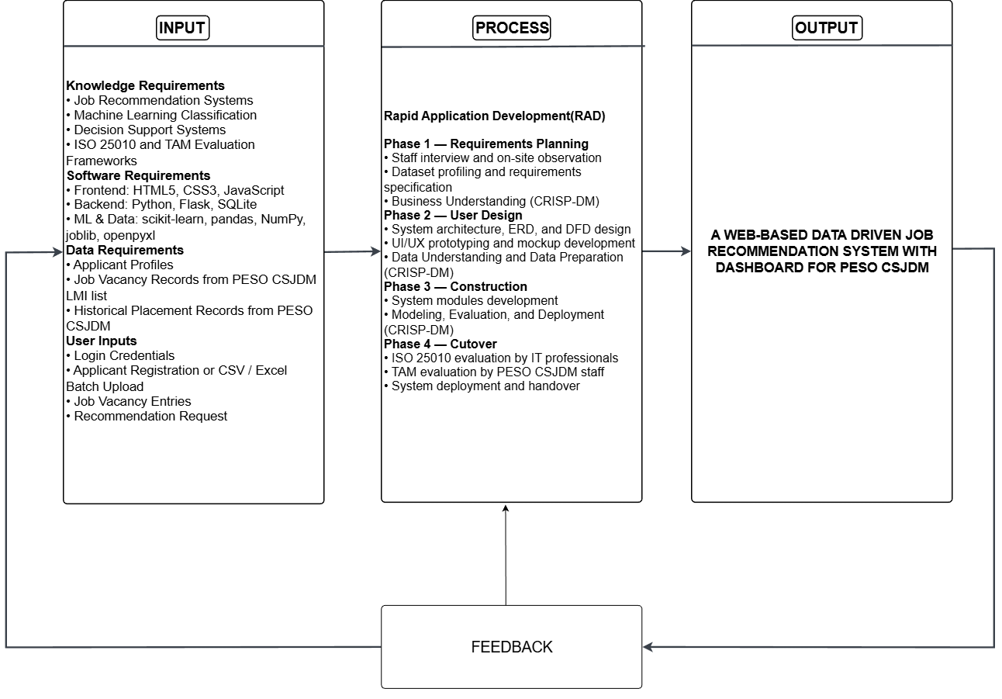
Conceptual Framework

Figure 1. Conceptual Framework
Figure 1 presents the conceptual framework of the study using the Input–Process–Output (IPO) model.
Input. The input column is organized into four sections. Knowledge Requirements cover the domain knowledge applied in the study: job recommendation systems, machine learning classification, decision support systems, and the ISO 25010 and TAM evaluation frameworks. Software Requirements list the technologies used to build the system: HTML5, CSS3, and JavaScript for the frontend; Python, Flask, and SQLite for the backend; and scikit-learn, pandas, NumPy, joblib, and openpyxl for machine learning and data handling. Data Requirements identify the three data sources the system depends on: applicant profiles, job vacancy records from the PESO CSJDM LMI list, and historical placement records from PESO CSJDM. User Inputs represent the actions PESO staff perform to interact with the system: login credentials to authenticate and access the system, applicant registration or CSV/Excel batch upload, job vacancy entries, and recommendation requests to trigger the classification pipeline for a selected applicant.
Process. The process column presents the four phases of Rapid Application Development (RAD), each paired with the corresponding CRISP-DM activities that govern the machine learning component. Phase 1 (Requirements Planning) covers staff interviews and on-site observation at PESO CSJDM, dataset profiling, and requirements specification, aligned with the Business Understanding phase of CRISP-DM. Phase 2 (User Design) covers system architecture, ERD, and DFD design alongside UI/UX prototyping reviewed with PESO staff, aligned with the Data Understanding and Data Preparation phases of CRISP-DM, in which the placement dataset is cleaned and prepared for modeling. Phase 3 (Construction) covers the development of all system modules integrated with the machine learning pipeline, aligned with the Modeling, Evaluation, and Deployment phases of CRISP-DM, in which the three classifiers are trained, compared by Macro F1-Score, and the best-performing model is serialized as a pre-trained model file for deployment. Phase 4 (Cutover) covers ISO/IEC 25010 evaluation by IT professionals, TAM evaluation by PESO CSJDM staff, and system deployment and handover.
Output. The framework produces two outputs for PESO CSJDM staff: Ranked Job Vacancies and the Analytical Dashboard.
Feedback. A feedback arrow connects the output back to the input, indicating that evaluation results, system usage, and newly accumulated placement data can be fed back into the input layer to support continuous improvement and periodic retraining of the machine learning model.
Development Methodology
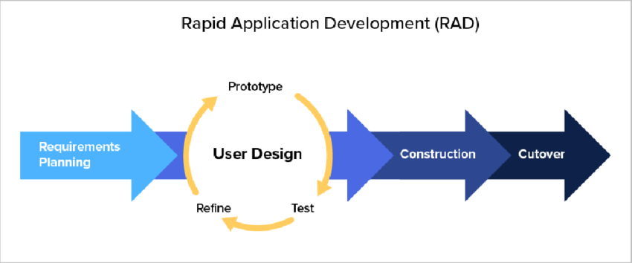
Two complementary frameworks were adopted: Rapid Application Development (RAD) for the web-based system, and CRISP-DM for the analytics component.

Figure 2. Rapid Application Development Model
Rapid Application Development (RAD). RAD is an iterative software development methodology centered on continuous user involvement through prototyping and feedback (Martin, 1991). RAD was selected over Waterfall and Agile because the system requires close, repeated consultation with PESO CSJDM staff: requirements are validated and refined after each prototype review before the next iteration is built, which fits an office whose workflows are best captured by showing working screens to the staff who use them, and because the fixed capstone timeframe favors RAD's compressed, prototype-driven cycles over Waterfall's sequential phase gates.
CRISP-DM. For the analytics component, CRISP-DM guided the development of the recommendation model. CRISP-DM is the standard, industry-independent process model for data mining and machine learning projects, consisting of six iterative phases: Business Understanding → Data Understanding → Data Preparation → Modeling → Evaluation → Deployment (Chapman et al., 2000; Schröer et al., 2021). These six phases map directly to how the Logistic Regression, Random Forest, and Naïve Bayes models were prepared, trained, evaluated, and deployed through the Flask application. The deployed model serves the Job Recommendation Module at inference time without requiring a separate training run.
Table 7 presents how the RAD and CRISP-DM phases were carried out in parallel.
Table 7. RAD and CRISP-DM Phase Alignment
Phase | RAD Activities | CRISP-DM Activities | Key Deliverable
1. Requirements Planning | Conduct interviews and on-site observation with PESO CSJDM staff; profile the historical placement dataset; define functional and non-functional requirements | Business Understanding: identify the referral decision problem, confirm data availability, define model performance goals | Requirements specification; Data Sharing Agreement
2. User Design | Design system architecture, DFDs, ERD, and high-fidelity mockups for all system modules; review prototypes with PESO CSJDM staff; refine per feedback | Data Understanding: examine dataset structure, field completeness, class distribution. Data Preparation: remove incomplete records, fill blank WORK EXPERIENCE entries with 'NO EXPERIENCE', consolidate sparsely represented job titles into occupational categories as the target label, split 80/20 stratified | Validated system design; cleaned dataset; selected feature set
3. Construction | Develop all system modules; integrate the ML pipeline with the Flask application for recommendation inference | Modeling: fit TF-IDF vectorizer on training partition only; train Logistic Regression, Random Forest, and Naïve Bayes on the resulting training vectors. Evaluation: evaluate all three algorithms on the held-out test set using Accuracy, Precision, Recall, and Macro/Weighted F1; select the model with the highest Macro F1. Deployment: serialize the best-performing pipeline with joblib; deploy to the Flask application for live recommendation requests | Working system; algorithm comparison results; deployed recommendation model
4. Cutover | Conduct ISO 25010 and TAM evaluations; apply corrections; prepare handover | — | Evaluated system; handover package

System Design
This section presents design diagrams that explain the overall structure and behavior of the system. Each diagram is numbered, labeled, and followed by an explanation.
Context Diagram
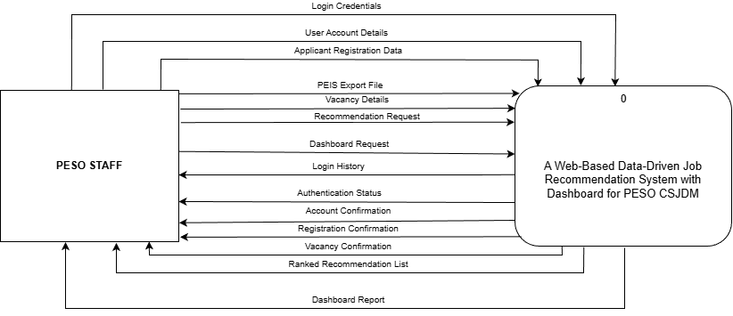
Figure 3. Context Diagram (Proposed)
Figure 3 presents the context diagram, which shows the whole system as a single process interacting with one external entity, PESO Staff. Staff supply seven inputs — login credentials, user account details, applicant registration data, PEIS export files, vacancy details, recommendation requests, and dashboard requests — and receive seven outputs — authentication status; account, registration, and vacancy confirmations; the ranked recommendation list; the dashboard; and login history for security audit. The machine learning model is trained offline by the research team before deployment, so staff never upload or retrain it; at runtime they simply submit a profile through a recommendation request and receive the ranked result. No external system connects to the system directly.
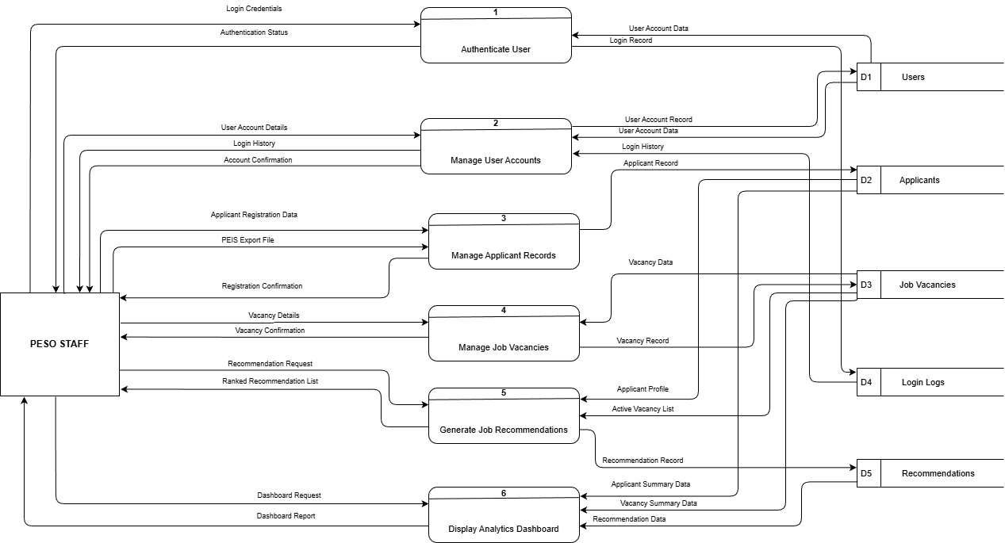
Data Flow Diagram Level 1

Figure 4. Data Flow Diagram Level 1
Figure 4 decomposes the system into six processes and five data stores, all accessed by the single external entity, PESO Staff. Process 1, Authenticate User, checks login credentials against the Users store (D1) and records every attempt in the Login Logs store (D4). Process 2, Manage User Accounts, maintains staff accounts in D1 and lets staff review login history from D4. Process 3, Manage Applicant Records, saves manually registered and PEIS-uploaded profiles to the Applicants store (D2). Process 4, Manage Job Vacancies, maintains vacancy records in the Job Vacancies store (D3). Process 5, Generate Job Recommendations, reads an applicant profile from D2 and the active vacancy list from D3, returns a ranked recommendation list to staff, and logs it to the Recommendations store (D5). Process 6, Display Analytics Dashboard, reads the Applicants, Job Vacancies, and Recommendations stores to produce the dashboard report.
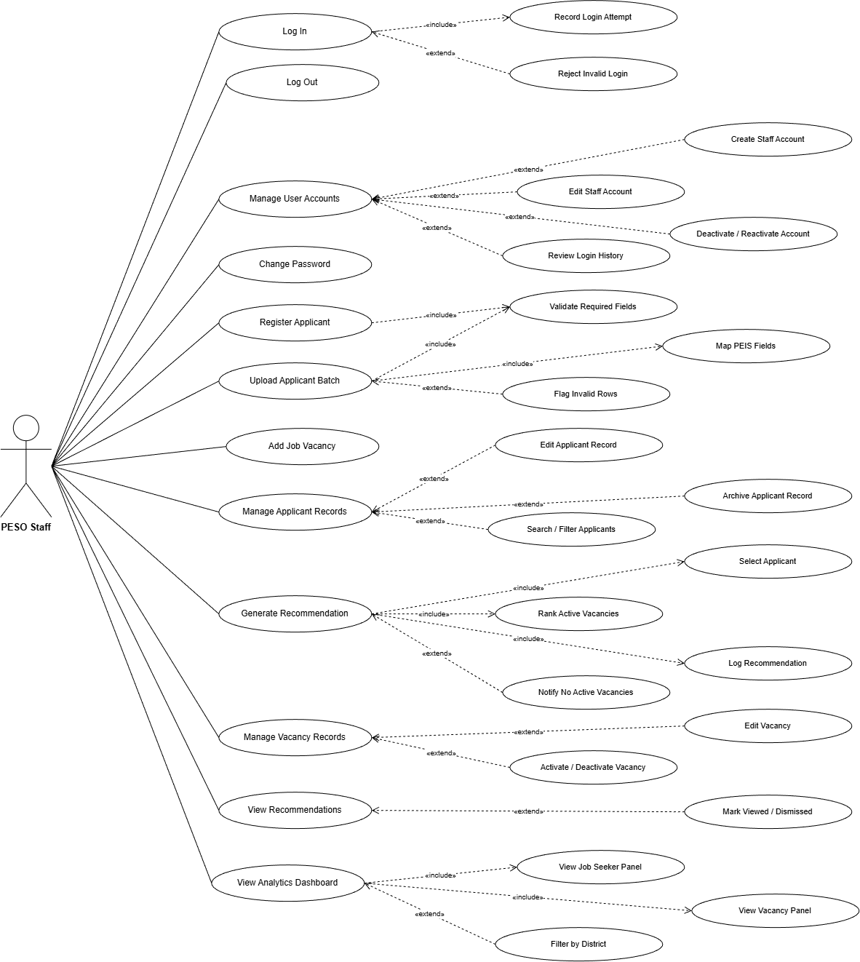
Use Case Diagram

Figure 5. Use Case Diagram
Figure 5 presents the use case diagram. The single actor, PESO Staff, interacts with twelve primary use cases, several of which are decomposed into finer sub-use-cases through UML «include» relationships, which denote mandatory sub-steps always performed as part of the base use case, and «extend» relationships, which denote optional or conditional actions.
Under access and account management, the primary use cases are Log In, Log Out, Manage User Accounts, and Change Password. Log In includes Record Login Attempt, since every attempt is written to the login log, and is extended by Reject Invalid Login when credentials fail. Manage User Accounts is extended by Create Staff Account, Edit Staff Account, Deactivate / Reactivate Account, and Review Login History, the last being the security audit of authentication events.
Under applicant management, the primary use cases are Register Applicant, Upload Applicant Batch, and Manage Applicant Records. Register Applicant and Upload Applicant Batch both include Validate Required Fields, which enforces the four machine-learning fields; Upload Applicant Batch additionally includes Map PEIS Fields and is extended by Flag Invalid Rows. Manage Applicant Records is extended by Edit Applicant Record, Archive Applicant Record, and Search / Filter Applicants.
Under vacancy management, the primary use cases are Add Job Vacancy and Manage Vacancy Records, the latter extended by Edit Vacancy and Activate / Deactivate Vacancy.
Under recommendation and analytics, the primary use cases are Generate Recommendation, View Recommendations, and View Analytics Dashboard. Generate Recommendation includes Select Applicant, Rank Active Vacancies, and Log Recommendation, and is extended by Notify No Active Vacancies when no active vacancy exists. View Recommendations is extended by Mark Viewed / Dismissed. View Analytics Dashboard includes View Job Seeker Panel and View Vacancy Panel and is extended by Filter by District. The recommendation model is pre-trained by the research team on verified historical placement records prior to deployment; model training is not a staff-facing function.
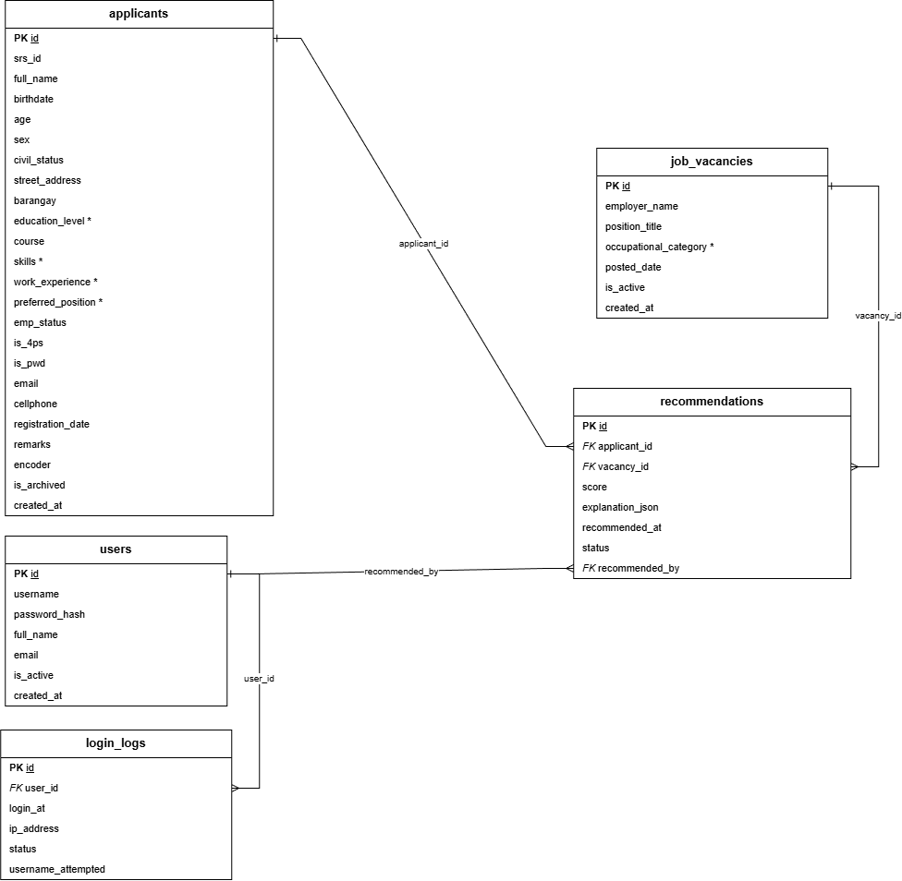
Entity Relationship Diagram (ERD)

Figure 6. Entity Relationship Diagram
Figure 6 presents the ERD. The database consists of five core tables, corresponding one-to-one with the five data stores in the Level 1 Data Flow Diagram. The users table stores staff account credentials, full name, email, and active status. The applicants table stores individual applicant profiles, including demographic attributes (sex, civil status, barangay) and the four ML input fields: skills, education level, work experience, and preferred position; a single applicant record is created regardless of the entry method used (manual encoding or CSV/Excel batch upload), so the two entry methods are input options that populate this one table rather than separate entities. The job_vacancies table stores employer name, position title, and occupational category for each active vacancy; the occupational category is the label the recommendation engine scores against when ranking vacancies for a selected applicant. The recommendations table is the persistent log of recommendation outputs. Each row represents one ranked vacancy result from a single recommendation run, identified by the applicant and vacancy foreign keys, together with the suitability score, the timestamp of the run, and the staff member who triggered it. The status field records whether the recommendation output was viewed or dismissed. Multiple rows sharing the same applicant_id and recommended_at timestamp represent the full ranked list produced in one recommendation session. The login_logs table maintains a security audit trail of authentication events by user, timestamp, IP address, and outcome.
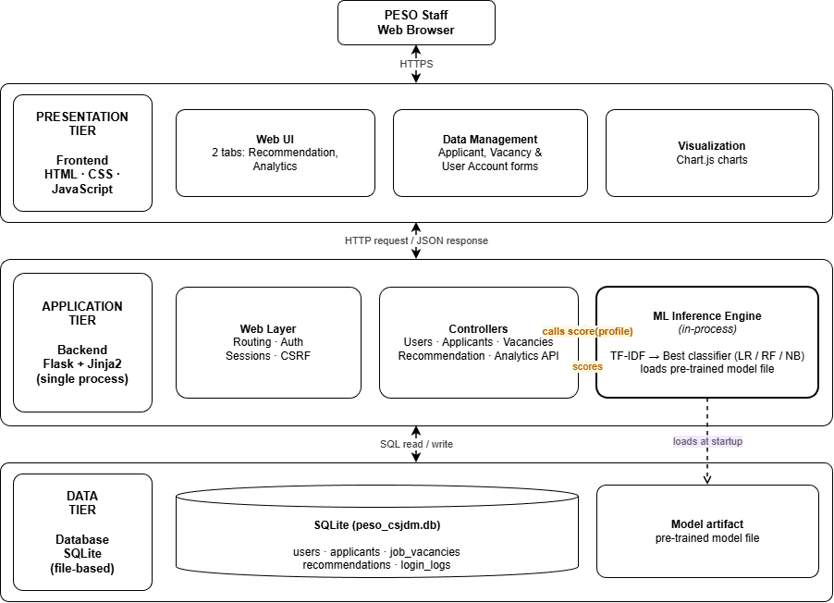
System Architecture Diagram

Figure 7. System Architecture Diagram
Figure 7 presents the three-tier architecture of the system. The frontend tier consists of the browser-rendered interface (Jinja2-templated HTML with Bootstrap styling and Chart.js visualizations) through which PESO staff carry out all workflows on desktop or mobile. The backend tier is a single Flask application handling routing, session management, business logic, and the machine learning inference: the trained pipeline (TF-IDF vectorizer and deployed classifier) is stored as a pre-trained model file and loaded into the Flask process at startup, called in-process whenever a recommendation request is made. The algorithm therefore lives inside the application rather than on a separate service. The database tier is a SQLite database file storing all five core tables, accessed exclusively through the backend.

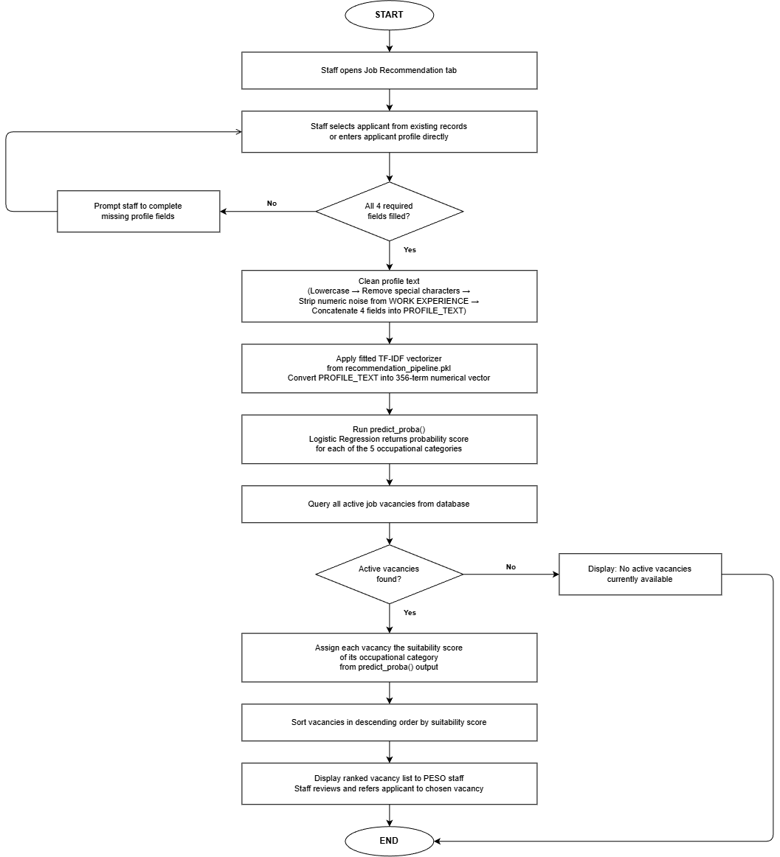
Flowcharts

Figure 8. System Process Flowchart
Figure 8 illustrates the system process for generating job recommendations for a specific applicant profile.
The process begins when PESO staff opens the Job Recommendation tab and selects an applicant from existing records or enters a new profile directly. Before proceeding, the system verifies that all four required fields are present: EDUC LEVEL, PREFERRED POSITION, SKILLS, and WORK EXPERIENCE. If any field is empty, the system prompts the staff to complete the missing information and the profile cannot proceed until all four fields are filled. All four fields are required because each contributes a distinct qualification signal — a profile with any missing field produces an incomplete text representation and an unreliable category score.
Once the profile is complete, the four fields are cleaned using the same text normalization applied during training: all text is lowercased, special characters are removed, numeric noise is stripped from the work experience field, and the four fields are concatenated into a single PROFILE_TEXT string. This cleaning step must exactly replicate the preprocessing applied during model training so that the vocabulary and term weights remain consistent between training and inference.
The cleaned PROFILE_TEXT is then passed through the fitted TF-IDF vectorizer loaded from the pre-trained model file, converting it into a 356-term numerical vector. The Logistic Regression classifier runs `predict_proba()` on that vector, returning a probability score for each of the five occupational categories. These scores represent the model's confidence that the applicant's profile belongs to each category based on patterns learned from the 1,083 preprocessed placement records.
The system then queries all currently active job vacancies from the database. If no active vacancies are found, the system notifies the staff and the process ends. When vacancies are present, each vacancy is assigned the suitability score of its occupational category from the `predict_proba()` output. The full list is sorted in descending order by suitability score and the top five ranked vacancies are displayed to PESO staff, who review them and decide which vacancy to refer the applicant to.
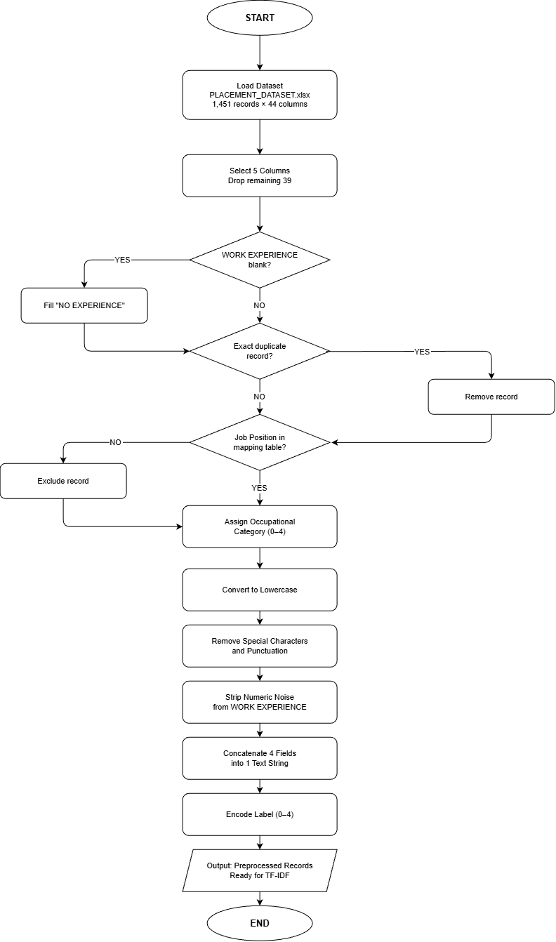
Figure 9. Data Pre-processing Flowchart
Figure 9 illustrates the data preprocessing pipeline applied to the PLACEMENT_DATASET.xlsx before TF-IDF vectorization.
The raw dataset contains 1,451 records across 44 columns. Only five columns are retained — EDUC LEVEL, PREFERRED POSITION, SKILLS, WORK EXPERIENCE, and Job Position — as these are the only fields relevant to job category classification. All remaining 39 administrative columns are dropped.
Each record is then checked for a blank WORK EXPERIENCE value. Blank entries are filled with "NO EXPERIENCE" to preserve the absence of work history as a meaningful value rather than an empty field. Records confirmed as exact duplicates across all five retained columns are removed and do not proceed further in the pipeline.
Each record's Job Position value is checked against a predefined mapping table. Records with unrecognizable job titles are excluded. Matched records are assigned to one of five occupational categories — Warehouse and Logistics, Production and Manufacturing, Sales/Service/Retail, Clerical and Administrative, and General Services and Security — because the raw Job Position column contains 88 unique titles, many appearing only once or twice, which is insufficient for reliable classifier training.
Text normalization is applied in three steps. All text is converted to lowercase. Special characters and punctuation are removed from all fields. Numeric noise is stripped specifically from WORK EXPERIENCE — entries such as "5 mos as CASHIER" are cleaned to retain only the role term "cashier."
The four normalized fields are then concatenated into a single text string per record so that all profile information contributes to one unified vector. Finally, the five category labels are encoded as integers zero through four, preparing the target column for classifier input. The preprocessed records are then ready for TF-IDF vectorization.
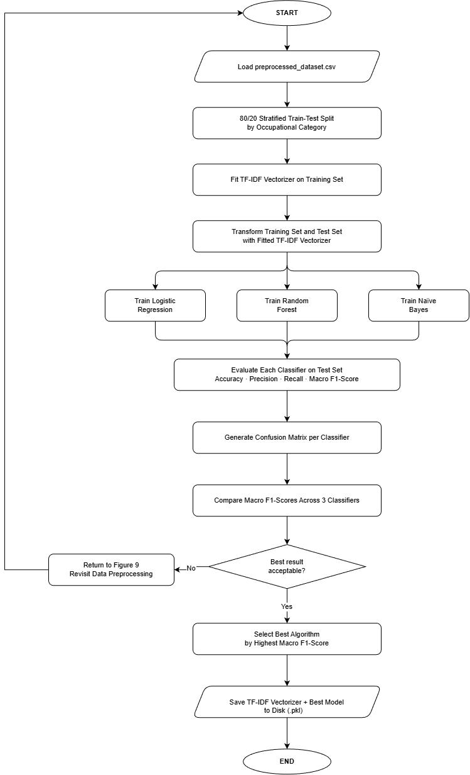
Figure 10. ML Algorithm Flowchart
Figure 10 illustrates the ML algorithm training pipeline that receives the 1,083 preprocessed records from Figure 9 and produces the trained model used by the job recommendation module.
The pipeline begins by splitting the dataset into a training set of 866 records (80%) and a test set of 217 records (20%) using stratified sampling by occupational category. Stratification ensures that each of the five categories appears in both partitions at the same proportion as the full dataset, so no category ends up underrepresented in either set. The split is performed before any vectorization to prevent data leakage — fitting TF-IDF on the full dataset first would allow IDF weights to be influenced by test records, producing performance scores that would not reflect true generalization.
TF-IDF vectorization is then fitted exclusively on the 866 training records, converting each applicant profile text into a weighted numerical vector. The same fitted vectorizer — with its fixed vocabulary and IDF weights — is then applied to the test set. This ensures the test set is treated as genuinely unseen data throughout the training phase.
The 866 training vectors are passed to three classifiers trained independently under identical conditions: Logistic Regression, Random Forest, and Naïve Bayes. All three train on identical data so that any difference in results is attributable to the algorithm alone. After training, each classifier is evaluated on the held-out test set and their Macro F1-Scores are compared. The full evaluation results and per-classifier breakdown are presented in Chapter IV. The classifier with the highest Macro F1-Score is selected and saved together with the fitted TF-IDF vectorizer as a pre-trained model file — the single artifact the Flask application loads at startup to serve job recommendations.
Mockups
Figure 11. Login Page
Figure 12. Job Recommendation Tab
Figure 13. Analytical Dashboard Tab
Figure 14. Applicant Registration Form
Figure 15. Job Vacancy Management
Tools, Technologies, and Development Environment
Table 8 lists the tools and technologies that will be used to develop the system. All tools are open-source or freely available, chosen to keep the system maintainable within a local government setting without licensing costs.
Table 8. Tools, Technologies, and Development Environment
Category | Tool / Technology | Version | Justification
Frontend | HTML5, CSS3, JavaScript | HTML5 / CSS3 / ES2015 | Standard web markup, styling, and scripting languages for building structured, accessible, and interactive system pages; all frontend output will be rendered through Jinja2 templates served by Flask
Frontend | Bootstrap (via CoreUI 5) | 5.3 | Open-source Bootstrap-based CSS framework providing pre-built, mobile-responsive UI components; will ensure consistent layout across desktop and mobile browsers without custom component development
Backend | Python | 3.14.2 | Single language for both the web application and machine learning pipeline; routing, business logic, session management, and ML inference will all run within one Flask process
Backend | Flask | 3.0 | Lightweight Python micro-framework for routing, Jinja2 templating, and session management; Werkzeug utilities bundled with Flask will handle password hashing and secure file uploads
Backend | Flask-WTF | 1.2 | Will provide CSRF token validation on all POST forms, protecting applicant and vacancy data against cross-site request forgery attacks
Database | SQLite | 3.46 | Serverless, file-based relational database bundled with Python; will store all five system tables in a single database file deployed alongside the application without requiring a separate database server
Python / ML Libraries | scikit-learn | 1.4 | Will provide TfidfVectorizer, LogisticRegression, RandomForestClassifier, MultinomialNB, and Pipeline for constructing and comparing the three classification models; NumPy (1.26) is included as a required numerical dependency
Python / ML Libraries | pandas | 2.2 | Will handle .xlsx file reading for PEIS-exported batch uploads and all CRISP-DM Data Preparation steps including duplicate removal and missing value handling
Python / ML Libraries | openpyxl | 3.1 | Excel reading engine for .xlsx files required for both training dataset ingestion and applicant batch upload processing
Model Serving | joblib | 1.4 | Will serialize the trained TF-IDF vectorizer and best-performing classifier into a pre-trained model file; the Flask application will reload this artifact at startup for live inference without retraining
Jupyter Notebook | Python Script (.py) | 3.14.2 | ML training, preprocessing, and model evaluation will be implemented as standalone Python scripts executed directly through the Visual Studio Code terminal; all CRISP-DM Modeling and Evaluation steps will be performed via the Python interpreter without a notebook interface
Data Visualization | Chart.js | 4.4 | Lightweight open-source charting library that will render all Analytical Dashboard charts; chart data will be fetched asynchronously from the Flask JSON API endpoint
Version Control | Git | 2.47 | Will track code changes and coordinate development across the five-member research team throughout all RAD phases
IDE / Code Editor | Visual Studio Code | 1.96 | Free, extensible editor with integrated terminal and Python/JavaScript extensions; will serve as the primary development environment for all team members
UI/UX Design | Figma | Web-based | Will be used to design high-fidelity mockups of all system screens prior to implementation, including the Job Recommendation tab, Analytical Dashboard, and applicant registration form
Diagram Tools | draw.io | Web-based | Will be used to create all system design diagrams including the context diagram, DFD, use case diagram, ERD, system architecture diagram, and flowcharts
Deployment | PythonAnywhere | Free tier | Free-tier cloud hosting for Flask applications; will provide always-on deployment without requiring separate server configuration or infrastructure costs

Development environment. Development will be carried out on Windows 10/11 machines using the Flask built-in development server for local testing, with application and ML dependencies isolated in a Python virtual environment.
Development Cost
Table 9 presents the estimated breakdown of the cost of building the system.
Table 9. Development Cost
Category | Details | Estimated Cost
Human Resource | 5 members × 300 hours each × ₱75/hour | ₱112,500.00
Software & Licensing | All tools open-source or freely available | ₱0.00
Hardware | Laptop depreciation: 5 units × ₱30,000 ÷ 3-year lifespan ÷ 12 months × 6 months | ₱25,000.00
Dataset Acquisition | Provided at no cost under Data Sharing Agreement | ₱0.00
Cloud Computing | None; all training performed on local hardware | ₱0.00
Internet & Utilities | ₱500/month × 5 members × 6 months | ₱15,000.00
Documentation & Printing | Manuscript, binding, evaluation instruments | ₱3,000.00
Transportation | Trips to PESO CSJDM for interviews, observation, evaluation | ₱2,000.00
Subtotal |  | ₱157,500.00
Contingency (10%) | Unforeseen expenses | ₱15,750.00
TOTAL |  | ₱173,250.00

The total estimated development cost of ₱173,250.00 is low primarily because all software tools used in this study are free and open-source, no paid dataset was required, and the system is trained and deployed on existing hardware rather than paid cloud infrastructure. The largest component is human resource, reflecting the combined development effort of the five-member research team over the six-month project period.
Evaluation Methods
This section describes how the system will be evaluated following implementation. The objective of the evaluation is to assess the technical quality of the system and its acceptability to users. Two established evaluation models will be used: the ISO/IEC 25010 Software Product Quality Model and the Technology Acceptance Model (TAM).
Evaluation Using ISO/IEC 25010
Purpose. ISO/IEC 25010 will be used to assess the technical quality of the developed system against an international software product quality standard, following the precedent of Philippine government and institutional systems evaluated under the same model (Canlas et al., 2021; Lagman et al., 2025).
Quality characteristics. The system will be evaluated across seven characteristics, each defined here in terms of the present system:
1. Functional Suitability evaluates whether the system accurately and completely delivers its specified functions: applicant and vacancy management, job recommendation with suitability ranking, and dashboard reporting. This characteristic also serves as the formal verification of Objective 1's functional requirements (FR-01 to FR-06).
2. Performance Efficiency covers the speed of generating recommendation outputs, loading applicant data, and handling daily use without degradation.
3. Usability covers clarity of the interface, ease of navigation across the two-tab analytics structure, and overall user experience for referral workflows.
4. Reliability evaluates whether the system consistently generates stable outputs and maintains uninterrupted operation under continuous daily use.
5. Security covers protection of applicant personal information, credentials, and recommendation records through authentication and access control.
6. Maintainability covers ease of updating the ML model, modifying features, and maintaining the database schema.
7. Portability evaluates whether the system operates across different browsers and devices without loss of function.
Evaluators. A minimum of three (3) IT professionals with expertise in web development, database management, or machine learning systems will be invited as evaluators, selected through purposive sampling.
Instrument. A structured evaluation form based on the seven ISO 25010 characteristics will be prepared, with each item rated on a 5-point Likert scale (5 = Strongly Agree to 1 = Strongly Disagree).
Process overview. The system will be deployed and made accessible to the evaluators with test accounts and guided scenarios covering all modules. Each evaluator will interact with the system and complete the instrument; responses will be tabulated and analyzed in Chapter IV.
Evaluation Using the Technology Acceptance Model (TAM)
Purpose. TAM will be used to measure user perceptions of usefulness, ease of use, and intention to adopt the system, following its validated application to web-based systems in public service contexts (Alsyouf et al., 2023).
TAM constructs. Because this is a Data and Business Analytics capstone, the questionnaire items explicitly reference the analytics features:
1. Perceived Usefulness (PU) assesses whether the system helps staff do their job better. Sample items: The ranked job recommendations help me identify suitable vacancies for applicants more efficiently than my current process; The Analytical Dashboard gives me a clearer picture of applicant and vacancy trends than my current process.
2. Perceived Ease of Use (PEOU) assesses whether the interface is clear and navigable, the two-tab analytics structure intuitive, and data entry and result review achievable without advanced technical skill.
3. Behavioral Intention to Use (BIU) assesses whether staff are willing to use the system regularly and intend to integrate both tabs into daily operations.
Respondents. Twenty-seven (27) PESO CSJDM staff members who directly manage applicant data and referral operations, a number within the guideline range of 15 to 30 end-users, will be selected through purposive sampling to ensure respondents have first-hand experience with the workflows the system supports.
Instrument. A TAM-based questionnaire aligned to the three constructs will be used, rated on the same 5-point Likert scale. Each respondent will receive a guided walkthrough covering the core workflows (registering or selecting an applicant, generating a ranked recommendation, and navigating the dashboard) before independently answering the questionnaire.
Data Handling and Analysis
A. Respondents and Population Description
The total evaluation population is thirty (30) respondents, broken down into two evaluator groups selected through purposive sampling. Table 10 summarizes the respondent groups.
Table 10. Respondent Groups
Respondent Group | Evaluation Framework | Sampling Method | n
PESO CSJDM staff (end-user respondents who directly manage applicant data and referral operations) | TAM | Purposive | 27
IT professionals (web development, database management, or ML systems expertise) | ISO/IEC 25010 | Purposive | 3
Total |  |  | 30

B. Data Analysis
Responses from both evaluator groups will be collected using a 5-point Likert scale: 5 – Strongly Agree, 4 – Agree, 3 – Neutral, 2 – Disagree, 1 – Strongly Disagree. Responses will be interpreted using the conversion scale in Table 11.
Table 11. Likert Scale Conversion
Rating Range | Interpretation
4.51 – 5.00 | Highly Acceptable
3.51 – 4.50 | Acceptable
2.51 – 3.50 | Moderately Acceptable
1.51 – 2.50 | Slightly Acceptable
1.00 – 1.50 | Not Acceptable

For this system, a mean of 4.51–5.00 (Highly Acceptable) indicates that the evaluated characteristic (for example, the accuracy of the recommendation workflow or the clarity of the two-tab interface) fully meets the criterion with no significant areas for improvement. A mean of 3.51–4.50 (Acceptable) indicates the criterion is satisfied with only minor refinements needed. A mean of 2.51–3.50 (Moderately Acceptable) indicates the system partially satisfies the criterion and requires targeted improvement before regular operational use at PESO CSJDM. A mean of 1.51–2.50 (Slightly Acceptable) indicates substantial revision is required, and 1.00–1.50 (Not Acceptable) indicates the criterion is not met and fundamental redesign is needed. Consistent with Objective 3, the study's target threshold for each evaluation dimension is a weighted mean of at least 3.51 ("Acceptable").
C. Statistical Treatment of Data
The Arithmetic Mean (AM) will be used to summarize Likert-scale responses:
AM = Σ(wᵢfᵢ) / n
Where:
• AM = Arithmetic Mean
• wᵢ = Likert scale weight (5, 4, 3, 2, 1)
• fᵢ = Frequency of responses for each weight
• n = Total number of respondents
AM will be computed per questionnaire item, per ISO/IEC 25010 quality characteristic, per TAM construct, and for the overall score of each instrument.
D. Statistical Tools Used
Frequency is used to count how many respondents chose each rating per item.
Percentage is used to express the proportion of responses per rating:
P = (F × 100) / N
Where: P = Percentage, F = Frequency of a particular rating, N = Total respondents.
Weighted Mean corresponds directly to the Arithmetic Mean formula above and is the main tool for interpreting the evaluation results in Chapter IV.
E. Algorithm Performance Metrics
The performance of the embedded algorithm will be evaluated independently from the system quality assessment conducted under ISO/IEC 25010 and the user acceptance evaluation conducted under TAM. Those two evaluations measure the quality and acceptability of the web-based system as a whole, while the algorithm performance evaluation specifically measures how accurately and reliably the classification model assigns applicant profiles to occupational categories. Because the system's algorithm is classification-based, the metrics reported are Accuracy, Precision, Recall, F1-Score, and Macro F1-Score, together with a per-class confusion matrix; regression and clustering metrics do not apply. The algorithm performance results apply to the Job Recommendation Module, which is the sole analytics module powered by the trained model.
Validation technique. A stratified holdout validation approach will be used. The 1,083 preprocessed placement records will be partitioned 80/20 into a training set (866 records) and a held-out test set (217 records), with stratified sampling applied so that each occupational category's proportion is preserved in both partitions. Stratification is necessary because the five categories are not evenly distributed: Sales/Service/Retail holds 317 records (29.3%), Production and Manufacturing holds 292 (27.0%), Warehouse and Logistics holds 175 (16.2%), Clerical and Administrative holds 149 (13.8%), and General Services and Security holds 150 (13.9%). Without stratification, the smaller categories may be underrepresented in the test partition, producing unreliable class-level performance estimates. The 80/20 proportion follows the convention applied in the supervised classification studies reviewed in Chapter II (Chihab et al., 2025; Adillah et al., 2026; Darma et al., 2026). All three candidate algorithms, Logistic Regression, Random Forest, and Naïve Bayes, will be trained on the identical training partition and evaluated on the identical test partition so that performance differences are attributable to the algorithm and not to data variation.
Performance metrics. Table 12 presents the classification metrics used to evaluate all three algorithms, their formulas, and their purpose in the context of the PESO job recommendation model.
Table 12. Classification Performance Metrics
Metric | Formula | Purpose
Accuracy | (TP + TN) / (TP + TN + FP + FN) | Overall proportion of correct category classifications across all 5 categories
Precision | TP / (TP + FP) | Proportion of recommended categories that are actually suitable
Recall | TP / (TP + FN) | Proportion of suitable categories the model successfully identifies
F1-Score | 2 × (Precision × Recall) / (Precision + Recall) | Harmonic mean of Precision and Recall, balancing both error types per class
Macro F1-Score | (1/k) × Σ F1ᵢ, where k = 5 | Unweighted average of per-class F1, giving all 5 categories equal importance

Where: TP (True Positive) = a job category correctly identified as a suitable match for the applicant's profile; TN (True Negative) = a category correctly identified as not suitable; FP (False Positive) = an unsuitable category incorrectly recommended; FN (False Negative) = a suitable category the model failed to identify. Precision, Recall, and F1-Score are computed separately for each of the five occupational categories and reported as both macro averages, where each category contributes equally to the final score, and weighted averages, where each category is weighted by its share of the test partition.
Selection criterion. The algorithm with the highest Macro F1-Score on the held-out test set will be selected for deployment. Macro F1 is used as the selection criterion rather than Accuracy because the five occupational categories differ in size — Sales/Service/Retail holds 317 records (29.3%) while Clerical and Administrative holds 149 (13.8%) and General Services and Security holds 150 (13.9%). Under an accuracy-only criterion, an algorithm that performs well on the three larger categories while failing on the two smaller ones would still record a deceptively high overall score, masking its inability to correctly recommend clerical or security positions to applicants in those groups. Macro F1 computes the F1-Score for each category separately and averages them with equal weight regardless of how many records each category holds, so failure on the 149-record Clerical category penalizes the score as severely as failure on the 317-record Sales category. The three supervised classification studies reviewed in Chapter II, Chihab et al. (2025), Adillah et al. (2026), and Tiwari and Upadhyay (2024), all selected their best algorithm using accuracy only without addressing class size differences in their evaluation criterion. The present study applies Macro F1 to correct this gap (Opitz, 2024; Grandini et al., 2020).
Confusion matrix. A 5×5 confusion matrix will be generated for each of the three algorithms after evaluation on the held-out test partition. The rows represent the five actual occupational categories and the columns represent the five categories assigned by the model, producing one cell per actual-predicted category pair. Cells on the main diagonal represent correct classifications for each category, while off-diagonal cells represent misclassifications showing which category the model confused with which. The matrix enables a precise diagnosis of where each algorithm succeeds and where it fails across all five occupational groups, beyond what aggregate metrics reveal.
The complete algorithm performance results, including the classification metrics comparison for Logistic Regression, Random Forest, and Naïve Bayes and the 5×5 confusion matrix for each algorithm, are presented and interpreted in Chapter IV.

REFERENCES
Adillah, M. F. N., Suakanto, S., & Utama, N. I. (2026). Evaluating civil servant selection through machine learning analysis of national insight, general intelligence, and personal characteristics test scores. Advance Sustainable Science Engineering and Technology, 8(2). https://doi.org/10.26877/asset.v8i2.2300
Alsyouf, A., Lutfi, A., Alsubahi, N., Alhazmi, F. N., Al-Mugheed, K., Anshasi, R. J., Alharbi, N. I., & Albugami, M. (2023). The use of a Technology Acceptance Model (TAM) to predict patients' usage of a personal health record system: The role of security, privacy, and usability. International Journal of Environmental Research and Public Health, 20(2), Article 1347. https://doi.org/10.3390/ijerph20021347
Bachita, E. B., & Bayoneta, M. J. A. R. (2021). Implementation of public employment services in a Philippine local government unit. Philippine Social Science Journal, 4(3), 133–144. https://doi.org/10.52006/main.v4i3.412
Bächli, M., Lalive, R., & Pellizzari, M. (2025). Helping jobseekers with recommendations based on skill profiles or past experience: Evidence from a randomized intervention (IZA Discussion Paper No. 17713). IZA – Institute of Labor Economics. https://www.iza.org/publications/dp/17713/helping-jobseekers-with-recommendations-based-on-skill-profiles-or-past-experience-evidence-from-a-randomized-intervention
Belot, M., de Koning, B. K., Fouarge, D., Kircher, P., Muller, P., & Phlippen, S. (2025). Advising job seekers in occupations with poor prospects: A field experiment (NBER Working Paper No. 33819). National Bureau of Economic Research. https://www.nber.org/papers/w33819
Beręsewicz, M., Wydmuch, M., Cherniaiev, H., & Pater, R. (2024). Multilingual hierarchical classification of job advertisements for job vacancy statistics (arXiv:2411.03779). arXiv. https://arxiv.org/abs/2411.03779
Betrand, C. U., Aliche, O. B., Onukwugha, C. G., Ofoegbu, C. I., Kelechi, D. A., Ugbor, I. C., & Oragba, N. M. (2025). Career guidance system using Decision Tree, Random Forest, and Naïve Bayes algorithm. International Journal of Science, Technology and Society, 13(2), 35–42. https://doi.org/10.11648/j.ijsts.20251302.11
Canlas, R. B., Piad, K. C., & Lagman, A. C. (2021). An ISO/IEC 25010 based software quality assessment of a faculty research productivity monitoring and prediction system. In Proceedings of the 2021 9th International Conference on Information Technology: IoT and Smart City (pp. 1–8). ACM. https://doi.org/10.1145/3512576.3512619
Chapman, P., Clinton, J., Kerber, R., Khabaza, T., Reinartz, T., Shearer, C., & Wirth, R. (2000). CRISP-DM 1.0: Step-by-step data mining guide. SPSS Inc.
Chihab, M., Boussatta, H., Chiny, M., Mabrouk, N., Chihab, Y., & Hadi, M. Y. (2025). AI-driven professional profile categorization and recommendation system. International Journal of Advanced Computer Science and Applications, 16(11). https://doi.org/10.14569/IJACSA.2025.0161140
Darma, S., Sarif, M. I., Alfayed, A. J., Syahdewa, A., & Tyas, K. (2026). IT career navigation: Performance evaluation of KNN and Naïve Bayes in career path recommendations for computer science students (Case study: Battuta University). Journal of Science and Social Research, 9(2), 2838–2847. https://doi.org/10.54314/jssr.v9i2.6269
Ertuğrul, D. Ç., & Bitirim, S. (2025). Job recommender systems: a systematic literature review, applications, open issues, and challenges. Journal of Big Data, 12, 140. https://doi.org/10.1186/s40537-025-01173-y
Grandini, M., Bagli, E., & Visani, G. (2020). Metrics for multi-class classification: An overview (arXiv:2008.05756). arXiv. https://arxiv.org/abs/2008.05756
Heakl, A., Mohamed, Y., Mohamed, N., Elsharkawy, A., & Zaky, A. (2024). ResuméAtlas: Revisiting resume classification with large-scale datasets and large language models (arXiv:2406.18125). arXiv. https://arxiv.org/abs/2406.18125
Kumar, D., Grosz, T., Rekabsaz, N., Greif, E., & Schedl, M. (2023). Fairness of recommender systems in the recruitment domain: An analysis from technical and legal perspectives. Frontiers in Big Data, 6, Article 1245198. https://doi.org/10.3389/fdata.2023.1245198
Kumar, N., Gupta, M., Sharma, D., & Ofori, I. (2022). Technical job recommendation system using APIs and web crawling. Computational Intelligence and Neuroscience, 2022, Article 7797548. https://doi.org/10.1155/2022/7797548
Lagman, A. C., Ramirez, I. C. R., Esteban, A. P., Rivera, R. P. L., Santos, R. D., & Juliano, J. J. (2025). Development and evaluation of an enterprise-level information system for digital governance in Philippine SUCs using Agile software methodology and ISO/IEC 25010 software quality model. 2024 IEEE 16th International Conference on Humanoid, Nanotechnology, Information Technology, Communication and Control, Environment, and Management (HNICEM), 1–6. https://doi.org/10.1109/hnicem64917.2024.11258693
Martin, J. (1991). Rapid application development. Macmillan Publishing.
Najjar, A., Amro, B., & Macedo, M. (2021). An intelligent decision support system for recruitment: Resumes screening and applicants ranking. Informatica, 45(4), 617–623. https://doi.org/10.31449/inf.v45i4.3356
Opitz, J. (2024). A closer look at classification evaluation metrics and a critical reflection of common evaluation practice (arXiv:2404.16958). arXiv. https://arxiv.org/abs/2404.16958
Qin, C., Zhang, L., Cheng, Y., Zha, R., Shen, D., Zhang, Q., Chen, X., Sun, Y., Zhu, C., Zhu, H., & Xiong, H. (2023). A comprehensive survey of artificial intelligence techniques for talent analytics (arXiv:2307.03195). arXiv. https://arxiv.org/abs/2307.03195
Republic Act No. 8759. (1999). An Act Institutionalizing a National Facilitation Service Network through the Establishment of a Public Employment Service Office in All Capital Towns of Provinces, Key Cities and Other Strategic Areas (Public Employment Service Office Act of 1999). Official Gazette of the Republic of the Philippines. https://www.officialgazette.gov.ph/2000/02/14/republic-act-no-8759/
Sacchi, S., & Scarano, G. (2025). Digital transformation of public employment services in the post-pandemic era. Evidence from Italy as a latecomer country. Australian Journal of Social Issues, 60(2), 456–472. https://doi.org/10.1002/ajs4.385
Sankarasetty, S., Kakaraparti, S., Saiful Haq, M., & Jonnalagadda, S. K. (2023). A comparative study on job recommendation using classification algorithms. In Proceedings of the 7th International Conference on Computing Methodologies and Communication (ICCMC 2023). IEEE. https://doi.org/10.1109/ICCMC56507.2023.10083728
Schröer, C., Kruse, F., & Gómez, J. M. (2021). A systematic literature review on applying CRISP-DM process model. Procedia Computer Science, 181, 526–534. https://doi.org/10.1016/j.procs.2021.01.199
Srihari, R., Adarsha, B. V., Hussain, M. U., & Singh, S. (2025). JobSphere: An AI-powered multilingual career copilot for government employment platforms (arXiv:2511.08343). arXiv. https://arxiv.org/abs/2511.08343
Tiwari, R., & Upadhyay, V. (2024). Applying convolutional neural networks (CNN) to job recommendation systems. International Journal of Science, Engineering and Technology, 12(5). https://www.ijset.in/wp-content/uploads/IJSET_V12_issue5_758.pdf
Winardi, S., Megawan, S., Wong, N. P., Kurniawan, R., Putra, F. A., & Cynthia, C. (2025). Utilizing TF-IDF content-based filtering for job recommendation systems. Journal Numerik, 8(5). https://doi.org/10.32672/jnkti.v8i5.9686
Yu, X., Zhang, J., & Yu, Z. (2024). ConFit: Improving resume-job matching using data augmentation and contrastive learning. In Proceedings of the 18th ACM Conference on Recommender Systems (RecSys '24). ACM. https://doi.org/10.1145/3640457.3688108

