Create a doc file containing the following information and diagrams
1. List of technologies and design patterns used
2. An overall activity or sequence diagram
3. An overall layer or component interaction diagram

Technologies used

Laravel Framework 5.4
Laravel DOM-PDF Library
RSS XML Writer (PHP Library)

Design patterns

Facade
Factory

Database Diagram

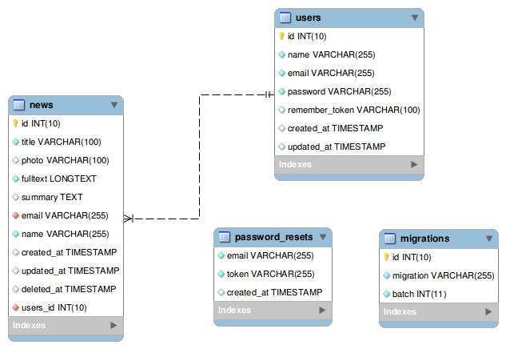

Sequence Diagram

Classes used

News
index()
dashboard()
saveNews($data)
show($id)
remove($data)
toPDF($id)

rss
index()

