
November 2023

Baud Rate Generator

FEATURES
- Baud Rate Configuration: Allows customization of data transmission speed.
- Clock Source Options: Offers flexibility in clock synchronization.
- Precision and Accuracy: Ensures reliable and stable data communication.
- Output Signal Formats: Supports various serial communication standards.
- Programmability: Adaptable to different communication protocols and devices.
- Error Handling: Provides mechanisms for error detection and correction in data transmission.

APPLICATIONS
- Serial communication interfaces (e.g., UART)
- Industrial automation and control systems
- IoT devices and sensors.

GENERAL DESCRIPTION

Baud rate generators are essential components in digital communication systems, responsible for setting the data transmission speed. They find widespread application in serial interfaces like UART, ensuring precise and accurate data transfer. Additionally, they play a crucial role in industrial automation, enabling control systems to communicate effectively, and are integral to IoT devices and sensors, facilitating efficient data exchange in the Internet of Things ecosystem
SYMBOL

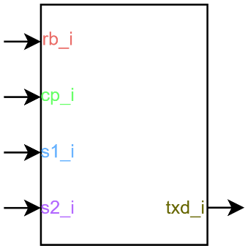

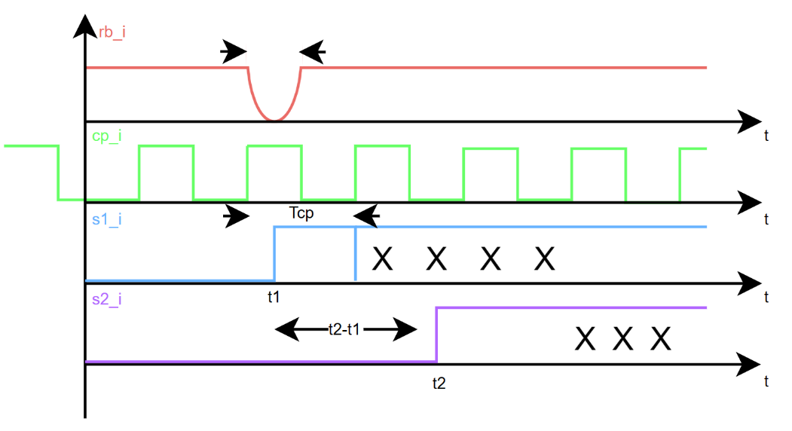

TIMING DIAGRAM

