CHAPTER 01:

**Internet:** The Internet is a network of computers communicating with each other.

**Reasons for Internet Growth in the 90s:**

* Development of the world wide web.
* Personal computers have become more available and affordable.
* Online service providers offered low-cost connections.

The World Wide Web is the graphical user interface to information stored on web servers connected throughout the Internet.

Q. What’s the difference between the Internet and the World Wide Web?

A. The WWW uses the Internet. The web uses the Internet to communicate between a client computer and a web server using HTML and the HTTP protocol.

**Who Owns the Internet:** There is no one in charge of the Internet, but some organizations are coordinating some aspects of it. E.g., the Internet Engineering Task Force (IEFT) for Internet protocol standard notification, Internet Architecture Board (IAB) and others.

**Intranet:** Private network used inside an organization to share information between people.

**Extranet:** Private network to share data between organizations. E.g., VPNs.

**W3C:** World Wide Web Consortium develop recommendations and prototype technologies related to the web.

**Ethics:** Americans with Disabilities Act (ADA) prohibits any kind of discrimination against people with disabilities. The Web Accessibility Initiative (WAI) is a great part of the W3C and is responsible for this.

**Universal Design for the Web:** Essential to keep the system robust and usable to the greatest extent possible of people. This would avoid unnecessary specialization and adaptations.

**Internet Backbone:** It is the infrastructure of a set of paths that local or regional networks connect to for long-distance interconnection.

**Network:**

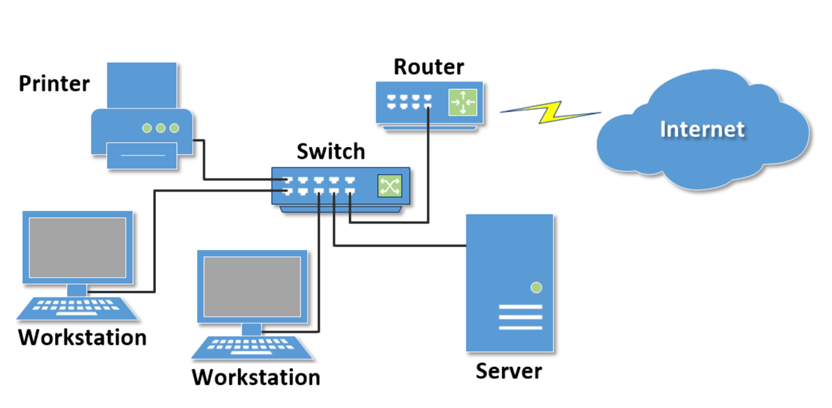

**The Client-Server Model:**

Client-Server architecture is a model where a client sends a request for resources to a server. When the server receives the request, it will send back the files to the client over the network.

Suggested flow for the web:

1. The browser (client) makes an HTTP request to access an URL.
2. The ISP (Internet Service Provider) asks the DNS (Domain Name Service) for the IP address.
3. The DNS checks the IP address relative to the URL, and sends it to the ISP, and the ISP send it to the browser.
4. The browser sends an HTTP request to the server.
5. The server processes the client request, gather the resources and send it back to the client.

**Web Client vs. Web Server:**

WC. Connected to the Internet when needed.

WS. It is continuously connected to the Internet.

WC. Uses HTTP.

WS. Uses HTTP.

WC. Request web pages from a server.

WS. Receives requests for web pages.

WC. Receives web pages and files from a server.

WS. Respond to a client request with a status code, the web page and files.

The web exchanges occur through the MIME type. MIME stands for Multi-Purpose Internet Mail Extensions. The MIME is a set of rules to exchange multimedia documents amongst computers on the web.

**Internet Protocols:**

* **FTP:** File Transfer Protocol is used to move files between computers on the Internet. Developers use it to send files to a web server or to retrieve from it.
* **Email:** to send email Simple Mail Transfer Protocol (SMTP), and to receive it can be Post Office Protocol (POP3) or Internet Mail Access Protocol (IMAP)
* **HTTP:** Hypertext Transfer Protocol for exchange file on the web.
* **TCP:** Transmission Control Protocol ensures the integrity of the data, breaking it into packets. The TCP is connection-oriented; in other words, it tries to guarantees that the data will arrive at the other end.
* **IP:** The Internet Protocol defines how the computer sends the packets over the Internet.

**TCP/IP Architecture:**

The Internet uses the TCO/IP architecture to exchange data between computers.

The TCP protocol breaks the data into packets and associate with each packet some information such as source, destination, checksum…

The IP protocol takes over after the TCP. The IP will be responsible for routing these packets throughout the Internet.

**Uniform Resource Identifiers and Domain Names:**

**URI and URLs:** The Uniform Resource Locator (URL) is a type of Uniform Resource Identifier (URI). The URI is used to represent a network location of a resource such as a web page, files, videos, etc. The URLs are used to describe the link with the protocol, the domain name and the hierarchical location of the file on the webserver.

E.g., <http://www.devfoundations.net/chapter1/index.html>

Internet protocol

Webserver

Domain name

Folder and Web page file name

**Slide 38**