# Lab Exercise 2

# Pacific Trails Resort

Melanie Bowie is the owner of Pacific Trails Resort, located on the California North Coast. The resort offers a quiet getaway, with luxury camping in yurts along with an upscale lodge for dining and visiting with fellow guests. The target audience for Pacific Trails Resort is couples who enjoy nature and hiking. Melanie would like a website that emphasizes the uniqueness of the location and accommodations. She would like the website to include a home page, a page about the special yurt accommodations, a reservations page with a contact form, and a page to describe the activities available at the resort.

A site map for the Pacific Trails Resort website is shown in [Figure 2.39](https://jigsaw.vitalsource.com/books/9780134801346/epub/OPS/xhtml/fileP700101479300000000000000000058B.xhtml?favre=brett#P70010147930000000000000000008B7). The site map describes the architecture of the website, which consists of a “Home” page with three main content pages: “Yurts,” “Activities,” and “Reservations.”

# Figure 2.39

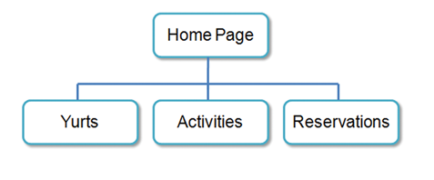

Pacific Trails Resort site map

[Figure 2.40](https://jigsaw.vitalsource.com/books/9780134801346/epub/OPS/xhtml/fileP700101479300000000000000000058B.xhtml?favre=brett#P70010147930000000000000000008BF) displays a wireframe sketch of the page layout for the website. It contains a header area, a navigation area, a main content area, and a footer area for copyright information.

**Figure 2.40**

# 

Pacific Trails Resort wireframe

**You have three tasks in this case study:**

1. **Create a folder for the Pacific Trails website.**
2. **Create the Home page: index.html.**
3. **Create the Yurts page: yurts.html.**

# Hands-On Practice Case Study

* **TASK 1: THE WEBSITE FOLDER.**Create a folder on your hard drive or portable storage device (thumb drive or SD card) called “pacific” to contain your Pacific Trails Resort website files.
* **TASK 2: THE HOME PAGE.**You will use a text editor to create the Home page for the Pacific Trails Resort website. The Home page is shown in [Figure 2.41](https://jigsaw.vitalsource.com/books/9780134801346/epub/OPS/xhtml/fileP700101479300000000000000000058B.xhtml?favre=brett#P70010147930000000000000000008D4).

# Figure 2.41

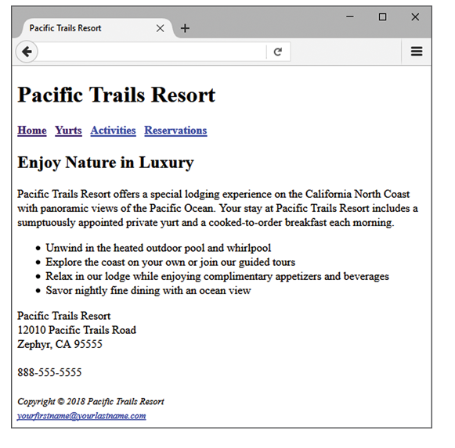

Pacific Trails Resort index.html

Launch a text editor, and create a web page with the following specifications:

* 1. **Web Page Title.** Use a descriptive page title. The company name is a good choice for the home page of a business website. On pages other than the home page, the title typically contains both the company name and a word or a phrase that describes the purpose of the page.
  2. **Wireframe Header.** Code the header element with the text, “Pacific Trails Resort” contained within a heading 1 element.
  3. **Wireframe Navigation.** Place the following text within a nav element with bold text (use the <b> element):
     + Home Yurts Activities Reservations
     + Code anchor tags so that “Home” links to index.html, “Yurts” links to yurts.html, “Activities” links to activities.html, and “Reservations” links to reservations.html. Add extra blank spaces between the hyperlinks with the &nbsp; special character as needed.
  4. **Wireframe Main Content.** Code the main page content within a main element. Use [Hands-On Practice 2.10](https://jigsaw.vitalsource.com/books/9780134801346/epub/OPS/xhtml/fileP70010147930000000000000000003B8.xhtml#P70010147930000000000000000003E7) as a guide.
     + Code the following text within an h2 element:
       - Enjoy Nature in Luxury
     + Configure the following sentences in a paragraph:
       - Pacific Trails Resort offers a special lodging experience on the California North Coast with panoramic views of the Pacific Ocean. Your stay at Pacific Trails Resort includes a sumptuously appointed private yurt and a cooked-to-order breakfast each morning.
     + Code the following content in an unordered list:
       - Unwind in the heated outdoor pool and whirlpool
       - Explore the coast on your own or join our guided tours
       - Relax in our lodge while enjoying complimentary appetizers and beverages
       - Savor nightly fine dining with an ocean view
     + Configure the following address and phone number contact information within a div element below the unordered list. Use line break tags to help you format this area.
       - Pacific Trails Resort
       - 12010 Pacific Trails Road
       - Zephyr, CA 95555
       - 888-555-5555
  5. **Wireframe Footer.** Configure the following copyright and e-mail link information within a footer element. Format it with small text size (use the <small> tag) and italics font style (use the <i> tag).
     + Copyright © 2018 Pacific Trails Resort
     + Place your name in an e-mail link on the line under the copyright.

The page in [Figure 2.41](https://jigsaw.vitalsource.com/books/9780134801346/epub/OPS/xhtml/fileP700101479300000000000000000058B.xhtml?favre=brett#P70010147930000000000000000008D4) may seem a little sparse, but don’t worry; as you gain experience and learn to use more advanced techniques, your pages will look more professional. White space (blank space) on the page can be added with <br> tags where needed. Your page does not need to look exactly the same as the sample. Your goal at this point should be to practice and get comfortable using HTML.

Save your page in the pacific folder, and name it index.html.

**TASK 3: THE YURTS PAGE.**Create the Yurts page shown in [Figure 2.42](https://jigsaw.vitalsource.com/books/9780134801346/epub/OPS/xhtml/fileP700101479300000000000000000058B.xhtml?favre=brett#P7001014793000000000000000000927). A technique that improves productivity is to create new pages based on existing pages so that you can benefit from your previous work. Your new Yurts page will use the index.html page as a starting point.

Figure 2.42

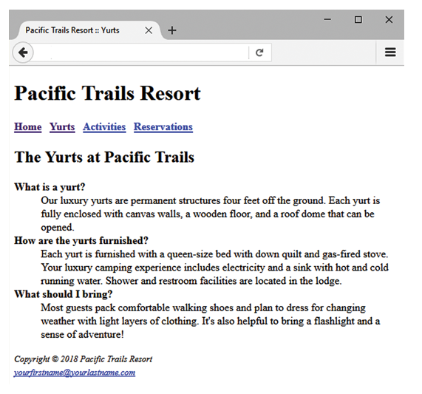

Pacific Trails Resort yurts.html

Open the index.html page for the Pacific Trails Resort website in a text editor. Select File > Save As, and save the file with the new name of yurts.html in the pacific folder. Now you are ready to edit the page.

1. **Web Page Title.** Modify the page title. Change the text contained between the <title> and </title> tags to the following:
   * Pacific Trails Resort :: Yurts
2. **Wireframe Main Content.**
   * Replace the text in the h2 element with the following:

The Yurts at Pacific Trails

* + Delete the Home page content paragraph, unordered list, and contact information.
  + Add the yurts content to the page as a FAQs (frequently asked questions) list by using a description list. Configure each question to have strong importance and bold font weight (use the <strong> phrase element) within a dt element. Configure each answer within a dd element. The text is shown as follows:
    - **What is a yurt?**
    - Our luxury yurts are permanent structures four feet off the ground. Each yurt is fully enclosed with canvas walls, a wooden floor, and a roof dome that can be opened.
    - **How are the yurts furnished?**
    - Each yurt is furnished with a queen-size bed with down quilt and gas-fired stove. Your luxury camping experience includes electricity and a sink with hot and cold running water. Shower and restroom facilities are located in the lodge.
    - **What should I bring?**
    - Most guests pack comfortable walking shoes and plan to dress for changing weather with light layers of clothing. It's also helpful to bring a flashlight and a sense of adventure!

Save your page, and test it in a browser. Test the hyperlink from the yurts.html page to index.html. Test the hyperlink from the index.html page to yurts.html. If your links do not work, review your work, paying close attention to these details:

* Verify that you have saved the pages with the correct names in the correct folder.
* Verify your spelling of the page names in the anchor elements.

Test again after you make the changes.