**CSIS 2270 - Lab #1**

20

**Introduction to Cisco Packet Tracer**

**Name: Leandro Miranda Fahur Machado ID No.: 300326045 Section#007**

**Due: 11:59 PM on Saturday, January 16th, 2021**

**Objectives:**

To introduce, explore and get familiar with using Cisco Packet Tracer simulator program to implement the different lab exercises of the networking course

**Introduction:**

Packet Tracer is a network design, simulation and modelling tool that allows you to develop your skill set in networking, cybersecurity, and the Internet of Things (IoT). It allows you to model complex systems without the need for dedicated equipment. It is used across numerous Cisco Academy courses to help develop and assess the skill set necessary for successful completion of the course.

**Requirements:**

1. You must enroll, using your college email address and go through the Packet Tracer free course provided by Cisco Networking Academy (Netacad) through the link for you to register for the packet tracer course is<https://www.netacad.com/portal/web/self-enroll/m/course-230255> , ( this is a free course to help you understand and work with Packet Tracer. It is short and helpful one, so please make sure that you get benefit from it.)
2. You must download and install Cisco Packet Tracer version 7.3.1 on your computer.
3. To start the Packet Tracer simulator, you will be asked to log in to your Cisco account (which you have created earlier) for verification.

**In this Lab:**

1. You will download and install Packet Tracer version 7.3.1
2. You will explore the Packet Tracer User Interface and functions.
3. You will Create a simple network topology
4. **Download and install Packet Tracer:**  [--------/5]

To obtain and install your copy of Cisco Packet Tracer follow these simple steps:

1. Log into your Cisco Networking Academy
2. Select Resources from the menu in the upper right portion of your screen.
3. Select Download Packet Tracer.
4. Select the version (7.3.1) of Packet Tracer you require.
5. Save the file to your computer.
6. Launch the Packet Tracer install program.
7. After installation, close and restart your web browser.
8. Launch Cisco Packet Tracer by selecting the appropriate icon.
9. When prompted, use your Netacad login information to authenticate.
10. Packet Tracer will launch and you are ready to explore its features.
11. **Packet Tracer User Interface:** [--------/9]
12. Launch the Packet Tracer program and explore the following user interface areas:

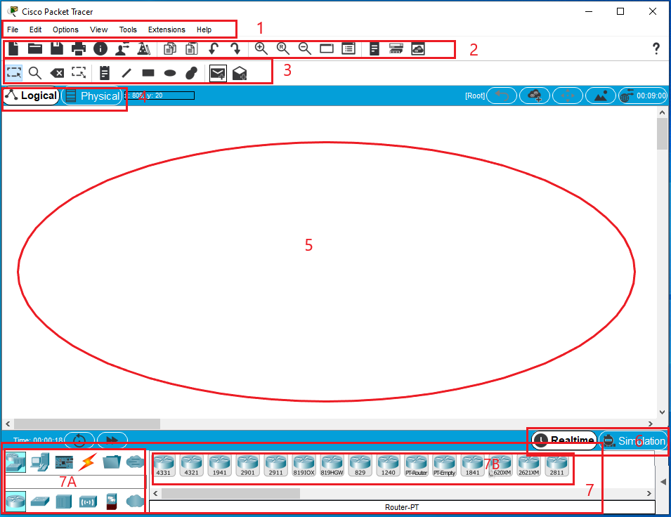

1. **Menu Bar:**  
   This bar provides the **File**, **Edit**, **Options**, **View**, **Tools**, **Extensions**, and **Help** menus. You will find basic commands such as **Open**, **Save**, **Save as Pkz, Print**, and **Preferences** in the **File** menu for example. You will also be able to access the **Activity Wizard** from the **Extensions** menu, and many more.
2. **Main Tool Bar**:  
   This bar provides shortcut icons to the **File** and **Edit** menu commands. This bar also provides buttons for **Copy**, **Paste**, **Undo**, **Redo**, **Zoom**, the **Drawing Palette**, and the **Custom Devices Dialog**. On the right, you will also find the **Network Information** button, which you can use to enter a description for the current network (or any text you wish to include).
3. **Common Tools Bar**:  
   This bar provides access to these commonly used workspace tools: **Select**, **Move Layout**, **Place Note**, **Delete**, **Inspect**, **Resize Shape**, **Add Simple PDU**, and **Add Complex PDU**.
4. **Logical/Physical Workspace and Navigation Bar**:  
   You can toggle between the Physical Workspace and the Logical Workspace with the tabs on this bar. In Logical Workspace, this bar also allows you to go back to a previous level in a cluster, create a **New Cluster**, **Move Object**, **Set Tiled Background**, and **Viewport**. In Physical Workspace, this bar allows you to navigate through physical locations, create a **New City**, create a **New Building**, create a **New Closet**, **Move Object**, apply a **Grid** to the background, **Set Background**, and go to the **Working Closet**.
5. **Workspace:**  
   This area is where you will create your network, watch simulations, and view many kinds of information and statistics.
6. **Realtime/Simulation Bar**:  
   You can toggle between Realtime Mode and Simulation Mode with the tabs on this bar. This bar also provides buttons to **Power Cycle Devices** and **Fast Forward Time** as well as the **Play Control** buttons and the **Event List** toggle button in Simulation Mode. Also, it contains a clock that displays the relative **Time** in Realtime Mode and Simulation Mode.
7. **Network Component Box**:  
   This box is where you choose devices and connections to put into the workspace. It contains the **Device-Type Selection** Box and the **Device-Specific Selection** Box.
   1. **Device-Type Selection Box**:  
      This box contains the type of devices and connections available in Packet Tracer. The **Device-Specific Selection** Box will change depending on which type of device you choose.
   2. **Device-Specific Selection Box:**  
      This box is where you choose specifically which devices you want to put in your network and which connections to make.
8. After you finish exploring the User Interface, answer the following questions:

Q1- Launch Packet Tracer, go to the menu bar and show in which menu you find the following functions:

* + - 1. Open Samples 🡪 File
      2. Redo 🡪 Edit
      3. Preferences 🡪 Cisco Packet Traces icon (in mac)

* + - 1. Simulation Mode 🡪 View
      2. Activity Sequence Editor 🡪 Extensions
      3. Tutorials 🡪 Help

Q2- Make a snapshot of the User Interface and indicate on it (by writing the   
 number of the item bellow) where are the following things then attach it to   
 your report:

* + - 1. Resize
      2. Add Simple PDU
      3. Activity Wizard
      4. Network Devices
      5. Realtime
      6. Set Background image

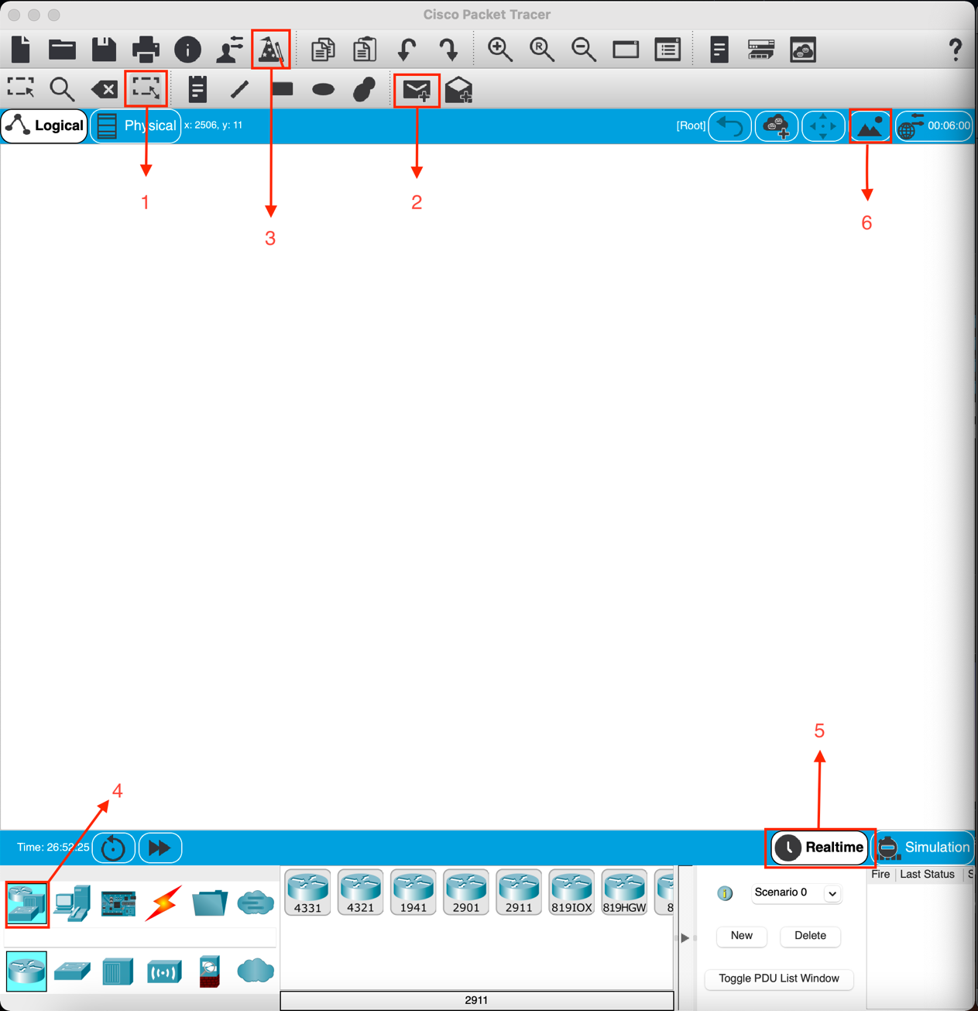

Q3- List three examples from the following network component groups

1. End Devices 🡪 PC, Server, Printer.
2. Switches 🡪 2960, PT-Switch, IE2000.
3. Routers 🡪 4331, 2911, 819HGW.
4. Connections 🡪 Console, Cooper Cross-Over, Phone.
5. **Creating Network Topology:** [--------/6]
6. To create a network, you need to
7. Select and deploy the different devices of this network. Finding a device to deploy requires looking in the Device-Type Selection Box (box #7A). The Device-Type Selection Box works on the concept of categories and sub-categories as shown in the figure. The top row of icons represents the category list consisting of: [Networking Devices], [End Devices], [Components], [Connections], [Miscellaneous], and [Multiuser]. Each category contains at least one sub-category group.
8. 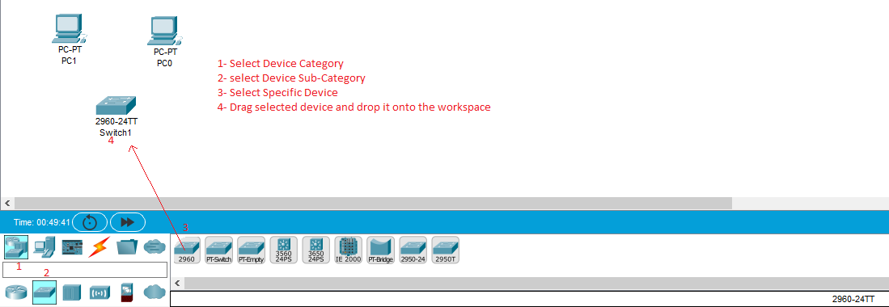Drag the selected device and drop it in the workspace (If necessary, modify the dragged device by changing or adding a module)
9. 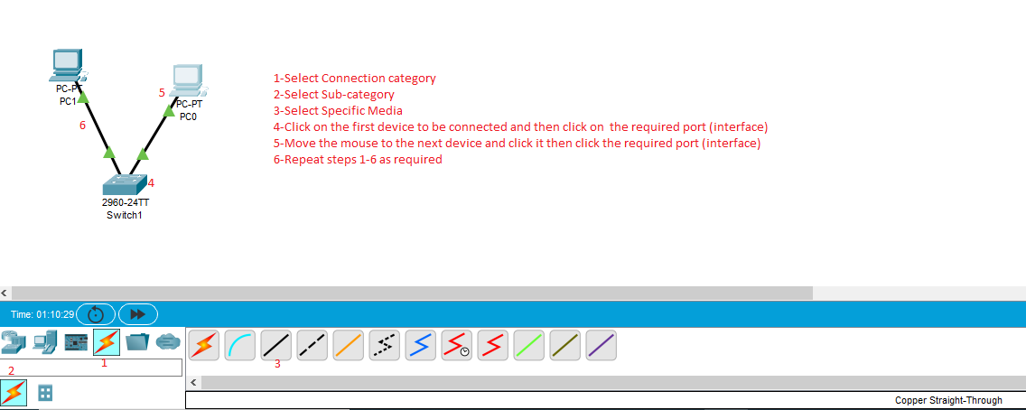Connect the network devices by selecting a suitable connection media, then click on the first device to be connected and select the required port (interface) and move the mouse with the trail of the line to the next device to be connected and click on it and select the required port (interface) and click it. Repeat this procedure as required.
10. Click File menu and select Save, give a name to your network and select where to save it, and you are done for now. **Next you have to properly configure the devices (next labs).**
11. Using Packet Tracer, create the network described below

Q4- You network contains four PCs (PC1, PC2, PC3, PC4), one Laptop (Laptop1), one Switch  
 (2960 switch) one Router (1941 router) and one HomeRouter1. PC1, PC2, PC3 are   
 connected through the FastEthernet0 interface (in each PC) to the FastEthernet0/1, 0/2,   
 0/3 interfaces of Switch 2960 using a copper straight-through cable. PC4 and the   
 Laptop are connected through the FastEthernet0 interface (in each of them) to the   
 GigabitEthernet0/1, 0/2 interfaces of the HomeRouter1 using a copper straight-through   
 cable. The Switch 2960 is connected through the FastEthernet0/23 interface to the   
 GigabitEthernet0/0 interface of Router1 and connect the Internet interface of the  
 HomeRouter1 to the GigabitEthernet0/1 interface of Router1. After you finish, you   
 supposed to have a network like the one shown below.

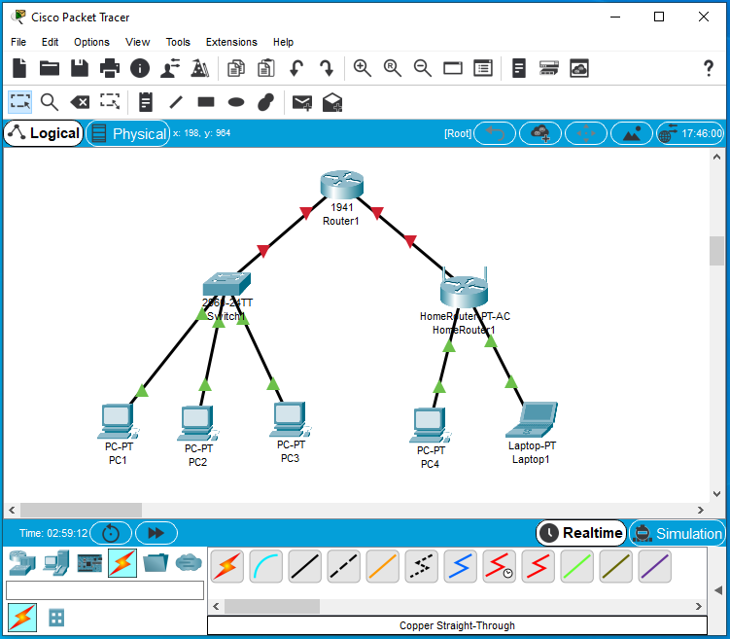

**Lab Submission instructions:**

1. Save your report file as yourFirstnameLastname_yourID_Lab1.docx.  
    (example: RupaManabala_1234_Lab1.docx)
2. Save your Packet Tracer file as yourFirstnameLastname_yourID_Lab1.pkt   
    (example: RupaManabala_1234_Lab1.pkt)
3. Put both files ( .pkt and .docx) in one folder and name it as   
    yourFirstnameLastname_yourID_Lab1 (example:RupaManabala_1234_Lab1)
4. Compress the folder into a zip file
5. Submit the compressed zip file no later than **11:59 PM** of **Saturday**, **January 16th, 2021** on Blackboard Course content section, **Course Lab Assignments** 🡪**Lab 1** (**Do not send labs by email please. Any lab submitted by email will be ignored**).
6. **Late submissions will NOT be accepted or graded.**
7. **Students who do not save lab files with proper names as indicated in 1,2,3 above, will lose 50% of the lab’s mark**.